Supplementary Materials

This file includes:
Figure. S1 to S6
Table S1 to S2

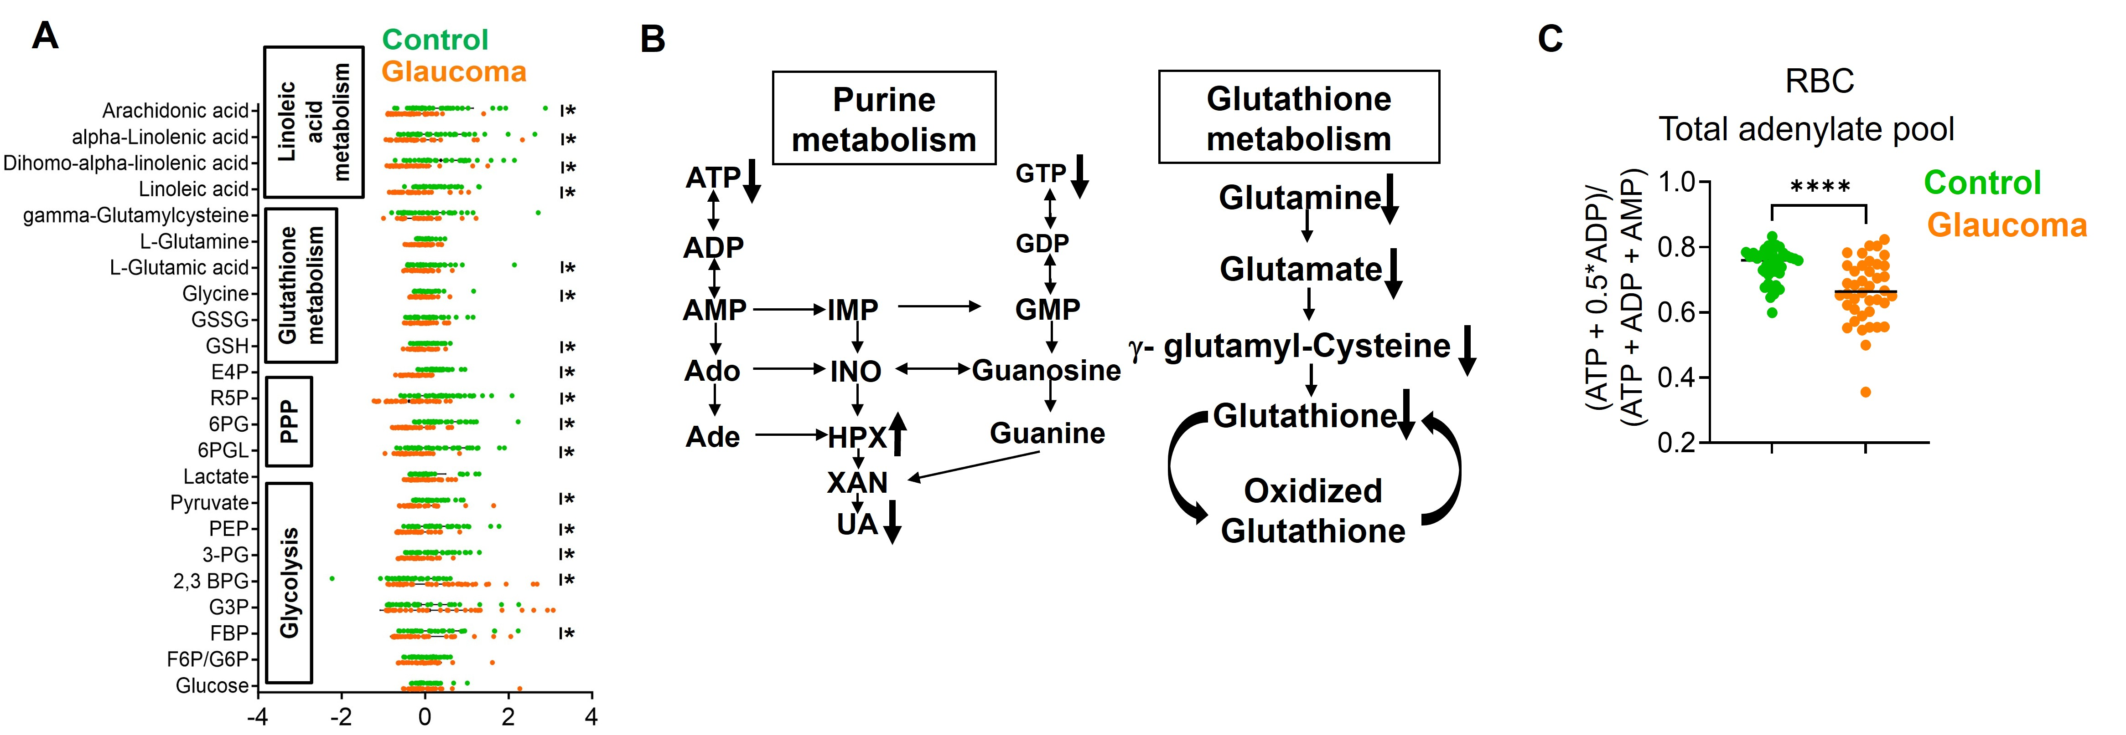
Figure S1. The indicated metabolic pathway in erythrocytes from control and glaucoma subjects. (A-B) Indicated erythrocyte intermediates of glycolysis, PPP, purine metabolism, linoleic acid metabolism and glutathione metabolism were revealed by untargeted metabolomics (n=40). (C) Total adenylate pools (AXP-calculated as (ATP + 0.5*ADP)/(ATP + ADP + AMP)) were measured in primary glaucoma and control erythrocytes (n=40). P were assessed by two-tailed unpaired t test, * P < 0.05.
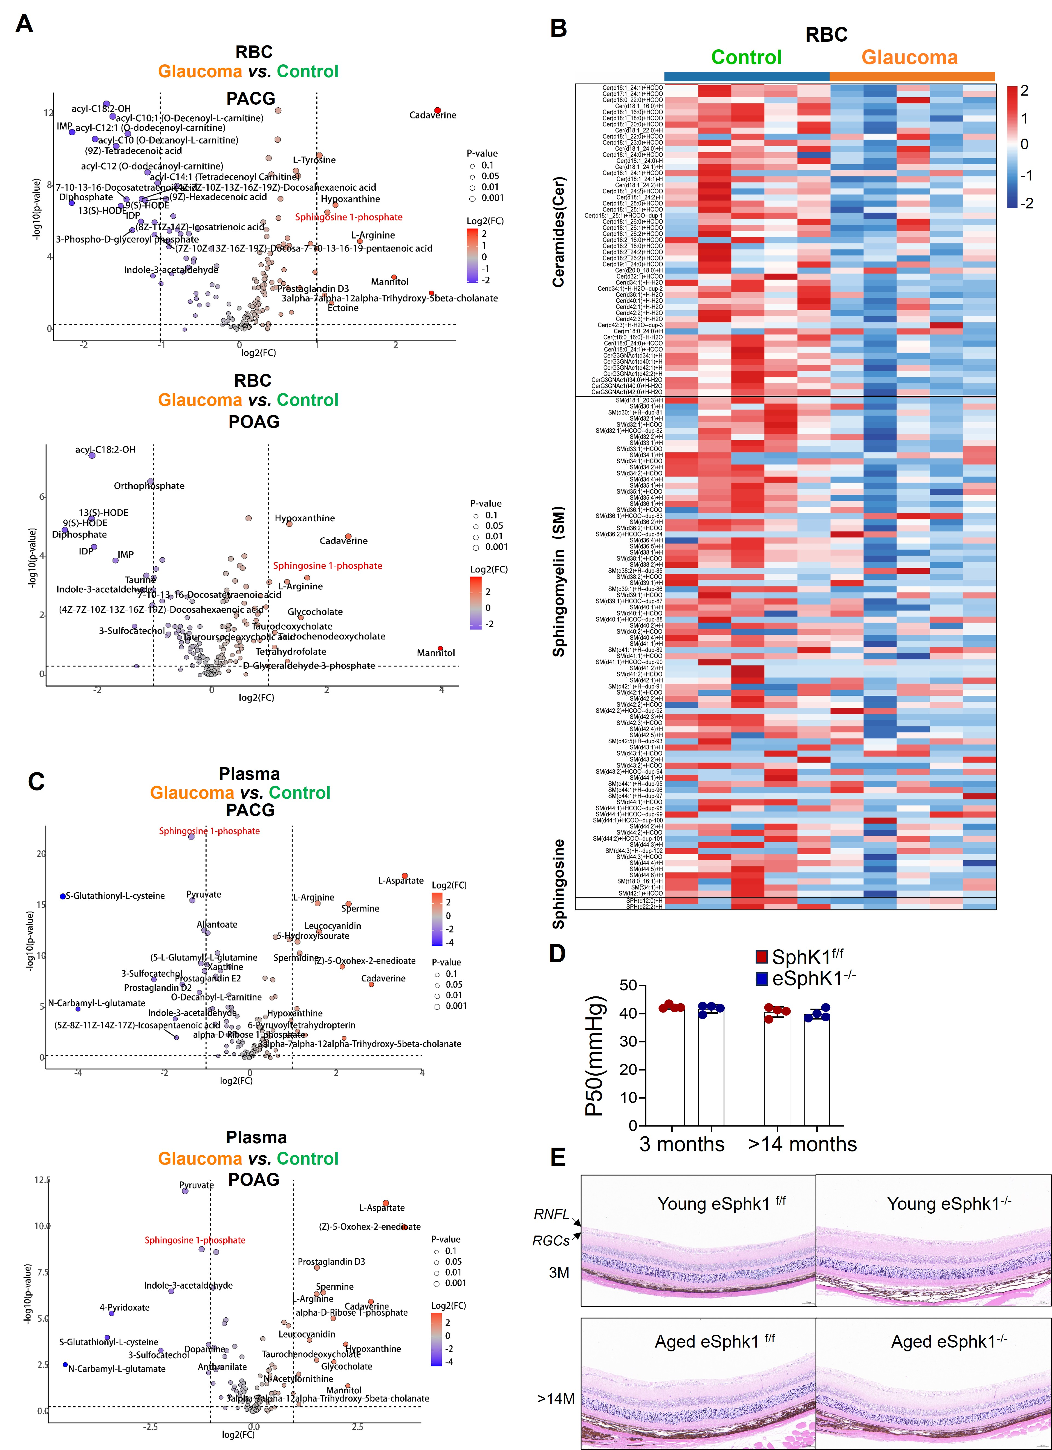
Figure S2. Metabolic intermediates in sphingolipid metabolism pathway in erythrocytes. (A) Featured metabolites with significant differences between erythrocytes of primary glaucoma subgroup and control group were shown in volcano plot. (B) Heat map of metabolic intermediate from sphingolipid metabolism in erythrocytes. (C) Featured metabolites with significant differences between erythrocytes of primary glaucoma subgroup and control group were shown in volcano plot. (D) The P50 value of erythrocytes in naïve young and aged Sphk1^{flox} and eSphk1^{-/-} mice (n=4). (E) Histology of retinal tissue of young and aged Sphk1^{flox} and eSphk1^{-/-} mice in normal conditions. P were assessed by two-tailed unpaired t test, * P < 0.05.
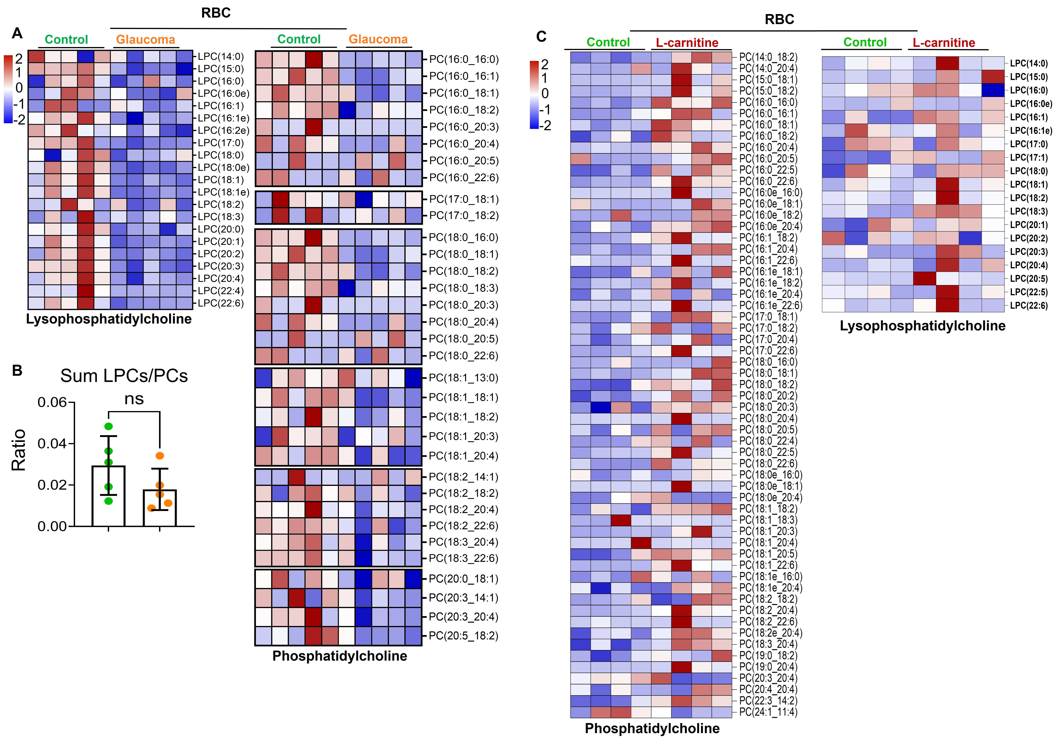

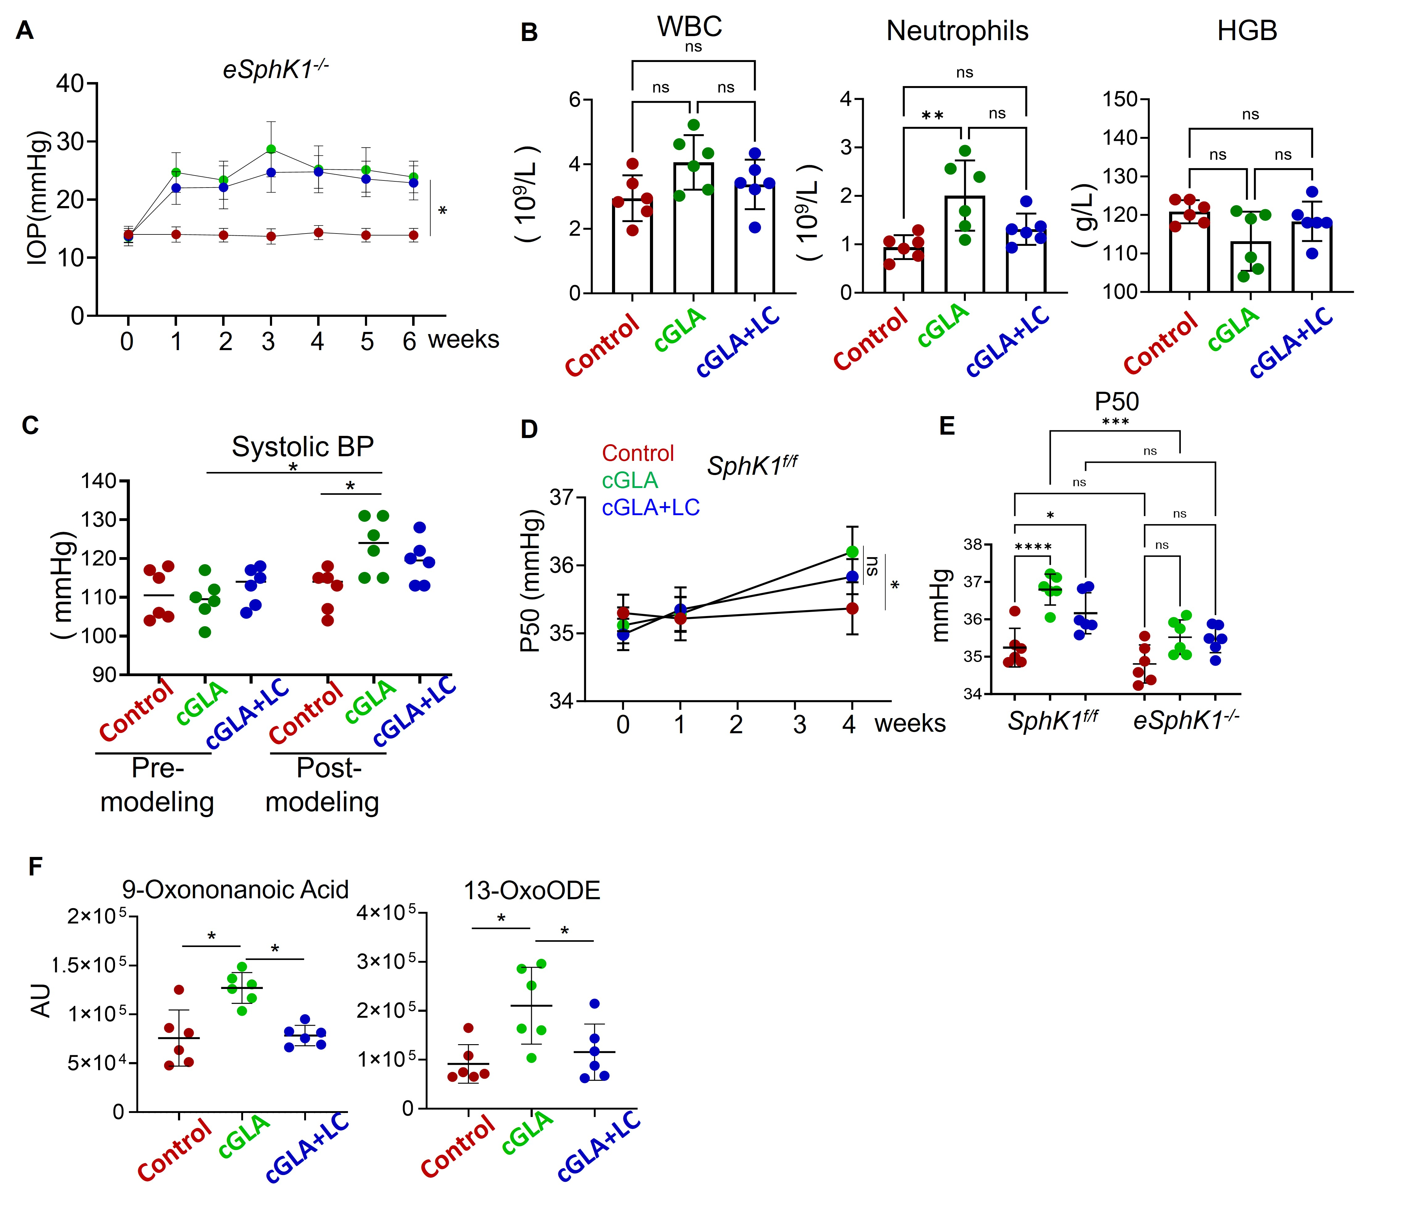
Figure S3. Lipid and metabolic alterations in glaucoma erythrocytes. (A) Heat map of lipid composition in control and glaucoma erythrocytes, measured by untargeted lipidomic analysis. Lipid species are categorized by the Lands cycle. (B) Ratio of total lysophosphatidylcholines (LPCs) to phosphatidylcholines (PCs) in control and glaucoma erythrocytes(n=5). (C) Heat map of lipid composition in glaucoma erythrocytes treated with or without L-carnitine, measured by untargeted lipidomic analysis. P were assessed by two-tailed unpaired t test, * P < 0.05.
Figure S4. Systemic Responses in the cGLA Model: Leukogram, Blood Pressure, and Oxidative Stress. (A) The IOP was monitored in cGLA of eSphk1^{-/-} mice (n=6). (B) Complete blood count (CBC) data of SphK1^{flox} cGLA model treated with or without L-carnitine(n=6). (C) Systolic blood pressure was measured in each group before and after induction of SphK1^{flox} cGLA model(n=6). (D) P50 of erythrocytes was measured, at different time point, from SphK1^{flox} cGLA model treated with or without L-carnitine (n=6). (E) P50 of erythrocytes from eSphk1^{-/-} cGLA model treated with or without L-carnitine (n=6). (F) Levels of oxidized lipid species in erythrocytes from the SphK1^{flox} cGLA model treated with or without L-carnitine(n=6).
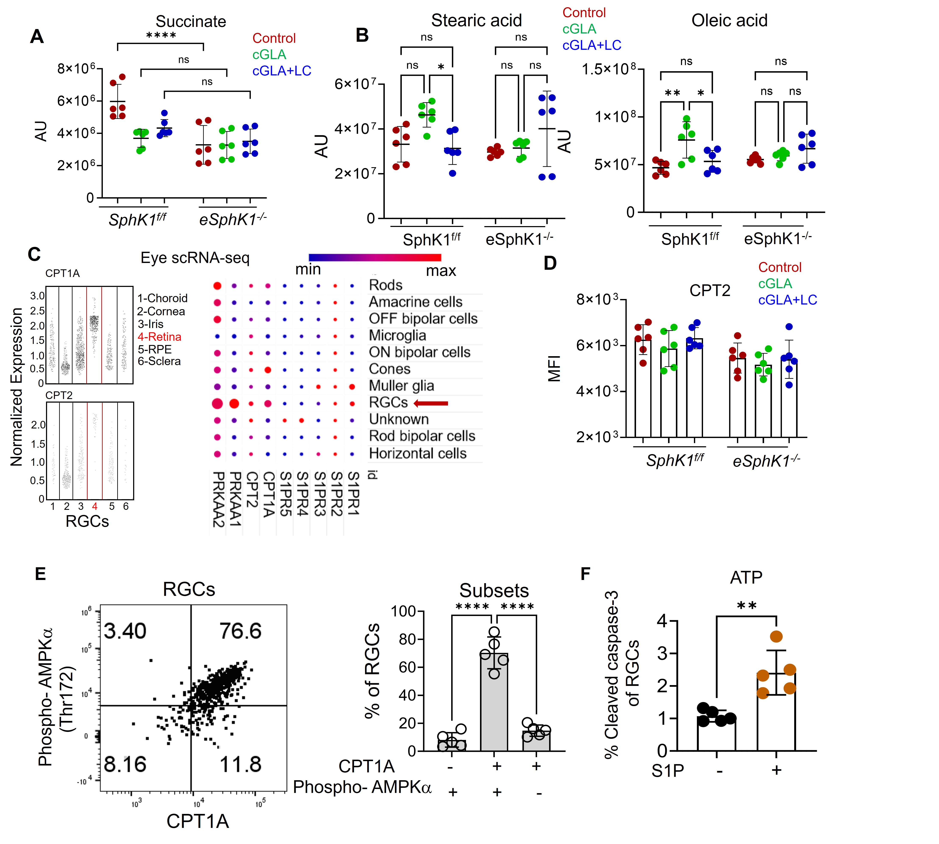
Figure S5. The levels of long-chain fatty acids are increased in the retina of cGLA. (A) The levels of succinate in retina of Sphk1^{flox} and eSphk1^{-/-} cGLA treated with or without L-carnitine (n=6). (B) The levels of long- chain fatty acid in retina of Sphk1^{flox} and eSphk1^{-/-} cGLA treated with or without L-carnitine (n=6). (C) Single-cell RNA sequencing (scRNA-seq) data from human eyes were reanalyzed from the public database GSE147979. (D) The protein levels of CPT2 in RGCs from retina of Sphk1^{flox} and eSphk1^{-/-} cGLA treated with or without L-carnitine (n=6). (E) The expression of CPT1A and phospho-AMPKα (Thr172) on RGCs by flow cytometry (n=5). (F) The ATP levels of RGCs cultured under oxygen-glucose deprivation/reperfusion conditions, with or without S1P in the presence of L-carnitine (n=5). P were assessed by two-tailed unpaired t test, * P < 0.05

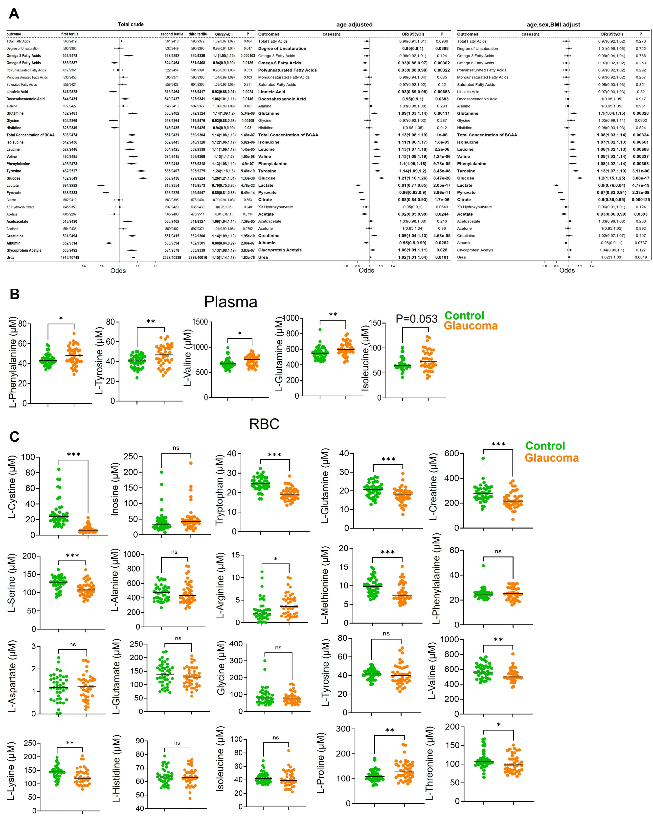
Figure S6. Metabolomic profiling of amino acids in plasma and erythrocytes in glaucoma. (A) Total crude, age adjusted and age, sex, BMI-adjusted baseline analysis of plasma metabolites significantly associated with POAG from the UK Biobank. (B-C) Quantitative analysis of indicated amino acid levels in glaucoma and control plasma and erythrocytes. P were assessed by two-tailed unpaired t test, * P < 0.05

Supplemental Table 1. Treatment History of Glaucoma Patients
Variable | Primary Glaucoma (n=40)
Newly Diagnosed (n, %) | 12 (30%)
Previously Diagnosed (n, %) | 28 (70%)
Topical Medications (n, %)
- Prostaglandin Analogs | 9 (22.5%)
- Beta-Blockers | 14 (35%)
- Alpha-Agonists | 14 (35%)
- Carbonic Anhydrase Inhibitors | 8(20%)
Glaucoma Surgery (n, %)
- Trabeculectomy | 10 (25%)
- Laser Peripheral Iridotomy (PACG) | 3(7.5%)
Mean Duration of Treatment (years) | 1.5 ± 1.7
Data expressed as n (%) or mean ± SD. Patients may be on multiple medications.

Supplemental Table 2. List of all differential metabolites identified through metabolic screening in the erythrocyte and plasma of glaucoma and control group.
Erythrocyte
Metabolite name | Fold change | log2(FC) | p.value
Cadaverine | 7.4783 | 2.9027 | 1.35E-25
Mannitol | 7.2535 | 2.8587 | 1.60E-06
3alpha-7alpha-12alpha-Trihydroxy-5beta-cholanate | 3.4487 | 1.786 | 0.002098
L-Arginine | 2.9014 | 1.5368 | 1.31E-11
Urate | 2.5889 | 1.3723 | 1.90E-12
Hypoxanthine | 2.5025 | 1.3234 | 2.14E-16
Sphingosine 1-phosphate | 2.3147 | 1.2108 | 1.63E-13
Ectoine | 2.2565 | 1.1741 | 0.0009
L-Tyrosine | 1.9749 | 0.98179 | 1.65E-16
2-3-Dinor-8-iso prostagLandin F2alpha | 1.8584 | 0.89404 | 5.42E-08
Ornithine | 1.8065 | 0.85318 | 2.26E-23
ADP-D-ribose | 1.7674 | 0.82159 | 5.61E-16
Sphinganine 1-phosphate | 1.7214 | 0.78361 | 2.16E-15
L-Proline | 1.7137 | 0.77715 | 3.44E-17
Allantoate | 1.7126 | 0.77619 | 3.35E-14
Dodecanedioic acid | 1.7073 | 0.77175 | 1.68E-09
1-4-beta-D-Xylan | 1.7036 | 0.76861 | 2.71E-07
Glycochenodeoxycholate | 1.6782 | 0.74692 | 2.38E-06
Cholesterol sulfate | 1.6692 | 0.73913 | 4.19E-10
Taurochenodeoxycholate | 1.6545 | 0.72636 | 0.022928
Taurodeoxycholate | 1.6545 | 0.72636 | 0.022928
Tauroursodeoxycholic acid | 1.6545 | 0.72636 | 0.022928
sn-Glycerol 3-phosphate | 1.5916 | 0.67051 | 7.42E-08
S-Glutathionyl-L-cysteine | 1.5762 | 0.65642 | 1.48E-05
N6-(1-2-Dicarboxyethyl)-AMP | 1.5709 | 0.65158 | 0.002143
Inosine | 1.5636 | 0.64486 | 0.001576
ProstagLandin D3 | 1.5475 | 0.62992 | 0.000769
3--5--Cyclic IMP | 1.5043 | 0.58906 | 1.07E-05
alpha-D-Ribose 1-phosphate | 1.4907 | 0.57602 | 0.00043
ProstagLandin G2 | 1.4848 | 0.57025 | 2.01E-27
acyl-C4-DC | 1.4674 | 0.55329 | 9.74E-08
N-N-Dimethylglycine | 1.4623 | 0.54825 | 7.74E-09
L-Citrulline | 1.458 | 0.54402 | 1.50E-12
L-Aspartate | 1.4447 | 0.53073 | 0.000281
Carnosine | 1.4269 | 0.51285 | 2.14E-06
L-Histidine | 1.4174 | 0.50327 | 2.71E-21
L-Alanine | 1.413 | 0.49874 | 1.08E-11
Glycine | 1.3971 | 0.48245 | 6.04E-13
L-Lysine | 1.3959 | 0.48124 | 3.75E-11
5-6-Dihydrothymine | 1.393 | 0.4782 | 0.00488
L-Threonine | 1.3795 | 0.46414 | 6.64E-09
L-Asparagine | 1.3775 | 0.4621 | 9.18E-12
5-Hydroxyisourate | 1.3625 | 0.44622 | 1.12E-10
GMP | 1.3585 | 0.44204 | 0.004505
Undecanoic acid | 1.3546 | 0.43789 | 1.06E-20
L-Phenylalanine | 1.3469 | 0.42962 | 1.21E-13
alpha-D-Glucosamine 1-phosphate | 1.3448 | 0.42735 | 6.47E-07
Pyridine-2-3-dicarboxylate | 1.3422 | 0.42464 | 6.83E-16
Sphingosine | 1.3341 | 0.41591 | 9.90E-07
Creatinine | 1.3322 | 0.41378 | 9.36E-08
Nonanoic acid | 1.3191 | 0.3996 | 3.30E-14
D-Glucose 6-phosphate | 1.3135 | 0.39346 | 0.000436
L-Glutamine | 1.3112 | 0.39093 | 2.72E-08
L-Valine | 1.3108 | 0.39042 | 7.01E-13
Ascorbate | 1.303 | 0.38188 | 9.45E-08
Adenine | 1.3028 | 0.38162 | 4.35E-09
Xanthine | 1.3023 | 0.38101 | 0.000419
Glycolate | 1.2961 | 0.3742 | 9.15E-08
Indole | 1.2959 | 0.37392 | 2.34E-14
Adenosine | 1.295 | 0.37291 | 2.92E-05
D-Arabitol | 1.2902 | 0.3676 | 2.62E-11
L-Serine | 1.2855 | 0.36235 | 1.79E-06
CMP-N-acetylneuraminate | 1.267 | 0.34138 | 7.59E-05
L-Glutamate | 1.2622 | 0.33599 | 0.000647
Picolinic acid | 1.2556 | 0.32843 | 8.31E-08
acyl-C16 (L-Palmitoylcarnitine) | 1.2521 | 0.32434 | 3.12E-05
L-Leucine | 1.2501 | 0.322 | 1.23E-05
3-Methyldioxyindole | 1.2419 | 0.31259 | 1.52E-06
D-Rhamnose | 1.2358 | 0.3054 | 0.011615
Creatine | 1.2292 | 0.29769 | 0.000149
Glutathione | 1.225 | 0.29279 | 0.000269
Lactate | 1.2195 | 0.28625 | 0.000684
Anthranilate | 1.217 | 0.28328 | 4.18E-11
N-Methylethanolamine phosphate | 1.2146 | 0.28052 | 0.000939
D-Ribose | 1.2144 | 0.28026 | 0.000186
Dopamine | 1.2135 | 0.2792 | 7.63E-08
acyl-C18 (Octadecanoyl-L-carnitine) | 1.2135 | 0.27918 | 0.000476
Decanoic acid | 1.2101 | 0.27512 | 2.55E-06
Dodecanoic acid | 1.1958 | 0.25798 | 0.02238
acyl-C20:4 | 1.1886 | 0.24932 | 0.014839
5-Oxoproline | 1.1864 | 0.2466 | 0.000944
UDP | 1.1796 | 0.23825 | 0.00335
2-Hydroxyglutarate | 1.1756 | 0.23344 | 0.029897
acyl-C18:2 (Linoleoyl-CoA) | 1.1713 | 0.22815 | 0.00068
Glutathione disulfide | 1.1593 | 0.21328 | 0.003595
acyl-C18:1 (O-octadecenoyl-L-carnitine) | 1.1539 | 0.20656 | 0.001135
trans-4-Hydroxy-L-proline | 1.1452 | 0.19556 | 0.027345
D-Glucose | 1.1368 | 0.185 | 0.024549
L-Tryptophan | 1.1334 | 0.18071 | 0.001253
Pyridoxal | 1.1221 | 0.16619 | 0.000113
ProstagLandin D2 | 1.106 | 0.14535 | 0.038144
ProstagLandin E2 | 1.106 | 0.14535 | 0.038144
Glycocholate | 1.0878 | 0.12145 | 0.00145
D-Glucosamine | 1.0575 | 0.080623 | 0.035905
Fumarate | 0.91006 | -0.13597 | 0.01352
acyl-C16:1 (Hexadecenoyl-carnitine) | 0.89804 | -0.15514 | 0.023275
acyl-C3 (propionyl-carnitine) | 0.86623 | -0.20718 | 0.031053
(S)-Malate | 0.85752 | -0.22175 | 0.000337
Guanine | 0.83454 | -0.26095 | 0.010291
(5Z-8Z-11Z-14Z-17Z)-Icosapentaenoic acid | 0.8202 | -0.28595 | 0.003935
Phosphoenolpyruvate | 0.79119 | -0.33791 | 0.003385
ADP | 0.79037 | -0.3394 | 4.65E-05
Phosphocreatine | 0.76724 | -0.38225 | 0.00218
D-Erythrose 4-phosphate | 0.76711 | -0.3825 | 1.68E-06
Dehydroascorbate | 0.7584 | -0.39897 | 2.60E-05
Tetradecanoic acid | 0.726 | -0.46197 | 2.21E-05
6-Phospho-D-gluconate | 0.71102 | -0.49204 | 2.87E-07
Indoxyl | 0.70685 | -0.50052 | 0.003254
7alpha-Hydroxy-3-oxo-4-cholestenoate | 0.68863 | -0.53819 | 5.26E-07
ATP | 0.68346 | -0.54907 | 3.87E-06
Linoleate | 0.67523 | -0.56655 | 1.77E-08
3-Phospho-D-glyceroyl phosphate | 0.6423 | -0.63869 | 8.01E-05
Citrate | 0.6392 | -0.64567 | 6.02E-08
(9Z)-Octadecenoic acid | 0.63613 | -0.65261 | 1.85E-09
Stearidonic acid | 0.62569 | -0.67648 | 9.21E-06
(9Z-12Z-15Z)-Octadecatrienoic acid | 0.62008 | -0.68947 | 3.07E-07
acyl-C14:1 (Tetradecenoyl Carnitine) | 0.5952 | -0.74854 | 1.13E-09
Orthophosphate | 0.57374 | -0.80152 | 7.84E-17
(8Z-11Z-14Z)-Icosatrienoic acid | 0.57171 | -0.80665 | 2.90E-09
acyl-C12 (O-dodecanoyl-carnitine) | 0.56718 | -0.81813 | 6.89E-10
(7Z-10Z-13Z-16Z-19Z)-Docosa-7-10-13-16-19-pentaenoic acid | 0.56003 | -0.83643 | 6.58E-09
3-Sulfocatechol | 0.55073 | -0.86058 | 0.000982
Taurine | 0.53712 | -0.89668 | 5.96E-14
(9Z)-Hexadecenoic acid | 0.50667 | -0.98087 | 1.05E-11
(4Z-7Z-10Z-13Z-16Z-19Z)-Docosahexaenoic acid | 0.4953 | -1.0136 | 2.18E-12
acyl-C12:1 (O-dodecenoyl-carnitine) | 0.46387 | -1.1082 | 3.26E-16
Indole-3-acetaldehyde | 0.45268 | -1.1434 | 9.87E-08
7-10-13-16-Docosatetraenoic acid | 0.44741 | -1.1603 | 4.17E-13
acyl-C10:1 (O-Decenoyl-L-carnitine) | 0.4061 | -1.3001 | 6.04E-20
(9Z)-Tetradecenoic acid | 0.39342 | -1.3459 | 8.18E-17
IDP | 0.37837 | -1.4021 | 1.10E-12
acyl-C10 (O-Decanoyl-L-carnitine) | 0.35788 | -1.4824 | 3.32E-16
acyl-C18:2-OH | 0.30447 | -1.7156 | 2.55E-23
13(S)-HODE | 0.29647 | -1.754 | 3.60E-15
9(S)-HODE | 0.29647 | -1.754 | 3.60E-15
Maltose | 0.29047 | -1.7835 | 0.000401
IMP | 0.2772 | -1.851 | 7.58E-18
Diphosphate | 0.20156 | -2.3107 | 3.30E-16
Plasma
Metabolite name | Fold change | log2(FC) | p.value
Leucocyanidin | 86.284 | 6.431 | 8.60E-45
L-Aspartate | 9.8785 | 3.3043 | 4.42E-41
Cadaverine | 6.566 | 2.715 | 2.70E-16
(Z)-5-Oxohex-2-enedioate | 5.2501 | 2.3923 | 5.45E-21
Spermine | 4.0465 | 2.0167 | 2.12E-29
alpha-D-Ribose 1-phosphate | 3.0904 | 1.6278 | 1.18E-07
3alpha-7alpha-12alpha-Trihydroxy-5beta-cholanate | 2.9338 | 1.5527 | 0.010648
L-Arginine | 2.7089 | 1.4377 | 3.87E-28
Hypoxanthine | 2.6858 | 1.4254 | 1.70E-10
Taurochenodeoxycholate | 2.197 | 1.1355 | 3.70E-05
Mannitol | 2.1841 | 1.127 | 0.000411
Spermidine | 1.9353 | 0.95253 | 4.86E-16
5-Hydroxyisourate | 1.7675 | 0.82169 | 8.63E-19
N-Acetylornithine | 1.7038 | 0.76875 | 4.29E-05
ProstagLandin D3 | 1.6731 | 0.74253 | 2.06E-08
4-Acetamidobutanoate | 1.6054 | 0.68297 | 0.016587
6-Pyruvoyltetrahydropterin | 1.5987 | 0.67691 | 0.001458
N-Methylethanolamine phosphate | 1.5435 | 0.62625 | 8.96E-12
2-Hydroxyglutarate | 1.4133 | 0.49906 | 1.19E-07
D-Glucose | 1.3179 | 0.39822 | 2.54E-10
2-Methyleneglutarate | 1.2974 | 0.37567 | 1.42E-06
D-Ribose | 1.2949 | 0.37285 | 0.000198
Pentobarbital | 1.2633 | 0.33721 | 0.047723
1-4-beta-D-Xylan | 1.2613 | 0.33495 | 1.57E-06
Hexanoic acid | 1.2137 | 0.27939 | 0.001892
Glycocholate | 1.1989 | 0.26173 | 4.13E-05
2-3-Dinor-8-iso prostagLandin F2alpha | 1.1557 | 0.20876 | 0.035226
UDP | 1.1424 | 0.19208 | 1.26E-08
L-Cystine | 1.1395 | 0.18845 | 0.012031
9(S)-HODE | 1.1218 | 0.16579 | 0.030244
L-Adrenaline | 1.104 | 0.14278 | 0.029786
Glycolate | 1.0967 | 0.13316 | 0.007968
Adenine | 0.94067 | -0.08823 | 0.040499
Ascorbate | 0.93658 | -0.09452 | 0.041338
2-Oxoglutaramate | 0.93615 | -0.09519 | 0.049942
9-Oxononanoic acid | 0.92141 | -0.11808 | 0.018005
L-Phenylalanine | 0.91759 | -0.12408 | 0.014338
Indole | 0.90148 | -0.14964 | 0.013811
D-Glyceraldehyde 3-phosphate | 0.89752 | -0.15598 | 3.53E-06
N-N-Dimethylglycine | 0.8969 | -0.15698 | 0.011703
IDP | 0.86363 | -0.21151 | 0.002448
O-Propanoylcarnitine | 0.85724 | -0.22223 | 0.005829
Sphinganine 1-phosphate | 0.85672 | -0.2231 | 0.007206
L-Methionine | 0.85554 | -0.2251 | 0.000571
L-Lysine | 0.83296 | -0.26369 | 1.96E-06
10-Hydroxydecanoic acid | 0.83107 | -0.26696 | 0.013282
Cortisol | 0.82996 | -0.26889 | 0.015107
trans-4-Hydroxy-L-proline | 0.80737 | -0.30869 | 1.15E-08
Urate | 0.80268 | -0.3171 | 2.65E-05
Butanoic acid | 0.77553 | -0.36674 | 2.48E-12
L-Tyrosine | 0.76655 | -0.38354 | 0.002591
5-Guanidino-2-oxopentanoate | 0.75813 | -0.39948 | 6.99E-13
Pentanoate | 0.75196 | -0.41127 | 3.36E-08
Lactate | 0.73615 | -0.44192 | 4.19E-09
Uracil | 0.72977 | -0.45448 | 2.42E-11
L-Serine | 0.72818 | -0.45763 | 6.23E-09
Succinate | 0.70484 | -0.50463 | 3.36E-16
Dehydroascorbate | 0.70235 | -0.50974 | 1.50E-11
3--5--Cyclic IMP | 0.67589 | -0.56514 | 5.62E-08
Sphingosine | 0.65377 | -0.61315 | 6.16E-08
L-Palmitoylcarnitine | 0.62034 | -0.68887 | 1.39E-15
Pantothenate | 0.5947 | -0.74976 | 1.37E-08
Biliverdin | 0.57841 | -0.78985 | 1.07E-07
Fumarate | 0.56552 | -0.82235 | 1.11E-19
Ornithine | 0.56177 | -0.83195 | 1.58E-20
Malate | 0.54158 | -0.88476 | 2.16E-22
Xanthine | 0.54129 | -0.88553 | 3.43E-13
Anthranilate | 0.53858 | -0.89276 | 9.22E-11
2-Oxoglutarate | 0.51713 | -0.95139 | 1.86E-27
5-Oxoproline | 0.51183 | -0.96627 | 7.80E-22
4-Pyridoxate | 0.50534 | -0.98468 | 1.35E-14
(7Z-10Z-13Z-16Z-19Z)-Docosa-7-10-13-16-19-pentaenoic acid | 0.48805 | -1.0349 | 6.06E-11
Allantoate | 0.46222 | -1.1133 | 1.05E-28
Dopamine | 0.4539 | -1.1396 | 5.20E-17
O-Decanoyl-L-carnitine | 0.45337 | -1.1412 | 1.84E-12
(5-L-Glutamyl)-L-glutamine | 0.44789 | -1.1588 | 6.64E-17
Bilirubin | 0.42726 | -1.2268 | 1.75E-11
ProstagLandin E2 | 0.38741 | -1.3681 | 7.00E-12
ProstagLandin D2 | 0.38741 | -1.3681 | 7.00E-12
Sphingosine 1-phosphate | 0.38119 | -1.3914 | 5.30E-48
Pyruvate | 0.33457 | -1.5796 | 1.36E-38
(5Z-8Z-11Z-14Z-17Z)-Icosapentaenoic acid | 0.32897 | -1.604 | 0.000105
Indole-3-acetaldehyde | 0.25591 | -1.9663 | 2.40E-13
3-Sulfocatechol | 0.22881 | -2.1278 | 1.74E-14
S-Glutathionyl-L-cysteine | 0.059125 | -4.0801 | 2.32E-26
N-Carbamyl-L-glutamate | 0.053583 | -4.2221 | 4.20E-08

