Table S1 Variation in polypeptides pattern between malt and feed barley lines.
Molecular Weight region | Pattern type | Molecular Weight (kDa) | Barley lines
Molecular Weight region | Pattern type | Molecular Weight (kDa) | Malt Barley | Feed Barley
A (73-98 kDa) | A1 | 98, 91.5, 82.5, 73 | K 551 | Azad, NB 1, NB 3
A (73-98 kDa) | A2 | 93, 82.5, 73 | ALFA 93, BCU 73, DL 88, DWRB 73, DWRUB 52 | HBL 316, HBL113, K 508, NDB 1173, PL 419, PL 426, RD 2660, VLB 56, VLB 85
A (73-98 kDa) | A3 | 82.5, 73 | DWR 28, RD 2503, RD 2668 | BH 393, JB 58, K 603, NB 2, PL 751, RD 2035, RD 2052, RD 2508, RD 2552, RD 2592, RD 2624
B (53-68 kDa) | B1 | 68, 63, 55.5, 53 | DWRUB 52
B (53-68 kDa) | B2 | 68, 63 | DWR 28 | PL 419
B (53-68 kDa) | B3 | 68, 63, 54 |  | NB 2
B (53-68 kDa) | B4 | 68, 63, 53 |  | NDB 1173, PL 751, RD 2508
B (53-68 kDa) | B5 | 68, 55.5, 53 | DWRB 73 | AZAD
B (53-68 kDa) | B6 | 68, 55.5 |  | K 560
B (53-68 kDa) | B7 | 68, 54 | K 551
B (53-68 kDa) | B8 | 68, 53 |  | PL 426
B (53-68 kDa) | B9 | 65, 63, 53 | DL 88 | RD 2552
B (53-68 kDa) | B10 | 65 |  | RD 2660
B (53-68 kDa) | B11 | 63, 55.5, 53 |  | HBL 316
B (53-68 kDa) | B12 | 63, 54 | RD 2503 | RD 2052
B (53-68 kDa) | B13 | 63, 53 | BCU 73, RD 2668 | BH 393, JB 58, K 508, NB 1, NB 3, RD 2035, RD 2592, RD 2624, RD 2715, VLB 85
B (53-68 kDa) | B14 | 63 | ALFA 93 | HBL 113, K 603, VLB 56
C (37.5-51 kDa) | C1 | 51, 48, 42 | DWR 28 | PL 419, RD 2660
C (37.5-51 kDa) | C2 | 51, 48 | ALFA 93 | HBL 113, K 603
C (37.5-51 kDa) | C3 | 51, 47, 45 |  | NB 2
C (37.5-51 kDa) | C4 | 51, 45, 44 | RD 2503 | RD 2052
C (37.5-51 kDa) | C5 | 51, 45 | K 551
C (37.5-51 kDa) | C6 | 49, 45, 44 |  | HBL 316, RD 2035
C (37.5-51 kDa) | C7 | 49, 45, 42 | DWRUB 52
C (37.5-51 kDa) | C8 | 49, 42 | DWRB 73, DL 88 | NDB 1173, PL 426, PL 751
C (37.5-51 kDa) | C9 | 49 |  | JB 58
C (37.5-51 kDa) | C10 | 48, 47, 45, 44 |  | NB 1, NB 3, RD 2624
C (37.5-51 kDa) | C11 | 48, 47, 45 |  | RD 2552
C (37.5-51 kDa) | C12 | 48, 47 |  | K 508
C (37.5-51 kDa) | C13 | 48, 47, 44 | BCU 73 | RD 2592
C (37.5-51 kDa) | C14 | 48, 47 |  | BH 393, RD 2715, VLB 85
C (37.5-51 kDa) | C15 | 45, 44 | RD 2668
C (37.5-51 kDa) | C16 | 45, 42 |  | AZAD, K 560
C (37.5-51 kDa) | C17 | 44 |  | RD 2508
C (37.5-51 kDa) | C18 | 40, 39, 37.5 |  | VLB 56
D (25.5-35 kDa) | D1 | 35, 33, 32, 31.5, 28 |  | PL 419
D (25.5-35 kDa) | D2 | 35, 33, 32, 31.5 | BCU 73, DWRUB 52, RD 2668 | HBL 316, K 560, K 603, RD 2508, RD 2635, VLB 85
D (25.5-35 kDa) | D3 | 35, 33, 32 |  | RD 2552
D (25.5-35 kDa) | D4 | 35, 33, 31.5, 28 |  | RD 2592
D (25.5-35 kDa) | D5 | 35, 33, 31.5 | K 551 | JB 58, RD 2660
D (25.5-35 kDa) | D6 | 35, 32, 31.5 | DWR 28
D (25.5-35 kDa) | D7 | 35, 31.5, 28 |  | NB 2
D (25.5-35 kDa) | D8 | 33, 32, 31.5 | DWRB 73, RD 2503 | BH 393, HBL 113, RD 2052
D (25.5-35 kDa) | D9 | 33, 32 |  | K 508
D (25.5-35 kDa) | D10 | 33, 31.5 | ALFA 93, DL 88 | NB 1, NB 3, NDB 1173, PL 426, PL 751
D (25.5-35 kDa) | D11 | 32, 31.5 |  | RD 2715, VLB 56
D (25.5-35 kDa) | D12 | 32 |  | AZAD
D (25.5-35 kDa) | D13 | 28 |  | RD 2624
E (8-18 kDa) | E1 | 18, 17.5, 17, 15, 13, 10.5, 9.5, 8.5, 8 | BCU 73, DWR 28, DWRB 73, K 551, RD 2668 | K 560, K 603, NB 1, NB 3, RD 2552
E (8-18 kDa) | E2 | 18, 17.5, 17, 15, 13, 10.5, 9.5, 8 | Alfa 93, DL 88, DWRUB 52, RD 2503 | Azad, BH 393, HBL 113, HBL 316, JB 58, K 508, NB 2, NDB 1173, PL 419, PL 426, PL 751, RD 2035, RD 2052, RD 2508, RD 2592, RD 2624, RD 2660, RD 2715, VLB 56, VLB 85

Table S2 Variation in polypeptides pattern between two rows and six rows barley lines.
Molecular Weight region | Pattern type | Molecular Weight (kDa) | Barley lines (two rows barley)
Molecular Weight region | Pattern type | Molecular Weight (kDa) | Two rows barley | Six rows barley
A (73-98 kDa) | A1 | 98, 91.5, 82.5, 73 |  | Azad, NB 1, NB 3, K 551
A (73-98 kDa) | A2 | 93, 82.5, 73 | ALFA 93, DWRB 73, DWRUB 52 | BCU 73, DL 88, HBL 316, HBL113, K 508, NDB 1173, PL 419, PL 426, RD 2660, VLB 56, VLB 85
A (73-98 kDa) | A3 | 82.5, 73 | DWR 28, RD 2668 | BH 393, JB 58, K 603, NB 2, PL 751, RD 2035, RD 2052, RD 2503, RD 2508, RD 2552, RD 2592, RD 2624
B (53-68 kDa) | B1 | 68, 63, 55.5, 53 | DWRUB 52
B (53-68 kDa) | B2 | 68, 63 | DWR 28 | PL 419
B (53-68 kDa) | B3 | 68, 63, 54 |  | NB 2
B (53-68 kDa) | B4 | 68, 63, 53 |  | NDB 1173, PL 751, RD 2508
B (53-68 kDa) | B5 | 68, 55.5, 53 | DWRB 73 | AZAD
B (53-68 kDa) | B6 | 68, 55.5 |  | K 560
B (53-68 kDa) | B7 | 68, 54 |  | K 551
B (53-68 kDa) | B8 | 68, 53 |  | PL 426
B (53-68 kDa) | B9 | 65, 63, 53 |  | DL 88, RD 2552
B (53-68 kDa) | B10 | 65 |  | RD 2660
B (53-68 kDa) | B11 | 63, 55.5, 53 |  | HBL 316
B (53-68 kDa) | B12 | 63, 54 |  | RD 2052, RD 2503
B (53-68 kDa) | B13 | 63, 53 | RD 2668 | BCU 73, BH 393, JB 58, K 508, NB 1, NB 3, RD 2035, RD 2592, RD 2624, RD 2715, VLB 85
B (53-68 kDa) | B14 | 63 | ALFA 93 | HBL 113, K 603, VLB 56
C (37.5-51 kDa) | C1 | 51, 48, 42 | DWR 28 | PL 419, RD 2660
C (37.5-51 kDa) | C2 | 51, 48 | ALFA 93 | HBL 113, K 603
C (37.5-51 kDa) | C3 | 51, 47, 45 |  | NB 2
C (37.5-51 kDa) | C4 | 51, 45, 44 |  | RD 2052, RD 2503
C (37.5-51 kDa) | C5 | 51, 45 |  | K 551
C (37.5-51 kDa) | C6 | 49, 45, 44 |  | HBL 316, RD 2035
C (37.5-51 kDa) | C7 | 49, 45, 42 | DWRUB 52
C (37.5-51 kDa) | C8 | 49, 42 | DWRB 73 | DL 88, NDB 1173, PL 426, PL 751
C (37.5-51 kDa) | C9 | 49 |  | JB 58
C (37.5-51 kDa) | C10 | 48, 47, 45, 44 |  | NB 1, NB 3, RD 2624
C (37.5-51 kDa) | C11 | 48, 47, 45 |  | RD 2552
C (37.5-51 kDa) | C12 | 48, 47 |  | K 508
C (37.5-51 kDa) | C13 | 48, 47, 44 |  | BCU 73, RD 2592
C (37.5-51 kDa) | C14 | 48, 47 |  | BH 393, RD 2715, VLB 85
C (37.5-51 kDa) | C15 | 45, 44 | RD 2668
C (37.5-51 kDa) | C16 | 45, 42 |  | AZAD, K 560
C (37.5-51 kDa) | C17 | 44 |  | RD 2508
C (37.5-51 kDa) | C18 | 40, 39, 37.5 |  | VLB 56
D (25.5-35 kDa) | D1 | 35, 33, 32, 31.5, 28 |  | PL 419
D (25.5-35 kDa) | D2 | 35, 33, 32, 31.5 | DWRUB 52, RD 2668 | BCU 73, HBL 316, K 560, K 603, RD 2508, RD 2635, VLB 85
D (25.5-35 kDa) | D3 | 35, 33, 32 |  | RD 2552
D (25.5-35 kDa) | D4 | 35, 33, 31.5, 28 |  | RD 2592
D (25.5-35 kDa) | D5 | 35, 33, 31.5 |  | JB 58, RD 2660, K 551
D (25.5-35 kDa) | D6 | 35, 32, 31.5 | DWR 28
D (25.5-35 kDa) | D7 | 35, 31.5, 28 |  | NB 2
D (25.5-35 kDa) | D8 | 33, 32, 31.5 | DWRB 73 | BH 393, HBL 113, RD 2052, RD 2503
D (25.5-35 kDa) | D9 | 33, 32 |  | K 508
D (25.5-35 kDa) | D10 | 33, 31.5 | ALFA 93 | DL 88, NB 1, NB 3, NDB 1173, PL 426, PL 751
D (25.5-35 kDa) | D11 | 32, 31.5 |  | RD 2715, VLB 56
D (25.5-35 kDa) | D12 | 32 |  | AZAD
D (25.5-35 kDa) | D13 | 28 |  | RD 2624
E (8-18 kDa) | E1 | 18, 17.5, 17, 15, 13, 10.5, 9.5, 8.5, 8 | DWR 28, DWRB 73, RD 2668 | BCU 73, K 551, K 560, K 603, NB 1, NB 3, RD 2552
E (8-18 kDa) | E2 | 18, 17.5, 17, 15, 13, 10.5, 9.5, 8 | Alfa 93, DWRUB 52, HBL 113 | Azad, BCU 73, BH 393, DL 88, HBL 316, JB 58, K 508, K 551, NB 2, NDB 1173, PL 426, PL 751, RD 2035, RD 2052, RD 2503, RD 2508, RD 2592, RD 2624, RD 2660, RD 2715, VLB 56, VLB 85

Table S3 Variation in polypeptides pattern between salinity tolerant and salinity susceptible barley lines.
Molecular Weight region | Pattern | Molecular Weight (kDa) | Salinity tolerant barley | Salinity susceptible barley
A (73-98 kDa) | A1 | 98, 91.5, 82.5, 73 | NB 1, NB 3 | K 551
A (73-98 kDa) | A2 | 93, 82.5, 73 | DL 88, NDB 1173 | Alfa 93, BCU 73, DL 88, DWRB 73, DWRUB 52
A (73-98 kDa) | A3 | 82.5, 73 | RD 2552 | DWR 28, RD 2503, RD 2668
B (53-68 kDa) | B1 | 68, 63, 55.5, 53 |  | DWRUB 52
B (53-68 kDa) | B2 | 68, 63 |  | DWR 28
B (53-68 kDa) | B3 | 68, 63, 53 | NDB 1173
B (53-68 kDa) | B4 | 68, 55.5, 53 |  | DWRB 73
B (53-68 kDa) | B5 | 68, 54 |  | K 551
B (53-68 kDa) | B6 | 65, 63, 53 | DL 88, RD 2552 | DL 88
B (53-68 kDa) | B7 | 63, 54 |  | RD 2503
B (53-68 kDa) | B8 | 63, 53 | NB 1, NB 3 | BCU 73, RD 2668
B (53-68 kDa) | B9 | 63 |  | ALFA 93
C (42-51 kDa) | C1 | 51, 48, 42 |  | DWR 28
C (42-51 kDa) | C2 | 51, 48 |  | ALFA 93
C (42-51 kDa) | C3 | 51, 45, 44 |  | RD 2503
C (42-51 kDa) | C4 | 51, 45 |  | K 551
C (42-51 kDa) | C5 | 49, 45, 42 |  | DWRUB 52
C (42-51 kDa) | C6 | 49, 42 | DL 88, NDB 1173 | DWRB 73, DL 88
C (42-51 kDa) | C7 | 48, 47, 45, 44 | NB 1, NB 3
C (42-51 kDa) | C8 | 48, 47, 45 | RD 2552
C (42-51 kDa) | C9 | 48, 47, 44 |  | BCU 73
C (42-51 kDa) | C10 | 45, 44 |  | RD 2668
D (28-35 kDa) | D1 | 35, 33, 32, 31.5 |  | BCU 73, DWRUB 52, RD 2668
D (28-35 kDa) | D2 | 35, 33, 32 | RD 2552
D (28-35 kDa) | D3 | 35, 33, 31.5 |  | K 551
D (28-35 kDa) | D4 | 35, 32, 31.5 |  | DWR 28
D (28-35 kDa) | D5 | 33, 32, 31.5 |  | DWRB 73, RD 2503
D (28-35 kDa) | D6 | 33, 31.5 | DL 88, NB 1, NB 3, NDB 1173 | ALFA 93, DL 88
E (8-18 kDa) | E1 | 18, 17.5, 17, 15, 13, 10.5, 9.5, 8.5, 8 | NB 1, NB 3, RD 2552 | BCU 73, DWR 28, DWRB 73, K 551, RD 2668
E (8-18 kDa) | E2 | 18, 17.5, 17, 15, 13, 10.5, 9.5, 8 | DL 88, NDB 1173 | Alfa 93, Azad, BH 393, DWRUB 52, HBL 113, HBL 316, JB 58, K 508, NB 2, PL 419, PL 426, PL 751, RD 2035, RD 2052, RD 2503, RD 2508, RD 2592, RD 2624, RD 2660, RD 2715, VLB 56, VLB 85

Table S4 Summary of the total seed storage protein bands of different barley types in the gel.
Zone | MW range (kDa) | Barley characteristics | No. of bands | Polymorphic bands (kDa) | Monomorphic bands (kDa)
A | 73-98 kDa | Malt | 5 | 98, 93, 91.5 | 82.5, 73
A | 73-98 kDa | Feed | 5 | 98, 93, 91.5 | 82.5, 73
A | 73-98 kDa | Two rows | 5 | 93 (98 and 91.5 kDa absent) | 82.5, 73
A | 73-98 kDa | Six rows | 5 | 98, 93, 91.5 | 82.5, 73
A | 73-98 kDa | Salt tolerant | 5 | 98, 93, 91.5 | 82.5, 73
A | 73-98 kDa | Salt susceptible | 5 | 98, 93, 91.5 | 82.5, 73
B | 53-68 kDa | Malt | 6 | 68, 65, 63, 55.5, 54, 53 | --
B | 53-68 kDa | Feed | 6 | 68, 65, 63, 55.5, 54, 53 | --
B | 53-68 kDa | Two rows | 6 | 68, 63, 55.5, 53 (65 and 54 kDa absent) | --
B | 53-68 kDa | Six rows | 6 | 68, 65, 63, 55.5, 54, 53 | --
B | 53-68 kDa | Salt tolerant | 6 | 68, 65 (55.5 and 54 kDa absent) | 63, 53
B | 53-68 kDa | Salt susceptible | 6 | 68, 65, 63, 55.5, 54, 53 | --
C | 37.5-51 kDa | Malt | 10 | 51, 49, 48, 47, 45, 44, 42 | 40, 39, 37.5
C | 37.5-51 kDa | Feed | 10 | 51, 49, 48, 47, 45, 44, 42 | 40, 39, 37.5
C | 37.5-51 kDa | Two rows | 10 | 51, 49, 47, 48, 45, 44, 42 | 40, 39, 37.5
C | 37.5-51 kDa | Six rows | 10 | 51, 49, 48, 47, 45, 44, 42 | 40, 39, 37.5
C | 37.5-51 kDa | Salt tolerant | 10 | 49, 48, 47, 45, 44, 42 (51 kDa absent) | 40, 39, 37.5
C | 37.5-51 kDa | Salt susceptible | 10 | 51, 49, 48, 47, 45, 44, 42 | 40, 39, 37.5
D | 25.5-35 kDa | Malt | 7 | 35, 33, 32 (28 kDa absent) | 31.5, 27.5, 25.5
D | 25.5-35 kDa | Feed | 7 | 35, 33, 32, 31.5, 28 | 27.5, 25.5
D | 25.5-35 kDa | Two rows | 7 | 35 (28 kDa absent) | 33, 32, 31.5, 27.5, 25.5
D | 25.5-35 kDa | Six rows | 7 | 35, 33, 32, 31.5, 28 | 27.5, 25.5
D | 25.5-35 kDa | Salt tolerant | 7 | 35, 32 (28 kDa absent) | 33, 31.5, 27.5, 25.5
D | 25.5-35 kDa | Salt susceptible | 7 | 35, 33, 32, 31.5, 28 | 27.5, 25.5
E | 8-18 kDa | Malt | 9 | 8.5 | 18, 17.5, 17, 15, 13, 10.5, 9.5, 8
E | 8-18 kDa | Feed | 9 | 8.5 | 18, 17.5, 17, 15, 13, 10.5, 9.5, 8
E | 8-18 kDa | Two rows | 9 | 8.5 | 18, 17.5, 17, 15, 13, 10.5, 9.5, 8
E | 8-18 kDa | Six rows | 9 | 8.5 | 18, 17.5, 17, 15, 13, 10.5, 9.5, 8
E | 8-18 kDa | Salt tolerant | 9 | 8.5 | 18, 17.5, 17, 15, 13, 10.5, 9.5, 8
E | 8-18 kDa | Salt susceptible | 9 | 8.5 | 18, 17.5, 17, 15, 13, 10.5, 9.5, 8

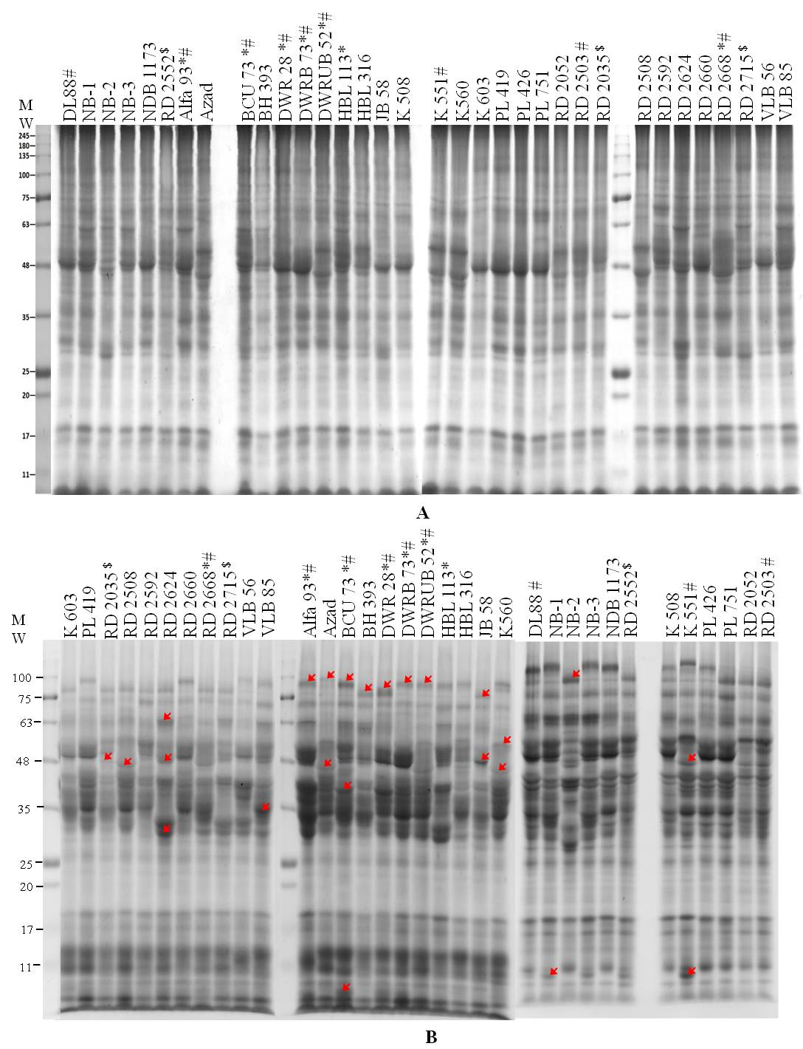
Fig. S1. SDS-PAGE of total seed protein extracts of thirty four genotypes of barley (H. vulgare) A. non reducing conditions, B. Reducing condition. * Two rows barley, # Malt barley, $ Dual purpose barley

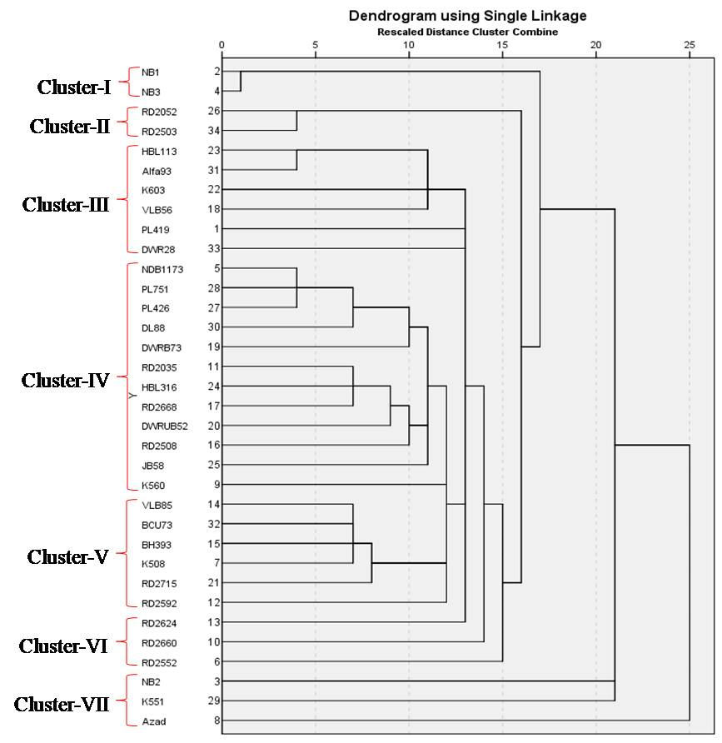
Fig. S2. UPGMA dendrogram derived from banding pattern of total seed storage protein profiles of 34 Indian barley varieties.

