Spatial niche differentiation and bacillin 20 mediated modulation shape fungal community diversity and network structure in roots and rhizospheres of corn and wheat

Bulbul Ahmed^{1,2}, Mahtab Nazari¹, Rachid Elfermi², Ahmad H. Kabir³, Mohamed Hijri⁴, Donald L Smith^{1*}
¹Department of Plant Science, Macdonald Campus of McGill University, 21,111 Lakeshore Road, Ste. Anne de Bellevue, Quebec, H9X 3V9, Canada
²current address: African Genome Center (AGC), University Mohamed VI Polytechnic, Lot 660, Hay Moulay Rachid, BP43150, Benguerir, Morocco.
³Department of Biology, Lamar University, Beaumont, TX, 77705, USA
⁴Institut de Recherche en Biologie Végétale, Département de Sciences Biologiques, Université de Montréal, 4101 Rue Sherbrooke Est, Montréal, QC, Canada

Corresponding author:

* donald.smith@mcgill.ca

Supplementary Figure 1. Co-occurrence network structure of fungal communities in roots and rhizospheres of corn and wheat. Network visualizations showing positive correlations among fungal amplicon sequence variants (ASVs) in (A) corn root, (B) corn rhizosphere, (C) wheat root, and (D) wheat rhizosphere compartments. Nodes represent individual ASVs, colored according to fungal phylum (light blue: Ascomycota; dark blue: Basidiomycota; green: Mortierellomycota; yellow-green: Chytridiomycota). Edges indicate significant Spearman correlations (ρ > 0.6, FDR-adjusted p < 0.05). Rhizosphere networks (b, d) exhibited higher connectivity and inter-phyla interactions, reflecting greater ecological complexity and cooperative potential, whereas root networks (a, c) were more compact and modular, suggesting host-mediated filtering and selective endophytic associations.

Supplementary Figure 2. Functional trophic mode composition of fungal communities in corn and wheat. Stacked bar plots showing the relative abundance of fungal trophic modes predicted by FUNGuild for (A) Zea mays (corn) and (B) Triticum aestivum (wheat) based on ITS amplicon data. Colors represent major trophic guilds, including pathotrophs, saprotrophs, and symbiotrophs, as well as mixed guilds (e.g., pathotroph-saprotroph, saprotroph-symbiotroph). In corn, saprotrophs dominated the fungal community, particularly in the rhizosphere, indicating active organic matter decomposition and nutrient cycling. In wheat, symbiotrophic fungi, including mycorrhizal and mutualistic taxa, were predominant, especially in the rhizosphere, reflecting host-dependent enrichment of beneficial fungal guilds.

Supplementary Figure 1.
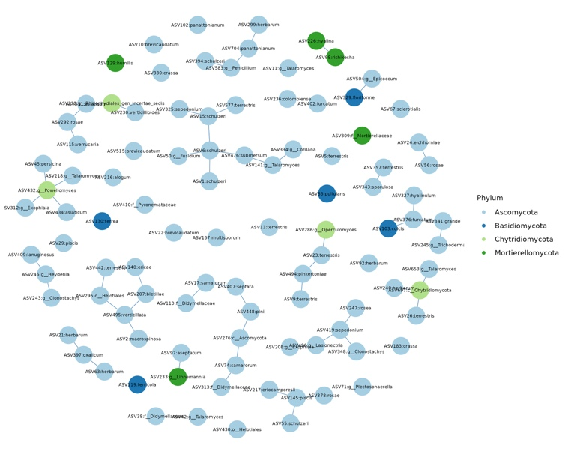
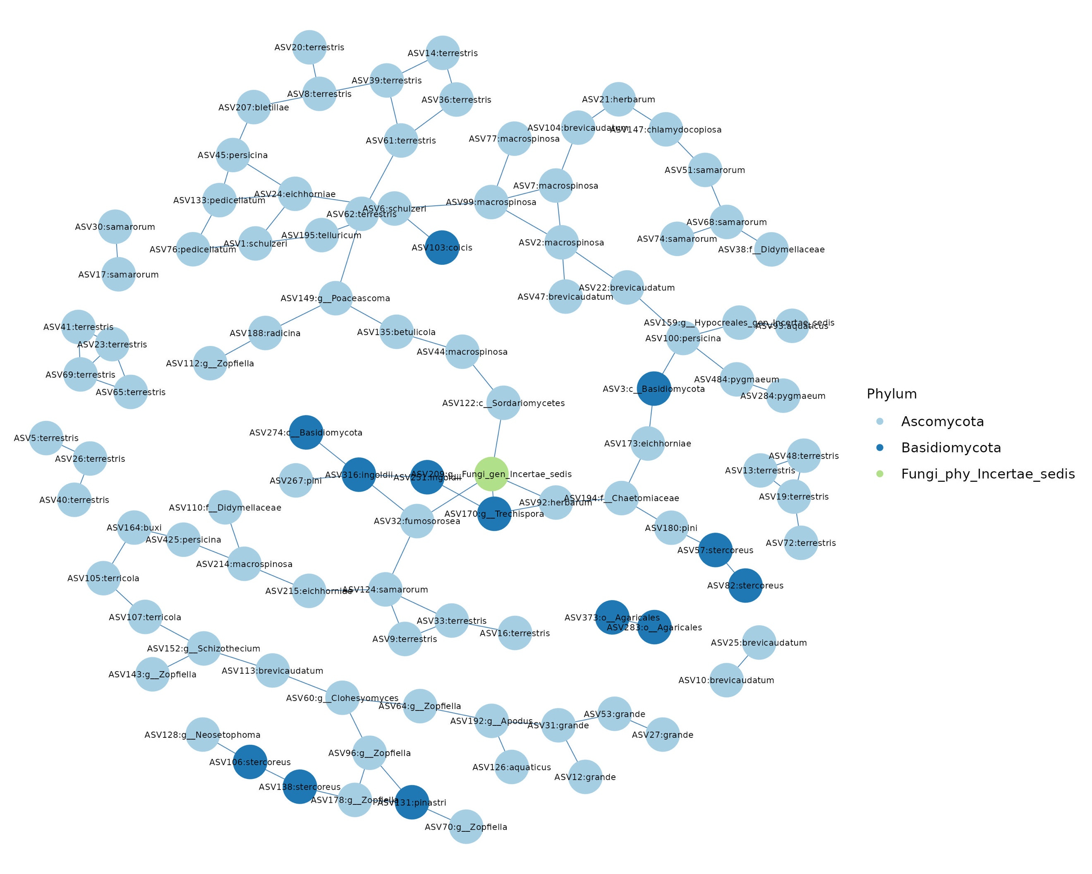
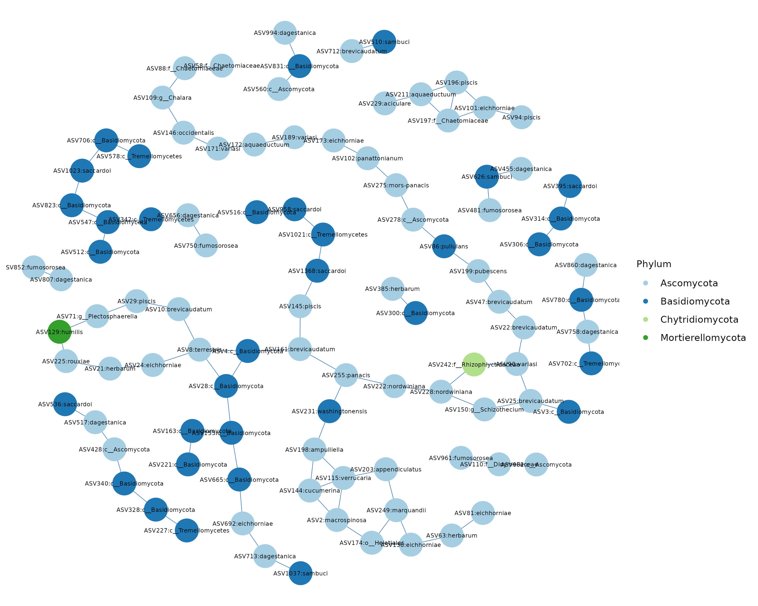
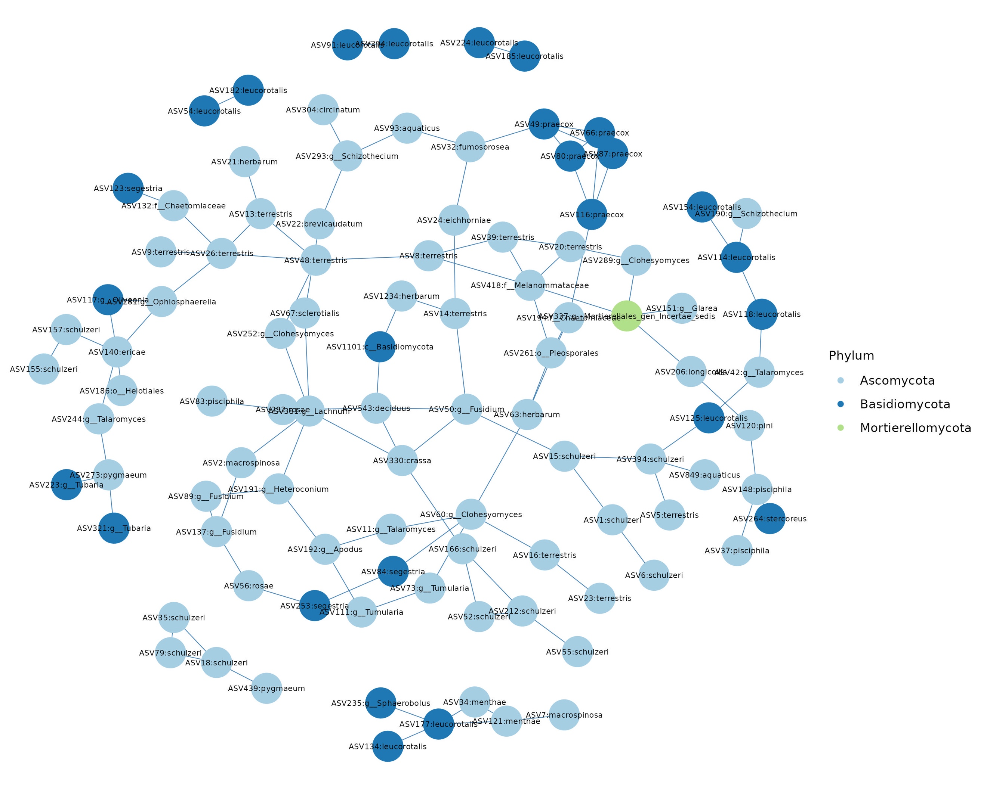
B
C
D
A
A

Supplementary Figure 2.
A
B

