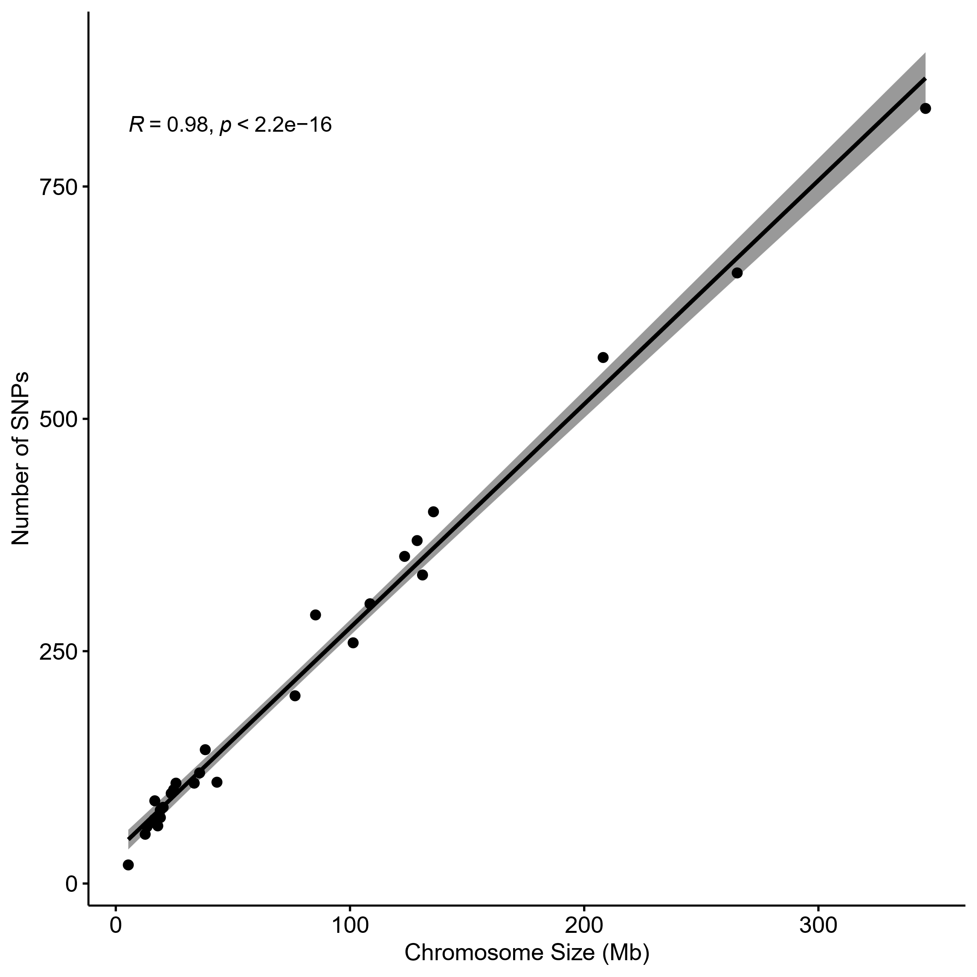
Figure S1. Distribution of SNPs in the loggerhead genome. Correlation between the number of filtered SNPs on each one of the 28 loggerhead genome chromosomes and the corresponding chromosome size. The R and p values of the Spearman correlation are also included in the graph.

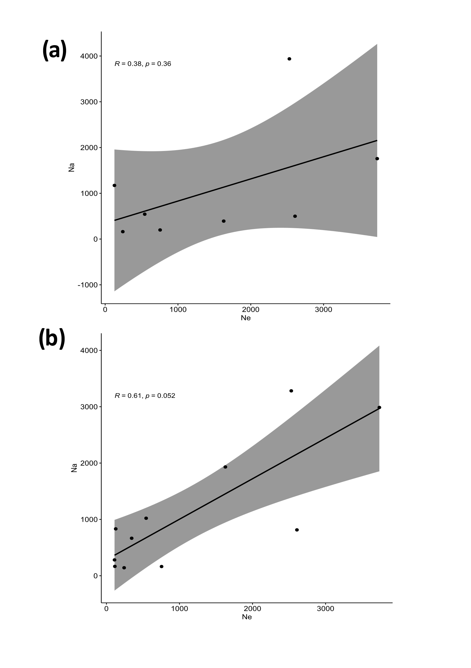
Figure S2. Relation between effective and adult population sizes. Correlation between the effective population size inferred with genomic data (Ne) and the number of adults (Na) estimated using the mean annual number of nests of each population a) before the year 1999 (Margaritoulis et al. 2003) and b) after the year 2000 (Casale et al., 2018). The R and p values of the Spearman correlation are also included in the graph.
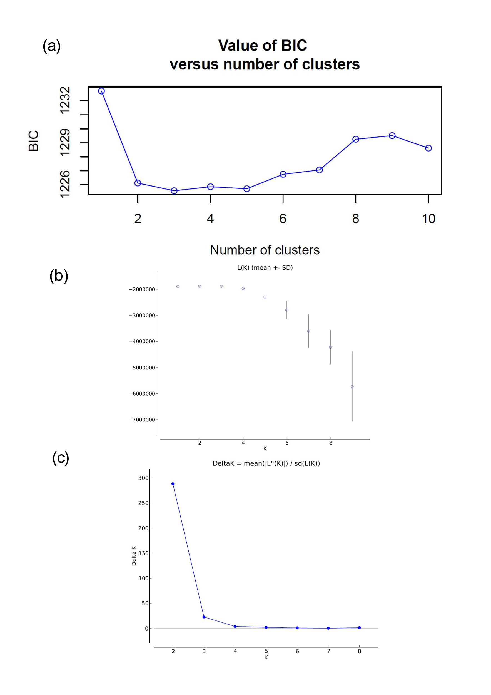
Figure S3. Determination of the number of genetic clusters in the Mediterranean nesting populations. a) Value of the Bayesian Information Criterion (BIC) along the different number of putative genetic clusters (K) obtained with DAPC. b) mean value of ln(K), with error bars, of the 10 simulations performed with STRUCTURE for each value of K. c) Evanno’s Delta K (ΔK) parameter considering the 10 simulations per K value obtained with STRUCTURE.
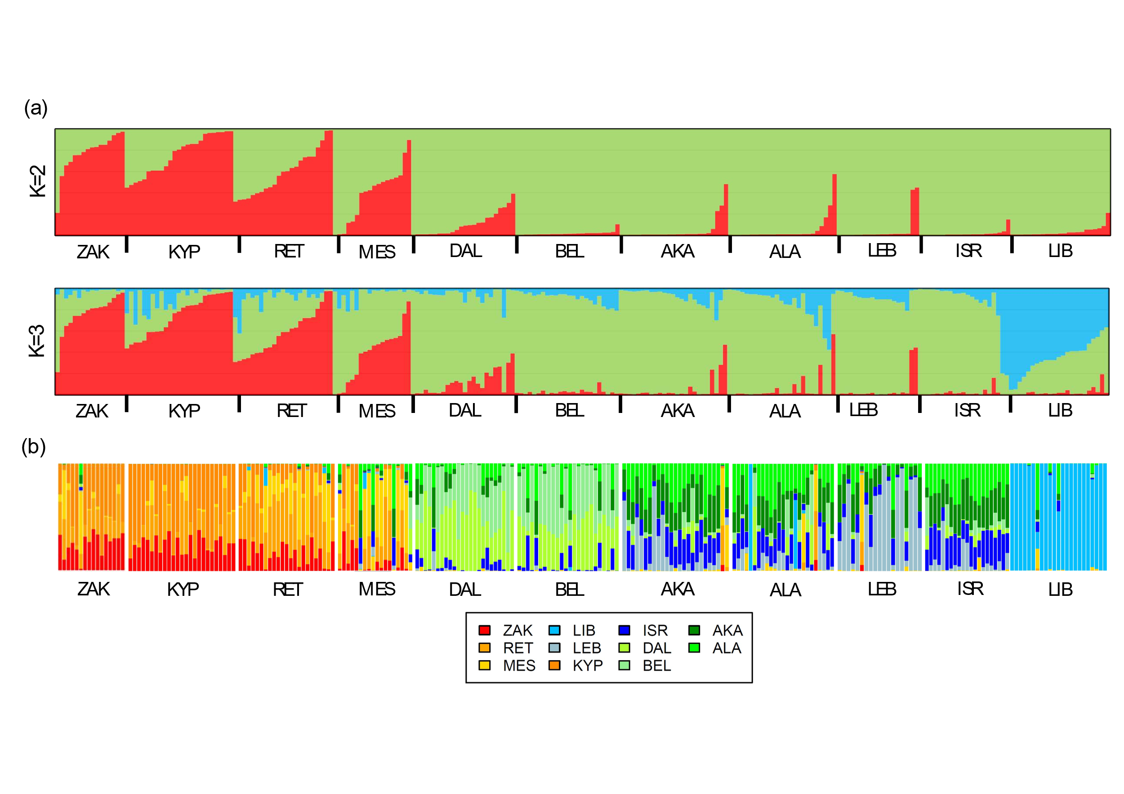
Figure S4. Individual memberships probabilities. a) Individual memberships probabilities to the genetic clusters obtained with STRUCTURE when assuming two (K=2) and three (K=3) genetic clusters. Each vertical line represents an individual turtle and the colours represent probabilities of assignment to the different genetic clusters inferred by the program. b) Individual self-assignment probabilities as inferred using DAPC. Each vertical line represents an individual turtle and the colours represent the 11 populations analysed in this study.

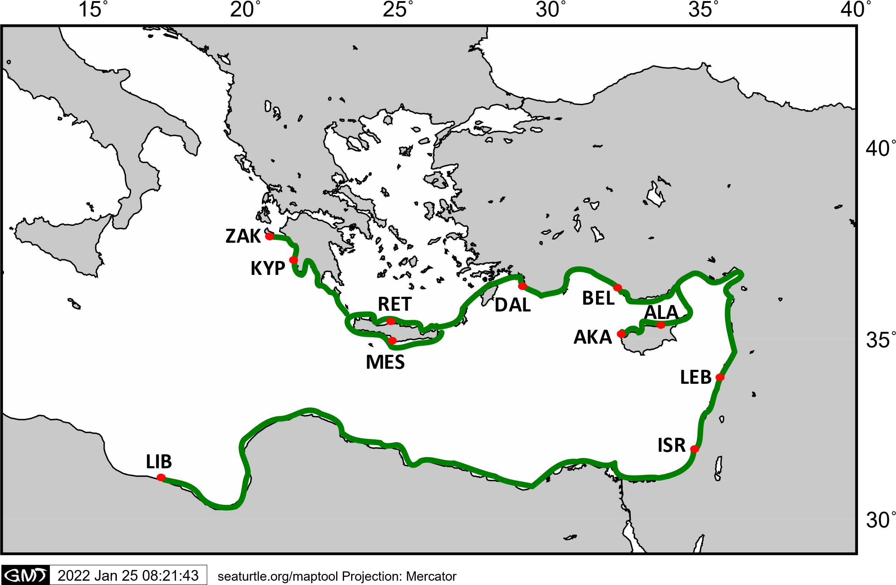
Figure S5 Coastal geographic distances. Representation on how the coastal geographic was calculated. Geographical coastal distance was considered following the methodology from Clusa et al. (2018) by measuring the distance along each pair of locations following the path represented in the map with a green line. When the path between two locations crossed the island of Crete, the mean value between the northern and southern route was considered.

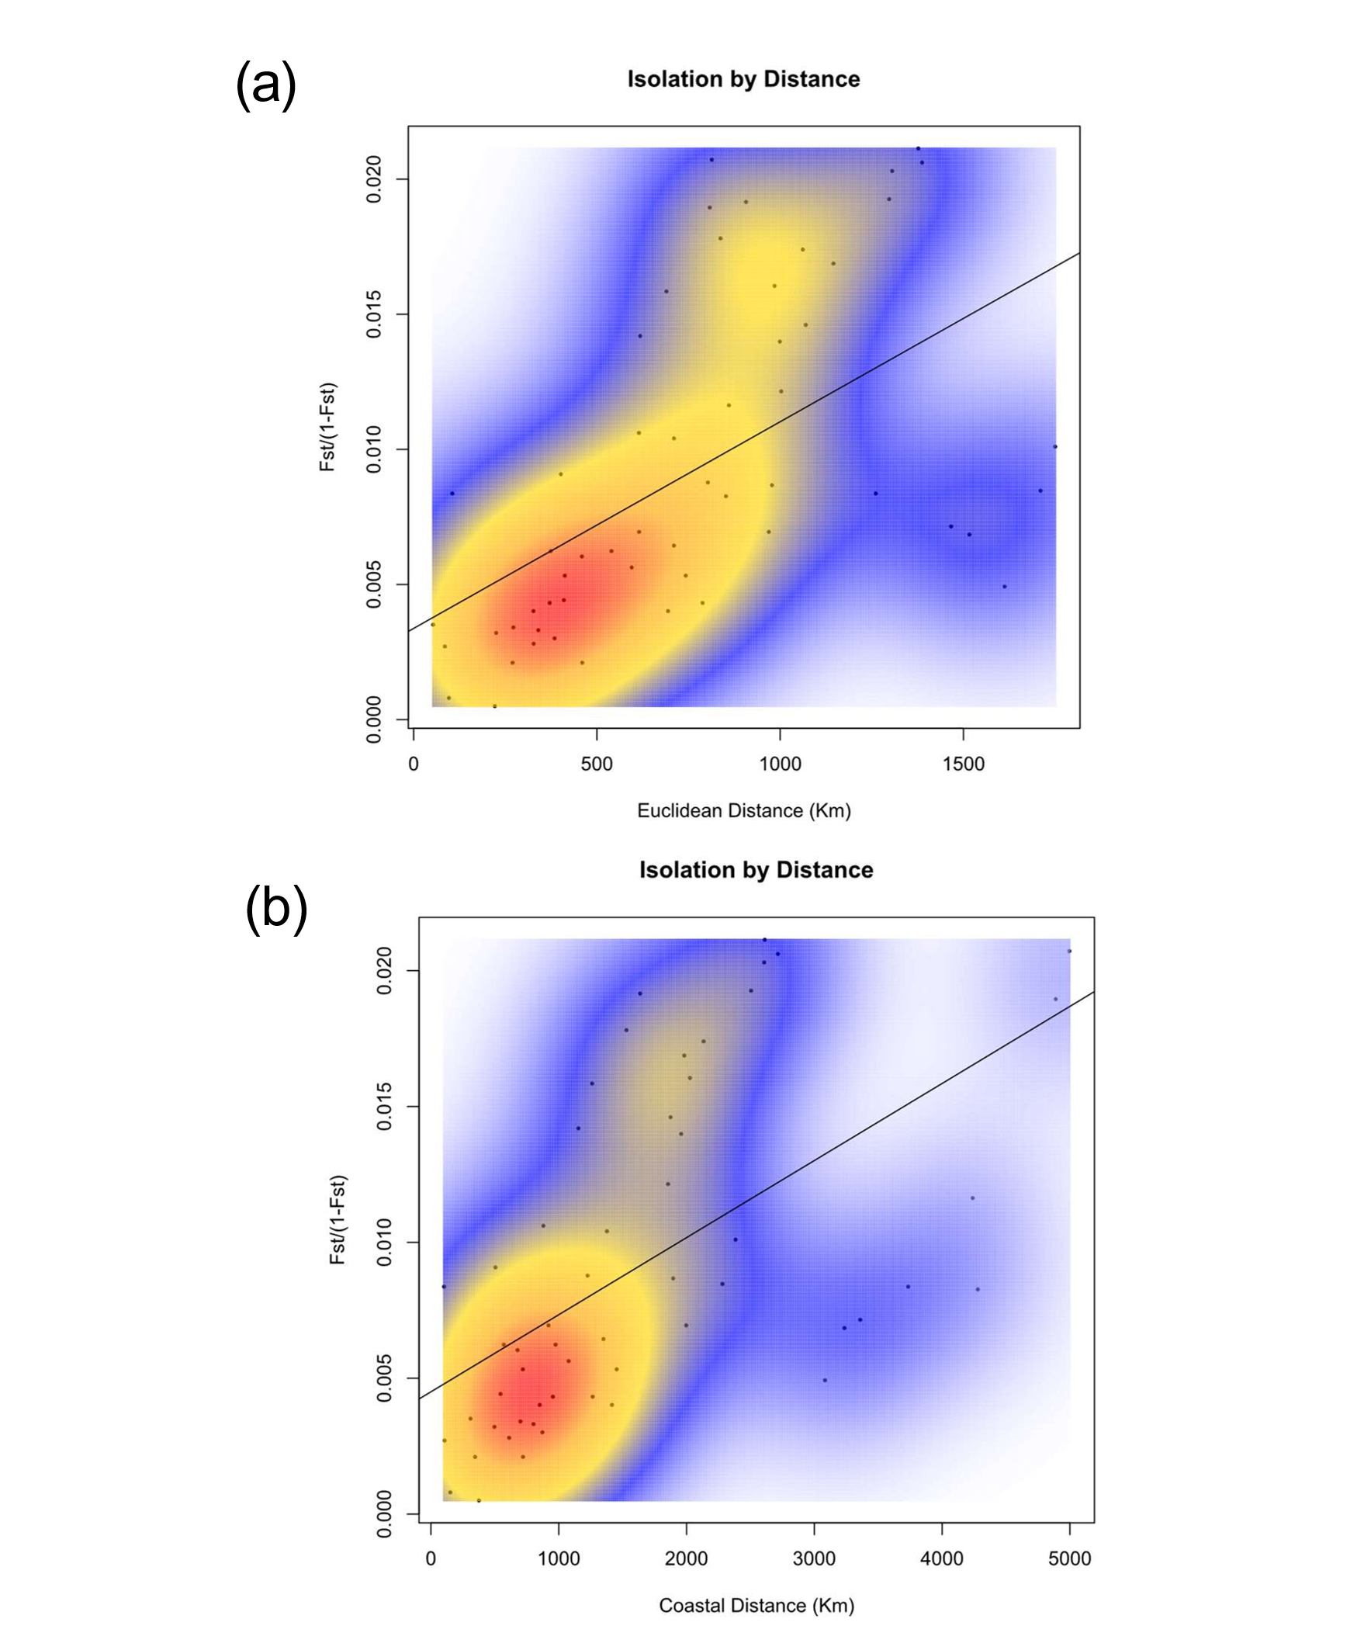
Figure S6. Isolation by distance tests. Mantel test between the weighted genetic distance and a) the Euclidean geographic distance and b) the coastal geographic distance (Figure S5) among all population pairs. The respective correlation lines are represented and the colours reflect the density of data points (red, high density, white low density).
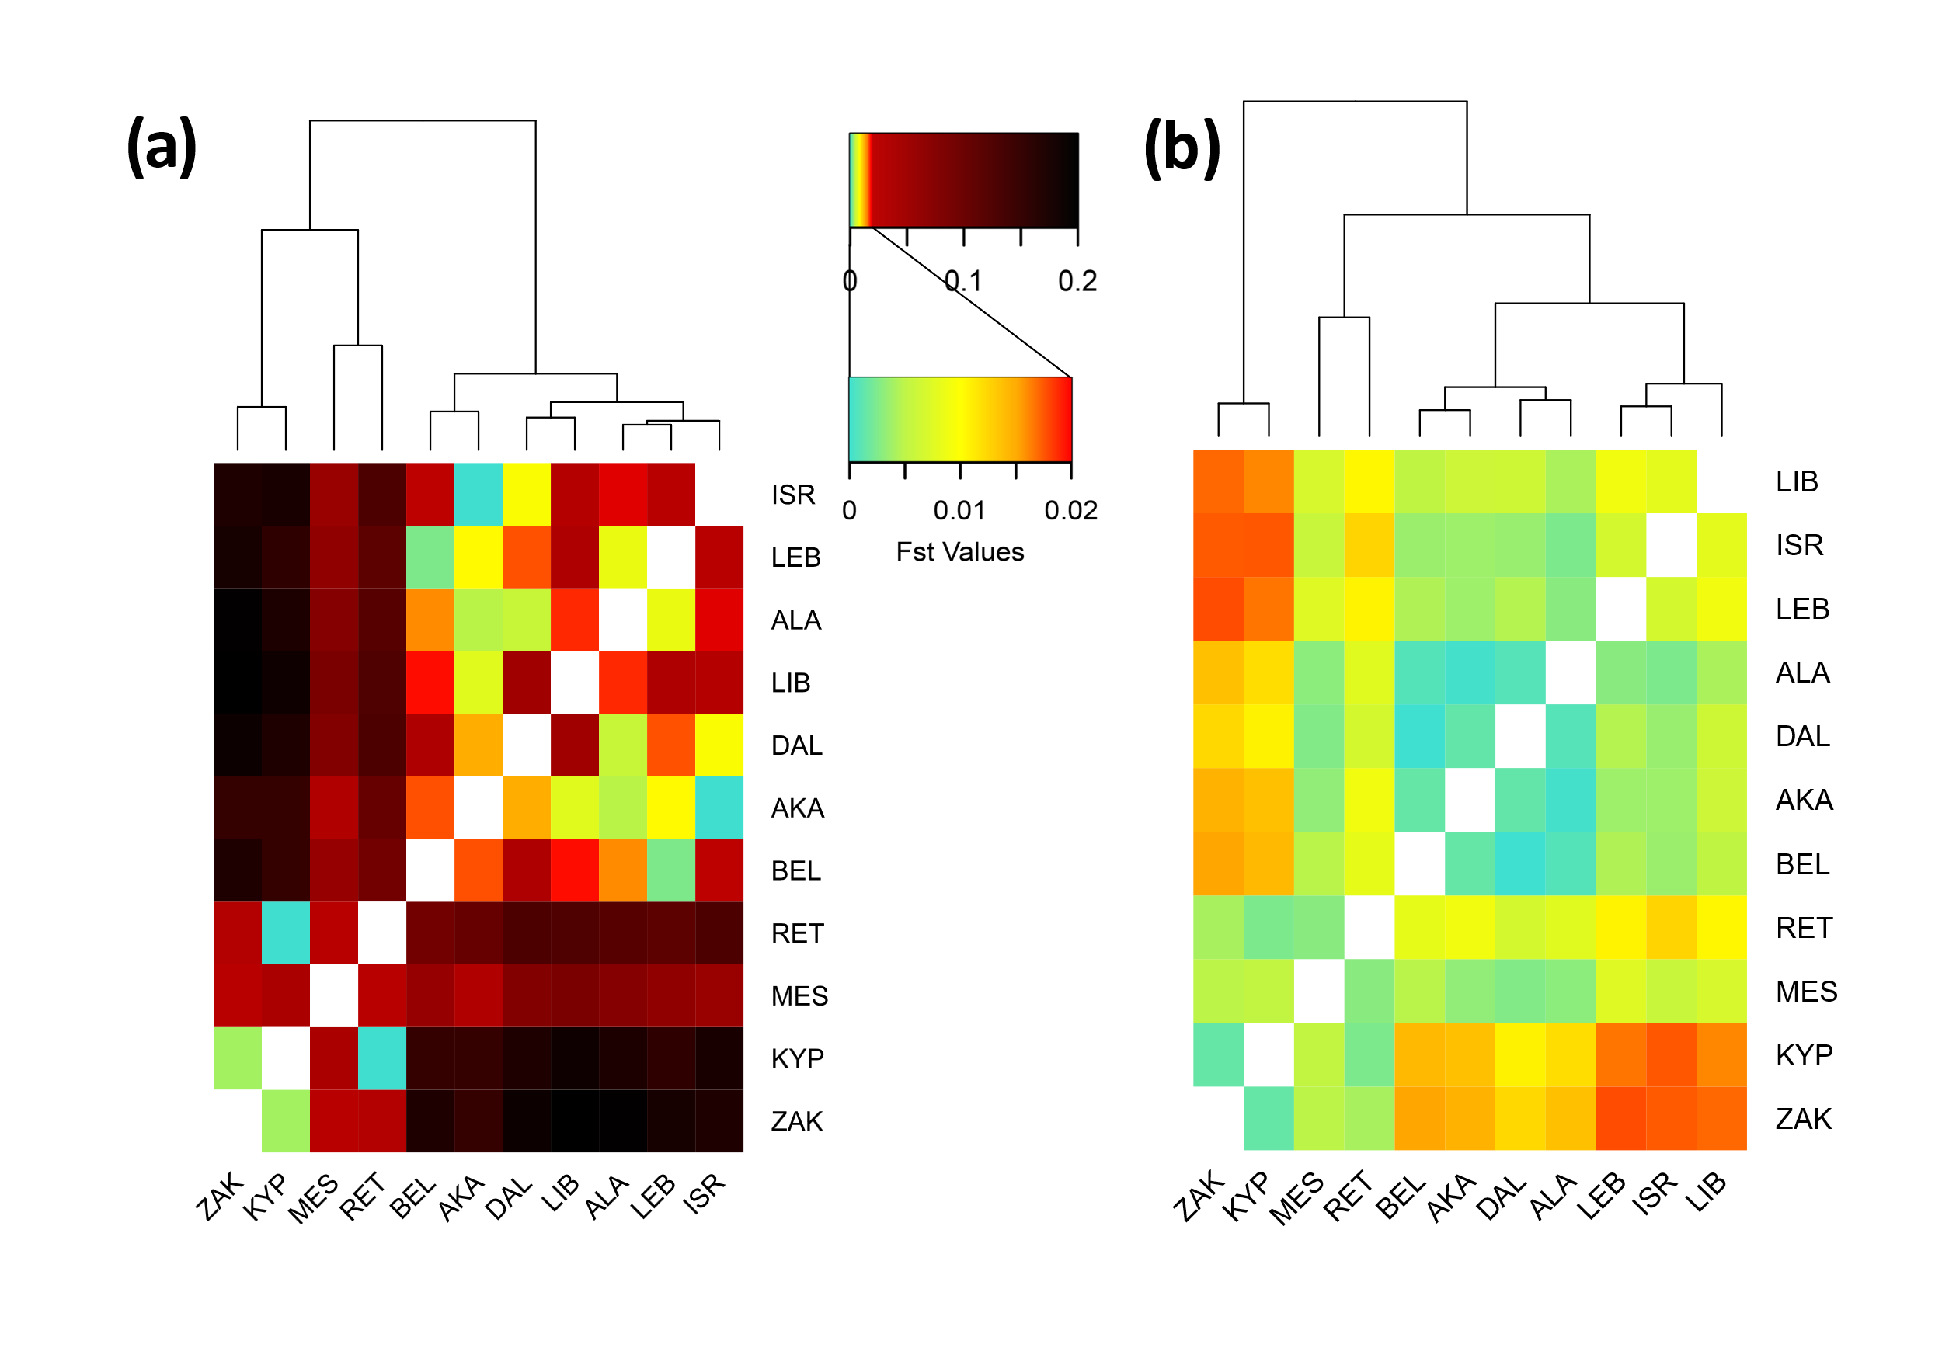
Figure S7. Comparison between neutral and outlier loci. Heatmap with dendrogram based on the F_{ST} values using a) the set of outlier loci shared between pcadapt and Bayescan (16 loci), and b) the set of neutral loci (5,844 loci) found by excluding from the overall dataset any loci found by either pcadapt or Bayescan. The legend shows in detail the colour scale used in both graphs and also in figure 2a.

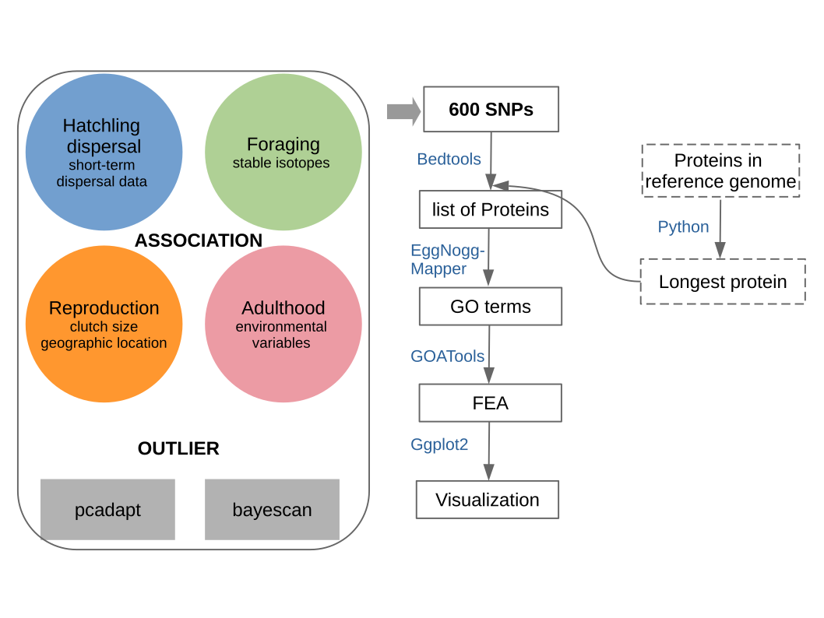
Figure S8: Workflow to identify the protein-coding genes overlapping the association and outlier SNPs.

