- Water yield (WY)
Annual water yield is estimated based on the water balance principle. The main algorithm is as follows:
$$WY\left(x\right)=\left(1-\frac{AET\left(x\right)}{P\left(x\right)}\right)×P(x)$$
where $WY\left(x\right)$ represents the annual water yield, AET(x) denotes the actual annual evapotranspiration of grid x, $P(x)$ represents the annual precipitation of grid unit x.
- Soil conservation (SC)
Soil conservation is used to evaluate the amount of soil erosion and soil retention in the study area (Wen and Liu, 2025); and its calculation formula is:
$$∆A=A°-Av=R×K×L×S×\left(1-Cy×Py\right)$$
where ΔA is the soil conservation (t ha⁻¹ y⁻¹), A₀ is the potential soil loss, A_{v} is the soil loss in the actual land cover and soil erosion control practice situation, R is the rainfall erosivity factor (MJ mm ha^{—1} h⁻¹ yr⁻¹), K is the soil erodibility factor (t ha h ha⁻¹ MJ⁻¹ mm⁻¹), L is the slope length factor (dimensionless), and S is the slope factor (dimensionless), $Cy$ and $Py$ (dimensionless) denote the vegetation cover factor and the soil erosion control factor under the actual land cover and erosion control practice conditions.
- Habitat quality assessment equation (HQ)
This study designed croplands, built-up land, and unused land as stressors, while forests, grasslands, and water body as habitats. The formula is as follows:
$$HQxj=Hj\left[[1-\left(\frac{D^{z}xj}{D^{z}xj+K^{z}}\right)\right]$$
where $HQxj$ represents the habitat quality of raster x in LULC j. $Hj$ is the habitat suitability of LULC j. z is the default parameter. K is the half- saturation constant, which is 0.2 in this paper. $Dxj$ describes the habitat degradation index of raster x in land use type j, which indicates the degree of habitat degradation under stress.
- Grain production (GP):
GP data were obtained directly from district level Statistical Year books and spatially allocated based on the vegetation condition index. The calculation formula is as follows:
$$GPij=GPt\left(\frac{NDVIij}{\sum_{i=1}^{n}{NDVIij}}\right)$$
where $GPij$ represents the grain production of the ith cultivated land grid in the jth province; $GPt$ Meteorological data Monthly precipitation, monthly temperature, monthly evapotranspiration National Meteorological Science Data Center (https://data.cma.cn/) represents the total grain production; $NDVIij$ represents the normalized difference vegetation index of ith land grid in the jth province.
Carbon Storage (CS)
The total organic carbon above ground, underground, in soil and dead in the ecosystem is calculated using the following formula:
$$C total=C above+C below+C dead+C soil$$
where C total represents the total carbon storage; C above denotes the above-ground biomass carbon; C below refers to the root biomass carbon; C dead signifies the carbon in dead organic matter; C soil indicates the carbon stored in the soil carbon pool.
Geo-Detector model
The GDM is a series of statistical methods developed by Wang and Xu (2017), to detect the spatial variability and further quantify the driving forces. The basic concept assumes that if independent variables of a certain element in the study area affect dependent variables, then their spatial distributions are also similar.
Factor detection. To explore the spatial differentiation of the ESs. The explanatory power of 9 influencing factors on the spatial differentiation of eco-environmental quality in the Yellow River Delta was also explored. The q value is used to perform the measurement. A larger q value leads to more obvious spatial differentiation of the ESs. If spatial differentiation is caused by the X influence factor, a greater q value indicates a stronger explanatory power of X to the ESs, and vice versa. The formula for calculating the q is as follows:
$$q=1-\frac{SSW}{SST}=1-\frac{\sum_{t=1}^{m}{{N_{t}}_{{σ^{2}}_{t}}}}{N_{σ^{2}}}$$
where SSW and SST refer to the within sum of squares in the sub region and total sum of squares in the whole area, respectively; t =1, …,m denotes the sub regions of the RSEI value or each influence factor; $N_{t}$and N stand for the total number of units in subrange t and the entire region, respectively; and ${σ^{2}}_{t}$and $σ^{2}$ indicate the variance of ESs value in region t and the entire study area.

Reference
Wang, J., & Xu, C. (2017). Geographical detector: Principle and prospective. Acta Geographica
Sinica, 72(1), 116-134
Wen, R., Liu, Z., 2025. Exploring trade-offs and synergies between economy development and ecosystem sustainability of the eco-fragile regions in the context of food security. J. Clean. Prod. 510, 145604. https://doi.org/https://doi.org/10.1016/j.jclepro.2025.145604

List of tables
Table S1 Descriptions of the data used in this study.
Type | Data | Source
Land data | LULC | Resource and Environmental Data Center  (https://www.resdc.cn/)
Natural data | Elevation | National Aeronautics and Space Administration (https://search.earthda ta.nasa.gov/search)
Natural data | NDVI | National ecological data center resource sharing service platform  https://www.nesdc.org.cn/
Natural data | Soil property | Harmonized World Soil Database  (https ://www.fao.org/soils-portal/data -hub/soil-maps-and-databases/harmonized-world-soil-database-v12/en/)
Natural data | Temperature | Resource and Environmental Data Center (https://www.resdc.cn/)
Natural data | Precipitation | Resource and Environmental Data Center (https://www.resdc.cn/)
Natural data | Evapotranspiration | Resource and Environmental Data Center (https://www.resdc.cn/)
Natural data | Depth to bedrock | Depth to Bedrock Map of China  http://globalchange.bnu.edu.cn/research/cdtb.jsp#cite
Socio- economic data | Nighttime Lights | https://doi.org/10.6084/m9.figshare.9 828827.v2
Socio- economic data | River map | https://www.openstreetmap.org/
Socio- economic data | Road map | https://www.openstreetmap.org/
Socio- economic data | GDP | Resource and Environmental Data Center (https://www.resdc.cn/)

Table S2. PLS-SEM Path Coefficients and Statistical Summary for pixel scale from 2000 to 2020.
Path | Original sample (O) | Sample mean (M) | Bias | Standard Deviation | T-statistics | 2.5% | 97.5%
2000
GP → CS | 0.547 | 0.547 | 0.000 | 0.014 | 38.655 | 0.518 | 0.573
GP → HQ | 0.648 | 0.648 | 0.000 | 0.013 | 50.027 | 0.621 | 0.672
HQ → CS | 0.844 | 0.844 | 0.000 | 0.006 | 130.879 | 0.831 | 0.856
SC → CS | 0.213 | 0.213 | 0.000 | 0.012 | 17.877 | 0.189 | 0.236
SC → GP | 0.749 | 0.749 | 0.000 | 0.005 | 148.269 | 0.739 | 0.759
SC → HQ | 0.252 | 0.252 | 0.000 | 0.012 | 20.290 | 0.227 | 0.276
SC → WY | 0.423 | 0.423 | 0.000 | 0.015 | 28.267 | 0.393 | 0.452
WY → CS | -0.421 | -0.421 | 0.000 | 0.007 | 57.960 | -0.435 | -0.406
WY → GP | 0.080 | 0.080 | 0.000 | 0.010 | 8.000 | 0.062 | 0.100
WY → HQ | -0.499 | -0.499 | 0.000 | 0.012 | 41.583 | -0.515 | -0.482
2010
GP → CS | 0.466 | 0.466 | 0.000 | 0.015 | 32.021 | 0.437 | 0.494
GP → HQ | 0.554 | 0.554 | 0.000 | 0.013 | 41.512 | 0.528 | 0.580
HQ → CS | 0.840 | 0.840 | 0.000 | 0.006 | 130.201 | 0.827 | 0.853
SC → CS | 0.133 | 0.133 | 0.000 | 0.011 | 11.956 | 0.111 | 0.154
SC → GP | 0.648 | 0.648 | 0.000 | 0.007 | 89.023 | 0.633 | 0.662
SC → HQ | 0.158 | 0.158 | 0.000 | 0.012 | 12.914 | 0.134 | 0.181
SC → WY | 0.611 | 0.610 | 0.000 | 0.018 | 33.333 | 0.572 | 0.644
WY → CS | -0.361 | -0.361 | -0.001 | 0.009 | 38.705 | -0.378 | -0.342
WY → GP | -0.180 | -0.180 | 0.000 | 0.013 | 13.569 | -0.206 | -0.154
WY → HQ | -0.429 | -0.430 | -0.001 | 0.009 | 45.709 | -0.447 | -0.410
2020
GP → CS | 0.493 | 0.493 | 0.000 | 0.013 | 37.090 | -0.200 | -0.162
GP → HQ | 0.584 | 0.584 | 0.000 | 0.012 | 48.679 | -0.471 | -0.441
HQ → CS | 0.845 | 0.845 | 0.000 | 0.007 | 129.825 | 0.337 | 0.383
SC → CS | 0.208 | 0.209 | 0.000 | 0.013 | 15.914 | 0.403 | 0.447
SC → GP | 0.733 | 0.733 | 0.000 | 0.006 | 117.452 | -0.005 | 0.016
SC → HQ | 0.246 | 0.247 | 0.000 | 0.014 | 17.669 | -0.006 | 0.019
SC → WY | 0.336 | 0.335 | 0.000 | 0.020 | 16.621 | -0.002 | 0.006
WY → CS | -0.450 | -0.451 | 0.000 | 0.007 | 60.314 | -0.002 | 0.005
WY → GP | 0.012 | 0.012 | 0.000 | 0.011 | 1.113 | 0.467 | 0.519
WY → HQ | -0.533 | -0.533 | 0.000 | 0.009 | 62.392 | -0.003 | 0.011

Table S3. PLS-SEM Path Coefficients and Statistical Summary for county scale from 2000 to 2020.
Path | Original sample (O) | Sample mean (M) | Bias | Standard Deviation | T-statistics | 2.5% | 97.5%
2000
GP → CS | 0.423 | 0.422 | 0.000 | 0.013 | 31.902 | 0.397 | 0.450
GP → HQ | 0.497 | 0.497 | 0.000 | 0.013 | 36.883 | 0.471 | 0.524
HQ → CS | 0.850 | 0.849 | 0.000 | 0.006 | 142.122 | 0.838 | 0.861
SC → CS | 0.141 | 0.141 | 0.000 | 0.010 | 13.577 | 0.121 | 0.162
SC → GP | 0.443 | 0.444 | 0.001 | 0.017 | 26.251 | 0.409 | 0.476
SC → HQ | 0.165 | 0.166 | 0.000 | 0.012 | 14.109 | 0.143 | 0.189
SC → WY | 0.116 | 0.116 | 0.000 | 0.015 | 7.582 | 0.086 | 0.146
WY → CS | -0.352 | -0.352 | 0.000 | 0.012 | 29.740 | -0.374 | -0.328
WY → GP | 0.120 | 0.120 | 0.000 | 0.013 | 9.406 | 0.095 | 0.145
WY → HQ | -0.414 | -0.414 | 0.000 | 0.014 | 29.122 | -0.441 | -0.385
2010
GP → CS | 0.388 | 0.388 | 0.001 | 0.007 | 7.729 | 0.360 | 0.415
GP → HQ | 0.458 | 0.458 | 0.001 | 0.010 | 38.598 | 0.429 | 0.485
HQ → CS | 0.847 | 0.847 | 0.000 | 0.009 | 19.251 | 0.835 | 0.859
SC → CS | 0.092 | 0.093 | 0.000 | 0.011 | 20.245 | 0.071 | 0.116
SC → GP | 0.394 | 0.397 | 0.002 | 0.006 | 8.900 | 0.355 | 0.431
SC → HQ | 0.109 | 0.109 | 0.000 | 0.007 | 8.856 | 0.084 | 0.136
SC → WY | 0.223 | 0.225 | 0.002 | 0.001 | 5.512 | 0.175 | 0.273
WY → CS | -0.257 | -0.259 | -0.002 | 0.001 | 5.542 | -0.281 | -0.230
WY → GP | 0.037 | 0.036 | 0.000 | 0.013 | 31.902 | 0.008 | 0.069
WY → HQ | -0.303 | -0.305 | -0.002 | 0.002 | 5.784 | -0.332 | -0.272
2020
GP → CS | 0.378 | 0.378 | 0.000 | 0.012 | 30.655 | 0.354 | 0.403
GP → HQ | 0.441 | 0.442 | 0.000 | 0.013 | 35.250 | 0.417 | 0.466
HQ → CS | 0.857 | 0.857 | 0.000 | 0.006 | 146.666 | 0.845 | 0.868
SC → CS | 0.138 | 0.138 | 0.000 | 0.011 | 12.406 | 0.116 | 0.160
SC → GP | 0.425 | 0.426 | 0.001 | 0.017 | 25.175 | 0.390 | 0.456
SC → HQ | 0.161 | 0.162 | 0.000 | 0.013 | 12.777 | 0.136 | 0.186
SC → WY | 0.056 | 0.057 | 0.000 | 0.019 | 2.987 | 0.021 | 0.094
WY → CS | -0.391 | -0.391 | 0.000 | 0.013 | 30.598 | -0.415 | -0.365
WY → GP | 0.034 | 0.034 | 0.000 | 0.015 | 2.325 | 0.006 | 0.063
WY → HQ | -0.456 | -0.457 | -0.001 | 0.015 | 30.347 | -0.485 | -0.426

Table S4. PLS-SEM Path Coefficients and Statistical Summary for Sub basin scale from 2000 to 2020.
Path | Original sample (O) | Sample mean (M) | Bias | Standard Deviation | T-statistics | 2.5% | 97.5%
2000
GP → CS | 0.540 | 0.541 | 0.001 | 0.019 | 27.770 | 0.501 | 0.577
GP → HQ | 0.641 | 0.642 | 0.001 | 0.017 | 36.946 | 0.607 | 0.674
HQ → CS | 0.842 | 0.842 | 0.000 | 0.009 | 98.265 | 0.825 | 0.859
SC → CS | 0.181 | 0.182 | 0.001 | 0.017 | 10.894 | 0.149 | 0.214
SC → GP | 0.792 | 0.792 | 0.000 | 0.005 | 158.941 | 0.782 | 0.802
SC → HQ | 0.215 | 0.216 | 0.001 | 0.018 | 12.113 | 0.180 | 0.249
SC → WY | 0.536 | 0.536 | 0.000 | 0.012 | 45.873 | 0.512 | 0.558
WY → CS | -0.481 | -0.481 | 0.000 | 0.010 | 46.633 | -0.500 | -0.460
WY → GP | -0.040 | -0.040 | 0.000 | 0.011 | 3.610 | -0.062 | -0.018
WY → HQ | -0.571 | -0.571 | 0.000 | 0.010 | 57.571 | -0.590 | -0.551
2010
GP → CS | 0.442 | 0.443 | 0.001 | 0.020 | 22.640 | 0.402 | 0.480
GP → HQ | 0.527 | 0.527 | 0.000 | 0.018 | 28.662 | 0.490 | 0.562
HQ → CS | 0.839 | 0.839 | 0.000 | 0.008 | 102.848 | 0.823 | 0.855
SC → CS | 0.145 | 0.146 | 0.001 | 0.016 | 9.248 | 0.114 | 0.177
SC → GP | 0.669 | 0.669 | 0.001 | 0.009 | 75.070 | 0.652 | 0.687
SC → HQ | 0.173 | 0.174 | 0.001 | 0.017 | 10.052 | 0.139 | 0.207
SC → WY | 0.628 | 0.626 | -0.001 | 0.024 | 26.238 | 0.577 | 0.671
WY → CS | -0.406 | -0.407 | -0.001 | 0.012 | 33.572 | -0.429 | -0.381
WY → GP | -0.375 | -0.375 | 0.000 | 0.022 | 17.333 | -0.417 | -0.332
WY → HQ | -0.484 | -0.484 | -0.001 | 0.011 | 44.192 | -0.504 | -0.462
2020
GP → CS | 0.378 | 0.378 | 0.000 | 0.012 | 30.655 | 0.354 | 0.403
GP → HQ | 0.441 | 0.442 | 0.000 | 0.013 | 35.250 | 0.417 | 0.466
HQ → CS | 0.857 | 0.857 | 0.000 | 0.006 | 146.666 | 0.845 | 0.868
SC → CS | 0.138 | 0.138 | 0.000 | 0.011 | 12.406 | 0.116 | 0.160
SC → GP | 0.425 | 0.426 | 0.001 | 0.017 | 25.175 | 0.390 | 0.456
SC → HQ | 0.161 | 0.162 | 0.000 | 0.013 | 12.777 | 0.136 | 0.186
SC → WY | 0.056 | 0.057 | 0.000 | 0.019 | 2.987 | 0.021 | 0.094
WY → CS | -0.391 | -0.391 | 0.000 | 0.013 | 30.598 | -0.415 | -0.365
WY → GP | 0.034 | 0.034 | 0.000 | 0.015 | 2.325 | 0.006 | 0.063
WY → HQ | -0.456 | -0.457 | -0.001 | -0.485 | -0.426 | -0.455 | -0.457

Table S5: Comparison of model parameters at county scales in 2020
ESs | model | split | R² | RMSE | CR R² | CR R² std
CS | Lasso | train | 0.932 | 0.004 | 0.932 | 0.006
CS | Lasso | test | 0.942 | 0.004 | 0.932 | 0.006
CS | Random Forest | train | 0.999 | 0.000 | 0.998 | 0.000
CS | Random Forest | test | 0.999 | 0.000 | 0.998 | 0.000
CS | XGBoost | train | 0.999 | 0.000 | 0.999 | 0.000
CS | XGBoost | test | 0.997 | 0.000 | 0.999 | 0.000
CS | LightGBM | train | 0.999 | 0.000 | 0.999 | 0.000
CS | LightGBM | test | 0.998 | 0.000 | 0.999 | 0.000
GP | Lasso | train | 0.995 | 0.000 | 0.997 | 0.000
GP | Lasso | test | 0.995 | 0.000 | 0.997 | 0.000
GP | Random Forest | train | 0.998 | 0.000 | 0.999 | 0.000
GP | Random Forest | test | 0.998 | 0.000 | 0.999 | 0.000
GP | XGBoost | train | 0.999 | 0.000 | 0.999 | 0.000
GP | XGBoost | test | 0.999 | 0.000 | 0.999 | 0.000
GP | LightGBM | train | 0.999 | 0.000 | 0.999 | 0.000
GP | LightGBM | test | 0.998 | 0.000 | 0.999 | 0.000
HQ | Lasso | train | 0.870 | 0.006 | 0.876 | 0.006
HQ | Lasso | test | 0.892 | 0.006 | 0.876 | 0.006
HQ | Random Forest | train | 0.994 | 0.000 | 0.997 | 0.001
HQ | Random Forest | test | 0.990 | 0.000 | 0.997 | 0.001
HQ | XGBoost | train | 0.998 | 0.000 | 0.998 | 0.001
HQ | XGBoost | test | 0.990 | 0.000 | 0.998 | 0.001
HQ | LightGBM | train | 0.996 | 0.000 | 0.998 | 0.000
HQ | LightGBM | test | 0.993 | 0.000 | 0.998 | 0.000
SC | Lasso | train | 0.903 | 0.003 | 0.900 | 0.007
SC | Lasso | test | 0.905 | 0.002 | 0.900 | 0.007
SC | Random Forest | train | 0.997 | 0.000 | 0.991 | 0.005
SC | Random Forest | test | 0.992 | 0.000 | 0.991 | 0.005
SC | XGBoost | train | 0.990 | 0.000 | 0.993 | 0.006
SC | XGBoost | test | 0.992 | 0.000 | 0.993 | 0.006
SC | LightGBM | train | 0.830 | 0.001 | 0.993 | 0.006
SC | LightGBM | test | 0.822 | 0.001 | 0.993 | 0.006
WY | Lasso | train | 0.989 | 0.000 | 0.831 | 0.018
WY | Lasso | test | 0.988 | 0.000 | 0.831 | 0.018
WY | Random Forest | train | 0.996 | 0.000 | 0.987 | 0.016
WY | Random Forest | test | 0.997 | 0.000 | 0.987 | 0.016
WY | XGBoost | train | 0.993 | 0.000 | 0.988 | 0.014
WY | XGBoost | test | 0.991 | 0.000 | 0.988 | 0.014
WY | LightGBM | train | 0.830 | 0.001 | 0.989 | 0.014
WY | LightGBM | test | 0.822 | 0.001 | 0.989 | 0.014

Notice: CR R² represents means R² for 10-fold cross validation, CR R² std is stander deviation for 10-fold cross validation.
ESs | model | split | R² | RMSE | CR R² | CR R² std
CS | Lasso | train | 0.936 | 0.009 | 0.933 | 0.001
CS | Lasso | test | 0.945 | 0.003 | 0.933 | 0.001
CS | Random Forest | train | 0.991 | 0.000 | 0.993 | 0.009
CS | Random Forest | test | 0.991 | 0.000 | 0.993 | 0.009
CS | XGBoost | train | 0.998 | 0.000 | 0.993 | 0.006
CS | XGBoost | test | 0.997 | 0.000 | 0.993 | 0.006
CS | LightGBM | train | 0.998 | 0.000 | 0.995 | 0.003
CS | LightGBM | test | 0.997 | 0.000 | 0.995 | 0.003
GP | Lasso | train | 0.994 | 0.001 | 0.995 | 0.000
GP | Lasso | test | 0.994 | 0.001 | 0.995 | 0.000
GP | Random Forest | train | 0.997 | 0.000 | 0.998 | 0.002
GP | Random Forest | test | 0.998 | 0.000 | 0.998 | 0.002
GP | XGBoost | train | 0.999 | 0.000 | 0.999 | 0.001
GP | XGBoost | test | 0.999 | 0.000 | 0.999 | 0.001
GP | LightGBM | train | 0.999 | 0.000 | 0.997 | 0.002
GP | LightGBM | test | 0.998 | 0.000 | 0.997 | 0.002
HQ | Lasso | train | 0.875 | 0.008 | 0.870 | 0.003
HQ | Lasso | test | 0.892 | 0.002 | 0.870 | 0.003
HQ | Random Forest | train | 0.993 | 0.000 | 0.992 | 0.005
HQ | Random Forest | test | 0.990 | 0.001 | 0.992 | 0.005
HQ | XGBoost | train | 0.998 | 0.000 | 0.996 | 0.003
HQ | XGBoost | test | 0.990 | 0.000 | 0.996 | 0.003
HQ | LightGBM | train | 0.996 | 0.000 | 0.998 | 0.009
HQ | LightGBM | test | 0.993 | 0.000 | 0.998 | 0.009
SC | Lasso | train | 0.903 | 0.009 | 0.902 | 0.009
SC | Lasso | test | 0.904 | 0.000 | 0.902 | 0.009
SC | Random Forest | train | 0.996 | 0.001 | 0.991 | 0.006
SC | Random Forest | test | 0.991 | 0.001 | 0.991 | 0.006
SC | XGBoost | train | 0.999 | 0.001 | 0.993 | 0.004
SC | XGBoost | test | 0.992 | 0.000 | 0.993 | 0.004
SC | LightGBM | train | 0.999 | 0.001 | 0.997 | 0.005
SC | LightGBM | test | 0.997 | 0.000 | 0.997 | 0.005
WY | Lasso | train | 0.830 | 0.001 | 0.831 | 0.016
WY | Lasso | test | 0.822 | 0.001 | 0.831 | 0.016
WY | Random Forest | train | 0.989 | 0.000 | 0.988 | 0.018
WY | Random Forest | test | 0.988 | 0.000 | 0.988 | 0.018
WY | XGBoost | train | 0.996 | 0.000 | 0.989 | 0.014
WY | XGBoost | test | 0.997 | 0.000 | 0.989 | 0.014
WY | LightGBM | train | 0.993 | 0.000 | 0.987 | 0.014
WY | LightGBM | test | 0.991 | 0.000 | 0.987 | 0.014
Table S6: Comparison of model parameters at sub basin scales in 2020

Notice: CR R² represents means R² for 10-fold cross validation, CR R² std is stander deviation for 10-fold cross validation.

List of figures
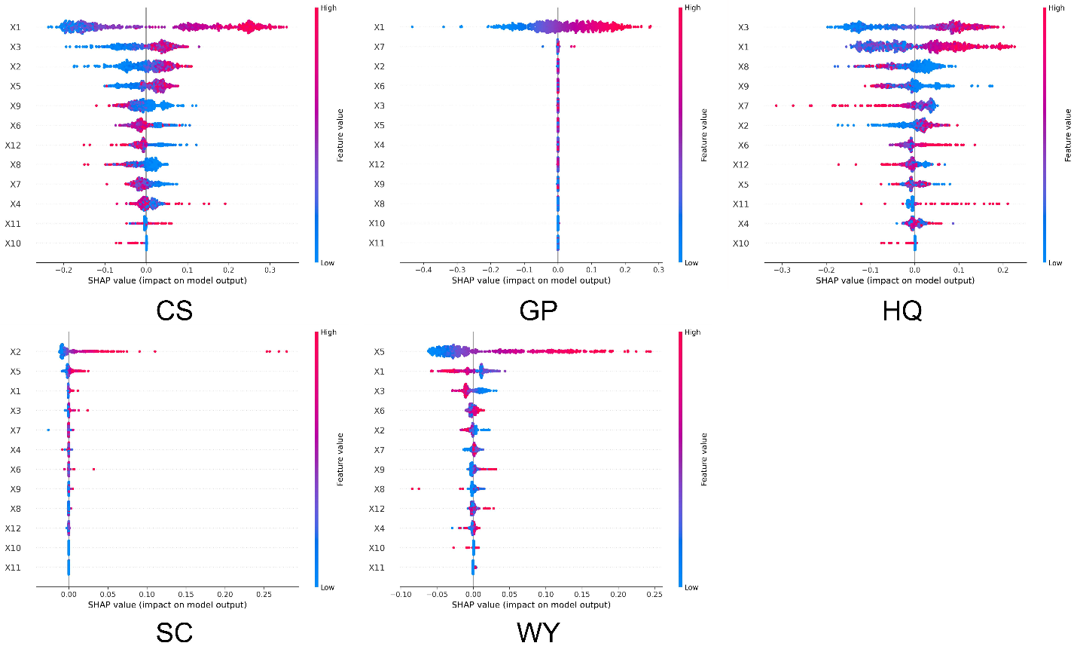 Figure S1. Feature importance of ESs at pixel scale in 2000.
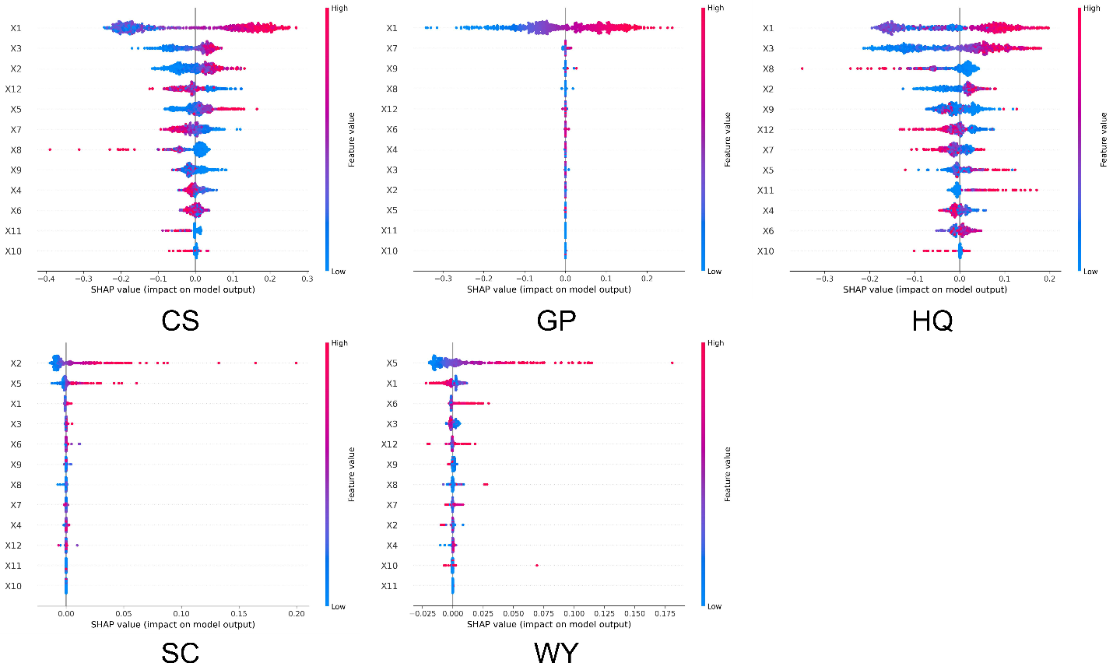
Figure S2. Feature importance of ESs at pixel scale in 2010.

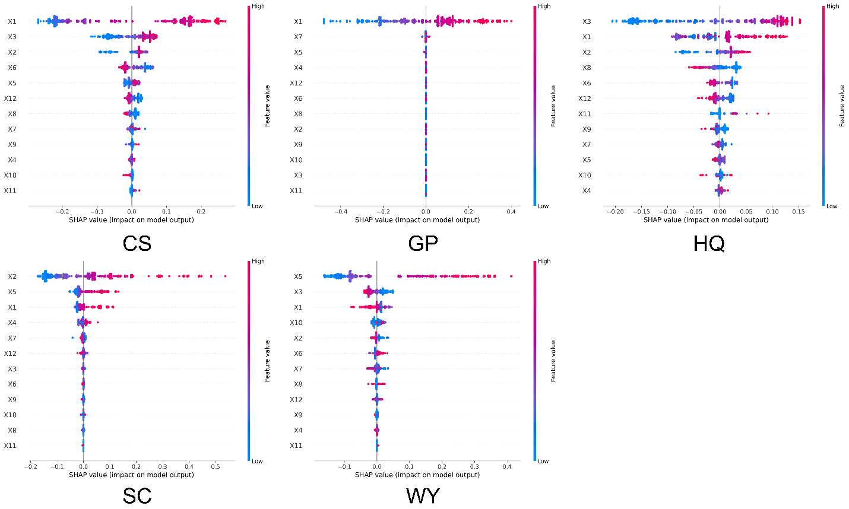

Figure S3. Feature importance of ESs at county scale in 2000.
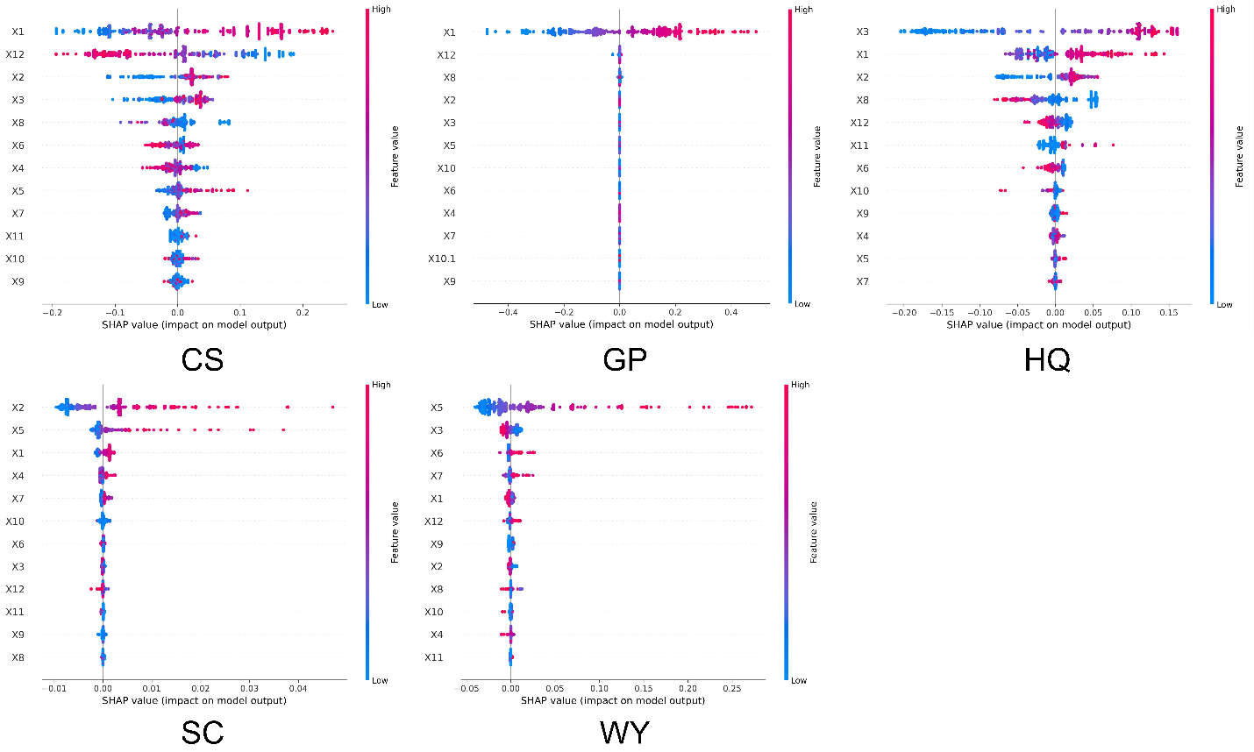
Figure S4. Feature importance of ESs at county scale in 2010.
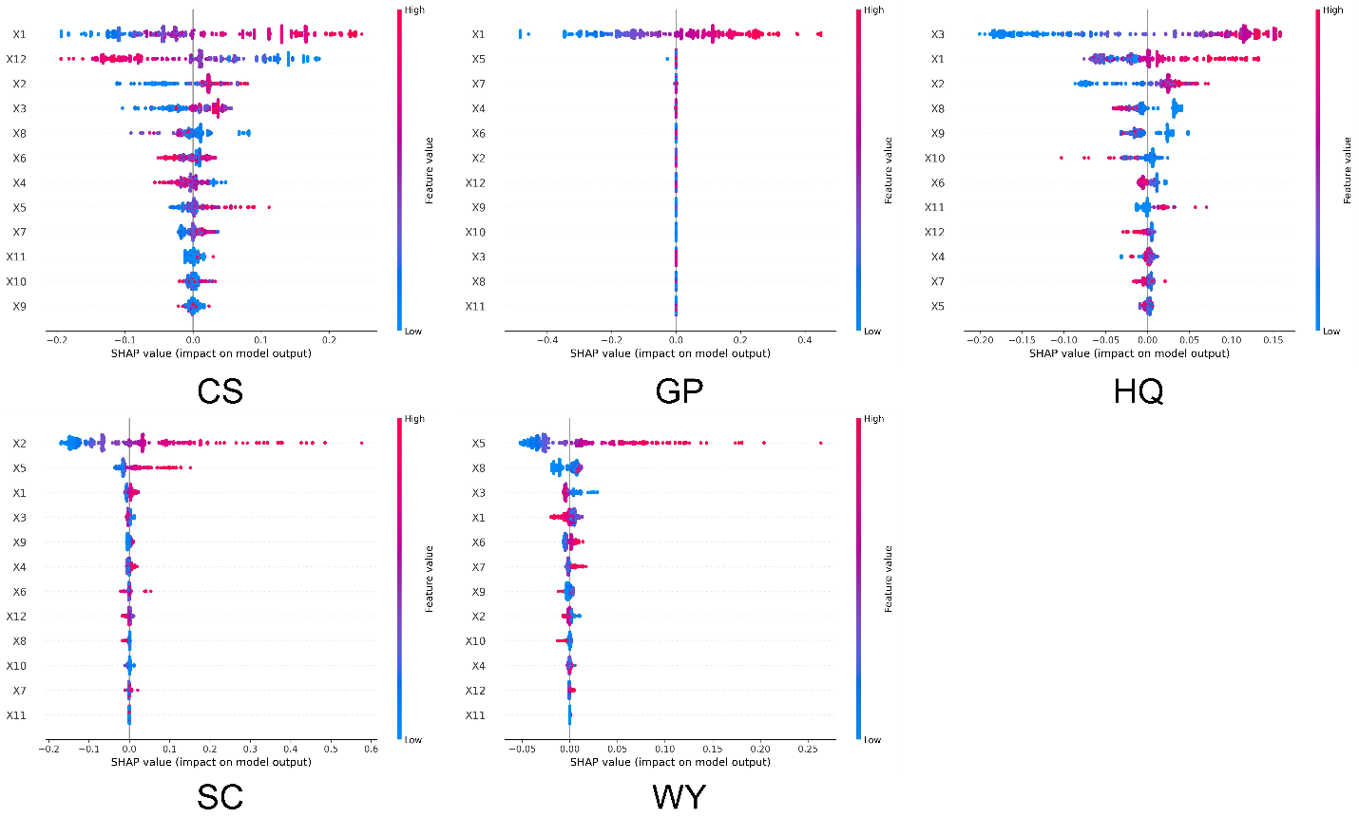
Figure S5. Feature importance of ESs at county scale in 2020.

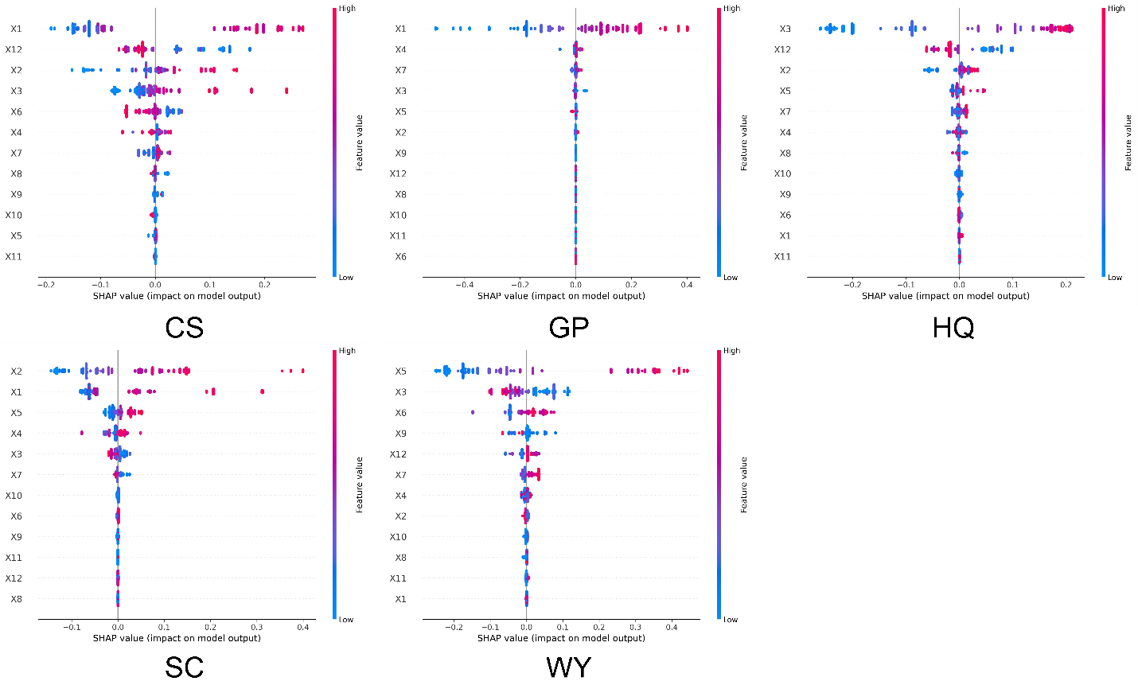
Figure S6. Feature importance of ESs at sub basin scale in 2000
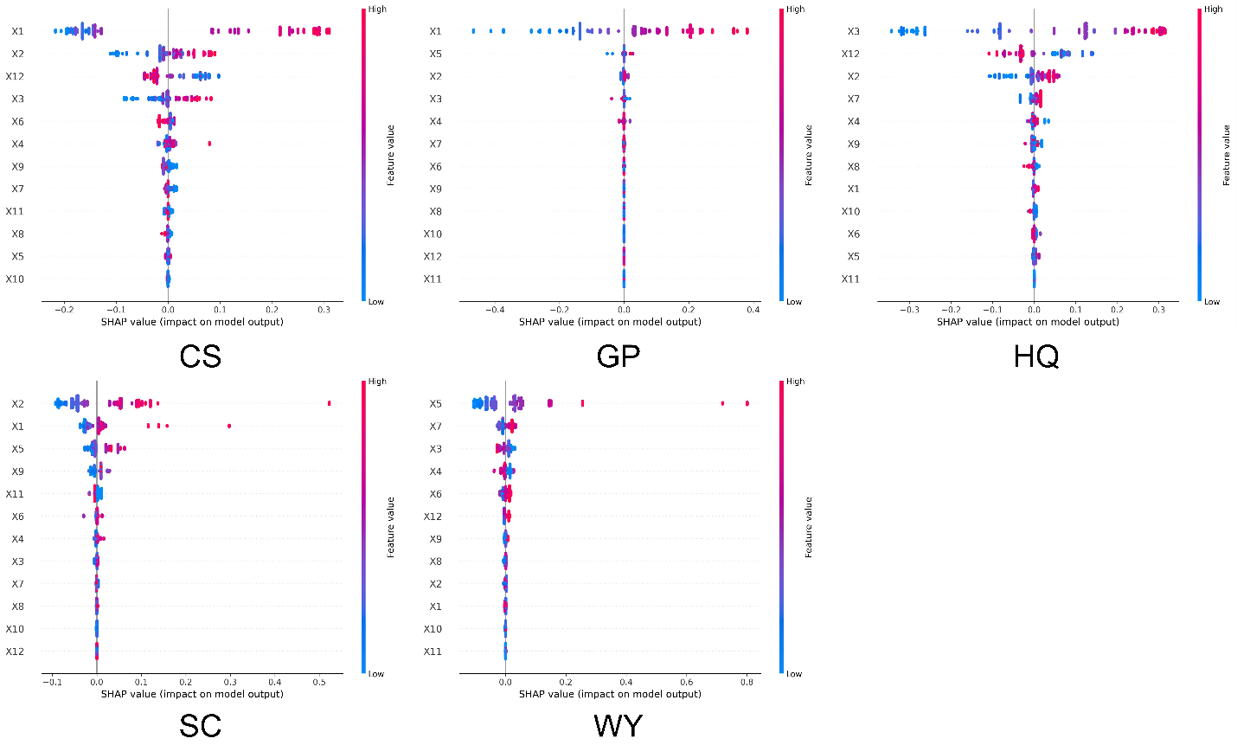
Figure S7. Feature importance of ESs at sub basin scale in 2010.

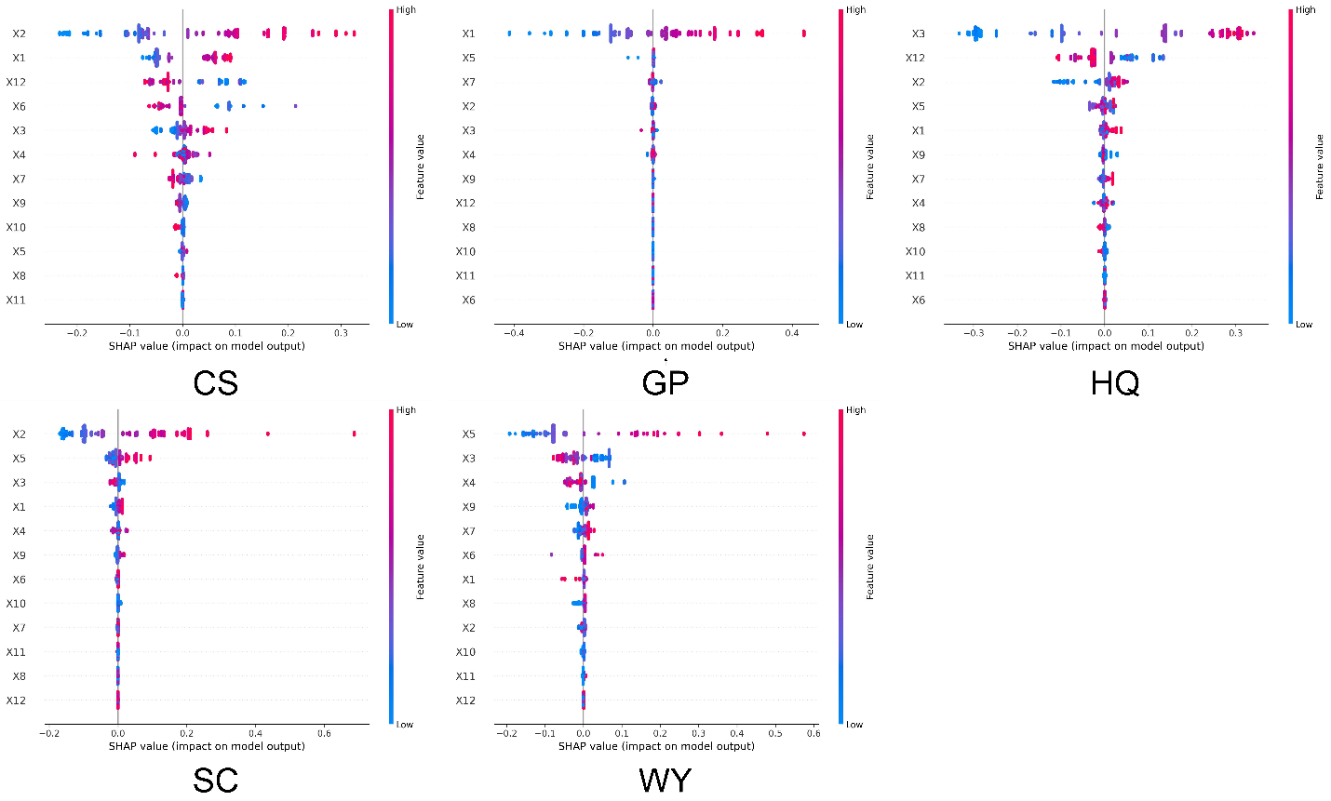
Figure S8. Feature importance of ESs at sub basin scale in 2020.

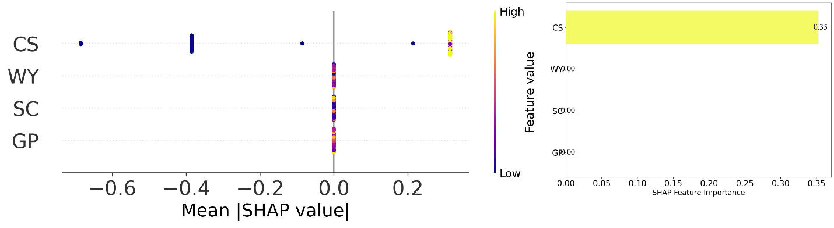
Figure S9: SHAP summary plot for pixel scale in 2020

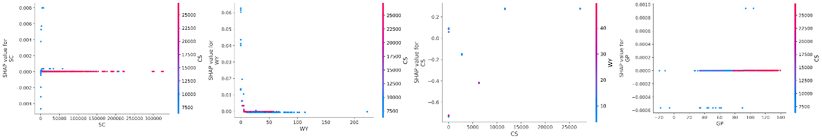
Figure S10: Dependence plots for features in pixel scale in 2020.

