Supporting Information of

Capturing a Tetratomic Nitrogen Ring cyclo-N₄ inside an Aza[82]fullerene
Yuanyuan Wang^{1†}, Ziqi Hu^{1,3†*}, Wangqiang Shen^{2†}, Tonghui Zhou^{1†}, Shinobu Aoyagi⁴, Yihao Yang¹, Zhiyong Wang⁵, Pengwei Yu², Jie Su¹, Eugenio Coronado³, Xing Lu^{2*} and Zujin Shi^{1*}
¹ National Laboratory for Molecular Sciences, State Key Laboratory of Rare Earth Materials Chemistry and Applications, College of Chemistry and Molecular Engineering, Peking University, Beijing 100871, People’s Republic of China.
² State Key Laboratory of Materials Processing and Die & Mould Technology, School of Materials Science and Engineering, Huazhong University of Science and Technology, 1037 Luoyu Road, Wuhan 430074, People’s Republic of China.
³ Instituto de Ciencia Molecular, Universidad de Valencia, C/Catedrático José Beltrán 2, 46980 Paterna, Spain.
⁴ Graduate School of Natural Sciences, Nagoya City University, Nagoya, 467-8501, Japan.
⁵Department of Chemistry, Renmin University of China, Beijing 100872, People’s Republic of China.
†These authors contributed equally to this work.

Contents
SI 1: Separations
SI 2: LDI-TOF mass spectra
SI 3: Crystal structure
SI 4: DFT calculations

SI 1: Separations
Figure S1.1 Multi-stage HPLC separation of Dy₂N₄@C₈₁N (Dy-I) with toluene as eluent and 310nm detection wavelength. a) The first stage: 20mm×250mm 5PYE column, flow rate: 15mL/min; b) the second stage: 20mm×250mm Buckyprep column, 12mL/min; c) the third stage: 20mm×250mm Buckyprep column, 15mL/min; d) the fourth stage: 10mm×250mm 5PBB column, 4mL/min; e) the final stage: 10mm×250mm 5PBB column, 4mL/min.
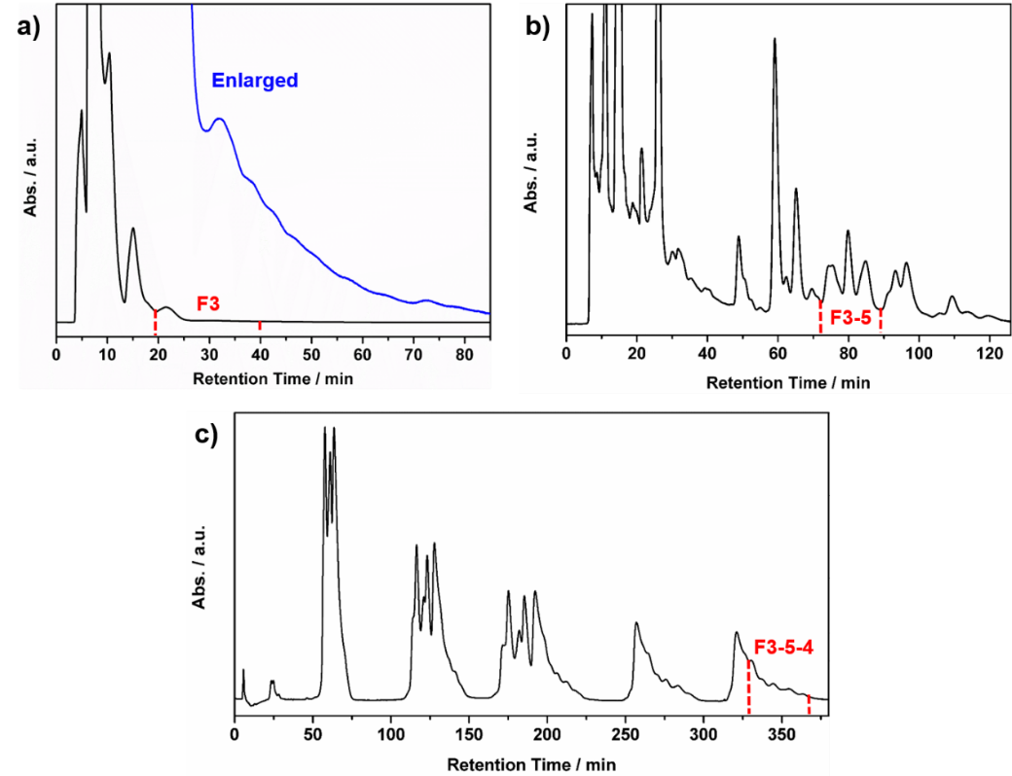

Figure S1.2 Multi-stage HPLC separation of Y₂N₄@C₈₁N (Y-I) with toluene as eluent and 310nm detection wavelength. a) The first stage: 20mm×250mm 5PYE column, flow rate: 15mL/min; b) the second stage: 20mm×250mm Buckyprep column, 12mL/min; c) the third stage: 20mm×250mm 5PBB column, 15mL/min; d) the final stage: 10mm×250mm Buckyprep column, 3mL/min.
Figure S1.3 Multi-stage HPLC separation of Dy₂C₂@C_{3v}(8)-C₈₂ with toluene as eluent and 310nm detection wavelength. a) The first stage: 20mm×250mm 5PYE column, flow rate: 15mL/min; b) the second stage: 20mm×250mm Buckyprep column, 12mL/min; c) the final stage: 20mm×250mm Buckyprep column, 12mL/min.

SI 2: LDI-TOF mass spectra
Figure S2.1 LDI-TOF mass spectrum of purified Dy₂C₂@C_{3v}(8)-C₈₂. The insets show its measured and calculated isotopic distribution.
Figure S2.2 LDI-TOF mass spectrum of purified Dy₂C₂@C_{3v}(8)-C₈₂. The insets show its measured and calculated isotopic distribution.

SI 3: Crystal structure
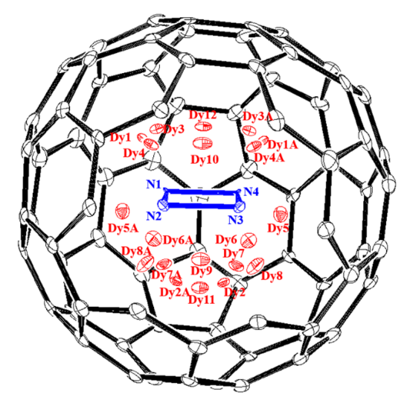
Figure S3.1 Disordered Dy sites relative to the N₄-unit in Dy-I. Those Dy sites labeled “A” are generated by crystallographic operation. The occupancies are following: Dy1, 0.27; Dy2, 0.19; Dy3, 0.08; Dy4, 0.07; Dy5, 0.07; Dy6, 0.06; Dy7, 0.06; Dy8, 0.04; Dy9, 0.16; Dy10, 0.08; Dy11, 0.05; Dy12, 0.03.
Figure S3.2 Fragment view showing the relationship of the major Dy₂N₄ cluster relative to the closest cage portions.
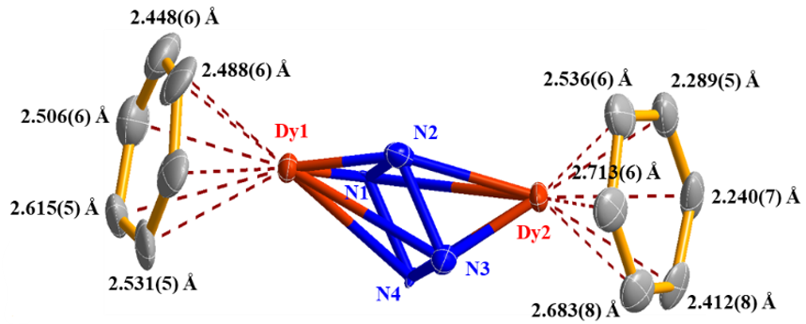
SI 4: DFT calculations
Figure S4.1 Molecular structures of optimized Y₂N₄@C₈₁N (Y-I) with the nitrogen substitution at different places on the cage: a) 566-junction at the middle of two metal ions, b) 666-junction and c) 566-junction while close to one metal ion. a) features the same nitrogen substitution location as Dy-I shown in Figure 2a and is the most stable structure. b) and c) are higher in energy of 21.4 kcal/mol and 27.6 kcal/mol, respectively. Higher-level optimization of a) using def2-TZVP basis set for C and N atoms with Grimme dispersion correction (DFT-D3) was further carried out to show the identical structure. The average N-N bond length of N₄ unit in Y-I is 1.47 Å, same as in Dy-I.
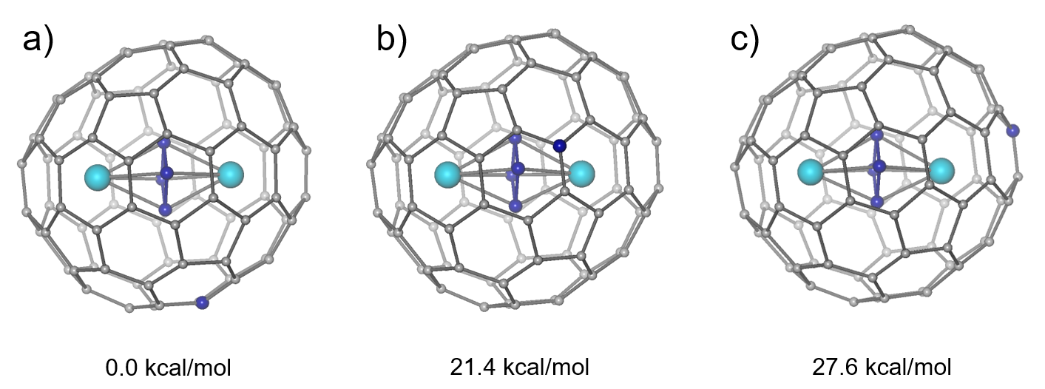
Figure S4.2 Isosurface of SOMO in Y-I, showing identical cluster-based character as illustrated in Figure 2c for Dy-I.
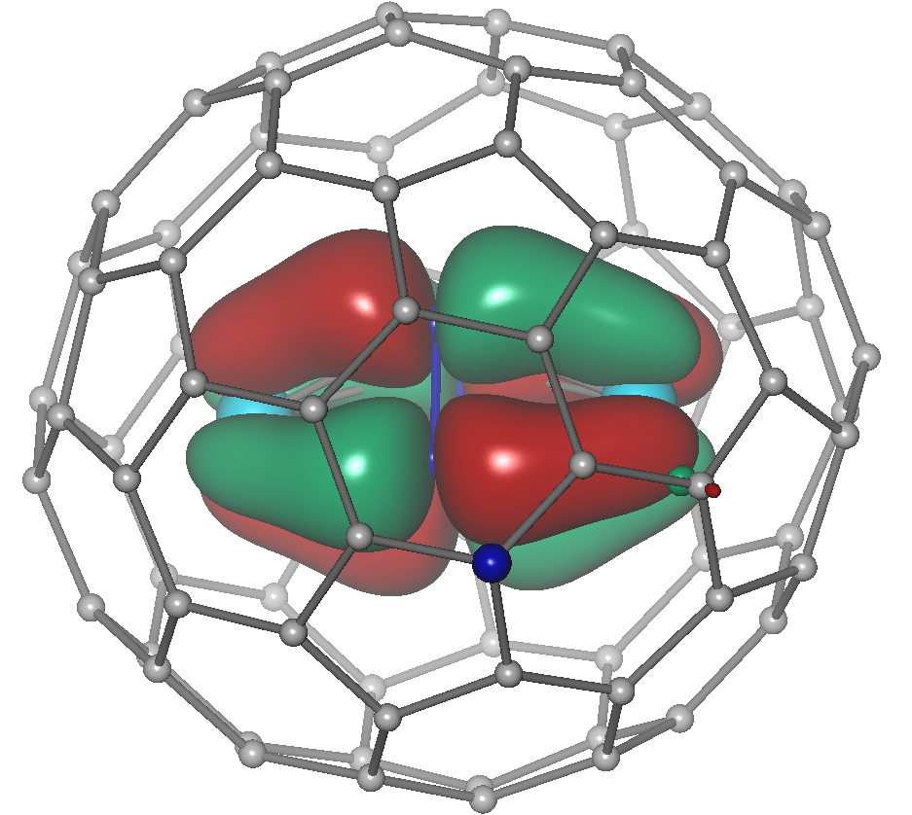
Figure S4.3 Molecular structures of optimized a) Dy-I and its b) cation Dy-I⁺ and c) anion Dy-I⁻.
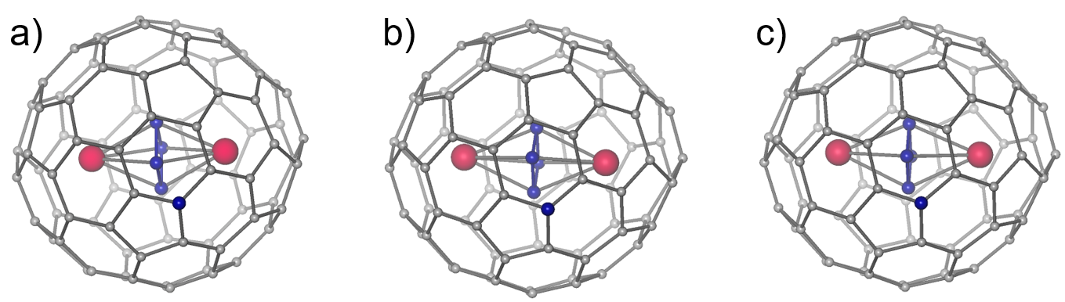
Figure S4.4 Kohn–Sham MO energy levels (occupied—black, unoccupied—pink) of Y-I, Dy-I, Dy-I⁺ and Dy-I⁻. The red color indicates the M₂N₄ cluster-based orbitals. The energy values of Dy-I⁺ cation and Dy-I⁻ anion orbitals are vertically translated for clarity. The dashed lines show the evolution of orbitals in neutral Dy-I molecule upon donating and accepting one electron, which result in Dy-I⁺ and Dy-I⁻, respectively. Spin-up (α) and spin-down (β) levels are shown separately for Y-I and Dy-I. The HOMO- or SOMO-LUMO gap in each case is indicated in blue with value in eV unit.
