Supplemental Material for
Effect of Nicotiana benthamiana exposed to long- or short-chain perfluoroalkyl substances: Levels, transfer and potential risk analysis

Huinian Liu,^{1, a, b} Wenli Hu,^{1, c} Xin Li,^{*, a, b} Sihui Lu,^{b} Fangwen Hu,^{d} Yanfen Liu,ª Tanghuan Xie,ª Zhuang Zhang,^{b} Yanni Xi,^{b} Zhu Su,ª and Chang Zhang^{a, b}
ª College of Environmental Science and Engineering, Hunan University, Changsha 410082, China
^{b} Key Laboratory of Environmental Biology and Pollution Control (Hunan University), Ministry of Education, Changsha 410082, China
^{c} College of Life Sciences, Hunan Normal University, Changsha 410081, China
^{d} Zhangjiajie College, Jishou University, Zhangjiajie 427000, China

Corresponding Author: Xin Li, Address: College of Environmental Science and Engineering, Hunan University, Changsha, P.R. China, E-mail: hgxlixin@hnu.edu.cn, Fax: +86 0731 88822829.

1: These authors contributed equally to this work.
Contents
Part 1. About materials and methods 3
1.1 Growth conditions 3
1.2 Extraction and analysis of target pollutants 4
1.3 Determination of physiological and biochemical indicators 6
1.4 Mineral element analysis 7
Part 2. About result and discussion 8
3.1 Effects of PFASs on germination 8
3.2 Effects of PFASs on the seeding growth 9
3.3 Bioaccumulation and translocation of PFASs 10
3.4 Physiological response to PFASs stress 11

Part 1. About materials and methods

1.1 Growth conditions
Seed pretreatment: Seeds of Nicotiana benthamiana was surface-sterilized by soaking in 75% ethanol for 5 min and 50% bleach for 5 min, followed by rinsing with sterile deionized-water for three times. Then the seeds were vernalized in a dark environment at 4 °C for 36 hours.

1.2 Extraction and analysis of target pollutants
Extraction: shoot and root samples were thoroughly rinsed with deionized water. Then, 0.5 g (fresh weight) of the homogenized sample was placed into a 50 mL polypropylene tube, and 2 mL of 0.25 M Na₂CO₃, 1 mL 0.5 M tetrabutyl ammonium hydrogen sulfate (CAS no. 32503-27-8), and 5 mL methyl tert-butyl ether (CAS no. 1634-04-4) were added for extraction. After sonicating the centrifuge tube in a 40 ℃ water bath for 20 min, centrifuge it at 4000 rpm for 30 min. Transfer the extraction supernatant to another clean centrifuge tube, extract the samples twice, and combine the two centrifugal liquids. The extract was slowly blown dry with a nitrogen blower, and the volume was adjusted to 1 mL with a methanol: water (1:1, v/v) mixture. After mixing on a vortex mixer, pass through a 0.22 μm PP membrane and transfer it into a 2mL liquid phase automatic sample injection vial.
Analysis: PFOA and HFPO-DA were using an Agilent 1260 high performance liquid chromatography (Serial No. DEACN47862) coupled to an Agilent 6470 triple quadrupole tandem mass spectrometry (Serial No. SG1813G106). The detailed parameters of instrumental analysis are given as follows. Analysis was performed using negative electrospray ionization, with unit resolution in Q1 and Q3. MRM transitions for the target compounds are provided in S-Table 1. High performance liquid chromatography was performed using a Synergi 4 μm Fusion-RP-C18 column (150 × 2 mm; Phenomenex) combined with a Security Guard cartridge for Fusion-RP HPLC columns (4 × 2 mm, Phenomenex). The mobile phase consisted of A) water and B) methanol, both added with 10 mmol ammonium acetate.
S-Table 1 | HPLC-MS/MS experimental parameters
Name | Time  min | A/B% | Flow mL/min | Max.  Pressure  Limit  bar | Precursor  /Product  Ion | Dwell | Frag-mentor | Collision  Energy | Polanty
PFOA | 4 | 30.0070.00 | 0.200 | 1300.00 | 413/369 | 200 | 67 | 5 | Negative
HFPO-DA | 4 | 30.0070.00 | 0.200 | 1300.00 | 329/285 | 200 | 67 | 5 | Negative

1.3 Determination of physiological and biochemical indicators
Relative electrical conductivity: Rinse the leaves 3 times with deionized water, and absorb the moisture on the surface of the leaves with absorbent paper. Then use a punch to take out leaf discs (avoid the main leaf veins), randomly take 10 of each group, put them into a centrifuge tube with 5 mL of deionized water, and soak for 12 hours. Measure the conductivity of the solution after the immersion is finished, and record it as R1. Then put the centrifuge tube in a boiling water bath and heat it for 20 min, and then measure the conductivity of the solution after it is at room temperature, which is recorded as R2.

1.4 Mineral element analysis
a. Weigh 0.1 g of the dried sample, transfer it into a 50 mL PTFE tube, add 6 mL HNO₃ and 1.5 mL HClO₄ in sequence, and let it stand for 12 h at room temperature in a fume hood.
b. After 12 hours, move into the graphite digestion apparatus. The ladder temperature setting and operation rules of the graphite digestion apparatus: 50 ℃, 0.5 h, heating time 2 min; 100 ℃, 1.0 h, heating time 2 min; 160 ℃, 2.0 h, heating time 2 min; Increase the temperature to 180 ℃ and continue heating. When the volume of the solution in the digestion tube remains 1-2 mL, the digestion tube can be taken out and cooled to room temperature.
c. Set the volume of the digestion solution to 50 mL and set aside.
d. Take 10 mL of the digestion solution after constant volume and use ICP-MS to determine the element content. (ICP-MS, Agilent 7900, Agilent Technologies, Inc., USA)
Formula: $TF=\frac{Mineral elements in shoots (DW, mg/g)}{Mineral elements in roots (DW, mg/g)}$

Part 2. About result and discussion

3.1 Effects of PFASs on germination
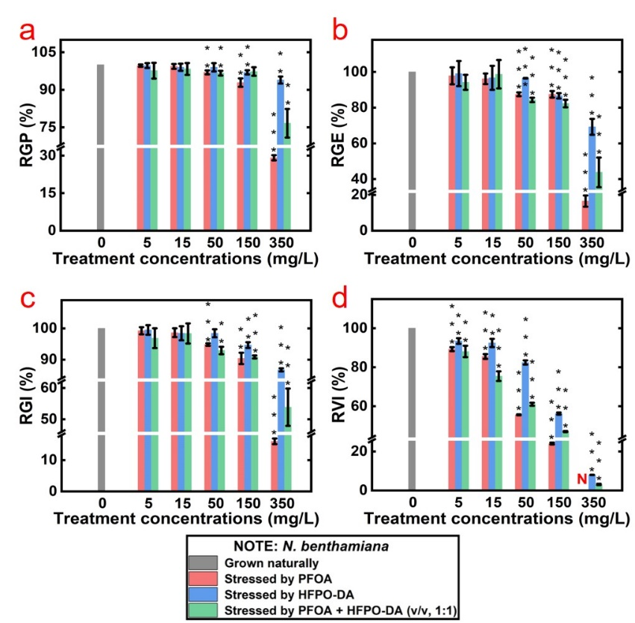
S-Fig. 1 | Effects of different concentrations of PFOA, HFPO-DA and (PFOA + HFPO-DA) exposure on germination.
(a) RGP, (b) RGE, (c) RGI, (d) RVI.
N: plants not obtain biomass. Each group use 100 seeds. Data are means ± SE of three independent groups. Asterisks indicate significant differences between the treatments and the control, where p < 0.05 (*), p < 0.01 (**) and p < 0.001 (***).

3.2 Effects of PFASs on the seeding growth
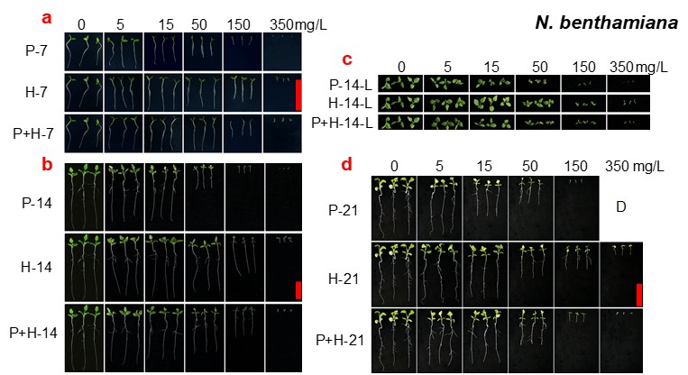
S-Fig. 2 | The growth morphology of N. benthamiana after exposed 7, 14, and 21 days.
(a) Stressed by PFOA (F-7), HFPO-DA (H-7) and (PFOA + HFPO-DA) (P+H-7) for 7 days. Scale bar, 20 mm. (b) Stressed by PFOA (P-14), HFPO-DA (H-14) and (PFOA + HFPO-DA) (P+H-14) for 14 days. Scale bar, 20 mm. (c) Leaf morphology after 14 days of stressed. (d) Stressed by PFOA (P-21), HFPO-DA (H-21) and (PFOA + HFPO-DA) (P+H-21) for 21 days. Scale bar, 40 mm. D: plants with no signs of life.

3.3 Bioaccumulation and translocation of PFASs
S-Table 2 | Bioaccumulation factor after exposed 21 days
Plant | Concentraion  (½ MS) mg/L | Tissue | BCFs L/kg (AVG)
Plant | Concentraion  (½ MS) mg/L | Tissue | PFOA | HFPO-DA | PFOA + HFPO-DA
N. benthamiana | 5 | Roots | 32.9 | 9.5 | 19.3
N. benthamiana | 5 | Shoots | 8.3 | 7.4 | 8.1
N. benthamiana | 15 | Roots | 31.0 | 9.4 | 21.2
N. benthamiana | 15 | Shoots | 10.4 | 6.5 | 8.2
N. benthamiana | 50 | Roots | 26.5 | 8.4 | 17.4
N. benthamiana | 50 | Shoots | 9.1 | 6.4 | 8.0
N. benthamiana | 150 | Roots | / | 7.9 | 12.8
N. benthamiana | 150 | Shoots | / | 6.8 | 8.3

3.4 Physiological response to PFASs stress
S-Table 3 | Mineral elements TF after exposed 21 days
Plant | Concentraion  (½ MS) mg/L | Mineral  elements | TF mg/g (AVG)
Plant | Concentraion  (½ MS) mg/L | Mineral  elements | PFOA | HFPO-DA | PFOA + HFPO-DA
N. benthamiana | 0 | K | 1.07
N. benthamiana | 0 | Ca | 1.49
N. benthamiana | 0 | Mg | 1.65
N. benthamiana | 0 | Na | 1.42
N. benthamiana | 5 | K | 1.16 | 1.19 | 1.14
N. benthamiana | 5 | Ca | 1.71 | 1.59 | 1.64
N. benthamiana | 5 | Mg | 1.66 | 1.83 | 1.61
N. benthamiana | 5 | Na | 1.95 | 1.30 | 1.60
N. benthamiana | 15 | K | 0.97 | 1.00 | 0.96
N. benthamiana | 15 | Ca | 1.58 | 1.68 | 1.55
N. benthamiana | 15 | Mg | 1.46 | 1.53 | 1.49
N. benthamiana | 15 | Na | 3.45 | 2.67 | 2.10
N. benthamiana | 50 | K | 0.76 | 0.83 | 0.83
N. benthamiana | 50 | Ca | 1.12 | 1.46 | 1.27
N. benthamiana | 50 | Mg | 1.07 | 1.45 | 1.03
N. benthamiana | 50 | Na | 3.95 | 2.67 | 3.95
N. benthamiana | 150 | K | / | 0.52 | 0.44
N. benthamiana | 150 | Ca | / | 1.07 | 0.99
N. benthamiana | 150 | Mg | / | 1.00 | 1.00
N. benthamiana | 150 | Na | / | 6.34 | 7.13

