Supplemental information for
Distinct mechanism of the long-B prokaryotic Argonaute-mediated nuclease activation in bacterial immunity
Min Liu^{1, *}, Qin Yu^{1,} *, Xiaoruo Zhang^{1,} *, Dujuan Shi¹, Qiong Xing^{1,} $, Fengtao Huang^{1, $} & Lixin Ma^{1, $}

¹State Key Laboratory of Biocatalysis and Enzyme Engineering, Hubei Key Laboratory of Industrial Biotechnology, School of Life Sciences, Hubei University, Wuhan, Hubei 430062, China.

*These authors contribute equally
$Corresponding author
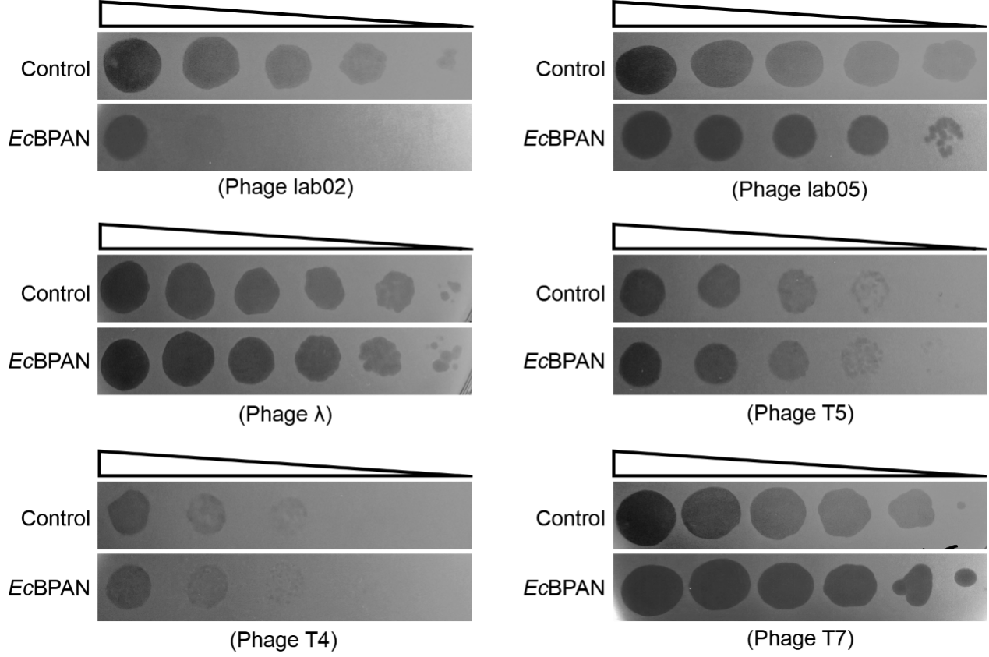
Fig S1. Anti-phage activity of EcBPAN system against various phages.
Phages T4, T5, T7, λ, lab02 and lab05 were used to test the anti-phage activity of the EcBPAN system. Expression of EcBPAN was induced with 0.01 mM IPTG. An empty vector was used as a control. All experiments were performed at 37 ℃ and repeated three times.

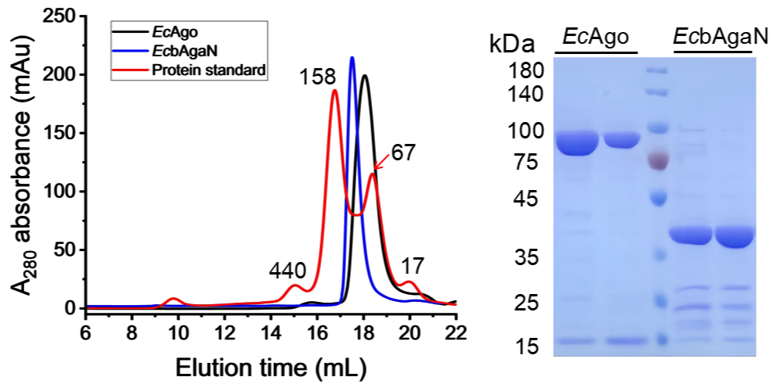
Fig S2. Analysis of size-exclusion chromatography (left) and SDS-PAGE (right) of EcAgo and EcbAgaN.
Fig S3. Structure determination of EcBPAN-guide RNA-target DNA complex.
Flowchart of image processing for EcBPAN-guide RNA-target DNA complex.

Fig S4. Structural comparison of EcAgo, RsAgo and TtAgo.
- Structural alignment of EcAgo (green) and RsAgo (pink, PDB ID: 6D8P).
- Structures of PAZ domain of EcAgo and TtAgo (PDB ID: 4NCB) were shown in cartoon.

Fig S5. Interaction between the EcAgo and target DNA.
- Interaction of nucleotide at the 3′-end of target DNA (T1’, G1’, A1’ and C1’) and the surrounding amino acids. Amino acids and nucleotide were shown in sticks. The interaction patterns between G1’, A1’ and C1’ and amino acids of EcAgo was simulated based on the interaction model of T1’.
- Single-nucleotide mismatches at different positions of target DNA exhibit different effects on cleavage activity of genomic DNA. All experiments were repeated three times.
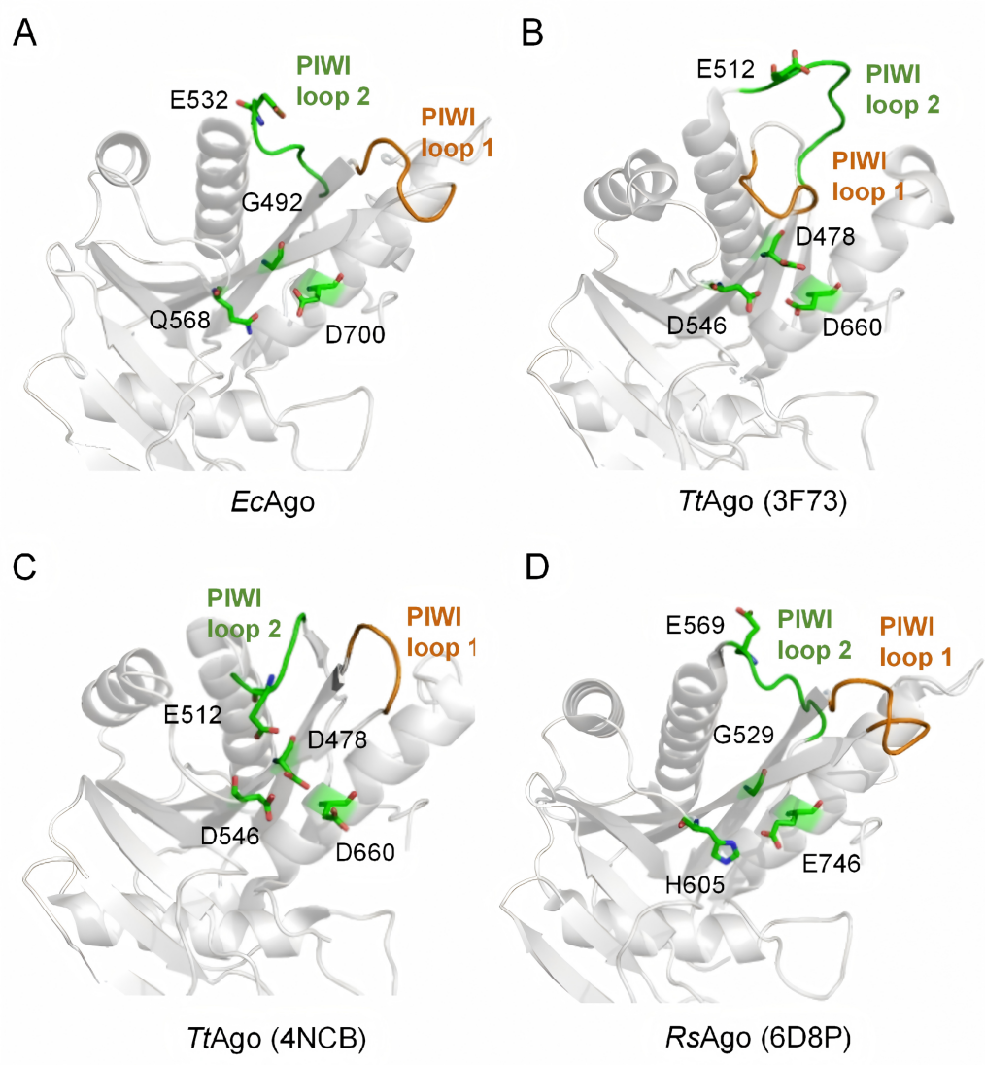
Fig S6. The catalytic tetrads of EcAgo, TtAgo, and RsAgo.
- Putative catalytic pocket residues in EcAgo. (B) Unplugged (PDB ID: 3F73) and (C) plugged-in (PDB ID: 4NCB) conformation confirmed by structures of TtAgo are shown. (D) RsAgo (PDB ID: 6D8P) adopt an unplugged conformation. The catalytic tetrads of Argonaute proteins are shown in sticks. PIWI loop 1 (orange) and PIWI loop 2 (green) are shown in cartoon.

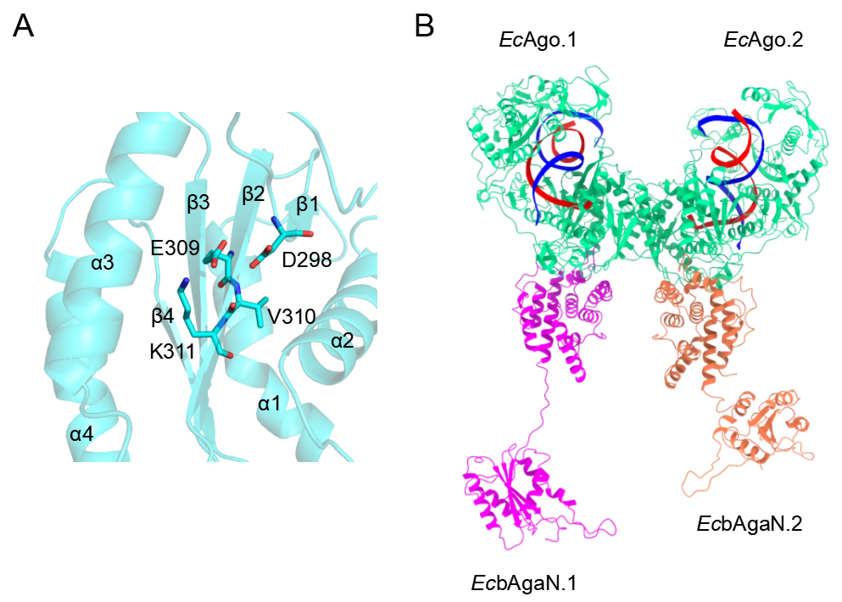
Fig S7. The structures of C-terminal nuclease domain of EcbAgaN and EcAgo-EcbAgaN complex.
- The α-β-α fold architecture of C-terminal nuclease domain of EcbAgaN and D-EVK motif are shown.
- The structure of EcAgo ternary complex dimer with responding interacting EcbAgaN is shown.

Table S1. Cryo-EM data collection, refinement and validation statistics.
EcBPAN-guide RNA-target DNA complex
(EPDB: 9WTQ, EMDB -66224)
Microscope | Titan Krios
Magnification | 105 000
Voltage (kV) | 300
Detector | Gatan K3
Pixel size (Å) | 0.425
Defocus (μm) | -1.0 to -2.2
Total dose (e/Å²) | 30
Total images | 25 605
Movie frames | 30
Refinement
Software | CryoSparc
Bin value | 3/4
Particles used | 309 746
Symmetry imposed | C2
FSC threshold | 0.143
Map Resolution (Å) | 3.27
Validation
Chains | 33
Atoms | 77 480
Residues | 8 928
Ligands | Mg
Bond lengths (Å) | 0.002
Bond angles (°) | 0.444
MolProbity Score | 1.74
Clash score | 5.99
Rotamer outlier (%) | 2.33
Favored (%) | 97.27
Allowed (%) | 2.73
Outliers (%) | 0.00
Table S2. The nucleic sequences used in genomic DNA degradation.
Oligonucleotide name | Sequence (5'-3') | Description
P-A1-gRNA | P-AUCAAAGCUUAGAUACCCUGG | RNA guide forms 5'-A pair with A-tDNA
P-U1-gRNA | P-UUCAAAGCUUAGAUACCCUGG | RNA guide forms 5'-U pair with U-tDNA
P-C1-gRNA | P-CUCAAAGCUUAGAUACCCUGG | RNA guide forms 5'-C pair with C-tDNA
P-G1-gRNA | P-GUCAAAGCUUAGAUACCCUGG | RNA guide forms 5'-G pair with C-tDNA
HO-A1-gRNA | HO-AUCAAAGCUUAGAUACCCUGG | RNA guide forms 5'-A pair with A-tDNA
A1-tDNA | CCAGGGTATCTAAGCTTTGAT | DNA target forms 5'-A pair with A1-gRNA
U1-tDNA | CCAGGGTATCTAAGCTTTGAA | DNA target forms 5'-U pair with U1-gRNA
C1-tDNA | CCAGGGTATCTAAGCTTTGAG | DNA target forms 5'-C pair with C1-gRNA
G1-tDNA | CCAGGGTATCTAAGCTTTGAC | DNA target forms 5'-G pair with G1-gRNA
tDNA-mm2 | CCAGGGTATCTAAGCTTTGCT | DNA target forms mismatched pair in position 2 with gRNA
tDNA-mm3 | CCAGGGTATCTAAGCTTTCAT | DNA target forms mismatched pair in position 3 with gRNA
tDNA-mm4 | CCAGGGTATCTAAGCTTAGAT | DNA target forms mismatched pair in position 4 with gRNA
tDNA-mm5 | CCAGGGTATCTAAGCTATGAT | DNA target forms mismatched pair in position 5 with gRNA
tDNA-mm6 | CCAGGGTATCTAAGCATTGAT | DNA target forms mismatched pair in position 6 with gRNA
tDNA-mm7 | CCAGGGTATCTAAGGTTTGAT | DNA target forms mismatched pair in position 7 with gRNA
tDNA-mm8 | CCAGGGTATCTAACCTTTGAT | DNA target forms mismatched pair in position 8 with gRNA
tDNA-mm9 | CCAGGGTATCTACGCTTTGAT | DNA target forms mismatched pair in position 9 with gRNA
tDNA-mm10 | CCAGGGTATCTCAGCTTTGAT | DNA target forms mismatched pair in position 10 with gRNA
tDNA-mm11 | CCAGGGTATCAAAGCTTTGAT | DNA target forms mismatched pair in position 11 with gRNA
tDNA-mm12 | CCAGGGTATGTAAGCTTTGAT | DNA target forms mismatched pair in position 12 with gRNA
tDNA-mm13 | CCAGGGTAACTAAGCTTTGAT | DNA target forms mismatched pair in position 13 with gRNA
tDNA-mm14 | CCAGGGTCTCTAAGCTTTGAT | DNA target forms mismatched pair in position 14 with gRNA
tDNA-mm15 | CCAGGGAATCTAAGCTTTGAT | DNA target forms mismatched pair in position 15 with gRNA
tDNA-mm16 | CCAGGCTATCTAAGCTTTGAT | DNA target forms mismatched pair in position 16 with gRNA
tDNA-mm17 | CCAGCGTATCTAAGCTTTGAT | DNA target forms mismatched pair in position 17 with gRNA
tDNA-mm18 | CCACGGTATCTAAGCTTTGAT | DNA target forms mismatched pair in position 18 with gRNA
tDNA-mm19 | CCCGGGTATCTAAGCTTTGAT | DNA target forms mismatched pair in position 19 with gRNA
tDNA-mm20 | CGAGGGTATCTAAGCTTTGAT | DNA target forms mismatched pair in position 20 with gRNA
tDNA-mm21 | GCAGGGTATCTAAGCTTTGAT | DNA target forms mismatched pair in position 21 with gRNA

Table S3. The recombinant plasmids used in this paper.
Plasmids | Description
pET28a-EcAgo | For in vitro assays
pET28a-EcAgo_D400A | For in vitro assays
pET28a-EcAgo_H726A | For in vitro assays
pET28a-EcAgo_R552A | For in vitro assays
pET28a-EcAgo_Y318F | For in vitro assays
pET28a-EcAgo_S524A | For in vitro assays
pET28a-EcAgo_N554A | For in vitro assays
pET28a-EcAgo_D559A | For in vitro assays
pET28a-EcAgo_N460A | For in vitro assays
pET28a-EcAgo_R321A | For in vitro assays
pET28a-EcAgo_Y426A | For in vitro assays
pET28a-EcbAgaN | For in vitro assays
pET28a-EcbAgaN_R77A | For in vitro assays
pET28a-EcbAgaN_D86K | For in vitro assays
pET28a-EcbAgaN_H134A | For in vitro assays
pET28a-EcbAgaN_D14A/Y15A/Q189A | For in vitro assays
pET28a-EcbAgaN_S332A/Y340A | For in vitro assays
pET28a-EcbAgaN_Q357A/E358A/K361A | For in vitro assays
pET28a-EcbAgaN_N286A/Q288A/Q292A | For in vitro assays
pET28a-EcbAgaN_(GGGGS)₂ linker | For in vitro assays
pET28a-EcbAgaN_M1 | For in vitro assays
pQE80L-EcAgo | For phage plaque assays
pQE80L-EcbAgaN | For phage plaque assays
pQE80L-EcAgo-EcbAgaN | For phage plaque assays
pQE80L-EcAgo-EcbAgaN_R77A | For phage plaque assays
pQE80L-EcAgo-EcbAgaN_D86K | For phage plaque assays
pQE80L-EcAgo-EcbAgaN_H134A | For phage plaque assays
pQE80L-EcAgo_Y318F-EcbAgaN | For phage plaque assays
pQE80L-EcAgo_N554A-EcbAgaN | For phage plaque assays
pQE80L-EcAgo_D559A-EcbAgaN | For phage plaque assays
pQE80L-EcAgo_R321A-EcbAgaN | For phage plaque assays

