Supplementary
Table S1
Correlations between feasibility scores, age, intelligence, socioeconomic status and compliance
 |  | Age | IQ | SES | Compliance
Enjoyment
Enjoyment of the training | r  p | -.116  .627 | -.009  .971 | .390  .089 | .457  .043*
Pressure/tension | r  p | -.112  .637 | .267  .256 | -.164  .490 | -.267  .256
Perceived difficulty | r  p | .190  .422 | -.364  .114 | .271  .247 | .500  .025*
Motivation | r  p | -.184  .450 | .091  .712 | .429  .067 | .515  .024*
App use in everyday life | r  p | -.345  .136 | .049  .837 | .325  .162 | .307  .188
Design of the training | r  p | -.160  .501 | .112  .637 | .467  .038* | .652  .002**
Metacognitive questions | r  p | .099  .687 | .058  .813 | .199  .415 | .373  .115
Physical activity | r  p | -.411  .072 | -.056  .815 | .385  .094 | .698  <.001**
Usability
Usability | r  p | -.031  .898 | .070  .768 | .161  .496 | .344  .137
Perceived duration of the training | r  p | .114  .631 | -.008  .972 | .188  .429 | .565  .009**
Level of autonomy
Accessibility | r  p | .334  .151 | .243  .302 | -.059  .803 | .236  .316
Perceived flexibility | r  p | .036  .881 | -.285  .224 | .532  .016* | .455  .044*
Perceived impact
Self-efficacy | r  p | -.430  .075 | -.116  .648 | .565  .015* | .590  .010*
Strategy use | r  p | -.110  .654 | .113  .643 | .172  .481 | .032  .894
User data
Session duration | r  p | -.197  .403 | -.130  .586 | .247  .293 | .353  .138
Compliance (%) | r  p | -.133  .575 | -.119  .617 | .314  .177 | -
Note. r = Spearman’s roh; p = significance (α < .05 = *, α < .01 = **). IQ = Intelligence, SES = socioeconomic status.

Table S2
Feasibility scorings and sex differences
 | Male | Female | t | df | p | d
Enjoyment
Enjoyment of the training | 3.09 | 2.90 | 0.79 | 17.9 | .441 | 0.35
Pressure/tension | 3.43 | 3.40 | 0.13 | 16.9 | .899 | 0.06
Perceived difficulty | 3.05 | 3.30 | -1.03 | 17.2 | .318 | -0.46
Motivation | 3.22 | 2.75 | 1.36 | 13.6 | .197 | 0.60
App use in everyday life | 2.20 | 1.90 | 1.34 | 16.6 | .198 | 0.60
Design of the training | 3.19 | 3.26 | -0.39 | 17.5 | .699 | -0.18
Metacognitive questions | 3.22 | 2.97 | 0.73 | 16.4 | .478 | 0.33
Physical activity | 3.04 | 2.96 | 0.33 | 18.0 | .747 | 0.15
Usability
Usability | 3.39 | 3.34 | 0.23 | 18.0 | .821 | 0.10
Perceived duration of the training | 3.00 | 2.33 | 2.53 | 18.0 | .021* | 1.13
Level of autonomy
Accessibility | 3.60 | 3.50 | 0.35 | 17.2 | .732 | 0.16
Perceived flexibility | 2.90 | 2.80 | 0.31 | 16.5 | .763 | 0.14
Perceived impact
Self-efficacy | 2.95 | 2.46 | 2.23 | 15.9 | .041* | 1.05
Strategy use | 2.84 | 3.02 | -0.51 | 17.0 | .618 | -0.23
User data
Session duration | 17.88 | 20.60 | -1.02 | 16.2 | 0.321 | -0.46
Compliance (%) | 98.00 | 92.67 | 0.94 | 10.2 | 0.368 | 0.42
Note. Data presented as: t = independent t-test; df = degrees of freedom, p = significance (α < .05 = *, α < .01 = **), d = effect size (Cohens’d; small effect d = 0.2, moderate effect d = 0.5, large effect d = 0.8).

Table S3
Absolute and relative changes and group differences in performance before the teaching and practicing of mnemonic strategies (“tricks”) and the long-term recall
 | Without mnemonic strategy use | Long-term recall | Absolute change | Relative change | U | p | g
Similarity trick | 26.19 (35.84) | 79.05 (34.34) | 52.86 (41.25) | 2.18 (3.42) | 1.0 | <.001** | 1.448
TV-trick | 35.34 (38.97) | 51.78 (39.68) | 14.68 (43.43) | 0.45 (1.30) | 35.5 | .173 | .358
Story trick | 47.30 (33.67) | 59.37 (40.66) | 20.18 (19.48) | 0.42 (0.44) | 14.0 | .030* | .298
Symbol trick | 56.89 (41.96) | 62.26 (39.34) | 5.37 (32.85) | 0.45 (1.22) | 11.0 | .191 | .126
Echo trick | 25.10 (24.93) | 26.63 (30.84) | 0.14 (19.65) | -0.06 (0.64) | 29.0 | .755 | .005
Notes. Group differences were calculated to compare the mean values between the groups ”without strategy” and “long-term recall”: U = Mann-Whitney-U-test; p = significance (α < .05 = *, α < .01 = **); g = effect size (Hedge’s g; small effect g = 0.2, moderate effect g = 0.5, large effect g = 0.8). Change scores were calculated accordingly: absolute changes (long-term – without strategy), relative changes (long-term – without strategy/without strategy).

Table S4
Absolute and relative changes and group differences in performance after the teaching and practicing of mnemonic strategies (“tricks”) and the long-term recall
 | With mnemonic strategy use | Long-term recall | Absolute change | Relative change | U | p | g
Similarity trick | 62.86 (43.38) | 79.05 (34.34) | 16.19 (31.86) | 0.09 (0.20) | 0.0 | .022* | .387
TV-trick | 57.14 (43.03) | 51.78 (39.68) | -14.22 (49.48) | 0.23 (2.03) | 22.0 | .108 | .193
Story trick | 65.71 (36.65) | 59.37 (40.66) | -3.85 (32.03) | -0.04 (0.54) | 52.0 | .327 | .156
Symbol trick | - | 62.26 (39.34) | - | - | - | - | -
Echo trick | 36.11 (31.33) | 26.63 (30.84) | -11.49 (24.34) | -0.32 (0.48) | 46.0 | .066 | .355
Notes. Group differences were calculated to compare the mean values between the groups ”with strategy” and “long-term recall”: U = Mann-Whitney-U-test; p = significance (α < .05 = *, α < .01 = **); g = effect size (Hedge’s g; small effect g = 0.2, moderate effect g = 0.5, large effect g = 0.8). Change scores were calculated accordingly: absolute changes (long-term – with strategy), relative changes (long-term – with strategy/with strategy).

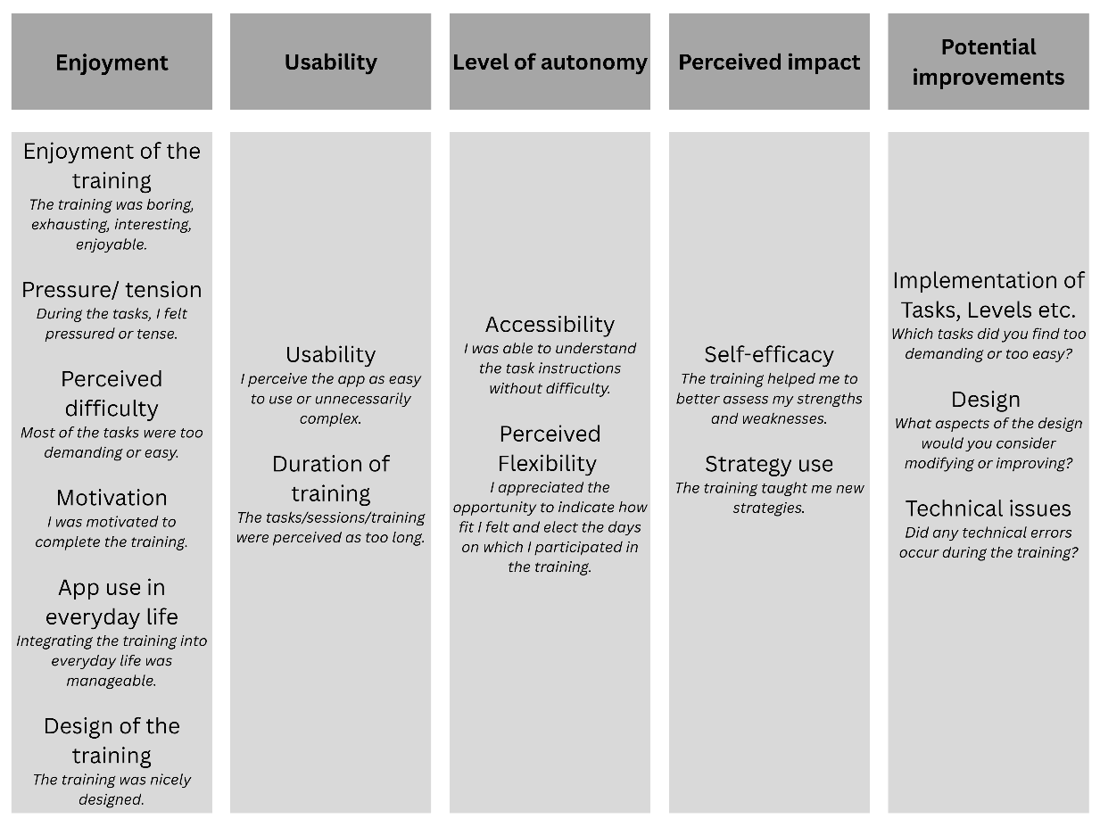

Figure S1. Subscales of the feasibility questionnaire.
Note. Examples of questions are italicized below the subscales.

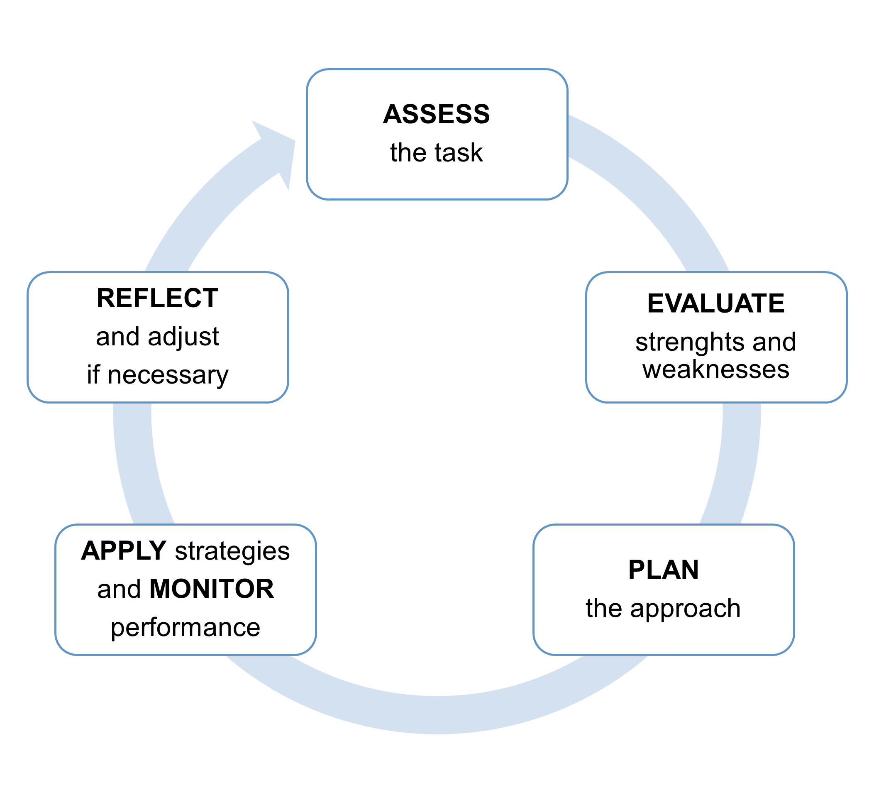
Figure S2. Metacognitive cycle adapted from Ambrose et al. 2010.

Supplementary material S1
Feasibility questionnaire
On the following pages, we ask you to give your honest feedback on your experience of using the Mio-App. As you read the statements, please try to think about what it was like for you to use the Mio-App.
Task design | Strongly disagree | Somewhat disagree | Somewhat agree | Strongly agree
I understood the explanations of the tasks without any problems. | ☐ | ☐ | ☐ | ☐
The tasks took too long. | ☐ | ☐ | ☐ | ☐
The sessions took too long. | ☐ | ☐ | ☐ | ☐
Most of the tasks were too difficult for me. | ☐ | ☐ | ☐ | ☐
Most of the tasks were too easy for me. | ☐ | ☐ | ☐ | ☐
Three sessions per week are too many. | ☐ | ☐ | ☐ | ☐
I could easily do more than three sessions per week. | ☐ | ☐ | ☐ | ☐
I completed the tasks without help from my parents or friends. | ☐ | ☐ | ☐ | ☐
Which tasks did you particularly enjoy?
Which tasks were too strenuous?
Which tasks were too difficult?
Which tasks were too easy?

Design/storyline | Strongly disagree | Somewhat disagree | Somewhat agree | Strongly agree
The App had an appealing design. | ☐ | ☐ | ☐ | ☐
I was interested in the story of the game. | ☐ | ☐ | ☐ | ☐
I wanted to know how the story continued. | ☐ | ☐ | ☐ | ☐
There was too much text for me. | ☐ | ☐ | ☐ | ☐
I would like the training to contain more story. | ☐ | ☐ | ☐ | ☐
I liked the characters of the training. | ☐ | ☐ | ☐ | ☐
I thought the space theme was appropriate for the training. | ☐ | ☐ | ☐ | ☐
What would you change about the design/layout?
What would you change about the story?

General satisfaction | Strongly disagree | Somewhat disagree | Somewhat agree | Strongly agree
I found the training boring. | ☐ | ☐ | ☐ | ☐
I found the training frustrating. | ☐ | ☐ | ☐ | ☐
I enjoyed doing the training. | ☐ | ☐ | ☐ | ☐
I had fun doing the training. | ☐ | ☐ | ☐ | ☐
I found the training mentally exhausting. | ☐ | ☐ | ☐ | ☐
I found the training physically exhausting. | ☐ | ☐ | ☐ | ☐
I found the tasks interesting. | ☐ | ☐ | ☐ | ☐
I would recommend the App to my friends. | ☐ | ☐ | ☐ | ☐
At the end of each session, I was already looking forward to the next one. | ☐ | ☐ | ☐ | ☐
I would do the training again at a later date. | ☐ | ☐ | ☐ | ☐
What could be changed to make the training more enjoyable for you?

Motivation | Strongly disagree | Somewhat disagree | Somewhat agree | Strongly agree
I was motivated to do the training. | ☐ | ☐ | ☐ | ☐
The rewards (stars) motivated me to complete the training. | ☐ | ☐ | ☐ | ☐
I found it easy to complete the training. | ☐ | ☐ | ☐ | ☐
I only did the training because my parents or others wanted me to. | ☐ | ☐ | ☐ | ☐
What motivated you to complete the training?
If you didn’t complete the training: What would motivate you to complete the training?
Was there anything missing that would have motivated you even more to do the training?

Perceived autonomy | Strongly disagree | Somewhat disagree | Somewhat agree | Strongly agree
It was great that I could always indicate how fit I am. | ☐ | ☐ | ☐ | ☐
I liked the option to choose which days I train. | ☐ | ☐ | ☐ | ☐
I always chose the same difficulty level (how fit I feel). | ☐ | ☐ | ☐ | ☐
Are the different levels (such as the questions about how fit you are) necessary?

Use in everyday life | Strongly disagree | Somewhat disagree | Somewhat agree | Strongly agree
It was easy to integrate the training into my daily routine. I found time for it. | ☐ | ☐ | ☐ | ☐
The training helped me perform better at school. | ☐ | ☐ | ☐ | ☐
I believe the training helped me feel better in my everyday life. | ☐ | ☐ | ☐ | ☐
I did some of the sessions more than once. | ☐ | ☐ | ☐ | ☐
I now use the strategies in my everyday life. | ☐ | ☐ | ☐ | ☐
I now use the strategies at school. | ☐ | ☐ | ☐ | ☐
I will remember the strategies in the future. | ☐ | ☐ | ☐ | ☐
I will remember the tasks in the future. | ☐ | ☐ | ☐ | ☐
Did you do the training only at home? Or also on the go?
Did you do the training alone? Or did someone help you sometimes?

Performance assessment | Strongly disagree | Somewhat disagree | Somewhat agree | Strongly agree
I am satisfied with my performance in the tasks. | ☐ | ☐ | ☐ | ☐
I performed well during the tasks. | ☐ | ☐ | ☐ | ☐
I felt under pressure during the tasks. | ☐ | ☐ | ☐ | ☐
I felt tense during the training. | ☐ | ☐ | ☐ | ☐
I was concerned that I would not do well in the training. | ☐ | ☐ | ☐ | ☐
My performance improved over the course of the training. | ☐ | ☐ | ☐ | ☐
In which tasks did you improve?

Questions before and after the tasks | Strongly disagree | Somewhat disagree | Somewhat agree | Strongly agree
The training helped me to better evaluate my strengths and weaknesses. | ☐ | ☐ | ☐ | ☐
The questions before and after the tasks were helpful. | ☐ | ☐ | ☐ | ☐
The questions before and after the tasks were exhausting. | ☐ | ☐ | ☐ | ☐
The questions before and after the tasks were stressful. | ☐ | ☐ | ☐ | ☐
I answered the questions accurately. | ☐ | ☐ | ☐ | ☐
I thought about the questions before answering them. | ☐ | ☐ | ☐ | ☐
The training taught me new tricks to learn better. | ☐ | ☐ | ☐ | ☐
Do you have suggestions on how the questions could be designed differently?

Coordinative challenges | Strongly disagree | Somewhat disagree | Somewhat agree | Strongly agree
I always actively participated in the coordinative challenges. | ☐ | ☐ | ☐ | ☐
The coordinative challenges were well designed. | ☐ | ☐ | ☐ | ☐
I enjoyed the coordinative challenges. | ☐ | ☐ | ☐ | ☐
The coordinative challenges were boring. | ☐ | ☐ | ☐ | ☐
The coordinative challenges were motivating. | ☐ | ☐ | ☐ | ☐
The coordinative challenges were strenuous. | ☐ | ☐ | ☐ | ☐
The coordinative challenges helped me to concentrate better on my tasks afterwards. | ☐ | ☐ | ☐ | ☐
I repeated the coordinative challenges outside of the App. | ☐ | ☐ | ☐ | ☐
Do you have suggestions on how the coordinative challenges could be designed differently?
What would increase your motivation to do the coordinative challenges?
How many of the coordinative challenges did you do? Which ones?

Usability | Strongly disagree | Somewhat disagree | Somewhat agree |  |  | Strongly agree
I can easily imagine using the App regularly. | ☐ | ☐ | ☐ |  |  | ☐
The App was unnecessarily complicated. | ☐ | ☐ | ☐ |  |  | ☐
The App was easy to use. | ☐ | ☐ | ☐ |  |  | ☐
I needed (technical) assistance to use the App. | ☐ | ☐ | ☐ |  |  | ☐
The various questions and games in the App are well integrated. | ☐ | ☐ | ☐ |  |  | ☐
I can imagine that most people will quickly know how to use the App. | ☐ | ☐ | ☐ |  |  | ☐
This App is very cumbersome to use. | ☐ | ☐ | ☐ |  |  | ☐
I had to learn a lot of things before I could use the App. | ☐ | ☐ | ☐ |  |  | ☐
Did you experience any (technical) difficulties with the App?
Did anything in the App not work?

Was there anything missing in the App?

What other feedback would you like to share with us regarding the App?

