SUPPORTING FIGURES

Figure_1. (A-C) Chemical structure of Phenazine-1,6-diol and determination of its purity by mass spectrometry.
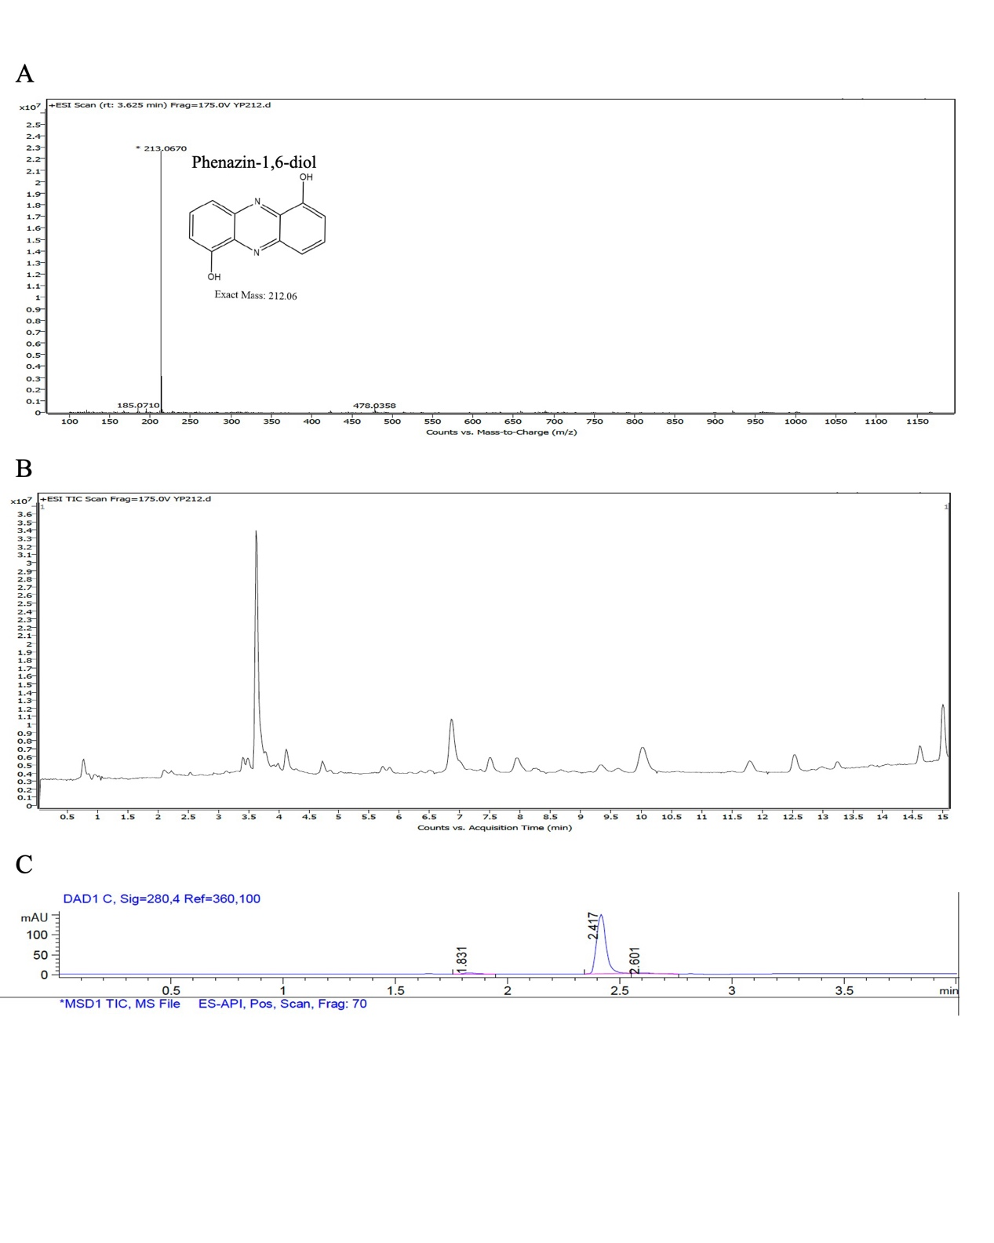

Figure_2. (A) The cytotoxic effect of Phenazine-1,6-diol on normal lung cell lines was determined by MTT assay. (B-F)The cytotoxic effect of Phenazine-1,6-diol on NSCLC cells by MTT assay.
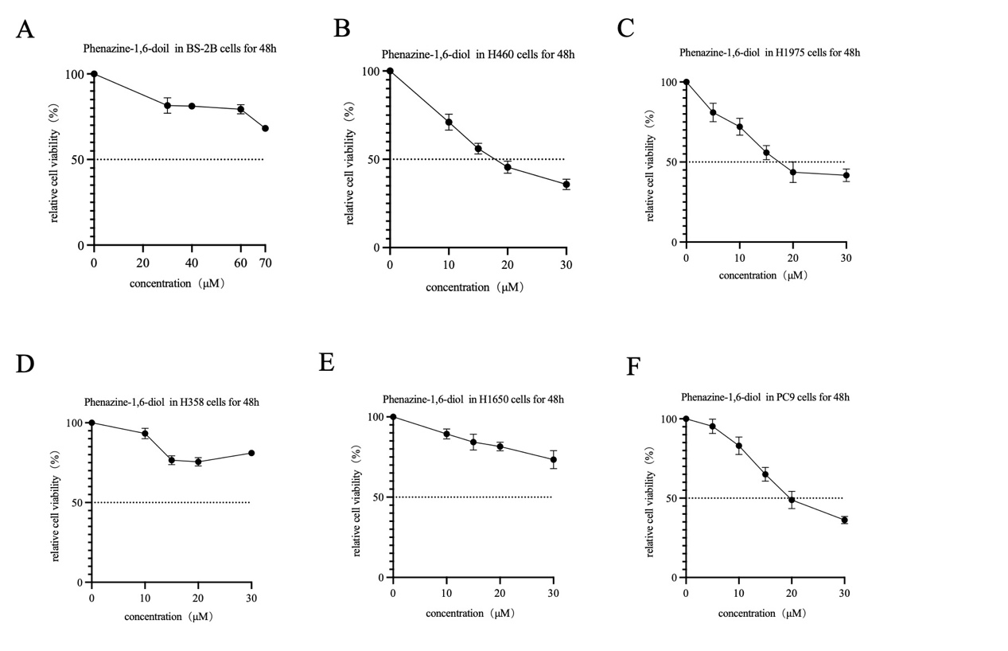

Figure_3. (A-B) Cell colony formation of H460 treated with Phenazine-1,6-diol, and its statistical results. (C)Western blot assay was conducted to determine the effect of 1,6-dihydroxyphenazine on cell cycle markers Cyclin B1 and P21 of H460 after 48h of Phenazine-1,6-diol treatment. （D-F）Phenazine-1,6-diol activated the PI3K/AKT pathway. All data were analyzed as mean ± SD (n=3, *p < 0.05, **p < 0.01, ***p < 0.001).
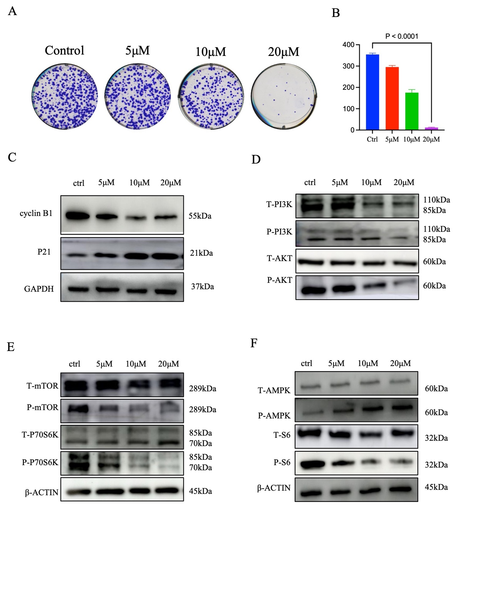

Figure_4. (A) Cleaved PARP, Bcl-2, Bax, cleaved caspase-3, and cleaved caspase-8 protein expression were evaluated by western blotting. (B-C) Flow cytometric analysis of cell apoptosis with different concentrations in 48h of Phenazine-1,6-diol and the apoptosis-positive reference agent sanguinarine. (D) MTT assay showing the viability of H460 cells treated with phenazine-1,6-diol (20 μM) for 48 h, co-cultured with or without the pan-caspase inhibitor Z-VAD-FMK (50 μM). (E) Western blot analysis of PARP and cleaved PARP in H460 cells after 48 h treatment with phenazine-1,6-diol or sanguinarine in the presence or absence of Z-VAD-FMK. GAPDH was used as the loading control. (F) Flow cytometry analysis of apoptosis using Annexin V-FITC/PI staining in H460 cells treated with Phenazine-1,6-diol and the apoptosis positive reference agent sanguinarine for 48 hours. Representative dot plots are shown. (G) Quantification of apoptotic cells from (F). Data are presented as mean ± SD from three independent experiments. All data were analyzed as mean ± SD (n=3, *p < 0.05, **p < 0.01, ***p < 0.001).
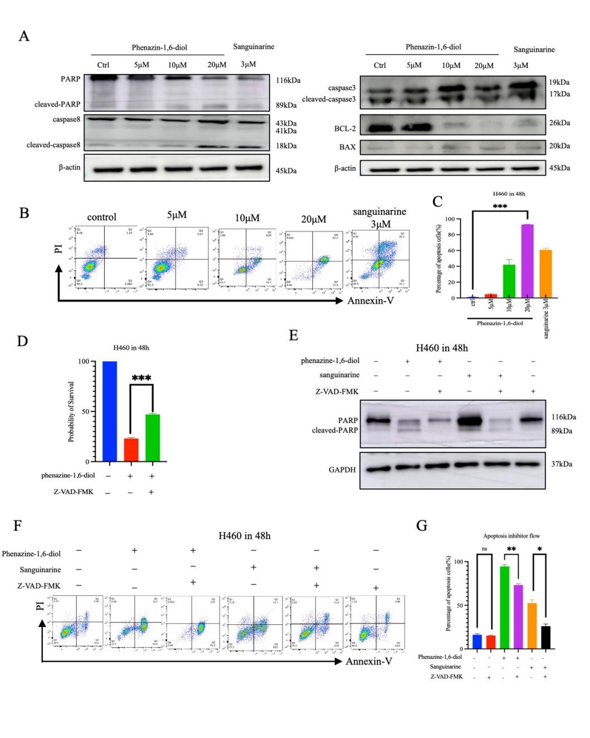

Figure_5. The results of normal H460 cells and DR5-knockout H460 cells after treatment with Phenazine-1,6-diol for 48 hours. (A) The expression of DR5 in H460 cells after phenazine-1,6-diol administration was verified through qPCR assay. (B) The expression of DR5 protein at the protein level in H460 cells after phenazine-1,6-diol administration was demonstrated using the Western blot assay. (C) The MTT assay was used to examine the survival rates of wild-type H460 cells and H460 cells lacking DR5 after treatment with phenazine-1,6-diol for 48 hours. (D) The expression levels of various apoptosis-related proteins in wild-type H460 cells and H460 cells with DR5 knockout were examined using a Western blot assay following 48-hour phenazine-1,6-diol treatment. (E) The apoptosis of wild-type H460 cells and H460 cells with DR5 knockout after phenazine-1,6-diol treatment for 48 hours was examined using flow cytometry. (F) Statistical analysis of DR5 protein expression in wild-type H460 cells and H460 cells with DR5 knockout after phenazine-1,6-diol treatment for 48 hours. (G) Flow cytometry analysis of apoptotic cells in wild-type H460 cells and H460 cells with DR5 knockout after phenazine-1,6-diol treatment for 48 hours. (H) The phenazine-1,6-diol-treated cell nuclei of wild-type H460 cells and H460 cells with DR5 knockout were examined using confocal microscopy after DAPI staining for 48 hours; blue indicates DAPI-stained cell nuclei.

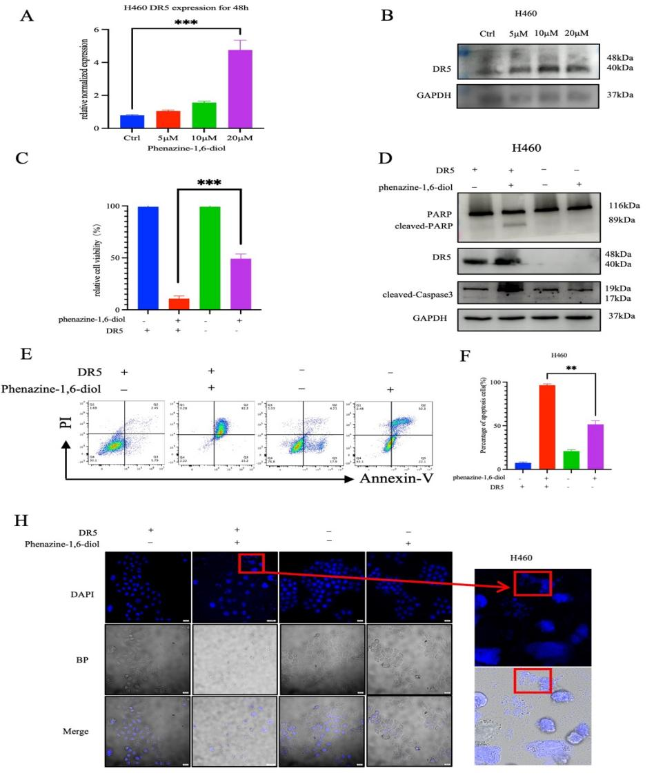

Figure_6. The in vivo animal experimental results of Phenazine-1,6-diol. (A) Schematic illustration of the in vivo experimental design. (B) Tumor growth curves over the 17-day treatment period. Tumor volumes were measured every other day and calculated as (length × width²)/2. (C) Body weight changes during the treatment period. (D) Representative images of excised tumors at the end of treatment. (E) Quantification of tumor weights and volumes at endpoint. (F) Representative images of spleens collected after 17 days of treatment. (G) Spleen weight analysis at endpoint. (H) Kaplan–Meier survival curves for mice in different treatment groups. (I) Representative histological and immunohistochemical images of tumor sections stained with hematoxylin and eosin (H&E), Ki67, and TUNEL. (J) Quantification of Ki67-positive cells (proliferation index) and TUNEL-positive cells (apoptotic index) from (I).
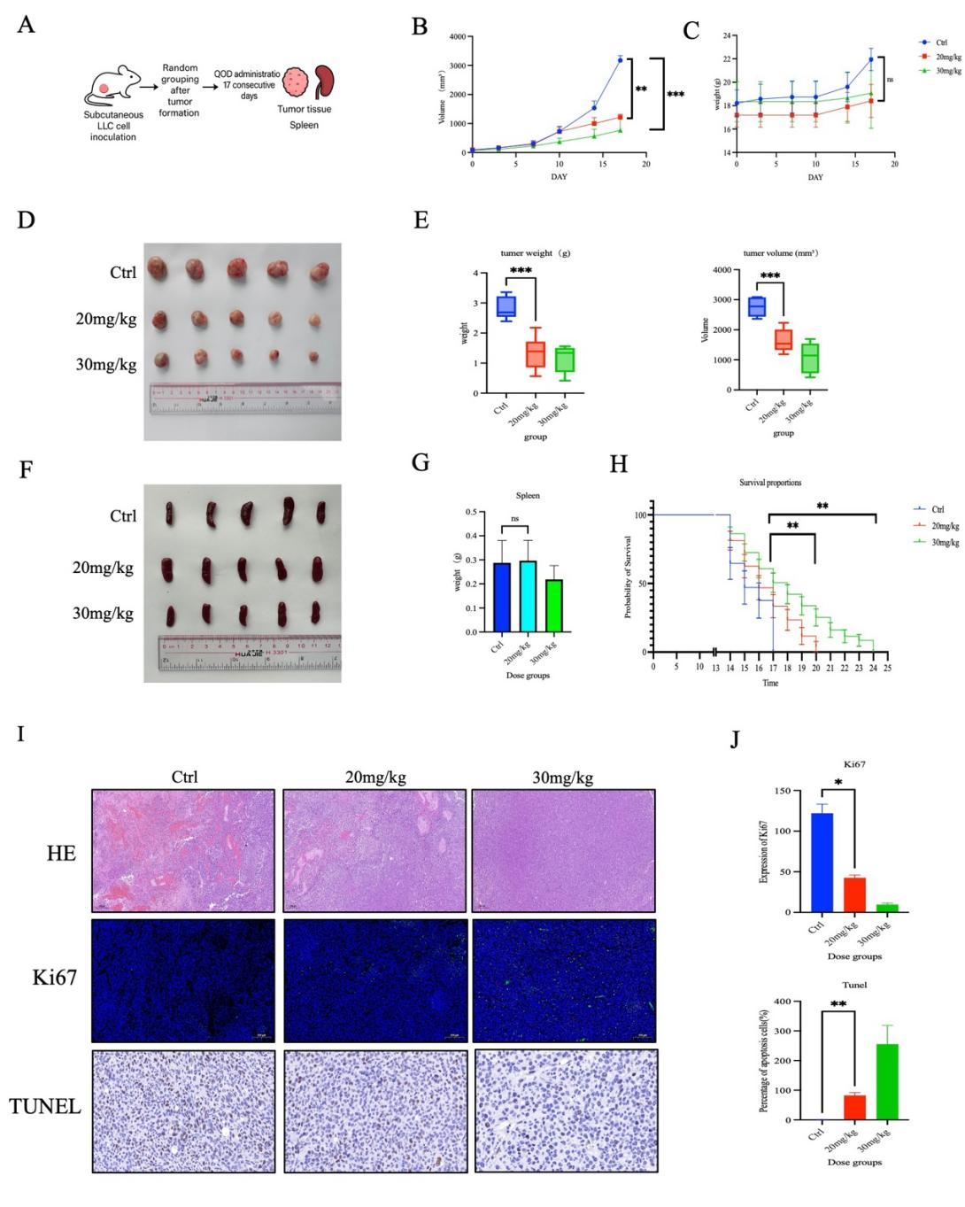

Figure_7：The proposed mechanism of the effect of phenazine–1,6–diol on NSCLC cells.
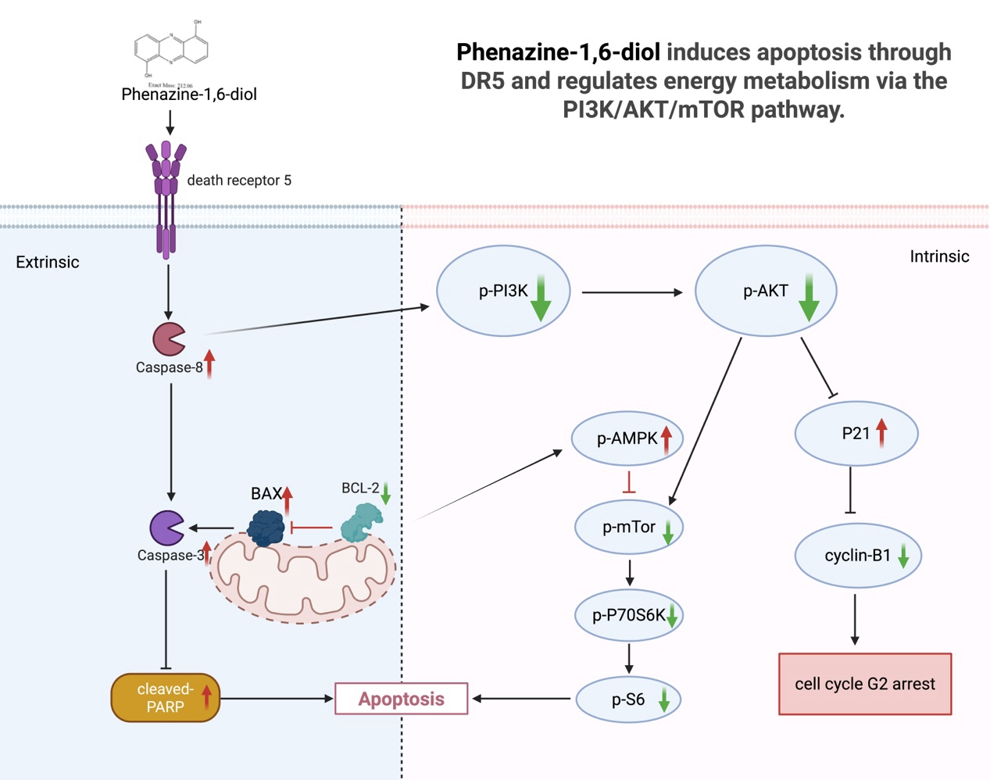

SUPPORTING TABLES
Table_1: The IC₅₀ values of phenazine-1,6-diol on NSCLC cell lines after 48 hours treatment. All data were analyzed as mean ± SD (n=3, *p < 0.05, **p < 0.01, ***p < 0.001, ****p < 0.0001).
Cells | IC₅₀ for 48h（μM）
BEAS-2B | 160.2 ±2.2
H460 | 17.76 ±1.16
H1975 | 20.33 ±2.21
H358 | 58.98 ±1.43
H1650 | 83.79 ±12.2
PC9 | 25.67 ±3.42

