Figure 1. LC₅₀ and LC₉₀ values in 12h and 24h EAECI in Ae. Aegypti larvae

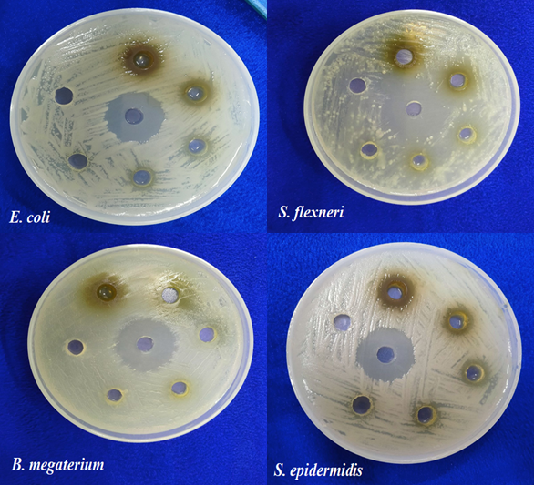
Figure 2. Antibacterial activity of ethyl acetate extract of EAECI against four bacterial strains: E. coli, S. flexneri, B. megaterium and S. epidermidis. Zones of inhibition surrounding the wells indicate varying degrees of antimicrobial effectiveness, suggesting the presence of bioactive compounds in the extract with broad-spectrum antibacterial potential
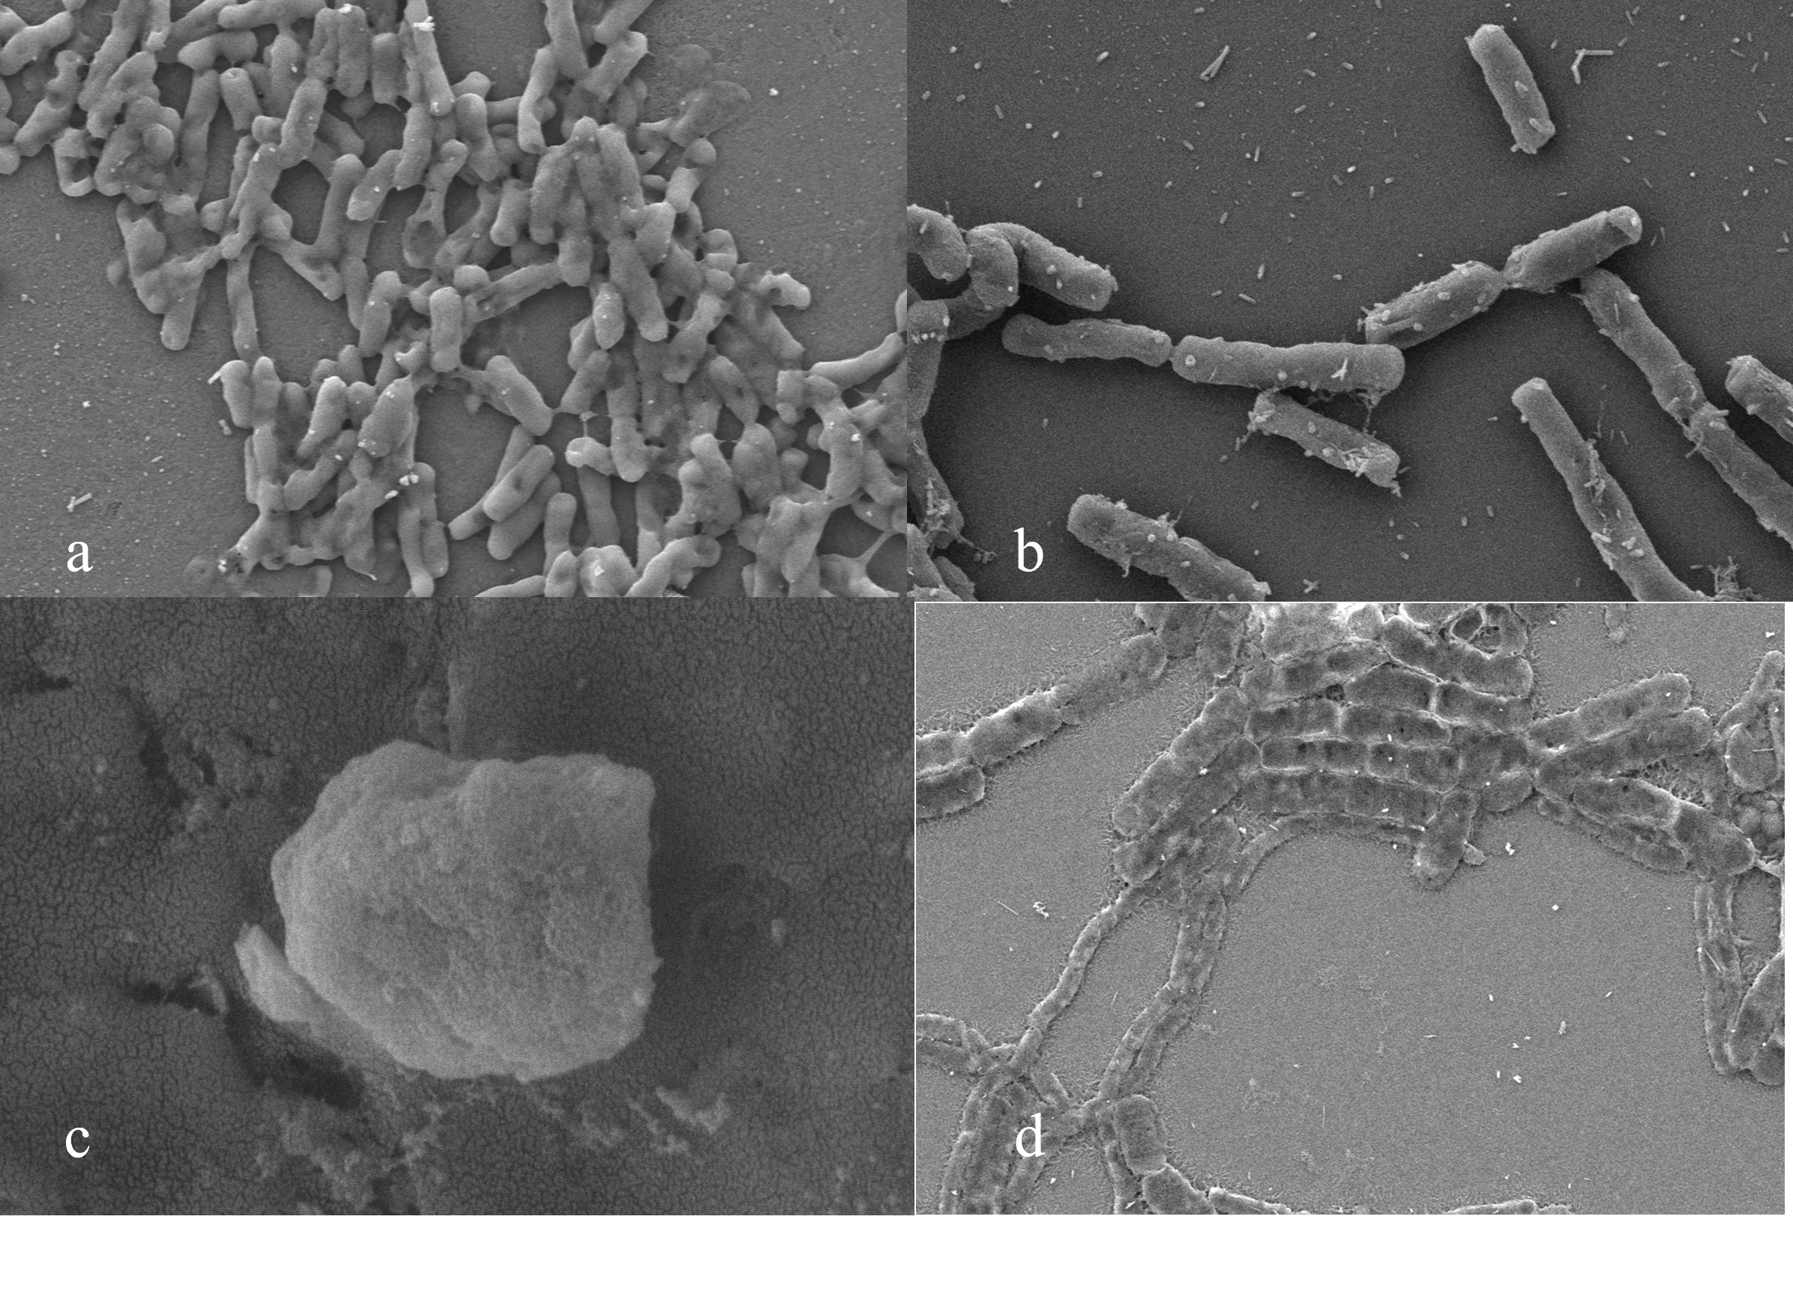
Figure 3. Figure 3. Scanning electron micrographs showing the antibacterial effects of ethyl acetate extract of C. indicum (EAECI) against four bacterial strains: (a) E. coli, (b) S. flexneri, (c) S. epidermidis and (d) B. megaterium. Treated cells exhibit structural alterations such as membrane disintegration, surface roughness, and cellular deformation, indicating bactericidal activity of the extract.

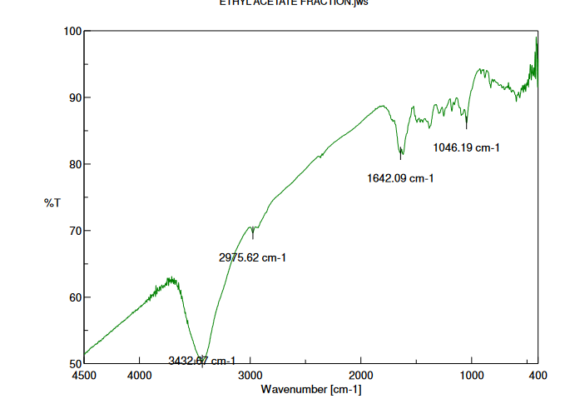
Figure 4. FTIR spectrum of the ethyl acetate extract of EAECI. Prominent absorption bands were observed at 3432.67 cm⁻¹ (O–H stretching of hydroxyl groups), 2975.62 cm⁻¹ (C–H stretching of alkanes), 1642.09 cm⁻¹ (C=C or C=O stretching of aromatic or carbonyl groups), and 1046.19 cm⁻¹ (C–O stretching of alcohols or ethers), indicating the presence of diverse functional groups associated with phytochemicals

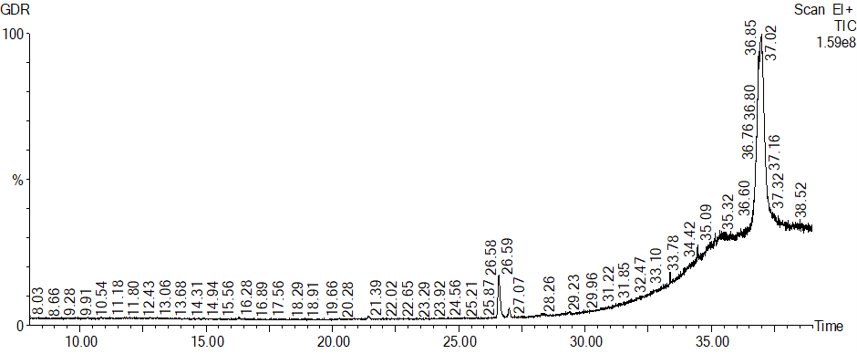
Figure 5. GC-MS chromatogram of EAECI, revealing the presence of phytochemical constituents based on retention time and peak area

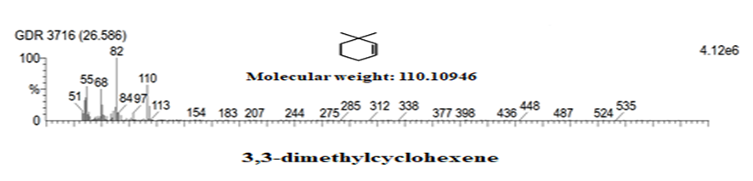
Figure 6. GC-MS identification of 3,3-dimethylcyclohexene from C. indicum ethyl acetate extract. Retention Time (RT): 26.586 min; Molecular Formula: C₈H₁₄; Molecular Weight: 110.11 g/mol; Peak Area: 1.74%
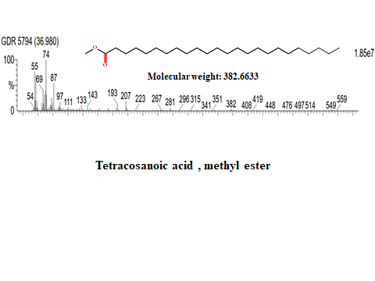
Figure 7. GC-MS identification of tetracosanoic acid, methyl ester from C. indicum ethyl acetate extract. Retention Time (RT): 36.980 min; Molecular Formula: C₂₅H₅₀O₂; Molecular Weight: 382.66 g/mol; Peak Area: 36.173%

