System suitability:
Table S1: System Suitability Parameters
S. No. | System suitability parameter | Result
1 | Theoretical Plates | 3604
2 | Tailing Factor | 1.18
3 | % RSD | 0.10

Table S2: System Suitability Areas
Injection No. | Area (mAU)
1 | 2142870
2 | 2142653
3 | 2142869
4 | 2144817
5 | 2147595
Average | 2144160.68
STDEV | 2111.42
% RSD | 0.10

System Precision
Table S3: System Precision Areas
Injection No. | Area (mAU)
1 | 2142870
2 | 2142653
3 | 2142869
4 | 2144817
5 | 2147595
6 | 2145009
Average | 2144302.14
STDEV | 1920.03
% RSD | 0.09

Specificity:
Table S4: Absolute difference between % Assay during specificity
Name of the sample | Assay (% w/w) of Rotigotine
As such sample | 100.53
Spiked sample | 99.86
Difference | 0.67
The absolute difference between the % Assay in such sample and the spiked sample is less than ±2.0%.
Ruggedness (Intermediate Precision):
Table S5: Details of Variations during Ruggedness
S. No. | Changes | Method Precision | Ruggedness
1 | Triethylamine | Merck (B. No. TF1Q786019) | Merck (B. No. TF1Q786019)
2 | Orthophosphoric Acid | Merck (B. No. CF0C700316) | Merck (B. No. CB0C700056)
3 | Methanol | Rankem (B. No. S176F76) | Merck (B. No. TM1ER24623)
4 | Acetonitrile | Rankem (B. No. TO66G20) | Rankem (B. No. T038F20)
5 | Date | 11 MAR 2024 | 08 APR 2024
6 | Column Details | LCC017/23 | LCC010/23
7 | Instrument Details | HPLC007 | HPLC019

Table S6: System Suitability Parameters during Ruggedness
S. No. | System suitability parameter | Result
1 | Theoretical Plates | 3812
2 | Tailing Factor | 1.21
3 | % RSD | 0.12

Table S7: System Suitability Areas for Ruggedness
Injection No. | Area (mAU)
1 | 2132857
2 | 2134772
3 | 2130727
4 | 2134796
5 | 2137561
Average | 2134142.51
STDEV | 2540.94
% RSD | 0.12

Table S8: Results of Method Precision & Intermediate Precision
Injection No. | Assay (%w/w) in  Method Precision | Assay (%w/w) in  Intermediate Precision
1 | 99.86 | 99.54
2 | 100.27 | 99.34
3 | 99.67 | 99.66
4 | 100.07 | 99.75
5 | 100.20 | 99.35
6 | 99.72 | 100.02
Average | 99.97 | 99.61
STDEV | 0.25 | 0.26
%RSD | 0.25 | 0.26
Overall Average | 99.79
Overall SD | 0.31
Overall RSD | 0.31

Linearity:
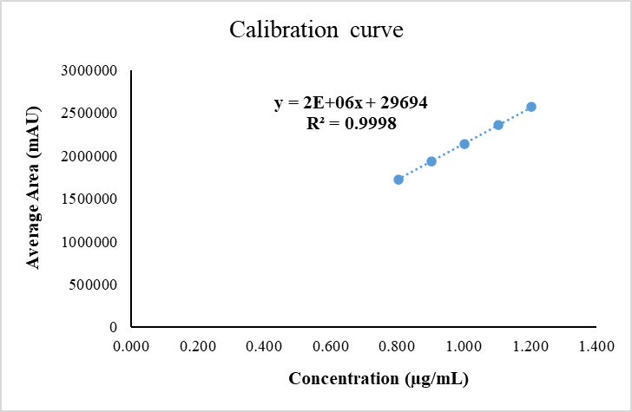
Figure S1: Calibration curve of Rotigotine
Robustness:
Table S9: Parameters varied during Robustness
Parameter | Actual | Low | High
Column Temperature | 40°C | 38°C | 42°C
Flow rate | 1.0 mL/min | 0.9 mL/min | 1.1 mL/min

Table S10: System Suitability Parameters observed during variation in column oven temp.
S. No | System Suitability Parameters | Actual Column Temperature (40°C) | Low Column Temperature (38°C) | High Column Temperature (42°C)
1 | Theoretical Plates | 3812 | 4529 | 2984
2 | Tailing Factor | 1.21 | 1.26 | 1.23
3 | %RSD | 0.12 | 0.11 | 0.19

Table S11: System Suitability Parameters observed during variation in Flow Rate
S. No | System Suitability Parameters | Actual Flow Rate  (0.8 mL/min) | Low Flow Rate  (0.7 mL/min) | High Flow Rate  (0.9 mL/min)
1 | Theoretical Plates | 3812 | 4312 | 2874
2 | Tailing Factor | 1.21 | 1.30 | 1.24
3 | %RSD | 0.12 | 0.13 | 0.16

Bench Top Solution Stability of Standard and Sample Solutions:
Table S12: Summary Results for solution stability study of standard solution and sample solution for Rotigotine
Time Interval | Similarity Factor for Standard | Sample Assay (%w/w) | Difference in %Assay of Sample
Initial | Not applicable | 99.50 | Not applicable
48 hours at RT | 1.00 | 98.99 | 0.51

Bench Top Stability of Mobile Phase:
Table S13: Summary Results for Mobile phase Stability Study
System suitability parameter | Result
Theoretical plates | 3931
Tailing factor | 1.14
% Relative standard deviation (RSD) | 0.12

Filter Validation:
Table S14: Filter Details
Filter description | Filter
Filter description | Nylon | PVDF
Manufacturer Name | mdi Membrane Technologies | mdi Membrane Technologies
Lot Number | SN7353G | SV2462L
Size in µm | 0.45 µm | 0.45 µm

Table S15: Assay Results for Filter Validation
Filter details | % Assay | Absolute difference
Centrifuged | 99.50 | Not Applicable
Nylon filter | 99.72 | 0.22
PVDF filter | 99.62 | 0.12

