Supplementary Table 1 Mean contents (mg/g) of Cucurbitacin-B (CCR), Charantin (CHR) and Plant Insulin (PLIN) in lyophilised powder of fresh fruits and mean fresh fruit weight (FR WT) over three replications among 25 bitter gourd varieties in an enhanced germplasm.

Genotype |  | Origin |  | CCR |  | Rank |  | CHR |  | Rank |  | PLIN |  | Rank |  | FR WT |  | Rank
M.c. var. muricara
CBM3 |  | USA |  | 0.360 |  | cdefg |  | 7.470 |  | abc |  | 0.260 |  | bc |  | 41.67 |  | e
CBM6 |  | USA |  | 0.420 |  | bcde |  | 6.455 |  | cdef |  | 0.185 |  | de |  | 33.13 |  | ef
CBM10 |  | USA |  | 0.645 |  | a |  | 7.580 |  | abc |  | 0.190 |  | de |  | 4.90 |  | h
CBM12 |  | USA |  | 0.435 |  | bcd |  | 7.880 |  | ab |  | 0.260 |  | bc |  | 3.84 |  | h
CBM13 |  | USA |  | 0.500 |  | b |  | 6.590 |  | bcdef |  | 0.210 |  | cd |  | 30.20 |  | ef
CBM18 |  | USA |  | 0.465 |  | bc |  | 7.305 |  | abcd |  | 0.205 |  | cd |  | 5.89 |  | h
CBMH10* |  | USA |  | 0.615 |  | a |  | 8.000 |  | a |  | 0.400 |  | a |  | 64.47 |  | d
CBMH12* |  | USA |  | 0.365 |  | cdefg |  | 7.600 |  | abc |  | 0.300 |  | b |  | 74.36 |  | bcd
Hybrid India Star |  | India |  | 0.150 |  | ijk |  | 4.200 |  | g |  | 0.110 |  | f |  | 74.83 |  | bcd
Hybrid India Baby |  | India |  | 0.400 |  | bcdef |  | 7.100 |  | abcde |  | 0.160 |  | def |  | 4.28 |  | h
Hybrid India Pearl |  | India |  | 0.210 |  | hijk |  | 6.950 |  | abcde |  | 0.160 |  | def |  | 72.26 |  | bcd
India Long Green |  | India |  | 0.330 |  | defgh |  | 6.420 |  | cdef |  | 0.140 |  | ef |  | 22.64 |  | fg
Hybrid India Green Queen |  | India |  | 0.300 |  | efgh |  | 7.435 |  | abc |  | 0.140 |  | ef |  | 25.29 |  | fg
Japan Green Spindle |  | Japan |  | 0.350 |  | cdefg |  | 6.950 |  | abcde |  | 0.140 |  | ef |  | 16.10 |  | gh
Japan Long |  | Japan |  | 0.240 |  | ghijk |  | 7.270 |  | abcd |  | 0.170 |  | def |  | 78.69 |  | bc
Small Baby |  | Thailand |  | 0.410 |  | bcdef |  | 6.420 |  | cdef |  | 0.130 |  | ef |  | 3.48 |  | h
Hybrid Baby Doll |  | Thailand |  | 0.290 |  | fgh |  | 5.370 |  | f |  | 0.130 |  | ef |  | 5.10 |  | h
M.c. var. charanria
Hybrid Beauty Winner |  | China |  | 0.150 |  | ijk |  | 7.480 |  | abc |  | 0.120 |  | f |  | 74.81 |  | bcd
Large Top |  | China |  | 0.270 |  | ghi |  | 7.160 |  | abcde |  | 0.130 |  | ef |  | 83.87 |  | b
Hong Kong Green |  | Hong Kong |  | 0.150 |  | ijk |  | 7.120 |  | abcde |  | 0.115 |  | f |  | 70.61 |  | cd
Hybrid Jumbo |  | Thailand |  | 0.260 |  | ghij |  | 7.460 |  | abc |  | 0.130 |  | ef |  | 70.87 |  | cd
Hybrid Bangkok Large |  | Thailand |  | 0.150 |  | ijk |  | 7.260 |  | abcd |  | 0.110 |  | f |  | 78.50 |  | bc
Hybrid White Pearl |  | Taiwan |  | 0.120 |  | k |  | 7.440 |  | abc |  | 0.170 |  | def |  | 82.37 |  | bc
Hybrid Taiwan White | Taiwan |  | 0.140 |  | jk |  | 5.850 |  | ef |  | 0.110 |  | f |  | 63.600 |  | d
Taiwan White | Taiwan |  | 0.130 |  | k |  | 5.985 |  | def |  | 0.115 |  | f |  | 146.33 |  | a
F-Value |  |  | 15.21 |  |  |  | 4.82 |  |  |  | 15.76
p-value |  |  | 1.15e-09 *** |  |  |  | 0.000107 *** |  |  |  | 7.72e-10 ***
SE(m) |  |  | 0.038 |  |  |  | 0.389 |  |  |  | 0.018
CV% |  |  | 17.27 |  |  |  | 7.98 |  |  |  | 14.56
*M.c. charantia × M.c. muricata hybrids (see methods for details)

Supplementary Table 2 Correlation of contents of Cucurbitacin-B (CCR-B), Charantin (CHR) and Plant Insulin (PLIN) inter se and with Fruit Weight (Fr Wt) among 25 bitter gourd varieties in an enhanced germplasm.
 |  | CCR-B | CHR | PLIN | Fr Wt
CCR-B | Pearson Correlation | 1 | .362 | .672** | -.650**
CCR-B | Sig. (2-tailed) |  | .076 | .000 | .000
CCR-B | N | 25 | 25 | 25 | 25
CHR | Pearson Correlation | .362 | 1 | .518** | -.083
CHR | Sig. (2-tailed) | .076 |  | .008 | .695
CHR | N | 25 | 25 | 25 | 25
PLIN | Pearson Correlation | .672** | .518** | 1 | -.150
PLIN | Sig. (2-tailed) | .000 | .008 |  | .473
PLIN | N | 25 | 25 | 25 | 25
Fr Wt | Pearson Correlation | -.650** | -.083 | -.150 | 1
Fr Wt | Sig. (2-tailed) | .000 | .695 | .473
Fr Wt | N | 25 | 25 | 25 | 25
**. Correlation is significant at the 0.01 level (2-tailed).

Supplementary Figure 1
1(a) The parent varieties, CBM10 and Taiwan White, and their hybrid CBMH10

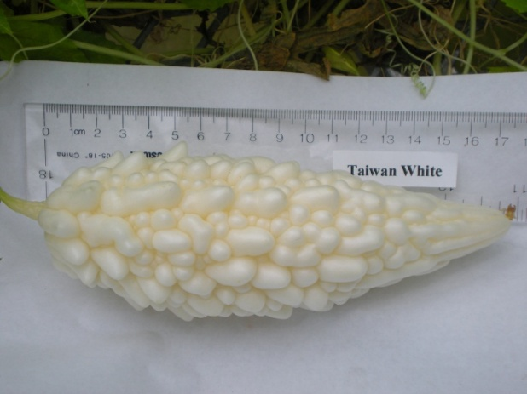
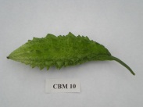
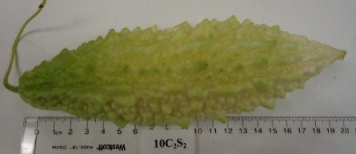

1(b) The parent varieties, CBM12 and Taiwan White, and their hybrid CBMH12

