Supplementary Information for
Divergent nutrient strategies mediate plant diversity responses to key functional group loss in desert steppes
Supplementary Materials and methods: Vegetation composition baseline condition
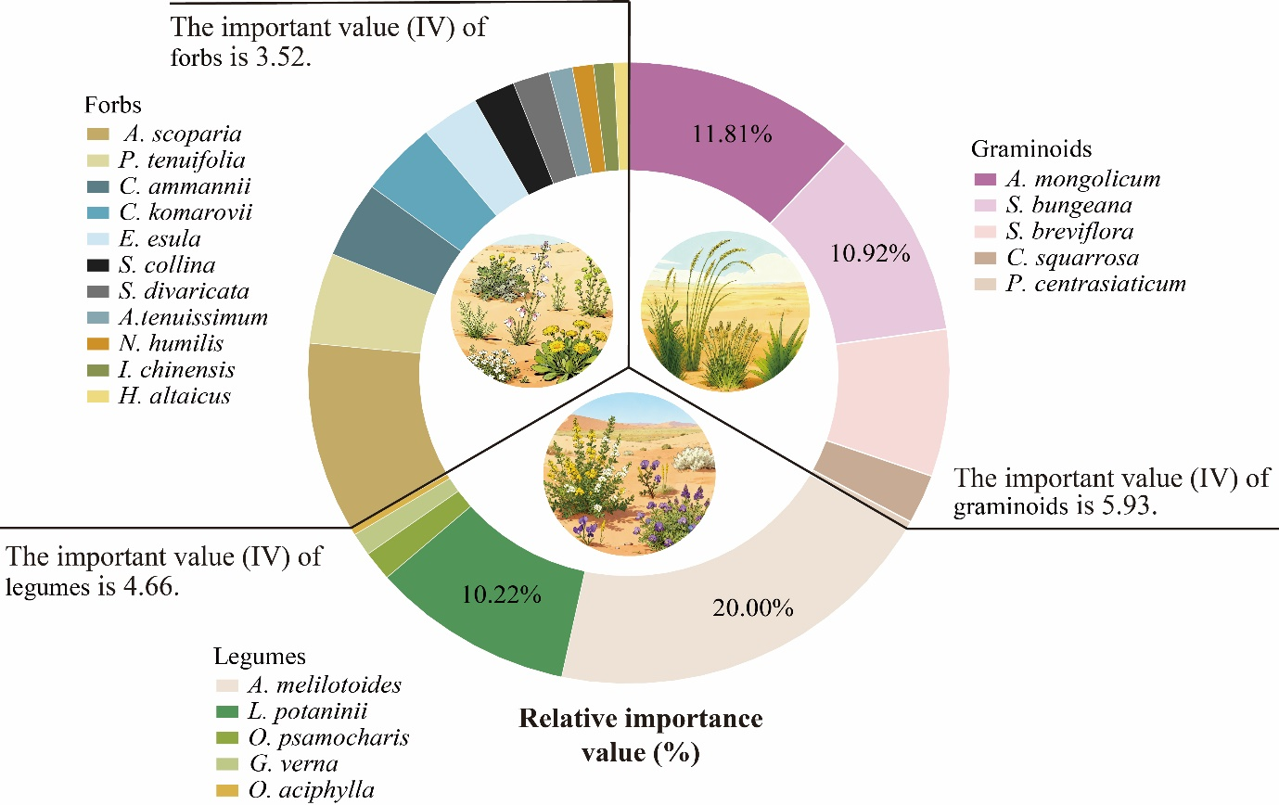
Graminoids and legumes constitute the key functional groups of plant communities in the desert steppe experimental plots.
Figure S1 Species composition, relative importance values, and functional group importance values in desert steppe plant communities. Importance values (IV) for each species were computed as IV = (relative density + relative coverage + relative frequency + relative height + relative biomass)/5. The classic formula for calculating plant community IV, proposed by Curtis and McIntosh (1951), is derived by averaging relative density, relative frequency, and relative coverage. For desert steppes with sparse vegetation, however, we adjusted this formula by adding plant height and biomass as parameters to calculate IV based on actual plant growth (Lv et al., 2021).
Supplementary References
Curtis, J. T., Mcintosh, R.P. (1951). An upland forest continuum in the Prairie-Forest Border Region of Wisconsin. Ecology, 32 (3).
Lv, G. Y., Wang, Z., Guo, N., Xu, X. B., Liu, P., Wang, C. (2021). Status of Stipa breviflora as the constructive species will be lost under climate change in the temperate desert steppe in the future. Ecological Indicators, 126.

