Appendix 1. Consolidated Health Economic Evaluation Reporting Standards (CHEERS) statement
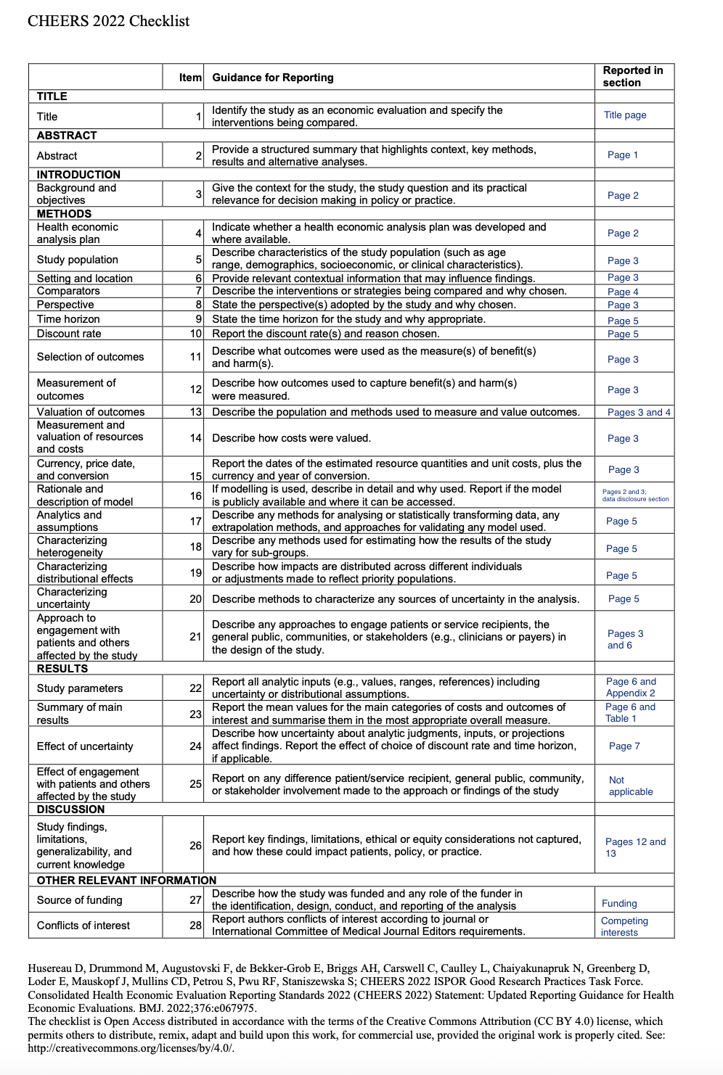

Appendix 2. MEDLINE search from inception up to March 15, 2025
1 | exp Brain Hemorrhage, Traumatic/ or exp Brain Injuries, Traumatic/ or exp Intracranial Hemorrhage, Traumatic/ | 42308
2 | Brain concussion/ or contrecoup injury/ or post-concussion syndrome/ or head injuries, penetrating/ or intracranial hemorrhage, traumatic/ or brain hemorrhage, traumatic/ or brain stem hemorrhage, traumatic/ or cerebral hemorrhage, traumatic/ or hematoma, epidural, cranial/ or hematoma, subdural/ or hematoma, subdural, acute/ or hematoma, subdural, chronic/ or hematoma, subdural, intracranial/ or subarachnoid hemorrhage, traumatic/ or skull fractures/ or skull fracture, basilar/ or skull fracture, depressed/ [****MeSH terms****] | 38796
3 | (trauma* adj (Head or brain or "intra-cranial*" or "intra cranial*" or intracranial* or "extra dural*" or "extra-dural*" or extradural* or "epi-dural*" or "epi dural*" or epidural* or "sub-dural*" or subdural* or "sub-arachnoid*" or "sub arachnoid*" or subarachnoid* or "diffuse axonal") adj2 (injur* or damage* or trauma*)).ti,ab,kf. | 59698
4 | (tbi* or dai*).ti,ab,kf. | 819494
5 | or/1-4 [****TBI terms****] | 879788
6 | exp "Aged, 80 and over"/ or exp Aged/ | 3659500
7 | exp Aging/ or exp Cognitive Aging/ | 307118
8 | exp Geriatrics/ | 32105
9 | (geriatric* or elder* or older* or ageing or aging or senior* or older adult* or retired or retiree* or elder* or pensioner* or nursing home* or older people or older patient* or gerontology or Sexagenarian* or septuagenarian* or octogenarian or nonagenarian* or centenarian* or sixties or seventies or eighties or nineties).kf,tw. | 1256871
10 | 6 or 7 or 8 or 9 [****Age restriction to older adults****] | 4440200
11 | limit 5 to "all aged (65 and over)" or (5 and 10) | 191313
12 | exp delirium/ or exp dementia/ or exp cognition disorders/ | 321111
13 | cognition/ or awareness/ or cognitive dissonance/ or cognitive reserve/ or comprehension/ or consciousness/ or metacognition/ or rumination, cognitive/ or executive function/ or higher nervous activity/ or intention/ or learning/ or association/ or association learning/ or avoidance learning/ or memory/ or deja vu/ or memory, episodic/ or memory, long-term/ or memory consolidation/ or memory, short-term/ or mental recall/ or recognition, psychology/ or repetition priming/ or retention, psychology/ or spatial memory/ or neurolinguistic programming/ or probability learning/ or problem-based learning/ or problem solving/ or heuristics/ or spatial learning/ or maze learning/ or elevated plus maze test/ or morris water maze test/ or open field test/ or verbal learning/ or paired-associate learning/ or serial learning/ or thinking/ or concept formation/ or creativity/ or decision making/ or consensus/ or judgment/ or neurocognitive disorders/ or amnesia/ or amnesia, anterograde/ or amnesia, retrograde/ or amnesia, transient global/ or cognition disorders/ or cognitive dysfunction/ or postoperative cognitive complications/ or delirium/ or emergence delirium/ or dementia/ or alzheimer disease/ or dementia, vascular/ or dementia, multi-infarct/ or diffuse neurofibrillary tangles with calcification/ or frontotemporal lobar degeneration/ or frontotemporal dementia/ or lewy body disease/ | 910242
14 | 12 or 13 | 934688
15 | 11 and 14 [****Age and cog impairment****] | 15716
16 | exp Rehabilitation/ | 375931
17 | cognitive behavioral therapy/ or "acceptance and commitment therapy"/ or cognitive restructuring/ or mindfulness/ | 40528
18 | cognitive behavioral therapy/ or "acceptance and commitment therapy"/ or cognitive restructuring/ or mindfulness/ | 40528
19 | (compensatory adj2 (skill* or strateg*) adj2 (train* or educat* or learn* or therap*)).ti,ab,kf. | 103
20 | (metacognitive adj2 (skill* or strateg*) adj2 (train* or educat* or learn* or therap*)).ti,ab,kf. | 101
21 | ("Attention process train*" or "memory train*" or "problem-solving train*" or "problem solving train*" or "goal management train*" or "language train*" or "communication train*" or "computer assisted train*" or "Lee Silverman voice treatment" or "vision restoration therap*" or "family therap*" or "noninvasive brain stimulation" or "neuropsychological rehab*").tw,kf. | 10433
22 | 16 or 17 or 18 or 19 or 20 or 21 [****Cog interventions****] | 422116
23 | 15 and 22 [****Age + cog impairment + cog interventions****] | 5874
24 | th.fs. [****MeSH term for therapy****] | 2256466
25 | 15 and 24 | 1718
26 | 23 or 25 [****2 ways to capture cog interventions****] | 6802
27 | (randomized controlled trial or controlled clinical trial).pt. or (randomized or placebo or randomly).ab. or clinical trials as topic/ or trial.ti. | 1673637
28 | (26 and 27) not (exp animals/ not humans.sh.) | 1330
29 | Epidemiologic Studies/ | 9675
30 | exp Case Control Studies/ | 1585585
31 | exp Cohort Studies/ | 2719874
32 | Cross Sectional Studies/ | 535817
33 | (epidemiologic adj (study or studies)).ab,ti. | 30119
34 | case control.ab,ti. | 170620
35 | (cohort adj (study or studies)).ab,ti. | 391369
36 | cross sectional.ab,ti. | 617646
37 | cohort analy$.ab,ti. | 14631
38 | (follow up adj (study or studies)).ab,ti. | 60098
39 | longitudinal.ab,ti. | 371727
40 | retrospective$.ab,ti. | 1206333
41 | prospective$.ab,ti. | 970366
42 | (observ$ adj3 (study or studies)).ab,ti. | 334824
43 | adverse effect?.ab,ti. | 221351
44 | 29 or 30 or 31 or 32 or 33 or 34 or 35 or 36 or 37 or 38 or 39 or 40 or 41 or 42 or 43 [****Types of studies to be included****] | 4826308
45 | medline.ti. | 1059
46 | embase.ti. | 126
47 | pubmed.ti. | 1025
48 | (database? and searching).ti. | 403
49 | *MEDLINE/ | 1223
50 | *PubMed/ | 748
51 | *Databases, Bibliographic/ | 1824
52 | 45 or 46 or 47 or 48 or 49 or 50 or 51 [****Databases to search****] | 4862
53 | 44 and 52 [****Types of studies included + databases to search****] | 289
54 | ((identify$ or develop$ or design$ or test$ or assess$ or evaluat$ or robust$ or optim$ or effic$ or effect$ or sensitiv$ or simpl$ or specific$ or precis$) adj3 ("search strat$" or "search filter?")).ab,ti. | 4142
55 | 44 and 54 | 797
56 | 53 or 55 | 1050
57 | 26 and 56 | 0
58 | 28 or 57 | 1330

Appendix 3. Risk of bias assessment of studies that populated model inputs
Parameter study source | Study design | Risk of bias assessment tool | Overall risk of bias | Notes
Baseline characteristics
Jain et al., 2023¹ | Narrative review | SANRA | Sumscore of 6 out 10 (acceptable) | No subgroup of older adults but reviewed Glasgow Coma Scale scores and its association with definition of TBI severity in the general population
Probabilities
McIntyre, 2012²: | Systematic review and meta-analysis | AMSTAR 2 | Critically low | Systematic review and meta-analysis; Older adults were defined as ≥60 years
Zhang, 2021³: | Secondary analysis of a longitudinal cohort study | ROBINS-E | Serious risk of bias | Secondary analysis of a longitudinal cohort study; 6,078 Participants with Mean Age of 77.5, MCI was diagnosed via cognitive tests, self-report or report by proxy respondent of diagnosis; Given potential confounding (no adjustment for comorbidities) and selection bias (excluded participants with fewer than two valid cognitive assessments)
Andersen, 2010⁴: | Retrospective cohort study | ROBINS-E | Moderate risk of bias | Retrospective cohort study; Mean age of participants was 77.1, only diagnosis of dementia (no TBI patients); Potential confounding and selection bias (64% participation)
Akhanemhe, 2024⁵ | Cross-sectional study | ROBINS-E | Moderate risk of bias | Cross-sectional study; Participants were made of 12,389 (7372 had TBI) non veterans and 701 veterans (490 had TBI), 43-56.8% were ≥65 years old; missing data
Ismail et al., 2022⁶ | Retrospective cohort study | ROBINS-E | Serious risk of bias | Retrospective cohort study; Mean age of 74-76.5 depending on the subgroup (MBI, NPS + or NPS -), no TBI patients
LoBue, 2018⁷ | Retrospective cohort study | ROBINS-E | Serious risk of bias | Retrospective cohort study; 2,719 participants diagnosed with MCI, 248 reported a history of TBI, mean age of 71.7
Monfared, 2022⁸ | Narrative review | SANRA | Sumscore 7/10 | Narrative review; Older adults (age ≥60 years); no TBI; Older adults
Costs
Chen, 2012⁹ | Retrospective cohort study | ROBINS-I | Moderate risk of bias | Limitations in confounding adjustment, use of administrative codes to classify TBI and diluted cost estimates (unclear per-user cost)
Kim, 2021¹⁰ | Randomized controlled trial | RoB 2 | High risk of bias | Included all ABI patients (not just TBI, also stroke patients); only 3/32 were TBI patients; Lack of a pre-registered protocol, unclear adherence monitoring, and possible therapist interaction bias
Leibson, 2015¹¹ | Cross-sectional study | ROBINS-E | Moderate risk of bias | Restricted to Olmsted County; participation bias (not all participants wanted to participate those who are older, more likely to be male and more likely to have comorbidities)
Utilities
Fuller, 2017¹² | Systematic review and mapping study | ROBIS | High risk of bias | High risk primary studies, lack of sensitivity analyses or alternative data sources, 27% of missing data on EQ-5D at 12 months
Ghani, 2022¹³ | Economic evaluation | ROBVALU | Serious risk of bias | Short follow-up of 6 months, which is likely insufficient to capture meaningful cognitive or functional decline
Pizzo, 2021¹⁴ | Economic evaluation | ROBVALU | Very serious risk of bias | Lack of standardized or validated outcome descriptions across studies; Unclear administration of preference elicitation tools; Missing details on participant understanding; Inadequate reporting of attrition and non-response
El Alili, 2020¹⁵ | Economic evaluation | ROBVALU | Very serious risk of bias | Use of proxies to estimate quality of life; During follow-up, 60 (52%) participants in the intervention group (n = 116) and 63 (55%) participants in the usual care group (n = 115) had incomplete quality of life adjusted data
Intervention efficacy
Cisneros, 2021¹⁶ | Semi-randomized pre-post study | RoB 2 | High concerns of bias | Pre-post study, no allocation concealment, no random allocation; Performance bias in the intervention group (neuropsychologists-led); Older adults were defined as those >55 years of age
Howrey, 2017¹⁷ | Prospective cohort study | ROBINS-I | Critical risk of bias | Only 16,583 out of 199,928 included in the final analyses; Potential factors that are unmeasured: social support, differences in physical environment
Frankel, 2006¹⁸ | Retrospective cohort study | ROBINS-I | Serious risk of bias | No statistical adjustment for covariates such as comorbidities, frailty, premorbid cognition, or socioeconomic status; Only 9 out of 3054 patients had TBI
ROBINS-E: Risk Of Bias In Non-randomized Studies - of Exposure; SANRA: Scale for the Assessment of Narrative Review Articles; RoB 2: Revised Cochrane risk-of-bias tool for randomized trials (RoB 2); ROBIS: Risk of Bias Assessment Tool for Systematic Reviews; ROBVALU: Risk of Bias in studies of Values and Utilities

Appendix 4. Reference costs and inflation adjustments applied in the model
Costs type | Reference cost and context | Inflation to 2024 CAD costs | Standard deviation (SD) | References
Cost of physical rehabilitation | Not applicable (no need for inflation) | $211.50 | $822.5 | Chen, 2012⁹, Thompson, 2012¹⁹ and Government of Canada²⁰
Cost of cognitive training | Not applicable (no need for inflation) | $281.25 | $56.25 | Kim, 2021¹⁰ and Government of Canada²¹
Cost of combination therapy (physical rehabilitation + cognitive training) | Not applicable (no need for inflation) | $492.75 | $98.55 | Addition of costs of physical rehabilitation and cognitive training and assuming a SD of 20%
Cost of cognitive states
Cost of well | $6,042  USD, 2010 | $11,287 | $7,205 | Leibson, 2015¹¹
Cost of mild cognitive impairment | $6,784  USD, 2010 | $12,675 | $8,345 | Leibson, 2015¹¹
Cost of mild dementia | $9,431  USD, 2010 | $17,616 | $11,647 | Leibson, 2015¹¹
Cost of advanced dementia | $11,678  USD, 2010 | $21,818 | $14,291 | Leibson, 2015¹¹

Appendix 5. Sample size
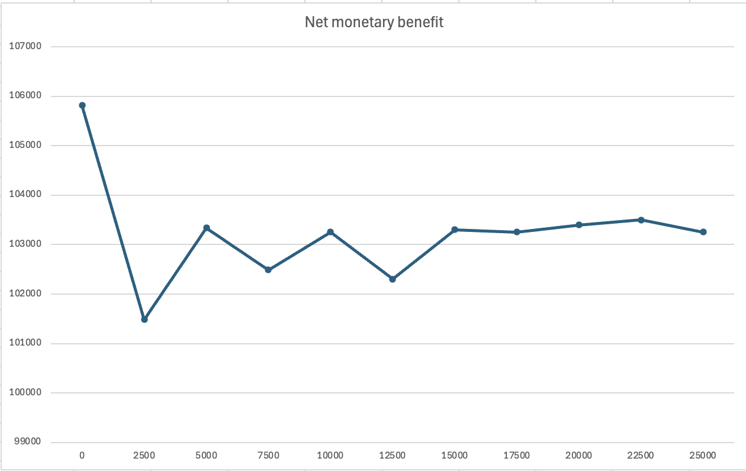  Number of first order iterations (trials) | 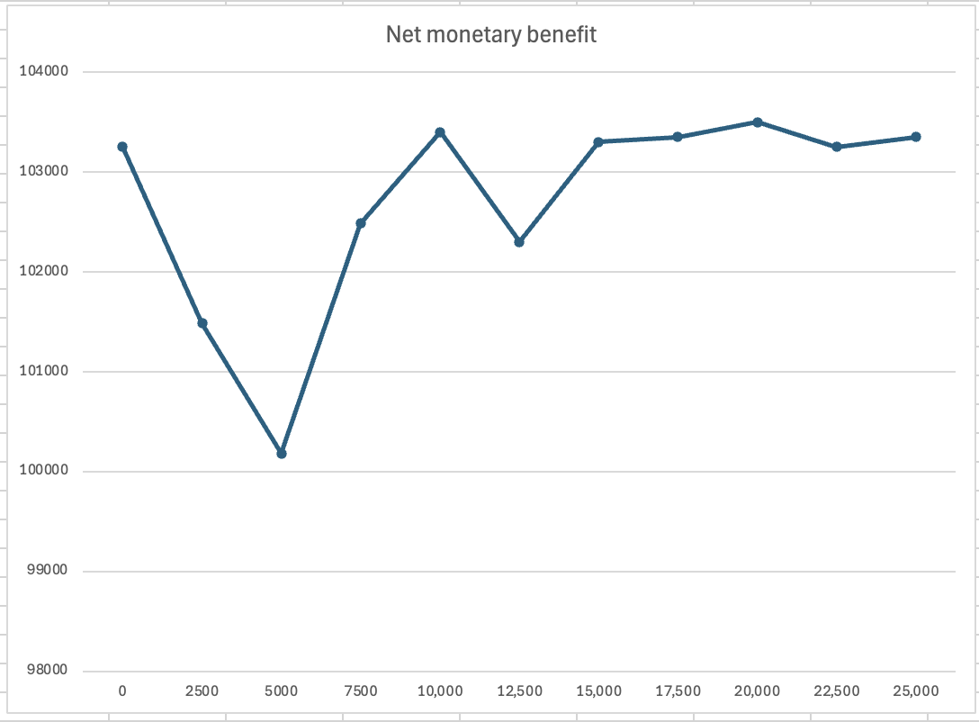  Number of second order iterations (samples)
The number of first- and second-order iterations for the model analysis were determined according to the stability of average NMB estimates by running samples of different first- and second-order iterations while holding the other constant.

Appendix 6. Expected value of perfect information (EVPI) across cost-effectiveness thresholds (λ) expressed in cost per quality adjusted life year (QALY).
Cost-effectiveness threshold (C$/QALY) | EVPI (C$ per person)
0.00 | 0.9
2500.00 | 9.2
5000.00 | 194.4
7500.00 | 838.5
10000.00 | 2106.6
12500.00 | 4050.5
15000.00 | 6675.4
17500.00 | 9261.3
20000.00 | 8520.1
22500.00 | 6761.3
25000.00 | 5358.7
27500.00 | 4255.6
30000.00 | 3394.2
32500.00 | 2711.7
35000.00 | 2185.9
37500.00 | 1773.8
40000.00 | 1462.6
42500.00 | 1225.9
45000.00 | 1049.4
47500.00 | 923.7
50000.00 | 833.2

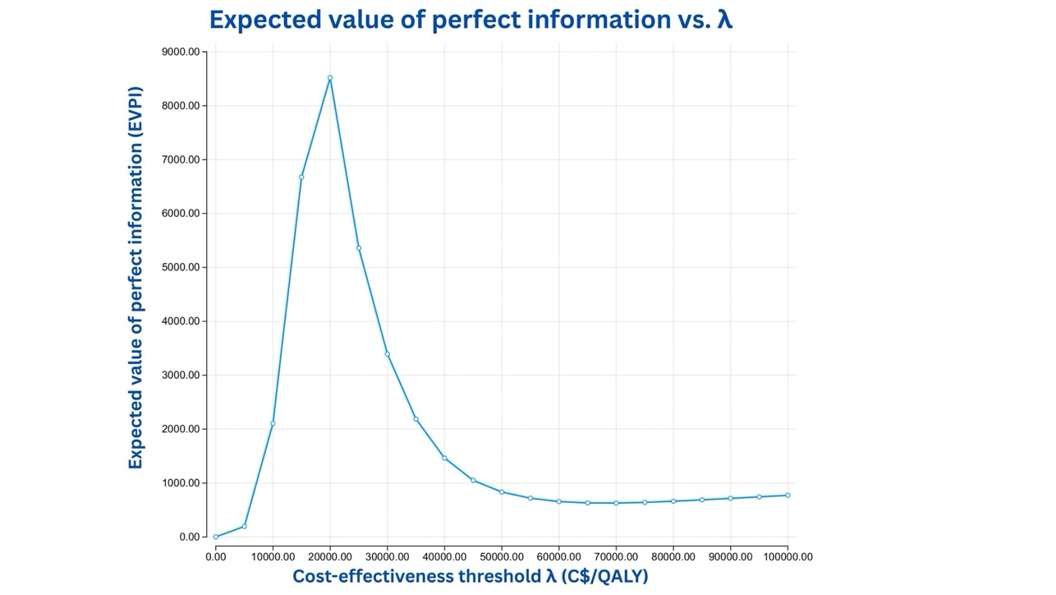

Appendix 7. Incremental Cost-Effectiveness (ICE) scatterplot comparing A) physical rehabilitation, B) cognitive training and C) combination therapy to usual care
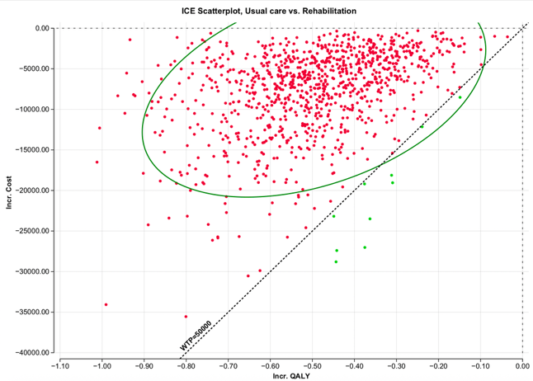 | 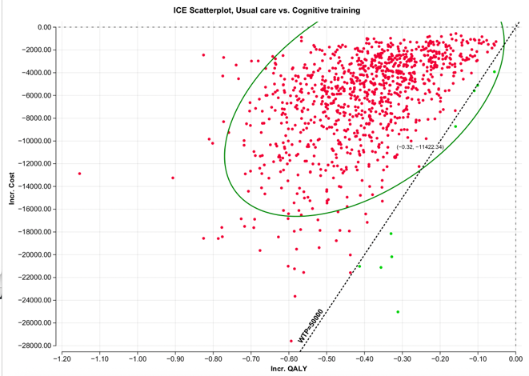 | 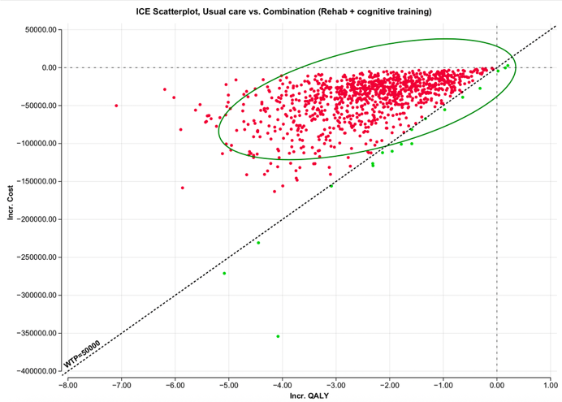

Appendix 8. Cost-effectiveness acceptability frontier
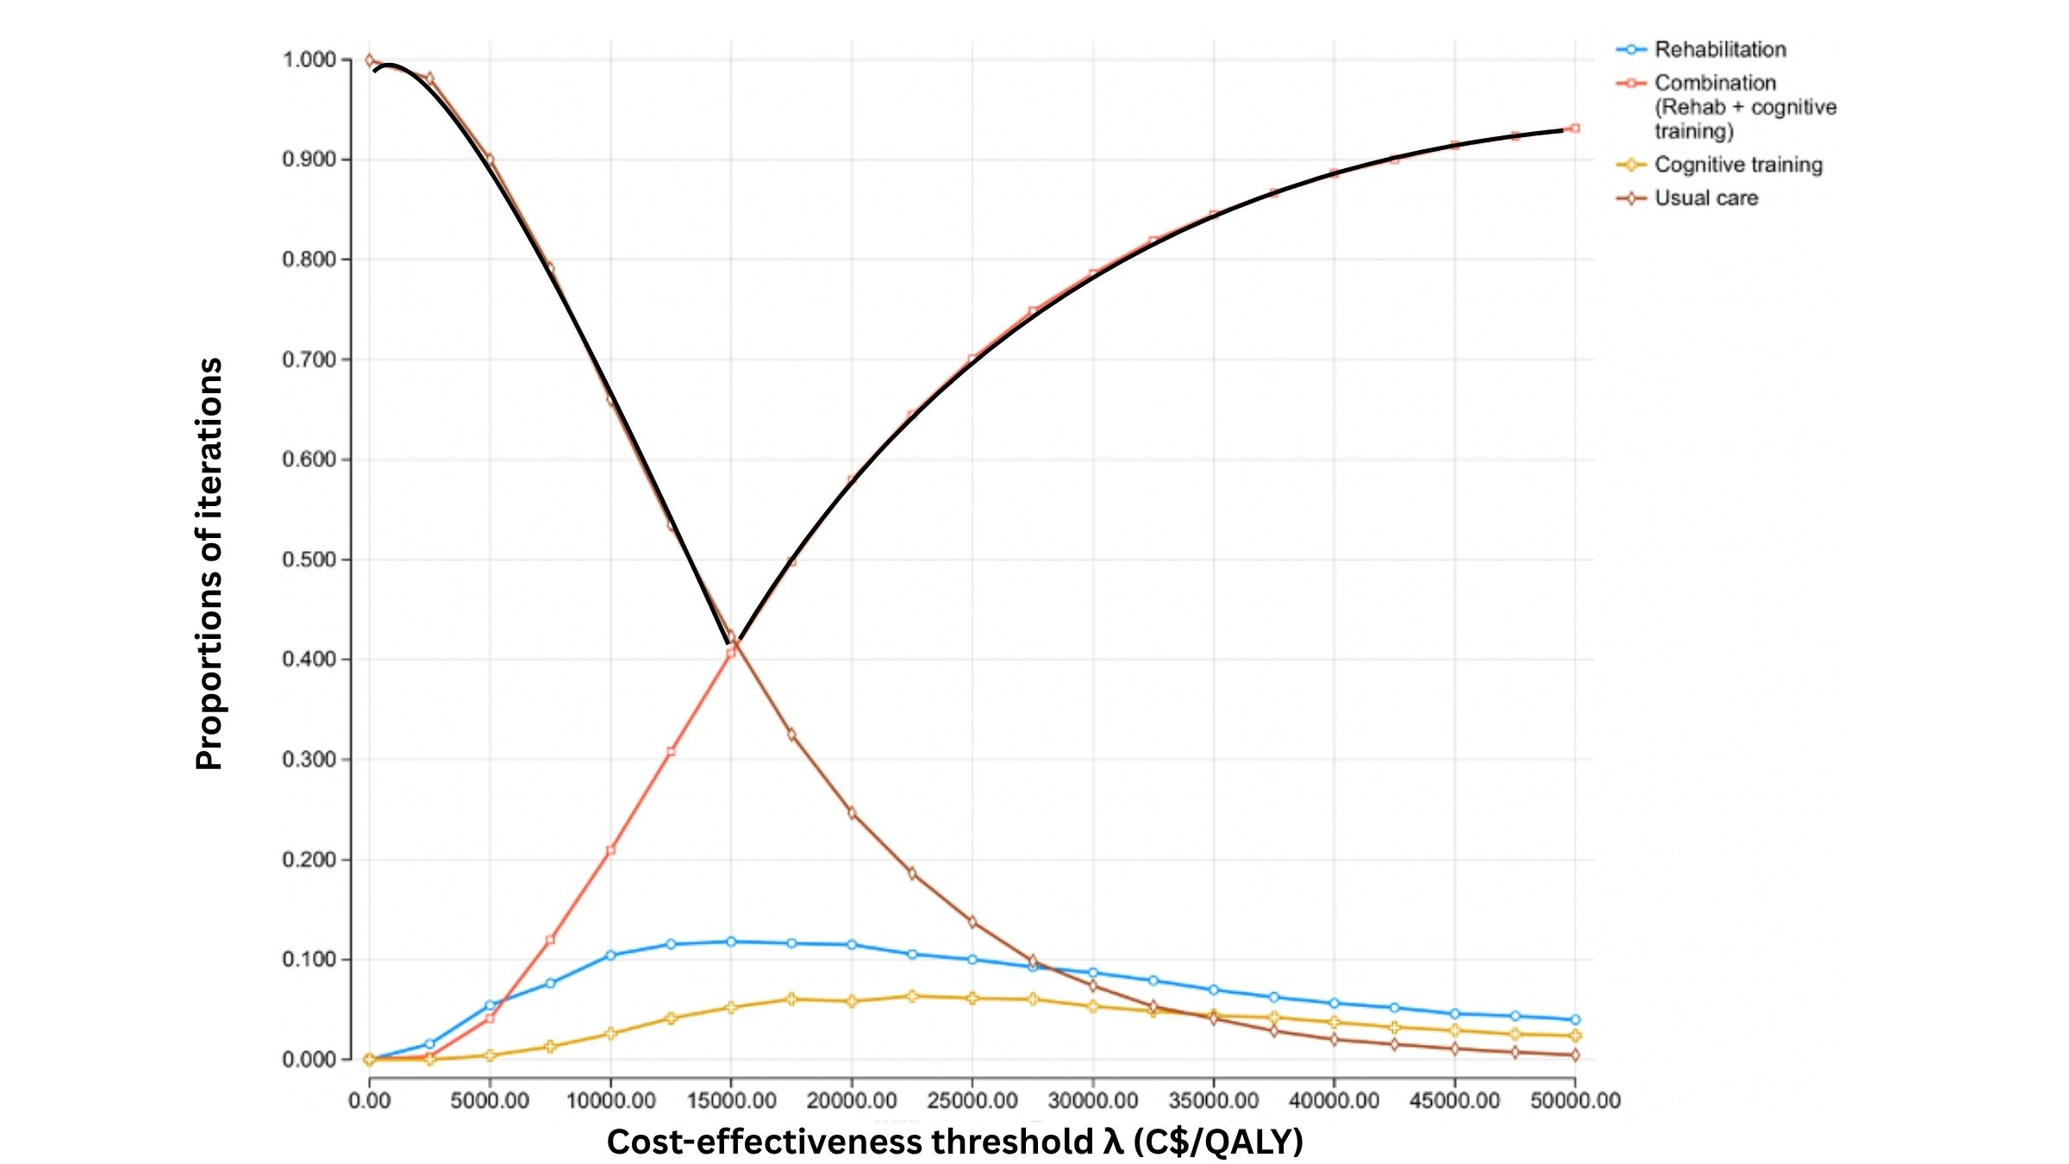

REFERENCES:
1. Jain S, Iverson LM. Glasgow Coma Scale. In: StatPearls [Internet]. Treasure Island (FL): StatPearls Publishing; 2025 [cited 2025 Mar 9]. Available from: http://www.ncbi.nlm.nih.gov/books/NBK513298/
2. McIntyre A, Mehta S, Aubut J, Dijkers M, Teasell RW. Mortality among older adults after a traumatic brain injury: a meta-analysis. Brain Inj. 2013;27(1):31–40.
3. Zhang Y, Natale G, Clouston S. Incidence of Mild Cognitive Impairment, Conversion to Probable Dementia, and Mortality. Am J Alzheimers Dis Other Demen. 2021 Jan 1;36:15333175211012235.
4. Andersen K, Lolk A, Martinussen T, Kragh-Sørensen P. Very Mild to Severe Dementia and Mortality: A 14-Year Follow-Up – The Odense Study. Dement Geriatr Cogn Disord. 2010 Feb 1;29(1):61–7.
5. Akhanemhe R, Stevelink SAM, Corbett A, Ballard C, Brooker H, Creese B, et al. Is lifetime traumatic brain injury a risk factor for mild cognitive impairment in veterans compared to non-veterans? European Journal of Psychotraumatology [Internet]. 2024 Jan 2 [cited 2025 Mar 9]; Available from: https://www.tandfonline.com/doi/abs/10.1080/20008066.2023.2291965
6. McGirr A, Nathan S, Ghahremani M, Gill S, Smith EE, Ismail Z. Progression to Dementia or Reversion to Normal Cognition in Mild Cognitive Impairment as a Function of Late-Onset Neuropsychiatric Symptoms. Neurology. 2022 May 24;98(21):e2132–9.
7. LoBue C, Woon FL, Rossetti HC, Hynan LS, Hart J, Cullum CM. Traumatic Brain Injury History and Progression from Mild Cognitive Impairment to Alzheimer Disease. Neuropsychology. 2018 May;32(4):401–9.
8. Tahami Monfared AA, Byrnes MJ, White LA, Zhang Q. Alzheimer’s Disease: Epidemiology and Clinical Progression. Neurol Ther. 2022 June;11(2):553–69.
9. Chen A, Bushmeneva K, Zagorski B, Colantonio A, Parsons D, Wodchis WP. Direct cost associated with acquired brain injury in Ontario. BMC Neurology. 2012 Aug 17;12(1):76.
10. Kim HS, Lim KB, Yoo J, Kim YW, Lee SW, Son S, et al. The efficacy of computerized cognitive rehabilitation in improving attention and executive functions in acquired brain injury patients, in acute and postacute phase. Eur J Phys Rehabil Med. 2021 Aug;57(4):551–9.
11. Leibson CL, Long KH, Ransom JE, Roberts RO, Hass SL, Duhig AM, et al. Direct medical costs and source of cost differences across the spectrum of cognitive decline: a population-based study. Alzheimers Dement. 2015 Aug;11(8):917–32.
12. Ward Fuller G, Hernandez M, Pallot D, Lecky F, Stevenson M, Gabbe B. Health State Preference Weights for the Glasgow Outcome Scale Following Traumatic Brain Injury: A Systematic Review and Mapping Study. Value Health. 2017 Jan;20(1):141–51.
13. Ghani Z, Saha S, Jarl J, Andersson M, Berglund JS, Anderberg P. Short Term Economic Evaluation of the Digital Platform “Support, Monitoring and Reminder Technology for Mild Dementia” (SMART4MD) for People with Mild Cognitive Impairment and their Informal Caregivers. J Alzheimers Dis. 86(4):1629–41.
14. Pizzo E, Wenborn J, Burgess J, Mundy J, Orrell M, King M, et al. Cost-utility analysis of community occupational therapy in dementia (COTiD-UK) versus usual care: Results from VALID, a multi-site randomised controlled trial in the UK. PLoS One. 2022;17(2):e0262828.
15. El Alili M, Smaling HJA, Joling KJ, Achterberg WP, Francke AL, Bosmans JE, et al. Cost-effectiveness of the Namaste care family program for nursing home residents with advanced dementia in comparison with usual care: a cluster-randomized controlled trial. BMC Health Services Research. 2020 Sept 4;20(1):831.
16. Cisneros E, de Guise E, Belleville S, McKerral M. A controlled clinical efficacy trial of multimodal cognitive rehabilitation on episodic memory functioning in older adults with traumatic brain injury. Ann Phys Rehabil Med. 2021 Sept;64(5):101563.
17. Howrey BT, Graham JE, Pappadis MR, Granger CV, Ottenbacher KJ. Trajectories of Functional Change After Inpatient Rehabilitation for Traumatic Brain Injury. Arch Phys Med Rehabil. 2017 Aug;98(8):1606–13.
18. Frankel JE, Marwitz JH, Cifu DX, Kreutzer JS, Englander J, Rosenthal M. A follow-up study of older adults with traumatic brain injury: taking into account decreasing length of stay. Arch Phys Med Rehabil. 2006 Jan;87(1):57–62.
19. Thompson HJ, Weir S, Rivara FP, Wang J, Sullivan SD, Salkever D, et al. Utilization and Costs of Health Care after Geriatric Traumatic Brain Injury. J Neurotrauma. 2012 July 1;29(10):1864–71.
20. Canada E and SD. Physiotherapist in the Toronto Region | Wages - Job Bank [Internet]. [cited 2025 July 26]. Available from: http://www.jobbank.gc.ca/explore_career/job_market_report/wage_occupation_report.xhtml
21. Canada E and SD. Occupational Therapist (OT) in the Toronto Region | Wages - Job Bank [Internet]. [cited 2025 July 26]. Available from: http://www.jobbank.gc.ca/explore_career/job_market_report/wage_occupation_report.xhtml

