Galvanic Corrosion Inhibition from aspect of Bonding Orbital Theory: Case study of Copper/Ruthenium Coupled Film using 3-Pyridinecarboxylic Acid

Kangchun Lee^{1, =}, Seho Sun^{1, =}, Ganggyu Lee¹, Gyeonghui Yoon², Donghyeok Kim²,
Junha Hwang¹, Hojin Jeong², Taeseup Song^{1, z}, and Ungyu Paik^{1, 2, z}

¹Department of Energy Engineering, Hanyang University, Seoul, South Korea
²Department of Nanoscale Semiconductor Engineering, Hanyang University, Seoul, South Korea

^{z}Co corresponding author: Professor Ungyu Paik (upaik@hanyang.ac.kr)
Professor Taeseup Song (tssong@hanyang.ac.kr)

Tel. +82-2-2220-0502
Fax +82-2-2281-0502

Supplementary figures

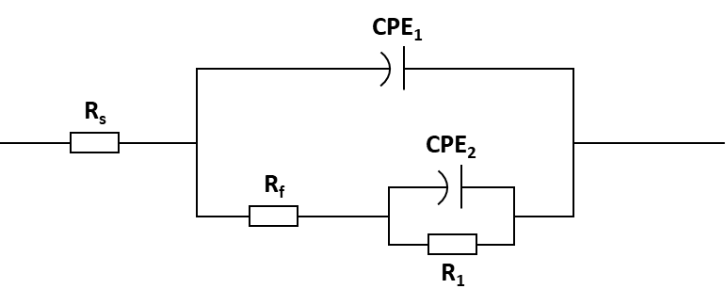
Figure S1. Equivalent circuits of the impedance spectra obtained in different inhibitor concentrations at pH 10 for Cu film and Ru film.

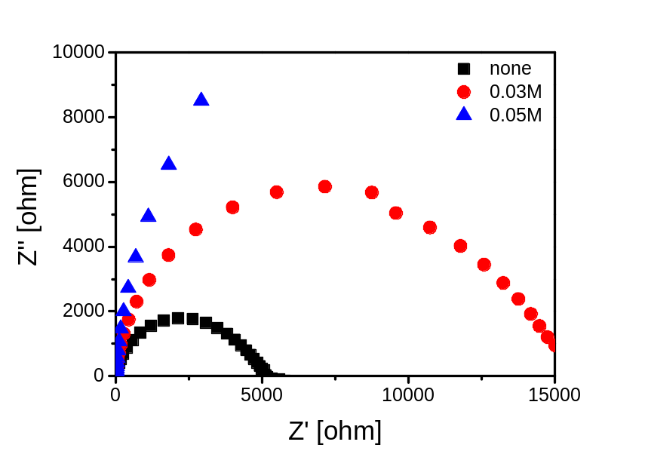

Figure S2. Magnified graph of Nyquist plot of Cu film according to nicotinic acid concentration at pH 10.0.

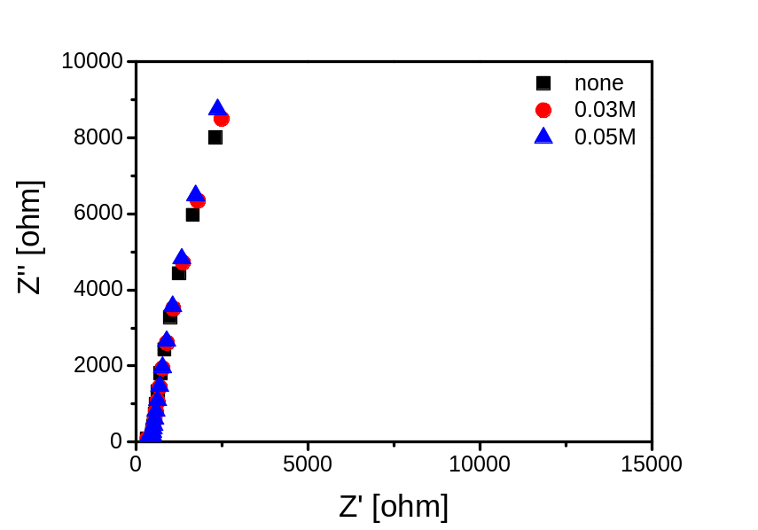

Figure S3. Magnified graph of Nyquist plot of Ru film according to nicotinic acid concentration at pH 10.0.

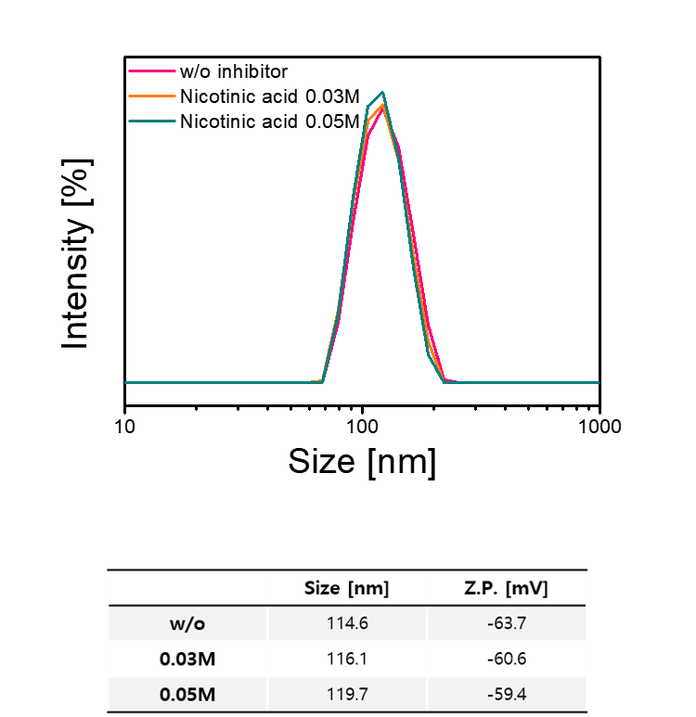

Figure S4. Zeta sizer and zeta potential evaluation for dispersion stability of CMP slurry according to concentration of nicotinic acid
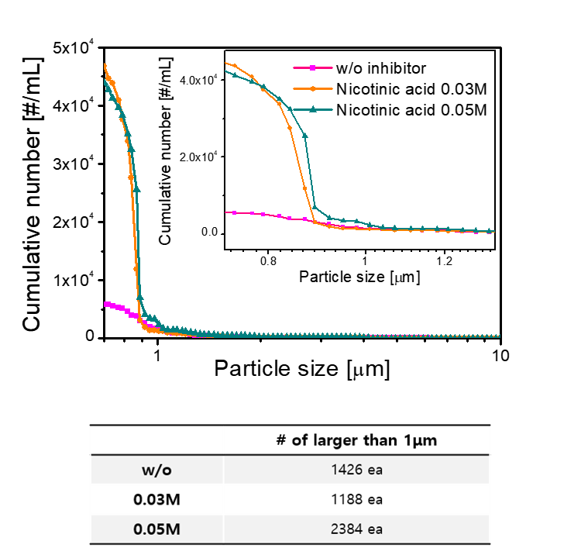
Figure S5. Large particle counter evaluation for dispersion stability of CMP slurry according to concentration of nicotinic acid

