Supplementary Information on:
Summer Hydrodynamics as a Dual Driver of Microplastic Retention and Settling in Shallow Water Columns
Hassan Elagami^{1,} ‡, *, Pouyan Ahmadi² ‡, *, Jan H. Fleckenstein^{2,3}, Christoph Thomas⁴, Wolfgang Babel⁴, Marco La Capra¹, Sven Frei ⁵, Benjamin S. Gilfedder⁶

¹Department of Hydrology, Bayreuth Center of Ecology and Environmental Research
(BayCEER), Bayreuth, Germany
²Department of Hydrogeology, Helmholtz-Center for Environmental Research, UFZ, Leipzig, Germany
³Hydrologic Modeling Unit, Bayreuth Center of Ecology and Environmental Research (BayCEER), University of Bayreuth, Bayreuth, Germany
⁴Micrometeorology Group, Bayreuth Center of Ecology and Environmental Research (BayCEER), University of Bayreuth, Bayreuth, Germany
⁵Department of Aquatic Ecology and Water Quality Management, Wageningen University, Netherlands
⁶ Chair of Hydrology, Faculty of Regional and Environmental Sciences, University of Trier, Trier, Germany
‡ These authors contributed equally to this research

*Corresponding Authors:
Hassan Elagami: Department of Hydrology, Bayreuth Center of Ecology and Environmental Research (BayCEER), University of Bayreuth, Bayreuth, Germany; orcid.org/0000-0002-2919-5230; Email: hassan.elagami@uni-bayreuth.de
Pouyan Ahmadi: Department of Hydrogeology, Helmholtz-Centre for Environmental Research, UFZ, Leipzig, Germany; orcid.org/0000-0002-5452-1560; Email: pouyan.ahmadi@ufz.de
Keywords: Microplastic particle, Wind-induced turbulence, Diurnal thermal convection, Peclet number, Turbulence-enhanced deposition.
S1: Measured water velocity vs. simulated water velocity at 0.25 m depth

Figure S1: Measured velocity at 0.25 m depth in experiment 1 and experiment 2 vs the CFD results for water velocity for the same depth.
S2: Mean Absolute Error (MAE) and Coefficient of Variation (CV)
MAE was used to quantify the average magnitude of errors between the experimental data (​y_{i}^{exp}) and the model predictions (y_{i}^{mod}), without considering their direction. Lower MAE indicates a closer agreement.
MAE=$\frac{1}{N} \sum_{i=1}^{N}{\left|y_{i}^{mod }- y_{i}^{exp }\right|}$
CV was used as a dimensionless measure of the relative variability of a signal, calculated as the ratio of the standard deviation (σ) to the mean (μ). A lower CV indicates that the values fluctuate less relative to their average.
$CV=\frac{σ}{μ}$
Table S2: Calculated MAE and CV for the experiments and the simulations. (These values were calculated for the times that curves were still changing slightly, but became flatter as their rate of change approached zero).
Experiment | Depth (m) | Model | MAE | CV
Exp1 | 0.25 | Experiment | – | 0.46
Exp1 | 0.25 | One-way | 20.05 | 0.36
Exp1 | 0.25 | Two-way | 9.47 | 0.41
Exp1 | 2.75 | Experiment | – | 0.73
Exp1 | 2.75 | One-way | 6.44 | 0.72
Exp1 | 2.75 | Two-way | 11.79 | 0.30
Exp2 | 0.25 | Experiment | – | 0.32
Exp2 | 0.25 | One-way | 51.81 | 0.95
Exp2 | 0.25 | Two-way | 12.27 | 0.17
Exp2 | 2.75 | Experiment | – | 0.18
Exp2 | 2.75 | One-way | 7.67 | 0.30
Exp2 | 2.75 | Two-way | 20.51 | 0.04

S3: Difference between the daily maximum and minimum temperature
Figure S3: Difference of maximum and minimum temperatures recorded during each day in A) Exp. 1, and B) Exp. 2. The 30th of July is the day with the maximum temperature difference highlighted on panel A.
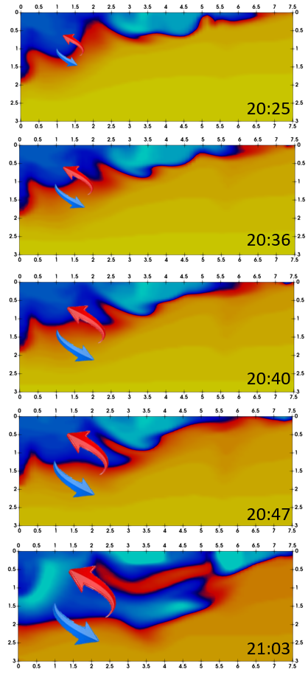
S4: Snapshots of forming convective and diffusive heat transport in the mesocosm

Figure S4: Time steps immediately preceding and following the snapshot shown in Figure 7A. As in that figure, the horizontal axis represents the mesocosm length (7.5 m) and the vertical axis its depth (3 m); the color scale and legend are identical to those used in Figure 7A.
S5: Deposited MP particles on the bed of the Mesocosm (CFD results)
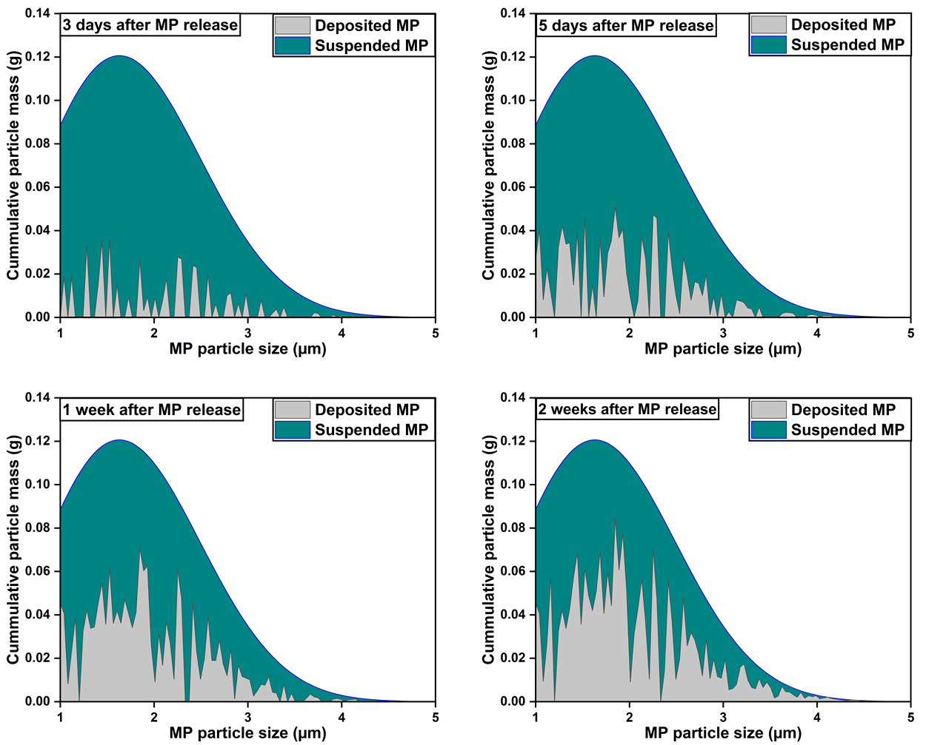
Figure S5: Deposited MP particles on the bed layer after 3 days, 5 days, 1 week, and 2 weeks after MP particle addition in the first experiment.

