Supplementary Materials - Host matters: coral reef fish species show distinct skin microbiome responses to abrupt environmental change

Table of Contents
Part 1: General Study Design 2
Table S1: GPS coordinates & metadata for sampling sites 2
Table S2: Study species – Tropical reef fish of Panama 2
Table S3: PCR conditions for 16S rRNA gene amplification 3
Table S4: Fish Sample Sizes. 3
Part 2: Environmental Parameters 4
Figure S1: Water temperature and dissolved oxygen in Panama’s Tropical Eastern Pacific. 4
Part 3: Alpha diversity metrics 5
Figure S2: Hill numbers by host species. 5
Table S5: Alpha diversity metrics 6
Table S6: Alpha diversity pairwise comparisons between species. 6
Part 4: Beta diversity metrics 6
Table S7: PERMANOVA results. 6
Figure S3: Dissimilarity between microbial communities - PCoA: rarefied to 2500 reads. 7
Figure S4: Dissimilarity between microbial communities - NMDS. 8
Figure S5: Relative abundances of skin microbial phyla – rarefied to 2500 reads 9
Part 5: Differential abundance analyses 10
MaAsLin2: 10
Figure S6: Water taxa differential abundance between regions and seasons. 11
Figure S7: Water taxa differential abundance between seasons in Las Perlas. 12
Figure S8: A. concolor taxa differential abundance in between seasons and regions. 13
Figure S9: M. dorsalis taxa differential abundance between seasons and regions. 14
Figure S10: A. xanthopterus taxa differential abundance between seasons and regions. 15
Figure S11: P. laticlavius taxa differential abundance in between seasons and regions. 16
Figure S12: C. panamensis taxa differential abundance in between seasons and regions: DESeq2. 17
Figure S13: E. labriformis taxa differential abundance in between seasons and regions: DESeq2. 18
Figure S14: C. colonus taxa differential abundance in between seasons and regions: DESeq2. 19

Supplementary Materials

Part 1: General Study Design

Table S1: GPS coordinates & metadata for sampling sites
Sampling site | Gulf | Coordinates
Machete | Gulf of Chiriquí | N7º38’17.4”, W81º44’13.6”
Cocos | Gulf of Chiriquí | N7º36’56.9”, W81º42’51.2”
Los Frijoles (Frijol & Frijolito) | Gulf of Chiriquí | N7º39’16.6”, W81º43’40.7”
Canales de Afuera | Gulf of Chiriquí | N7º41’45.4”, W81º37’58.5”
Granito de Oro | Gulf of Chiriquí | N7º35’38.2”, W81º42’46.2”
Pacheca | Gulf of Panama | N8º39’46.1”, W79º03’20.6”
Chapera | Gulf of Panama | N8º35’31.3”, W79º01’08.6”
Saboga | Gulf of Panama | N8º37’42.4”, W79º03’18.6”

Table S2: Study species – Tropical reef fish of Panama. Skin microbiome samples were collected from 10 species of tropical reef fish, including representatives from a range of trophic groups and four different families (Acanthuridae, Chaetodontidae, Pomacentridae, and Serranidae).
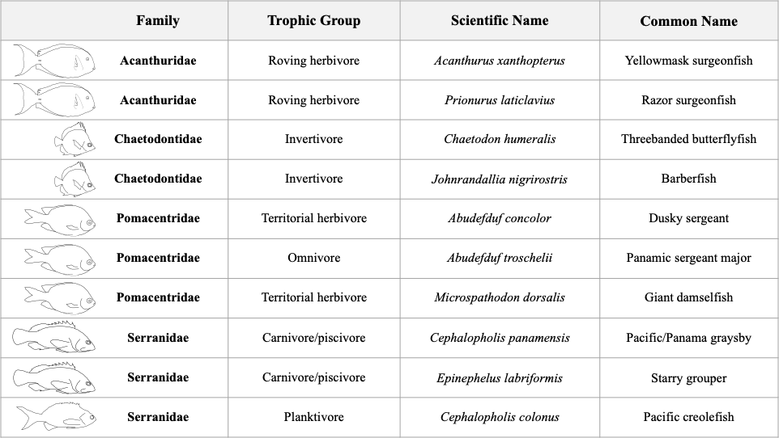

Table S3: PCR conditions for 16S rRNA gene amplification. We amplified the V4 region of the 16S ribosomal RNA gene (16S rRNA) using four sets of phased primers 515F ([CTA]GTGYCAGCMGCCGCGGTAA) and 806R ([ATC]GGACTACNVGGGTWTCTAAT) adapted for Illumina sequencing. Nucleotides in brackets ([ATC]/ [CTA]) were added one-by-one to the phased primer sets, such that 515F/806R “IL” had no added nucleotides, “ILN” had 1 (blue C/A), “IL2N” had 2 (green & blue), and “IL3N” had 3 (red, green, blue). Full sequences for both 16S rRNA and index PCR available in the metadata excel file.
PCR Conditions
35 Cycles

94ºC | 94ºC | 50ºC | 72ºC | 72ºC | 10ºC
3 min | 45 s | 1 min | 1 min 30 s | 10 min | hold

Table S4: Fish Sample Sizes. We aimed to collect 10 individuals per species during each sampling season and region and sequenced nine skin swabs for each group. Initial sample sizes (total fish samples sequenced), sample sizes after trimming (removing samples with fewer than 1000 reads), and sample sizes after rarefaction to 2500 reads given by species for each gulf (G of C = Gulf of Chiriquí, G of P = Gulf of Panama).
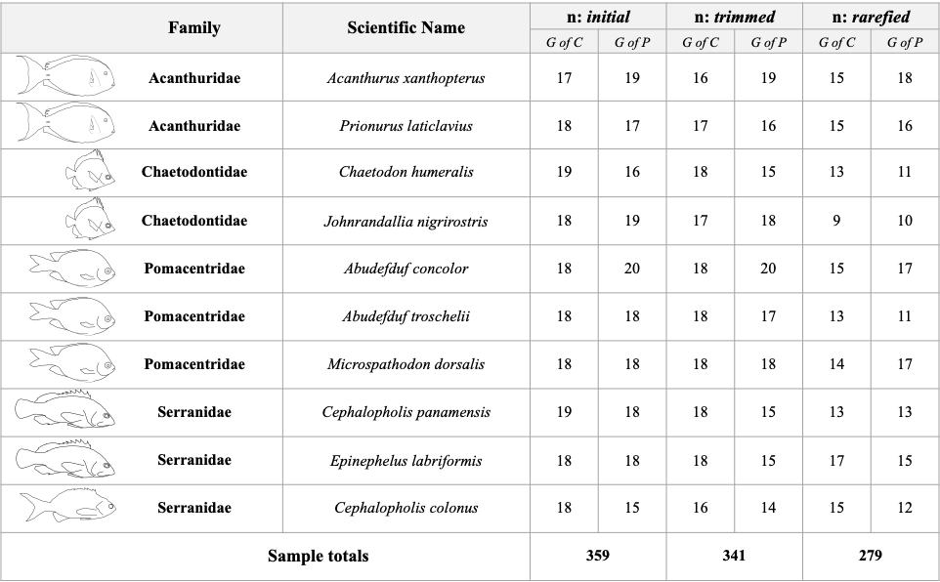

Part 2: Environmental Parameters

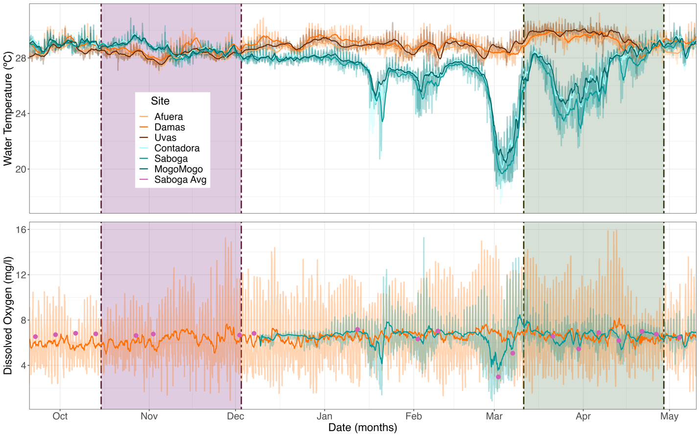
A
B
Figure S1: Water temperature and dissolved oxygen in Panama’s Tropical Eastern Pacific. (A) Temperature (ºC) and (B) dissolved oxygen (DO; mg/L) readings at our sampling sites in the Gulf of Chiriquí (orange) and Gulf of Panama (turquoise). Vertical shaded bars denote sampling dates during the wet (Oct-Nov; purple) and dry (Mar-Apr; green) seasons. Dry season sampling began shortly after water temperatures dropped in the Gulf of Panama, indicative of upwelling. Simple moving average (dark lines; values averaged across (A) 48 and (B) 24 hours) overlaid over raw temperature/dissolved oxygen values. (B) Dissolved oxygen data loggers were only deployed in the Gulf of Panama in December 2021; additional data reported from STRI’s Physical Monitoring Program, which takes weekly manual DO measurements (Saboga Avg: purple points).*

*Notes for Fig. S1: We deployed loggers at fixed depths in shallow reef sites in both gulfs (Temp: 4.6-6.1 m, DO: 5.5-7.2 m avg. depth). Our loggers collected data in 15- or 30-minute intervals, and we later standardized the merged dataset to 30 minutes. Given that the DO logger for the Gulf of Panama was deployed part way through our sampling period (December 2021), we sourced additional DO data from the STRI Physical Monitoring Program (PMP), which has measured environmental parameters, including DO, weekly across the Gulf of Panama since 2017, using a manual YSI EXO 2 sonde (35). These data measure DO across a range of depths, in approximately 5-m depth intervals, from around 5 to 20 m, and multiple measurements are taken consecutively at each depth. Since our loggers were placed at fixed depths, we subset the PMP dataset to include only the shallowest measurements (binning measurements taken at 3 to 7 m depth) and calculated the average DO for each day, then plotted these points alongside our miniDOT dataset. PMP data were generally collected between 8:30 and 10:00 AM, and average values were logged as 9:00 AM when merged with our DO data. Despite different measurement techniques, the PMP and miniDOT datasets were consistent across overlapping sampling timepoints, increasing our confidence that the PMP values for October-December 2021 reasonably estimate local conditions at our Gulf of Panama sampling sites.

Part 3: Alpha diversity metrics
B
A
Figure S2: Hill numbers by host species. Boxplots of the three alpha diversity Hill numbers: observed richness (q0), Shannon exponential (q1), Simpson multiplicative inverse (q3). (A) unrarefied, (B) rarefied to 2500 reads.

Table S5: Alpha diversity metrics. Various metrics assessing microbial community variation within individual fish skin samples, to gage community diversity, evenness, dominance, and rarity (unrarefied & rarefied to 2,500 reads/sample). Available as two separate csv files: “Table_S5_ROHR06_skin_alpha_div_metrics_[non_rarefied]/[rarefied2500].csv”

Table S6: Alpha diversity pairwise comparisons between species. Adjusted P-values (Kruskal-Wallis; Dunn post-hoc, Bonferroni-Hochberg correction) for pairwise comparisons between (A) fish host species and (B) trophic groups for observed (q0; top right), Shannon (q1; top left), and Inverse Simpson (q2; bottom) alpha diversity metrics run on unrarefied dataset. Significant comparisons (P < 0.05) are shaded in green; smaller P-values correspond to darker shading.
A
Shannon
Observed
Inv. Simpson
Shannon
Observed
Inv. Simpson
B

Part 4: Beta diversity metrics

Table S7: PERMANOVA results. Permutational multivariate analysis of variance (PERMANOVA) were run (10000 permutations) with three dissimilarity/distance metrics: Bray-Curtis, Jaccard, and UniFrac on (1) the whole fish skin dataset, (2) the water dataset, and (3) the species-by-species datasets. All tests were run on both unrarefied and rarefied (to 2500 reads; shaded columns) datasets. Complete results are reported for each PERMANOVA, including the model run (Model), degrees of freedom (Df), sum of squares (SumOfSqs), partial R2 (R2), pseudo-F statistic (F), p-value (Pr(>F)), and residual R2 (Residual R2). Significant comparisons (P < 0.05) are shaded in green; smaller P-values correspond to darker shading. For the whole fish skin dataset, we tested trophic group, species, region, and season independently, then ran a model looking at the interactions between trophic group, species, region, site within region, and season, using the strata argument to constrain permutations within trophic group, given the nestedness of species within trophic group. For the species-by-species and water datasets, we tested region, season, and the interaction between region and season. Excel file: “Table_S7_PERMANOVA results raw.xlsx”

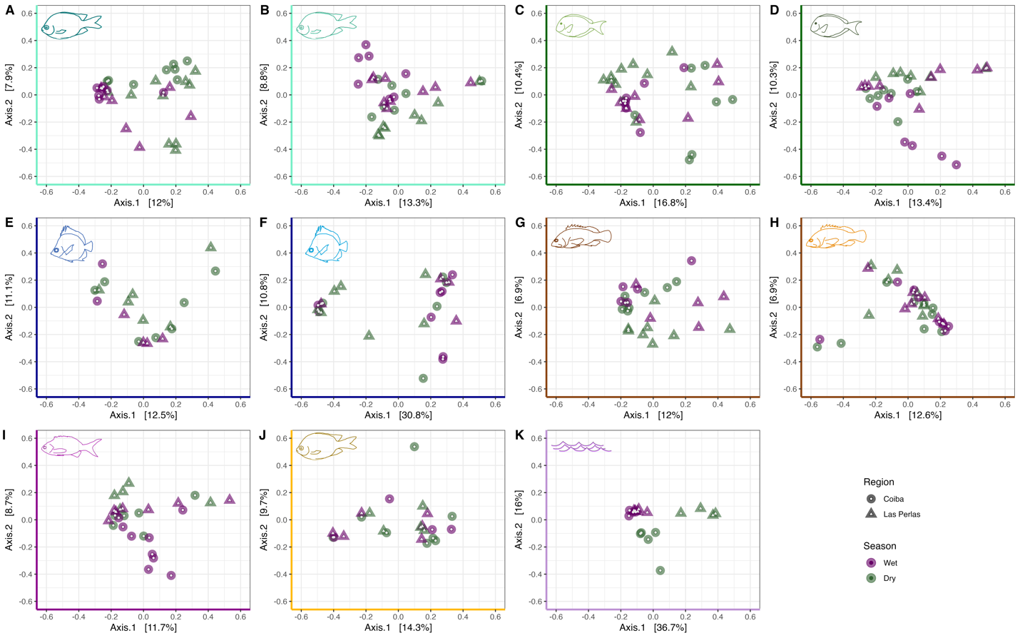
Figure S3: Dissimilarity between microbial communities - PCoA: rarefied to 2500 reads. PCoA plots displaying all microbiome samples included in this study, based on Bray-Curtis dissimilarities between communities. (A – J) Fish skin microbiomes across regions (circle: Gulf of Chiriquí; triangle: Gulf of Panama) and seasons (purple: non-upwelling, green: upwelling), split by host species. Axis colours and icons indicate trophic groups and study species, respectively (see Fig. 1). (K) Water microbiome, included for comparison. Individual points represent single fish (n = 279) or water (n = 19) samples.
Figure S4: Dissimilarity between microbial communities - NMDS. NMDS plots displaying all microbiome samples, based on Bray-Curtis dissimilarities between communities. (A – J) Fish skin microbiomes across regions (circle: Gulf of Chiriquí; triangle: Gulf of Panama) and seasons (purple: non-upwelling, green: upwelling), split by host species. Axis colours and icons correspond to each of our study species. (K) Water microbiome, included for comparison. Individual points represent single fish (n = 341) or water (n = 19) samples.

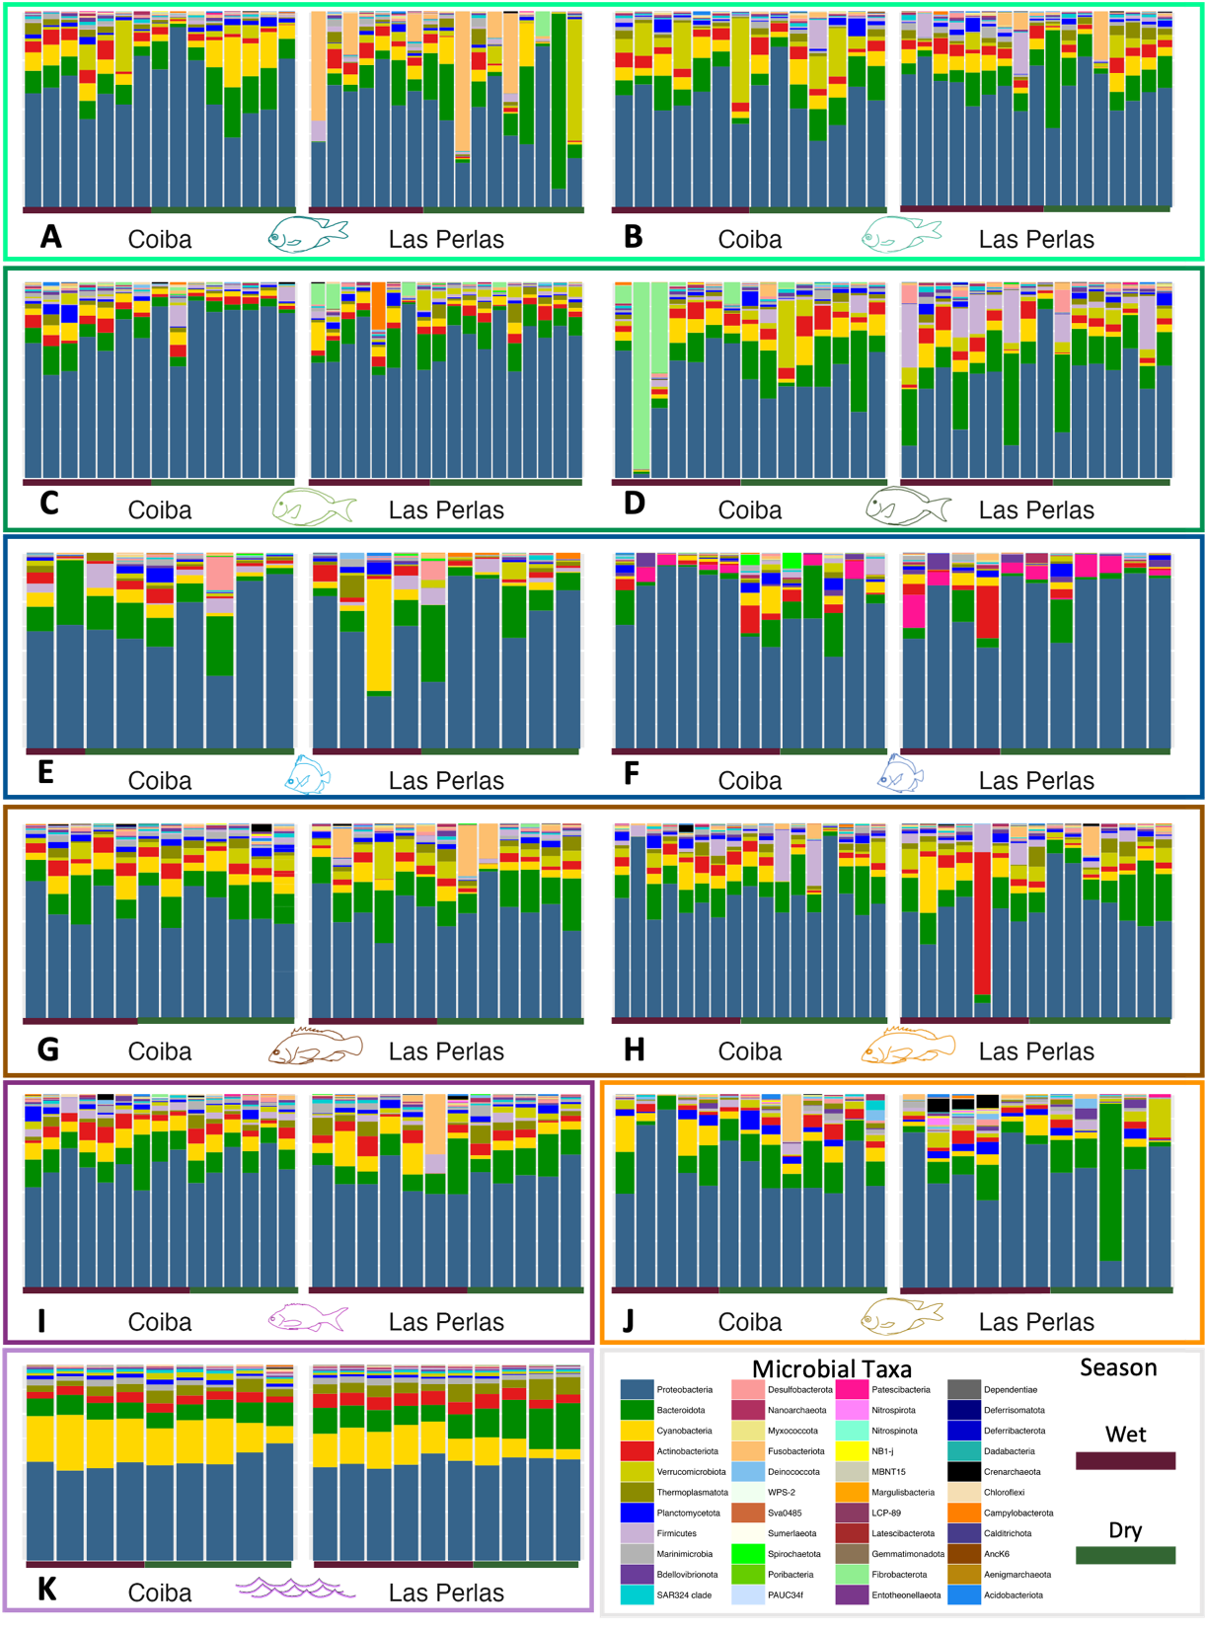
Figure S5: Relative abundances of skin microbial phyla – rarefied to 2500 reads. Stacked bar plots of phylum-level microbiome composition, split by gulf (left: Coiba - Gulf of Chiriquí, right: Las Perlas - Gulf of Panama). (A - J) Individual bars represent a single fish. Panels arranged by trophic group (coloured boxes), fish icons denote species (see Fig. 1), and coloured bars along the bottom of each panel mark sampling seasons (purple = wet, green = dry). (H) Water microbiome community composition from the surrounding reef for comparison.

Part 5: Differential abundance analyses

MaAsLin2:
MaAsLin2 Methods
In addition to DESeq2, as described in the main text, we also ran MaAsLin2 on our water dataset to compare the two differential abundance methods. As for DESeq2, un-normalized counts were used for MaAsLin2, and taxa present in less than 10% of samples in each dataset were filtered out. MaAsLin2 was run with standard parameters; applying total sum scaling for normalization, log-transforming the data, running a linear model with “region_season” as a fixed effect (this column returns all the region and season combinations), and applying Benjamini-Hochberg (BH) correction for multiple comparison, setting the significance threshold at 0.05. Results from both tests for the water dataset are reported below, and DESeq2 was chosen to run on the fish dataset, given the flexibility provided by the “contrasts” argument for testing pairwise comparisons. When testing more than two groups (i.e., region and season), for MaAsLin2, we set the reference as Gulf of Panama wet season (non-upwelling) and ran pairwise comparisons between this reference and (1) Gulf of Panama dry season (upwelling), (2) Gulf of Chiriquí wet season, and (3) Gulf of Chiriquí dry season. DESeq2 was run with standard parameters, specifying the desired contrasts, and returning the log2 fold change, Wald test p-values, and adjusted p-values with Benjamini-Hochberg (BH) multiple comparison correction. The significance threshold was set to p-adj = 0.05.
MaAsLin2 Results and Comparison with DESeq2
For the water dataset, out of 1298 filtered taxa (49.5% of the initial 2624 taxa passed 10% filter step; see methods), 524 and 528 taxa were significantly differentially abundant between the Gulf of Panama wet and dry season samples for DESeq2 and MaAsLin2, respectively (Table S7). Among these, 318 (24%) were enriched (log-fold change; LFC >0) and 206 (16%) decreased in the dry season (DESeq2) while for MaAsLin2, 237 were enriched and 291 decreased. In contrast, across gulfs during the wet season there were only 116 DA taxa identified by DESeq2 and 185 by MaAsLin2. While seasonal shifts were lesser in the Gulf of Chiriquí, there were still 350 DA taxa detected between the wet and dry seasons (DESeq2). When comparing the two gulfs during the dry season, there were 465 DA taxa (188 increased and 277 decreased in the Gulf of Chiriquí relative to the Gulf of Panama; DESeq2). The log2-fold changes in the top 25 DA taxa for each set of pairwise comparisons are plotted in Fig. S6 as well as the top 50 DA taxa for the comparison between Gulf of Panama wet and dry seasons (Fig. S7). Note that given the structure of MaAsLin2, we set the Gulf of Panama wet season as the reference, and thus only have data to compare with DESeq2 for Gulf of Panama wet vs. dry and Gulf of Panama wet vs. Gulf of Chiriquí wet.

Table S8: Differentially abundant taxa between regions and seasons for fish and water microbiomes. Significant DESeq2 results (p-adj < 0.05, Wald test, BH correction) reported for four key region-season comparisons: Gulf of Chiriquí (Coiba) wet vs. dry season, Gulf of Panama (Las Perlas) wet vs. dry season, Gulf of Panama wet season vs. Gulf of Chiriquí wet season, and Gulf of Panama dry season vs. Gulf of Chiriquí dry season. For fish, bold values indicate total significant DA taxa, values in parentheses are shared DA taxa between fish and water samples.
 | Gulf of Chiriquí wet vs. dry | Gulf of Panama wet vs. dry | G of Panama vs. G of Chiriquí wet | G of Panama vs. G of Chiriquí dry | Total DA taxa
Abudefduf concolor | 2 (0) | 4 (0) | 7 (0) | 4 (0) | 17 (0)
Microspathodon dorsalis | 3 (0) | 20 (6) | 4 (0) | 15 (8) | 42 (14)
Acanthurus xanthopterus | 22 (2) | 0 (0) | 14 (0) | 22 (8) | 58 (10)
Prionurus laticlavius | 14 (0) | 27 (13) | 12 (1) | 20 (11) | 73 (25)
Cephalopholis panamensis | 6 (0) | 4 (0) | 7 (0) | 1 (0) | 18 (0)
Epinephelus labriformis | 12 (1) | 4 (0) | 10 (0) | 7 (0) | 33 (1)
Cephalopholis colonus | 1 (0) | 7 (3) | 4 (0) | 5 (0) | 17 (3)
Water | 350 | 524 | 116 | 465 | 1455

Table S9: Significant DA taxa shared between fish and water microbiomes. All microbial taxa that shared significant DESeq2 results (p-adj < 0.05, Wald test, BH correction) between fish skin and water in one or more of four key region-season comparisons: Gulf of Chiriquí (Coiba) wet vs. dry season, Gulf of Panama (Las Perlas) wet vs. dry season, Gulf of Panama wet season vs. Gulf of Chiriquí wet season, and Gulf of Panama dry season vs. Gulf of Chiriquí dry season. Shaded taxa appear in multiple comparisons. The adjusted p-values and log2-fold change are reported for each taxon for both the fish and water samples. Available as a separate Excel document: “Table_S9_shared_significant_DA_taxa_water_fish.xlsx”

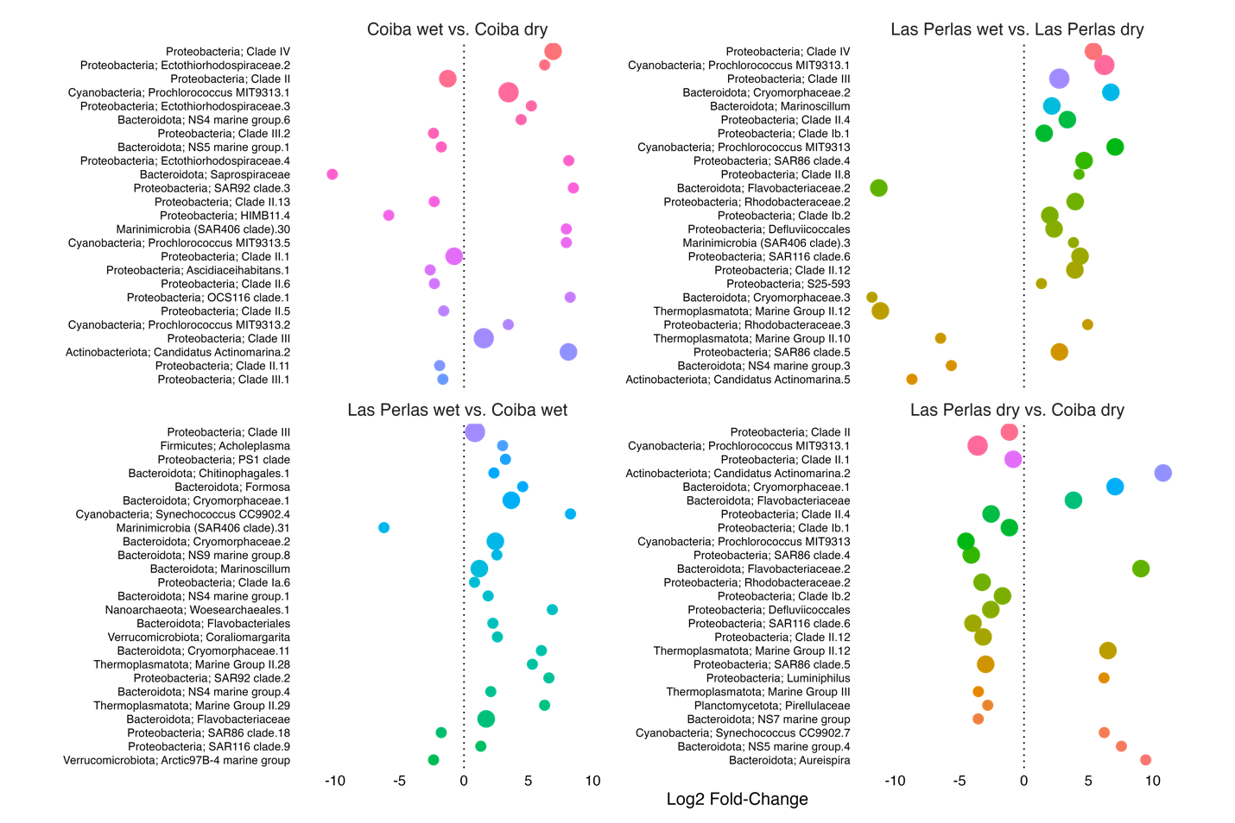
Figure S6: Water taxa differential abundance between regions and seasons. Log2-fold changes in top 25 most significantly differentially abundant taxa (DESeq2: Wald test, BH correction) per set of pairwise comparisons between water microbiome communities (e.g., Coiba – Gulf of Chiriquí - wet season vs. Coiba dry season; top left-hand panel). Lowest p-adjusted values displayed at top of plot (p-values for these taxa ranged from 5.2e-57 to 1.8e-04). Point size corresponds to the number of times each taxon was among the top 25 taxa across all four panels and colours are maintained across all panels.
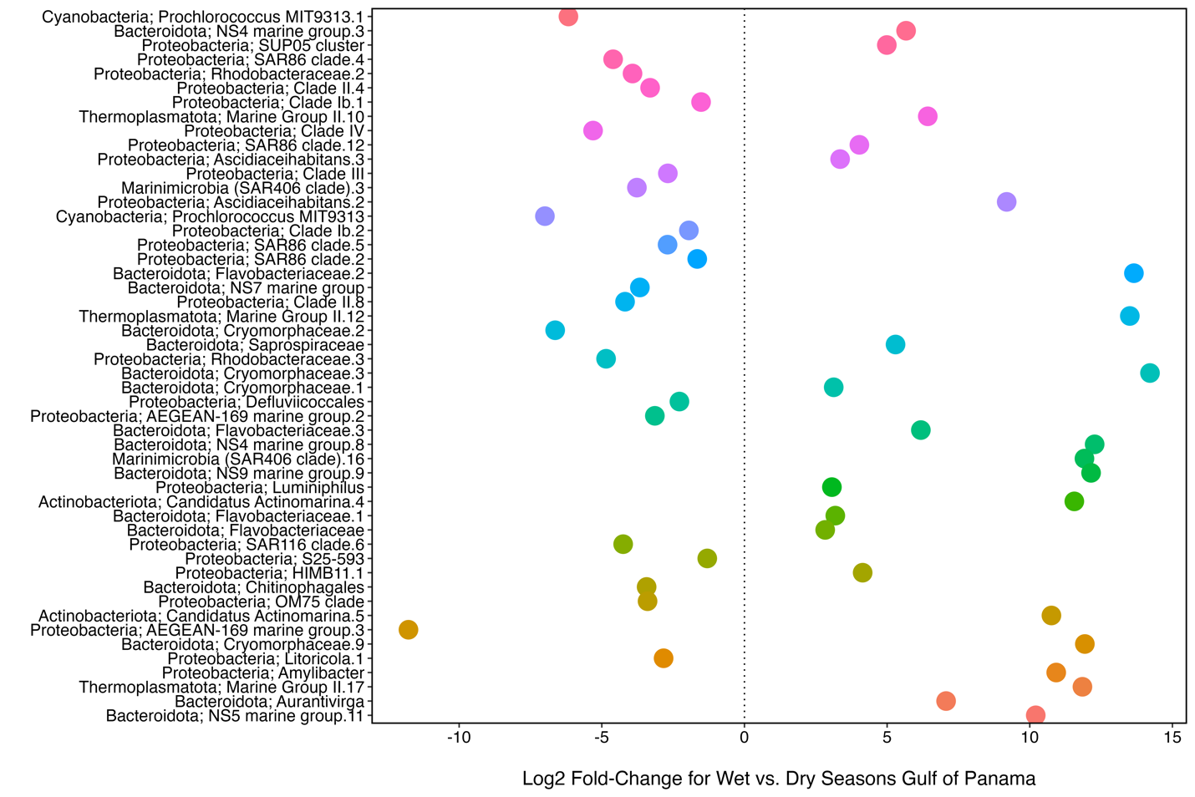
Figure S7: Water taxa differential abundance between seasons in Las Perlas. Log2-fold changes in top 50 most significantly differentially abundant taxa (DESeq2: Wald test, BH correction) in water microbiome samples between the wet and dry (upwelling) seasons in Las Perlas, Gulf of Panama. Lowest p-adjusted values displayed at top of plot (p-values for these taxa ranged from 5.2e-57 to 1.8e-04).

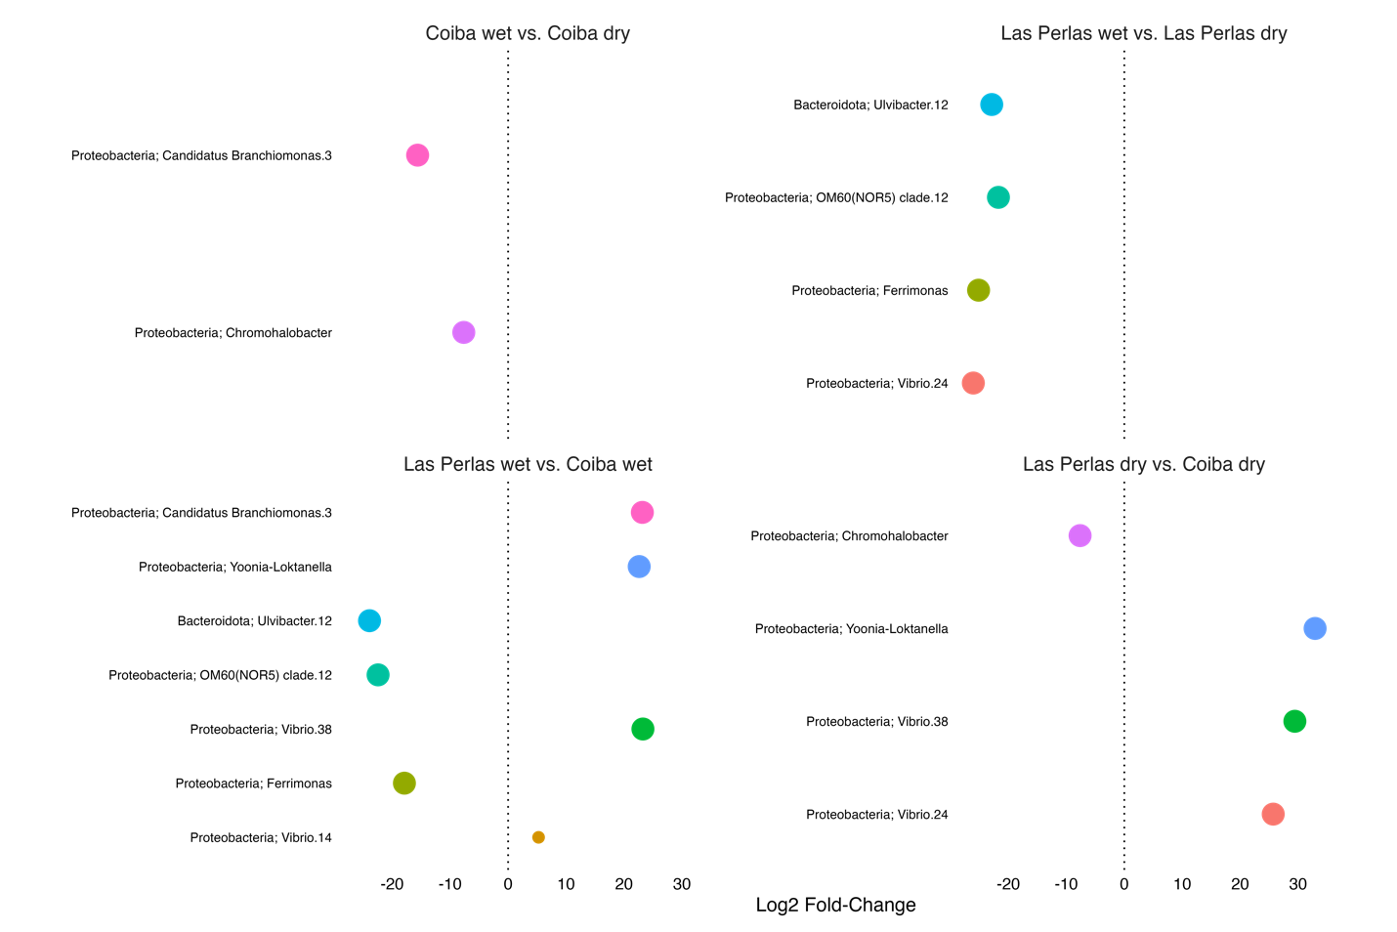
Figure S8: A. concolor taxa differential abundance in between seasons and regions. Log2-fold changes in all significantly differentially abundant taxa (DESeq2: p-adj < 0.05, Wald test, BH correction) per set of pairwise comparisons between fish microbiome communities (e.g., Coiba – Gulf of Chiriquí wet season vs. Coiba dry season; top left-hand panel). Lowest p-adjusted values displayed at top of plot. Point size corresponds to the number of times each taxon was among the significant taxa across all four panels and colours are maintained across all panels. Shared significant DA taxa between water and fish samples denoted with an asterisk.

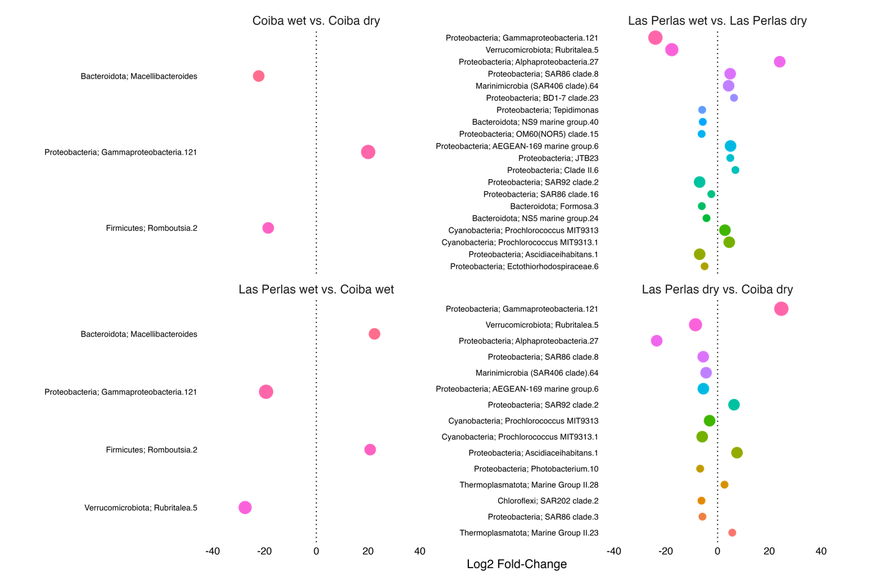
Figure S9: M. dorsalis taxa differential abundance between seasons and regions. Log2-fold changes in all significantly differentially abundant taxa (DESeq2: p-adj < 0.05, Wald test, BH correction) per set of pairwise comparisons between fish microbiome communities (e.g., Coiba – Gulf of Chiriquí wet season vs. Coiba dry season; top left-hand panel). Lowest p-adjusted values displayed at top of plot. Point size corresponds to the number of times each taxon was among the significant taxa across all four panels and colours are maintained across all panels.

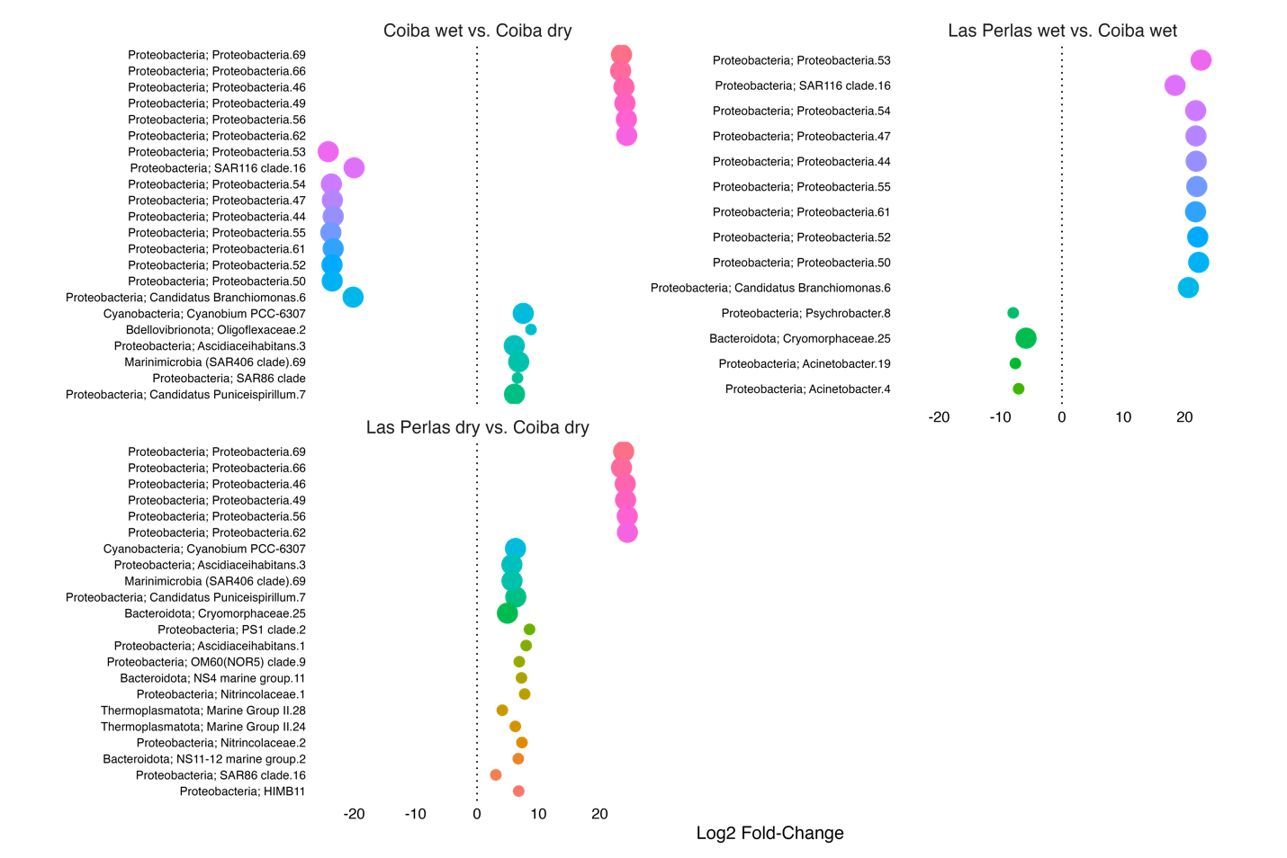
Figure S10: A. xanthopterus taxa differential abundance between seasons and regions. Log2-fold changes in all significantly differentially abundant taxa (DESeq2: p-adj < 0.05, Wald test, BH correction) per set of pairwise comparisons between fish microbiome communities (e.g., Coiba – Gulf of Chiriquí wet season vs. Coiba dry season; top left-hand panel). Lowest p-adjusted values displayed at top of plot. Point size corresponds to the number of times each taxon was among the significant taxa across all four panels and colours are maintained across all panels.

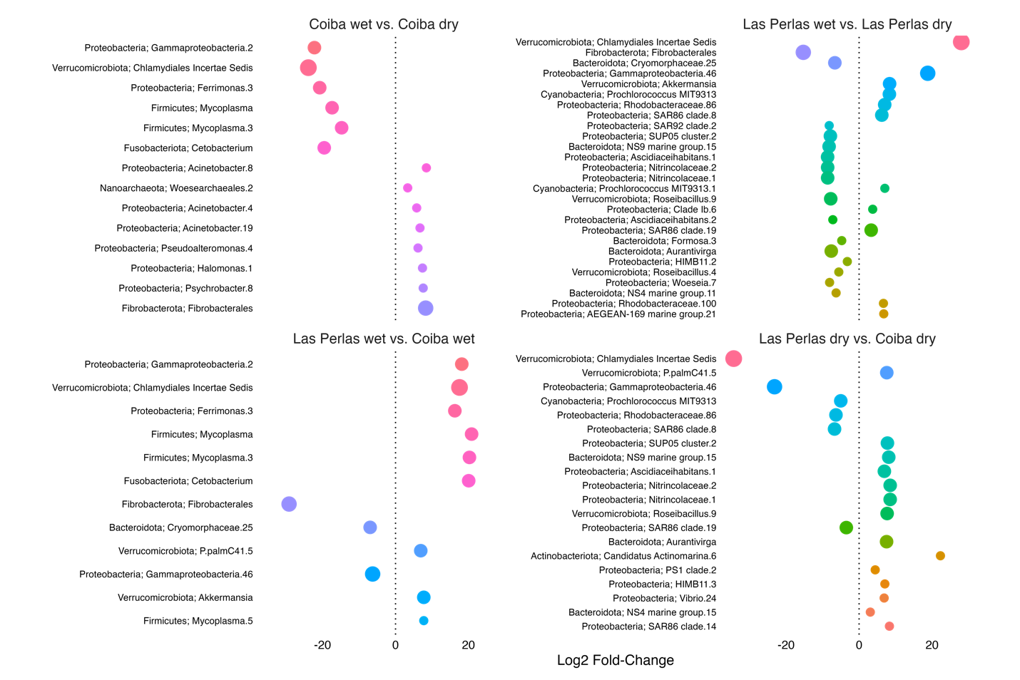
Figure S11: P. laticlavius taxa differential abundance in between seasons and regions. Log2-fold changes in all significantly differentially abundant taxa (p-adj < 0.05, Wald test, BH correction) per set of pairwise comparisons between fish microbiome communities (e.g., Coiba – Gulf of Chiriquí wet season vs. Coiba dry season; top left-hand panel). Lowest p-adjusted values displayed at top of plot. Point size corresponds to the number of times each taxon was among the significant taxa across all four panels and colours are maintained across all panels.

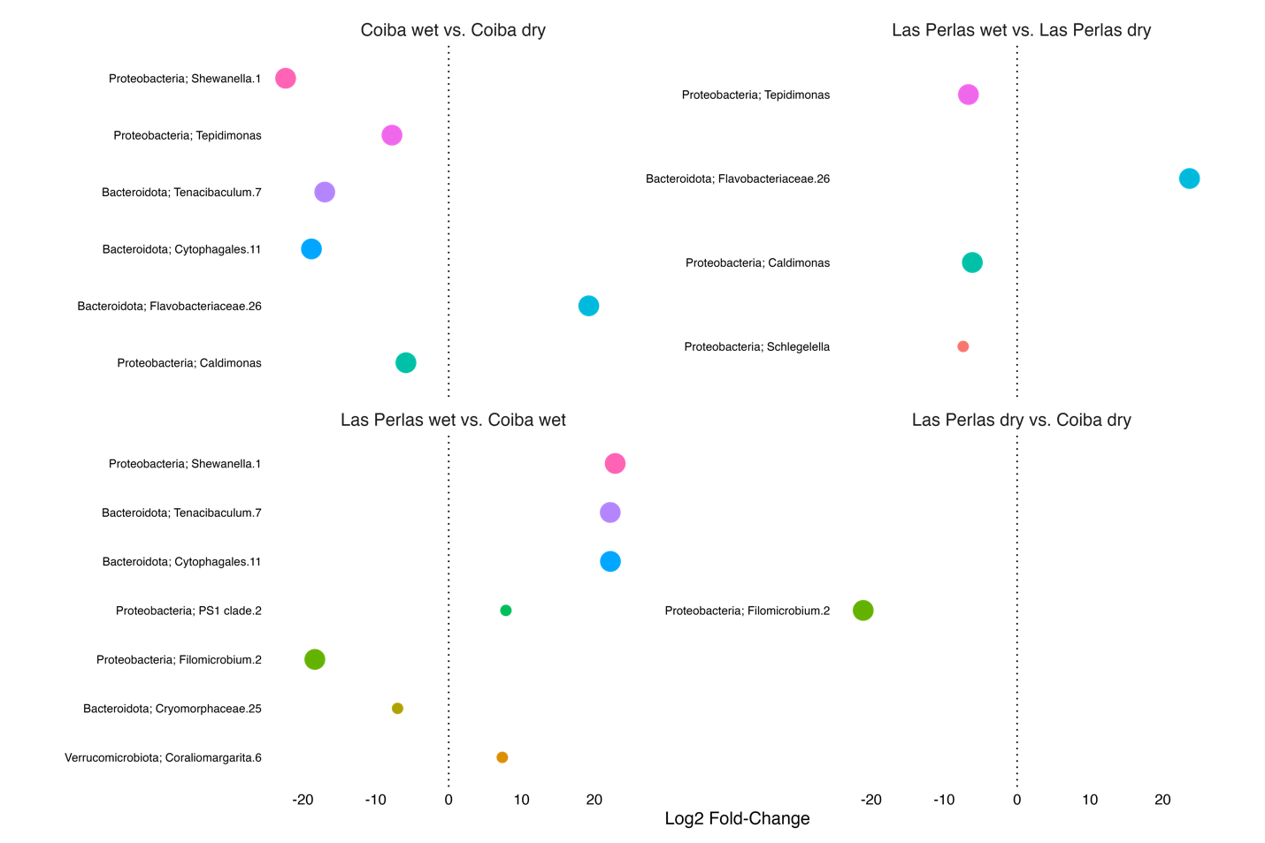
Figure S12: C. panamensis taxa differential abundance in between seasons and regions: DESeq2. Log2-fold changes in all significantly differentially abundant taxa (p-adj < 0.05, Wald test, BH correction) per set of pairwise comparisons between fish microbiome communities (e.g., Coiba – Gulf of Chiriquí wet season vs. Coiba dry season; top left-hand panel). Lowest p-adjusted values displayed at top of plot. Point size corresponds to the number of times each taxon was among the significant taxa across all four panels and colours are maintained across all panels.

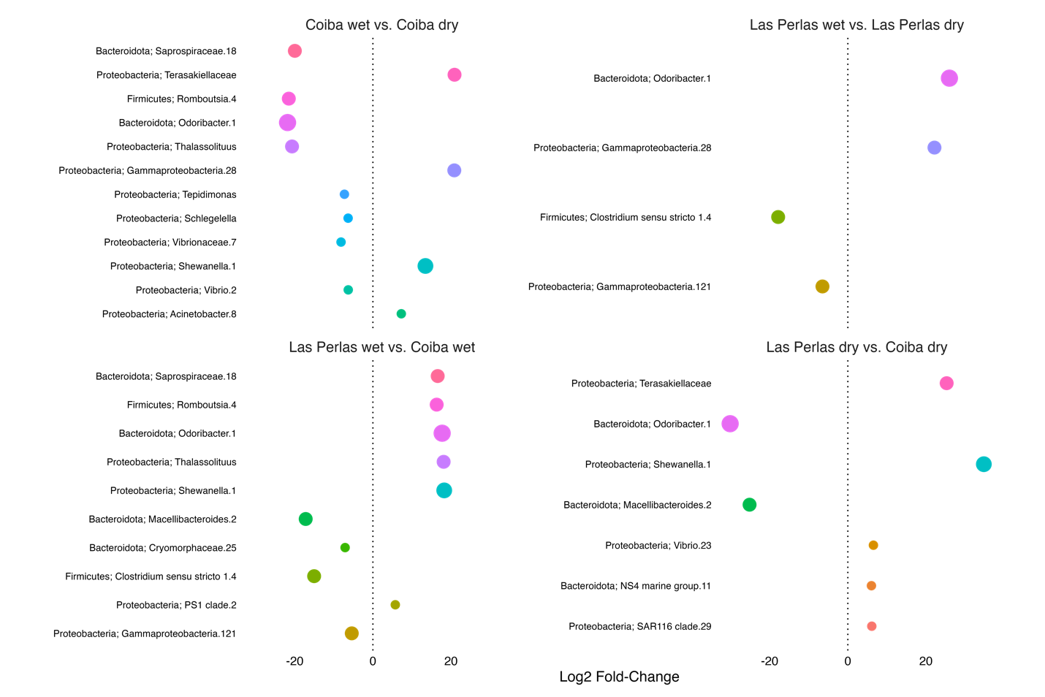
Figure S13: E. labriformis taxa differential abundance in between seasons and regions: DESeq2. Log2-fold changes in all significantly differentially abundant taxa (p-adj < 0.05, Wald test, BH correction) per set of pairwise comparisons between fish microbiome communities (e.g., Coiba – Gulf of Chiriquí wet season vs. Coiba dry season; top left-hand panel). Lowest p-adjusted values displayed at top of plot. Point size corresponds to the number of times each taxon was among the significant taxa across all four panels and colours are maintained across all panels.

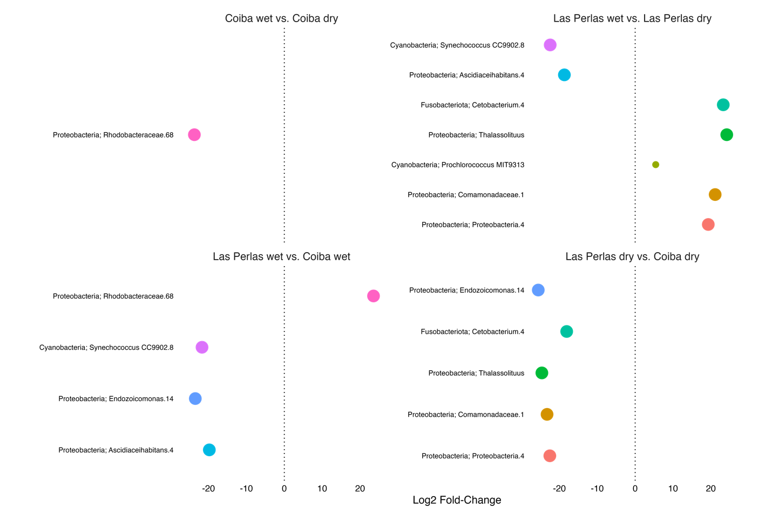
Figure S14: C. colonus taxa differential abundance in between seasons and regions: DESeq2. Log2-fold changes in all significantly differentially abundant taxa (p-adj < 0.05, Wald test, BH correction) per set of pairwise comparisons between fish microbiome communities (e.g., Coiba – Gulf of Chiriquí wet season vs. Coiba dry season; top left-hand panel). Lowest p-adjusted values displayed at top of plot. Point size corresponds to the number of times each taxon was among the significant taxa across all four panels and colours are maintained across all panels.

