Supplementary materials
Shared genetic architecture across fibrotic diseases

Table of content
- Supplementary Note: Cohort information on ethics and genotyping and imputation details
- Supplementary Figure 1. Manhattan plot of plantar fibromatosis
- Supplementary Figure 2. Manhattan plot of Peyronie´s disease
- Supplementary Figure 3. Manhattan plot of phimosis
- Supplementary Figure 4. Manhattan plot of trigger finger
- Supplementary Figure 5. Manhattan plot of hypertrophic skin
- Supplementary Figure 6. Manhattan plot of idiopathic pulmonary fibrosis
- Supplementary Figure 7. Manhattan plot of Dupuytren´s contracture
- Supplementary Figure 8. Manhattan plot of cirrhosis
- Supplementary Figure 9. Manhattan plot of chronic kidney disease
- Supplementary Figure 10. Manhattan plot of systemic sclerosis
- Supplementary Figure 11. Manhattan plot of inflammatory bowel disease
- Supplementary Figure 12. Tissue enrichment
- Supplementary Figure 13. Genetic variants and effect estimates
- Supplementary Figure 14. Multi-disease colocalization plots for organ/non-organ pairs
- Supplementary Figure 15. Pathway enrichment for organ fibrotic diseases
- Supplementary Figure 16. Pathway enrichment for non-organ fibrotic diseases
- Supplementary Figure 16. Cell enrichment for organ fibrotic diseases
- Supplementary Figure 18. Cell enrichment for non-organ fibrotic diseases
Supplementary Note: Cohort information on ethics and genotyping and imputation details
- Copenhagen Hospital Biobank (CHB)¹
  - Ethics: The biological samples stored in CHB were based on leftover material from routine blood analyses. Patients were informed by electronic mail (E-Boks) about the opt-out possibility of CHB, by either having their biological specimens excluded from use in research in general or having their samples specifically excluded from CHB. Since 2004 a national Register on Tissue Application (Vævsanvendelsesregistret) lists all individuals who have chosen to opt out and whose samples cannot be used for research purposes. Before initiating this study, individuals listed in the Register on Tissue Application were excluded.
  - The study was conducted under the CHB-oral cardiometabolic health protocol approved by the Zealand Region Committee on Health Research Ethics and the Capital Region Data Protection Office (SJ-989 and P-2022-913).
  - Genotyping and imputation: Samples were genotyped using Illumina Global Screening Array chips and long-range phased together with ~238,000 genotyped samples from North-western Europe using Eagle. Samples and variants with less than 98% yield were excluded. A haplotype reference panel was prepared in the same manner as for the Icelandic data (see below) by phasing whole-genome sequence genotypes of 15,576 individuals from Scandinavia, the Netherlands, and Ireland using the phased chip data. Graphtyper was used to call the genotypes which were subsequently imputed into the phased chip data. Whole genome sequencing, chip-typing, quality control, long-range phasing, and imputation from which the data for this analysis were generated was performed at deCODE genetics.

- The Danish Blood Donor Study (DBDS)²
  - Ethics: For DBDS, informed consent was obtained from all participants. DBDS are approved by the National Committee on Health Research Ethics (NVC 1700407, SJ-470) and the Danish Data Protection Agency (P-2019-99).
  - Genotyping and imputation: Samples were genotyped using Illumina Global Screening Array chips and long-range phased together with ~238,000 genotyped samples from North-western Europe using Eagle. Samples and variants with less than 98% yield were excluded. A haplotype reference panel was prepared in the same manner as for the Icelandic data (see below) by phasing whole-genome sequence genotypes of 15,576 individuals from Scandinavia, the Netherlands, and Ireland using the phased chip data. Graphtyper was used to call the genotypes which were subsequently imputed into the phased chip data. Whole genome sequencing, chip-typing, quality control, long-range phasing, and imputation from which the data for this analysis were generated was performed at deCODE genetics.

- UK Biobank³
  - Ethics: The UK Biobank cohort has been approved by the Northwest Multicenter Research Ethics Committee, UK (Ref: 16/NW/0274). Written informed consent has been obtained from all study participants.
  - Genotyping and imputation: Genotypic data were available for 488,380 individuals and were imputed to the HRC, UK10K and 1,000 Genomes Phase 3 reference panels using IMPUTE4 to identify ≈ 93M variants for 487,409 individuals. Using the genotyped SNPs, persons were excluded if they had: high levels of missingness or heterozygosity, SNP genotype call rate < 98%, or if phenotypic and genotypic gender information was discordant.

- FinnGen⁴
  - Ethics: Patients and control subjects in FinnGen provided informed consent for biobank research, based on the Finnish Biobank Act. Separate research cohorts, gathered before the Finnish Biobank Act was initialized (in September 2013) and start of FinnGen (August 2017), were collected based on study-specific consents and later assigned to the Finnish biobanks after approval by Fimea, the National Supervisory Authority for Welfare and Health. The Coordinating Ethics Committee of the Hospital District of Helsinki and Uusimaa (HUS) approved the FinnGen study protocol Nr HUS/990/2017. The FinnGen study is approved by Finnish Institute for Health and Welfare (THL), approval number THL/2031/6.02.00/2017, amendments THL/1101/5.05.00/2017, THL/341/6.02.00/2018, THL/2222/6.02.00/2018, THL/283/6.02.00/2019, THL/1721/5.05.00/2019, Digital and population data service agency VRK43431/2017-3, VRK/6909/2018-3, VRK/4415/2019-3 the Social Insurance Institution (KELA) KELA 58/522/2017, KELA 131/522/2018, KELA 70/522/2019, KELA 98/522/2019, and Statistics Finland TK-53-1041-17.75
  - Genotyping and imputation: A custom-made FinnGen ThermoFisher Axiom array (>650,000 SNPs) was used to genotype FinnGen samples. Genotype calls were made with AxiomGT1 algorithm. Individuals with ambiguous gender, high genotype missingness (>5%), excess heterozygosity (±4 SD), and non-Finnish ancestry were excluded. Variants with high missingness (>2%), low Hardy-Weinberg equilibrium (< 1×10-6), or low minor allele count (<3) were excluded. High coverage (25–30×) WGS data were used to develop the Finnish population-specific SISu v3 imputation reference panel with Beagle 4.1. More than 16 million variants have been imputed (https://finngen.gitbook.io/documentation/methods/genotype-imputation).

- Million Veteran Program⁵
  - Ethics: The MVP cohort was approved by VA Central Institutional Review Board. All participants provided written informed consent.⁶
  - Genotyping and imputation: Genotyping was by a custom-made array (the ‘MVP 1.0 array’), which is based on the Affymetrix Axiom Biobank Array and includes approximately 723,000 markers. Quality control procedures included a normalization procedure for mitigating plate-to-plate variation, cleaning and harmonizing genotype calls across batches, excluding samples with contamination, mislabeling, misidentification, >5% missingness of genotypes, or sex mismatch. Markers with >1% missingness as well as non-autosomal markers were removed. The QC procedures are described in detail in Hunter-Zink et al.13

Supplementary Figure 1. Manhattan plot of plantar fibromatosis
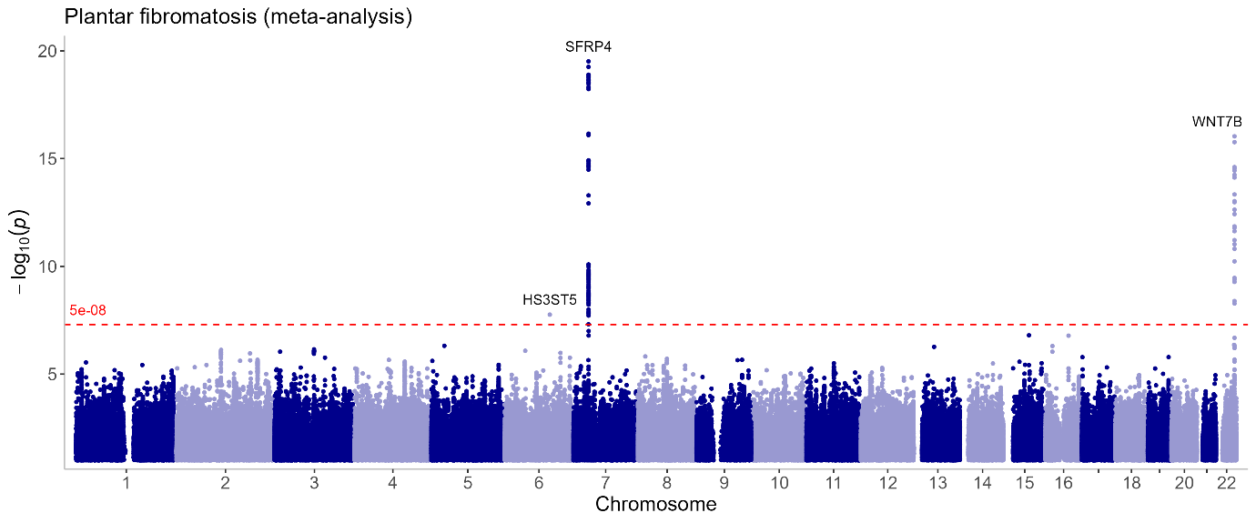
Legend
Figure shows a Manhattan plot. Annotation by nearest gene. See Supplementary Table 1 for sample size inclusion.
Supplementary Figure 2. Manhattan plot of Peyronie´s disease
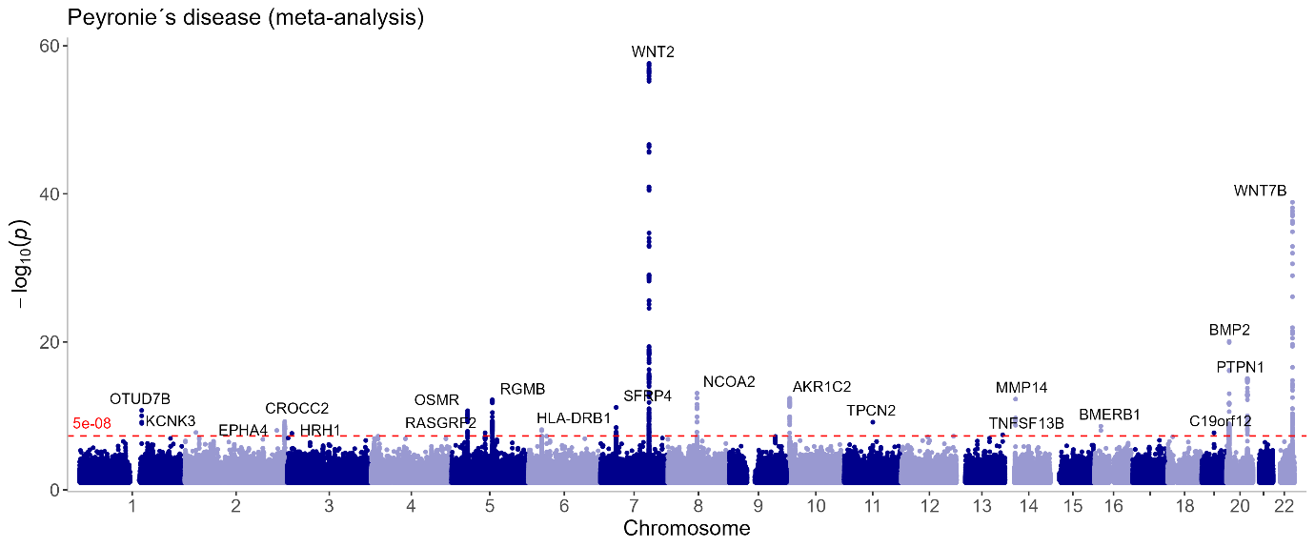
Legend
Figure shows a Manhattan plot. Annotation by nearest gene. See Supplementary Table 1 for sample size inclusion.
Supplementary Figure 3. Manhattan plot of phimosis
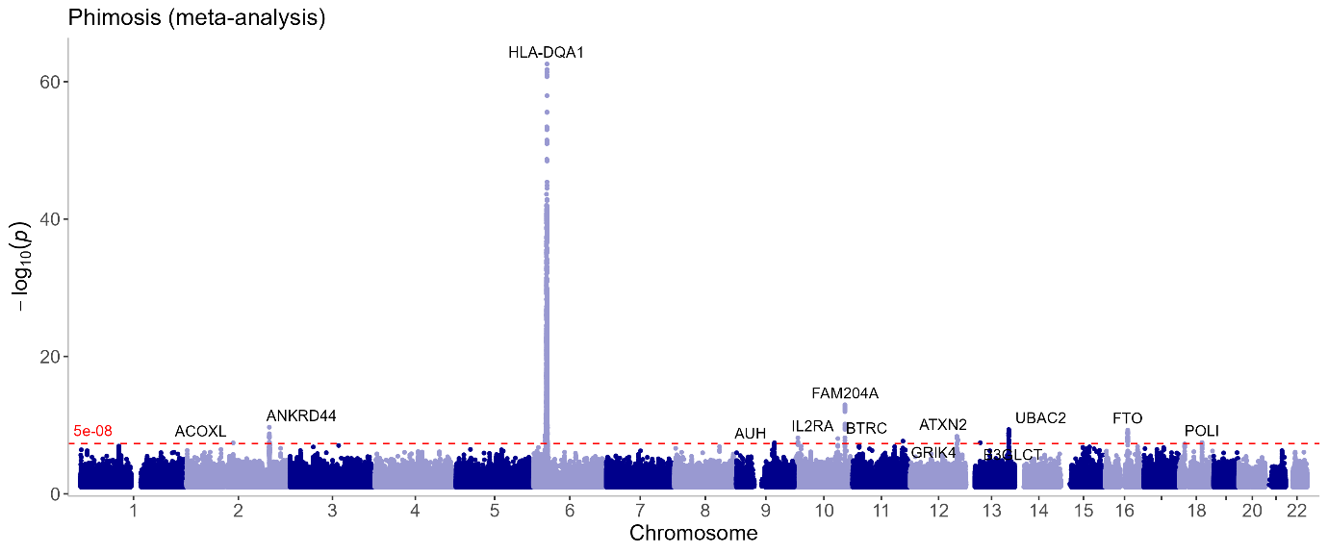
Legend
Figure shows a Manhattan plot. Annotation by nearest gene. See Supplementary Table 1 for sample size inclusion.
Supplementary Figure 4. Manhattan plot of trigger finger
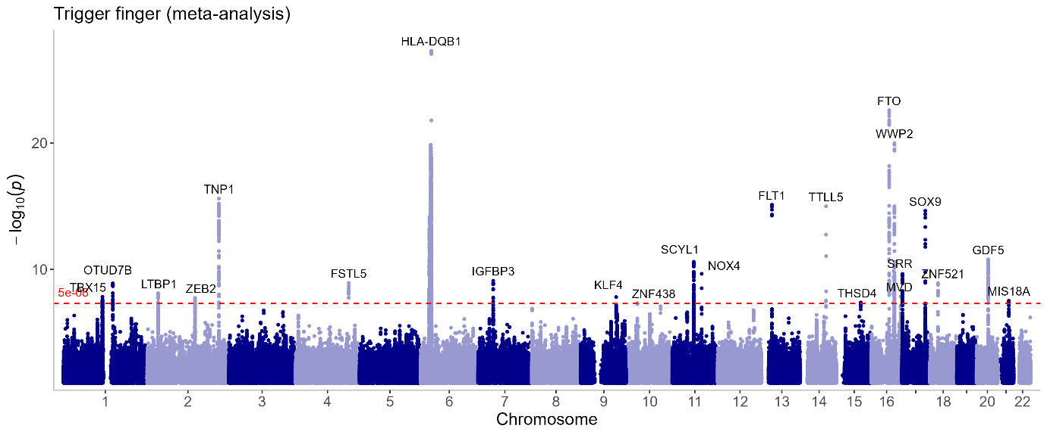
Legend
Figure shows a Manhattan plot. Annotation by nearest gene. See Supplementary Table 1 for sample size inclusion.
Supplementary Figure 5. Manhattan plot of hypertrophic skin
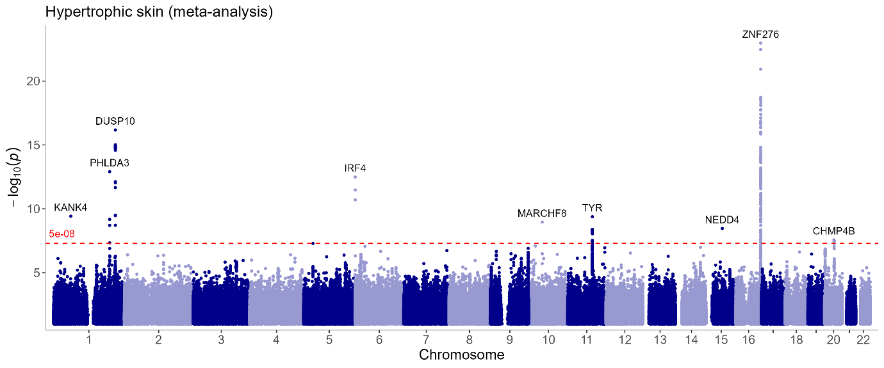
Legend
Figure shows a Manhattan plot. Annotation by nearest gene. See Supplementary Table 1 for sample size inclusion.
Supplementary Figure 6. Manhattan plot of idiopathic pulmonary fibrosis
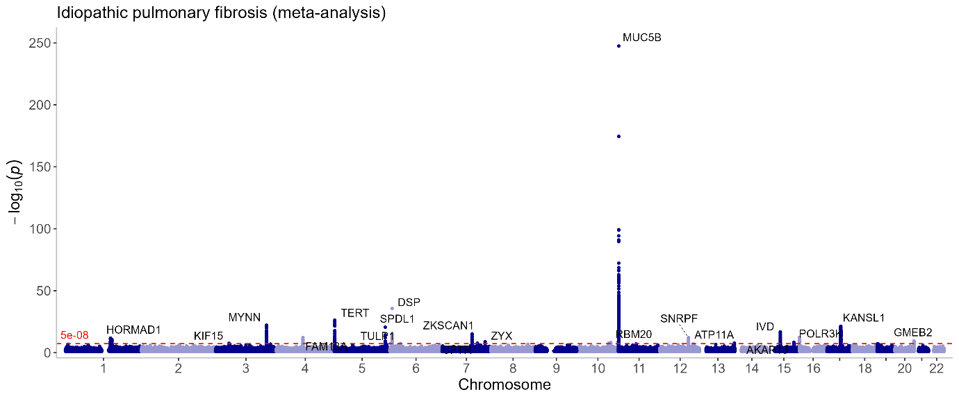
Legend
Figure shows a Manhattan plot. Annotation by nearest gene. See Supplementary Table 1 for sample size inclusion. Y-axis truncated at -log10(P) of 300 to add gene names, however hit on CHR 11 at -log10(P) of 358.
Supplementary Figure 7. Manhattan plot of Dupuytren´s contracture
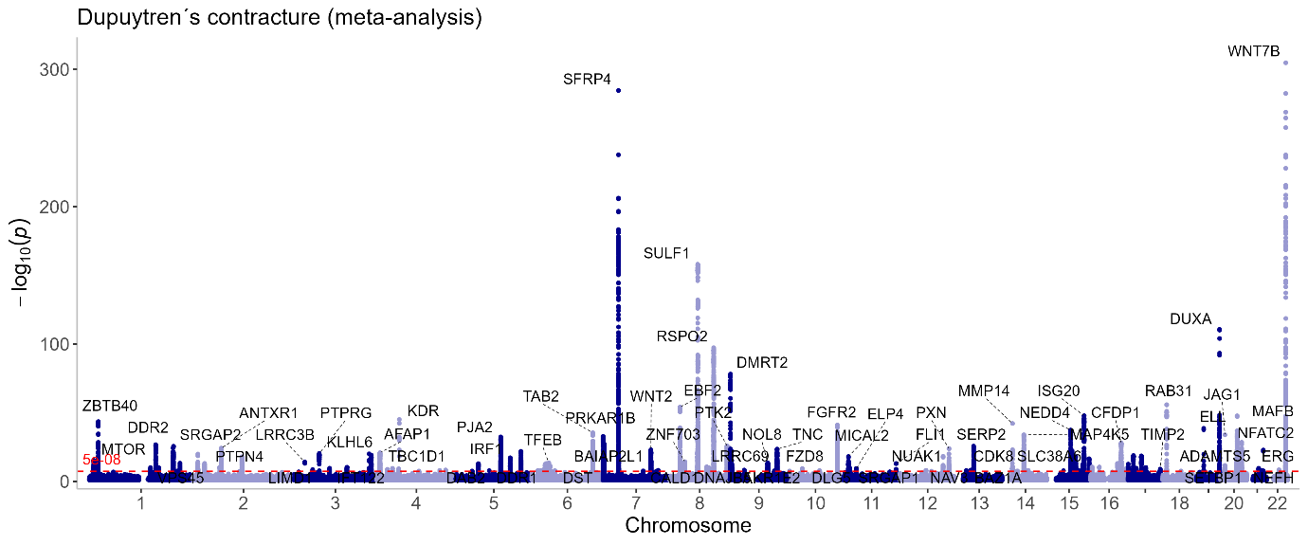
Legend
Figure shows a Manhattan plot. Annotation by nearest gene. See Supplementary Table 1 for sample size inclusion. Y-axis truncated at -log10(P) of 300 to add gene names, however hit on CHR 22 at -log10(P) of 847.
Supplementary Figure 8. Manhattan plot of cirrhosis
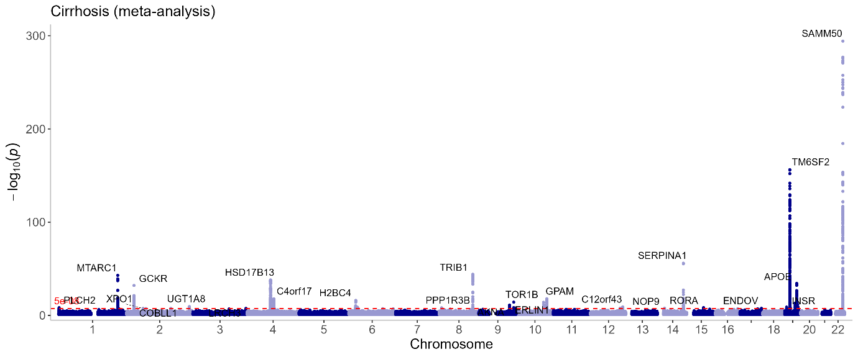
Legend
Figure shows a Manhattan plot. Annotation by nearest gene. See Supplementary Table 1 for sample size inclusion. Y-axis truncated at -log10(P) of 300 to add gene names, however hit on CHR 22 at -log10(P) of 648.

Supplementary Figure 9. Manhattan plot of chronic kidney disease
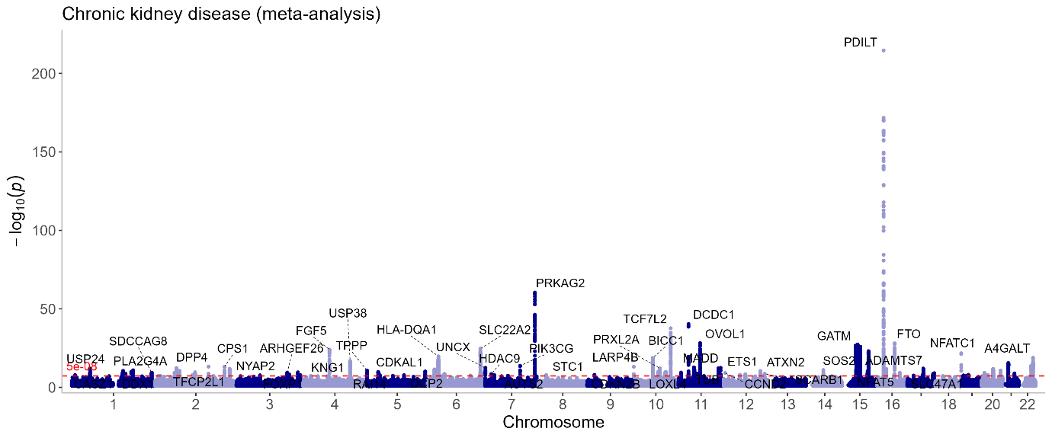
Legend
Figure shows a Manhattan plot. Annotation by nearest gene. See Supplementary Table 1 for sample size inclusion.
Supplementary Figure 10. Manhattan plot of systemic sclerosis
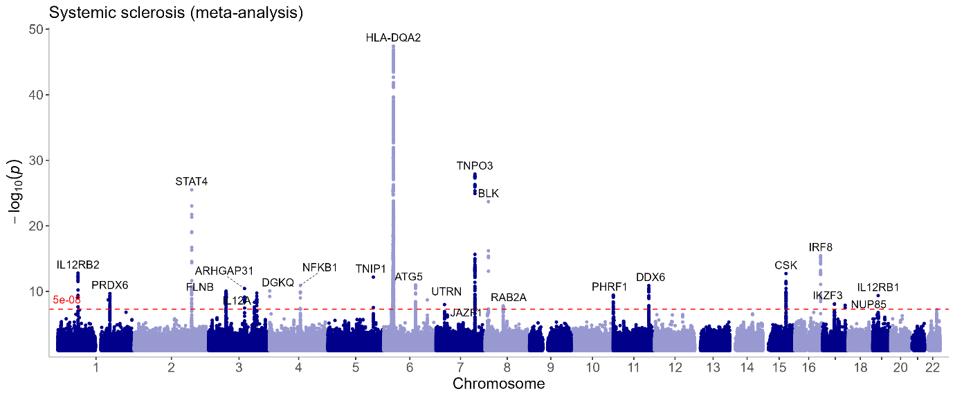
Legend
Figure shows a Manhattan plot. Annotation by nearest gene. See Supplementary Table 1 for sample size inclusion.
Supplementary Figure 11. Manhattan plot of inflammatory bowel disease
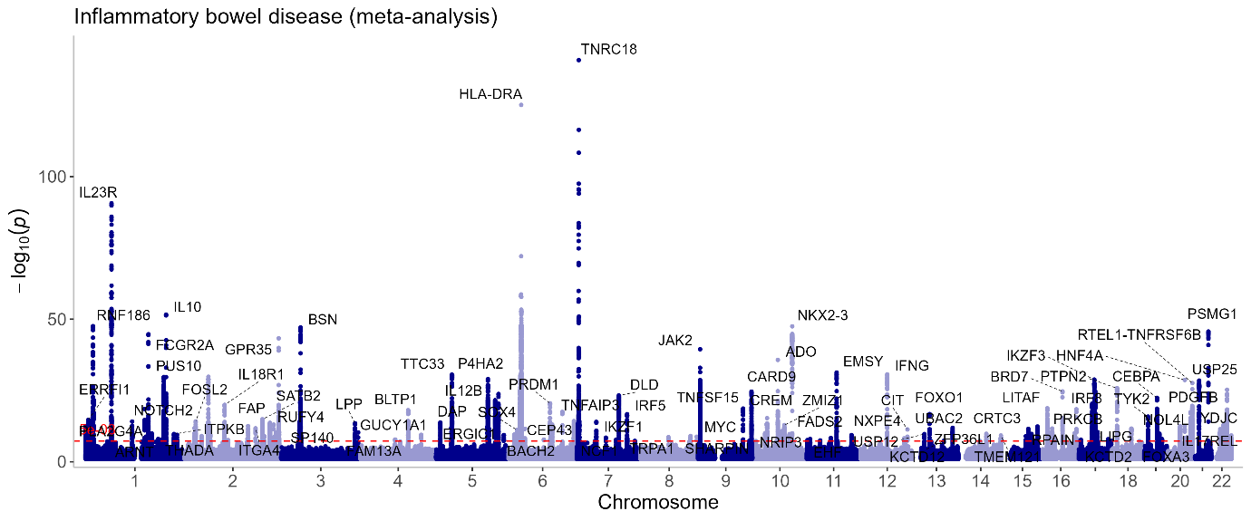
Legend
Figure shows a Manhattan plot. Annotation by nearest gene. See Supplementary Table 1 for sample size inclusion.
Supplementary Figure 12. Tissue enrichment
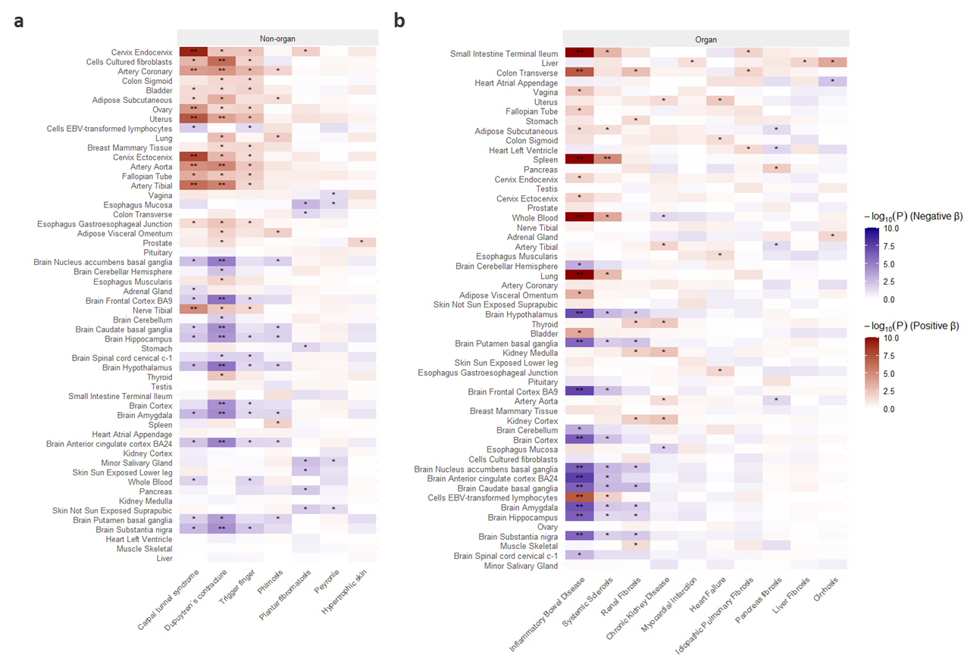
Legend
Tissue enrichment plots using MAGMA per summary statistics for a) Non-organ fibrotic diseases, and b) Organ fibrotic diseases. Red indicates positive Betas and blue indicates negative Betas. One asterisk (*) indicates if p-value is significant and two asterisks (**) denotes if p-value is significant after Bonferroni correction (0.05/(tissues*traits)).

Supplementary Figure 13. Variant frequency and effect correlations.

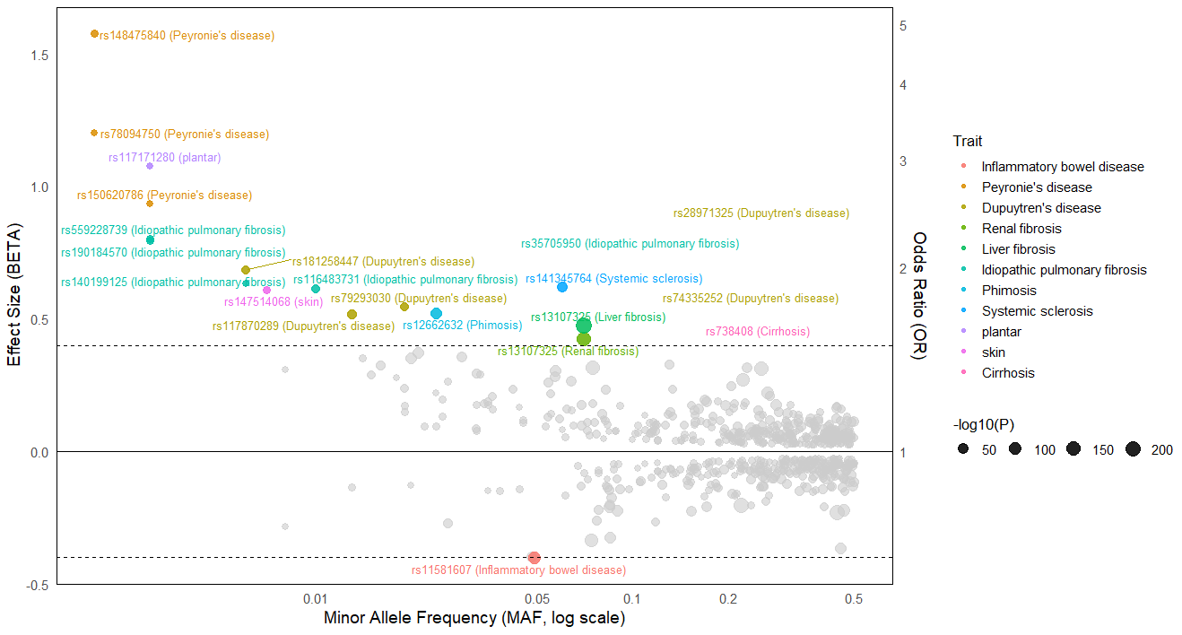Legend
x-axis shows minor allele frequency (MAF) and y-axis shows effect estimates (beta and odds ratio). Colored dots are for absolute BETA > 0.4.

Supplementary Figure 14. Multi-disease colocalization plots for organ/non-organ pairs
Chromosome: 1, Window: 21.9-22.9 MBP

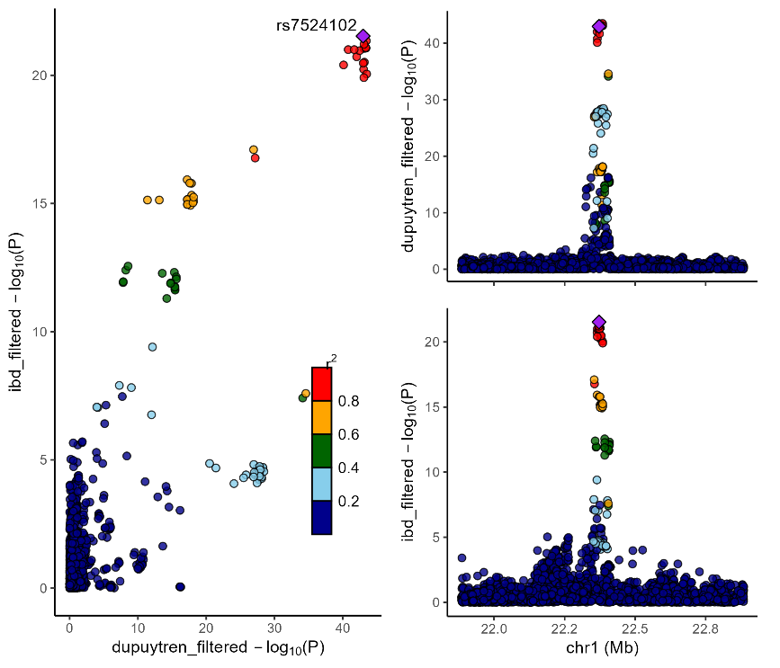
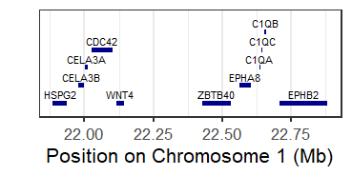
ZBTB40
Dupuytren
IBD

Chromosome: 2, Window: 64.9-65.9 MBP
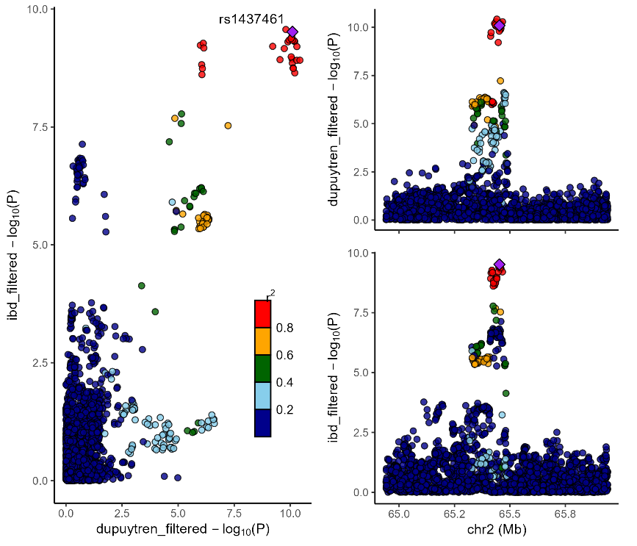
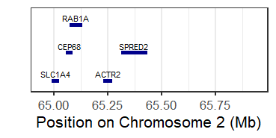
SPRED2
Dupuytren
IBD

Chromosome: 2, Window: 164.1-165.1 MBP

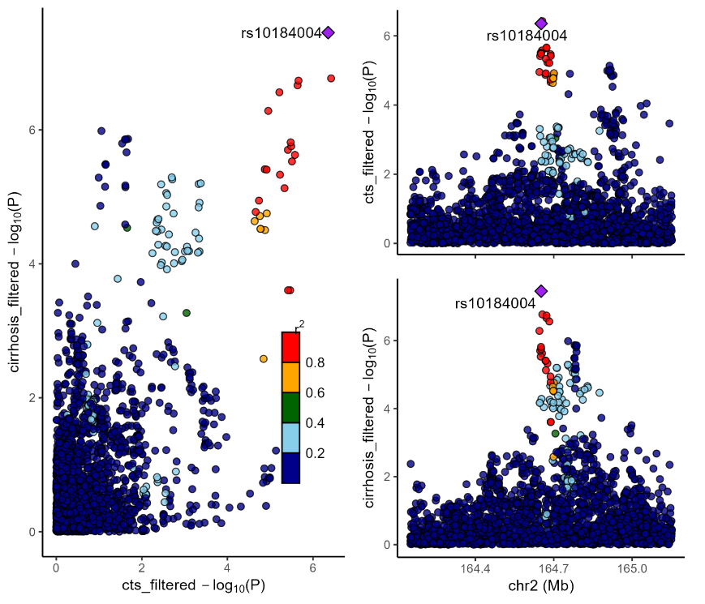
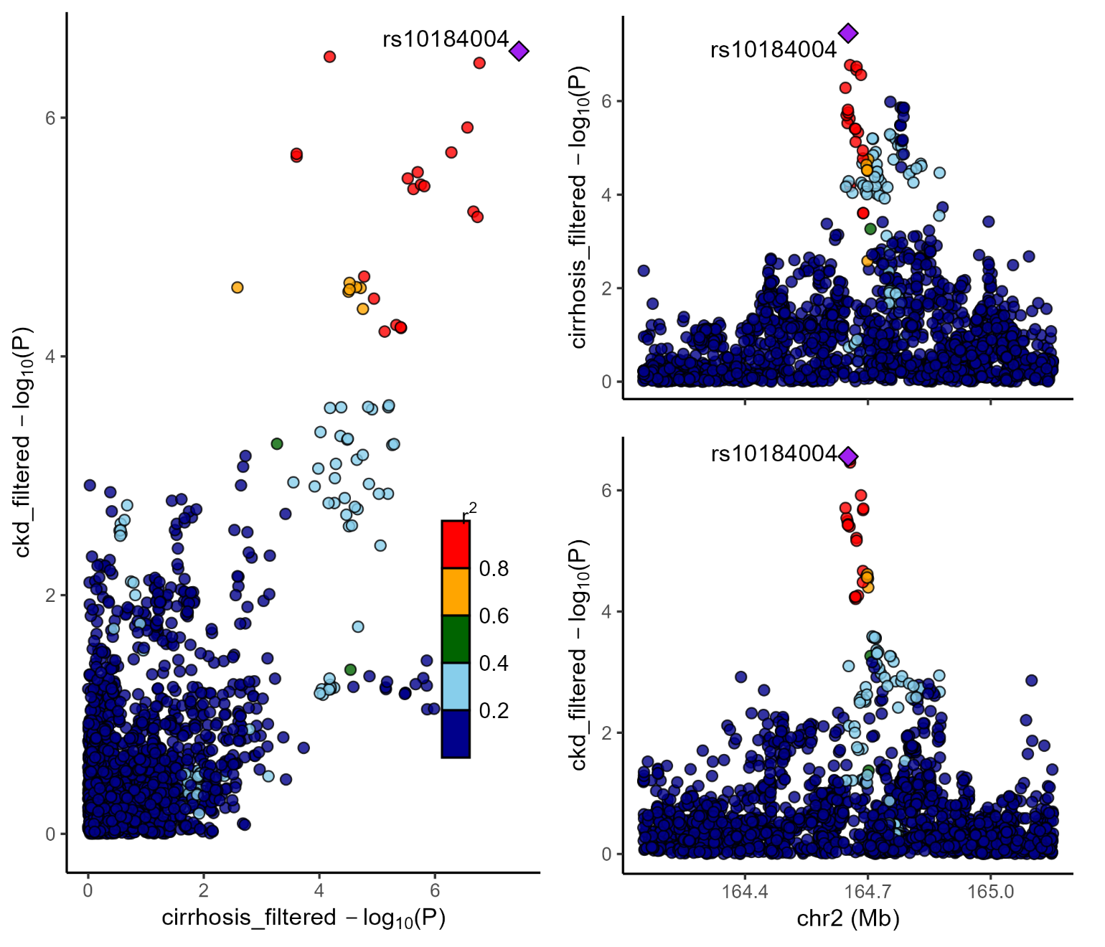
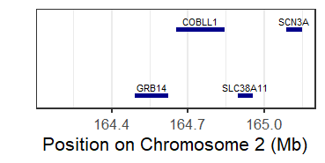
COBLL1
CTS
Cirrhosis
CKD

Chromosome: 3, Window: 49.1-50.1 MBP
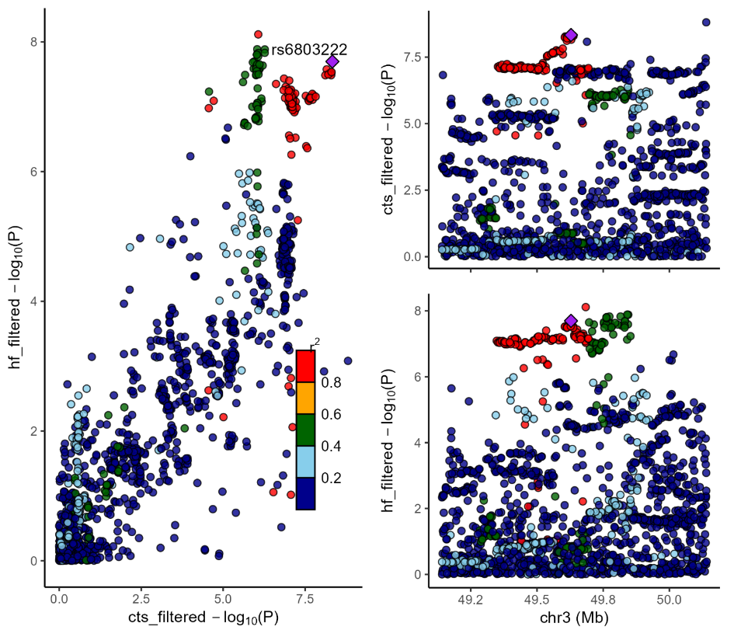
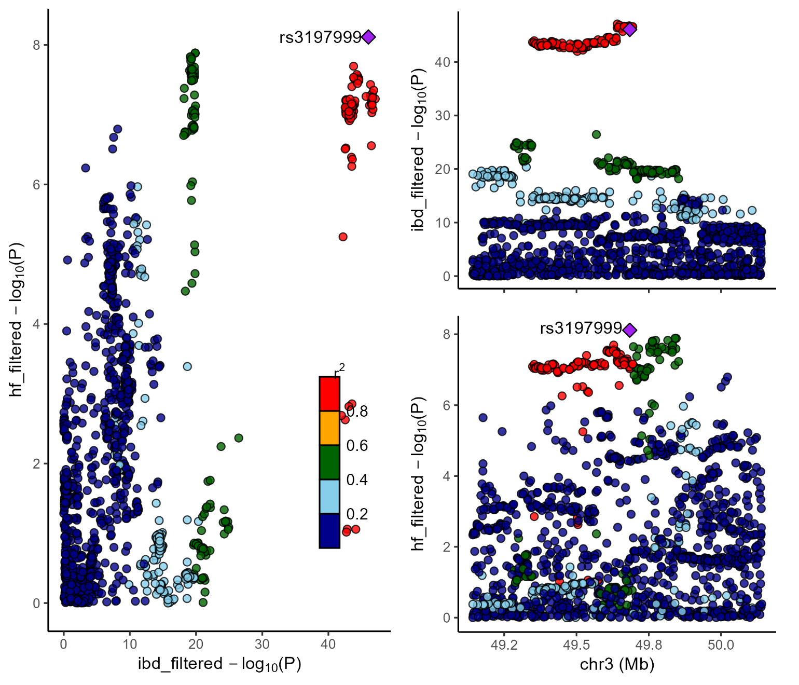
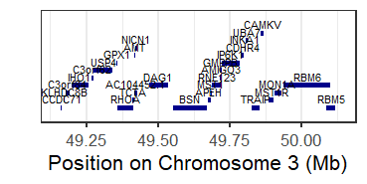
MST1
IBD
Heart failure
CTS

Chromosome: 4, Window: 101.8-102.8 MBP
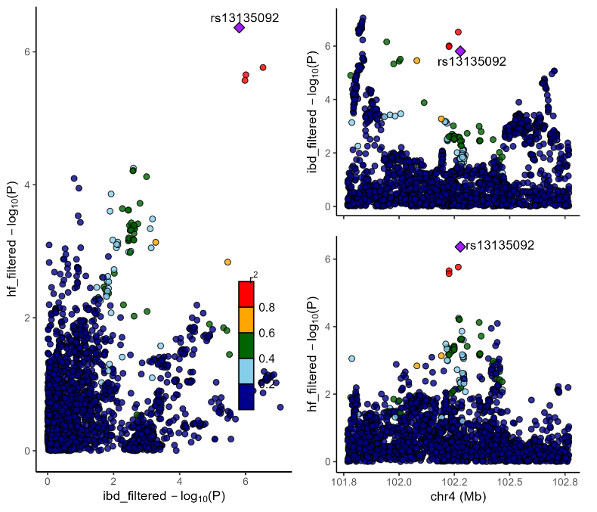
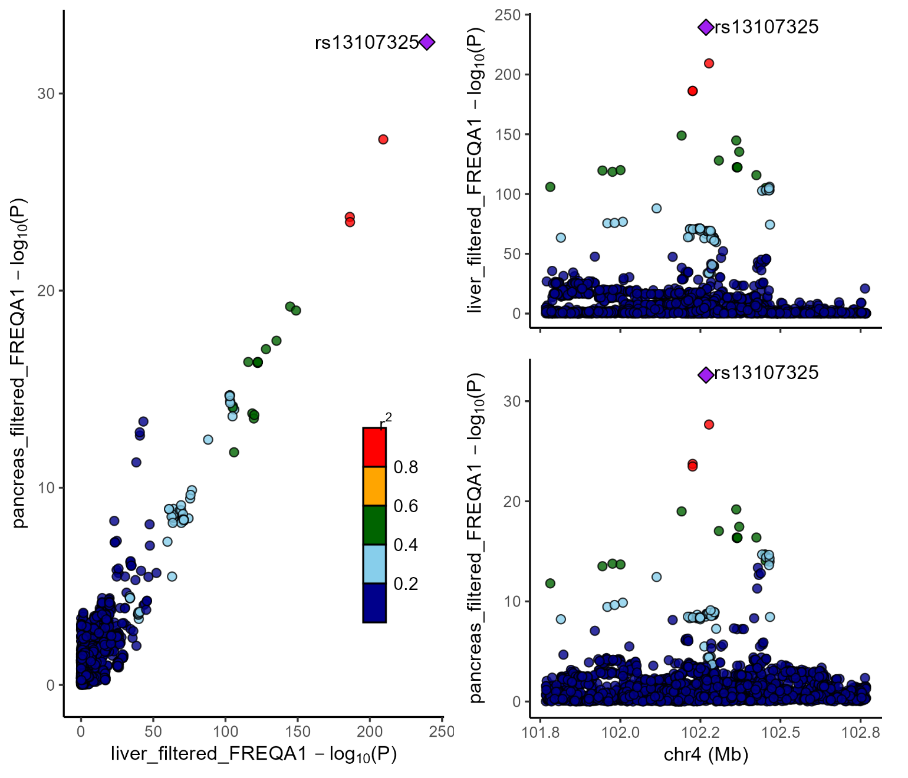
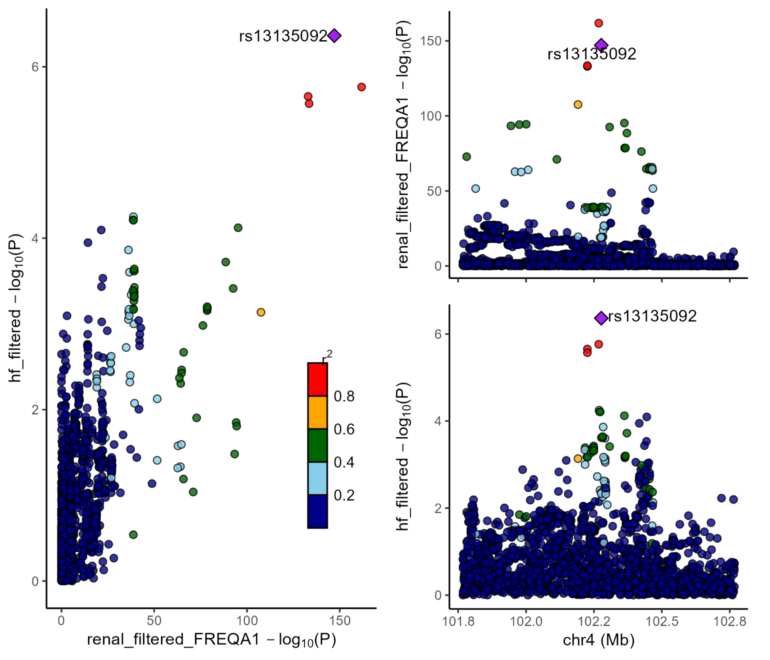
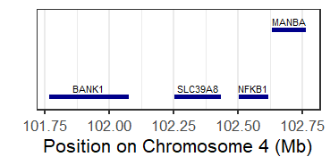
SLC39A8
Liver fibrosis
Pancreas fibr.
Heart failure
IBD
Renal fibrosis

Chromosome: 6, Window: 35.0-36.0 MBP
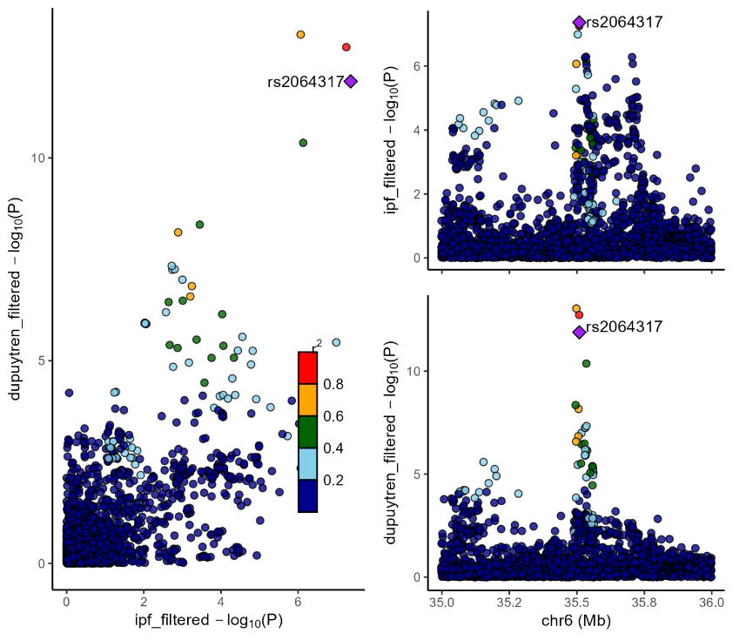
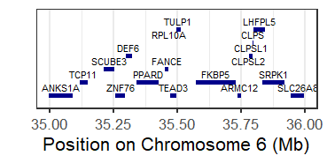
TULP1
IPF
Dupuytren

Chromosome: 9, Window: 21.6-22.6 MBP
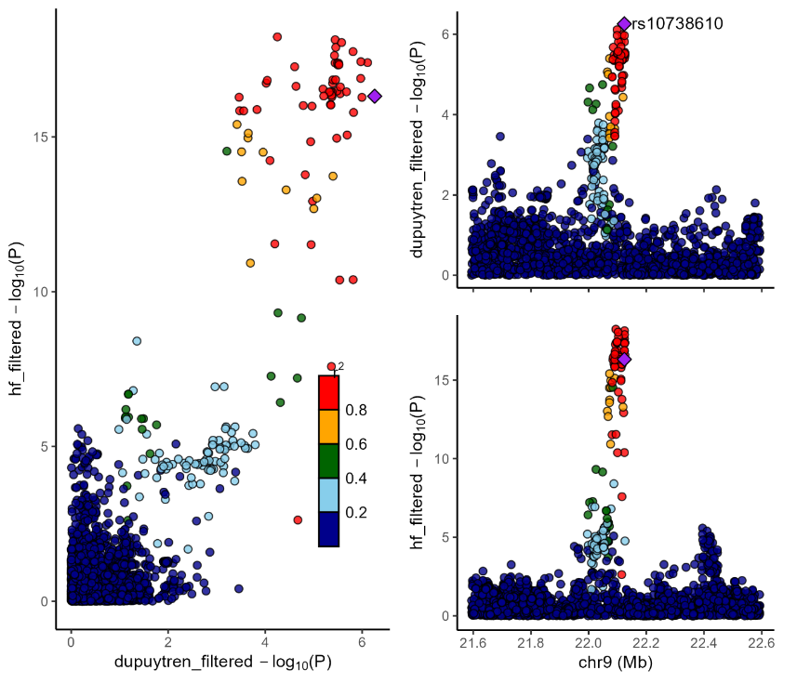
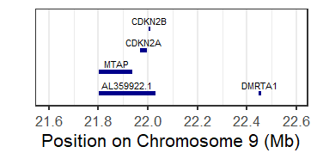
CDKN2B
Dupuytren
Heart failure

Chromosome: 10, Window: 97.6-98.6 MBP

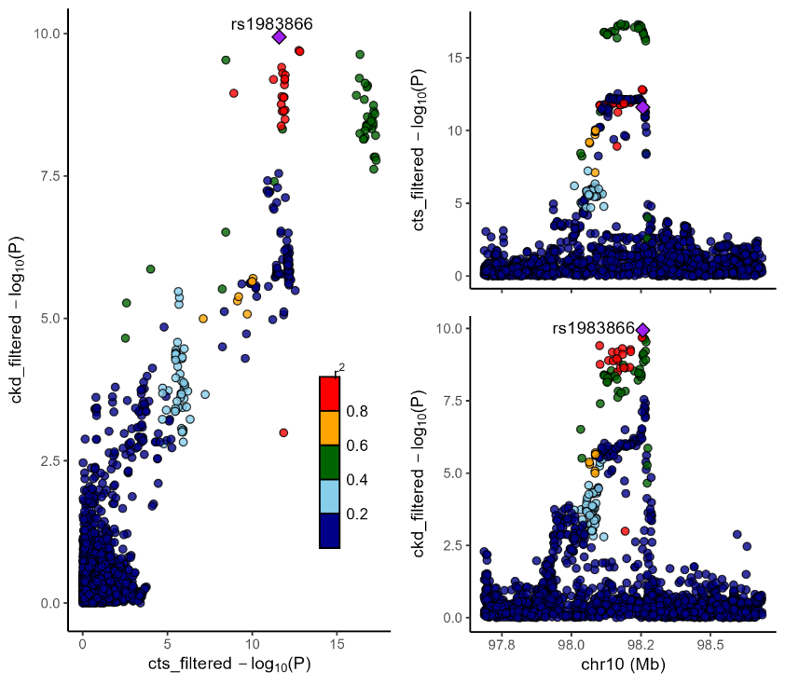
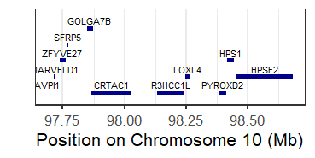
R3HCC1L
CTS
CKD

Chromosome: 12, Window: 110.9-111.9 MBP
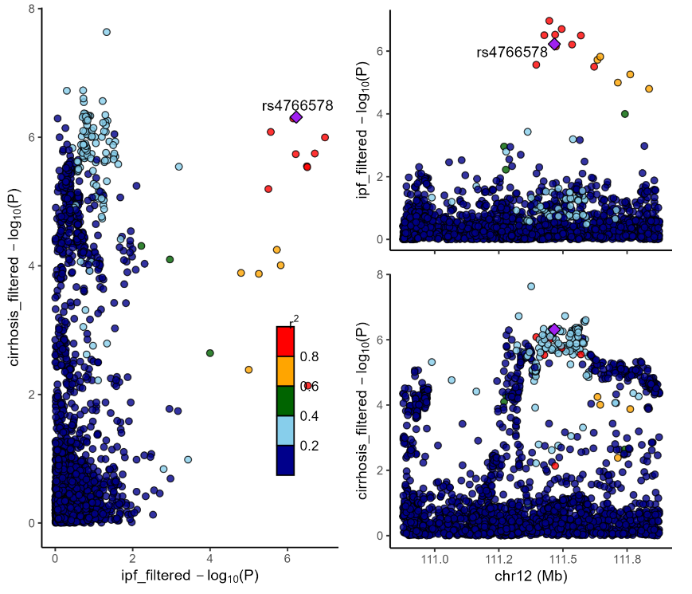
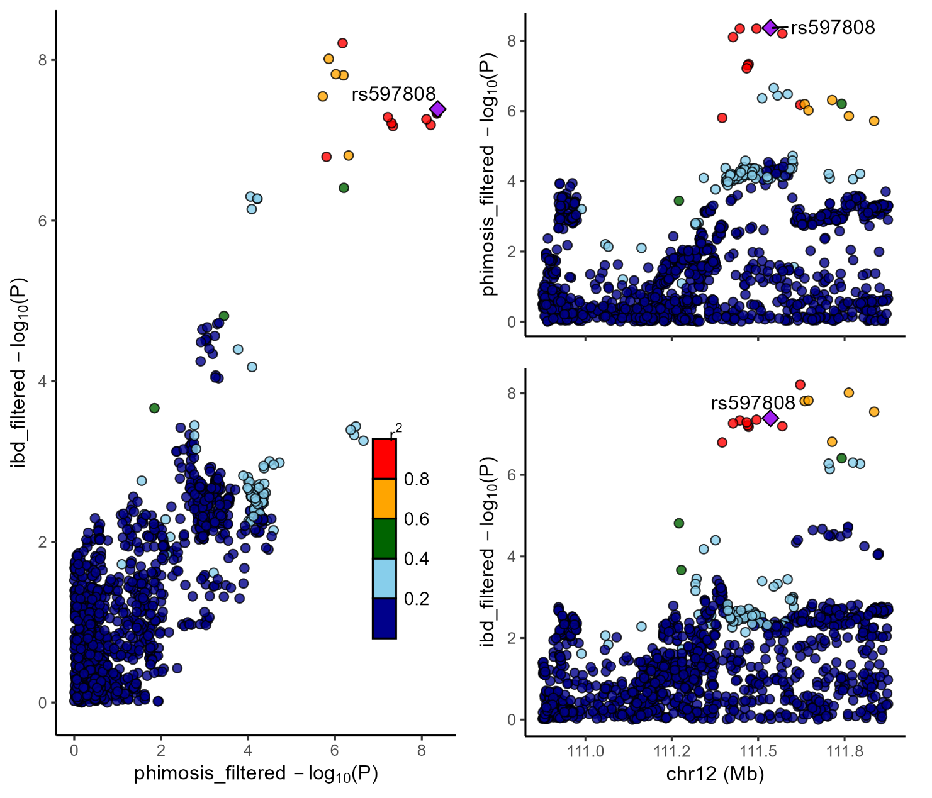
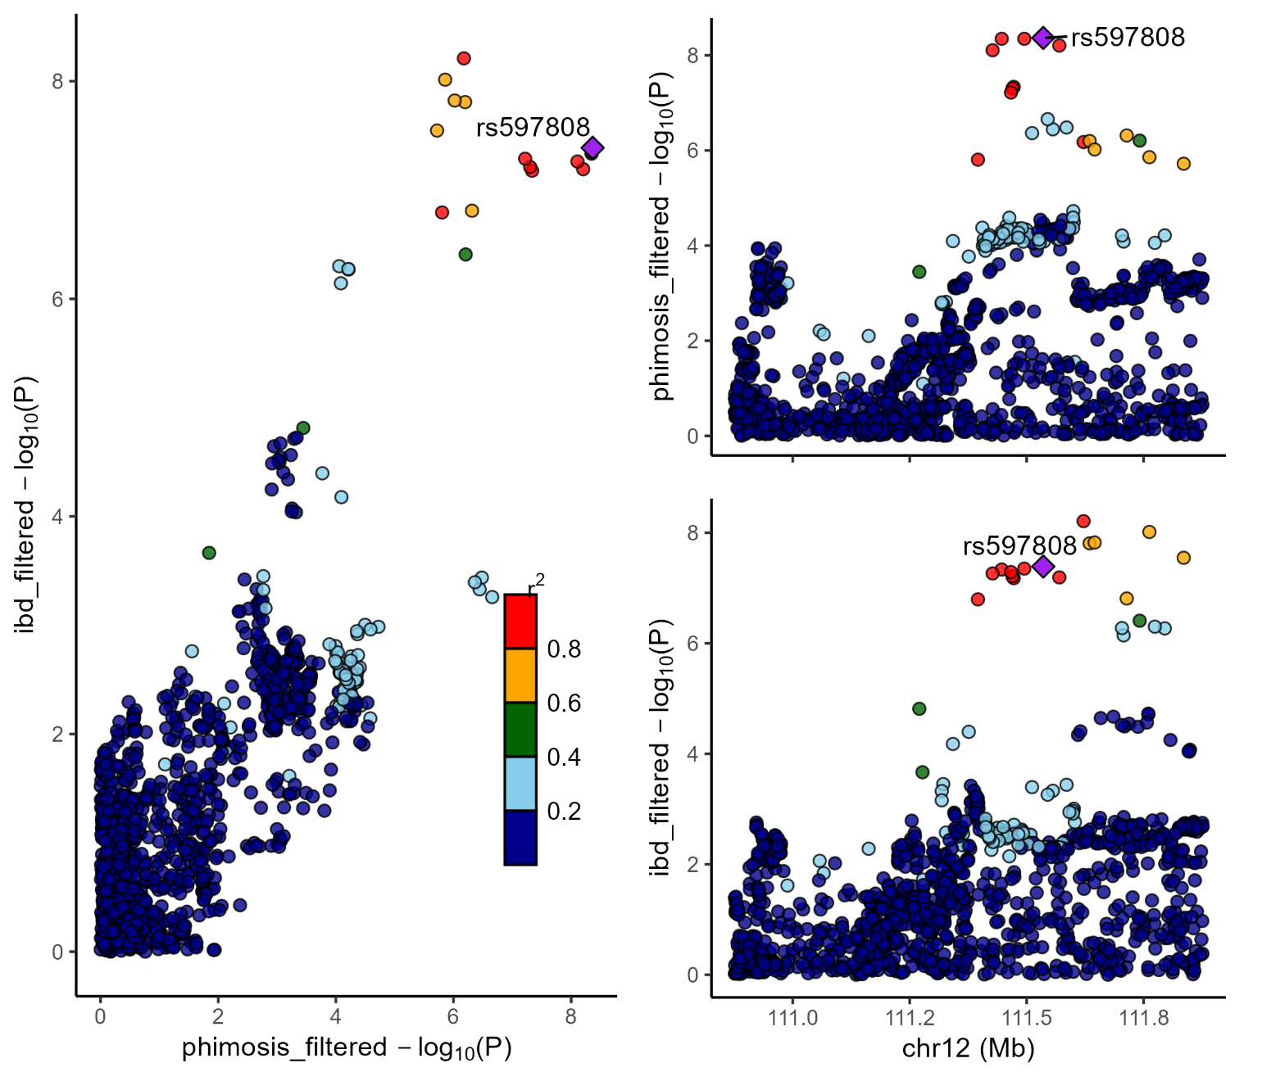
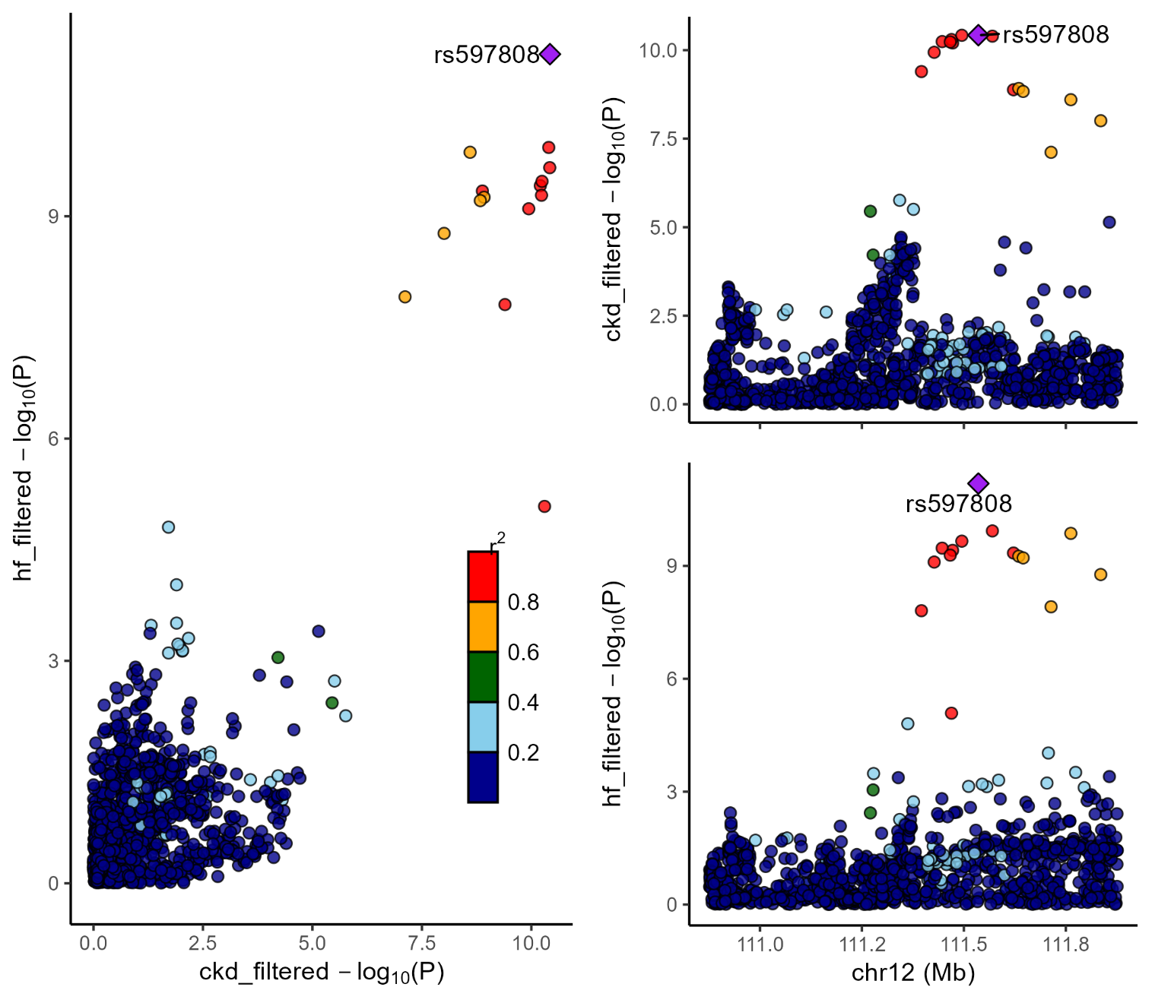
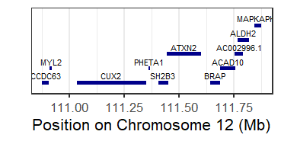
ATXN2
CKD
Heart failure
IPF
IBD
Phimosis
Chromosome: 13, Window: 98.9-99.9 MBP

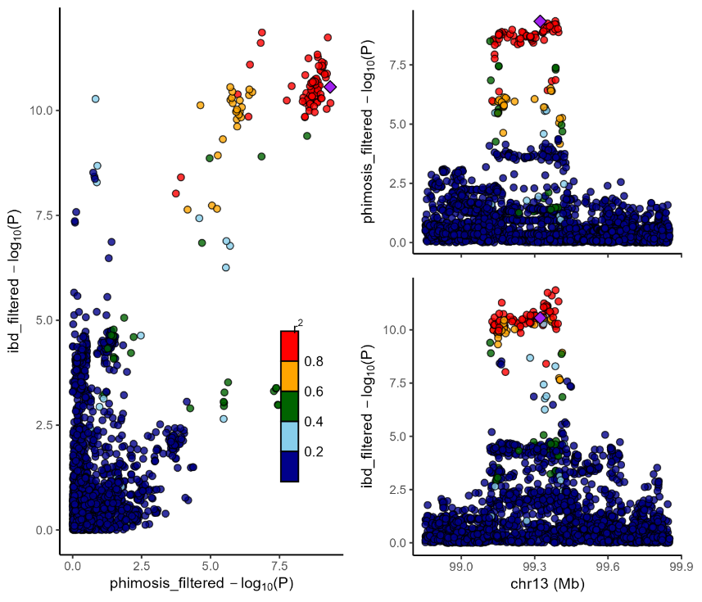
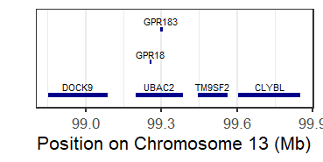
GPR18
Phimosis
IBD

Chromosome: 14, Window: 93.9-94.9 MBP
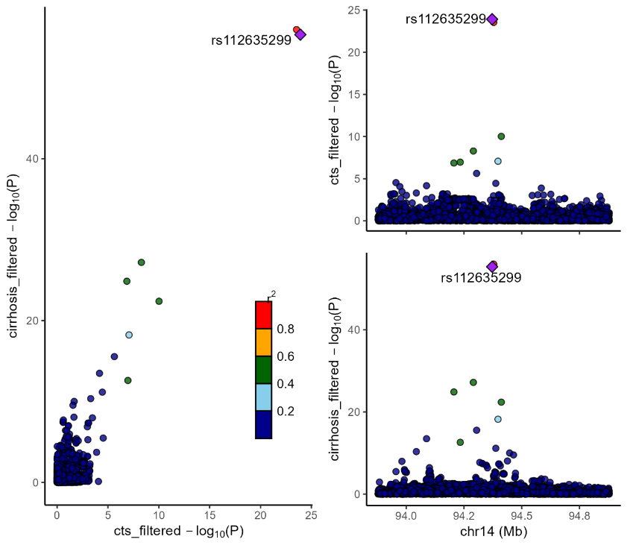
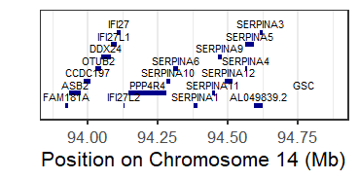
SERPINA1
CTS
Cirrhosis

Chromosome: 16, Window: 53.2-54.2 MBP
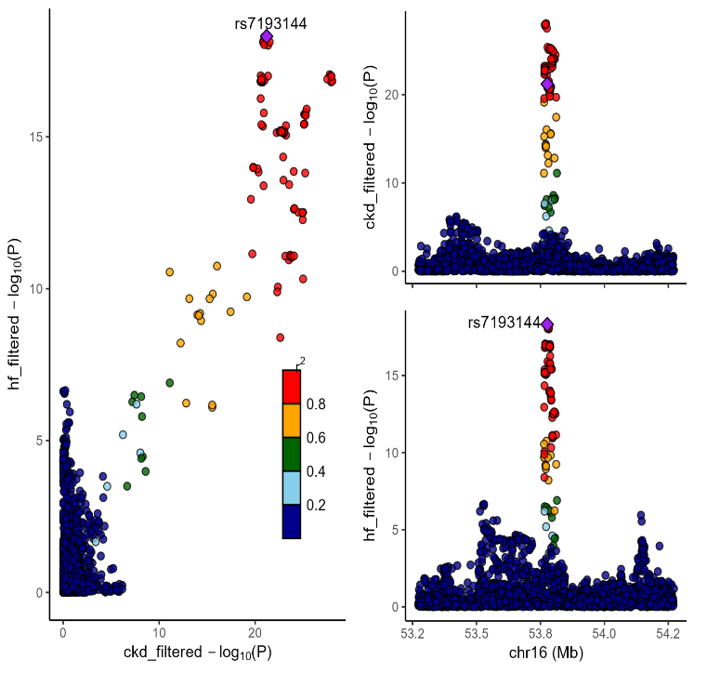
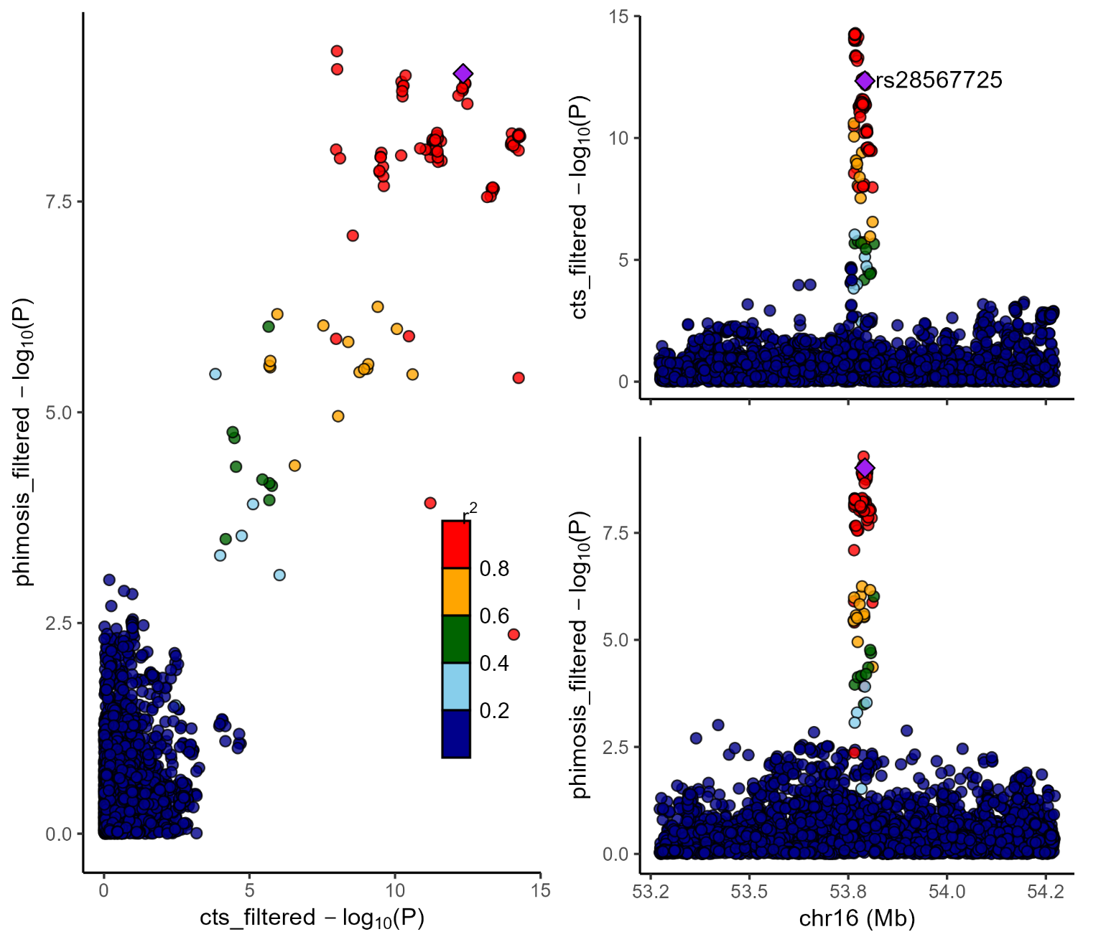
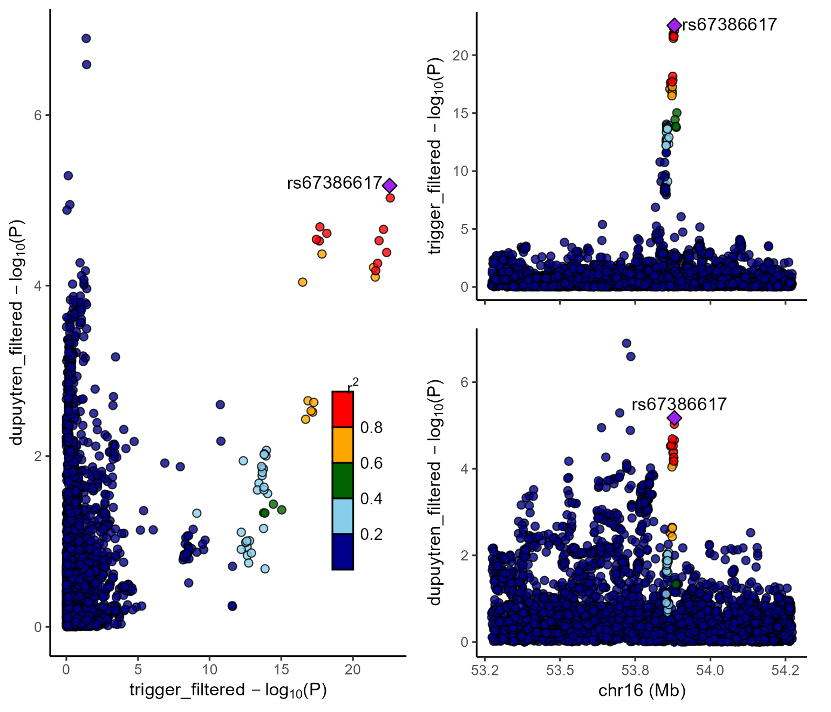
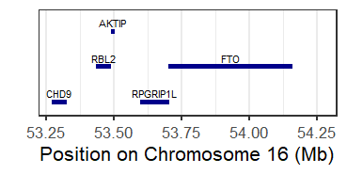
FTO
Trigger finger
Dupuytren
Phimosis
CTS
Heart failure
CKD

Chromosome: 17, Window: 1.7-2.7 MBP
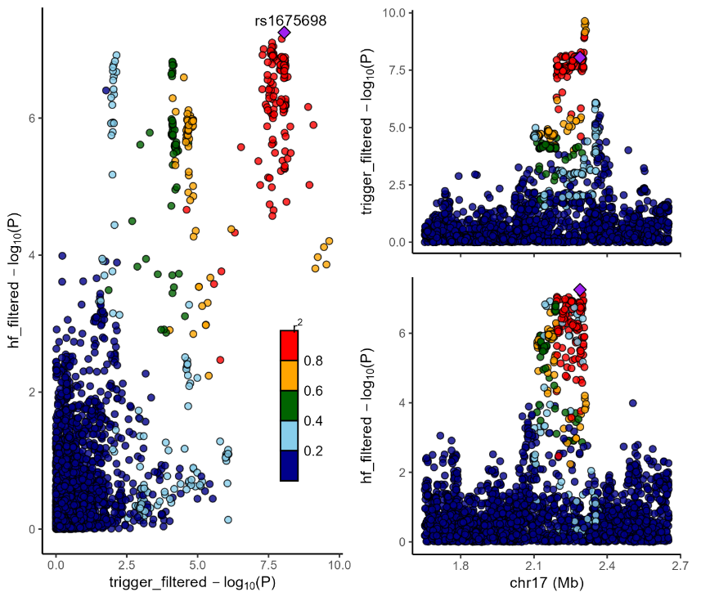
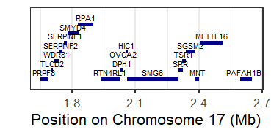
SRR/SMG6
Trigger finger
Heart failure

Chromosome: 17, Window: 46.4-47.4 MBP
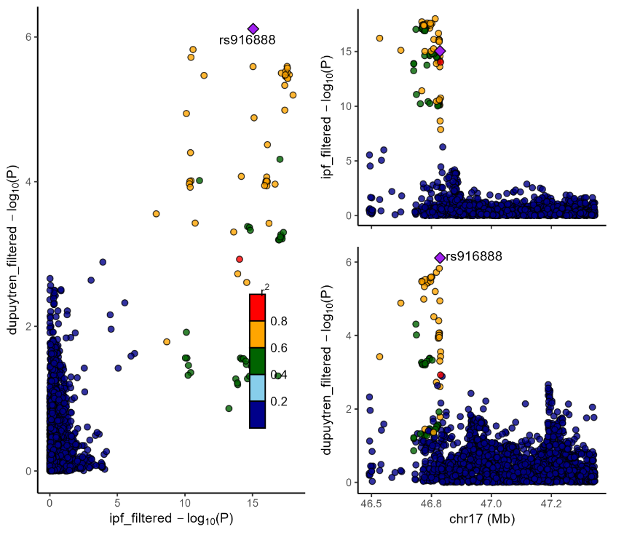
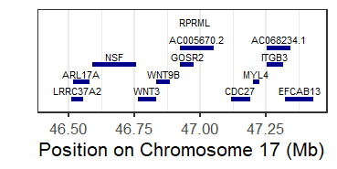
WNT3
IPF
Dupuytren

Chromosome: 18, Window: 78.9-79.9 MBP

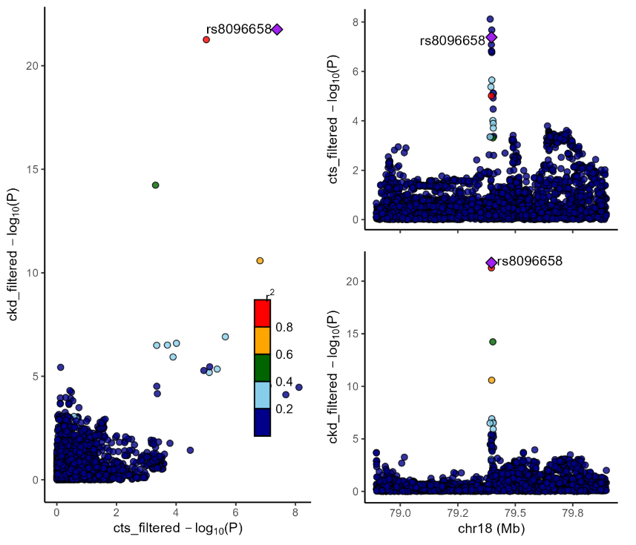
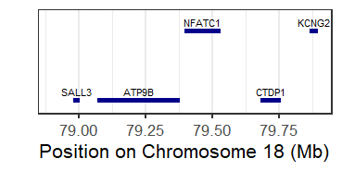
NFATC1
CTS
CKD

Legend
Colocalization analyses showing results for colocalized traits with PP4>0.7 for trait-trait with non-organ to organ pair
.

Supplementary Figure 15. Pathway enrichment for organ fibrotic diseases
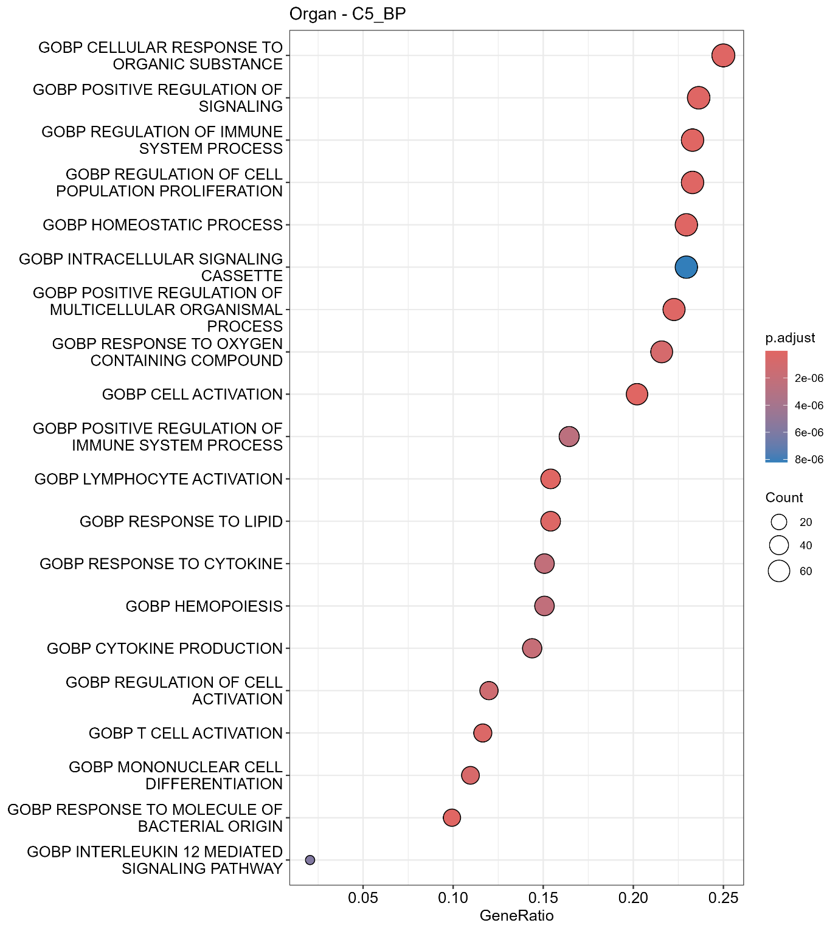
Legend: Illustrates pathway enrichment for gene ontology biologic pathways C5 for organ fibrosis diseases (myocardial fibrosis, cirrhosis, idiopathic pulmonary fibrosis, pancreas fibrosis, liver fibrosis, renal fibrosis, heart failure, chronic kidney disease, systemic sclerosis, inflammatory bowel disease) and sorted by GeneRatio as well as colored by P-values with adjustment by Bonferroni.

Supplementary Figure 16. Pathway enrichment for non-organ fibrotic diseases
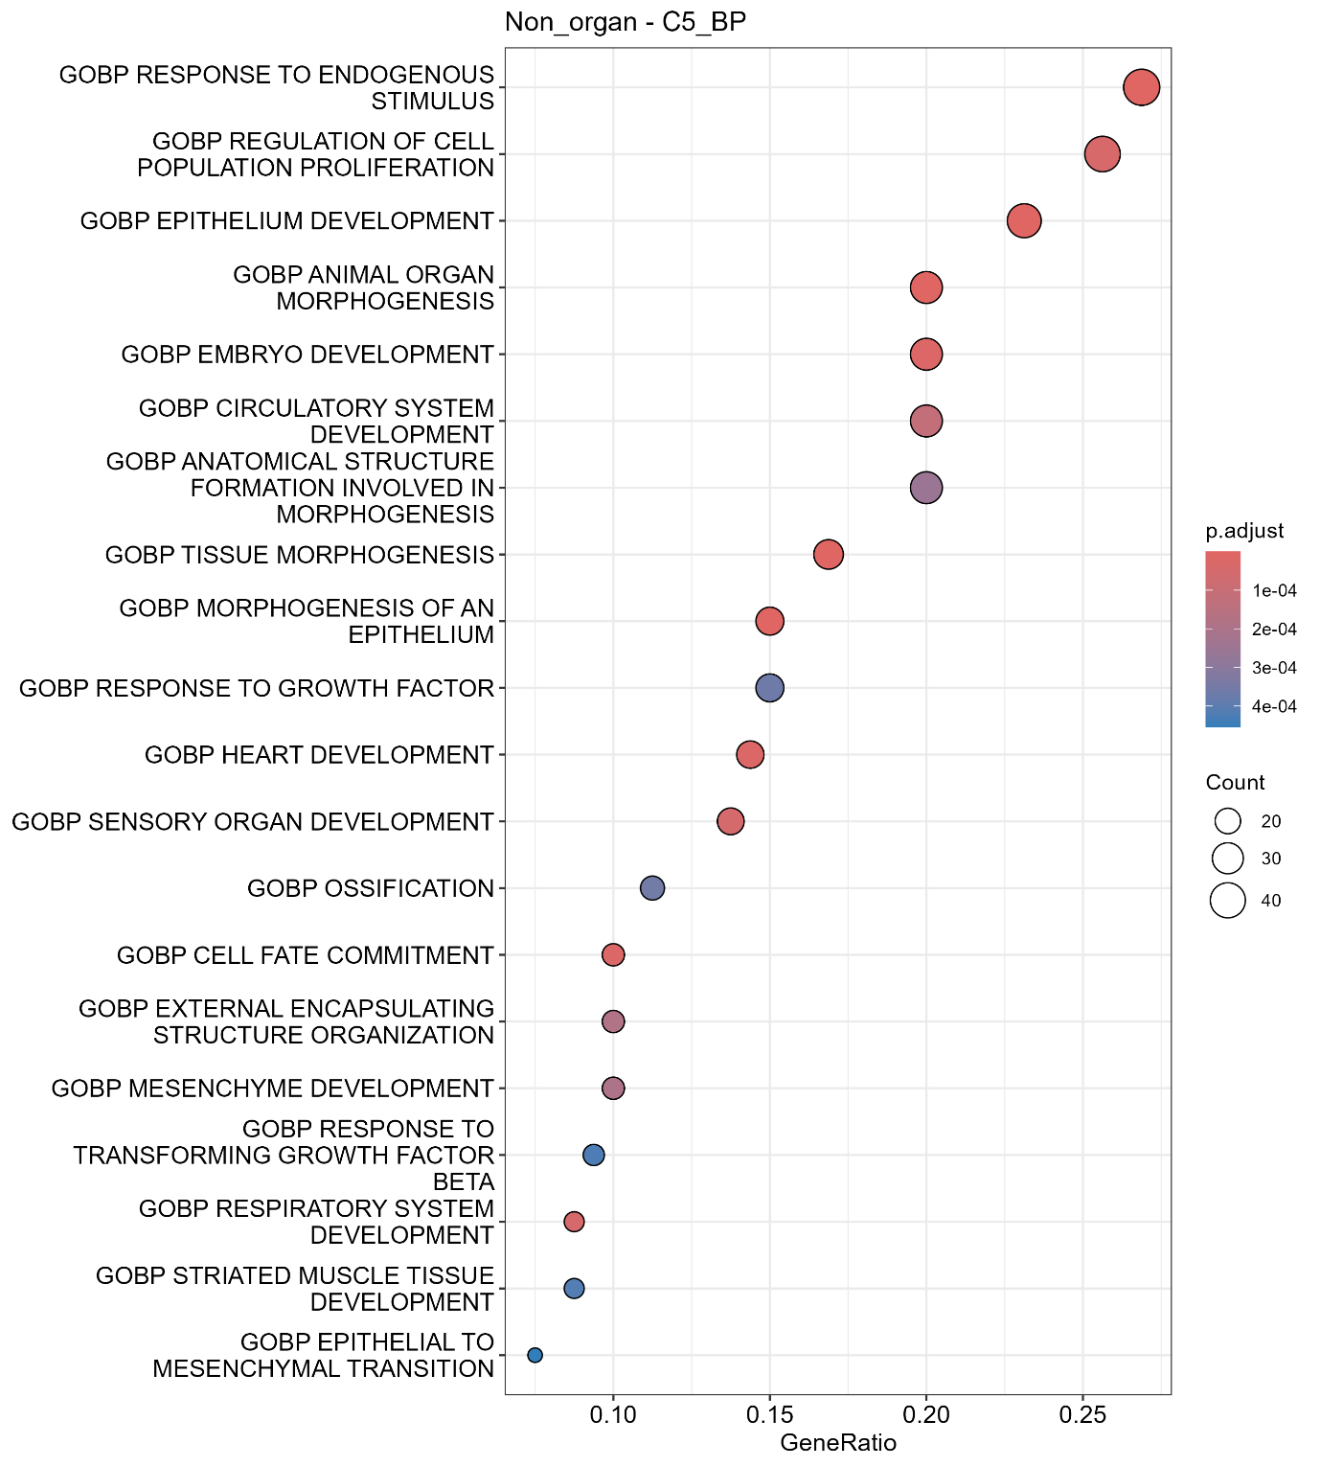
Legend: Illustrates pathway enrichment for gene ontology biologic pathways C5 for non-organ fibrosis diseases (Dupuytren´s contracture, Peyronie´s disease, plantar fibromatosis, trigger finger, hypertrophic skin, phimosis, carpal tunnel syndrome) and sorted by GeneRatio as well as colored by P-values with adjustment by Bonferroni.

Supplementary Figure 17. Cell enrichment for organ fibrotic diseases
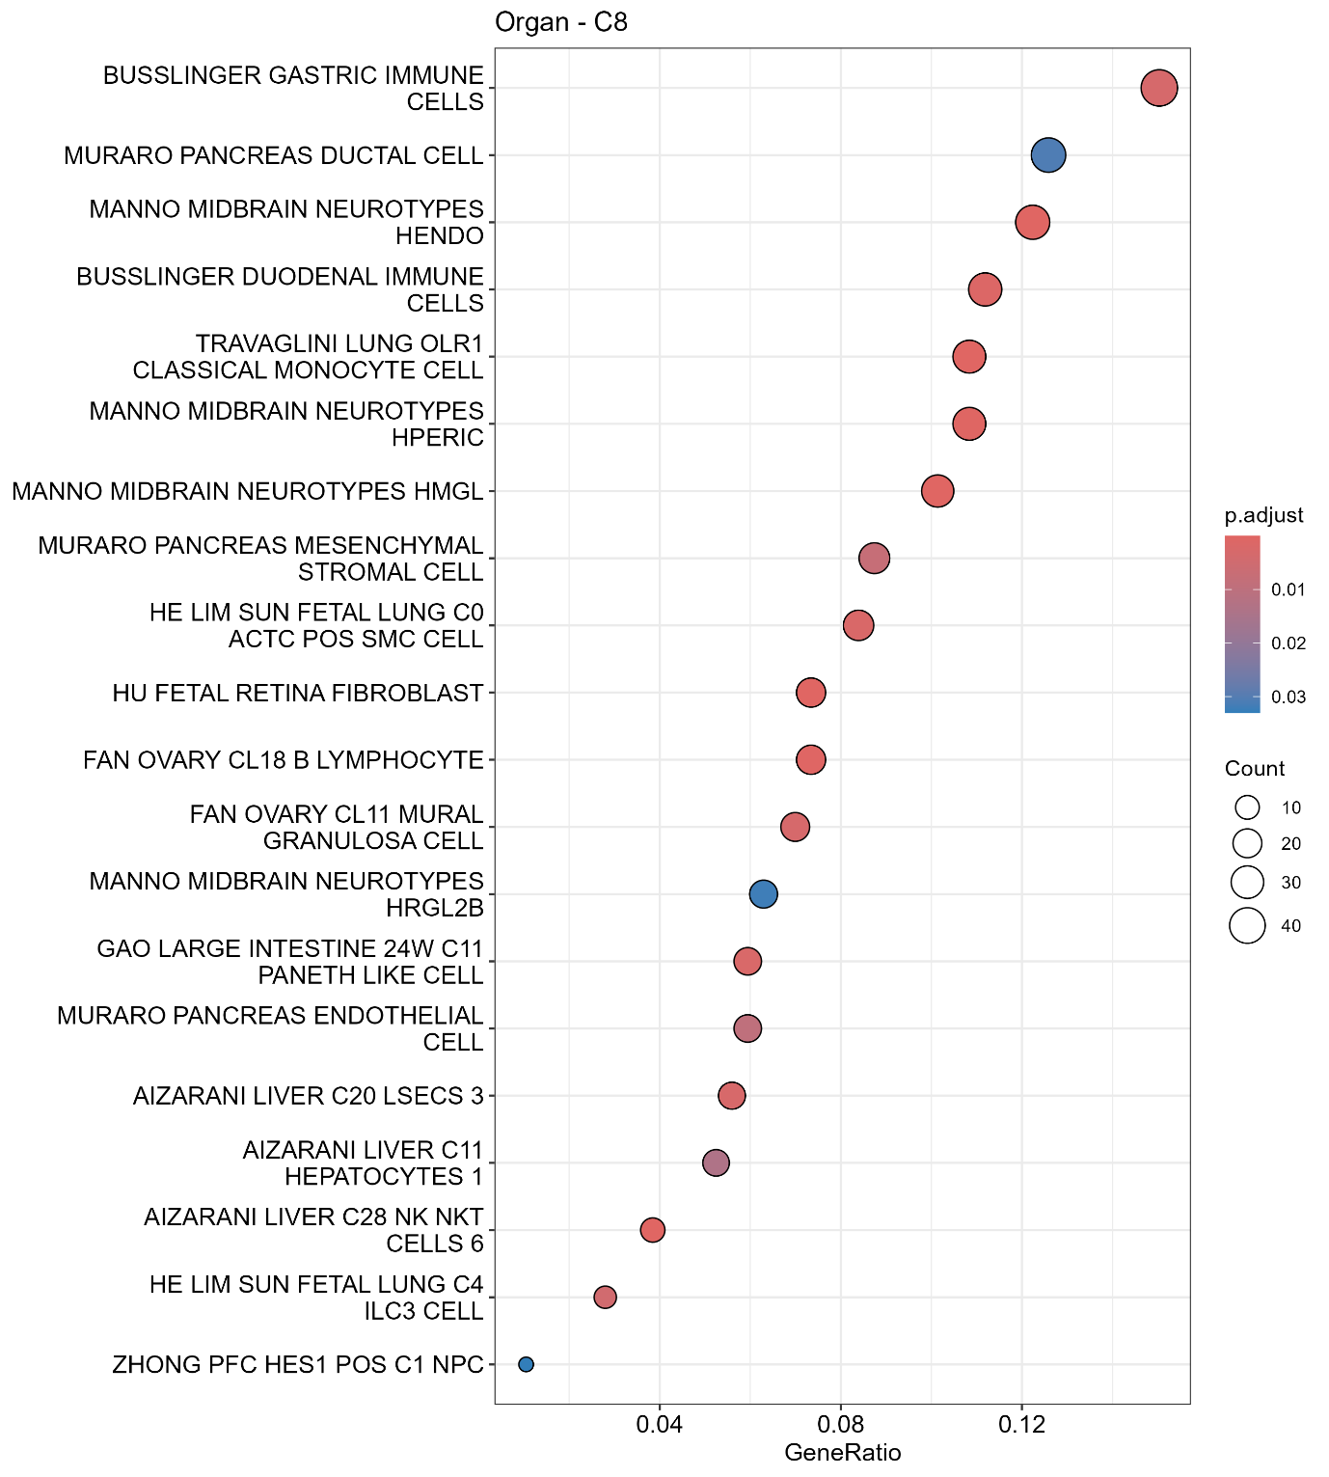
Legend: Illustrates cell enrichment C8 organ fibrosis diseases (myocardial fibrosis, cirrhosis, idiopathic pulmonary fibrosis, pancreas fibrosis, liver fibrosis, renal fibrosis, heart failure, chronic kidney disease, systemic sclerosis, inflammatory bowel disease) and sorted by GeneRatio as well as colored by P-values with adjustment by Bonferroni.

Supplementary Figure 18. Cell enrichment for non-organ fibrotic diseases
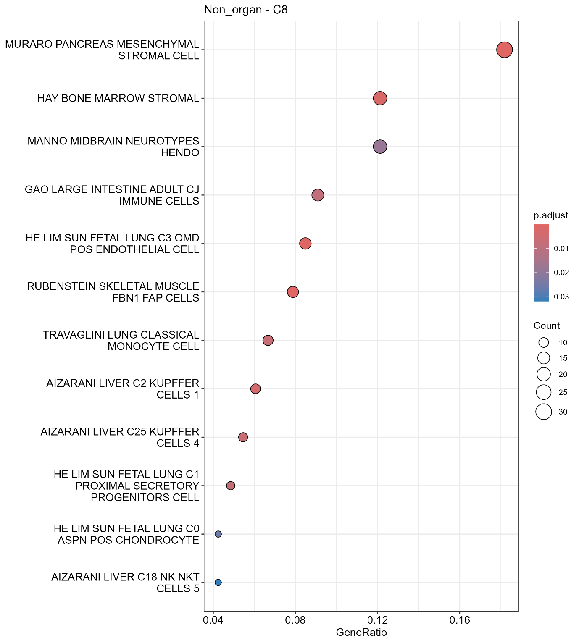
Legend: Illustrates cell enrichment C8 non-organ fibrosis diseases (Dupuytren´s contracture, Peyronie´s disease, plantar fibromatosis, trigger finger, hypertrophic skin, phimosis, carpal tunnel syndrome) and sorted by GeneRatio as well as colored by P-values with adjustment by Bonferroni.

References
1. Sørensen, E. et al. Data Resource Profile: The Copenhagen Hospital Biobank (CHB). International Journal of Epidemiology vol. 50 Preprint at https://doi.org/10.1093/ije/dyaa157 (2021).
2. Erikstrup, C. et al. Cohort Profile: The Danish Blood Donor Study. Int J Epidemiol 52, (2023).
3. Bycroft, C. et al. The UK Biobank resource with deep phenotyping and genomic data. Nature 562, (2018).
4. Kurki, M. I. et al. FinnGen provides genetic insights from a well-phenotyped isolated population. Nature 613, (2023).
5. Gaziano, J. M. et al. Million Veteran Program: A mega-biobank to study genetic influences on health and disease. J Clin Epidemiol 70, (2016).
6. Evangelou, E. et al. Genetic analysis of over 1 million people identifies 535 new loci associated with blood pressure traits. Nat Genet 50, (2018).

