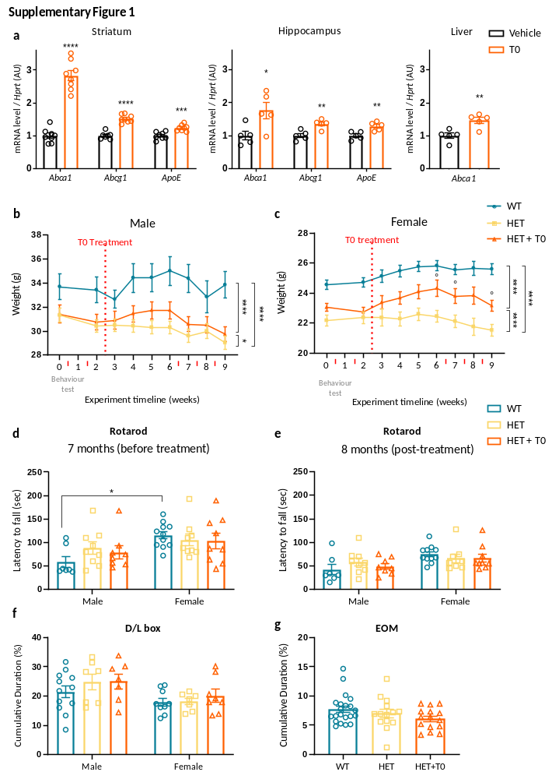
Supplementary Figure 1: T0901317 does not improve motor phenotypes in zQ175 mice. (a) WT mice were treated with vehicle or T0901317 (21 mg/kg) by oral gavage and mRNA levels of LXR target genes (Abca1, ApoE, Abcg1) were measured in the striatum, hippocampus and liver after RTqPCR relative to Hprt housekeeping gene, data were normalized to vehicle group (striatum: n=7-8 per group; hippocampus and liver: n=5 per group). (b, c) Male (b) and female (c) body weight were measured weekly in WT (n=7 males, n=11 females), HET (n=9 males, n=8 females) and HET+T0 (n=8 males, n=9 females) mice. The vertical dotted red line represents the starting point of treatment, red arrows indicate behavioral testing time points. (d, e) Locomotor coordination was evaluated by latency to fall measured in the accelerated rotarod test before (d) and after (e) T0901317 treatment (WT: n=7 males and n=11 females; HET: n=9 for males and n=8 females; HET+T0: n=8 males and 9 females). (f, g) Anxiety-like behavior was assessed by the percentage of time spent in the light compartment of the Dark/Light box (WT: n=12 males and n=9 females; HET: n=7 males and females; HET+T0: n=7 males and n=8 females) (f), or in the open arms of the elevated O-maze (n=21 WT, n=14 HET, n=15 HET+T0) (g). Data are represented as mean ± SEM. Statistical analysis: two-tailed unpaired Student’s t-test (a), two-way repeated measures ANOVA (b, c), two-way (d, e, f) or one-way (g) ANOVA followed by Tukey’s post hoc test. Group effect: * p<0.05, ** p<0.01, *** p<0.001, **** p<0.0001, ns=not significant (a-g). Difference between HET and HET+T0 weight: ° p<0.05 (b, c).

Supplementary Figure 2: T0901317 rescues striatal and hippocampal synaptic gene expression and SPN identity genes. (a) Dotplots representing top enriched terms from Gene Ontology (GO) Biological Process (BP) 2023, GO Cellular Component 2023, predicted transcriptional factors (ChEA) 2022 or HD-related signature (HD signature) 2021 databases, based on genes downregulated in the striatum of HET mice and corrected by T0901317. The colour scale represents the log₁₀(1/FDR), reflecting enrichment significance. Dot size indicates the percentage of genes from the input set present in each terms. (b) Synaptic subcellular localisation analysis using SynGO database for the 199 downregulated genes in HET striatum and corrected by T0901317. (c, d) Dot plot representing top enriched GO BP 2023 terms for downregulated genes in HET corrected by T0901317 (c) or downregulated by T0901317 (d) in hippocampus. Enrichment scores are shown as log₁₀(1/FDR), with dots representing gene-term overlap percentage. (e) mRNA level (RPK, reads per kilobases) of Bdnf and Dnmt3l from bulk RNAseq data in hippocampus (n=5 per group). Data are represented as mean ± SEM, p-value are from differential expression analysis. For functional enrichment analysis, using EnrichR software, a significance threshold of adjusted p-value (FDR) < 0.1 was used. Adjusted p-values were calculated using the Benjamini-Hochberg method for multiple testing correction.

Supplementary Figure 3: Characterization of molecular and cellular effects of T0901317 in HD striatum. (a-b) mRNA levels of LXR target genes (Abca1, ApoE, Abcg1, FasN) were measured in the striatum (a) and liver (b) of WT, HET and HET+T0 mice (n=5 per group) after RTqPCR relative to Hprt housekeeping gene, data are normalized to the WT group. (c) Sections from the dorsal striatum (ST), the Nucleus Accumbens (NAc: Core and Shell) and the motor cortex (Cx) for immunostaining with EM48 (white) antibody and Hoechst labelling for nucleus (blue). Scale bare = 60 µm. (d) Quantification of aggregates density (number/µm²) (n=5, except for HET+T0 in shell: n=4). Data are represented as mean ± SEM. Statistical analysis: one-way ANOVA followed by Tukey’s post hoc test (a, b), two-tailed unpaired Student’s t-test (d, for dorsal striatum, core and motor cortex) or Mann-Whitney test (d, for shell). Group effect: * p<0.05, ** p<0.01, *** p<0.001, **** p<0.0001, ns=not significant (a, b, d).

Supplementary Figure 4: Characterisation of T0901317 effect on brain structures and metabolites. (a) Representative coronal scans obtained by structural MRI and segmentation templates overlaid. Cerebral brain region volumes (percentage of total brain volume) were measured in males (n=5 WT, n=4 HET and HET+T0) (b) and females (n=3 WT, n=4 HET and HET+T0) (c). Abbreviation for brain regions: Cx: Cortex; DG of Hipp: Dentate gyrus of hippocampus; ML/MLF: Medial lemniscus/medial longitudinal fasciculus; NAc: Nucleus Accumbens; SG of Hipp: Striatum granulosum of hippocampus. (d-g) Striatal and hippocampal metabolite relative concentrations were measured in WT, HET and HET+T0 (n=6 per group) mice with ¹H-RMN. Anatomical images with the acquisition voxel (green squared), and a representative ¹H-RMN spectrum for striatum (d) or hippocampus (f). Concentration of metabolites (GABA: γ-aminobutyrique acid; Gln: glutamine; Glu: Glutamate; Ins: Inositol; NAA: N-acetyl aspartic acid; NAAG: N-Acetylaspartylglutamate; Tau: Taurine) relative to total creatine (tCr) as an internal control (e, g). (h) Section from the paraventricular nucleus of hypothalamus for immunostaining against oxytocin. Scale bare = 100 µm. (i) Quantification of the number neurons expressing oxytocin in the paraventricular nucleus in WT, HET and HET+T0 mice (n=5 WT and HET+T0, n=4 HET). Data are represented as mean ± SEM. Statistical analysis: two-way ANOVA followed by Tukey’s post hoc test (b, c, e, g) or Kruskal-Wallis followed by Dunn’s post hoc test (i). Group effect: * p<0.05, ** p<0.01, *** p<0.001, **** p<0.0001 (b, c, e, g).

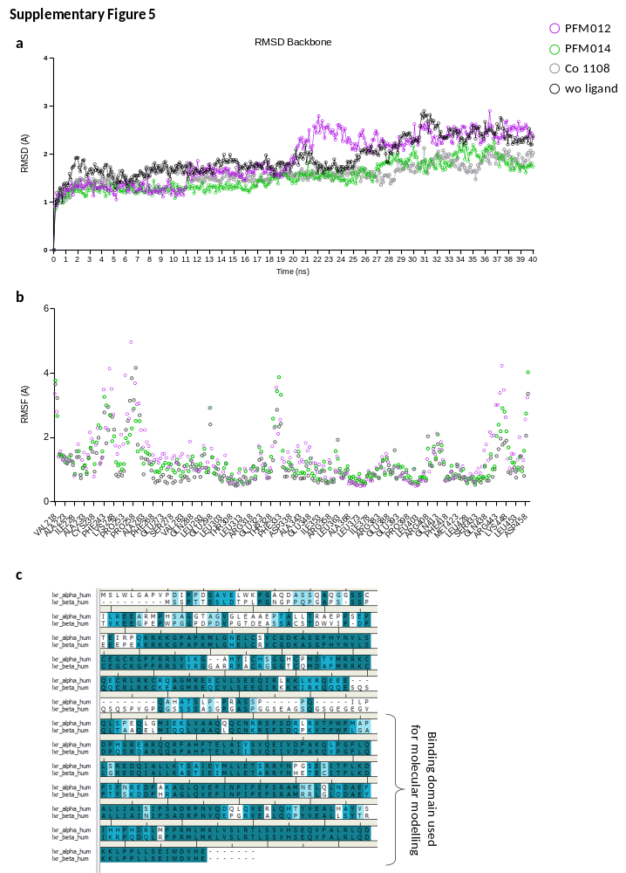
Supplementary Figure 5: Dynamic of LXR protein in presence of various ligands. (a) Root-Mean-Square Deviation (RMSD) of LXRβ in presence of various ligand (PFM012, PFM014 and 24(S), 25-epoxycholesterol (Co1108)). PFM014 and Co1108 showed similar profile compared to PFM012. (b) Root-mean-square-fluctuation (RMSF) of LXRβ AA during the 40 ns dynamics in presence of various ligand (PFM012, PFM014 and 24(S), 25-epoxycholesterol (Co1108)). (c) Sequence alignment of LXRβ, and LXRα and localization of LBD domain used for molecular modelling studies.
List of tables

Supplementary Table 1: Count table with Reads Per Kilobase (RPK) from striatal or hippocampal bulk RNAseq data, in the three groups WT, HET and HET+T0 (n=5/group for each structure) (Figure 3 and Supplementary Figure 2)
Supplementary Table 2: List of Differentially Expressed Genes (DEG) in HET striatum (ST) or hippocampus (HP) compared to WT, and indication of whether they overlap with the other tissue or with Geomic dataset pathogenic or compensatory responses.
Supplementary Table 3: Top 20 pathways enriched among the HET vs WT DEG common to the striatum and hippocampus (Fig.3a)
Supplementary Table 4: Top 20 pathways enriched among striatal HET vs WT DEG that overlap with compensatory and pathogenic effects from the Geomic dataset (Fig.3c)
Supplementary Table 5: Results of DEG analysis of striatal (ST) and hippocampal (HP) genes according to the following comparison: HET+T0 vs HET, HET+T0 vs WT, HET vs WT (Fig. 3a-c)
Supplementary Table 6: Gene class in rescue plot (Fig.3d-e)
Supplementary Table 7: Top 20 pathways enriched among downregulated genes in HET striatum and corrected by T0901317 (Supp. Fig.2a)
Supplementary Table 8: Top 20 pathways enriched among downregulated genes in HET hippocampus and corrected by T0901317 (Supp. Fig.2c)
Supplementary Table 9: Top 20 pathways enriched among downregulated genes in hippocampus induced by T0901317 (Supp. Fig.2d)

