Supplementary material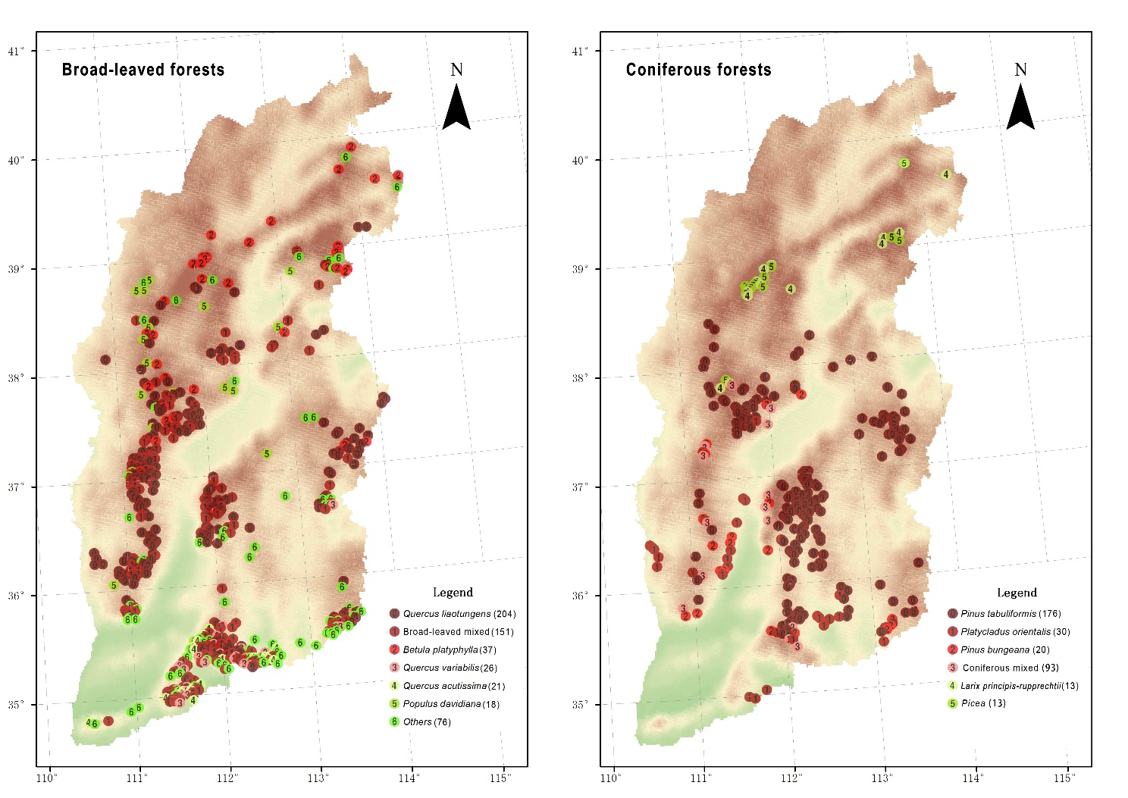
Figure S1 Maps showing the distribution of the sample plots for the investigation of biomass carbon density for natural broad-leaved and coniferous forests in Shanxi, China. The number in parentheses denotes the number of the sample plots.
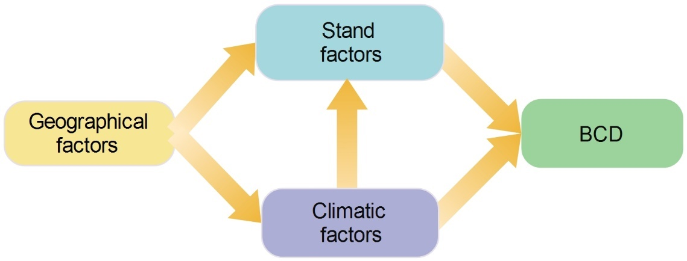
Figure S2 The exploratory structure equation models showing the geographical, climatic and stand factors that have direct and indirect effects on BCD (biomass carbon density) of natural broad-leaved and coniferous forests in Shanxi, China.
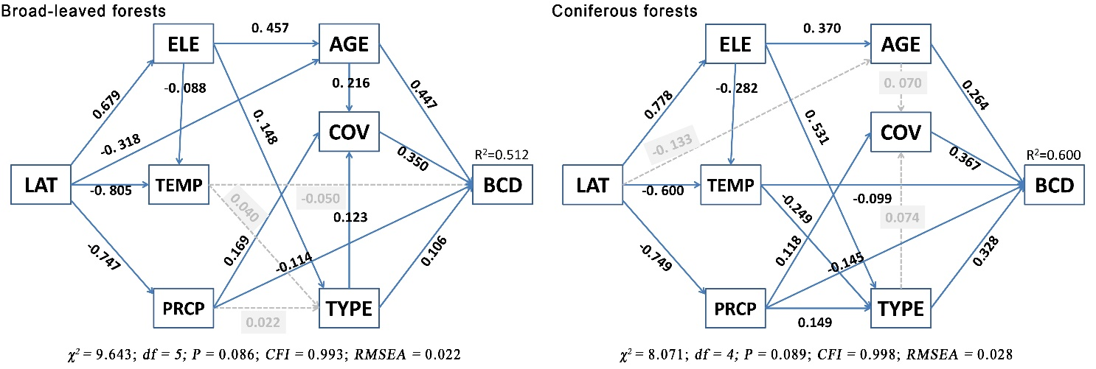
Figure S3 The good-fitting structure equation models showing the factors that have direct and indirect effects on biomass carbon density of broad-leaved (left) and coniferous (right) forests in Shanxi, China. LAT, latitude; ELE, elevation; TEMP, annual mean air temperature; PRCP, annual mean precipitation; AGE, stand age; COV, stand coverage; TYPE: forest types. Indicators for a good-fitting model are an insignificant χ² test statistic (P > 0.05; indicating that sample and observed covariance matrices are statistically indistinguishable), CFI > 0.95 and RMSEA < 0.08 (Grace et al., 2016; Hoyle, 2012). In the good-fitting model, solid arrows indicate significant paths (P < 0.05), while dashed arrows are non-significant paths. The numbers along the arrows are standardized regression weights indicating the effect size (black, significant; grey, non-significant). The thickness of the arrow is proportion to the size of the effect.
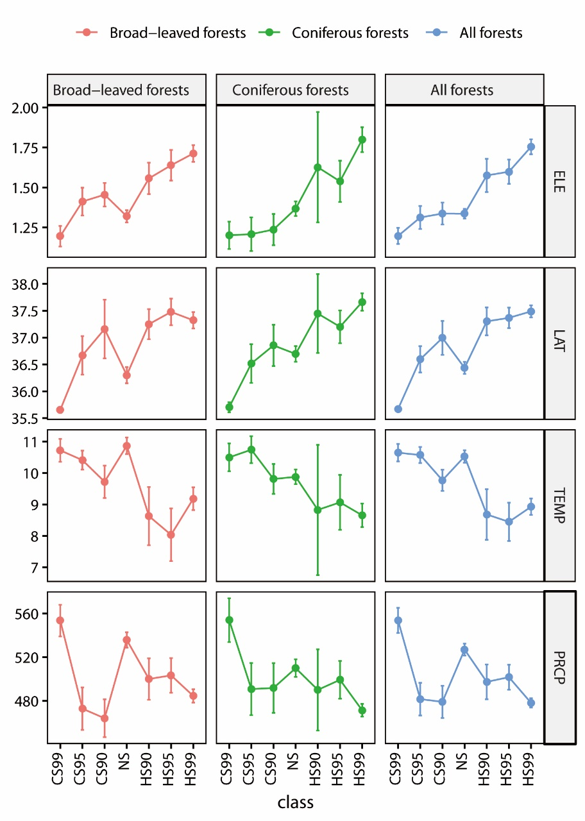
Figure S4 The plot showing the changes of different factors with the hot spots groups at different significant levels (right) of natural broad-leaved and coniferous forests in Shanxi, China. ELE: elevation, LAT: latitude, TEMP; temperature, PRCP: precipitation

