Supplementary Information

Assessing the Effectiveness of Graded Response Action Plan (GRAP) in Managing Delhi’s Air Quality

Tanvi Anand¹ and Abhishek Chakraborty^{1*}
¹Environmental Sciences and Engineering Department, Indian Institute of Technology Bombay
Powai, Mumbai – 400076, India
*Corresponding author; email: abhishekc@iitb.ac.in
1. METHODOLOGY
Utilising NAAQ's standard formulae for air quality indices of each pollutant, sub-AQI of each pollutant can be calculated. CPCB's breakpoint tables can be used to define custom AQI sub-index functions for each pollutant: PM₁₀, PM₂. ₅, SO₂, NOₓ, CO, O₃, and NH₃. These functions use piecewise linear interpolation within specified concentration ranges to convert pollutant concentrations into AQI values. Missing or non-numeric entries are handled gracefully, and invalid data points are assigned an AQI of zero.
Formula S1
- PM10
  - If PM10 ≤ 50: AQI = PM10
  - If 50 < PM10 ≤ 100: AQI = PM10
  - If 100 < PM10 ≤ 250: AQI = 100 + (PM10 - 100) * (100 / 150)
  - If 250 < PM10 ≤ 350: AQI = 200 + (PM10 - 250)
  - If 350 < PM10 ≤ 430: AQI = 300 + (PM10 - 350) * (100 / 80)
  - If PM10 > 430: AQI = 400 + (PM10 - 430) * (100 / 80)
- PM2.5
  - If PM2.5 ≤ 30: AQI = PM2.5 * (50 / 30)
  - If 30 < PM2.5 ≤ 60: AQI = 50 + (PM2.5 - 30) * (50 / 30)
  - If 60 < PM2.5 ≤ 90: AQI = 100 + (PM2.5 - 60) * (100 / 30)
  - If 90 < PM2.5 ≤ 120: AQI = 200 + (PM2.5 - 90) * (100 / 30)
  - If 120 < PM2.5 ≤ 250: AQI = 300 + (PM2.5 - 120) * (100 / 130)
  - If PM2.5 > 250: AQI = 400 + (PM2.5 - 250) * (100 / 130)
- SO2
  - If SO2 ≤ 40: AQI = SO2 * (50 / 40)
  - If 40 < SO2 ≤ 80: AQI = 50 + (SO2 - 40) * (50 / 40)
  - If 80 < SO2 ≤ 380: AQI = 100 + (SO2 - 80) * (100 / 300)
  - If 380 < SO2 ≤ 800: AQI = 200 + (SO2 - 380) * (100 / 420)
  - If 800 < SO2 ≤ 1600: AQI = 300 + (SO2 - 800) * (100 / 800)
  - If SO2 > 1600: AQI = 400 + (SO2 - 1600) * (100 / 800)
- NOx
  - If NOx ≤ 40: AQI = NOx * (50 / 40)
  - If 40 < NOx ≤ 80: AQI = 50 + (NOx - 40) * (50 / 40)
  - If 80 < NOx ≤ 180: AQI = 100 + (NOx - 80) * (100 / 100)
  - If 180 < NOx ≤ 280: AQI = 200 + (NOx - 180) * (100 / 100)
  - If 280 < NOx ≤ 400: AQI = 300 + (NOx - 280) * (100 / 120)
  - If NOx > 400: AQI = 400 + (NOx - 400) * (100 / 120)
- CO
  - If CO ≤ 1: AQI = CO * (50 / 1)
  - If 1 < CO ≤ 2: AQI = 50 + (CO - 1) * (50 / 1)
  - If 2 < CO ≤ 10: AQI = 100 + (CO - 2) * (100 / 8)
  - If 10 < CO ≤ 17: AQI = 200 + (CO - 10) * (100 / 7)
  - If 17 < CO ≤ 34: AQI = 300 + (CO - 17) * (100 / 17)
  - If CO > 34: AQI = 400 + (CO - 34) * (100 / 17)
- Ozone
  - If Ozone ≤ 50: AQI = Ozone
  - If 50 < Ozone ≤ 100: AQI = 50 + (Ozone - 50)
  - If 100 < Ozone ≤ 168: AQI = 100 + (Ozone - 100) * (100 / 68)
  - If 168 < Ozone ≤ 208: AQI = 200 + (Ozone - 168) * (100 / 40)
  - If 208 < Ozone ≤ 748: AQI = 300 + (Ozone - 208) * (100 / 539)
  - If Ozone > 748: AQI = 400 + (Ozone - 748) * (100 / 539)
- NH3
  - If NH3 ≤ 200: AQI = NH3 * (50 / 200)
  - If 200 < NH3 ≤ 400: AQI = 50 + (NH3 - 200) * (50 / 200)
  - If 400 < NH3 ≤ 800: AQI = 100 + (NH3 - 400) * (100 / 400)
  - If 800 < NH3 ≤ 1200: AQI = 200 + (NH3 - 800) * (100 / 400)
  - If 1200 < NH3 ≤ 1800: AQI = 300 + (NH3 - 1200) * (100 / 600)
  - If NH3 > 1800: AQI = 400 + (NH3 - 1800) * (100 / 600)
Taking the maximum of these sub-AQI values (at least 3 must be present, PM10 mandatory), the AQI of a particular station for that timestamp. This process was conducted for both 24h as well as hourly station-wise data.
2. RESULTS AND DISCUSSION
Fig S1: Time series trend of AQI and VC with shaded GRAP stages for Oct 2022 to March 2023.
Fig S2: Time series trend of AQI and VC with shaded GRAP stages for Oct 2023 to March 2024.

Fig S3: Average AQI and VC (m²/s) as per GRAP stages for Oct 2022 - Mar 2023
Fig S4: Average AQI and VC as per GRAP stages for Oct 2023 - Mar 2024

Fig S5: Relative change in AQI and VC for Oct 2022 – Mar 2023
Fig S6: Relative change in AQI and VC for Oct 2023 – Mar 2024

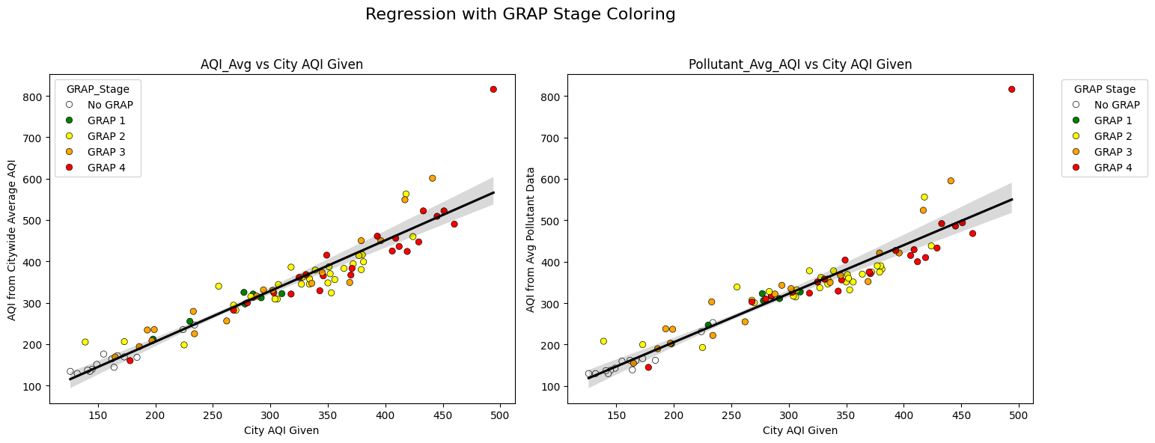
Fig S7: Linear regression plots to compare CCR given AQI (City AQI) values to AQI as derived by (i) Averaging calculated station wise AQI values (ii) Averaging station wise pollutant levels and calculating AQI

Fig S8: Pollutant concentrations variation with GRAP stages for 2024 winter for top 5 stations.

Figure 8 highlights the persistence of high PM2.5 levels, with visible spikes around mid-November. The top 5 stations consistently show elevated PM2.5 values exceeding 600 AQI during peak periods, despite the implementation of GRAP Stage 3. The synchronous spike across geographically diverse stations suggests anthropogenic events and low boundary layer height, and calm wind speeds. Even typically clean areas are not immune to episodic spikes caused by mass gatherings and meteorological stagnation. GRAP stage 4 is the most effective reduction strategy for pollutant levels of PM_{2.5} as well as PM₁₀ at all stations. This suggests that the most stringent GRAP interventions (e.g., construction bans, vehicle restrictions) have a measurable and immediate impact on PM_{2.5} levels. The cross-station consistency in reduction shows policy uniformity working across spatial zones.

Date | GRAP Stage | Top 5 |  |  |  |  | Bottom 5
Date | GRAP Stage | Jahangirpuri | Wazirpur | Bawana | Mundka | Anand VIhar | IGI Airport | IHBAS Dilshad | Mandir Marg | Aurobindo Marg | Pusa
10/14/2024 | 1 | Failure | Failure | Failure | Failure | Failure | Failure | Failure | Failure | Failure | Failure
10/21/2024 | 2 | Failure | Partial Success | Partial Success | Partial Success | Partial Success | Partial Success | Partial Success | Partial Success | Definite Success | Partial Success
11/14/2024 | 3 | Detrimental | Detrimental | Detrimental | Detrimental | Detrimental | Failure | Detrimental | Detrimental | Detrimental | Detrimental
11/17/2024 | 4 | Definite Success | Definite Success | Definite Success | Definite Success | Definite Success | Definite Success | Definite Success | Definite Success | Definite Success | Definite Success
12/5/2024 | 3 | Failure | Partial Success | Partial Success | Partial Success | Partial Success | Failure | Partial Success | Failure | Failure | Failure
12/16/2024 | 4 | Failure | Definite Success | Partial Success | Definite Success | Definite Success | Definite Success | Definite Success | Definite Success | Partial Success | Definite Success
12/24/2024 | 3 | Detrimental | Detrimental | Detrimental | Detrimental | Detrimental | Partial Success | Detrimental | Detrimental | Definite Success | Definite Success
12/27/2024 | 2 | Definite Success | Definite Success | Definite Success | Definite Success | Definite Success | Definite Success | Definite Success | Definite Success | Definite Success | Definite Success

Table S1: Stage-wise success and failure for the least and most polluted 5 stations in 2024.

