Supporting information for Plant and Soil
Root dipping application of wastewater-derived struvite to rice seedlings for a safe and efficient supply of N and P in paddy cropping systems
Elden Willems¹*, Margot Dehaene¹, Telina Ialison², Léna Wantiez¹, Matheus Sampaio Carneiro Barreto³, Yasuhiro Tsujimoto⁴, Erik Smolders¹, Tantely Razafimbelo², Maarten Everaert¹

¹KU Leuven, Department of Earth and Environmental Science, Division of Soil and Water Management, Kasteelpark Arenberg 20, 3001 (Belgium)
²Laboratoire des RadioIsotopes, Université d’Antananarivo, Antananarivo, 101, Madagascar
³The Global Critical Zone Science Chair, Mohammed VI Polytechnic University, Lot 660, Hay Moulay Rachid, Ben Guerir, 43150, Morocco
⁴Japan International Research Center for Agricultural Sciences, JIRCAS, Tsukuba, Ibaraki 305-8686, Japan
* Corresponding author: elden.willems@kuleuven.be

Table S1 Elemental analysis of commercial TSP and commercial struvite.
 | TSP  (mg/g) | Struvite  (mg/g)
N | 0.00 | 54.300
P | 187.819 | 123.285
Ca | 137.686 | 0.544
S | 15.875 | 0.057
Mg | 9.230 | 96.937
Fe | 8.777 | 0.180
Al | 4.601 | 0.043
Si | 4.219 | 0.398
Al | 4.104 | 0.037
K | 2.303 | 0.575
Na | 1.409 | 0.035
Mn | 0.797 | 0.052
 | (mg/kg) | (mg/kg)
Zn | 175.80 | 2.08
B | 130.21 | 121.84
Cr | 54.05 | 4.24
As | 34.51 | 3.30
Pb | 31.29 | 1.08
Ni | 8.49 | 0.13
Mo | 7.75 | 0.62
Cu | 7.44 | 0.09
Co | 1.37 | 0.02
Cd | 1.01 | 0.08
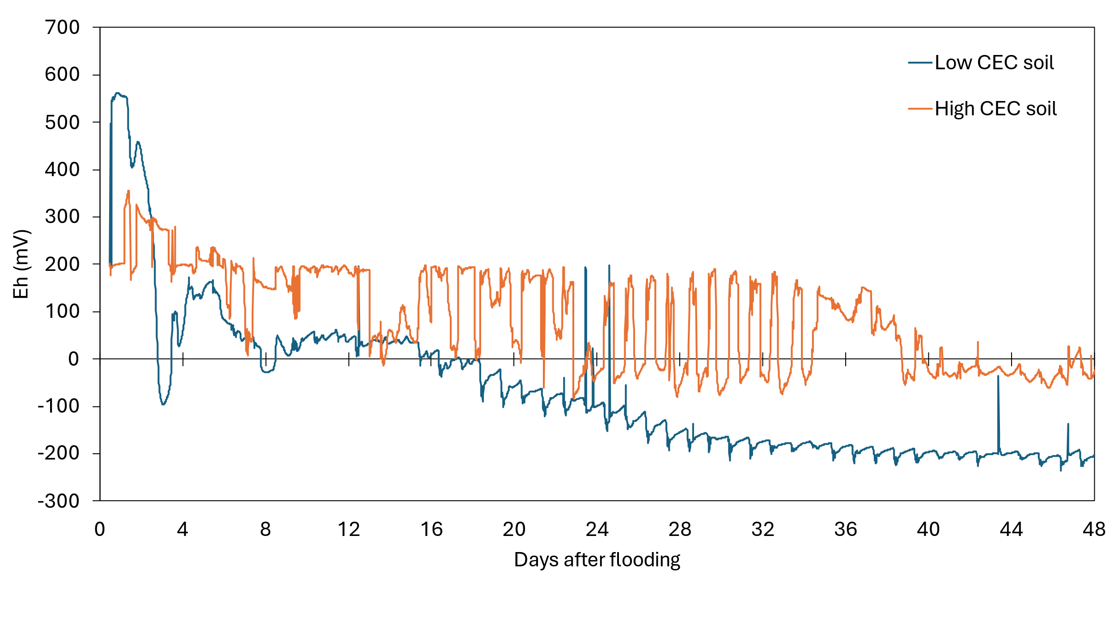
Figure S1: soil reduction potential (Eh) against days after flooding during the growth experiment.
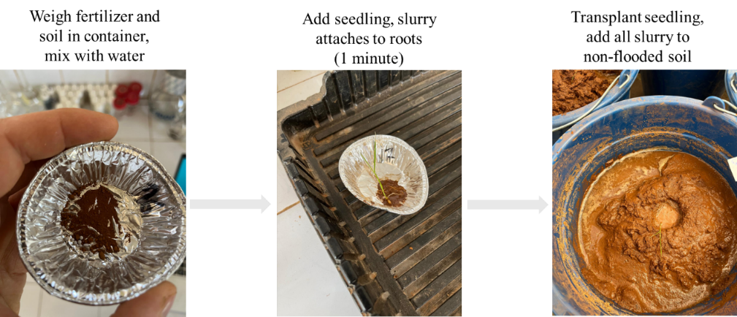
Figure S2: Dipping protocol.
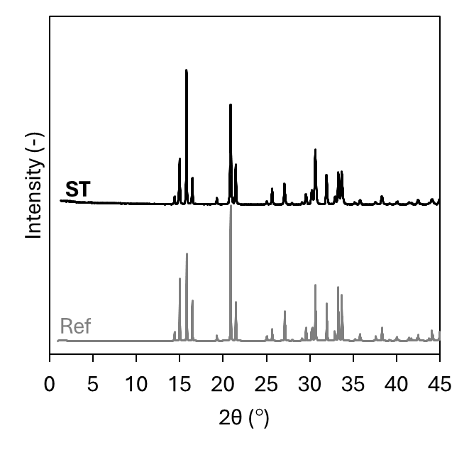
Figure S3: XRD patterns of commercial struvite (ST) and a standard pure struvite (REF) (PDF 01-077-2303).

