Supplementary file:
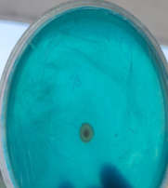
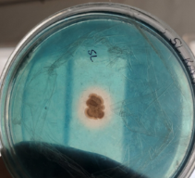
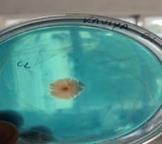
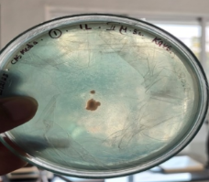
a) IL b) CL c) SL d) SS

Figure S1a-d: Absence of halos around the colonies indicating the production of siderophores by the isolates IL, CL, SL and SS

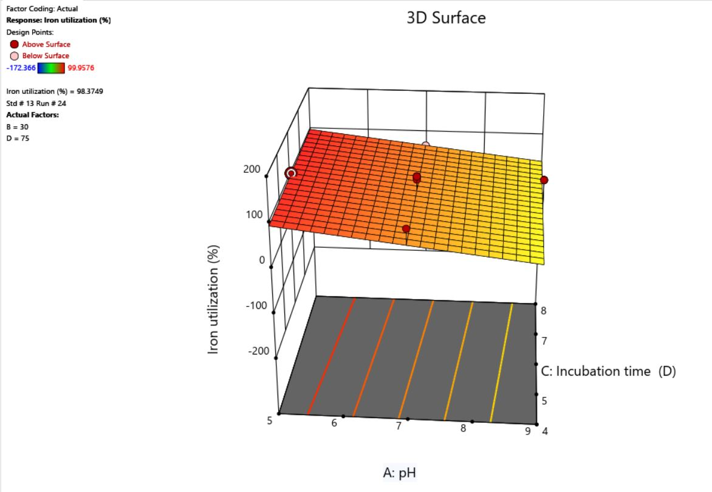
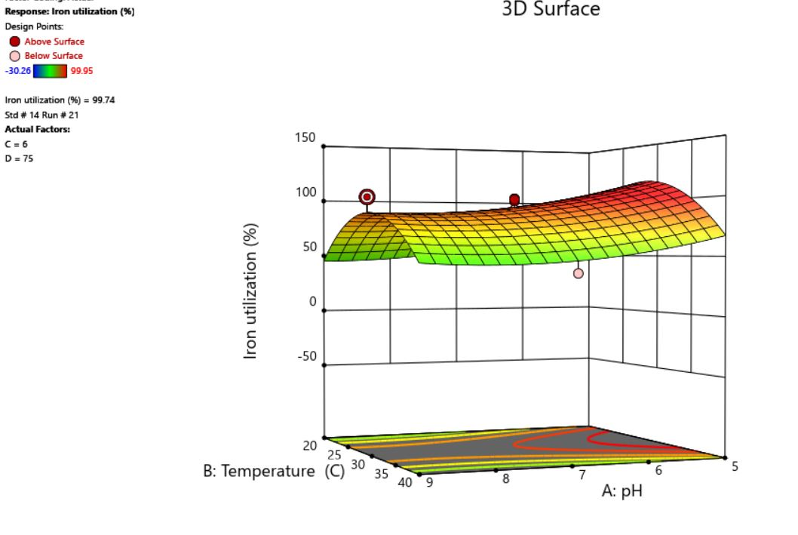
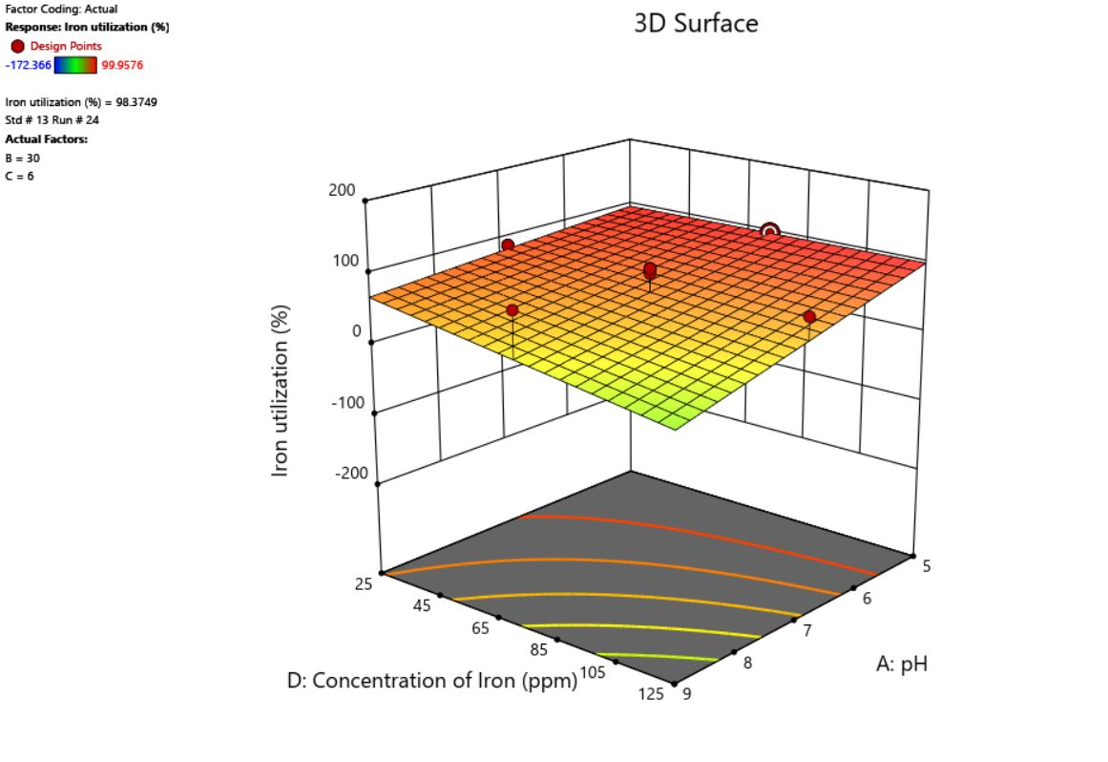
Figure S2-4: Optimization of Culture conditions for the production of siderophores by strain SR

Siderophore Production %
A. pH
C. Incubation time (D)
Siderophore Production %
A. pH
B. Temperature (℃)
Siderophore Production %
A. pH
D. Concentration of Iron (ppm)
S2) S3)
S4) b)

