Supplementary Figure 1: Orangutan iPSCs demonstrated hallmarks of primed pluripotency, maintained a normal karyotype, and were footprint-free. (A) Primary fibroblasts from a North Bornean orangutan. (B) Karyotype of orangutan fibroblasts demonstrating 48 chromosomes, XX. (C) Primary orangutan iPSCs derived via episomal electroporation. (D) AP staining of orangutan iPSCs derived via Sendai transduction. (E) Primary orangutan F⁺iPSCs derived via episomal electroporation. (F) AP staining of orangutan F⁺iPSCs derived via Sendai viral transduction. (G) Karyotype of orangutan F⁺iPSCs derived via Sendai viral transduction demonstrating 48 chromosomes, XX. (H) qRT-PCR analysis for the expression of endogenous pluripotency markers in F⁺iPSCs derived via Sendai viral transduction, normalized to GAPDH and ACTB, and controlled to source fibroblasts. (I) Gel electrophoresis of PCR-amplified products using primers to detect the Sendai viral genome; (+) refers to the positive control in the form of fibroblasts 5 days post-Sendai viral transduction; (-) refers to the negative control in the form of fibroblasts; Passage 18 and 29 refers to F⁺iPSCs at stated passages. (J) Immunostaining confirming positive expression of pluripotency markers in F⁺iPSCs. (K) EB formation from F⁺iPSCs. (L) qRT-PCR analysis for the expression of endogenous pluripotency and germ layer markers in attached EBs formed from F⁺iPSCs, normalized to GAPDH and controlled to source F⁺iPSCs. (M) Immunostaining confirming positive expression of trilineage differentiation markers in EBs formed from F⁺iPSCs. Both F⁺iPSCs and F–iPSCs lines remained stable for over 20 passages, preserving their pluripotent phenotype without signs of genomic instability.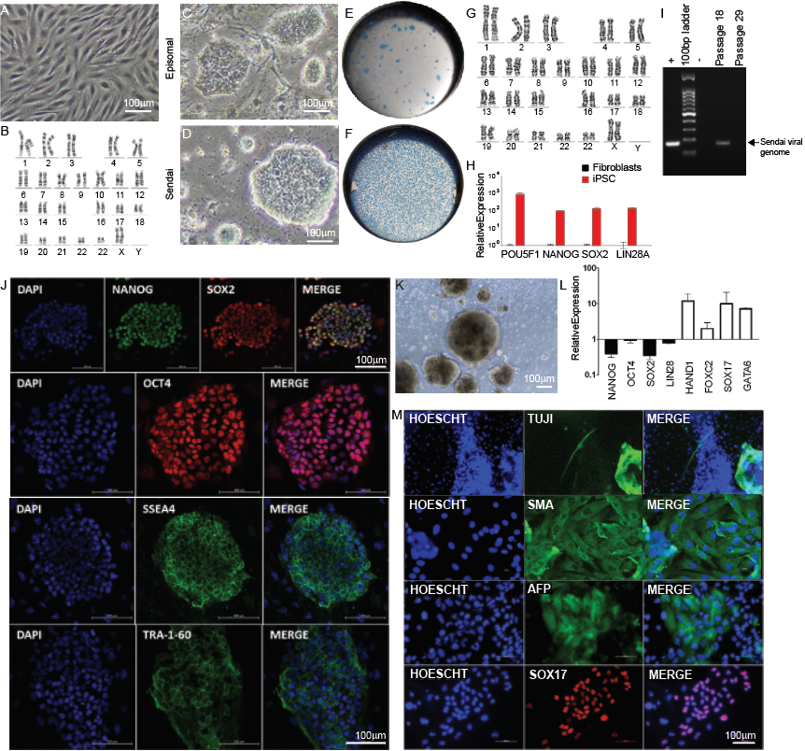

Supplementary Figure 2: Orangutan F⁺iPSCs, but not F⁻iPSCs, can form mono-blastoids that encompass the three principal lineages of the preimplantation embryo. (A) Efficiency of blastoid formation using various numbers of F⁺iPSCs per microwell. (B) Days 0, 1, and 6 of culture of F⁺iPSCs or F⁻iPSCs in an AggreWell system to form mono-blastoids. (C) Immunostaining confirming localization of SOX2 and OCT4 (EPI-markers) to cells in the ICM-like compartment, CDX2 and GATA2 (TE-markers) to cells in the TE-like compartment, and SOX17 and GATA4 (PE/HYPO-markers) to cells lining the blastocoel-facing EPI-like cells, of orangutan F⁺blastoids; by contrast, F⁻blastoids demonstrated poorly defined patterning. (D) qRT-PCR analysis for the expression of core pluripotency, naïve pluripotency, TE, and PE/HYPO markers in aggregates harvested from F⁺blastoid formation, normalized to GAPDH and ACTB, and controlled to source F⁺iPSCs.
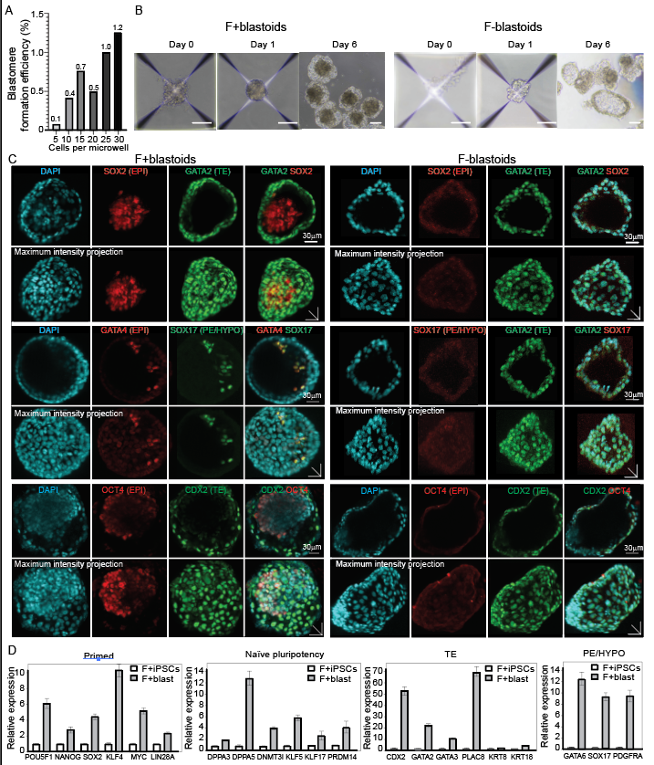

Supplementary Figure 3: Orangutan F⁺blastoids exhibited differentially expressed genes representing blastocyst-associated lineages. (A) Violin plot demonstrating exclusion of cells containing less than 500 genes per cells in scRNA-seq analysis of F⁺blastoids. (B) Top 7 DEGs in each cluster in F⁺blastoids. (C) Expression levels of EPI-associated markers (POU5F1, SOX2, KLF4, DPPA2, DPPA3, DPPA5, DNMT3L, PRDM14, KLF17, FGF4, GDF3), TE-associated markers (CDX2, GATA2, GATA3, PLAC8, KRT7, KRT8, KRT18, KRT19, CD24), and PE/HYPO-associated markers (SOX17, GATA6, GATA4, PDGFRA, COL4A1) in F⁺blastoids.
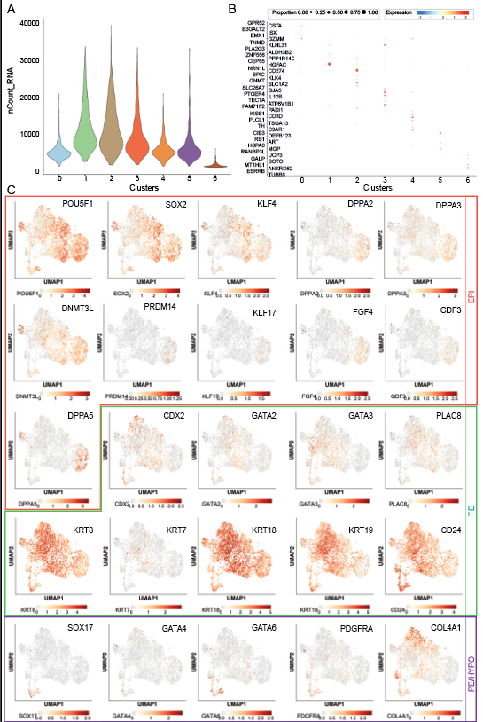

Supplementary Figure 4: Orangutan bi-blastoids are morphologically and structurally similar to human blastocysts, and encompass the three principal lineages of the preimplantation embryo. (A) Overall efficiency of blastoid formation using different cell ratios of F⁺iPSCs and F⁻iPSCs. (B) 240 was the average number of cells per bi-blastoid, which was not significantly different from 394, the average number of cells of F+blastoid. (C) Surface areas of orangutan blastoids compared to human blastoids. (D) Diameters of orangutan blastoids, where x is measured at the widest point of the blastoid parallel to the blastocoel-facing EPI-like cells, and y is measured at the widest point of blastoid perpendicular to y. (E) Immunostaining confirming localization of SOX2 and NANOG (EPI-markers) to GFP⁻ cells in the ICM-like compartment, CDX2 and GATA2 (TE-markers) to GFP⁺ cells in the TE-like compartment, ZO-1 (TE tight junction molecule) in the intercellular space between TE-like cells, and SOX17 (PE/HYPO-marker) distributed in a salt-and-pepper pattern in the TE-like compartment, of orangutan bi-blastoids.
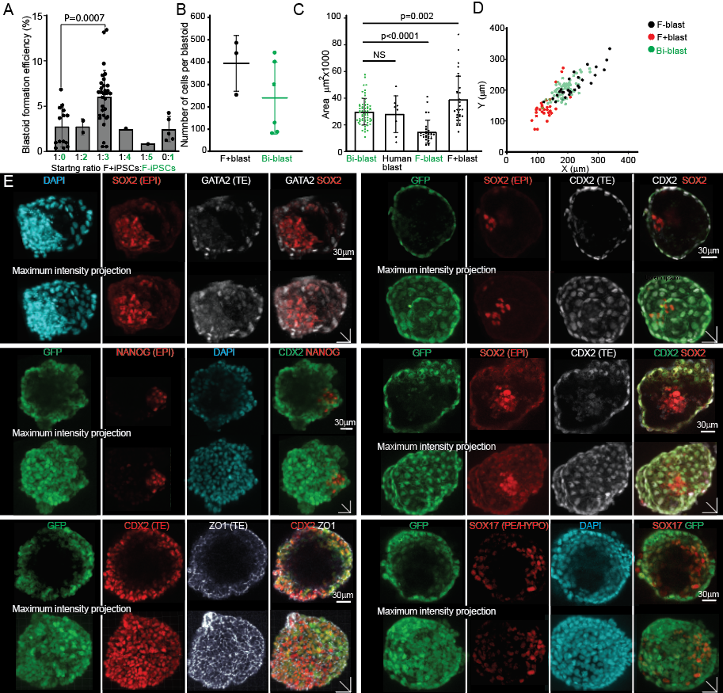

Supplementary Figure 5: Integrated UMAP analysis revealed a transcriptomic overlap between cells of orangutan blastoids, human blastocysts, and human blastoids. (A) Expression levels of EPI-associated markers (POU5F1, SOX2, KLF4, DPPA2, DPPA3, DPPA5, DNMT3L, PRDM14, KLF17, FGF4, GDF3), TE-associated markers (CDX2, GATA2, GATA3, PLAC8, KRT7, KRT8, KRT18, KRT19, CD24), and PE/HYPO-associated markers (SOX17, GATA6, GATA4, PDGFRA, COL4A1) in bi-blastoids. (B) Integrated UMAP analysis of annotated single cells isolated from orangutan blastoids, human blastoids, and human blastocysts; NR = non-reprogrammed. 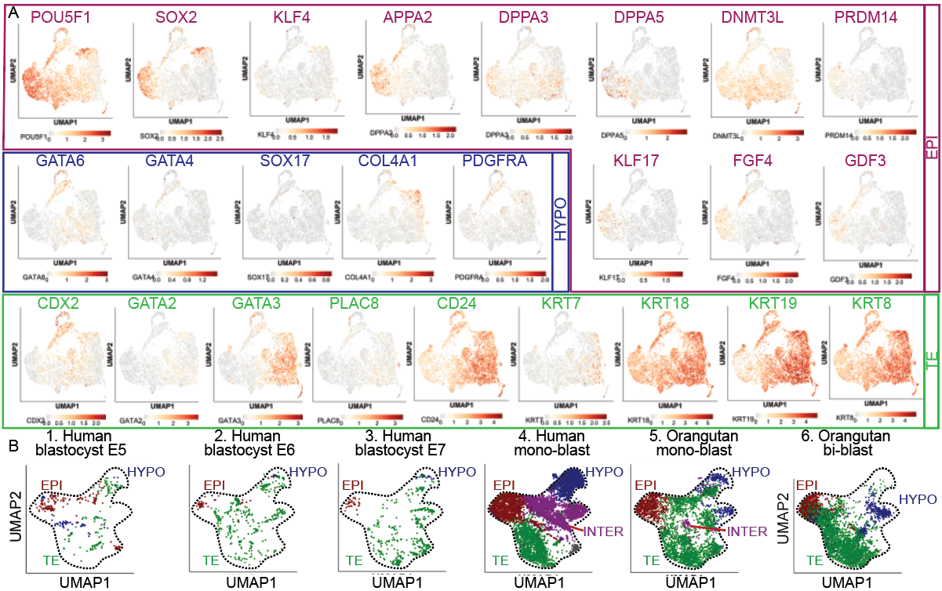
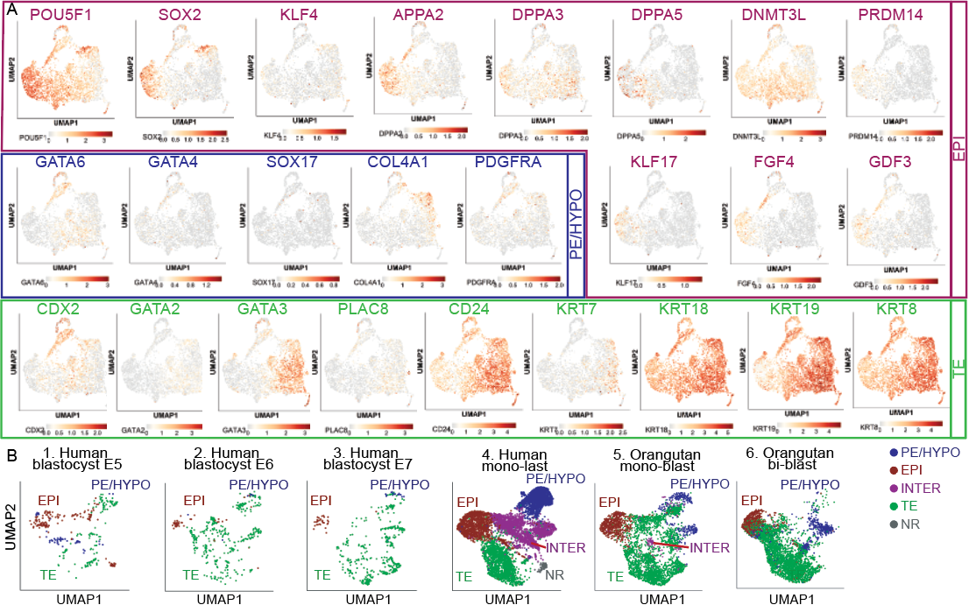

Supplementary Figure 6: Normalized gene expression of pluripotent stem cell and trophectoderm markers in F⁺iPSCs and derived ESCLCs and TSCLCs.
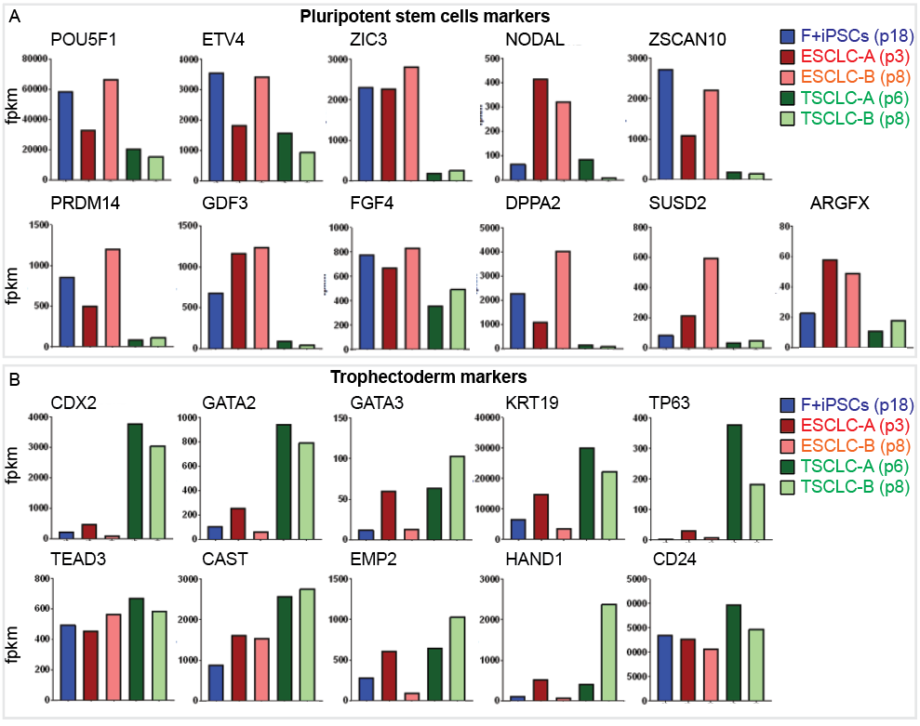

Supplementary Figure 7: Orangutan blastoids can recapitulate aspects of implantation in vitro. (A) In vitro attachment assay of bi-blastoids. (B) Immunostaining demonstrating GATA3+ post-implantation trophoblast-like cells and GATA6+ hypoblast-like cells localizing to the periphery of OCT4+ and NANOG+ post-implantation epiblast-like cells, and SOX2+CDX2+ early amnion-like cells, in orangutan blastoids after in vitro attachment assay.
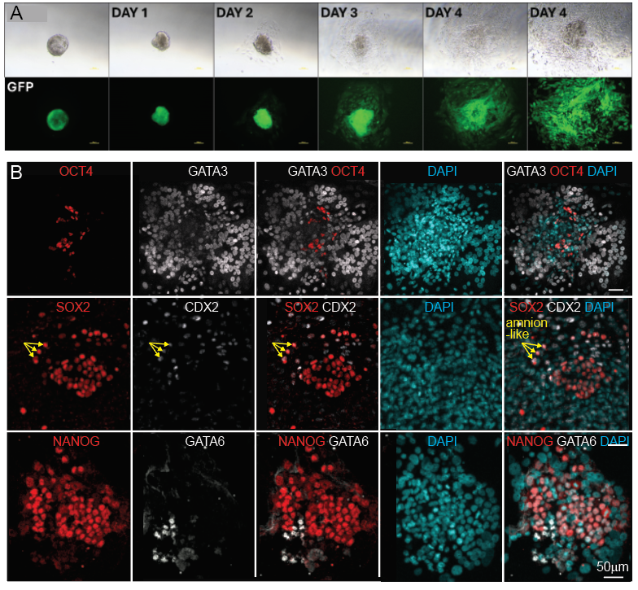

Supplementary Table 1: Primers.
Gene | Forward | Reverse
GAPDH | CTCTCTGCTCCTCCTGTTCG | CCCGATACGACCAAATCCGTT
ACTB | CGTGAACATCCGCAAAGACC | TGATCTTCATGGTGCTGGGT
NANOG | GAACTCTCCAACATCCTGAACCTC | AGGTGCTGAGGCTTTCTGAGTC
POU5F1 | GGGAAGGTGTTCAGCCAAACG | TGCACGAGGGTTTCTGCTTTG
SOX2 | TGAACGGCTCGCCAACCTAC | CTGGAGTGGGAGGAAGAGGTAAC
KLF4 | CAAAGAGTTCCCATCTCAAGGC | GTGCCCAGTGTGTTTACGG
MYC | TTACAACACCCGAGCAAGGA | GCTGGTTTTCCACTACCCGG
LIN28A | AGCTTCTTCTCCGAACCAC | AGCCACCTGCAAACTGCT
DPPA3 | TTTACAGCGGGAGAGGAGTAAG | GGCCCCTTGTTTGTTGGTATTC
DPPA5 | GTGGGTGAAAGTTCCCGAAGAC | CCTGCTCGATGTAAGGGATTCG
DNMT3L | GCTCAACAAAGAAGACGAGGAC | TCCACACACGGACAGCATTC
KLF5 | GGAGAAACGACGCATCCACTAC | GAACCTCCAGTCGCAGCCTTC
KLF17 | CCCACCCAGTCTTCATGTACG | GGGCGCTGAGTTCTCGTTATC
PRDM14 | TGTTTCTCTCAGTCTTCCAGCC | TGATGTGTGTGCGGAGTATGC
SUSD2 | CCCCTTCACCATCTCACTGGAC | GTTCACCAACTCGCTCTTCTCC
HAND1 | GAGAGCATTAACAGCGCATTCG | CACGTCCATCAGGTAGGCG
FOXC1 | AGTAGCTGTCAAATGGCCTTC | TGCCTTGATGGGTTCCTTTGG
SOX17 | TGGACCGCACGGAATTTGAAC | GACACCACCGAGGAAATGGC
GATA6 | CTTCCCCCACAACACAACCT | TAGAGCCCATCTTGACCCGA
GATA4 | CCTGTCATCTCACTACGGGCA | GACGCATAGCCTTGTGGGGA
PDGFRA | GACCCTCCTTTTACCACCTGA | TTGTCTGAGTCCACACGCAT
CDX2 | CTATGCGAGTGGATGCGGAAG | GGATGGTGATGTAGCGACTGTAG
GATA2 | TCAGACGACAACCACCACC | GAAGCACTCCGCCCCTTTCT
GATA3 | GCGGGCTCTACCACAAAATG | ATTGGCGTTCCTCCTCCAGA
KRT8 | AGTACCAGGAGCTGATGAACGTC | TCATGTTCTGCATCCCAGACTC
KRT18 | GATGCCCCCAAATCTCAGGA | ACTGTGGTGCTCTCCTCAATC
PLAC8 | GCTCCCCAGAACTCCAACTG | ACGCTTGTTCCACACAGACA
TF63 | AGAAACGAAGATCCCCAGATGA | CTGTTGCTGTTGCCTGTACGTT
HAVCR1 | AAACCCACCCTACGATACTGC | TATGTGCTGGGGACAGTTGAG
TFAP2C | ACCGTGACCCCGATTTTGGA | ATTCCCATTGCTGCTCCCGT
ITGB6 | ATCGGTCTGCACAGCAAGAACT | AAGCAGGCAGTCTTCACAGGT
GABRP | TGGTGGTGTTGTCCTGGGTT | GTTGGTGTTGGGAAGGGAAGC
BMP4 | GCTGTAGGAGCCATTCCGT | TTCTTCCCCGTCTCAGGTATCA
PRDM1 | ACCTGGCTGCGTGTCAGAAC | GTGCTCGGTTGCTTTAGATTGCTC

Supplementary Table 2: Antibodies.
Antibodies | Source / Cat. No. | Dilution
NANOG | PeptroTech / 500-p236 | 1/100-200
SOX2 | R&D Systems / af2018 | 1/25-50
OCT4 | Abcam / ab19857 | 1/250-500
SSEA4 | Abcam / ab16287 | 1/500
TRA-1-60 | Abcam / ab16288 | 1/500
TUJ-1 | R&D Systems / mab1195 | 1/100
SMA | R&D Systems / mab1420 | 1/50
AFP | R&D Systems / mab1368 | 1/20
SOX17 | Abcam / ab224637 | 1/250
GATA6 | R&D Systems / af1700 | 1/10
GATA4 | eBioscience / 14998082 | 1/200
CDX2 | Abcam / ab76541 | 1/250-500
GATA2 | Abcam / ab109241 | 1/200
NR2F2 | Abcam / ab211776 | 1/25-50
ZO-1 | Invitrogen / 339100 | 1/50
CK7 | Abcam / ab181598 | 1/300
HLA-G | Santa Cruz Biotechnology / sc21799 | 1/50
hCG-β | Abcam / ab9582 | 1/100

