Supplementary information
for
Contralesional activity reflects compensation, while brainstem detour pathways support skilled motor recovery after stroke
Panzeri Matteo^{1,2}, Thiem Nina^{3,4}, Hoffmann, Christian^{3,4}, Schillinger Ulrike³, Barapatre Nirav⁴, Musall Simon⁵, Helmchen Fritjof^{1,2,6}, Wahl Anna-Sophia^{1,2,3,4}*

Supplementary Table S1, S2
Supplementary Figures S1-S5

Table S1
Panel | Statistical test | Post hoc test / multiple comparisons | Comparison | P-value
1D | two-sample t-test | n.a. | Stroke vs. Stroke + training | 0,124
1E (middle) | Linear mixed effect model | Bonferroni | Early: sham vs. stroke | < 0.001
1E (middle) | Linear mixed effect model | Bonferroni | Early: sham vs. stroke + training | < 0.001
1E (middle) | Linear mixed effect model | Bonferroni | Late: sham vs. stroke | < 0.001
1E (middle) | Linear mixed effect model | Bonferroni | Late: sham vs. stroke + training | < 0.001
1E (right) | Linear mixed effect model | Bonferroni | Late: sham vs stroke + training | 0,001
1E (right) | Linear mixed effect model | Bonferroni | Late: stroke vs. stroke + training | < 0.001
1F (left) | Linear mixed effect model | Bonferroni | Early: stroke vs. stroke + training | 0,025
1F (left) | Linear mixed effect model | Bonferroni | Late: sham vs. stroke + training | 0,004
1F (middle) | Linear mixed effect model | Bonferroni | Early: sham vs. stroke | 0,001
1F (middle) | Linear mixed effect model | Bonferroni | Early: sham vs. stroke + training | 0,016
1F (middle) | Linear mixed effect model | Bonferroni | Late: sham vs. stroke | 0,001
1F (middle) | Linear mixed effect model | Bonferroni | Late: sham vs stroke + training | < 0.001
1F (right) | Linear mixed effect model | Bonferroni | Early: sham vs. stroke | < 0.001
1F (right) | Linear mixed effect model | Bonferroni | Early: sham vs. stroke + training | 0,001
1F (right) | Linear mixed effect model | Bonferroni | Late: sham vs. stroke | 0,042
1F (right) | Linear mixed effect model | Bonferroni | Late: sham vs. stroke + training | < 0.001
1G | Spearman correlation | n.a.
2D - E | Linear mixed effect models  (one per ROI) | False discovery rate control over all comparisons.  Benjamini-Hochberg correction | (MOp_R) Early: Sham vs. Stroke | < 0.001
2D - E | Linear mixed effect models  (one per ROI) |  | (MOp_R) Early: Sham vs. Stroke + training | < 0.001
2D - E | Linear mixed effect models  (one per ROI) |  | (MOp_R) Late: Sham vs. Stroke | 0,004
2D - E | Linear mixed effect models  (one per ROI) |  | (MOp_R) Late: Sham vs. Stroke + training | 0,013
2D - E | Linear mixed effect models  (one per ROI) |  | (MOp_L) Early: Sham vs. Stroke + training | 0,016
2D - E | Linear mixed effect models  (one per ROI) |  | (MOp_L) Late: Stroke vs. Stroke + training | < 0.001
2D - E | Linear mixed effect models  (one per ROI) |  | (MOs-lateral_R) Early: Sham vs. Stroke | < 0.001
2D - E | Linear mixed effect models  (one per ROI) |  | (MOs-lateral_R) Early: Sham vs. Stroke + training | < 0.001
2D - E | Linear mixed effect models  (one per ROI) |  | (MOs-lateral_L) Late: Stroke vs. Stroke + training | 0,048
2D - E | Linear mixed effect models  (one per ROI) |  | (MOs-medial_R) Early: Sham vs. Stroke | 0,011
2D - E | Linear mixed effect models  (one per ROI) |  | (MOs-medial_R) Early: Sham vs. Stroke + training | < 0.001
2D - E | Linear mixed effect models  (one per ROI) |  | (MOs-medial_R) Late: Sham vs. Stroke | 0,020
2D - E | Linear mixed effect models  (one per ROI) |  | (MOs-medial_R) Late: Sham vs. Stroke + training | 0,026
2D - E | Linear mixed effect models  (one per ROI) |  | (MOs-medial_L) Early: Sham vs. Stroke + training | 0,013
2D - E | Linear mixed effect models  (one per ROI) |  | (RSP-anterior_R) Early: Sham vs. Stroke + training | 0,032
2D - E | Linear mixed effect models  (one per ROI) |  | (RSP-anterior_L) Late: Stroke vs. Stroke + training | 0,027
2D - E | Linear mixed effect models  (one per ROI) |  | (SSp-bfd_R) Early: Sham vs. Stroke | 0,011
2D - E | Linear mixed effect models  (one per ROI) |  | (SSp-bfd_R) Late: Sham vs. Stroke | 0,012
2D - E | Linear mixed effect models  (one per ROI) |  | (SSp-bfd_L) Late: Stroke vs. Stroke + training | 0,017
2D - E | Linear mixed effect models  (one per ROI) |  | (SSp-ll_R) Early: Sham vs. Stroke | < 0.001
2D - E | Linear mixed effect models  (one per ROI) |  | (SSp-ll_R) Early: Sham vs. Stroke + training | < 0.001
2D - E | Linear mixed effect models  (one per ROI) |  | (SSp-ll_R) Late: Sham vs. Stroke | < 0.001
2D - E | Linear mixed effect models  (one per ROI) |  | (SSp-ll_R) Late: Sham vs. Stroke + training | 0,015
2D - E | Linear mixed effect models  (one per ROI) |  | (SSp-ll_L) Late: Stroke vs. Stroke + training | 0,004
2D - E | Linear mixed effect models  (one per ROI) |  | (SSp-nose+mouth_R) Early: Sham vs. Stroke | 0,007
2D - E | Linear mixed effect models  (one per ROI) |  | (SSp-nose+mouth_R) Early: Sham vs. Stroke + training | 0,002
2D - E | Linear mixed effect models  (one per ROI) |  | (SSp-nose+mouth_L) Late: Sham vs. Stroke + training | 0,049
2D - E | Linear mixed effect models  (one per ROI) |  | (SSp-nose+mouth_L) Late: Stroke vs. Stroke + training | 0,011
2D - E | Linear mixed effect models  (one per ROI) |  | (SSp-tr_R) Early: Sham vs. Stroke | 0,018
2D - E | Linear mixed effect models  (one per ROI) |  | (SSp-tr_R) Early: Sham vs. Stroke + training | 0,010
2D - E | Linear mixed effect models  (one per ROI) |  | (SSp-tr_R) Late: Sham vs. Stroke | 0,017
2D - E | Linear mixed effect models  (one per ROI) |  | (SSp-tr_L) Late: Stroke vs. Stroke + training | 0,016
2D - E | Linear mixed effect models  (one per ROI) |  | (SSp-ul_R) Early: Sham vs. Stroke | < 0.001
2D - E | Linear mixed effect models  (one per ROI) |  | (SSp-ul_R) Early: Sham vs. Stroke + training | < 0.001
2D - E | Linear mixed effect models  (one per ROI) |  | (SSp-ul_R) Late: Sham vs. Stroke | < 0.001
2D - E | Linear mixed effect models  (one per ROI) |  | (SSp-ul_R) Late: Sham vs. Stroke + training | < 0.001
2D - E | Linear mixed effect models  (one per ROI) |  | (SSp-ul_L) Late: Sham vs. Stroke + training | 0,030
2D - E | Linear mixed effect models  (one per ROI) |  | (SSp-ul_L) Late: Stroke vs. Stroke + training | < 0.001
2D - E | Linear mixed effect models  (one per ROI) |  | (VIS-medial_R) Late: Stroke vs. Stroke + training | 0,004
2D - E | Linear mixed effect models  (one per ROI) |  | (VIS-medial_L) Late: Stroke vs. Stroke + training | 0,016
2D - E | Linear mixed effect models  (one per ROI) |  | (VISa_R) Late: Sham vs. Stroke | 0,048
2D - E | Linear mixed effect models  (one per ROI) |  | (VISa_R) Late: Stroke vs. Stroke + training | 0,037
2D - E | Linear mixed effect models  (one per ROI) |  | (VISa_L) Late: Stroke vs. Stroke + training | 0,016
2D - E | Linear mixed effect models  (one per ROI) |  | (VISp_R) Late: Stroke vs. Stroke + training | 0,037
2D - E | Linear mixed effect models  (one per ROI) |  | (VISrl_L) Late: Stroke vs. Stroke + training | 0,040
2F | Spearman correlation | n.a.
4A (top) | Linear mixed effect models  (one per ROI) | False discovery rate control over all comparisons.  Benjamini-Hochberg correction | (MOp_R) Early: Sham vs. Stroke | 0,002
4A (top) | Linear mixed effect models  (one per ROI) |  | (MOp_R) Early: Sham vs. Stroke + training | < 0.001
4A (top) | Linear mixed effect models  (one per ROI) |  | (MOp_R) Late: Sham vs. Stroke | 0,05
4A (top) | Linear mixed effect models  (one per ROI) |  | (MOp_R) Late: Sham vs. Stroke + training | 0,05
4A (top) | Linear mixed effect models  (one per ROI) |  | (MOs-lateral_R) Early: Sham vs. Stroke | 0,042
4A (top) | Linear mixed effect models  (one per ROI) |  | (MOs-medial_R) Early: Sham vs. Stroke | 0,038
4A (top) | Linear mixed effect models  (one per ROI) |  | (SSp-bfd_R) Early: Sham vs. Stroke | 0,017
4A (top) | Linear mixed effect models  (one per ROI) |  | (SSp-ll_R) Early: Sham vs. Stroke | < 0.001
4A (top) | Linear mixed effect models  (one per ROI) |  | (SSp-ll_R) Early: Sham vs. Stroke + training | < 0.001
4A (top) | Linear mixed effect models  (one per ROI) |  | (SSp-ll_R) Late: Sham vs. Stroke | 0,008
4A (top) | Linear mixed effect models  (one per ROI) |  | (SSp-ll_R) Late: Sham vs. Stroke + training | 0,009
4A (top) | Linear mixed effect models  (one per ROI) |  | (SSp-nosemouth_R) Early: Sham vs. Stroke + training | 0,037
4A (top) | Linear mixed effect models  (one per ROI) |  | (SSp-tr_R) Early: Sham vs. Stroke | 0,002
4A (top) | Linear mixed effect models  (one per ROI) |  | (SSp-tr_R) Early: Sham vs. Stroke + training | 0,007
4A (top) | Linear mixed effect models  (one per ROI) |  | (SSp-ul_R) Early: Sham vs. Stroke | < 0.001
4A (top) | Linear mixed effect models  (one per ROI) |  | (SSp-ul_R) Early: Sham vs. Stroke + training | < 0.001
4A (top) | Linear mixed effect models  (one per ROI) |  | (SSp-ul_R) Late: Sham vs. Stroke | 0,002
4A (top) | Linear mixed effect models  (one per ROI) |  | (SSp-ul_R) Late: Sham vs. Stroke + training | 0,002
4A (bottom) | Spearman correlation | n.a.
4B (top) | Linear mixed effect models  (one per ROI) | False discovery rate control over all comparisons.  Benjamini-Hochberg correction | (MOp_R) Early: Sham vs. Stroke | 0,017
4B (top) | Linear mixed effect models  (one per ROI) |  | (MOp_R) Early: Sham vs. Stroke + training | 0,024
4B (top) | Linear mixed effect models  (one per ROI) |  | (MOp_L) Late: Stroke vs. Stroke + training | 0,013
4B (top) | Linear mixed effect models  (one per ROI) |  | (MOs-lateral_L) Late: Sham vs. Stroke + training | 0,041
4B (top) | Linear mixed effect models  (one per ROI) |  | (MOs-lateral_L) Late: Stroke vs. Stroke + training | 0,013
4B (top) | Linear mixed effect models  (one per ROI) |  | (MOs-medial_R) Early: Sham vs. Stroke | 0,014
4B (top) | Linear mixed effect models  (one per ROI) |  | (MOs-medial_R) Early: Sham vs. Stroke + training | 0,028
4B (top) | Linear mixed effect models  (one per ROI) |  | (MOs-medial_R) Late: Sham vs. Stroke | 0,034
4B (top) | Linear mixed effect models  (one per ROI) |  | (MOs-medial_L) Late: Stroke vs. Stroke + training | 0,016
4B (top) | Linear mixed effect models  (one per ROI) |  | (RSP-anterior_L) Late: Stroke vs. Stroke + training | 0,034
4B (top) | Linear mixed effect models  (one per ROI) |  | (SSp-ll_R) Early: Sham vs. Stroke | 0,013
4B (top) | Linear mixed effect models  (one per ROI) |  | (SSp-ll_R) Early: Sham vs. Stroke + training | 0,016
4B (top) | Linear mixed effect models  (one per ROI) |  | (SSp-ll_L) Late: Stroke vs. Stroke + training | 0,016
4B (top) | Linear mixed effect models  (one per ROI) |  | (SSp-tr_R) Early: Sham vs. Stroke | 0,013
4B (top) | Linear mixed effect models  (one per ROI) |  | (SSp-tr_R) Early: Sham vs. Stroke + training | 0,023
4B (top) | Linear mixed effect models  (one per ROI) |  | (SSp-tr_R) Late: Stroke vs. Stroke + training | 0,041
4B (top) | Linear mixed effect models  (one per ROI) |  | (SSp-tr_L) Late: Stroke vs. Stroke + training | 0,016
4B (top) | Linear mixed effect models  (one per ROI) |  | (SSp-ul_R) Early: Sham vs. Stroke | 0,034
4B (top) | Linear mixed effect models  (one per ROI) |  | (SSp-ul_R) Early: Sham vs. Stroke + training | 0,041
4B (top) | Linear mixed effect models  (one per ROI) |  | (SSp-ul_L) Late: Stroke vs. Stroke + training | 0,047
4B (top) | Linear mixed effect models  (one per ROI) |  | (VISa_R) Late: Stroke vs. Stroke + training | 0,041
4B (top) | Linear mixed effect models  (one per ROI) |  | (VISa_L) Late: Stroke vs. Stroke + training | 0,034
4B (bottom) | Spearman correlation | n.a.
4C (bottom) | Spearman correlation | n.a.
S1C-D | Spearman correlation | n.a.
S1F (right) | Linear mixed effect model | Bonferroni | Late: Sham vs. Stroke | 0,006
S1F (right) | Linear mixed effect model | Bonferroni | Late: sham vs. stroke + training | 0,047
S2A-C | Spearman correlation | n.a.
S3B | Linear mixed effect models  (one per ROI) | False discovery rate control over all comparisons.  Benjamini-Hochberg correction | (MOp_R) Early: Sham vs. Stroke | < 0.001
S3B | Linear mixed effect models  (one per ROI) |  | (MOp_R) Early: Sham vs. Stroke + training | < 0.001
S3B | Linear mixed effect models  (one per ROI) |  | (MOp_R) Late: Sham vs. Stroke | 0,002
S3B | Linear mixed effect models  (one per ROI) |  | (MOp_R) Late: Sham vs. Stroke + training | 0,004
S3B | Linear mixed effect models  (one per ROI) |  | (MOp_L) Early: Sham vs. Stroke | 0,047
S3B | Linear mixed effect models  (one per ROI) |  | (MOp_L) Early: Sham vs. Stroke + training | 0,013
S3B | Linear mixed effect models  (one per ROI) |  | (MOp_L) Late: Stroke vs. Stroke + training | 0,001
S3B | Linear mixed effect models  (one per ROI) |  | (MOs-lateral_R) Early: Sham vs. Stroke | < 0.001
S3B | Linear mixed effect models  (one per ROI) |  | (MOs-lateral_R) Early: Sham vs. Stroke + training | < 0.001
S3B | Linear mixed effect models  (one per ROI) |  | (MOs-lateral_R) Late: Sham vs. Stroke | 0,013
S3B | Linear mixed effect models  (one per ROI) |  | (MOs-lateral_L) Late: Stroke vs. Stroke + training | 0,025
S3B | Linear mixed effect models  (one per ROI) |  | (MOs-medial_R) Early: Sham vs. Stroke | 0,005
S3B | Linear mixed effect models  (one per ROI) |  | (MOs-medial_R) Early: Sham vs. Stroke + training | < 0.001
S3B | Linear mixed effect models  (one per ROI) |  | (MOs-medial_R) Late: Sham vs. Stroke | 0,005
S3B | Linear mixed effect models  (one per ROI) |  | (MOs-medial_R) Late: Sham vs. Stroke + training | 0,01
S3B | Linear mixed effect models  (one per ROI) |  | (MOs-medial_L) Early: Sham vs. Stroke | 0,047
S3B | Linear mixed effect models  (one per ROI) |  | (MOs-medial_L) Early: Sham vs. Stroke + training | 0,007
S3B | Linear mixed effect models  (one per ROI) |  | (RSP-anterior_R) Early: Sham vs. Stroke + training | 0,047
S3B | Linear mixed effect models  (one per ROI) |  | (SSp-bfd_R) Early: Sham vs. Stroke | 0,007
S3B | Linear mixed effect models  (one per ROI) |  | (SSp-bfd_R) Late: Sham vs. Stroke | 0,01
S3B | Linear mixed effect models  (one per ROI) |  | (SSp-ll_R) Early: Sham vs. Stroke | 0,002
S3B | Linear mixed effect models  (one per ROI) |  | (SSp-ll_R) Early: Sham vs. Stroke + training | < 0.001
S3B | Linear mixed effect models  (one per ROI) |  | (SSp-ll_R) Late: Sham vs. Stroke | 0,001
S3B | Linear mixed effect models  (one per ROI) |  | (SSp-ll_R) Late: Sham vs. Stroke + training | 0,009
S3B | Linear mixed effect models  (one per ROI) |  | (SSp-ll_L) Late: Stroke vs. Stroke + training | 0,024
S3B | Linear mixed effect models  (one per ROI) |  | (SSp-nosemouth_R) Early: Sham vs. Stroke | 0,003
S3B | Linear mixed effect models  (one per ROI) |  | (SSp-nosemouth_R) Early: Sham vs. Stroke + training | < 0.001
S3B | Linear mixed effect models  (one per ROI) |  | (SSp-nosemouth_L) Late: Stroke vs. Stroke + training | 0,001
S3B | Linear mixed effect models  (one per ROI) |  | (SSp-tr_R) Early: Sham vs. Stroke | 0,024
S3B | Linear mixed effect models  (one per ROI) |  | (SSp-tr_R) Early: Sham vs. Stroke + training | 0,018
S3B | Linear mixed effect models  (one per ROI) |  | (SSp-tr_R) Late: Sham vs. Stroke | 0,013
S3B | Linear mixed effect models  (one per ROI) |  | (SSp-tr_L) Late: Stroke vs. Stroke + training | 0,047
S3B | Linear mixed effect models  (one per ROI) |  | (SSp-ul_R) Early: Sham vs. Stroke | < 0.001
S3B | Linear mixed effect models  (one per ROI) |  | (SSp-ul_R) Early: Sham vs. Stroke + training | < 0.001
S3B | Linear mixed effect models  (one per ROI) |  | (SSp-ul_R) Late: Sham vs. Stroke | < 0.001
S3B | Linear mixed effect models  (one per ROI) |  | (SSp-ul_R) Late: Sham vs. Stroke + training | < 0.001
S3B | Linear mixed effect models  (one per ROI) |  | (SSp-ul_L) Late: Stroke vs. Stroke + training | 0,004
S3B | Linear mixed effect models  (one per ROI) |  | (VISa_R) Late: Sham vs. Stroke | 0,029
S3B | Linear mixed effect models  (one per ROI) |  | (VISa_L) Late: Stroke vs. Stroke + training | 0,047
S3B | Linear mixed effect models  (one per ROI) |  | (VISrl_R) Late: Sham vs. Stroke | 0,047
S3D | Linear mixed effect models  (one per ROI) | False discovery rate control over all comparisons.  Benjamini-Hochberg correction | (MOp_R) Early: Sham vs. Stroke | 0,002
S3D | Linear mixed effect models  (one per ROI) |  | (MOp_R) Early: Sham vs. Stroke + training | < 0.001
S3D | Linear mixed effect models  (one per ROI) |  | (MOp_R) Late: Sham vs. Stroke | 0,011
S3D | Linear mixed effect models  (one per ROI) |  | (MOp_R) Late: Sham vs. Stroke + training | 0,022
S3D | Linear mixed effect models  (one per ROI) |  | (MOp_L) Late: Stroke vs. Stroke + training | 0,005
S3D | Linear mixed effect models  (one per ROI) |  | (MOs-lateral_R) Early: Sham vs. Stroke | < 0.001
S3D | Linear mixed effect models  (one per ROI) |  | (MOs-lateral_R) Early: Sham vs. Stroke + training | < 0.001
S3D | Linear mixed effect models  (one per ROI) |  | (MOs-medial_R) Early: Sham vs. Stroke | 0,002
S3D | Linear mixed effect models  (one per ROI) |  | (MOs-medial_R) Early: Sham vs. Stroke + training | < 0.001
S3D | Linear mixed effect models  (one per ROI) |  | (MOs-medial_R) Late: Sham vs. Stroke | 0,014
S3D | Linear mixed effect models  (one per ROI) |  | (MOs-medial_R) Late: Sham vs. Stroke + training | 0,027
S3D | Linear mixed effect models  (one per ROI) |  | (MOs-medial_L) Early: Sham vs. Stroke + training | 0,014
S3D | Linear mixed effect models  (one per ROI) |  | (SSp-bfd_R) Late: Sham vs. Stroke | 0,046
S3D | Linear mixed effect models  (one per ROI) |  | (SSp-ll_R) Early: Sham vs. Stroke | 0,005
S3D | Linear mixed effect models  (one per ROI) |  | (SSp-ll_R) Early: Sham vs. Stroke + training | < 0.001
S3D | Linear mixed effect models  (one per ROI) |  | (SSp-ll_R) Late: Sham vs. Stroke | 0,004
S3D | Linear mixed effect models  (one per ROI) |  | (SSp-ll_R) Late: Sham vs. Stroke + training | 0,037
S3D | Linear mixed effect models  (one per ROI) |  | (SSp-ll_L) Late: Stroke vs. Stroke + training | 0,024
S3D | Linear mixed effect models  (one per ROI) |  | (SSp-nosemouth_R) Early: Sham vs. Stroke | 0,037
S3D | Linear mixed effect models  (one per ROI) |  | (SSp-nosemouth_R) Early: Sham vs. Stroke + training | 0,009
S3D | Linear mixed effect models  (one per ROI) |  | (SSp-nosemouth_L) Late: Stroke vs. Stroke + training | 0,024
S3D | Linear mixed effect models  (one per ROI) |  | (SSp-tr_R) Early: Sham vs. Stroke + training | 0,037
S3D | Linear mixed effect models  (one per ROI) |  | (SSp-tr_R) Late: Sham vs. Stroke | 0,041
S3D | Linear mixed effect models  (one per ROI) |  | (SSp-tr_L) Late: Stroke vs. Stroke + training | 0,024
S3D | Linear mixed effect models  (one per ROI) |  | (SSp-ul_R) Early: Sham vs. Stroke | < 0.001
S3D | Linear mixed effect models  (one per ROI) |  | (SSp-ul_R) Early: Sham vs. Stroke + training | < 0.001
S3D | Linear mixed effect models  (one per ROI) |  | (SSp-ul_R) Late: Sham vs. Stroke | < 0.001
S3D | Linear mixed effect models  (one per ROI) |  | (SSp-ul_R) Late: Sham vs. Stroke + training | 0,001
S3D | Linear mixed effect models  (one per ROI) |  | (SSp-ul_L) Late: Stroke vs. Stroke + training | 0,014
S3D | Linear mixed effect models  (one per ROI) |  | (VIS-medial_R) Late: Stroke vs. Stroke + training | 0,014
S3D | Linear mixed effect models  (one per ROI) |  | (VIS-medial_L) Late: Stroke vs. Stroke + training | 0,016
S3D | Linear mixed effect models  (one per ROI) |  | (VISa_L) Late: Stroke vs. Stroke + training | 0,022
S3D | Linear mixed effect models  (one per ROI) |  | (VISp_L) Late: Stroke vs. Stroke + training | 0,037
S3D | Linear mixed effect models  (one per ROI) |  | (VISrl_L) Late: Stroke vs. Stroke + training | 0,038
S4A | Linear mixed effect models  (one per ROI) | False discovery rate control over all comparisons.  Benjamini-Hochberg correction | (MOp_R) Early: Sham vs. Stroke | < 0.001
S4A | Linear mixed effect models  (one per ROI) |  | (MOp_R) Early: Sham vs. Stroke + training | < 0.001
S4A | Linear mixed effect models  (one per ROI) |  | (MOp_R) Late: Sham vs. Stroke | 0,004
S4A | Linear mixed effect models  (one per ROI) |  | (MOp_R) Late: Sham vs. Stroke + training | 0,01
S4A | Linear mixed effect models  (one per ROI) |  | (MOp_L) Early: Sham vs. Stroke + training | 0,04
S4A | Linear mixed effect models  (one per ROI) |  | (MOp_L) Late: Stroke vs. Stroke + training | < 0.001
S4A | Linear mixed effect models  (one per ROI) |  | (MOs-lateral_R) Early: Sham vs. Stroke | < 0.001
S4A | Linear mixed effect models  (one per ROI) |  | (MOs-lateral_R) Early: Sham vs. Stroke + training | < 0.001
S4A | Linear mixed effect models  (one per ROI) |  | (MOs-lateral_L) Late: Stroke vs. Stroke + training | 0,04
S4A | Linear mixed effect models  (one per ROI) |  | (MOs-medial_R) Early: Sham vs. Stroke | 0,003
S4A | Linear mixed effect models  (one per ROI) |  | (MOs-medial_R) Early: Sham vs. Stroke + training | < 0.001
S4A | Linear mixed effect models  (one per ROI) |  | (MOs-medial_R) Late: Sham vs. Stroke | 0,005
S4A | Linear mixed effect models  (one per ROI) |  | (MOs-medial_R) Late: Sham vs. Stroke + training | 0,004
S4A | Linear mixed effect models  (one per ROI) |  | (MOs-medial_L) Early: Sham vs. Stroke + training | 0,013
S4A | Linear mixed effect models  (one per ROI) |  | (MOs-medial_L) Late: Stroke vs. Stroke + training | 0,043
S4A | Linear mixed effect models  (one per ROI) |  | (RSP-anterior_R) Early: Sham vs. Stroke | 0,036
S4A | Linear mixed effect models  (one per ROI) |  | (RSP-anterior_R) Early: Sham vs. Stroke + training | 0,013
S4A | Linear mixed effect models  (one per ROI) |  | (RSP-anterior_L) Late: Stroke vs. Stroke + training | 0,027
S4A | Linear mixed effect models  (one per ROI) |  | (RSP-posterior_R) Late: Stroke vs. Stroke + training | 0,013
S4A | Linear mixed effect models  (one per ROI) |  | (RSP-posterior_L) Late: Stroke vs. Stroke + training | 0,025
S4A | Linear mixed effect models  (one per ROI) |  | (SSp-bfd_R) Early: Sham vs. Stroke | 0,005
S4A | Linear mixed effect models  (one per ROI) |  | (SSp-bfd_R) Late: Sham vs. Stroke | 0,003
S4A | Linear mixed effect models  (one per ROI) |  | (SSp-bfd_L) Late: Stroke vs. Stroke + training | 0,011
S4A | Linear mixed effect models  (one per ROI) |  | (SSp-ll_R) Early: Sham vs. Stroke | < 0.001
S4A | Linear mixed effect models  (one per ROI) |  | (SSp-ll_R) Early: Sham vs. Stroke + training | < 0.001
S4A | Linear mixed effect models  (one per ROI) |  | (SSp-ll_R) Late: Sham vs. Stroke | < 0.001
S4A | Linear mixed effect models  (one per ROI) |  | (SSp-ll_R) Late: Sham vs. Stroke + training | 0,004
S4A | Linear mixed effect models  (one per ROI) |  | (SSp-ll_L) Late: Stroke vs. Stroke + training | 0,001
S4A | Linear mixed effect models  (one per ROI) |  | (SSp-nosemouth_R) Early: Sham vs. Stroke | 0,005
S4A | Linear mixed effect models  (one per ROI) |  | (SSp-nosemouth_R) Early: Sham vs. Stroke + training | 0,003
S4A | Linear mixed effect models  (one per ROI) |  | (SSp-nosemouth_L) Late: Stroke vs. Stroke + training | 0,01
S4A | Linear mixed effect models  (one per ROI) |  | (SSp-tr_R) Early: Sham vs. Stroke | 0,001
S4A | Linear mixed effect models  (one per ROI) |  | (SSp-tr_R) Early: Sham vs. Stroke + training | 0,001
S4A | Linear mixed effect models  (one per ROI) |  | (SSp-tr_R) Late: Sham vs. Stroke | 0,002
S4A | Linear mixed effect models  (one per ROI) |  | (SSp-tr_R) Late: Stroke vs. Stroke + training | 0,045
S4A | Linear mixed effect models  (one per ROI) |  | (SSp-tr_L) Late: Stroke vs. Stroke + training | 0,004
S4A | Linear mixed effect models  (one per ROI) |  | (SSp-ul_R) Early: Sham vs. Stroke | < 0.001
S4A | Linear mixed effect models  (one per ROI) |  | (SSp-ul_R) Early: Sham vs. Stroke + training | < 0.001
S4A | Linear mixed effect models  (one per ROI) |  | (SSp-ul_R) Late: Sham vs. Stroke | < 0.001
S4A | Linear mixed effect models  (one per ROI) |  | (SSp-ul_R) Late: Sham vs. Stroke + training | < 0.001
S4A | Linear mixed effect models  (one per ROI) |  | (SSp-ul_L) Late: Sham vs. Stroke + training | 0,042
S4A | Linear mixed effect models  (one per ROI) |  | (SSp-ul_L) Late: Stroke vs. Stroke + training | < 0.001
S4A | Linear mixed effect models  (one per ROI) |  | (VIS-medial_R) Late: Sham vs. Stroke | 0,036
S4A | Linear mixed effect models  (one per ROI) |  | (VIS-medial_R) Late: Stroke vs. Stroke + training | < 0.001
S4A | Linear mixed effect models  (one per ROI) |  | (VIS-medial_L) Late: Stroke vs. Stroke + training | 0,003
S4A | Linear mixed effect models  (one per ROI) |  | (VISa_R) Early: Sham vs. Stroke | 0,015
S4A | Linear mixed effect models  (one per ROI) |  | (VISa_R) Late: Sham vs. Stroke | 0,005
S4A | Linear mixed effect models  (one per ROI) |  | (VISa_R) Late: Stroke vs. Stroke + training | 0,008
S4A | Linear mixed effect models  (one per ROI) |  | (VISa_L) Late: Stroke vs. Stroke + training | 0,005
S4A | Linear mixed effect models  (one per ROI) |  | (VISp_R) Late: Stroke vs. Stroke + training | 0,03
S4A | Linear mixed effect models  (one per ROI) |  | (VISp_L) Late: Stroke vs. Stroke + training | 0,01
S4A | Linear mixed effect models  (one per ROI) |  | (VISrl_R) Late: Sham vs. Stroke | 0,036
S4A | Linear mixed effect models  (one per ROI) |  | (VISrl_R) Late: Stroke vs. Stroke + training | 0,027
S4A | Linear mixed effect models  (one per ROI) |  | (VISrl_L) Late: Stroke vs. Stroke + training | 0,005

Supplementary Table 1. Statistical tests, post-hoc tests (if applicable) and exact p-values (3 significant figures) of significant comparisons used in figure panels. Region of interest (ROI) names are suffixed with “_L” for the left hemisphere shown in the panels, and “_R” for the right hemisphere shown in the panels. ROI abbreviations are fully named in supplementary table 2.

Table S2
Area abbreviation | Area description
MOp | Primary motor cortex (M1)
MOs-lateral | Anterior-lateral portion of the secondary motor cortex (M2)
MOs-medial | Posterior-medial portion of the secondary motor cortex (M2)
SSp-ll | Somatosensory cortex - hindlimb
SSp-ul | Somatosensory cortex - forelimb
SSp-nosemouth | Merged ROI from mouth and nose somatosensory ROIs
SSp-bfd | Somatosensory cortex - barrel cortex
SSp-tr | Somatosensory cortex - trunk
RSp-anterior | Anterior part of the retrosplenial cortex
RSP-posterior | Posterior part of the retrosplenial cortex
VISp | Primary visual cortex (V1)
VIS-medial | Medial visual areas
VISa | Posterior parietal cortex - area "a" ("PPC-a")
VISrl | Posterior parietal cortex - area "rl" ("PPC-rl")

Supplementary Table 2. List of regions of interest names and abbreviations, based on the Allen Brain Atlas.

Supplementary Figure 1
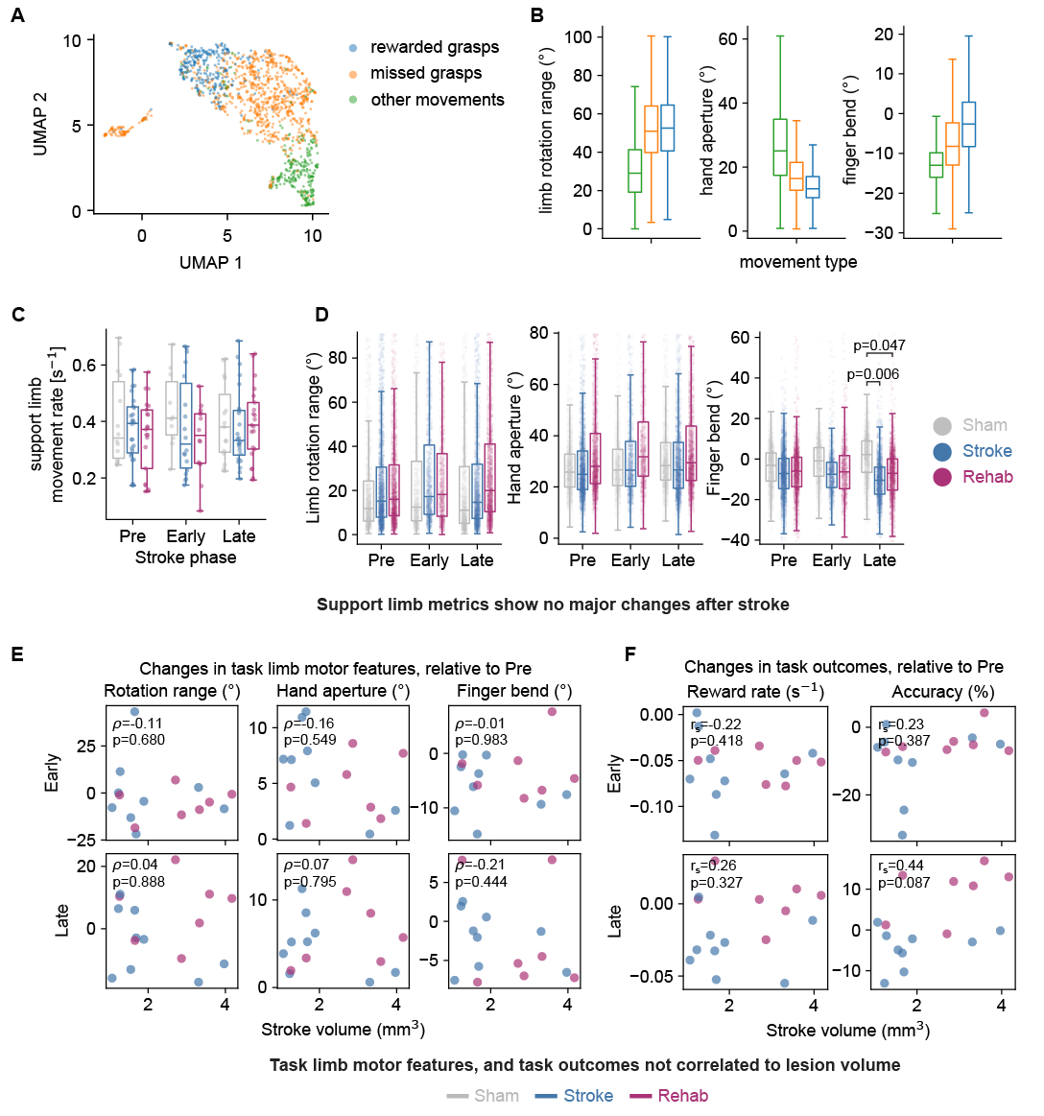
Supplementary Figure 1. Further fine motor skill quantifications. A. UMAP embedding of all pre-stroke grasps from one mouse, color coded by the type of movement (n=1497 grasps, n=1 mice). B. Comparison of fine motor features across different movement types. Data from all detected pre-stroke movements (n=28033 grasps, n=21 mice). C. Comparison of the rate of support limb movements (number of movements per second) between different cohorts. Datapoints are individual sessions (n=163 sessions, n=21 mice). D. Comparison of support limb fine motor features across cohorts. Datapoints represent average support limb fine motor feature during a rewarded grasp (n=14115 rewarded grasps, n=21 mice).E. Spearman correlations between task limb motor features and stroke volume. Individual datapoints represent average motor features for each mouse in the given experimental phase, relative to pre-stroke (n=16 mice). F. Spearman correlations between task-performance metrics (reward rate and accuracy), and lesion size. Datapoints represent averages over the experimental phase for each mouse (n=16 mice). In C. and D. statistical comparisons are performed using linear mixed effect models (one model per plot) and p-values are adjusted per-model for multiple comparisons (post-hoc Bonferroni correction).

Supplementary Figure 2

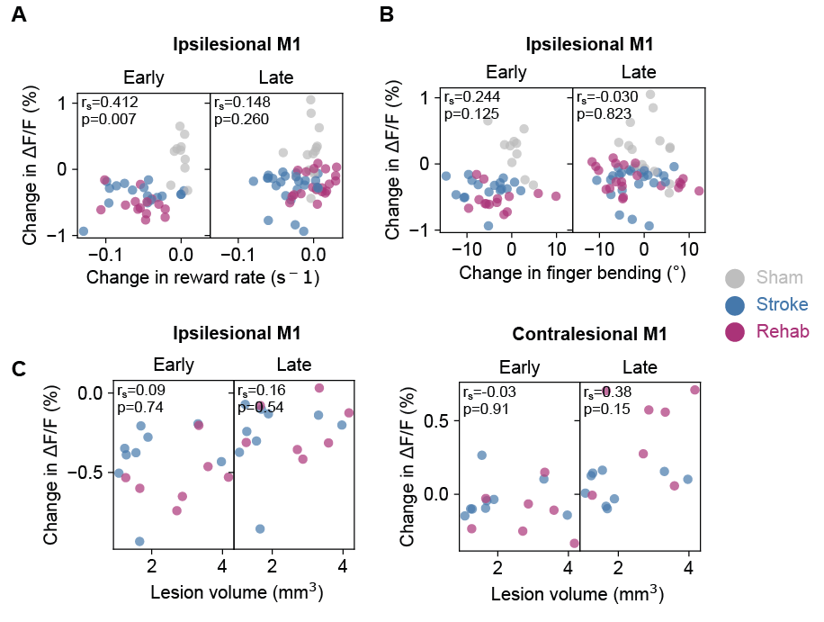

Supplementary Figure 2. Correlations of activity with behavioral parameters and lesion sizes. A. Spearman correlation between change in $∆F/F_{0}$ of the ipsilesional M1 and session reward rate. Individual datapoints sessions averages over rewarded grasps (n=163 sessions, n=21 mice) and are relative to pre-stroke baseline. B. Same as for A. but correlating the activity with the session-average finger bending fine motor parameters. C. Spearman correlations between change in cortical activity (averaged for all grasps within session) and lesion volume. Left: ipsilesional M1, right: contralesional M1. Individual datapoints average over the given experimental phase (n=16 mice) and are relative to pre stroke baseline.

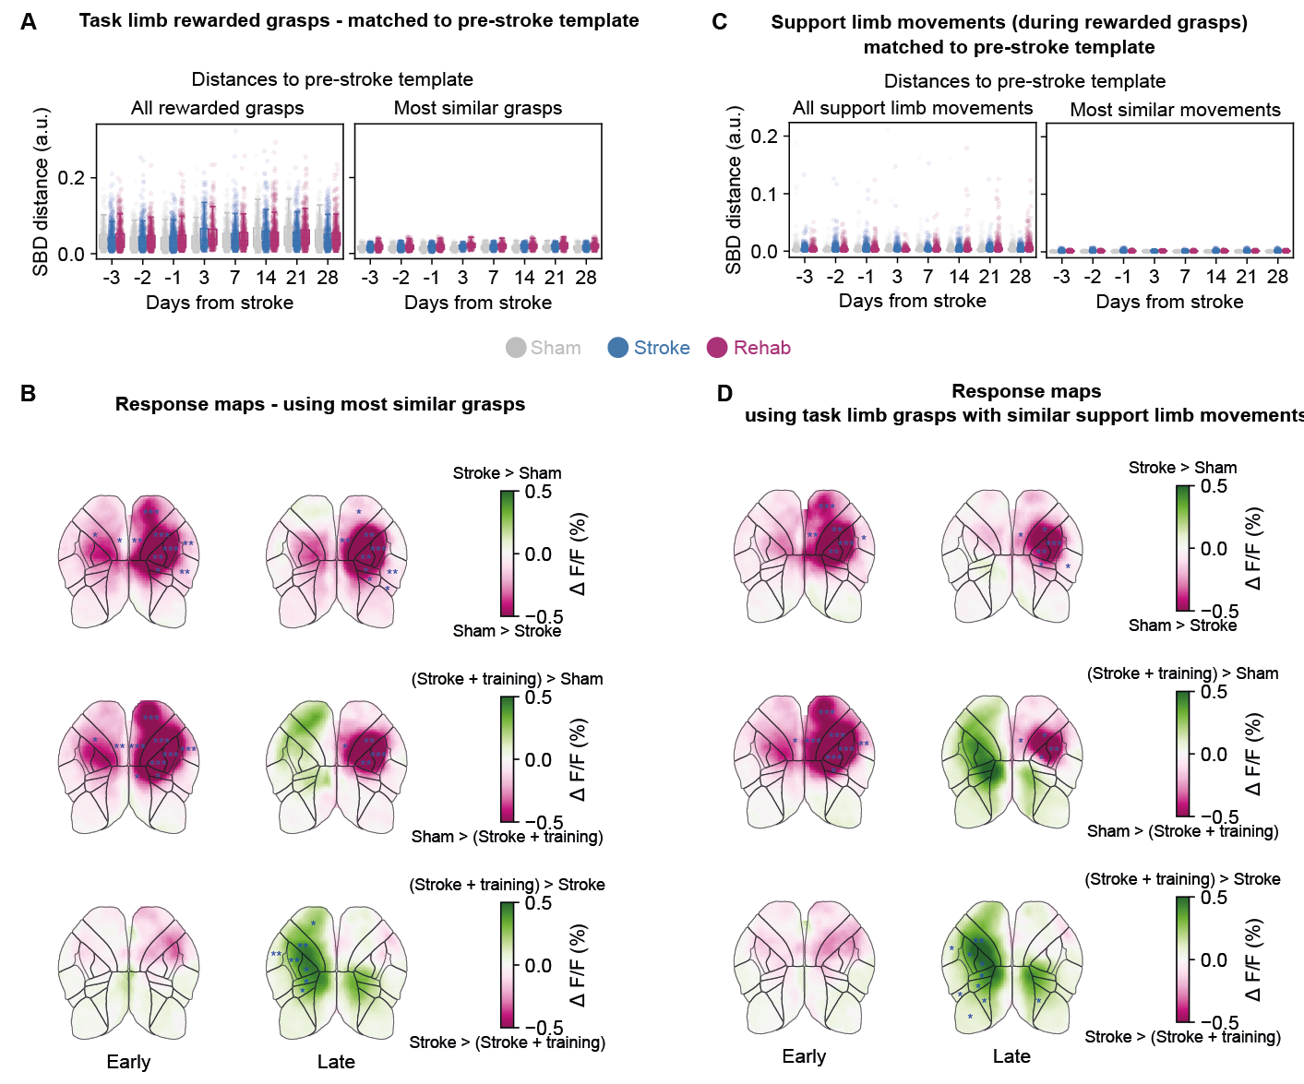
Supplementary Figure 3
Supplementary Figure 3. Increase in contralesional activity is not driven by changes in task or support limb trajectories. A. Shape-based distances (SBD) between individual task-limb grasps their pre-stroke template grasp (calculated per mouse). Datapoints represent individual grasps. Left: all rewarded grasps (n=14115 grasps, n=21 mice). Right: grasps that are classified as similar to pre-stroke template (n=6073 grasps, n=21 mice). B. Differences in $∆F/F_{0}$ response maps between groups, using the subset of similar grasps. Maps obtained by averaging response-window activity over grasps (n=6073 grasps, n=21 mice). Data is normalized to pre-stroke baseline. Blue overlays represent results of statistical testing. C. Same as A. but matching support-limb trajectories (during rewarded task-limb grasps). Left: all support limb movements (n=14115 grasps, n=21 mice), right: subset of support limb movements classified as similar (n=6411 grasps, n=21 mice). D. same as B. but using the subset of task-limb that exhibit similar support-limb movements. In B. and D. statistical comparisons are computed using linear mixed-effect models (one per ROI) and p-values are adjusted by controlling the false discovery rate (Benjamini-Hochberg correction). Blue asterisks indicate significances for the corresponding outlined ROI: *p<0.05, **p<0.01, *** p<0.001.
Supplementary Figure 4
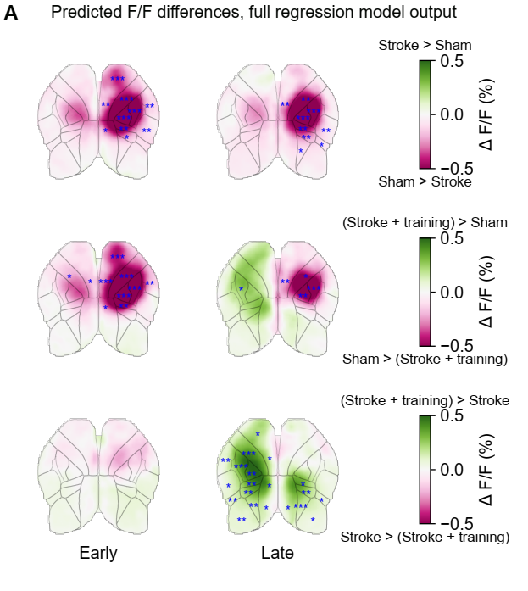
Supplementary Figure 4. Outputs of the full ridge regression models capture the increase in contralesional activity seen in the widefield imaging data. A. Differences in $∆F/F_{0}$ predicted by the full ridge regression model, between cohorts at different post-stroke phases. Datapoints are response window averaged $∆F/F_{0}$, over individual grasps (n=102 sessions, n=21 mice). Statistical comparisons are computed using linear mixed-effect models (one per ROI) and p-values are adjusted for multiple comparisons by controlling the false discovery rate (Benjamini-Hochberg correction). Blue asterisks indicate significances for the corresponding outlined ROI: *p<0.05, **p<0.01, *** p<0.001.

Supplementary Figure 5
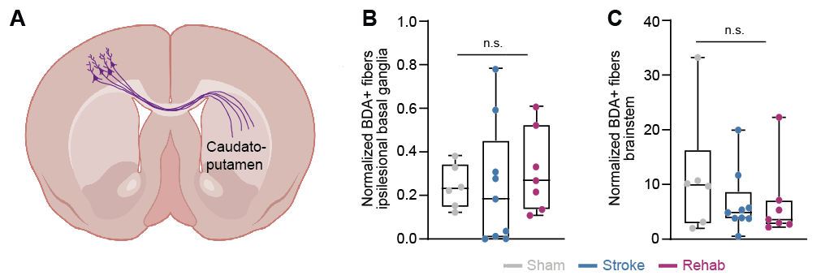Supplementary Figure 5. A. Scheme revealing BDA+ fibers projecting from the contralesional hemisphere to the basal ganglia. B. Normalized BDA+ fiber count in the ipsilesional basal ganglia were compared for the different experimental groups (Sham n=6, Stroke n=9, Stroke + training group n=7). C. Total BDA+ fiber density in the brain in the three experimental groups. For B. and C. statistical comparison was performed with a Kruskal-Wallis test setting a significance level of p<0.05.

