Forensic Profiling of Nerium oleander using FTIR spectroscopy
Punnya C V, punnyavi52@gmail.com
Dr. Ankita Kritit Parmar *
School of Behavioural Sciences and Forensic Investigations, Rashtriya Raksha University, Lavad, Dahegam, Gandhinagar – 382305
Abstract
Toxic plants can be considered those plants that, when touched or consumed in a prescribed quantity, can be harmful to an organism. The botanical family Apocynaceae has various medical purposes, and they were poisonous too. And these plants were used for suicide and homicides. The various plant parts, such as leaves, flowers, stems, roots, and fruits of Nerium oleander were collected from various locations of RRU. In the current study, the powdered samples were analysed by FTIR spectroscopy. This study was conducted to understand the structural composition of these plants. The obtained spectrum revealed the functional groups in the form of bands. The spectra obtained for all samples were of distinct intensities but had the presence of similar functional groups, which were continuously repeating. And the presence of extremely poisonous ions such as cyanide, thiocyanate, and sulphur was also identified. This study can be considered reliable and helps in the identification and comparison of plant poison and in confirming the cause of death.
Keywords: Nerium oleander, FTIR spectroscopy, functional groups.
Background of the study
Plants have been widely studied for their medicinal, toxicological, and forensic significance. The Apocynaceae family represents a diverse and fascinating group of plants known for their ecological significance and profound medicinal properties. Throughout history, these botanical treasures have played a crucial role in human civilisation, serving as sources of food, shelter, and remedies for a wide range of ailments. “Dogbane” is another name for this family. Among them, Nerium oleander (Oleander) is well-known for their bioactive compounds, some of which exhibit toxic and pharmacological properties. This plant contains cardiac glycosides and alkaloids, which can have fatal consequences when ingested or misused.
Nerium oleander (L.), is a poisonous shrub with beautiful blooms. The many cardiac glycosides present in every section of the oleander plant are the primary poisons responsible for acute cardio toxicity. Dizziness, emesis, diarrhea, arrhythmia, and even death can result from even a small amount of oleander. N. oleander's toxicity has long been known. The plant's seeds and roots are particularly abundant in cardio toxic glycosides, but they are present throughout the plant. Every part of the oleander plant includes two strong cardiac glycosides, or cardenolides: oleandrin and neriine.

The forensic profiling is essential for toxicological investigations because of their poisonous nature, which frequently links them to poisoning cases. Fourier transform infrared (FTIR) spectroscopy is a type of vibrational spectroscopy. Although FTIR is a very useful technique for confirming the identity of pure chemicals, its usefulness for compound mixtures is limited. Finding functional groups in molecules that vibrate in response to specific light wavelengths by stretching or bending in various ways is the basis of the technique. Plotting these vibrations and their strength (percent transmission) against the light frequency (cm⁻¹) that the sample is exposed to yields an FTIR spectrum. Certain parts of the FTIR spectrum, known as the fingerprint region, are unique to the drug under test. In earlier studies,

Methodology
Materials Required: Plant specimen, deionised water, mortar and pestle, zip lock bags, cotton, methanol
Sample Collection
In the present study, three different plant parts of Nerium oleander were subjected to analysis using an FTIR spectrometer. The specimens were collected from the premises of Rashtriya Raksha University, Lavad, Gandhinagar, Gujarat during the months of March 2024.
Sample Size
Table 1 Details of the sample
S. No | Name of Plant | Part
1. | Nerium oleander | Leaf
2. | Nerium oleander | Flower
3. | Nerium oleander | Stem

Sample Preparation
For preparing the sample for analysis, 10 grams of various parts such as leaves, stem, root and flowers were collected from Nerium oleander. The collected parts were then cleaned with water in order to remove contaminants and dust particles. The cleaned parts were dried under sunlight and weighed. Further, they were crushed using mortar and pestle and filtered using a sieve. The completely powdered samples were then stored separately with their sample names in sealed zip- lock bags to avoid contamination. Then 0.1 grams of each sample were analysed using the FTIR spectrometer.
FTIR
The powdered samples were using Attenuated Total Reflectance - Fourier Transform Infrared Spectrophotometer. The chosen spectral range was 400–4000 cm-1, or the mid-infrared region (MIR area), for the analysis. All the samples were scanned three times, and the mean spectral value was noted for analysis. The sample surface was sterilised using cotton and methanol before the run of each analyte. Between successive sample tests, a scan was made to remove the clear crystal surface background from the actual spectra.

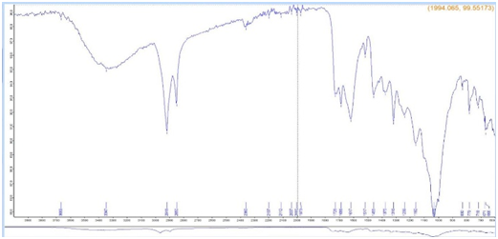
Results
Fig 1: FTIR spectrum of Nerium oleander leaf
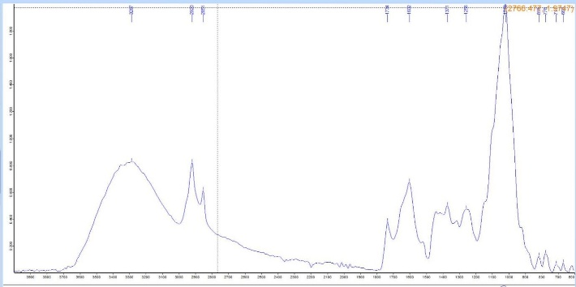
The leaf spectrum displayed typical polymeric –OH stretches and methoxy groups along with prominent bands for alkyne groups, isothiocyanates, cyanide ions, esters, amides, and aromatic rings. The presence of nitro compounds, phosphate and carbonate ions, disulfides, and various halogens.

Fig 2: FTIR spectrum of Nerium oleander flower
The flower displayed aromatic ring systems, aldehydes, esters, and vibrations of the -OH and methylene groups. There were noticeable functional groups, including amines, azo and imino groups, nitrates, aromatic ethers, and compounds containing sulfur and halogen, which suggested complex secondary metabolites with the potential to be toxic.

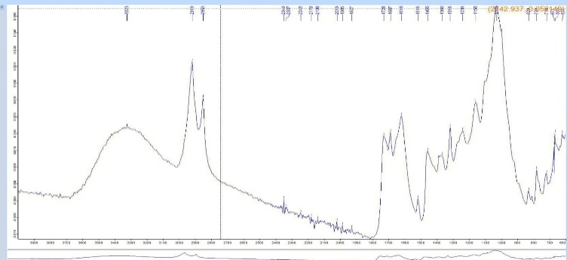
Fig 3: FTIR spectrum of Nerium oleander stem
Ammonium ions, polymeric -OH, methoxy groups, transition metal carbonyls, esters, and imino groups were detected by FTIR analysis of the stem. Its presence of nitrogen containing functional groups, such as amines and nitro compounds, as well as phosphates, sulfates, disulfides, and several halogenated functional groups, highlighted its toxic and complex chemical makeup.
Discussion
Plant pieces, extracts, or vomit remnants can be readily discovered at a crime scene and may be the primary clue in poisoning cases, leading to the culprit’s identification and the victim’s legal justice. Among the often-employed plant poisons in cases of suicide and homicide are riccinus, aconitum, conium, datura, cerium, and oleander. As a result, analyzing the differences in the chemical makeup of, N. oleander plant would help identify potential offenders and provide information for a forensic investigation that is now underway.
By analysing the figures, it was observed that there are some band assignments which are continuously repeating. They are Normal polymeric “OH” stretch, Methylene C-H asym./sym .Stretch, Methyl C-H asym./ sym. Bend ,Methylene C-H asym ./ sym. Stretch and Methylene C-H bend . Skeletal C-C vibration, Alkyne C-H bend and Vinyl C-H in plane bend. Aliphatic chloro compounds C-Cl stretch, Aliphatic fluoro compounds C-F stretch and Aliphatic bromo compounds C-Br stretch. Phenol or tertiary alcohol OH bend, Primary or secondary OH, in – plane bend. Aromatic ethers, aryl – O stretch and peroxides C- O- O stretch. Primary amine, NH bend and primary amine, CN stretch. Secondary amine,> N-H bend, secondary amine, CN stretch and Tertiary amine, CN stretch.Aromatic primary amine, CN stretch, Aromatic secondary amine, CN stretch and Aromatic tertiary amine, CN stretch.Carboxylate, ketone, Aldehyde, Ester and Transition metal carbonyls.Thiocyanate (- SCN), Isothiocyanate (- NCS), Open chain azo (-N =N) and Open – chain imino (- C=N-). Aromatic nitro compounds, organic sulfates, sulfonates and Organic phosphates P = O stretch. Thioethers CH3- (S C-S) stretch, Aryl thioethers ¢- S (C-S stretch), Disulfides (C- S stretch) and Disulfides (S- S stretch).Carbonate ion, sulfate ion, Nitrate ion, Phosphate ion, cyanide ion, thiocyanate and related ions and silicate ion.
Other than these, there are some band assignments like Amide, Heterocyclic amine > NH stretch, Alkyl carbonate, Ammonium ion, Terminal (vinyl) C-H stretch, Medial cis – or trans C-H stretch and Quinone or conjugated ketones.
Conclusion
Because it produced consistent results, infrared (IR) spectroscopy has been shown to be a highly effective method for the sensitive, quick, accurate, and objective evaluation of plant samples. These plant remnants could be found at a variety of crime scenes, including ones involving rape, suicide, murder, and break-ins. In the event of suicidal poisoning, it might be found in its natural state near to the body or perhaps as a trace found in vomit or froth that has been partially swallowed. It might be consumed in homicidal incidents and discovered partially or completely digested in the victim’s gut. In each of these cases, FTIR spectroscopy can be used to analyse the plant evidence, and the resulting spectrum can then be compared with the standard spectrum of suspected samples.
In the current research work it was found that, there were similarities in the peaks of all the plant parts. It was discovered that N. Oleander is extremely poisonous in the wild, in contrast to earlier research. According to the pilot study, there may be a chance to detect more toxic plants in the future by using FTIR analysis to identify different plants in the same family. Moreover, it is suggested that increasing the sample size with the use of various integrated spectroscopic techniques and other chemical methods could result in greater efficiency.
Declarations
Ethics approval and consent to participate
Not Applicable
Authors Contribution
Punnya C. V. (School of Behavioural Sciences and Forensic Investigations, Rashtriya Raksha University) conceived and designed the study, carried out the FTIR experiments, analysed the data, and drafted the manuscript.
Dr. Ankita Kritit Parmar supervised the research, validated the findings, and critically revised the manuscript for intellectual content. Both authors read and approved the final version of the manuscript.
Consent for Publication
Not Applicable
Funding
This research did not receive any specific grant from funding agencies in the public, commercial, or not-for-profit sectors.
Availability of data and material
The datasets generated during the current study are available in the How to Read and Interpret FTIR Spectroscope of Organic Material Apr 2019 Indonesian Journal of Science and Technology 4(1):97-118
DOI: 10.17509/ijost.v4i1.15806
Acknowledgements
Not Applicable
References
- Çilesizoğlu, N. B., Yalçin, E., Çavuşoğlu, K., &Kuloğlu, S. S. (2022). Qualitative and quantitative photochemical screening of Nerium oleander L. Extracts associated with toxicity profile. Scientific Reports, 12(1). https://doi.org/10.1038/s41598-022-26087-0
- Sawi, N. M. E., Geweely, N. S., Qusti, S., Mohamed, M., & Kamel, A. (2010). Cytotoxicity and antimicrobial activity of Nerium oleander Extracts. Journal of Applied Animal Research, 37(1), 25–31. https://doi.org/10.1080/09712119.2010.9707089
- Amend, N., Worek, F., Thiermann, H., & Wille, T. (2021). Investigation of cardiac glycosides from oleander in a human induced pluripotent stem cells derived cardiomyocyte model. Toxicology Letters, 350, 261–266. https://doi.org/10.1016/j.toxlet.2021.07.020
- Chaudhary, K., Prasad, D. N., & Sandhu, B. S. (2015). Preliminary pharmacognostic and phytochemical studies on Nerium oleander Linn. (White cultivar). Journal of Pharmcognosy and Phytochemistry, 4(1), 185–188. https://www.phytojournal.com/archives/2015/vol4issue1/PartD/4-2-2.1-654.pdf
- [Separation and identifying features of the cardiac aglycones and glycosides of Nerium oleander L. Flowers by thin-layer chromatography]. (1993, November 1). PubMed. https://pubmed.ncbi.nlm.nih.gov/8015691/
- Singh, Y., Nimoriya, R., Rawat, P., Mishra, D. K., & Kanojiya, S. (2022). Quantitative evaluation of cardiac glycosides and their seasonal variation analysis in Nerium oleander using UHPLC‐ESI‐MS/MS. Phytochemical Analysis, 33(5), 746–753. https://doi.org/10.1002/pca.3126
- Oryan, A., Maham, M., Rezakhani, A., & Maleki, M. (1996b). Morphological studies on experimental oleander poisoning in cattle. Journal of Veterinary Medicine. Series A, 43(1–10), 625–634. https://doi.org/10.1111/j.1439-0442.1996.tb00496.x
- Langford, S. D., & Boor, P. J. (1996). Oleander toxicity: an examination of human and animal toxic exposures. Toxicology, 109(1), 1–13. https://doi.org/10.1016/0300-483x(95)03296-r
- Kassop, D., Donovan, M. S., Cohee, B. M., Mabe, D. L., Wedam, E. F., & Atwood, J. E. (2014). An unusual case of cardiac glycoside toxicity. International Journal of Cardiology, 170(3), 434–437. https://doi.org/10.1016/j.ijcard.2013.11.019
- Rubini, S., Rossi, S. S., Mestria, S., Odoardi, S., Chendi, S., Poli, A., Merialdi, G., Andreoli, G., Frisoni, P., Gaudio, R. M., Baldisserotto, A., Buso, P., Manfredini, S., Govoni, G., Barbieri, S., Centelleghe, C., Corazzola, G., Mazzariol, S., & Locatelli, C. A. (n.d.). A Probable Fatal Case of Oleander (Nerium oleander) Poisoning on a Cattle Farm: A New Method of Detection and Quantification of the Oleandrin Toxin in Rumen. Toxins, 11(8), 442. https://doi.org/10.3390/toxins11080442
- Ghavri, K., & Adhav, M. (2021). Thin Layer Chromatographic analysis for detecting various bioactive compounds in the ethanolic leaf extracts of Thevetia peruviana (Pers.) K. Schum [Thevetia White]. International Advanced Research Journal in Science, Engineering and Technology, 8(11). https://doi.org/10.17148/iarjset.2021.81107
- Vineeshma M, Angrish A, Jasuja OP. FTIR Spectroscopy-based Examination of Cascabella thevetia (L.) Lippold: Preliminary Studies on Geographical Variations. Int J Eth Trauma Victimology. 2023;9(1):51-56.
- A REVIEW ON COMMON MEDICINAL PLANTS BELONG TO APOCYNACEAE FAMILY FOUND IN MAVELIKARA TALUK. (2023). IJCRT, ISSN: 2320-2882.
- Onyeaka, H., Passaretti, P., Miri, T., & Al-Sharify, Z. T. (2022b). The safety of nanomaterials in food production and packaging. Current Research in Food Science, 5, 763–774. https://doi.org/10.1016/j.crfs.2022.04.005
- Serrano, R. (2018). Toxic plants: knowledge, medicinal uses and potential human health risks. Environment and Ecology Research, 6(5), 487–492. https://doi.org/10.13189/eer.2018.060509
- Nandiyanto, A. B. D., Oktiani, R., &Ragadhita, R. (2019). How to read and interpret FTIR spectroscope of organic material. Indonesian Journal of Science and Technology, 4(1), 97. https://doi.org/10.17509/ijost.v4i1.15806

