Supplementary Figure S 2
Mortality associated lipid species in ACLF

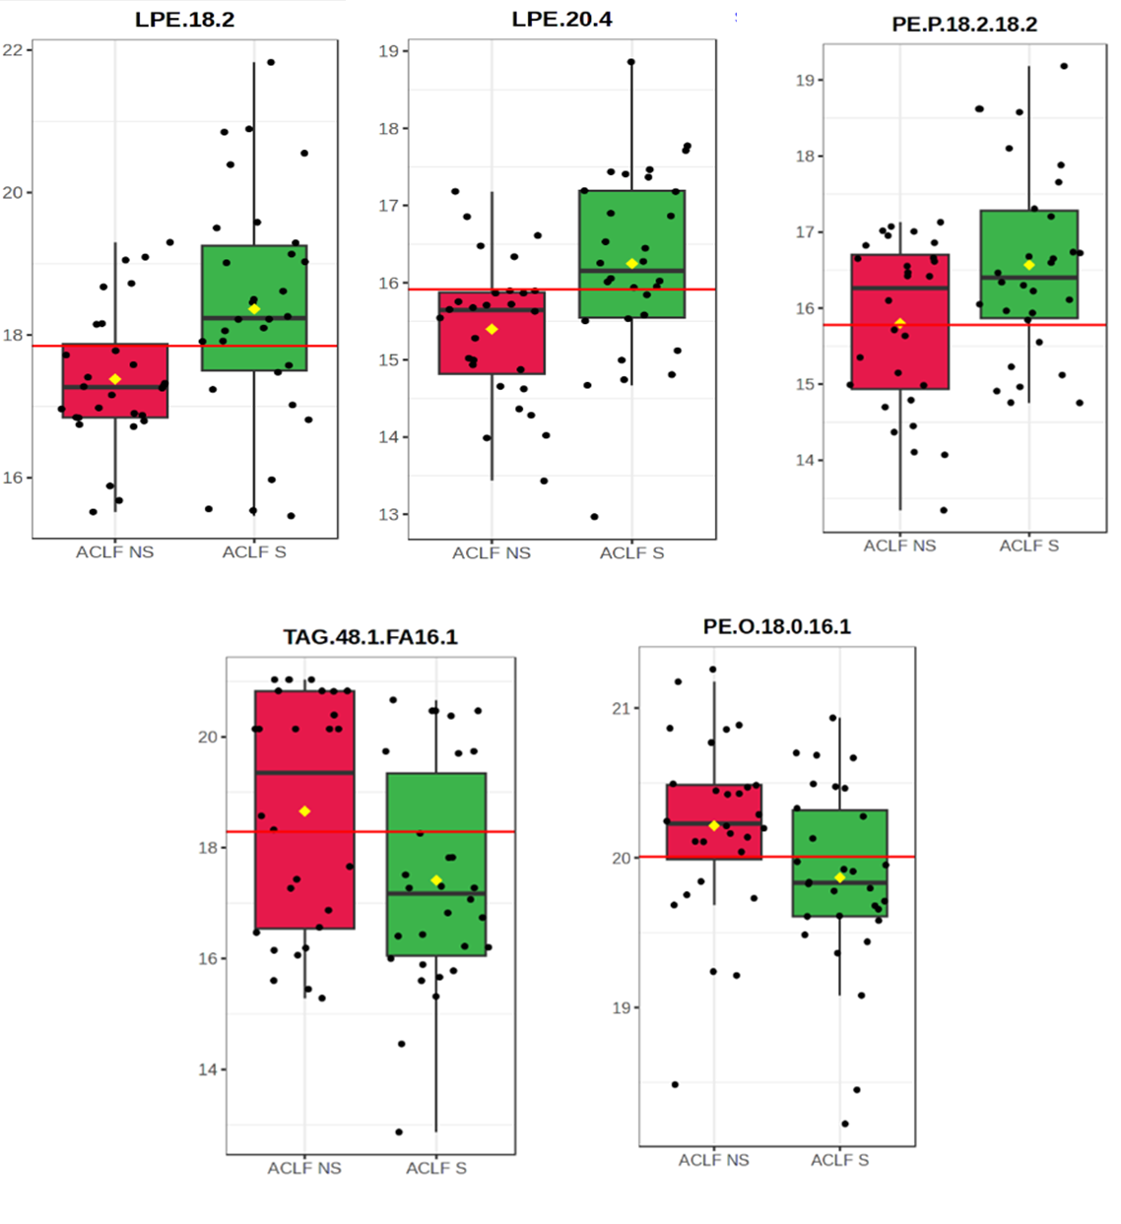
Figure. Boxplots showing relative abundance of selected lipid species between ACLF survivors (ACLF S) and non-survivors (ACLF NS). LPE(18:2), LPE(20:4), and PE(P-18:2/18:2 were reduced in survivors, whereas TAG(48:1/FA16:1) and PE(O-18:0/16:1) were elevated in non-survivors.

