Supplementary Figure S 1
Lipidomics data normalization in Metaboanalyst
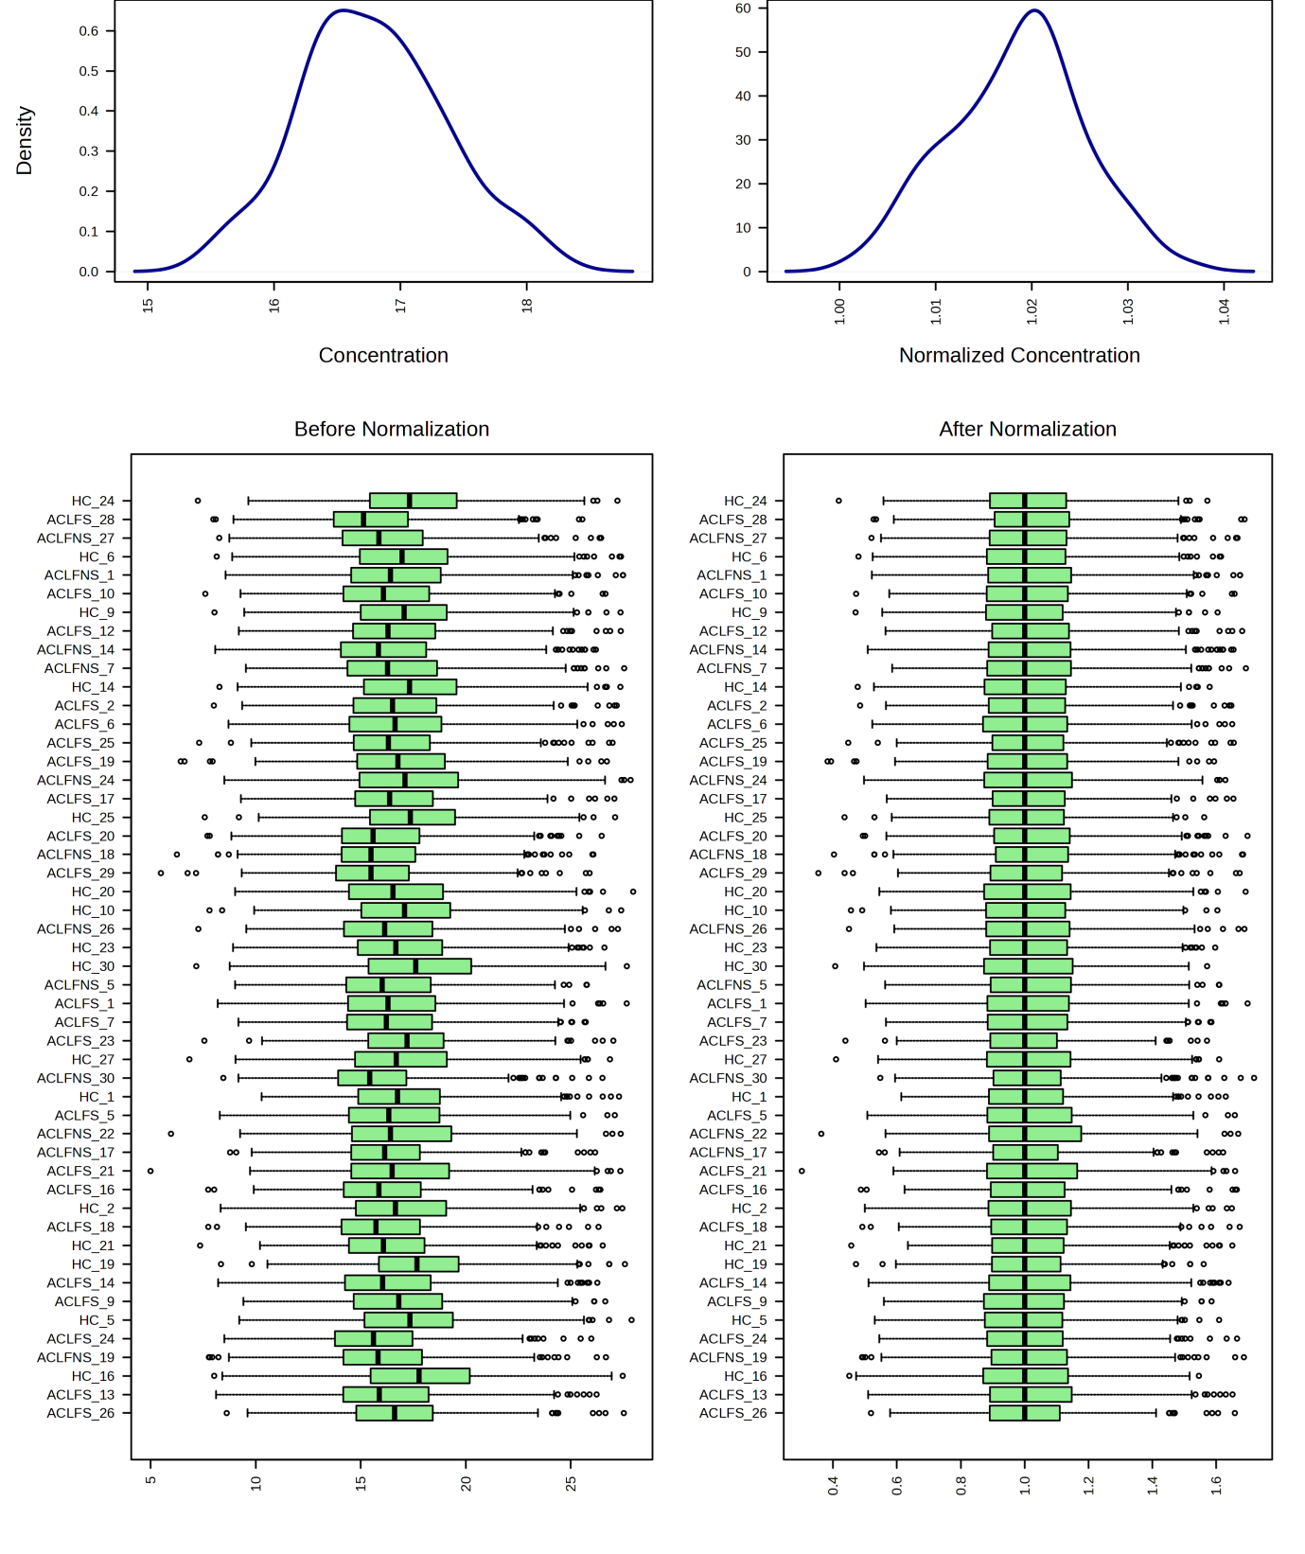

Figure. Representation of samples after data normalization in Metaboanalyst
Density plot (top panel) and box plots (lower panel) of a representative set of 50 samples showing the effect of data normalization.

