Supplementary Figure S4
Network analysis of transcription factor and kinase enrichment for differential genes and proteins
Network diagrams summarizing the results of Transcription Factor Enrichment Analysis (TFEA) and Kinase Enrichment Analysis (KEA) performed on (a) significantly differential genes (previously published transcriptomics study Saha et al 2021) and (b) significantly differential proteins (present study ). In each network, nodes represent enriched transcription factors (TFs) and kinases. Highlighted within both networks are the central hubs MAPK1, MAPK14 and PPARG, illustrating their prominent associations with upstream TFs and downstream targets in ACLF.
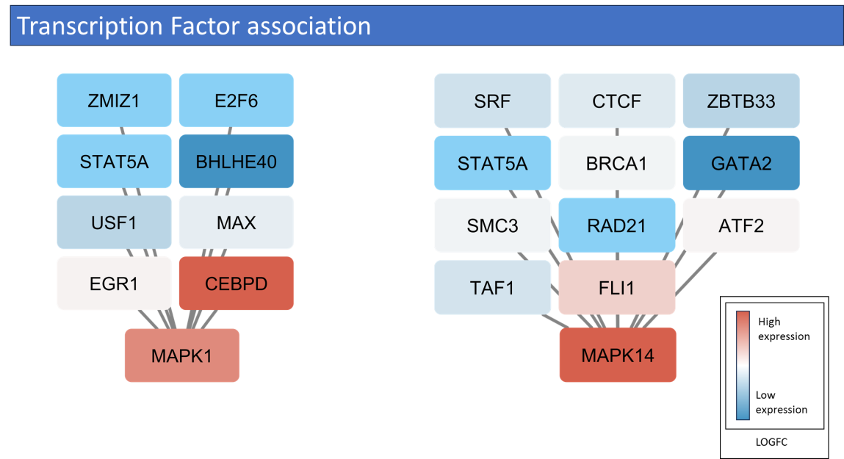

- 1. Transcription factor associations with MAPK1 and MAPK14
Network diagrams depicting key transcription factors identified by enrichment analysis around the kinases MAPK1 (left) and MAPK14 (right). Node color reflects the average log₂ fold‐change of each transcription factor in ACLF 1 (red, high; blue, low), and edges represent predicted regulatory interactions. For MAPK1, ZMIZ1, E2F6, STAT5A, BHLHE40, USF1, MAX and EGR1/CEBPD converge on this central hub. For MAPK14, SRF, CTCF, ZBTB33, STAT5A, BRCA1, GATA2, SMC3, RAD21, ATF2 and TAF1/FLI1 feed into MAPK14, highlighting its integration with multiple regulatory modules in ACLF.

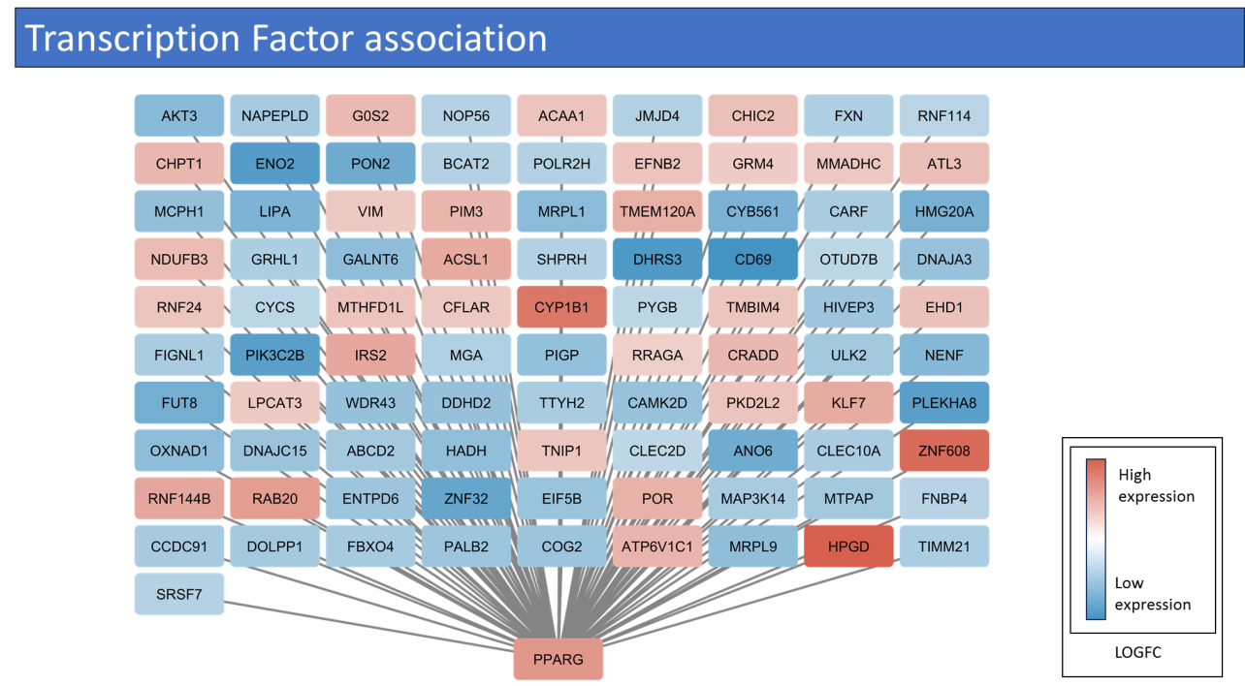
- 2. Transcription factor enrichment analysis of differentially expressed genes (DEGs) in ACLF whole blood samples.
The network highlights transcription factors enriched among DEGs identified from transcriptomics data. Here, PPARG is seen as a central transcriptional regulator, with multiple DEG nodes focusing on the transcription factors connected to it, which points towards its potential role in orchestrating immune-metabolic gene expression changes in ACLF.

