Supplementary Figure S3
Overlapping lipid signatures in ACLF and other acute diseases
A. Venn diagram of 59 lipid species common to ACLF 1 (this study) and ACLF 2 (Clària et al. 2021), with the inset listing all overlapping lipids.
B. Venn diagram of the five lipids shared between ACLF 1 and sepsis (Mecatti et al. 2020), naming PC (34:1), PC (34:2), PC (36:1), PC (36:3) and PS (40:1).
C. Venn diagram of the 56 species common to ACLF 1 and severe COVID-19 (Ciccarelli et al. 2022), with the inset enumerating all shared DG, LPC, LPE, PC, PE, PI and CE species.
D. Venn diagram of the 19 overlapping lipids between ACLF 1 and trauma (Wu et al. 2022), listing the shared PCs, PEs and PIs.
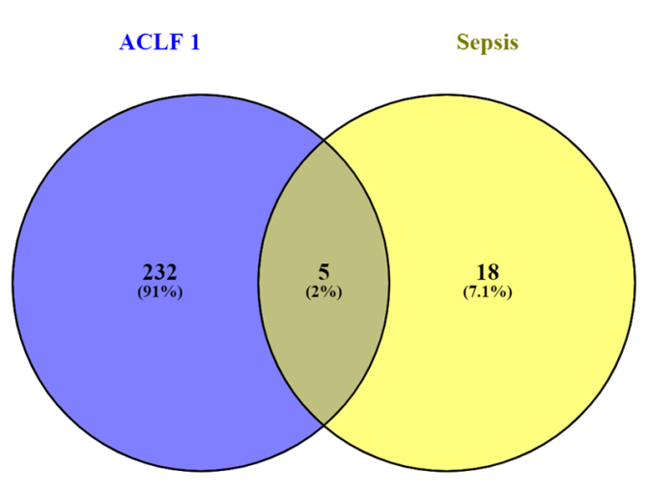
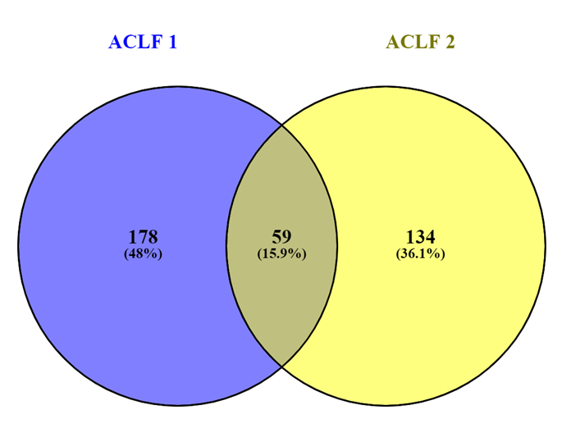
59 common lipids in "ACLF 1" and "ACLF 2" 5 common lipids in "ACLF 1" and "Sepsis":
TG (40:0) LPC (18:0) PE (36:2) PC (34:1), PC (34:2), PC (36:3), PC (36:1), PS (40:1)
TG (46:1) LPC (22:6) PE (36:4)
TG (48:1) LPE (18:0) PE (36:5)
TG (50:1) LPE (18:2) PE (38:4)
TG (50:3) LPE (20:4) PE (38:5)
TG (51:2) PC (32:1) PE (38:6)
TG (52:2) PC (32:2) PE (38:7)
TG (52:3) PC (34:3) PE (40:6)
TG (52:4) PC (34:1) PE (40:7)
TG (52:5) PC (36:3) PI (32:1)
TG (54:3) PC (36:2) PI (34:1)
TG (54:6) PC (36:4) PI (36:1)
TG (54:7) PC (36:5) PI (36:3)
CE (20:4) PC (38:4) PI (36:4)
LPC (14:0) PC (38:1) PI (38:4)
LPC (16:1) PC (38:5) PI (40:6)
LPC (16:0) PC (40:4) PS (36:3)
LPC (18:1) PC (40:5) PS (36:1)
LPC (18:2) PE (34:2) PS (38:0)
PS (38:4)
PS (40:6

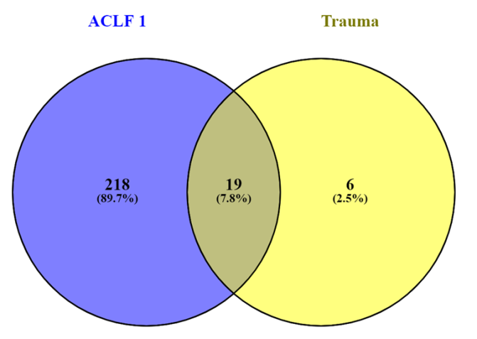
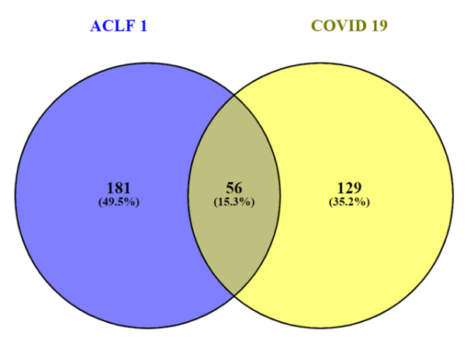

56 common lipids in "ACLF 1" and "COVID 19":
19 common lipids in "ACLF 1" and "Trauma":
PC (32:1)
PC (34:1)
PC (34:2)
PC (36:2)
PC (36:3)
PC (36:4)
PC (38:4)
PC (40:6)
PC (40:7)
PC (36:1)
PE (36:1)
PE (36:2)
PE (36:4)
PE (38:4)
PE (38:6)
PE (40:6)
PE (34:2)
PI (36:2)
PI (40:4)
CE (20:4) LPE (16:0) PC (40:7)
DG (34:2) LPE (18:0) PC (40:8)
DG (36:1) LPE (18:1) PE (36:5)
DG (36:2) LPE (18:2) PE (36:3)
DG (38:4) LPE (20:4) PE (36:4)
DG (40:8) LPE (22:6) PE (38:5)
LPC (14:0) PC (32:1) PE (40:6)
LPC (16:0) PC (32:2) PE (40:7)
LPC (16:1) PC (34:1) PE (34:1)
LPC (18:0) PC (34:2) PE (34:2)
LPC (18:1) PC (34:4) PI (32:1)
LPC (18:2) PC (34:0) PI (36:1)
LPC (20:1) PC (36:2) PI (36:2)
LPC (20:2) PC (36:3) PI (36:3)
LPC (20:3) PC (38:4) PI (36:4)
LPC (20:4) PC (38:5) PI (38:4)
LPC (22:4) PC (38:6) PI (38:3)
LPC (22:5) PC (36:0) PI (40:6)
LPC (22:6) PC (40:5)

