Supplementary Figure S5. Structural Overlay of Selected Docked Lipids with Garcinoic Acid (GA) in the PPARγ Binding Pocket (PDB: 7AWD).

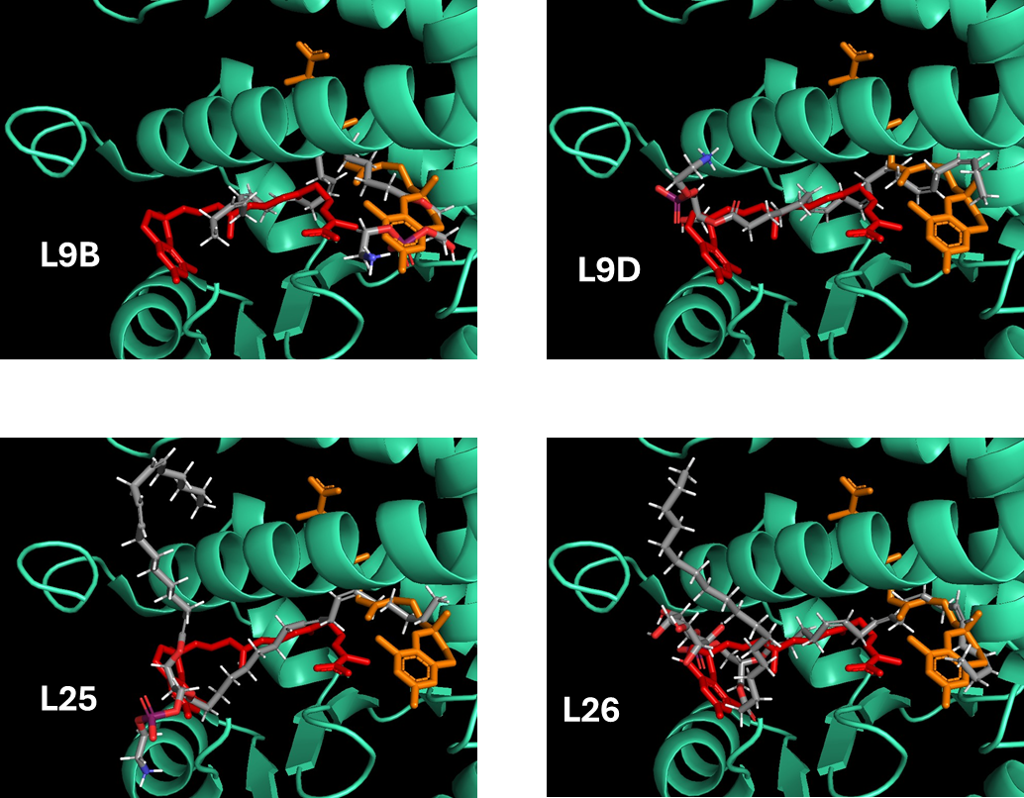
Representative docked lipid ligands (L9B, L9D, L25, and L26; gray) superimposed with two co-crystallized GA molecules in the PPARγ ligand-binding domain. GA in the orthosteric pocket is shown in red, and GA in the allosteric pocket in orange. Docking used the crystal structure of the GA–PPARγ complex.

