Supp. Table 1: Results of logistic regression analysis to identify the background factors that were related to BCVA worse than 1.0 logMAR units (0.1 decimal BCVA).
Independent variables | β | P-Value
Age (years) | 0.243 | 0.016*
Sex (men/women) | 0.031 | 0.741
Affected eye (right/left) | -0.195 | 0.038*
Hypertension | 0.002 | 0.984
Diabetes mellitus | -0.122 | 0.213
Period from symptom onset  to initial visit to hospital (weeks) | -0.144 | 0.155
Standardized partial regression coefficient (β), and P-values are calculated for six independent variables which were associated with visual acuities poorer than 1.0 logMAR (0.1 decimal BCVA) at the initial visit to the hospital eyes in eyes with CRVO. * P < 0.05 was considered significant.

Supp. Figure 1

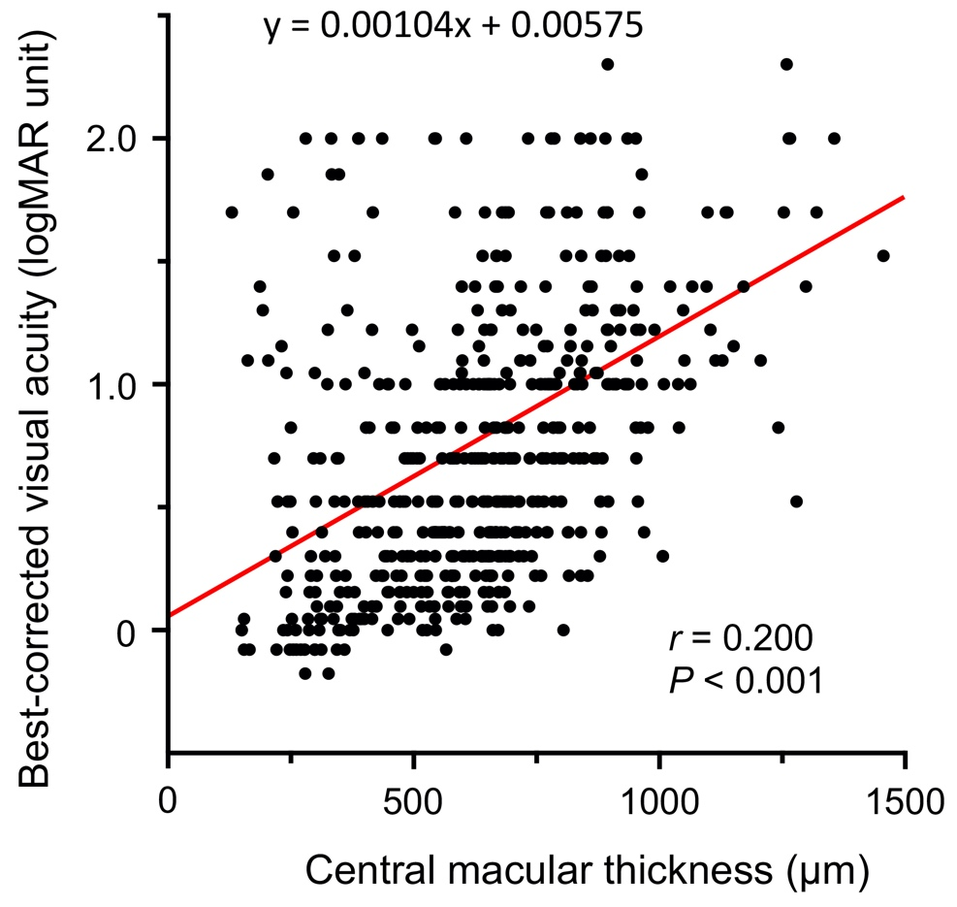

Suppl. Figure 1: Plot of BCVA (in logMAR units) against central macular thickness (CMT) at the initial examination. There was a significant correlation between the BCVA and CMT at the initial examination (r = 0.200, P <0.001). The best-fit linear regression line is also shown by the red line.

