Systematic Optimization of 293T Cell Electroporation: Balancing High-Efficiency Gene Delivery with Cell Viability
Table S1:Chica buffers used in electroporation experiments.
Buffer | Composition
1M | 5mM KCl; 15mM MgCl2; 120mM Na2HPO4/NaH2PO4 pH7.2; 50mM Manitol
1S | 5mM KCl; 15mM MgCl2; 120mM Na2HPO4/NaH2PO4 pH7.2; 50mM Sodium Succinate
1SM | 5mM KCl; 15mM MgCl2; 120mM Na2HPO4/NaH2PO4 pH7.2; 25mM Sodium Succinate; 25mM Manitol
2M | 5mM KCl, 15mM MgCl2; 15mM HEPES; 150mM Na2HPO4/NaH2PO4 pH7.2; 50mM Manitol
2S | 5mM KCl, 15mM MgCl2; 15mM HEPES; 150mM Na2HPO4/NaH2PO4 pH7.2; 50mM Sodium Succinate

Figure S1：Transfection Flow Cytometry Results in Different Buffers
Group | Results
1S | 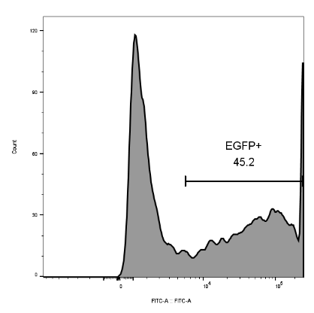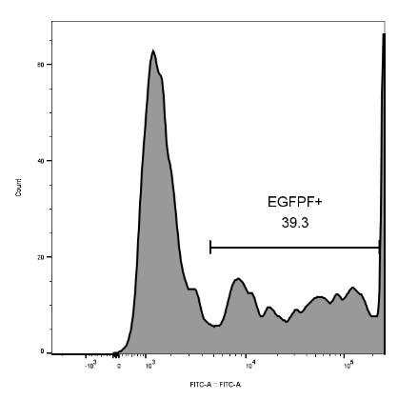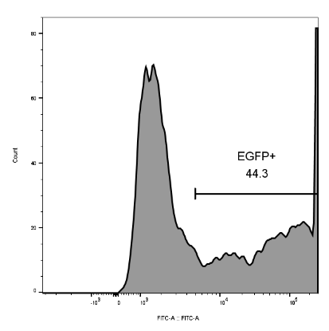
2S | 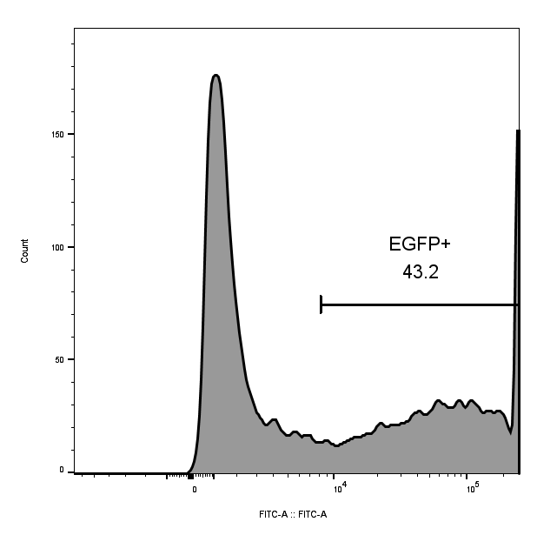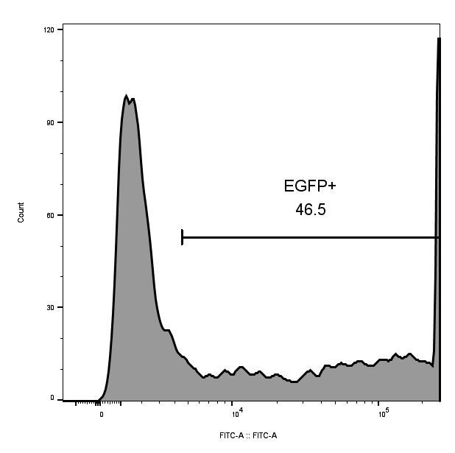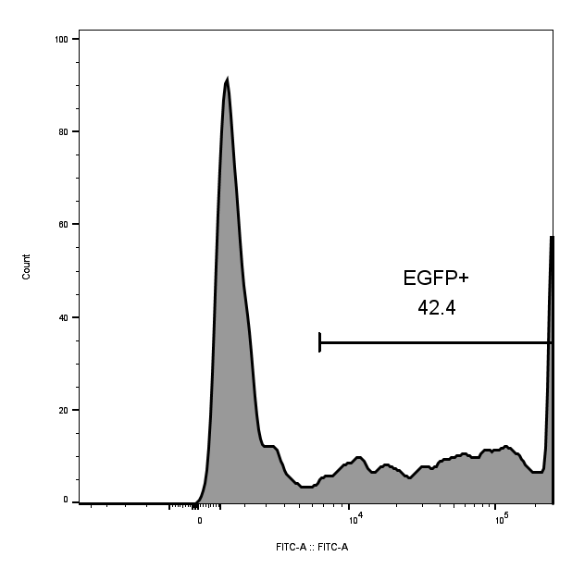
1M | 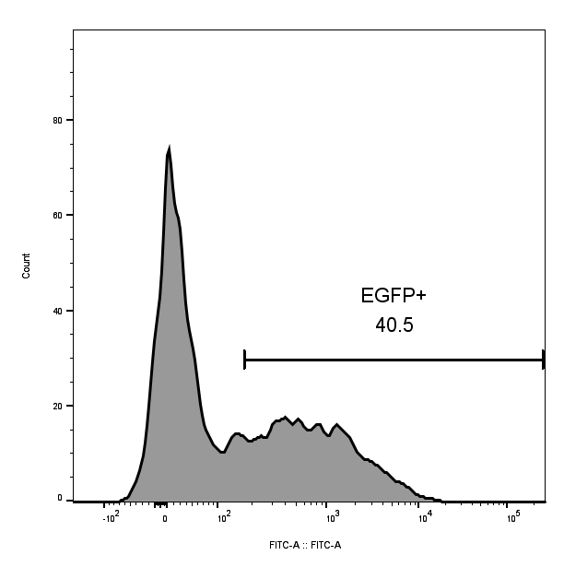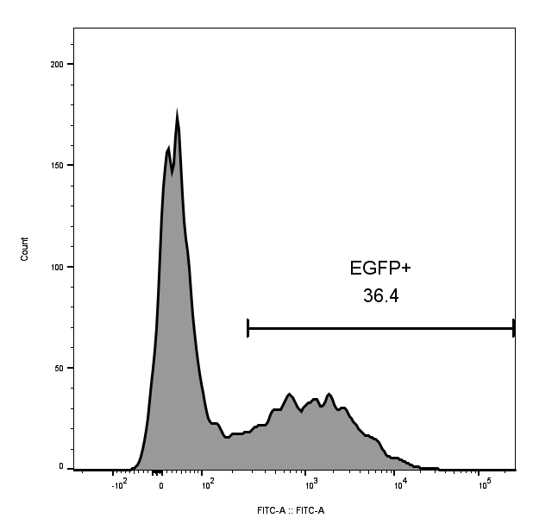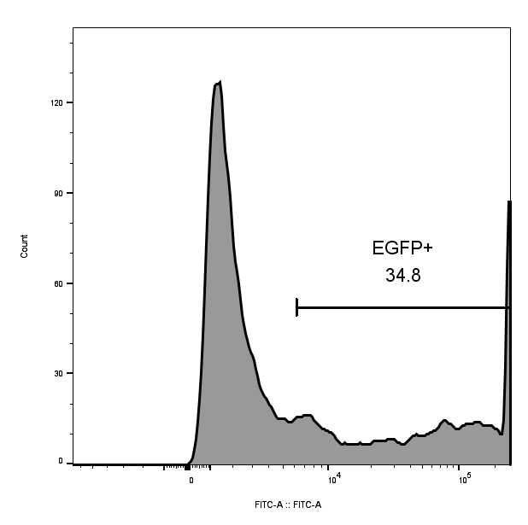
2M | 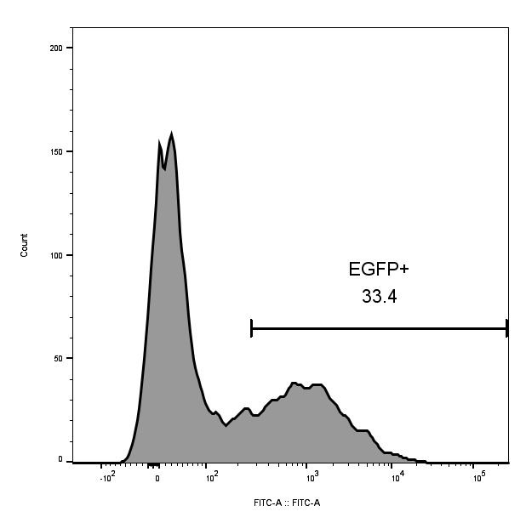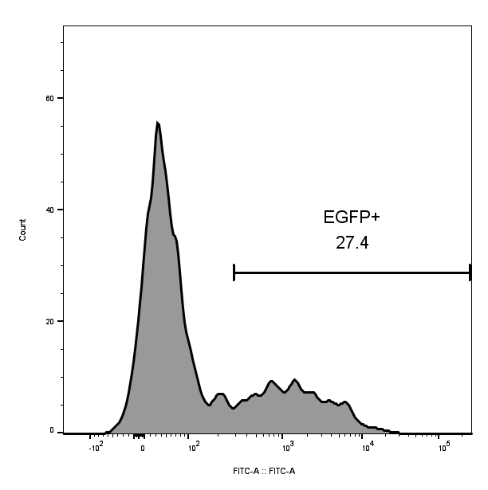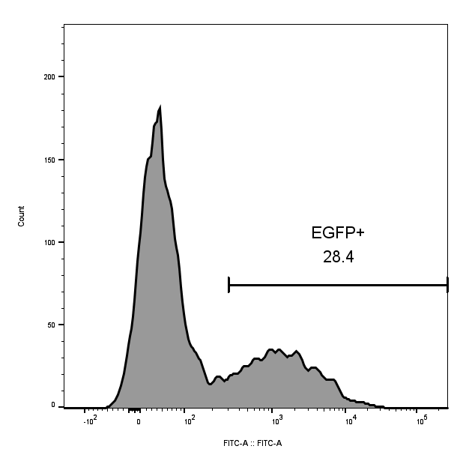
1SM | 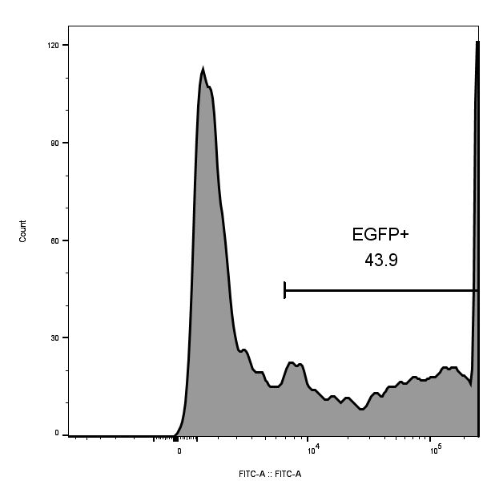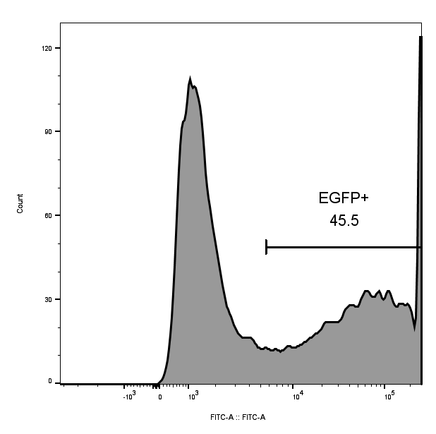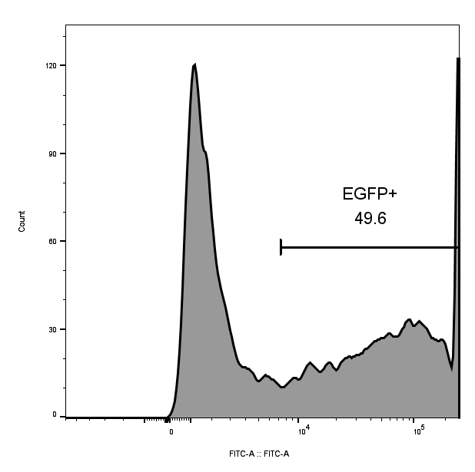
BTX | 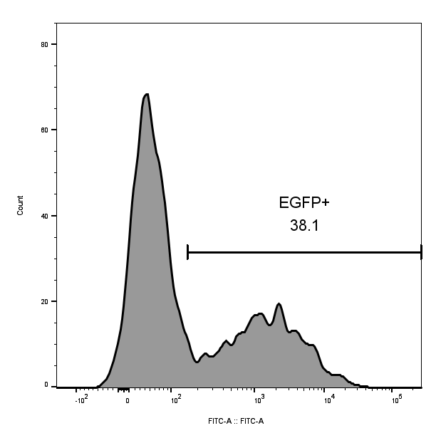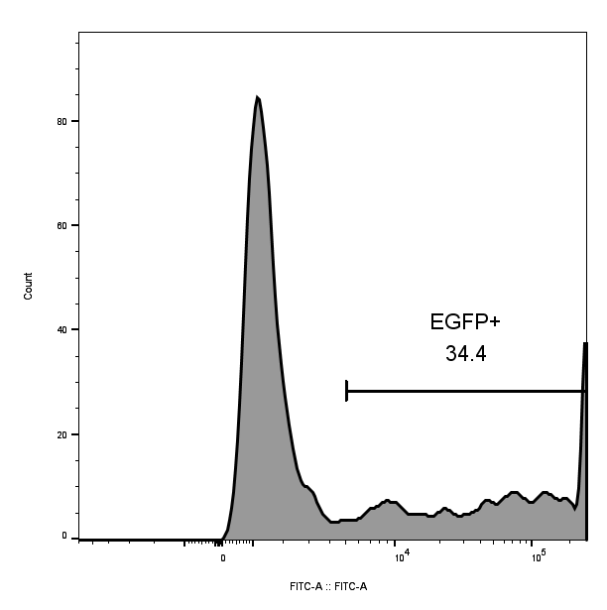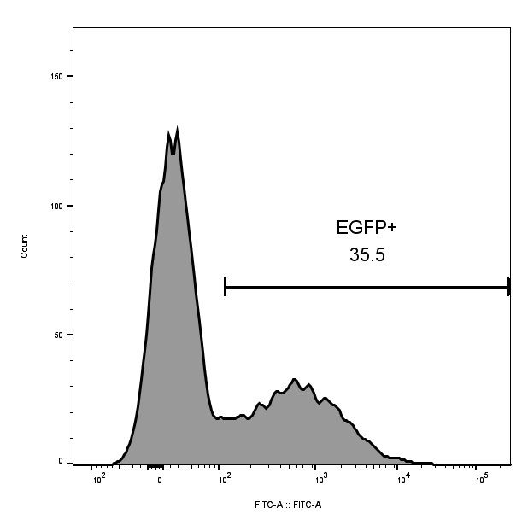
DMEM | 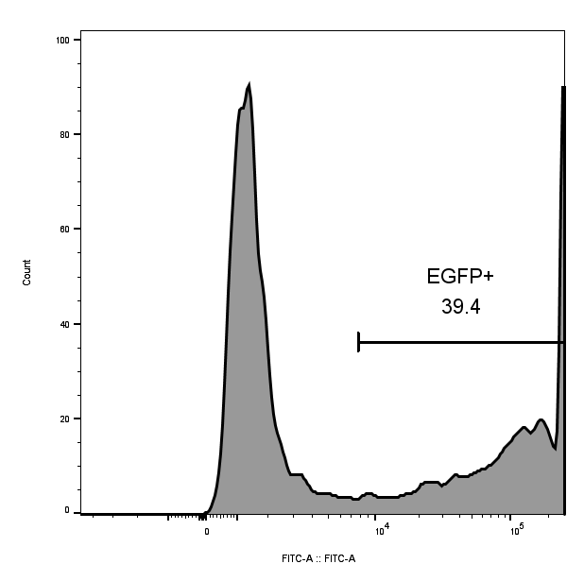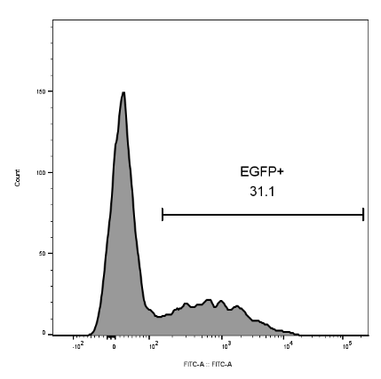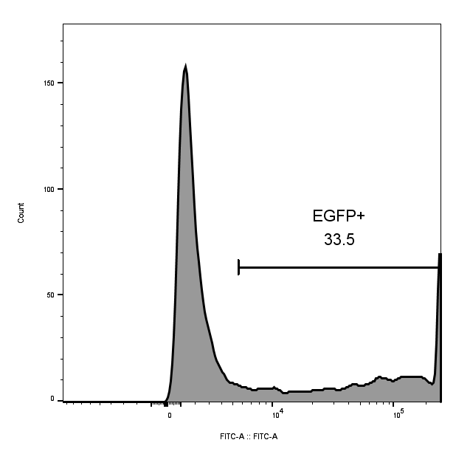
Figure S1：Transfection Flow Cytometry Results in Different Buffers. Electroporation was independently repeated three times (n=3) in each buffer, and the flow cytometry results for each run are shown in the figure above. The average value was taken as the final transfection efficiency for each group.

Table S2: Orthogonal Group Cell Absorbance Data
Group | 1 hole(OD) | 2 hole(OD) | 3 hole(OD)
1 | 2.247 | 2.131 | 2.145
2 | 2.063 | 2.034 | 2.384
3 | 1.552 | 1.594 | 1.387
4 | 2.405 | 2.301 | 2.313
5 | 1.529 | 1.439 | 1.405
6 | 2.198 | 2.395 | 2.472
7 | 1.744 | 2.054 | 1.689
8 | 2.328 | 2.262 | 2.320
9 | 1.152 | 1.071 | 1.005
blank control | 2.648 | 2.500 | 2.350
medium group | 0.247 | 0.282 | 0.247

Figure S2: Flow cytometry results of orthogonal group transfections
1 | 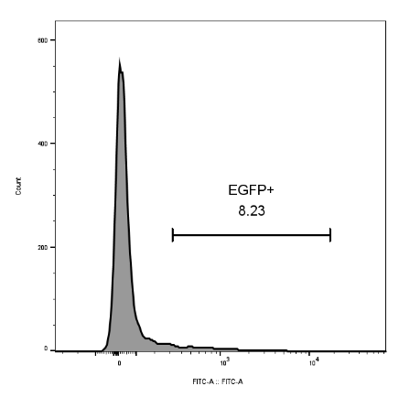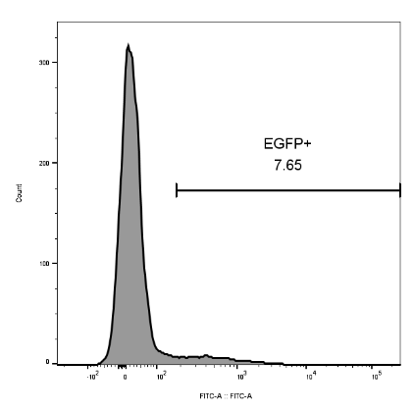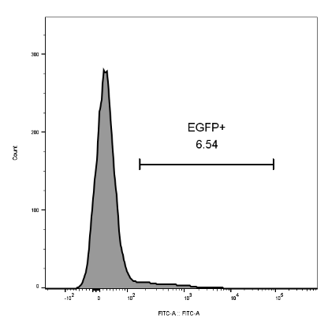
2 | 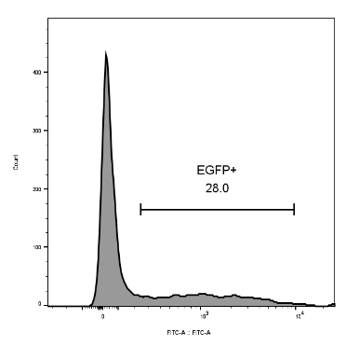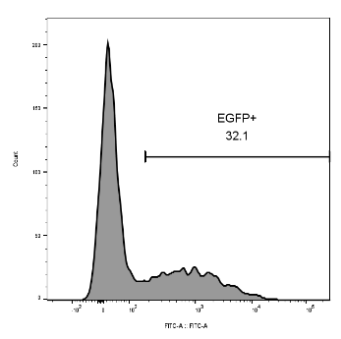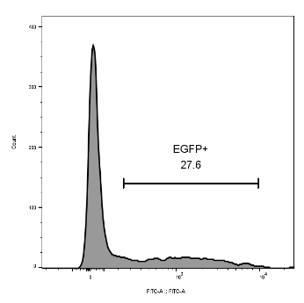
3 | 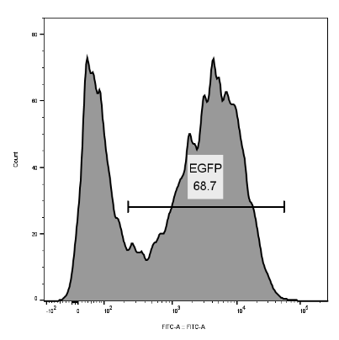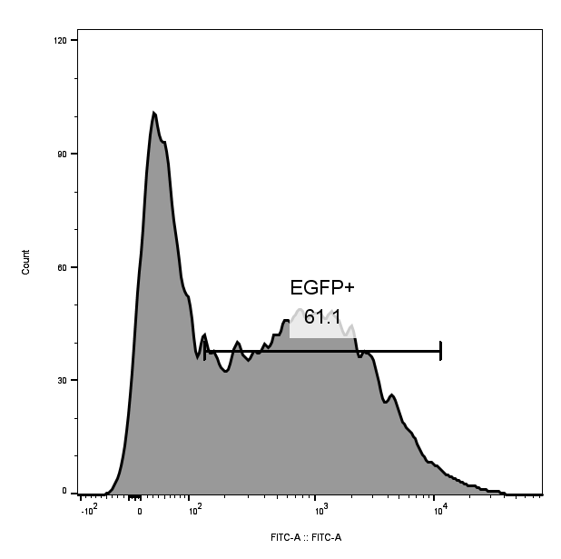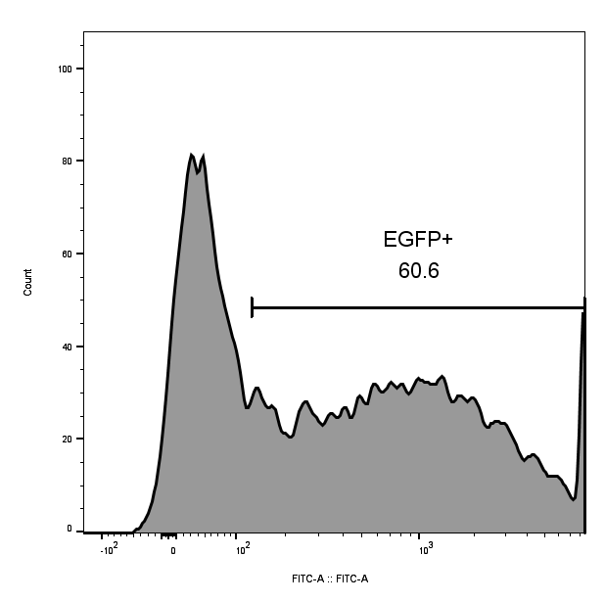
4 | 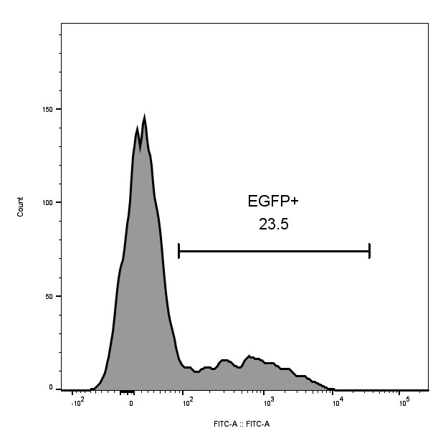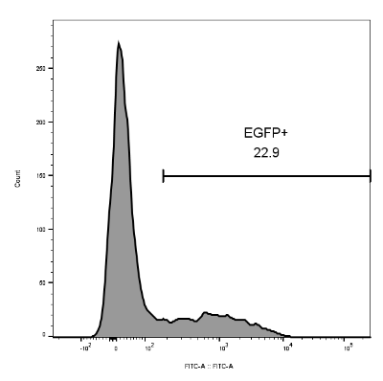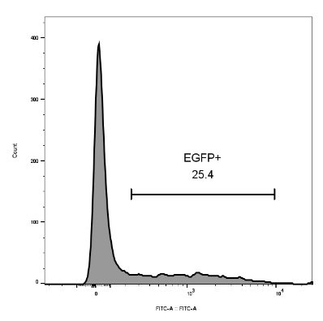
5 | 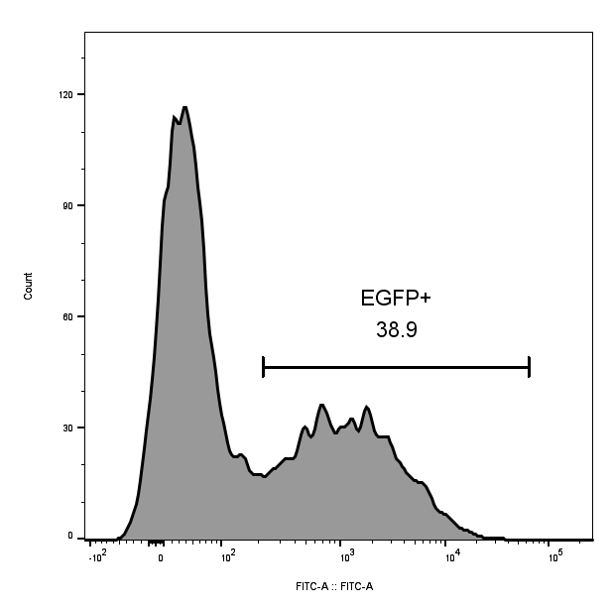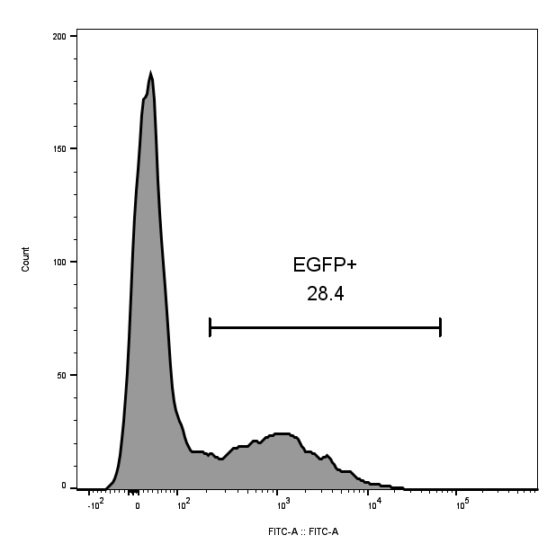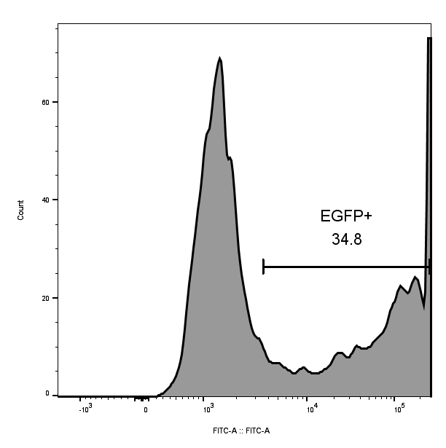
6 | 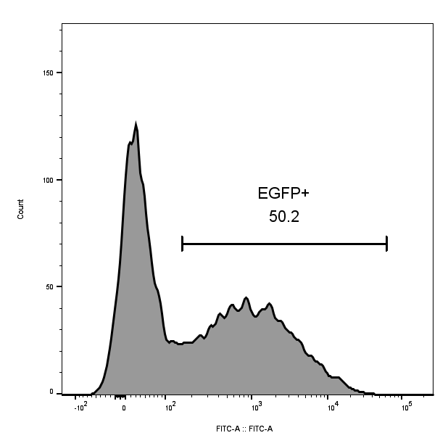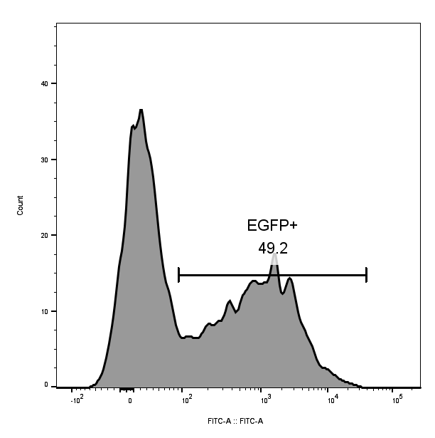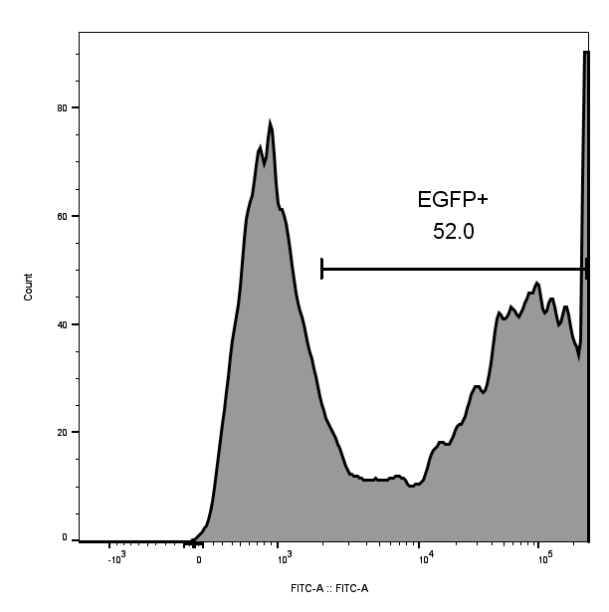
7 | 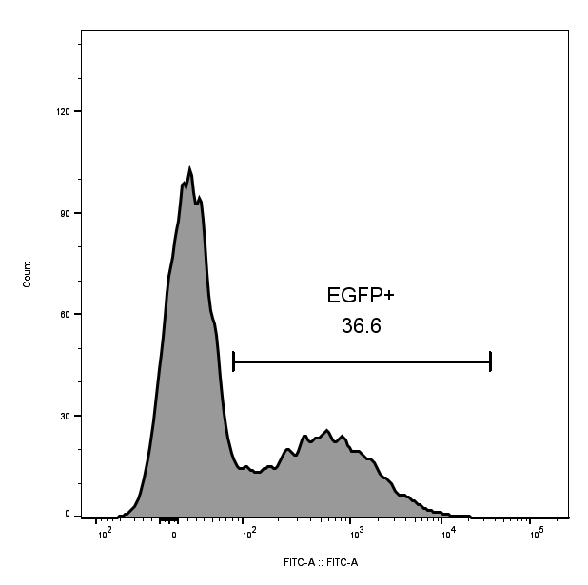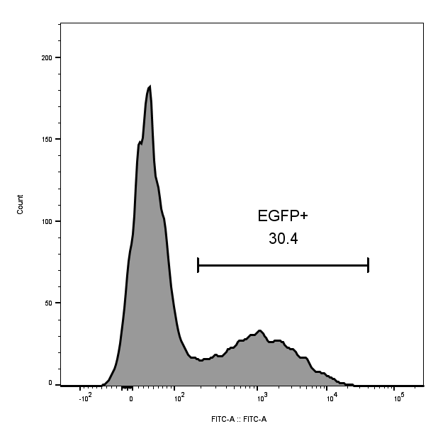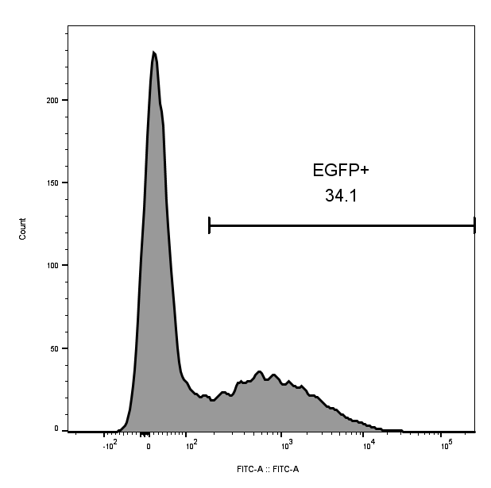
8 | 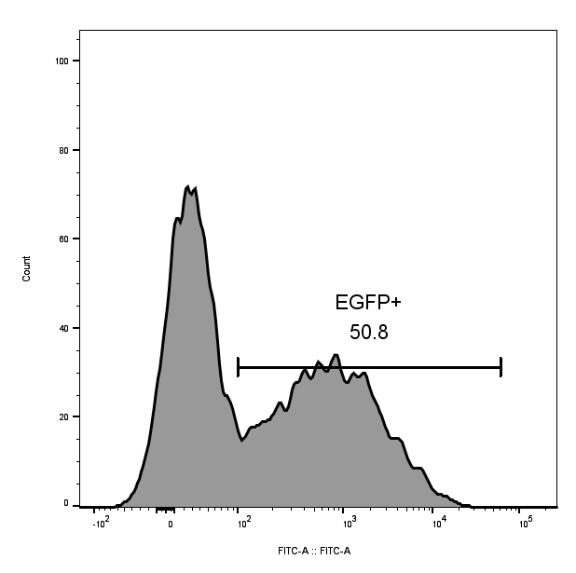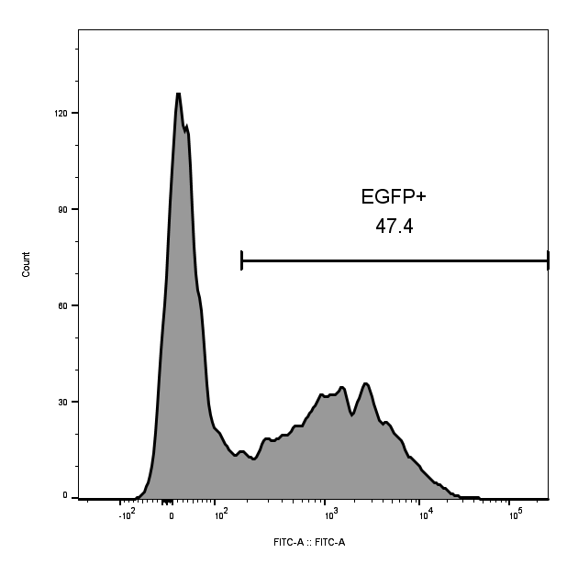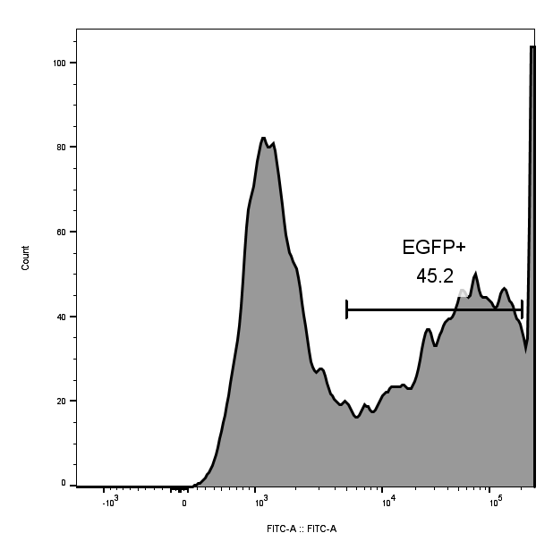
9 | 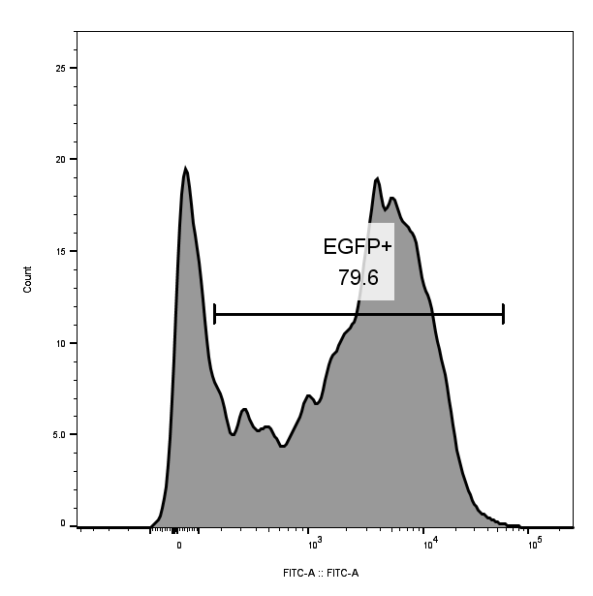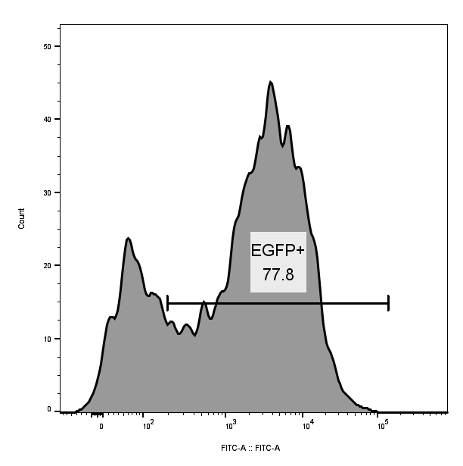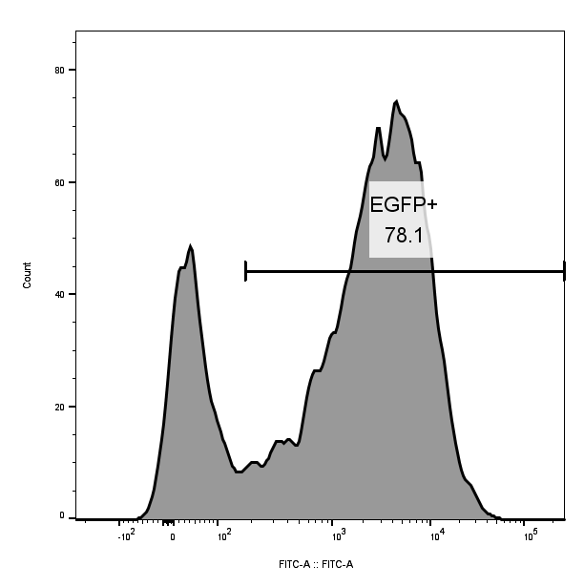
Verific-ation group | 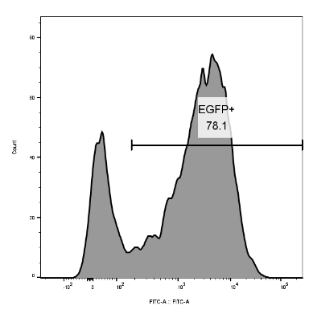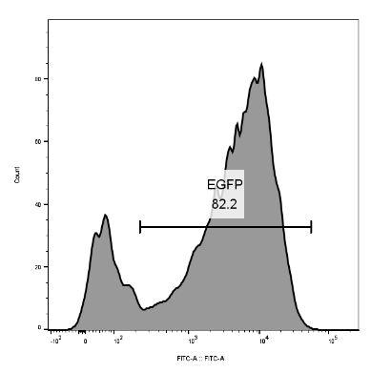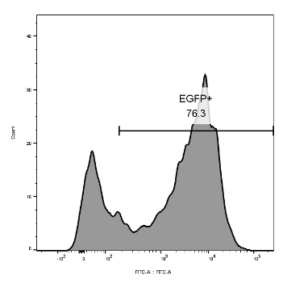
Figure S2：Flow cytometry results of orthogonal group transfections. According to the orthogonal design, each group underwent 3 independent repetitions of electroporation (n=3), and the flow cytometry results for each repetition are shown in the figure above. The final transfection efficiency of each group was calculated based on its average value.

