Supporting Information
Synthesis of 2-(3,5-diarylaminophenyl)-2H-benzo[d][1,2,3]triazoles with aggregation induced emission properties and its applications as a blue OLED component
Zhichao Wang, Xu Wu, Mingzhi Huang and Jinhao Zhao*
Experimental Procedures
Material and Instruments
Unless otherwise mentioned, solvents and reagents were purchased from commercial sources and used as received. For the purpose of the measurement of photophysical properties, THF was distilled from sodium. Melting points were measured with a micro melting point apparatus. Infrared spectra were obtained with an FTIR spectrometer. NMR spectra were operated at 400 MHz for ¹H NMR, 101 MHz for ¹³C NMR. All the NMR spectra were recorded at room temperature. Chemical shifts were quoted in parts per million (ppm) referred to the appropriate solvent peak or 0.0 ppm for tetramethylsilane. The following abbreviations are used to describe peak patterns as appropriate: s = singlet, d = doublet, t = triplet, q = quartet, m = multiplet. Coupling constants J were reported in hertz. High-resolution mass spectra (HRMS) data were obtained with matrix-assisted laser desorption ionization time-of-flight (MLADI-TOF) mass spectrometer. Flash column chromatography was performed employing 300-400 mesh silica gel. Thin layer chromatography (TLC) was performed on silica gel HSGF254. The absorption spectra were measured using UV-vis spectrometer. FL spectra were recorded on a fluorospectro photometer with a xenon lamp excitation source. Thermogravimetric Analysis (TGA) was obtained with a thermal analyzer at heating and cooling rates of 10 K/min under an N₂ atmosphere.
Device Fabrication: before device fabrication, the ITO glass substrates were pre-cleaned carefully. Then hole transporting material PEDOT: PSS was made with 4000 r/s for 45 s and annealing 25 min at 150ºC. Emission Layer was prepared in chlorobenzene. Then it was made with 3000 r/s for 50 s and annealing 20 min at 100ºC. After the organic film deposition, 40 nm of TPBi, 1.5 nm of LiF and 1000 nm of aluminium were thermally evaporated onto the organic surface.
General procedure for synthesis of organic molecular
- Synthesis of 2-(3,5-dibromophenyl)-2H-benzo[d][1,2,3]triazole¹
Figure S1 Synthesis of 2-(3,5-dibromophenyl)-2H-benzo[d][1,2,3]triazole
Oxone (40g, 65.2mmol) was treated with 48mL of concentrated H₂SO₄. The suspension was then poured onto 260g of ice, and the mixture was stirred at room temperature until all of the ice had melted. 2-nitroaniline (6.00g, 43.4mmol) was added and stirred vigorously for 20 h. The mixture was extracted with DCM and dried over anhydrous Na₂SO₄. The solvent was evaporated under vacuum, and the residue was purified by flash column chromatography with petroleum ether: DCM = 1:1, collected the cyan eluent. The resulting product was recrystallized with ethanol to give 1-nitro-2-nitrosobenzene as a cyan solid, yield 87%. A solution of 3,5-dibromoaniline (2.5g, 10mmol) and 1-nitro-2-nitrosobenzene (1.8g, 12mmol) was stirred in acetic acid (50mL) for 14 h at room temperature. The solution was poured on ice, and the resulting solid was collected by filtration and purified by crystallization from ethanol. The resulting precipitate is directly used in the next step. The previous product (1.9g, 5mmol) was dissolved in a mixture of t-BuOH (42mL) and 4M aqueous NaOH (36mL). The solution was stirred at 80°C when formamidinesulfinic acid (2.4g, 22.5mmol) was added in portions. After stirring for 16 h, the mixture was poured on ice. The resulting solid was collected by filtration and purified by flash column chromatography with petroleum ether: DCM = 4:1 to afford the 2-(3,5-dibromophenyl)-2H-benzo[d][1,2,3]triazole as a colorless needles, yield 55%. ¹H NMR (400 MHz, Chloroform-d) δ 8.52 (d, J = 1.5 Hz, 2H), 7.91 (dd, J = 6.6, 3.1 Hz, 2H), 7.74 (t, J = 1.6 Hz, 1H), 7.45 (dd, J = 6.6, 3.1 Hz, 2H).
- Synthesis of compounds 1a, 1b, 1c, 1d, 1e
All compounds were synthesized by reaction with diarylamine according to Buchwald-Hartwig coupling. 2-(3,5-dibromophenyl)-2H-benzo[d][1,2,3]triazole(1eq), Pd₂(dba)₃(0.1eq), (t-Bu)₃PH⁺BF₄⁻(0.3eq), t-BuONa(4eq) and diarylamine(2.2eq) were added into the Schrenk tube. After replacing the air with N₂, toluene(1mL/0.1mmol) was added to dissolve the reactants. The mixture was stirred and refluxed overnight under N₂. After cooling to room temperature, the solvent was removed via vacuum. The residue was purified by flash column chromatography to afford the desired products.
Compound 1a: DCM: PE = 1:4 as eluent, milky powder, yield 99%, mp 253-254°C. ¹H NMR (400 MHz, CDCl₃): δ 8.77 (d, J = 1.9 Hz, 2H), 8.19 (d, J = 7.7 Hz, 4H), 7.99 – 7.88 (m, 3H), 7.67 (d, J = 8.2 Hz, 4H), 7.54 – 7.42 (m, 6H), 7.40 – 7.32 (m, 4H).¹³C NMR (101 MHz, CDCl₃): δ 145.4, 142.8, 140.5, 140.4, 127.9, 126.4, 124.8, 123.9, 120.8, 120.6, 118.6, 117.5, 109.8. HRMS (ESI-TOF): cacld. for C₃₆H₂₃N₅ [M+H]⁺, 526.2026; found: 526.2025. IR (cm⁻¹): 3061, 1603, 1578, 1493, 1331, 872, 772, 745, 722, 701.
Figure S2 ¹H NMR of 1a in CDCl₃
Figure S3 ¹³C NMR of 1a in CDCl₃
Compound 1b: DCM: PE = 1:2 as eluent, light yellow powder, yield 97%, mp 230-231°C. ¹H NMR (400 MHz, CDCl₃): δ 7.81 (dd, J = 6.4, 2.8 Hz, 2H), 7.61 (s, 2H), 7.33 (dd, J = 6.5, 2.8 Hz, 2H), 7.24 (t, J = 7.5 Hz, 8H), 7.13 (d, J = 7.7 Hz, 8H), 7.01 (t, J = 7.1 Hz, 4H), 6.84 (s, 1H).¹³C NMR (101 MHz, CDCl₃): δ 149.5, 147.1, 144.9, 142.1, 129.4, 127.1, 124.6, 123.4, 118.3, 109.5, 77.4, 77.1, 76.8. HRMS (ESI-TOF): cacld. for C₃₆H₂₇N₅ [M+H]⁺, 530.2339; found: 530.2342. IR (cm⁻¹): 3059, 1609, 1588, 1491, 1306, 852, 760, 749, 695.
Figure S4 ¹H NMR of 1b in CDCl₃
Figure S5 ¹³C NMR of 1B in CDCl₃
Compound 1c: DCM: PE = 1:2 as eluent, greenish yellow powder, yield 99%, mp 221-222°C. ¹H NMR (400 MHz, CDCl₃): δ 7.83 (dd, J = 6.6, 3.1 Hz, 2H), 7.49 (d, J = 2.1 Hz, 2H), 7.35 (dd, J = 6.6, 3.1 Hz, 2H), 7.03 (q, J = 8.6 Hz, 16H), 6.71 (t, J = 2.0 Hz, 1H), 2.30 (s, 12H).¹³C NMR (101 MHz, CDCl₃): δ 149.6, 144.8, 144.7, 141.9, 132.8, 129.9, 126.9, 124.7, 118.3, 116.9, 108.1, 77.4, 77.0, 76.7, 20.9. HRMS (ESI-TOF): cacld. for C₄₀H₃₅N₅ [M+H]⁺, 586.2965; found: 586.2964. IR (cm⁻¹): 3026, 2917, 1587, 1508, 1440, 1314, 813, 760, 709, 686.
Figure S6 ¹H NMR of 1c in CDCl₃
Figure S7 ¹³C NMR of 1c in CDCl₃
Compound 1d: DCM: PE = 1:4 as eluent, yellow powder, yield 99%, mp 230-231°C. ¹H NMR (400 MHz, CDCl₃): δ 8.57 (d, J = 1.8 Hz, 2H), 7.90 (dd, J = 6.6, 3.1 Hz, 2H), 7.52 (m, 1H), 7.44 (dd, J = 6.7, 3.0 Hz, 2H), 6.79 – 6.64 (m, 12H), 6.15 (dd, J = 7.6, 1.5 Hz, 4H).¹³C NMR (101 MHz, CDCl₃): δ 145.3, 144.9, 144.0, 143.1, 134.1, 133.5, 128.0, 123.5, 123.3, 122.2, 118.5, 116.0, 113.4, 77.4, 77.0, 76.7. HRMS (ESI-TOF): cacld. for C₃₆H₂₃N₅O₂ [M+H]⁺, 557.1846; found: 557.1844. IR (cm⁻¹): 3071, 1592, 1489, 1330, 1274, 1046, 880, 780, 740, 701.
Figure S8 ¹H NMR of 1d in CDCl₃
Figure S9 ¹³C NMR of 1d in CDCl₃
Compound 1e: DCM: PE = 1:1 as eluent, brownish yellow powder, yield 99%, mp 249-250°C. ¹H NMR (400 MHz, CDCl₃): δ 7.82 (dd, J = 6.6, 3.1 Hz, 2H), 7.32 (dd, J = 6.6, 3.1 Hz, 2H), 7.25 (s, 2H), 7.10 – 6.98 (m, 8H), 6.72 – 6.59 (m, 9H), 2.91 (s, 24H), ¹³C NMR (101 MHz, CDCl₃): δ 147.1, 144.7, 126.5, 126.4, 118.3, 113.8, 77.4, 77.0, 76.7, 41.1. HRMS (ESI-TOF): cacld. for C₄₄H₄₇N₉ [M+H]⁺, 701.3949; found: 701.395. IR (cm⁻¹): 3060, 1598, 1515, 1443, 1345, 1320, 816, 747, 669.
Figure S10 ¹H NMR of 1e in CDCl₃
Figure S11 ¹³C NMR of 1e in CDCl₃

Table S1 Single crystal data
Compunds | 1b | 1c | 1d
Formula | C₃₆H₂₇N₅ | C₄₀H₃₅N₅ | C₃₆H₂₃N₅0₂
CCDC | 2118387 | 2118392 | 2118391
a [Å] | 12.3727 | 7.643 | 22.589
b [Å] | 18.5148 | 14.586 | 24.078
c [Å] | 12.0455 | 15.485 | 4.839
α [ ° ] | 90 | 85.476 | 90
β [ ° ] | 95.804 | 86.875 | 90
γ [ ° ] | 90 | 81.720 | 90
Z | 4 | 2 | 4
V [Å³] | 2745.21 | 1701.3 | 2632
D [g cm⁻³] | 1.281 | 1.143 | 1.407
Space group | P 21/c | P -1 | P n a 21
Hall group | -P 2ybc | -P 1 | P 2c -2n
Mu [mm⁻¹] | 0.077 | 0.068 | 0.090
R (reflections) | 0.0384 | 0.0454 | 0.0343
wR2 (reflections) | 0.0988 | 0.1288 | 0.0825

Figure S12 Thermogravimetric Analysis of 5 compounds
Table S2 Photophysical properties:
Compounds |  | 1a | 1b | 1c | 1d | 1e
FL in powder(nm) |  | 413 | 468 | 480 | 505 | 556
CH | Abs(nm) | 310 | 306 | 306 | 315 | 317
CH | ε(L·mol⁻¹·cm⁻¹) | 28150 | 62150 | 59750 | 35850 | 28600
CH | FL (nm) | 375 | 422 | 437 | 469 | 527
CH | Stokes Shift  (nm/cm⁻¹) | 65/5591 | 116/8983 | 131/9796 | 154/10424 | 210/12570
TOL | Abs(nm) | 311 | 306 | 308 | 317 | 315
TOL | ε (L·mol⁻¹·cm⁻¹) | 33950 | 65800 | 51650 | 39850 | 64800
TOL | FL (nm) | 413 | 460 | 474 | 539 | 572
TOL | Stokes Shift  (nm/cm⁻¹) | 102/7941 | 154/10941 | 166/11370 | 222/12993 | 257/14264
THF | Abs(nm) | 309 | 306 | 305 | 316 | 315
THF | ε (L·mol⁻¹·cm⁻¹) | 35200 | 60950 | 50800 | 44650 | 45500
THF | FL (nm) | 450 | 481 | 495 | 560 | \
THF | Stokes Shift  (nm/cm⁻¹) | 141/10140 | 175/11890 | 190/12585 | 244/13788 | \
DCM | Abs(nm) | 309 | 306 | 308 | 315 | 315
DCM | ε (L·mol⁻¹·cm⁻¹) | 36500 | 63300 | 57900 | 42650 | 63300
DCM | FL (nm) | 468 | 511 | 532 | 573 | \
DCM | Stokes Shift  (nm/cm⁻¹) | 159/10995 | 205/13110 | 224/13671 | 258/14294 | \
MeCN | Abs(nm) | 308 | 306 | 306 | 312 | 306
MeCN | ε (L·mol⁻¹·cm⁻¹) | 27400 | 60200 | 48700 | 42600 | 59200
MeCN | FL (nm) | 501 | 528 | 547 | \ | \
MeCN | Stokes Shift  (nm/cm⁻¹) | 193/12507 | 222/13740 | 241/14398 | \ | \
Figure S13 Solvent effect of 5 compounds
Figure S14 (a) 3D Emission spectrum in aqueous THF solutions, (b) the relative intensity and photos and (c) DLS (fw = 90%, 95%) of five compounds.
Figure S15 Mechanochromic property of compounds 1a; (a) normalized emission spectra; (b) emission cycles.

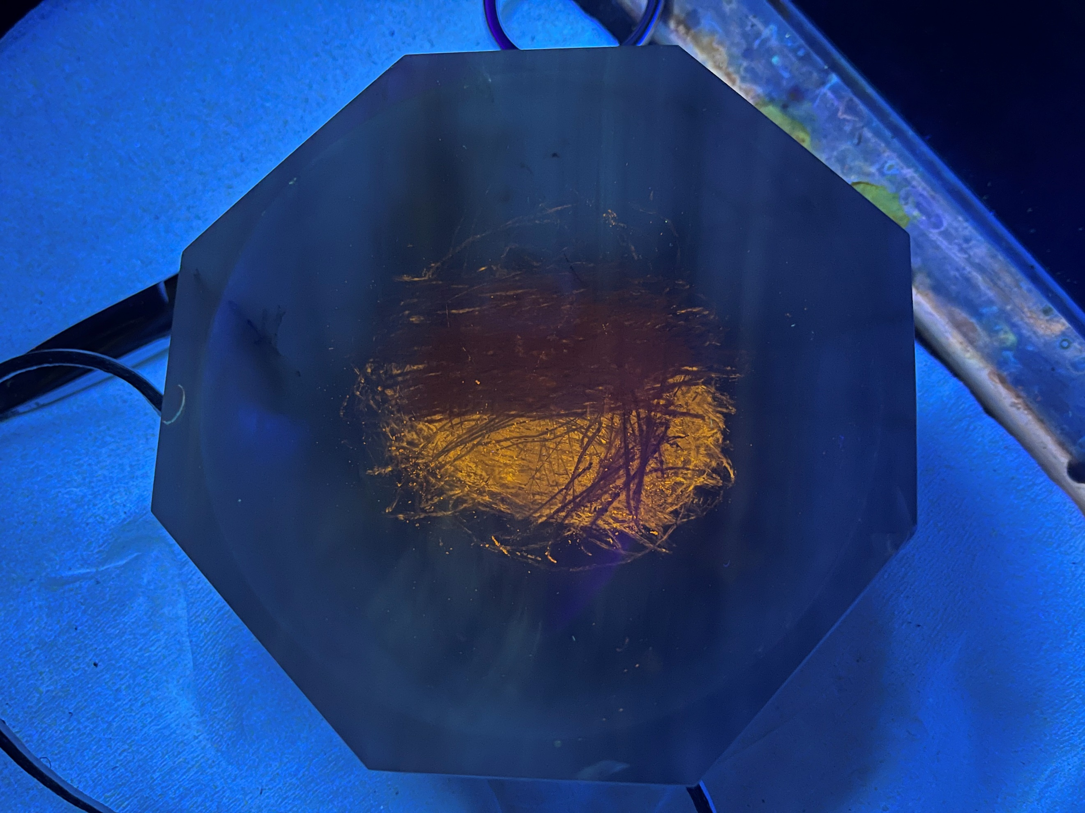
Figure S16 Photo of mechanochromic property of compounds 1e.

Table S3 Device performance
Device | Emitter | V_{turn-on}(V) ª | CIE₁₉₃₁(x,y) | λ_{EL}(nm) | EQE(%) ^{b} | CE(cd/A) ^{b} | PE(lm/W) ^{b}
1 | 1b | 4.2 | (0.28,0.43) | 514 | 0.73 | 1.70 | 0.94
2 | 1b: PVK=1: 4 | 4.2 | (0.17,0.19) | 463 | 0.71 | 0.97 | 0.57
3 | 1c | 3.0 | (0.19,0.36) | 482 | 0.82 | 1.73 | 1.36
4 | 1c: PVK=1: 4 | 3.5 | (0.19,0.30) | 487 | 0.87 | 1.64 | 1.10
ª Applied voltage at the luminance of 1 cd/m².
^{b} Value at 100 cd/m².
Figure S17 C-I-V curves of devices 1, 2, 3 and 4.

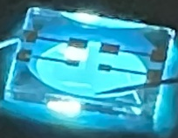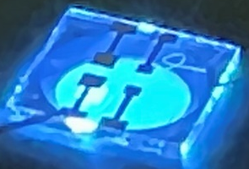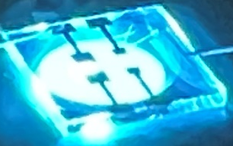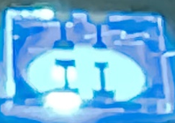
Figure S18 Photos of devices 1, 2, 3 and 4.

Reference
1. H. Wettach, F. Pasker and S. Höger, Macromolecules, 2008, 41, 9513-9515.

