LPL/AQP7/GPD2 promotes glycerol metabolism under hypoxia and prevents cardiac dysfunction during ischemia.
Ishihama S., et al.
Methods
Materials and Chemicals
Antibodies against the following proteins were used: α-actinin (Cell Signaling Technology: Cat#CST-3134) and lipoprotein lipase (Abcam: Cat#ab21356). To detect apoptosis, heart sections were assessed by TUNEL staining using the In Situ Cell Death Detection Kit (Roche Diagnostics).
Adult Murine Cardiomyocyte Isolation
The protocol for isolation of adult murine cardiomyocytes was modified from Ackers-Johnson et al. ¹. Male mice (8–10 weeks old) were anesthetized with hydrochloric acid medetomidine (0.3 mg/kg), midazolam (4 mg/kg), and butorphanol tartrate (5 mg/kg). The chest was opened to fully expose the heart. The inferior vena cava was cut and EDTA buffer was immediately injected into the right ventricle. Hearts were quickly removed, cannulated from the aorta with a blunted 24-gauge needle, and then connected to a perfusion apparatus for retrograde perfusion. EDTA buffer and perfusion and collagenase buffer (type II and IV collagenase: Worthington; protease XIV, Sigma-Aldrich) were perfused via the aortic cannula. After the heart was removed from the perfusion apparatus, the atria were removed and the ventricles cut and gently separated into small pieces with forceps and dissociated by gentle pipetting. Stop Buffer was added, the cell suspension was passed through a 100-μm strainer, and the myocytes allowed to settle by gravity for 20 min. The cell suspension was subjected to four sequential rounds of gravity settling using three intermediate Ca²⁺ reintroduction buffers to gradually restore extracellular Ca²⁺ concentration to 1.8 mM. Settled cells were then plated in plating buffer (MEM containing 5% FBS, 2.0 mM L-glutamine, and 10 nM 2, 3-butanedione monoxime) for 1 h, at which point the medium was removed and adherent cells were resuspended in culture medium (MEM containing 0.1% fatty acid free BSA, 2.0 mM L-glutamine, 10 nM 2,3-butanedione monoxime, 10 μg/mL insulin, 5.5 μg/mL transferrin, and 5.0 ng/mL selenium) for 2 h. Then, the culture medium was changed to each study-conditioned medium and cells were cultured at each study condition. The glucose-free culture media consisted of DMEM-no glucose containing 0.1% fatty acid-free BSA, 2.0 mM L-glutamine, 10 nM 2,3-butanedione monoxime, 10 μg/mL insulin, 5.5 μg/mL transferrin, and 5.0 ng/mL selenium. To establish culture media with each indicated glycerol concentration, the appropriate amount of glycerol was added to the glucose-free culture medium. For hypoxia studies, cells were exposed to hypoxia conditions generated using an AnaeroPack System (Mitsubishi GAS Chemical).
Cell Viability
After 1 h of culture under normoxic or hypoxic conditions, cell viability assay was done using trypan blue stain. The way of trypan blue stain was described previously ².
Intracelluar ATP Concentration
Cardiomyocyte intracellular ATP concentration was measured using Cell titer gro 2.0 (Promega). The GPD2 (mGPDH) inhibitor (Sigma: Cat#530655) was dissolved in DMSO (final concentration < 0.1%).
GPD2 Enzymatic Activity
Mitochondria were isolated from cardiomyocytes or heart tissue using the Mitochondrial Isolation Kit (Abcam: Cat#ab110168) according to the manufacturer’s instructions. GPD2 enzymatic activity was measured as the rate of reduction of cytochrome C following the addition of glycerophosphate. Mitochondria were isolated less than 3 h prior to conducting activity assays from fresh mouse hearts. Enzyme assays measuring GPD2 activity using murine cardiac mitochondrial lysate preparations were performed using cytochrome c as the electron acceptor and measuring the gain of absorbance at 550 nm. The reaction buffer consisted of 10 mM Tris-HCl, 50 μM cytochrome c, 25 μM sodium azide, 1 mM EDTA, and 50 mM KCl; reactions were conducted at 37°C.
Mice
The GPD2 (mGPDH)-KO mouse line was obtained from the Tokyo University ³. The AQP7-KO mouse line (RBRC06294) was obtained from the RIKEN BRC ⁴. Mice carrying floxed alleles of Lpl were obtained from Columbia University ⁵. Myocardial Infarction was induced in 8–10-week-old male mice as described previously ². For isolation of adult murine cardiomyocytes, 8–10-week-old male mice were also used. All procedures of animal car and use in this study were approved by the Animal Ethics Review Board of Nagoya University School of Medicine.
Generation of Inducible LPL Knockout Mice
Tamoxifen-inducible, cardiomyocyte-specific LPL knockout mice (cmc-LPL-KOs) were generated by intercrossing the αMHC–CreERT2 line to LPL^{flox/flox} mice ^{5,6}. Cre-mediated recombination of floxed alleles was induced via intraperitoneal injection of 1 mg tamoxifen dissolved in 100 μl Miglyol for five consecutive days. Vehicle-treated mice received Miglyol only and αMHC–CreERT2^{+/−}-LPL^{wt/wt} mice were used as controls. Experiments were performed 5-7 days following the end of induction.
Myocardial Infarction Mouse Model
Myocardial infarction was induced in 8–10-week-old male mice as described previously ². After the left anterior descending artery was ligated, mice were sacrificed at 1, 7, or 28 days following surgery. Prior to sacrifice, mice were fasted overnight. Echocardiography was performed using a Vevo 1100 (Fujifilm VisualSonica Inc.).
Frozen mouse heart samples were embedded in optimal cutting temperature compound (Sakura Finetek Japan). The samples obtained from at least 6 sites, from below the ligation site to the apex, were sectioned to 6-μm thickness, then stained with PicroSirius red to assess cardiac fibrosis. Infarct size measurement was obtained according to length measurement ⁷.
Immunostaining Assay
Samples for immunohistochemistry were fixed with 4% paraformaldehyde at 4 °C for 1 h and washed thoroughly in PBS. Then, 0.5% Triton X-100 in PBS was applied for 30 min at room temperature and samples were blocked with Protein Block Serum-Free (DAKO) for 30 min at room temperature. Thereafter, they were incubated overnight at 4°C with the primary antibodies, followed by reaction with Alexa-conjugated secondary antibodies (Alexa Fluor 488 and 647; Life ThermoFisher). Nuclei were visualized using Cellstain DAPI Solution (Wako: Cat#340-07971). The isolated cardiomyocytes and the heart sections were observed using a BZ-X microscope or a Zeiss LSM780 confocal laser scanning microscope with ZEN software (Zeiss).
To assess the expression of LPL on the cell surface, isolated cardiomyocytes without permeabilization were incubated with the anti-LPL primary antibodies. After washing in PBS five times, Triton X-100 was applied and the cardiomyocytes incubated with anti-α-actinin primary antibodies. The LPL expression on the cell surface of isolated cardiomyocytes was counted in every 10 groups of 20 random individual cells using Image J (NIH); high expression was defined as the cell exhibiting over five particles. The fluorescence intensity of LPL at the infarct or non-infarct area was quantitated using Image J.
Quantitative Reverse Transcription-PCR
To analyze mRNA expression, RNA was extracted from the C57BL/6 mouse left ventricle using an RNeasy Mini kit (Qiagen) following the manufacturer’s protocol and reverse-transcribed using the ReverTra Ace qPCR RT Master Mix (Toyobo). Quantitative reverse transcription-PCR analysis was performed using SYBER Premix Ex Taq II (TaKaRa Bio) and the following primers: Nppa (ANP) 5′-TGA CAG GAT TGG AGC CCA GA-3′, 5′-GAC ACA CCA CCA GGG CTT AGG A-3′; Rps18 5′-TTC TGG CCA ACG GTC TAG ACA AC-3′, 5′-CCA GTG GTC TTG GTG TGC TGA-3′; and Gk (glycerol kinase) 5′-TGC ATG ATC CTC TAA GCA GAC C-3′, 5′-ACA TCA TGA CAG TGG AGG CA-3′. Data are presented following normalization with Rps18.
Quantification and statistical analysis
Data are presented as the mean ± SEM in all experiments. All statistical analyses for animal experiments were performed using GraphPad Prism 8 (GraphPad Software Inc.). Data were analyzed by the Student unpaired t test to compare means when there were two experimental groups, by one-way ANOVA with the Tukey post hoc test to compare means among >2 groups, and by two-way ANOVA with Tukey’s post-hoc test or two-way repeated measures ANOVA with Bonferroni post-hoc testing when there were two or more independent variables. “n” refers to the number of independent experiments or mice per group. Significance was defined as p < 0.05.

References
1. Ackers-Johnson, M., et al. A Simplified, Langendorff-Free Method for Concomitant Isolation of Viable Cardiac Myocytes and Nonmyocytes From the Adult Mouse Heart. Circ. Res, 119, 909-920 (2016).
2. Eguchi, S., et al. Cardiomyocytes capture stem cell-derived, anti-apoptotic microRNA-214 via clathrin-mediated endocytosis in acute myocardial infarction. J. Biol. Chem. 294, 11665-11674 (2019).
3. Eto, K., et al. Role of NADH shuttle system in glucose-induced activation of mitochondrial metabolism and insulin secretion. Science 283, 981-985 (1999).
4. Maeda, N., et al. Adaptation to fasting by glycerol transport through aquaporin 7 in adipose tissue. Proc. Natl. Acad. Sci. U.S.A. 101, 17801-17806 (2004).
5. Augustus, A., et al. Cardiac-specific knock-out of lipoprotein lipase alters plasma lipoprotein triglyceride metabolism and cardiac gene expression. J. Biol. Chem. 279, 25050-25057 (2004).
6. Takefuji, M., et al. G(13)-mediated signaling pathway is required for pressure overload-induced cardiac remodeling and heart failure. Circulation 126, 1972-1982 (2012).
7. Takagawa, J., et al. Myocardial infarct size measurement in the mouse chronic infarction model: comparison of area- and length-based approaches. J. Appl. Physiol. 102, 2104-2111 (2007).

SUPPLEMENTAL INFORMATION
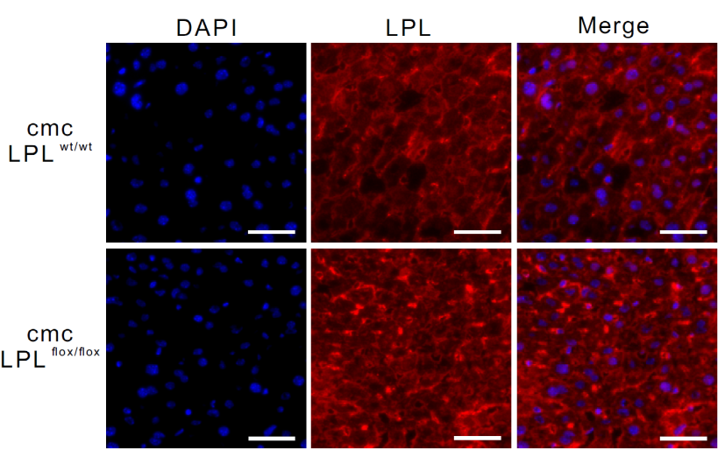
Figure S1: Immunostaining showing LPL expression in the liver of wild-type (wt) and cardiomyocyte LPL-floxed (flox/flox) mice (blue, DAPI; red, LPL; scale bar, 50 μm). Related to Figure 1.

