Supplementary Information

Metagenomic Cell-free DNA Sequencing for Treatment Monitoring in Sepsis
AUTHORS: Omary Mzava^{1,#}, Liz-Audrey Djomnang Kounatse^{1,#}, Alexandre Pellan Cheng, Luis G. Gomez-Escobar², Joan Lenz¹, Emma Belcher¹, Edward J. Schenck², Iwijn De Vlaminck^{1,*}

AFFILIATIONS:
¹Meinig School of Biomedical Engineering, Cornell University; Ithaca, NY, USA
²Division of Pulmonary and Critical Care Medicine, Department of Medicine, Weill Cornell Medicine, New York

# These authors contributed equally
* To whom correspondence should be addressed: vlaminck@cornell.edu

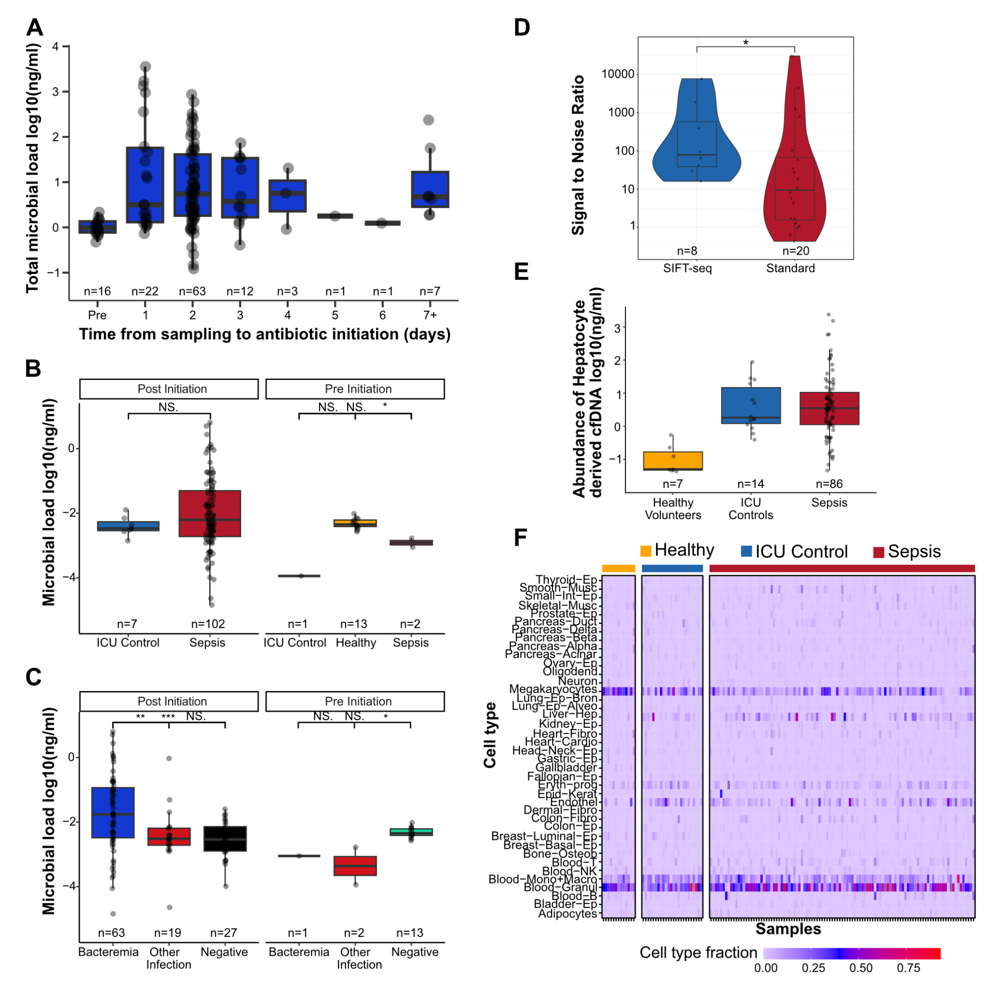
Supplemental Figure S1: Ongoing antibiotic treatment does not significantly affect the microbial load in plasma samples; cfDNA overwhelmingly comes from immune cells post-infection. A) Boxplot of the total microbial abundance in samples collected pre- and post-antibiotic initiation. B) Boxplot of Microbial load in different sample groups by collection time relative to antibiotic initiation. C) Comparison of microbial load in samples collected pre- and post-antibiotic initiation. D) Evaluation of SIFT seq specificity by ratio of cultured pathogen abundance to negative culture equivalent. *Species where the SNR was 0 were omitted E) Hepatocyte abundance in different study groups. F) Heatmap of cell types of origin of cfDNA in plasma. Boxes in the boxplots indicate 25th and 75th percentiles, the band in the box indicates the median, and whiskers extend to 1.5 x Interquartile Range (IQR) of the hinge. Outliers (beyond 1.5 × IQR) are plotted individually. *** p-value < 0.001, ** p-value < 0.01, * p-value < 0.05, NS. (Not significant) p-value ≥ 0.05.

Table 1: Sample Summary; Demographic and clinical summary

Modality | Population
median Age | 64
Female (%) | 40.3
Male (%) | 59.7
Sepsis cases (%) | 81.4
Non-sepsis cases (%) | 18.6
Vasopressor on ED floor (%) | 32.6
Average SOFA score | 7.2 ± 3.8
cancer (%) | 30.2
Death within 28 days (%) | 16.3
Death within 60 days(%) | 3.9
Samples collected during antibiotic usage | 108
Bacteremia | 64
Other Infection | 21

Table 2: Specimen collection timing relative to antibiotic initiation

Patient Characteristics | Range (Hours) | Median (Hours) | mean (Hours)
Bacteremia | 17-152 | 40.5 | 43.3
Other infections | 12-572 | 47 | 103.75
No Culture | NA | NA | NA

Table 3: Area Under the Curve (AUC) and 95% Confidence Intervals for Individual cfDNA Metrics, Total Day 1 SOFA Score, and the Combined Model in Distinguishing Sepsis from ICU Controls.
Parameter | Area Under the Curve (AUC) | 95% Confidence Interval (CI)
Microbial cfDNA | 0.703 | 0.589 - 0.816
Simpson Index | 0.75 | 0.675 - 0.855
Solid Organs Derived cfDNA | 0.712 | 0.576 - 0.847
Immune Cells Derived cfDNA | 0.71 | 0.582 - 0.837
Total Day 1 SOFA Score | 0.787 | 0.673 - 0.901
Total CfDNA Concentration | 0.727 | 0.595 - 0.859
Combined | 0.874 | 0.803 - 0.945

Step-by-step SIFT-seq wet lab protocol.

Reagents
- CT conversion reagent (Zymo Cat# D5003-1)
- M-Solubilization Buffer (Zymo Cat# D5021-7)
- M-Dilution Buffer (Zymo Cat# D5002-2)
- M-Reaction Buffer (Zymo Cat# D5021-8)
- M-Binding buffer (Zymo Cat# D5001-3)
- M-Desulphonation Buffer (Zymo Cat# D5001-5)
- M-Elution Buffer (Zymo Cat# D5001-6)
- M-Wash Buffer (Zymo Cat# D5001-4)
- Zymo spin IC columns (Zymo Cat# C1004-50)
- QIAamp Circulating Nucleic Acid Kit (QIAGEN, Cat# 55114)
- UDI Primer Set-24 (SRSLY Cat# CBS-UD-24)
- PicoPlus DNA NGS Library Preparation Base Kit (SRSLY Cat# CBS-K250B-24)
- AmpureXP Beads (Beckman Coulter Cat# A63880)
- KAPA HiFi HotStart Uracil+ ReadyMix (2X) (Roche Cat# 7959052001)
- Qubit ssDNA Assay Kit (Invitrogen Cat# Q10212)

Equipment
- Thermocycler
- Water bath
- Centrifuge

Step 1: Bisulfite Conversion
- Preheat thermal cycler. Program 98°C for 10 min and 64°C for 3.5 hours.
- Set the water bath to 60°C.
- Thaw plasma aliquots and spin down for 10 min at 14,000 RPM and 10°C.
- Transfer 100 µL of the supernatant to a 1.5 ml tube.
- Add CT Conversion reagent to plasma at a 6.5:1 ratio of reagent: supernatant. (650 µL reagent:100 µL plasma). Vortex and spin down.
- Split the above mixture in equal volumes into a PCR tube strip (8 PCR tubes)
- Incubate in the 98°C thermoshaker for 10 minutes.
- Incubate in the 64°C thermoshaker for 3.5 hours
- Immediately proceed to the next step(or store in 4°C for up to 20 hours)

Step 2: cfDNA Extraction and Desulphonation
- Add an appropriate amount of carrier RNA to Buffer ACL. (7.9 ml of ACL and 50.6 µL of carrier RNA for 8 x 1 ml protocol)
- Add 100 µL of Proteinase K into a 50 ml centrifuge tube
- Complete the volume of plasma sample to 1 ml with 1X PBS and add to the 50 ml tube containing Proteinase K (add 250 µL 1X PBS for 750 µL plasma+CT)
- Add 0.8 ml Buffer ACL (with carrier RNA). Pulse vortex 30 seconds
- Incubate at 60°C for 30 minutes
- Place the tube back on the lab bench and unscrew the cap
- Add 1.8 ml Buffer ACB to the lysate. Pulse vortex 15-30 seconds
- Incubate on ice for 5 minutes
- Prepare the manifold
- Add the lysate-buffer ACB mixture to the tube extender and turn on the vacuum. Drain the column.
- Apply 600 µL ACW1. Drain the column.
- Apply 750 µL ACW2. Drain the column.
- Apply 750 µL 96-100% ethanol. Drain the column and repeat for a total of two washes.
- Transfer the column to a collection tube and centrifuge at 14,000 RPM for 3 minutes.
- Transfer to an elution tube.
- Add 155 µL of Buffer AVE to the center of the column. Close the lid and incubate for 3 minutes at room temperature.
- Centrifuge at 14,000 RPM for 1 minute
- Add 600 µL of M-Binding Buffer to a Zymo-Spin IC Column assembled in a collection tube.
- Load the sample (150 µL from step 17) into the Zymo-Spin IC Column containing the M-Binding Buffer. Close the cap and mix by inverting the column several times.
- Centrifuge at full speed (14,000 x g) for 30 seconds. Discard the flow-through
- Add 100 µL of M-Wash Buffer to the column. Centrifuge at full speed for 30 seconds
- Add 200 µL of M-Desulphonation Buffer to the column and let stand at room temperature (20-30°C) for 20 minutes.
- After the incubation, centrifuge at full speed for 30 seconds.
- Add 200 µL of M-Wash Buffer to the column. Centrifuge at full speed for 30 seconds.
- Repeat this wash step.
- Place the column into a 1.5 ml microcentrifuge tube and add 32 µL of M-Elution Buffer directly to the column matrix. Centrifuge at 30 seconds at full speed to elute the DNA
- Measure ssDNA abundance.
- Samples can be stored at -20°C until library preparation.
Step 3: SRSLY library preparation: implemented according to vendor recommendations.

