Supplementary Material

Speed-accuracy Trade-off

In order to assess the possibility of a speed-accuracy trade-off, a repeated measures ANOVA was conducted using percentage accuracy rates for the different IOR conditions (cued and uncued) and dopamine manipulations (agonist, antagonist, and placebo). See Table 1 for descriptive statistics. None of the main effects or the interaction were significant (see Table 2). As such, no speed-accuracy trade-off was apparent.
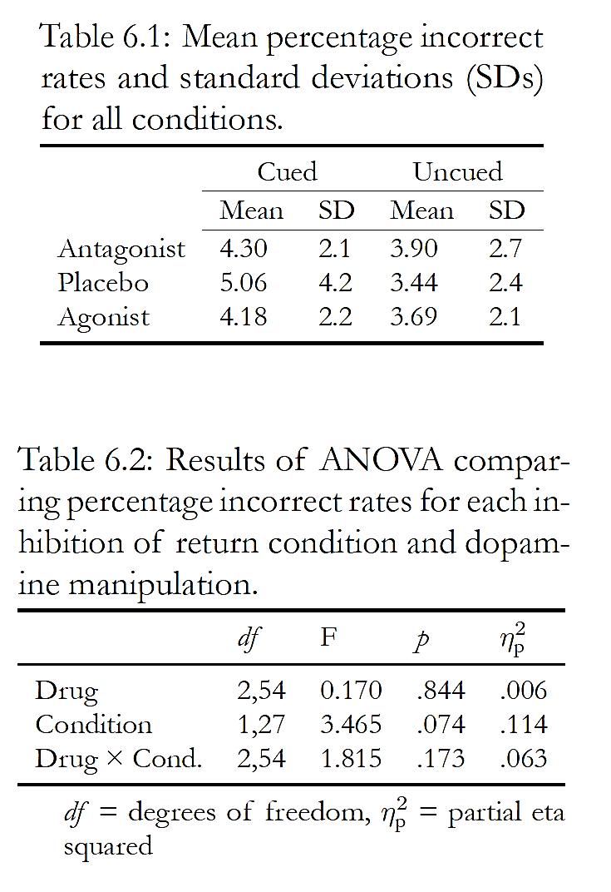
Table 2: Results of ANOVA comparing percentage incorrect rates for each inhibition of return (IOR) cue condition and dopamine manipulation.
Table 1: Mean percentage incorrect rates and standard deviations (SDs) for all conditions.

1.2 Proportional IOR

As the active drugs both significantly increased RTs across task conditions, proportional IOR scores were calculated for each participant and each visit. This was to ensure that the observed differences IOR magnitudes were not caused by drugs generally speeding responses, thus reducing the relative difference between cued and uncued RTs. Proportional IOR was calculated as IOR magnitudes divided by grand mean RTs (calculated as the average RT across all responses for each participant and visit), hence providing IOR as a percentage of overall RT. This normalisation approach is analogous to the coefficient of variation sometimes used in RT research to control for baseline differences in response speed (e.g. Epstein et al., 2011).
Proportional IOR scores were then analysed using a two-way mixed-design ANOVA with dopamine manipulation as a within-subjects variable (agonist, antagonist, placebo), and visit order as a between-subjects variable. The main effect of dopamine manipulation was significant F(2, 46) = 9.04, p < .001. Planned pairwise comparisons demonstrated significantly smaller proportional IOR magnitudes in the agonist (M = 2.8%) and antagonist (M = 2.3%) manipulations, versus placebo (M = 4.1%); p < .05. There was no significant difference between agonist and antagonist proportional IOR scores (p = .216). The main effect of visit order and the interaction between visit order and dopamine manipulation were not significant (p = .093 & p = .508, respectively). These findings perfectly replicated the pattern of results found with non-proportional IOR.

1.3 Impulsivity Screening

BIS-11 scores have been related to individual differences in D2Rs in PET studies of impulsivity (Buckholtz et al., 2010). In order to minimise the influence of individual differences in D2Rs on the results of this study, participants with “medium” scores on the BIS-11 were recruited for the study. Medium scores were defined as within 1.5 standard deviations of the mean score identified by Stanford et al. (2009) (based on a population of 1,577 healthy adults). 162 individuals completed the online impulsivity questionnaire. The final thirty-one participants had a mean overall BIS-11 impulsivity score of 54.9 (SD = 4.0), and a mean cognitive instability subscale score of 5.9 (SD = 1.2).

1.4 Sample Size Calculation

The sample size was established using a power analysis based on the effect size of a previous study from our lab, which identified clear behavioural and ERP effects using the same task (d = 1.38). The analysis was conducted using the R package ‘pwr’ (Champely, 2015) and calculated that a minimum of 9 participants would be necessary to obtain a significant IOR effect with 80% certainty (p < .05). However, the present study utilises three dopamine manipulation conditions. Therefore, the value was multiplied by three to give a minimum of 27 participants. There have only been two previous dopamine manipulation studies of IOR: Rokem et al. (2012), which had 21 participants; and Fillmore & Vogel-Sprott (2000), which had 14. However, neither of these studies reported effect sizes, utilised a target-target paradigm, measured EEG, or included three within-subjects conditions. As such, a more detailed power analysis could not be conducted.

5.5 Health Screening
Thirty-one individuals attended further health-screening by a clinician. All were deemed fully eligible to participate in the study. It was required that participants were non-smokers with normal or corrected-to-normal vision, were not colour blind, and were fluent in the English language. It was also required that they had none of the following: History of significant head injuries or seizures, diagnosis of any neurological or psychiatric condition, history of drug or alcohol abuse, use of psychotropic medication within the past six months, use of dopaminergic drug within the past month (or lifetime use exceeding three months), or history of heart problems. It was required that females were not pregnant or trying to conceive.
As amisulpride can cause small changes in heart function (prolongation of the QTc interval) (Täubel et al., 2017), a clinician ensured that heart rate, blood pressure, and electrocardiogram measures were within a healthy range. Clinicians also took a brief medical history focusing on cardiac abnormalities. Participants’ general practitioners were informed of the study and were asked to notify the research team of any potential concerns.

5.6 Precautions and Aftercare
To avoid possible drug interactions, participants were asked to refrain from taking prescription or non-prescription medications for the duration of the study, with the exception of the contraceptive pill and paracetamol (unless discussed with a study clinician). They were also asked to refrain from consuming alcohol 24 hours prior to participation days, and to consume their typical amounts of caffeine on participation days.
At the end of each visit, participants received a ‘contact card’, stating that the carrier had participated in a research study involving dopamine agonists and antagonists. The card also included contact phone numbers for members of the research team, as well as the participant’s unique identification number for emergency unblinding. Participants were instructed to call one of these numbers if they experienced any unusual sensations after their visit.

