Supporting Information
Title: Genome-centric portrait of the microbes’ cellulolytic competency
Authors: Yubo Wang¹, Liguan Li¹, Yu Xia^{1,2}, Feng Ju³, Tong Zhang^{1,2#}
Author affiliation:
- Environmental Microbiome Engineering and Biotechnology Laboratory, Centre for Environmental Engineering Research, University of Hong Kong Shenzhen Institute of Research and Innovation, Shenzhen, China
- School of Environmental Science and Engineering, Southern University of Science and Technology, Shenzhen, China
- Department of Environmental and Resource Engineering, Westlake University, Hangzhou, China
# Corresponding author:
Address: Environmental Biotechnology Lab,
The University of Hong Kong,
Pokfulam Road, Hong Kong
Tel: 852-28591968 (lab), 28578551 (office)
Fax: 852-25595337
E-mail: zhangt@hku.hk
Supplementary Methods

Calculation of the frequencies of two CAZy modules co-occurring in one same gene

Among all the carbohydrate active genes annotated in the complete genomes of the 2642 microbe strains, we specifically focused on genes harboring at least one of the 21 selected CAZy modules that were highly relevant in cellulose hydrolysis. And these 21 selected CAZy modules include the 3 exoglucanase GH modules, the 8 endoglucanase GH modules, the 7 xylanase GH modules, the cohesion, the dockerin and the SLH module. We may take the calculation of the frequencies at which other CAZy modules may present in same genes as GH9 as an example to illustrate the principles of the calculation: firstly, all the carbohydrate active genes harboring the GH9 module were retrieved from genomes of the 2642 prokaryotic strains, and the total number of the GH9 module annotated in these genes were counted as ‘N’; secondly, among these GH9 harboring genes, count the total number of each of other CAZy modules (n₁, n₂, n₃ …n_{i}….); thirdly, divide n_{i} by the total number of the GH9 module (N), and ($\frac{ni}{N}$) *100% was taken as the frequency at which each the other CAZy module would co-occur with GH9 module in same carbohydrate active genes. Same principles were applied to all the 21 CAZy modules to calculate the frequencies at which other CAZy modules may present in same genes with them. The script applied in this calculation has been deposited in Github (available at https://github.com/yuboer/genome-centric-portrait-of-cellulose-hydrolysis).

Table S1. Preliminary grouping of the 2642 complete genomes
Grouping  No. | Number of GH modules with different activities |  |  |  | Number of  genomes
Grouping  No. | Exoglucosidase | Endoglucosidase | Hemicellulase | Oligosaccharidase | Number of  genomes
Group I | >=1 | >=1 | >=0 | >=0 | 270
Group II | >=1 | 0 | >=0 | >=0 | 101
Group III | 0 | >=1 | >=0 | >=0 | 805
Group IV | 0 | 0 | >=1 | >=0 | 432
Group V | 0 | 0 | 0 | >=1 | 632
Group VI | 0 | 0 | 0 | 0 | 402

Table S2. GH modules respectively corresponding to the exoglucanase, endoglucanase, xylanase and oligosaccharidase activities

Cellulase |  | Hemicellulase |  | Oligosaccharide-degrading
GH module | Known activity | GH  module | Known activity | GH  module | Known activity
GH6 | endo/exoglucanase | GH10 | endo-1,4-ß-xylanase | GH1 | ß-glucosidase, exo-ß-1,4-glucanase,  ß-xylosidase, ß-galactosidase, ß-mannosidase
GH9 | endo/exoglucanase | GH11 | endo-1,4-ß-xylanase | GH2 | ß-galactosidase
GH48 | endo/exoglucanase | GH16 | xyloglucanase | GH3 | ß-glucosidase, exo-ß-1,3-1,4-glucanase,  1,4-ß-xylosidase
GH5 | endoglucanase | GH26 | ß-mannanase; xylanase | GH29 | ɑ-fucosidase
GH7 | endoglucanase | GH28 | galacturonase | GH35 | ß-galactosidase
GH8 | endoglucanase | GH53 | endo-1,4-ß-galactanase | GH38 | ɑ-mannosidase
GH12 | endoglucanase | G113 | ß-mannanase | GH39 | ß-xylosidase
GH44 | endoglucanase | GH134 | ß-mannanase | GH42 | ß-galactosidase
GH45 | endoglucanase | GH30 | endo-1,4-ß-xylanase; ß-glucosidase;  ß-xylosidase | GH47 | ɑ-mannosidase
GH51 | endoglucanase | GH43 | ß-xylosidase, endo-1,4-ß-xylanase,  arabinanase | GH52 | ß-xylosidase
GH61 | endoglucanase | GH98 | endo-1,4-ß-xylanase | GH59 | ß-galactosidase; galactocerebrosidase
GH74 | endoglucanase |  |  | GH92 | ɑ-mannosidase
GH124 | endoglucanase |  |  | GH94 | cellubiose phosphorylase
 |  |  |  | GH116 | ß-galactosidase; ß-xylosidase
 |  |  |  | GH120 | ß-xylosidase
 |  |  |  | GH125 | exo-a-1,6-mannosidase

Table S3. Summary of the CBM modules respectively binding to cellulose, hemicellulose, glycogen and chitin

CBM modules targeting different components of the cellulosic substrate
Cellulose | Hemicellulose | Glycogen | Chitin
CBM2 | CBM9 | CBM20 | CBM5
CBM3 | CBM13 | CBM21 | CBM18
CBM6 | CBM15 | CBM25 | CBM19
CBM7 | CBM22 | CBM26 | CBM50
CBM8 | CBM23 | CBM34 | CBM55
CBM9 | CBM24 | CBM48
CBM10 | CBM27 | CBM53
CBM11 | CBM29 | CBM69
CBM16 | CBM31 | CBM67
CBM17 | CBM35 | CBM32
CBM28 | CBM39 | CBM42
CBM30 | CBM41
CBM37 | CBM43
CBM44 | CBM44
CBM46 | CBM52
CBM49 | CBM54
CBM63 | CBM56
CBM64 | CBM59
CBM4 | CBM60
CBM1 | CBM61
 | CBM62
 | CBM65
 | CBM66

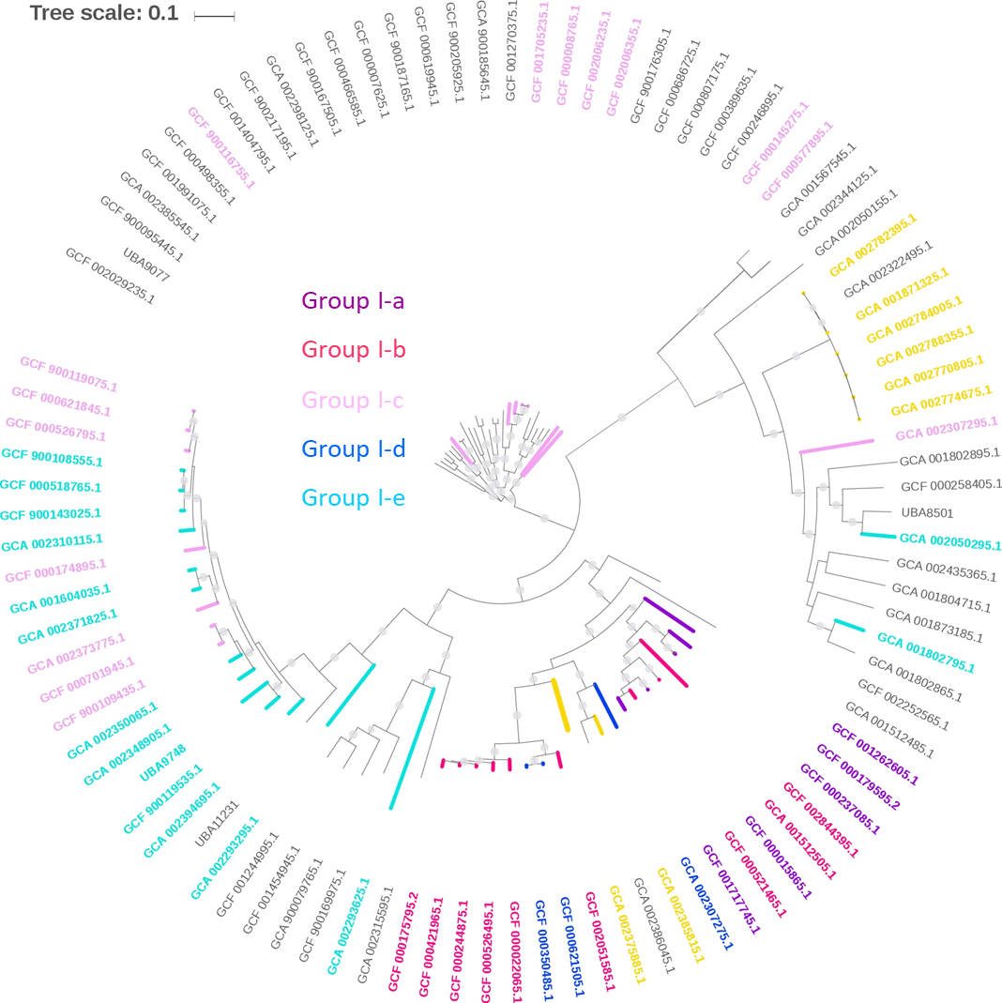
Figure S1. Maximum likelihood tree of the potential cellulolytic genomes and their phylogenetically closely related reference genomes annotated among the 7904 reference genomes. Branches and nodes of the genomes categorized into the 5 cellulolytic groups were highlighted. Genomes that were the top two phylogenetically closest genomes to at least one of these potential cellulolytic genomes were also included in this figure and they were of grey branches and grey nodes. The tree was constructed using mafft alignment [1]with 100 bootstraps based on a set of 120 concatenated universal single-copy proteins annotated in each genome [2].

References
1. Katoh K, Standley DM: MAFFT multiple sequence alignment software version 7: improvements in performance and usability. Mol Biol Evol 2013, 30(4):772-780.
2. Parks DH, Chuvochina M, Waite DW, Rinke C, Skarshewski A, Chaumeil PA, Hugenholtz P: A standardized bacterial taxonomy based on genome phylogeny substantially revises the tree of life. Nat Biotechnol 2018, 36(10):996-1004.

