Green-solvent extraction of guabijú (Myrcianthes pungens) fruit: a sustainable antioxidant source for oil-in-water emulsions

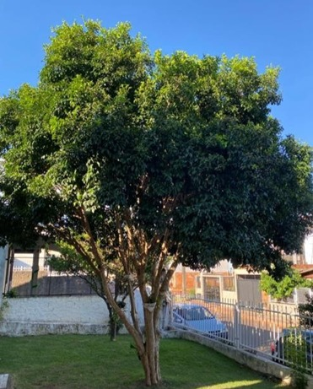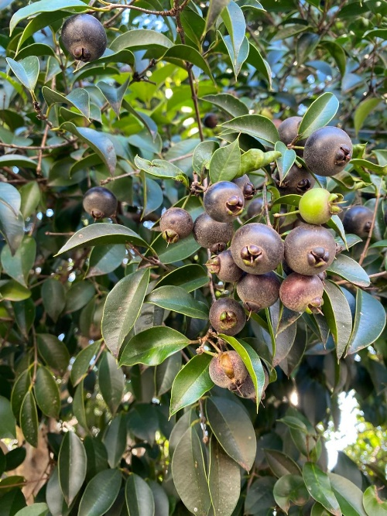
a
b
Fig S1 Tree (a) where the samples (b) were collected

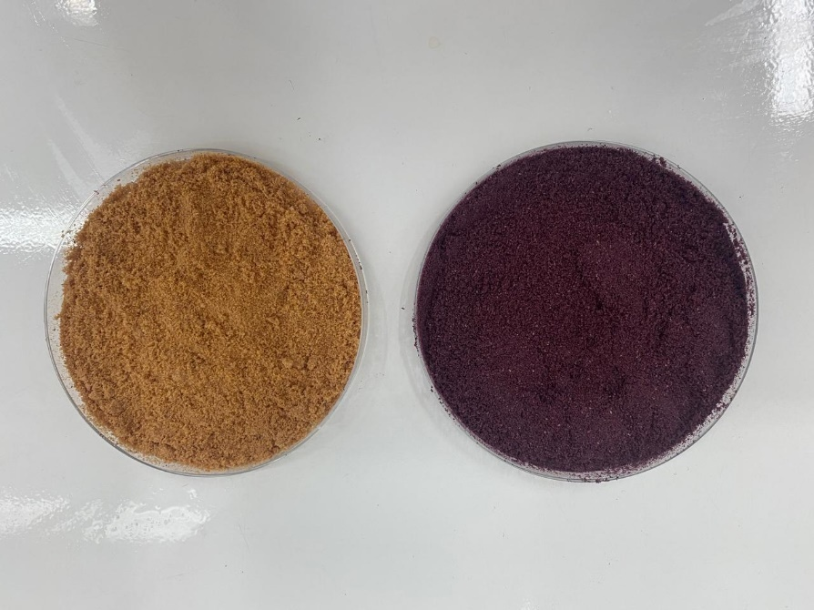
a
b

Fig S2 Lyophilized powder of guabijú peel (a) and pulp (b)
Table S1 Analytical validation parameters for the quantification of compounds by HPLC-DAD
Compounds | Retention time (min) | LD (mg.mL⁻¹) | LQ (mg.mL⁻¹) | Intra-day precision (%)* | Equation | R²
Cyanidin-3-glucoside | 4.693 | 0.0001 | 0.0005 | 1.10 | y = 325.73x + 0.0213 | 0.9979
Gallic acid | 18.857 | 0.0002 | 0.0006 | 3.95 | y= 2473.5x + 2.1999 | 0.9979
Catechin | 26.633 | 0.0008 | 0.0025 | 9.37 | y= 550.15x +1.9202 | 0.9920
Caffeic acid | 30.307 | 0.0001 | 0.0005 | 2.01 | y= 1585.5x -1.1204 | 0.9996
Ellagic acid | 32.383 | 0.0001 | 0.0004 | 6.29 | y= 5762.5x -17.692 | 0.9974
Quercetin | 43.160 | 0.0002 | 0.0006 | 3.42 | y= 1868.1x -7.2438 | 0.9991
Trans-cinnamic acid | 48.160 | 0.0001 | 0.0003 | 2.34 | y= 7155.6x -1.3828 | 0.9998
LD: Limit of detection. LQ: Limit of quantification. y: peak area in mAU; x: concentration in mg·mL⁻¹. *Highest coefficient of variation among the three concentrations evaluated. R²: determination coefficient

