Supplementary Figures: Comparing the Effect of Faecal Microbiota and Faecal Filtrate Transplantations on Intestinal Health in Weaned Piglets
Figure S1. Flowchart illustrating the preparation of capsules used in each treatment group: control, faecal microbiota transplantation (FMT), and faecal filtrate transplantation (FFT). Created with BioRender (https://biorender.com/).

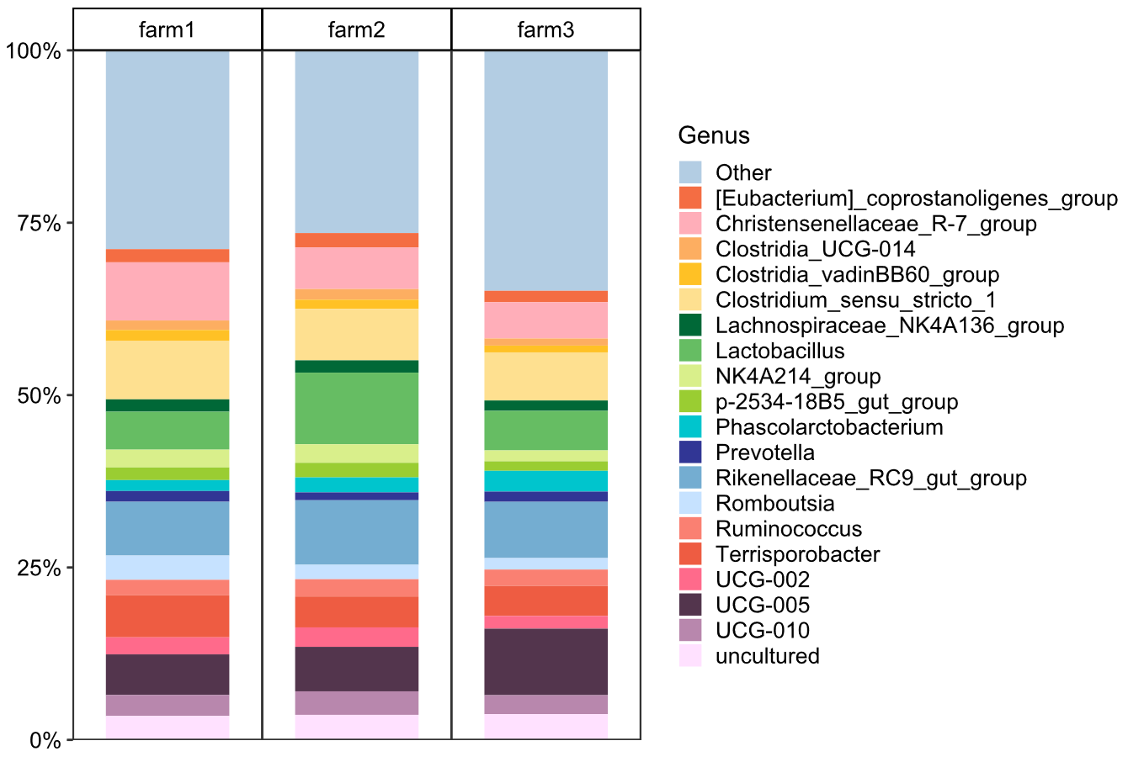
Figure S2. Relative abundance (%) of the top 20 genus in the sow donor faecal material from high health status farm 1, farm 2 and farm 3.

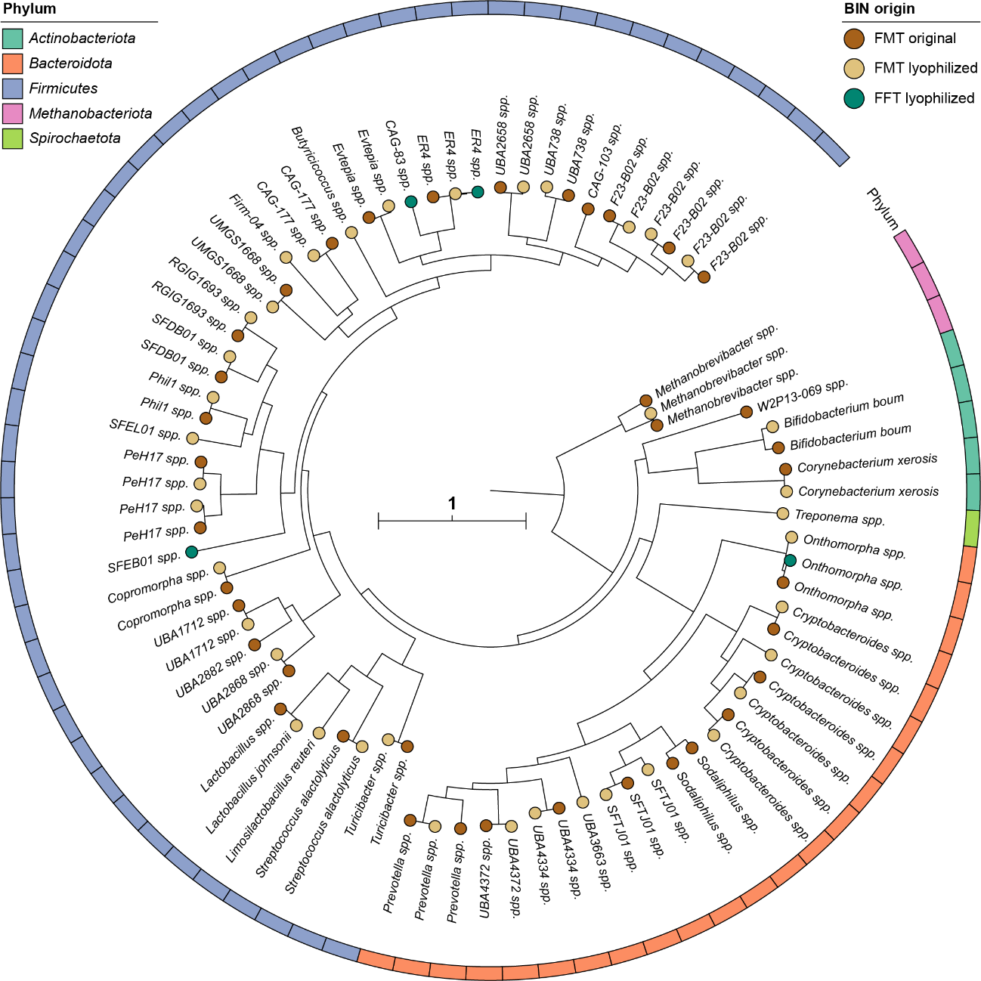
Figure S3. Phylogenetic tree based on all 81 genome assemblies (BIN), generated using Phylophlan. The figure shows that lyophilization had minimal impact on the bacterial composition of faecal microbiota transplantation (FMT). Phyla are indicated with colours. The sample of origin is indicated as filled circle. The tree was arbitrary rooted on Methanobacteriota. The scale bar indicates the expected number of substitutions per site.
Figure S4. Crypt depth observed for ileum (A), jejunum (B), duodenum (C), and caecum (D) in piglets treated with faecal microbiota transplantation (FMT), faecal filtrate transplantation (FFT) and control. Data are presented as the mean ± SD.

Figure S5. Villus height observed for ileum (A), jejunum (B) and duodenum (C) in piglets treated with faecal microbiota transplantation (FMT), faecal filtrate transplantation (FFT) and control. Data are presented as the mean ± SD. Asterisks denotes significant differences between group (P <0.05) calculated with one-way ANOVA.

Figure S6. Free IgA concentration in serum in the control and faecal microbiota transplantation (FMT) group. Data are presented as the mean ± SD.
Figure S7. Alpha-diversity comparison in faecal samples of pigs treated with faecal microbiota transplantation (FMT), faecal filtrate transplantation (FFT) and control. (A) Shannon index from 16S rRNA data through the study. (B) Chao1 and Shannon index from shotgun data on day 7. Comparisons were performed using the Wilcoxon rank-sum test. Original farm refers to faecal samples taken in the farm of origin before piglets arrive to the experimental farm.

Figure S8. Two-dimensional principal coordinates analysis (PCoA) plot based on the Bray-Curtis dissimilarity matrix at genus level in piglets treated with faecal microbiota transplantation (FMT), faecal filtrate transplantation (FFT), and control. Data are based on 16S rRNA sequencing and refer to (A) original farm (refers to faecal samples taken in the farm of origin before piglets arrive to the experimental farm), (B) day 11, (C) day 16, and (D) day 21. (E) PCoA at feature level of samples collected at day 7 based on shotgun data. Differences between groups were analysed with PERMANOVA.
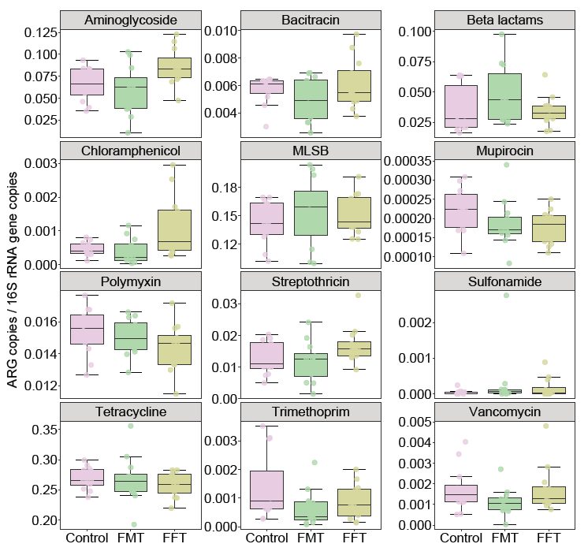
Figure S9. Relative abundance (copy/16S rRNA) of antimicrobial resistance genes (ARGs) at class level in faecal samples collected at day 7.

