Preparation and Characterization of Ag@TiO₂/α-Fe₂O₃ Ternary Nanocomposite for enhanced visible light photocatalytic performance

Nesrine Ben Saber ^{a,b}, Amine Mezni ^{a,*}

ª Department of Chemistry, College of Science, Taif University, P.O. Box 11099, Taif 21944, Saudi Arabia
^{b} Université de Carthage, Faculté des Sciences de Bizerte, LR18 ES11, Laboratoire des composés hétéro-organiques et des matériaux nanostructurés, 7021, Zarzouna, Tunisie

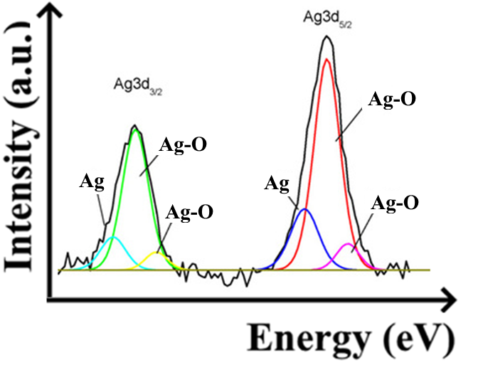
Figure S1. Deconvolution XPS spectrum of Ag element.

