Supplementary Materials: Crystal structure prediction via combining graph network and Bayesian optimization

Guanjian Cheng¹, Xin-Gao Gong^{2,3}, Wan-Jian Yin^{1,4,5}

¹College of Energy, Soochow Institute for Energy and Materials InnovationS (SIEMIS), and Jiangsu Provincial Key Laboratory for Advanced Carbon Materials and Wearable Energy Technologies, Soochow University, Suzhou 215006, China
²Key Laboratory for Computational Physical Sciences (MOE), State Key Laboratory of Surface Physics, Department of Physics, Fudan University, Shanghai 200433, China
³Shanghai Qi Zhi Institute, Shanghai, 200232, China
⁴Light Industry Insititute of Electrochemical Power Sources, Soochow University, Suzhou 215006, China
⁵Key Lab of Advanced Optical Manufacturing Technologies of Jiangsu Province & Key Lab of Modern Optical Technologies of Education Ministry of China, Soochow University, Suzhou 215006, China

Table S1: Twenty-three atomic features C.
# | Property | Unit
1 | Atomic number | -
2 | Group number | -
3 | Period number | -
4 | atomic mass | -
5 | density | g/cm³
6 | volume | cm³/mol
7 | atomic radii | pm
8 | van der Waals radii | pm
9 | covalent radii | pm
10 | melt | K
11 | boil | K
12 | specific heat | J∙g⁻¹∙K⁻¹
13 | Pauling electronegativity | -
14 | first ionization energy | eV
15 | dipole polarizability | a. u.
16-19 | the number of outer shell electrons in s, p, d, f orbitals | -
20 | element valence state | -
21 | the number of valence electrons in POTCAR | -
22 | LDAUU | -
23 | MAGMOM | -

Table S2: Six cell feature L
# | Property | Unit
1-3 | a, b, c | Å
4-6 | α, β, γ | Degree

Table S3: Four lattice features derived from atomic coordinates {R_{i}} and cell feature L
# | Property | Unit
1 | Atom spatial distance | Å
2 | Area of the Voronoi polyhedron | Å²
3 | Volume of the Voronoi polyhedron | Å³
4 | Solid angle of the Voronoi polyhedron | Sterradian

Figure S2. GN-predicted formation enthalpies and DFT-calculated total energies for random CaS structure in every 50 RAS steps. The DFT-calculated total energies are realigned for eye-guding comparisons.

Figure S3. The process of GN-BOSS approach to search the crystal structure of CaS. Typical structures derived from GN-BOSS process are shown in (b-h). This is an extension of searching step from 7500 (Figure 3) to 20000, to show the tiny structural refinement from (e) to (h).

# | Prototype structure | Relaxed structure | # | Prototype structure | Relaxed structure
1 | 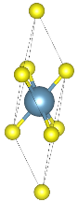  166 [$R\overline{3}m$] | 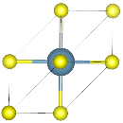  225 [$Fm\overline{3}m$] | 2 | 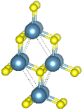  216 [$F\overline{4}3m$] | 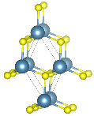  216 [$F\overline{4}3m$]
3 | 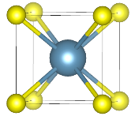  221 [$Pm\overline{3}m$] | 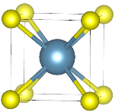  221 [$Pm\overline{3}m$] | 4 | 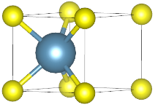  187 [$P\overline{6}m2$] | 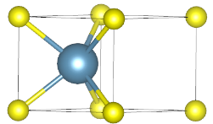  187 [$P\overline{6}m2$]
5 | 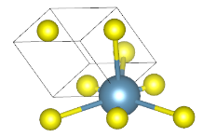  160 [$R3m$] | 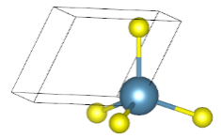  216 [$F\overline{4}3m$] | 6 | 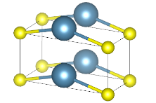  25 [$Pmm2$] | 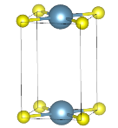  25 [$Pmm2$]
7 | 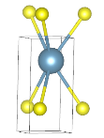  187 [$P\overline{6}m2$] | 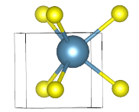  187 [$P\overline{6}m2$] | 8 | 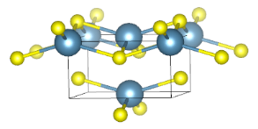  59 [$Pmmn$] | 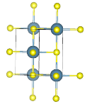  225 [$Fm\overline{3}m$]
9 | 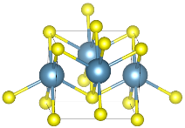  59 [$Pmmn$] | 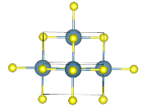  225 [$Fm\overline{3}m$] | 10 | 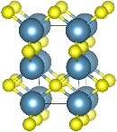  131 [$P4_{2}/mmc$] | 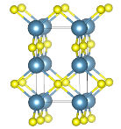  131 [$P4_{2}/mmc$]
11 | 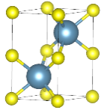  194 [$P6_{3}/mmc$] | 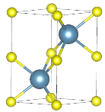  194 [$P6_{3}/mmc$] | 12 | 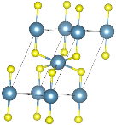  166 [R$\overline{3}m$] | 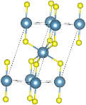  166 [R$\overline{3}m$]
13 | 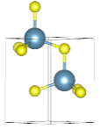  186 [$P6_{3}mc$] | 186 [$P6_{3}mc$] | 14 | 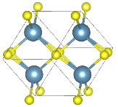  71 [$Immm$] | 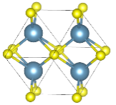  71 [$Immm$]
15 | 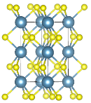  194 [$P6_{3}/mmc$] | 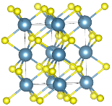  194 [$P6_{3}/mmc$] | 16 | 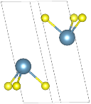  166 [R$\overline{3}m$] | 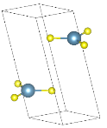  166 [R$\overline{3}m$]
17 | 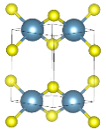  129 [$P4/nmm$] | 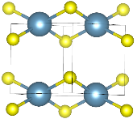  129 [$P4/nmm$] | 18 | 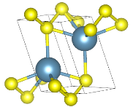  63 [$Cmcm$] | 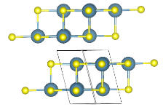  63 [$Cmcm$]
Figure S4: Eighteen AB prototype structures with their group number and index for CaS before and after DFT relaxation. The marked red boxes are RS structure.

Figure S5. The process of GN-RAS (4 atoms), GN-BO (4 atoms), GN-PSO (4 atoms) and GN-BO-SYM (8 atoms) approaches to search the crystal structures of LiF, NaF, KF, and RbF. Absolute values of ∆H’s for four approaches have been shifted to guide eyes. Lowest-energy structures within 10,000 steps for each approach have been shown at right side.
Figure S6. The process of GN-RAS (4 atoms), GN-BO (4 atoms), GN-PSO (4 atoms) and GN-BO-SYM (8 atoms) approaches to search the crystal structures of CsF, LiCl, NaCl, and KCl. Absolute values of ∆H’s for four approaches have been shifted to guide eyes. Lowest-energy structures within 10,000 steps for each approach have been shown at right side.
Figure S7. The process of GN-RAS (4 atoms), GN-BO (4 atoms), GN-PSO (4 atoms) and GN-BO-SYM (8 atoms) approaches to search the crystal structures of RbCl, CsCl, BeO, and MgO. Absolute values of ∆H’s for four approaches have been shifted to guide eyes. Lowest-energy structures within 10,000 steps for each approach have been shown at right side.
Figure S8. The process of GN-RAS (4 atoms), GN-BO (4 atoms), GN-PSO (4 atoms) and GN-BO-SYM (8 atoms) approaches to search the crystal structures of CaO, SrO, BaO, and ZnO. Absolute values of ∆H’s for four approaches have been shifted to guide eyes. Lowest-energy structures within 10,000 steps for each approach have been shown at right side.
Figure S9. The process of GN-RAS (4 atoms), GN-BO (4 atoms), GN-PSO (4 atoms) and GN-BO-SYM (8 atoms) approaches to search the crystal structures of CdO, BeS, MgS, and CaS. Absolute values of ∆H’s for four approaches have been shifted to guide eyes. Lowest-energy structures within 10,000 steps for each approach have been shown at right side.
Figure S10. The process of GN-RAS (4 atoms), GN-BO (4 atoms), GN-PSO (4 atoms) and GN-BO-SYM (8 atoms) approaches to search the crystal structures of SrS, BaS, ZnS, and CdS. Absolute values of ∆H’s for four approaches have been shifted to guide eyes. Lowest-energy structures within 10,000 steps for each approach have been shown at right side.
Figure S11. The process of GN-BO-SYM (8 atoms) and DFT-PSO-SYM (8 atoms) approaches to search the crystal structures of C.

Figure S12. The process of GN-BO-SYM (8 atoms) and DFT-PSO-SYM (8 atoms) approaches to search the crystal structures of Si.

Figure S13. The process of GN-BO-SYM (5 atoms) and DFT-PSO-SYM (5 atoms) approaches to search the crystal structures of CsPbI₃.

Figure S14. The process of GN-BO-SYM (10 atoms) and DFT-PSO-SYM (10 atoms) approaches to search the crystal structures of CsPbI₃.

