Table 1
Table 2
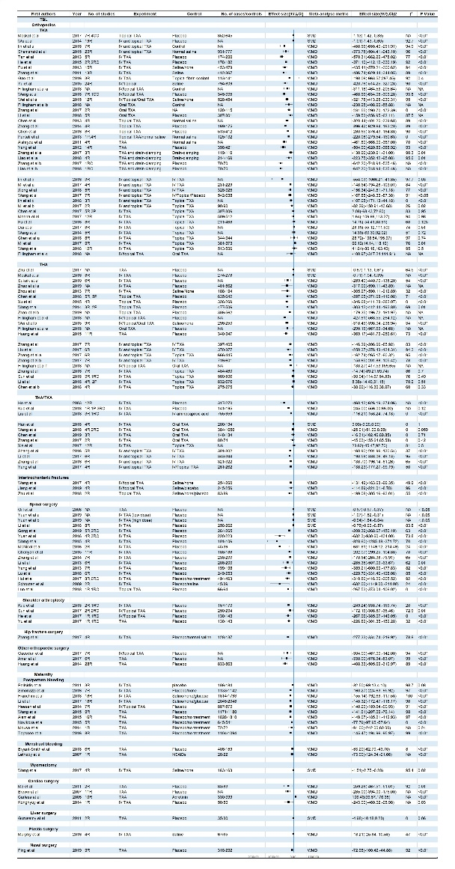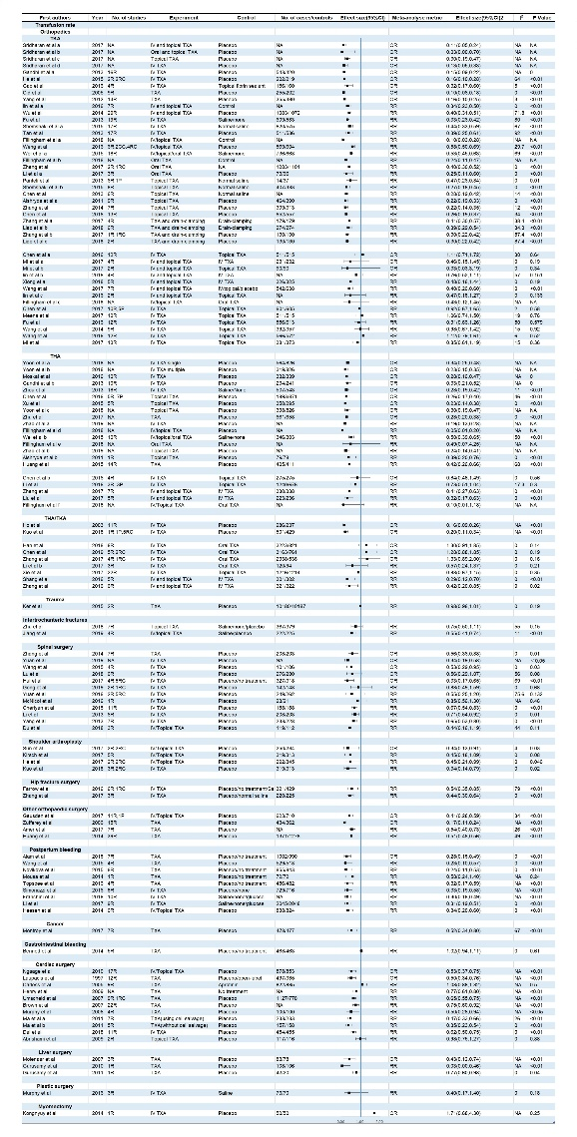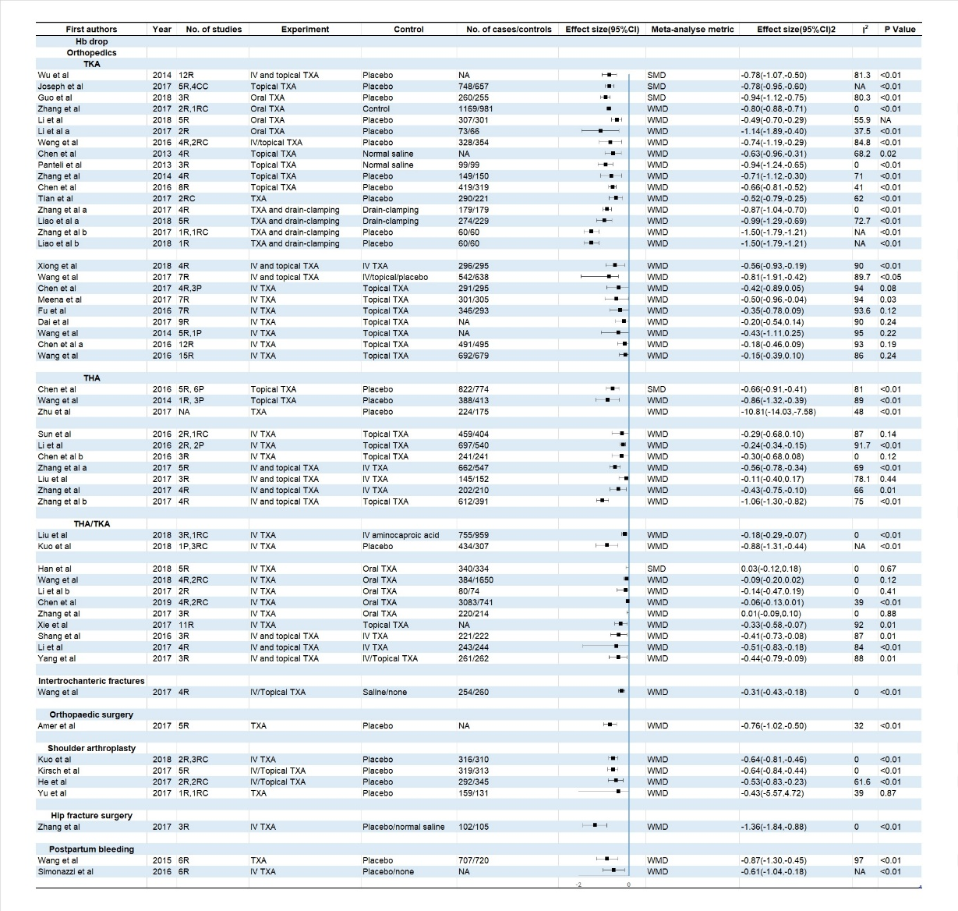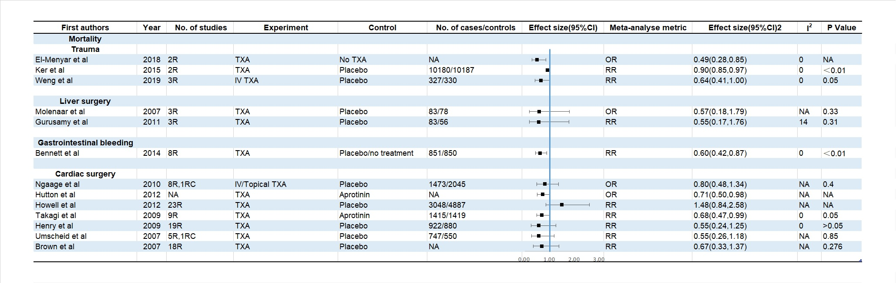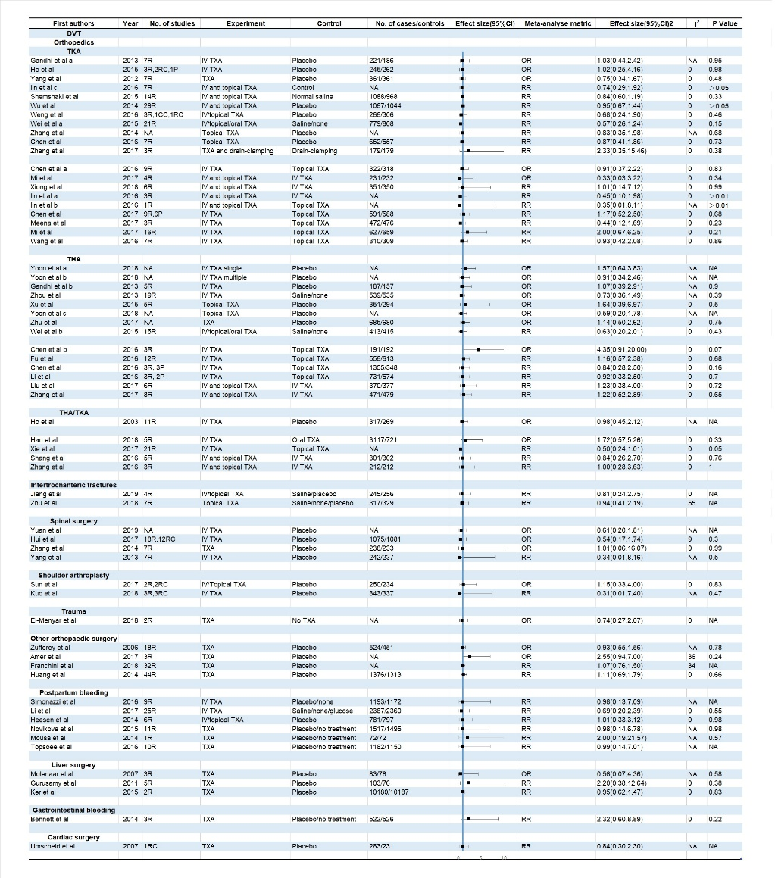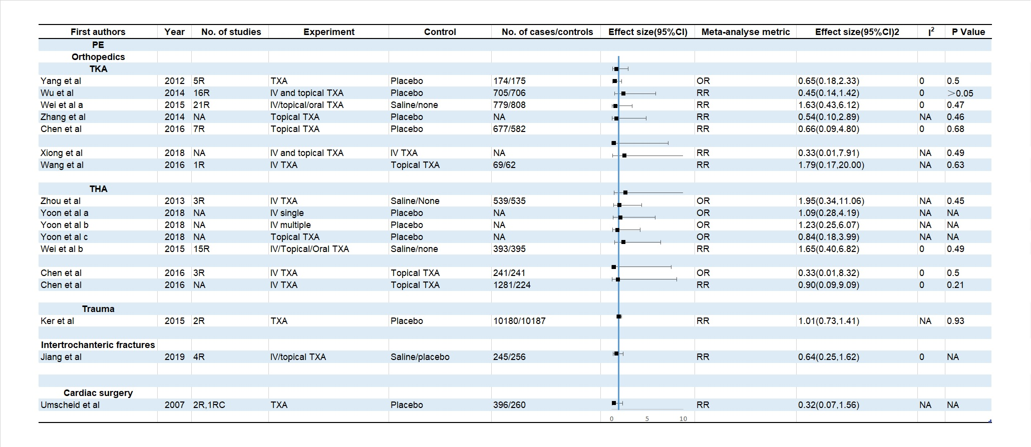
Table 3
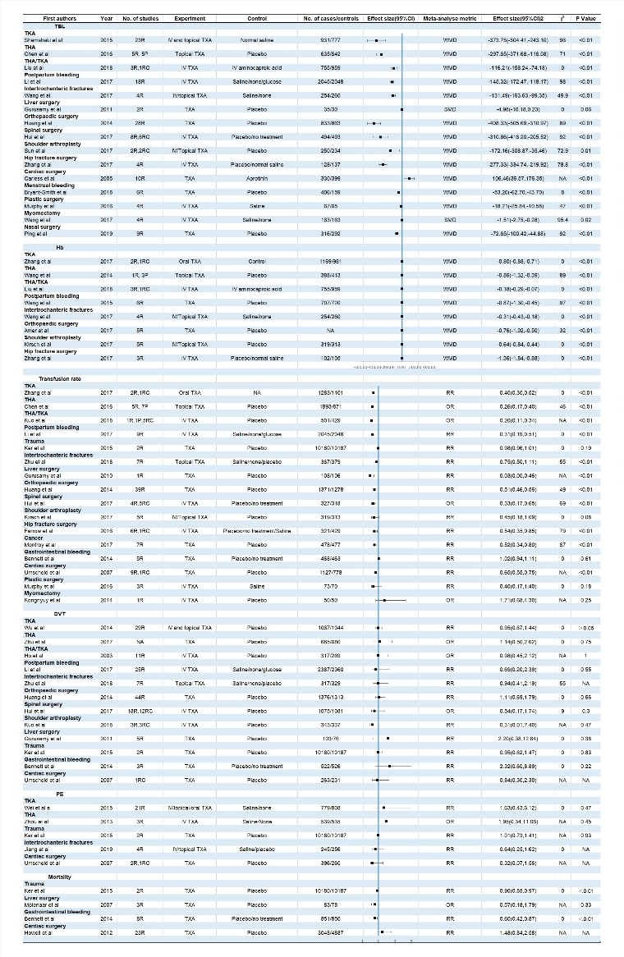
Table 4
Level of evidence | End points
Level of evidence | TBL | Transfusion rate | Hb drop | Mortality | DVT | PE
Convincing | - | - | - | - | - | -
Probable | - | Reducing transfusion rate of TKA (TXA vs placebo), THA (TXA vs placebo; combine administration vs single administration), TKA/THA(combine administration vs single administration), postpartum bleeding, orthopaedic surgery, shoulder arthroplasty | Reducing Hb drop of intertrochanteric fractures, orthopaedic surgery, hip fracture surgery | Reducing mortality of trauma, gastrointestinal bleeding | - | -
Possible | Reducing TBL of TKA (combine administration vs single administration; TXA vs placebo), THA (combine administration vs single administration; TXA vs placebo), TKA/THA (combine administration vs single administration; TXA vs placebo), postpartum bleeding, intertrochanteric fractures, orthopaedic surgery, spinal surgery, shoulder arthroplasty, hip fracture surgery, cardiac surgery, menstrual bleeding, plastic surgery, myomectomy, nasal surgery | Reducing TBL of TKA/THA(TXA vs placebo), liver surgery, spinal surgery, hip fracture surgery, cancer, cardiac surgery | Reducing Hb drop of TKA(TXA vs placebo; combine administration vs single administration), THA(TXA vs placebo; combine administration vs single administration), TKA/THA(TXA vs placebo; combine administration vs single administration), postpartum bleeding, shoulder arthroplasty | - | - | -
No associations | No association with TKA(IV TXA vs topical/oral TXA), THA(IV TXA vs topical/oral TXA), TKA/THA(IV TXA vs topical/oral TXA), liver surgery | No association with TKA(combine administration vs single administration; IV TXA vs topical/oral TXA), THA(IV TXA vs topical/oral TXA), TKA/THA(IV TXA vs topical/oral TXA), trauma, intertrochanteric fractures, gastrointestinal bleeding, plastic surgery, myomectomy | No association with TKA(IV TXA vs topical TXA), THA(IV TXA vs topical TXA), TKA/THA(IV TXA vs topical TXA) | No association with liver surgery, cardiac surgery | No association with TKA, THA, TKA/THA, postpartum bleeding, intertrochanteric fractures, orthopaedic surgery, spinal surgery, shoulder arthroplasty, liver surgery, trauma, gastrointestinal bleeding, cardiac surgery | No association with TKA, THA, trauma, intertrochanteric fractures, cardiac surgery
Limited/ Contrasting | - | - | - | - | - | -

