Supplementary Information

Supplementary Table 1: Study eligibility criteria
Category | Criteria
Inclusion Criteria | Adults aged ≥45 years
Inclusion Criteria | Hospitalized for heart failure within the past 12 months
Inclusion Criteria | NYHA Class I–III
Inclusion Criteria | Fluent in English
Inclusion Criteria | Passed mini–cognitive screening assessment
Inclusion Criteria | Able to walk independently without assistive devices
Inclusion Criteria | Participants without smartphones were provided one with a data plan
Exclusion Criteria | Severe visual or tactile impairments (e.g., legal blindness, severe arthritis)
Exclusion Criteria | Prior heart transplantation or durable mechanical circulatory support device
Exclusion Criteria | History of renal failure
Exclusion Criteria | End-stage or terminal illness (e.g., advanced cancer)

Supplementary Table 2: Post-cluster analysis assessment of between-cluster differences (cluster profiling; baseline data only)
 | Cluster 1 (Challenged Survivors) | Cluster 2 (Activated Learners) | Cluster 3 (Engaged Self-Regulators) | Test (df) | P-value
Continuous variables (m, sd)
Age | 55.3 (7) | 56.7 (7.6) | 63.3 (9.6) | F(2, 143) = 13.8 | < .001**
Self-care behaviors  (EHFScB) | 71.1 (19.3) | 74.1 (19.2) | 74.3 (17.4) | F(2, 143) = 0.4 | .65
Quality of life  (KCCQ) | 34.1 (25.1) | 36.7 (20.9) | 59.4 (21.2) | F(2, 143) = 20.8 | < .001**
Functional status  (KCCQ) | 50.7 (21.1) | 49.3 (24.1) | 75.6 (19.2) | F(2, 143) = 26 | < .001**
Categorical variables (%, n)
Sex (male) | 71% (29) | 64% (27) | 60% (38) | χ²(2) = 1.2 | .556
Prior tracker use (yes) | 24.4% (10) | 21.4% (9) | 54% (34) | χ²(2) = 15.0 | < .001**
Group (intervention) | 49% (20) | 45% (19) | 46% (29) | χ²(2) = 0.12 | .943
Minority status (White/non-Hispanic) | 73.2% (30) | 64.3% (27) | 85.7% (54) | χ²(2) = 6.6 | .037*
Note: Following a significant multivariate MANOVA, continuous variables were compared using one-way ANOVA, and categorical variables using Pearson’s chi-square tests. Values are presented as mean (SD) for continuous and percentages for categorical variables.

Supplementary Table 3: Characteristics of sub-sample of interviewed participants
Pt | Cluster | Gender | Age | Race/ ethnicity | Education | Financial hardship | Synced days out of 168 (tracker/ scale) | Cluster fit
1 | 1 | M | 58 | Black | HS | Yes | 62/ 18 | Strong
2 | 1 | M | 64 | White | HS | Yes | 168/ 71 | Strong
3 | 1 | M | 57 | White | HS | No | 118/ 74 | Moderate
4 | 1 | M | 56 | Black | HS | Yes | 129/ 26 | Strong
5 | 1 | F | 55 | White | HS | Yes | 162/ 148 | Weak
6 | 2 | M | 56 | White | HS | Yes | 167/ 153 | Strong
7 | 2 | M | 49 | White | College+ | Yes | 158/ 83 | Strong
8 | 2 | M | 54 | White | College+ | Yes | 162/ 72 | Moderate
9 | 2 | M | 55 | White | College+ | Yes | 130/ 26 | Strong
10 | 2 | M | 56 | Black | College+ | Yes | 92/ 65 | Strong
11 | 2 | F | 46 | Black | College+ | Yes | 148/ 91 | Strong
12 | 3 | M | 46 | White (Hispanic/ Latino) | College+ | No | 168/ 148 | Strong
13 | 3 | F | 65 | White | College+ | No | 167/ 161 | Strong
14 | 3 | F | 49 | White | HS | No | 57/ 56 | Strong
15 | 3 | F | 74 | White (Hispanic/ Latino) | HS | No | 137/ 101 | Strong
16 | 3 | F | 64 | White | College+ | Yes | 168/ 156 | Moderate
17 | 3 | F | 69 | White | College+ | No | 167/ 150 | Moderate
18 | 3 | M | 61 | White | College+ | Yes | 106/ 163 | Moderate
19 | 3 | F | 60 | White | College+ | No | 147/ 131 | Strong
20 | 3 | M | 56 | White | College+ | Yes | 148/ 101 | Strong
21 | 3 | F | 63 | White | College+ | No | 168/ 115 | Strong
22 | 3 | F | 77 | White | College+ | No | 165/ 151 | Strong
23 | 3 | M | 70 | White | College+ | No | 156/ 157 | Strong
24 | 3 | F | 50 | White | College+ | No | 168/ 157 | Moderate
25 | 3 | M | 70 | White | College+ | No | 165/ 115 | Strong
26 | 3 | F | 76 | Black | College+ | No | 131/ 127 | Strong

Supplementary Table 4: COREQ Checklist
Item No |  | Guide Questions/Description | Comment
Domain 1: Research team and reflexivity
Personal Characteristics
1. Interviewer/ facilitator |  | Which author/s conducted the interview or focus group? | All interviews were independently conducted by either RT or NC.
2. Credentials |  | What were the researcher’s credentials? E.g., PhD, MD | The researchers’ credentials were as follows:  RT: BA  NC: RN, MSN, and FNP-C  EW: RN, MA  EH: RN, PhD  MB: PhD, MS, MEd  KR: RN, MSEE, PhD, FAAN
3. Occupation |  | What was their occupation at the time of the study? | NC, RT, and EW were PhD candidates, EH and MB were Assistant Professors, and KR was a Professor at the University of Texas at Austin.
4. Gender |  | Was the researcher male or female? | All female.
5. Experience and training |  | What experience or training did the researcher have? | The two authors who conducted the qualitative interviews had experience facilitating interviews from prior studies. They also received training and guidance from more senior authors (KR, EH).
Relationship with participants
6. Relationship established |  | Was a relationship established prior to study commencement? | No.
7. Participant knowledge of the interviewer |  | What did the participants know about the researcher? e.g. personal goals, reasons for doing the research? | Interview participants were informed that they were part of a sub-sample of main study participants who was being invited to share more about their experience in the study and with the DHTs generally. They did not know anything about the researchers beyond the research goals.
8. Interviewer characteristics |  | What characteristics were reported about the interviewer/facilitator? e.g. Bias, assumptions, reasons and interests in the research topic | While bias and assumptions are not discussed in the manuscript, both interview facilitators (NC and RT) were highly invested in the research as the main study will provide the basis for their dissertations. Both are also interested in health equity and attuned to social determinants of health that shape health behaviors, outcomes, and access to technology.
 | Domain 2: Study design
 | Theoretical framework
 | 9. Methodological orientation and Theory | What methodological orientation was stated to underpin the study? e.g. grounded theory, discourse analysis, ethnography, phenomenology, content analysis | Our interview guide and data analysis procedures were guided by the AIM-ACT theoretical framework, and we also used reflexive thematic analysis as a more high-level data analysis method.
 | Participant selection
 | 10. Sampling | How were participants selected? e.g., purposive, convenience, consecutive, snowball | Given that the main study was progressively recruiting participants between over a period of more than two years, interview participants were similarly staggered, maintaining a ratio of approximately 1 interview participant per 5 main study participants. We contacted participants to solicit interviews progressively as they neared completion of the main study.  Participants were initially randomly selected, but upon subsequent team reflections and discussions, efforts were made to interview participants more evenly spread across low, moderate, and high engagement levels. We considered low engagers to be participants who synced on 40% of days or less and high engagers to be participants who synced on 80% of days or more, with moderate engagers somewhere in the middle. We did not systematically select participants based on these thresholds, we simply tried to be mindful of maintaining a balance of engagement levels across the sub-sample of interviewed participants.
 | 11. Method of approach | How were participants approached? e.g., face-to-face, telephone, mail, email | Participants were approached primarily by text message, which was the default communication method between researchers and participants in the main study. Researchers used Google Voice accounts to text and call with study participants.
 | 12. Sample size | How many participants were in the study? | Reported in Section 3.4 in the manuscript.
 | 13. Non-participation Setting | How many people refused to participate or dropped out? Reasons? | All interview participants were enrolled in and approaching completion of the main study. Some individuals who were asked to do an interview did not respond to the solicitation, but no one refused interview participation.
 | 14. Setting of data collection | Where was the data collected? e.g., home, clinic, workplace | Reported in Section 3.4 in the manuscript.
 | 15. Presence of nonparticipants | Was anyone else present besides the participants and researchers? | No.
 | 16. Description of sample | What are the important characteristics of the sample? e.g. demographic data, date | Characteristics of the sample are included in Appendix 2. The interviews were conducted between May 2023 and May 2025. Given that the main study was progressively recruiting participants between November 2022 and May 2025, interview participants were similarly staggered.
 | Data collection |  |  |  | No
 | 17. Interview guide | Were questions, prompts, and guides provided by the authors? Was it pilot tested? | Semi-structured interviews were facilitated by an interview guide. This approach provided a clear structure to the interviews and ensured that all topics of interest would be covered, while allowing flexibility to the interviewers to probe when they deemed it relevant, as well as omit questions that were not relevant or had already been answered.  The interview guide began by asking about participants’ health history, prior experience with DHTs, motivation for joining the study, and overall experience in the study. Then, each DHT was discussed individually (i.e., smart scale, activity tracker, and mobile app for all participants; the game app for the intervention group only). For each DHTs, interviewers asked the participant to describe their experience, how the DHT affected their daily self-care, and what (if any) issues or problems they faced.
 | 18. Repeat interviews | Were repeat interviews carried out? If yes, how many? | No, one interview only.
 | 19. Audio/visual recording | Did the research use audio or visual recording to collect the data? | Reported in Section 3.4 in the manuscript.
 | 20. Field notes | Were field notes made during and/or after the interview or focus group? | The interviewers made brief field notes after completing each interview to reflect on how they felt the interview went and note down any major points that the participant made about their overall experience in the study and factors that shaped it.
 | 21. Duration | What was the duration of the interviews or focus group? | Interviews ranged in length from 18 to 45 minutes, with most interviews taking approximately 30 minutes.
 | 22. Data saturation | Was data saturation discussed? | The team discussed and reflected on recurring themes across interviews, but data saturation did not drive the sample size; the protocol for the main study was followed.
 | 23. Transcripts returned | Were transcripts returned to participants for comment and/or correction? | No.
 | Domain 3: analysis and findings
 | Data analysis
 | 24. Number of data coders | How many data coders coded the data? | Three coders (RT, NC, and EW) coded the data.
 | 25. Description of the coding tree | Did the authors provide a description of the coding tree? | The coding tree consisted of the AIM-ACT framework elements, as described in Section 2.3.
26. Derivation of themes |  | Were themes identified in advance or derived from the data? | The broad thematic areas were pre-determined; they were structured by the AIM-ACT theoretical framework.
27. Software |  | What software, if applicable, was used to manage the data? | Reported in Section 3.4 in the manuscript.
28. Participant checking |  | Did participants provide feedback on the findings? | No.
 | Reporting
 | 29. Quotations presented | Were participant quotations presented to illustrate the themes/findings? Was each quotation identified? e.g., participant number | Yes, participant quotes are included throughout section 4.2 along with participant numbers.
 | 30. Data and findings consistent | Was there consistency between the data presented and the findings? | As this is a mixed methods study, the findings were initially quantitatively derived, with qualitative data used to validate and expand upon these findings. The alignment between the qualitative and quantitative findings is discussed in Section 4.3.4.
 | 31. Clarity of major themes | Were major themes clearly presented in the findings? | The qualitative findings are used in this paper to add richness and depth to the descriptions of three psychosocial phenotypes, which we present in Section 4.3.
 | 32. Clarity of minor themes | Is there a description of diverse cases or a discussion of minor themes? | Yes, diverse cases, which diverged from the “typical” profile of each psychosocial phenotype, are discussed in Section 4.3.4.

Supplementary Figure 1: Silhouette analysis for optimal k for k-medoids cluster analysis

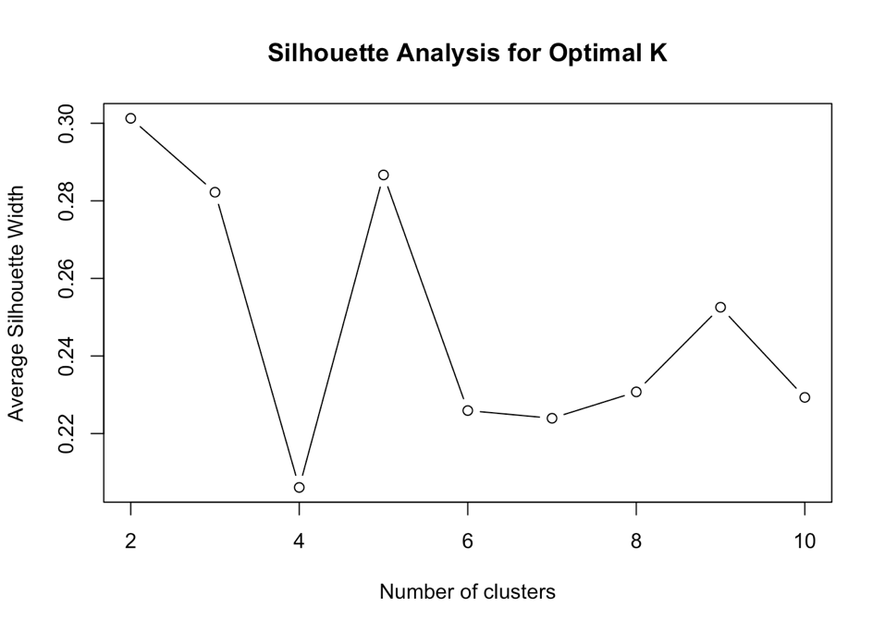

Supplementary Figure 2: Silhouette plot demonstrating cohesion and separation for the 3 psychosocial phenotypes

