Supplementary Information for

Systematic Baikal seal hunting and exploitation at a single site since Neolithic

Bruno Mitter, Peter Vršanský, Gonzalo Linares-Matás, Jana Mellnerová Šuteková, Júlia Kotulová, Helena Pálková, Rastislav Milovský, Miroslav Hain, Daniel Kosnáč, Noel Amano
Correspondence to: geolvrsa@savba.sk (Institute of Zoology SAS, Bratislava)

This Supplementary material includes:
Supplementary Note 1. Further details related to faunal analysis
Supplementary Note 2. Further details to seal behavior
Supplementary Note 3. Associated charcoal
Supplementary Figures 1-14
Supplementary References

Supplementary Note 1. Further details related to faunal analysis

Fragmentation and Taphonomic Evidence
All bone fragments recovered during fieldwork in 1997, totaling 945, were analyzed. These were deposited throughout different periods, but assigned to one cultural layer. A rabbit bone and dog femur were displaced from the main assemblage during the post-excavation stage and could not be assessed taphonomically.
Bones are generally well-preserved with mostly fair bone tissue integrity and cortical preservation, medium erosion with a similar proportion of non-eroded and highly eroded specimens and minimal level of trampling (n=5). Heavy-weathered specimens account for less than 6.4% (Supplementary Figure 2). Abrasion impacted 11.4 % of the assemblage, with some severely abraded specimens.
Recorded fragmentation in the assemblage is minimal as only 15,6% of total fragments are unidentifiable to class level. Bone frequencies highly but non-significantly correlate with bone density (r=0.602, p=0.065; see Supplementary Table 14) suggesting a density-mediated attrition profile, which may have been caused by a combination of factors, including carnivore ravaging, winnowing by waterborne processes as well as potential biochemical diagenetic damages. One specimen exhibited acidification of surface, due to possible digestion by carnivore or diagenetic alteration. Predominantly mild and medium concentration of dentritic root-etching marks impacted most of the assemblage. Carvivore gnawing is present on 5% of all specimens (n=28, and 25 of identified specimens), suggesting some degree of carnivore attrition. Only 2,9% of all fragments exhibited rodent gnawing, yet the number is possibly underrepresented due to microscopic nature and known living population of rodents on islands – not necessarily, it depends on the degree of exposure of the remains and whether they were weathered/dry (see Supplementary Figure 2-3). Moreover most of bones burned.

Further taxonomic identification
Four identified specimens of genus Canis were present (see Supplementary Table 1). Only the greater ischiatic spine of os coxae provides enough dichotomy to differentiate between Canis familiaris and Canis lupus. Three specimens were assigned to category dog/wolf (Canis lupus) including right mandible, left phalange and metacarpal 3/4. Three bear specimens were identified. These include an almost complete unfused vertebra with carnivore puncture and four possible trampling marks, and two complete exceptionally well preserved fully fused specimens of bear. Judging by the occupation of the area by only one brown bear species, and the tradition of hunting brown bears in the area the bones could be tentatively assigned to Ursus arctos. Other bones resembling those of bears or dogs but otherwise not clearly identifiable, mainly phalanges and metacarpals/tarsals have been assigned to class Carnivora (NISP=9). As some complete bones and bone fragments show similar traits among carnivorous species we were unable to differentiate between most of these Carnivora specimens (see Supplementary Table 1).
Given the bulk of the assemblage remains from Ushkany Island included bones of ungulate (NISP=1) and quantity of unidentified mammal fragments (TNF=113). Certain remains were identified only to the family level, these findings show the only large mammal species of the assemblage. Cervidae are represented by scapula fragment, Bovidae evidenced by remains of tooth, and Equidae demonstrated with the only cut-marked mandible of assemblage (see Figure 4 and Supplementary Tables 1 and 10).
Only three bird bone specimens were recorded (NISP=3). One coracoid bone belonging to a cormorant, Phalacrocorax spp. was identified to species level. It exhibits one cutmark. This migratory bird might therefore partially provide information about seasonality as it is most likely present during periods of open waters. One non-anthropically modified specimen of Ferruginous duck (Aythya nyroca) was identified. Lack of distinct morphological markers make the identification of the third fragmented bird bone element difficult to identify any further. The specimens that could not be securely identified to genus were assigned to the family level.

Burning
The most common modifications on faunal fragments observed at Tonkij Ushkany Island were burning and calcination (Supplementary Figures 6-7 and Table 9). Burning modifications were recorded for all the identified taxa except the bovid tooth. Calcination impacted 33% of bird remains (n=1). A very high portion of seal remains were burned/calcined (90,94%, n=482). By comparison, 50% of ursid (n=1) and 100% of canid specimens (n=5) exhibited burning. The remaining identified carnivore specimens exhibited a high level of burning/calcination (81,81%, n=9). Additionally, cervid, equid and medium ungulate specimens exhibited burning (respectively, n=1). The pattern of completely burned/calcined carpals, tarsals, metacarpals, metatarsals, and phalanges, the presence of burning in the inner skull, and burned weathered fractures suggest that the burning process occurred post-skeletal disarticulation and deposition, perhaps associated with waste management practices or the use of bones as fuel.

Butchery marks
Although fragmentation, weathering, and frequent burning may obscure butchery evidence, marks associated with butchery practices were recorded on total 325 fragments. Cutmarks were recorded on 121 identified specimens (%NISP=13,52) with n=531 identified cutmarks, mostly on seals, canids and ursids bone fragments (see Supplementary Tables 8-10). The assessment of the placement of 478 cutmarks and of 148 other butchery marks on 103 seal skeletal fragments enables us to describe the carcass processing sequence employed at the site ^{1–3}.
Evisceration is indicated by cutmarks on the ventral surface of vertebral bodies (NISP=8) and ribs (NISP=1). Skinning is evidenced by cutmarks on lateral nasal part of crania (Cut NISP=2, #Cuts=12) and may be evidenced on flippers - metatarsals, metacarpals, distal radio-ulna and distal tibio-fibula. Gross dismemberment produces major meat yielding units such as head, limbs, and back. The head decapitation is evidenced by cutmarks on the base of the occipital bone (Cut NISP=1, #Cuts=2) and atlas (Cut NISP=3, #Cuts=9). Dismemberment of limbs is documented by a series of cutmarks around the articular end of the scapula (Cut NISP=3; #Cuts=13) and on the pelvis (Cut NISP=2; #Cuts=10); and also on articular surfaces of the proximal humerus (Cut NISP=2; #Cuts=2) and femur (Cut NISP=4, #Cuts=7). Further, midline splitting of the back is evidenced by multiple chop marks (NISP=5) and transverse and longitudal cutmarks on vertebrae (NISP=27) following the main axis of the bone. Another processing sequence, disarticulation, reduces meat yielding units into parts used for cooking and further processing. This is evidenced by front limb partitioning cut marks produced on the distal humerus (Fused: Cut NISP=3, #Cuts=9; Unfused: Cut NISP=2, #Cuts=3), the proximal radius (Cut NISP=1, #Cuts=3), the distal radius (Cut NISP=1, #Cuts=1), and the distal ulna (Cut NISP=2, #Cuts=9); hind limb partitioning with transverse cuts on posterior side of distal femur (Cut NISP=1; #Cuts=7); cut marks (CutNISP=6; #Cuts=13; though these could be from skinning as well) and a chop mark (NISP=1) at the medial surface of distal end of the os cruris, indicate division of hindlimb into two units: the higher meat yielding tibio-fibula portion and the less meat yielding but beloved by contemporary Siberian hunters flipper portion. One of the final butchery stages involves defleshing/filleting, documented through cut-marks left from the separation of the meat from bones mainly on shafts of long bones and ribs that account for the most of recorded cutmarks (see Figure 2 and Suplementary Table 8). Such marks are primarily present on long bones, exhibiting a range of orientations: transverse, longitudinal and/or oblique. On the other hand, marrow extraction could be represented by spiral fractures and impact notches, found mainly in the area of mid shaft on several tibia fragments, one humerus, femur and two metatarsals. These recorded butchery marks match the ethnoarchaeological carcass processing sequence ^{1,3–5}, suggesting that humans were the main factor contributing to the creation of the recorded cut, chop, scrape marks and possibly impact notches.
No evidence of bone tool production or other type of bone working was observed among all collected specimens.
Bones of non-seal fauna remains exhibit a high frequency of butchery marks, accounting for 44% of all identified non-seal specimens (NISP=12) with recorded 40 cutmarks (see supplementary 10). Majority of the non-seal cutmarked specimens belong to the order Carnivora, Canis lupus and Ursus arctos. These exhibit mainly skinning marks on phalanges or metatarsals and metacarpals. Four shallow oblique striae present on an unfused bear vertebra might have been caused by trampling (cf. ref. ⁶) these trampling marks are located on the left side of the spinous process. This specimen also exhibits a circular notch on the left side of the vertebral body recorded as a carnivore puncture. Further, a horse mandible presents deep parallel superimposed cutmarks on the buccal part of the ramus.

Supplementary Note 2. Further details to seal behavior

Seal biology and zooarchaeological implications.
Freezing of lake impacts life history, distribution and behaviour of Baikal seal. The freezing of the lake since the beginning of winter, lasting until mid-May, causes uneven distribution of seals across the lake, so assemblages have the potential to show some degree of sex and age differentiation. Adults settle in the North deep waters while juveniles occupy South shores. Females concentrate mainly in the deeper areas of the central Baikal, After 11 months of pregnancy, females give birth from late February to early April and utilize dens (logovo) for birth and rearing. With ice melting significant regrouping of seals occurs throughout the spring, The number of juveniles gradually decreases towards the North and East of the lake, and the number of adults steadily increases⁷. During 2 weeks from late May to early June, animals lose in some cases more than 30 % of their weight due to molting and sun basking. Summer spanning from July to September, is characterized with intensive feeding, maximum dispersal, grouping due to the relaxation and low undernourishment and infection rate by e.g. canine distemper virus. The peak of haulouts on isolated rocky portions or islands across Baikal is generally in August with highest concentration of seals is in the Central Baikal. Ushkany Islands observe up to 1000 already in early July⁸ with currently decreasing trend, possibly due to VIP tourism and also climate change⁹. Others congregations previously formed in Ayaya Bay, Cape Sev. Cedar, capes Pongonye, Khoboy, Sagan, Shoroite-Khushun^{7,8}. During summer seals occupy deep waters, avoiding shallow waters mainly due to absence of golomiankas and possibly warm water. Yet east coast is always almost 2 times more saturated with seals, in contrast to the west due to well-defined shelf supporting varied ecosystem⁹. During autumn seals fragment from large congregation into groups of dozens of individuals till December.

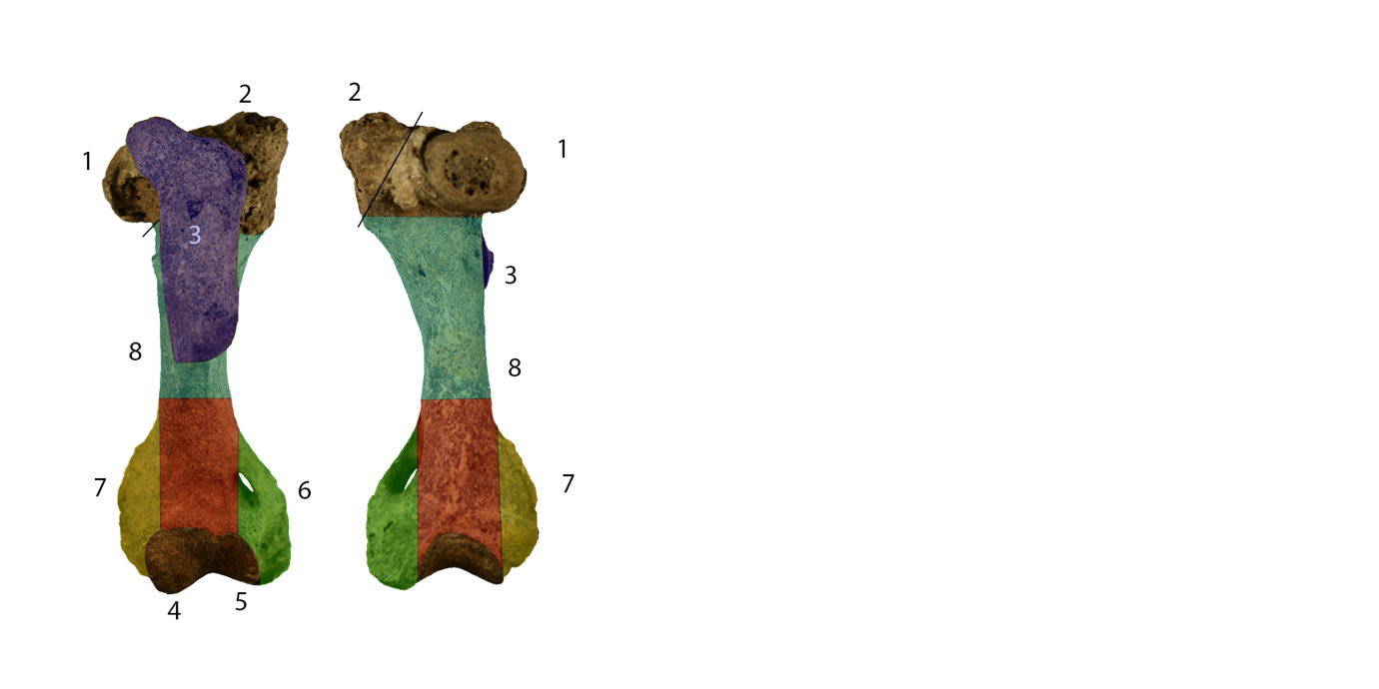
Supplementary Figure 1 Example of the system for recording bone fragments used in this study.

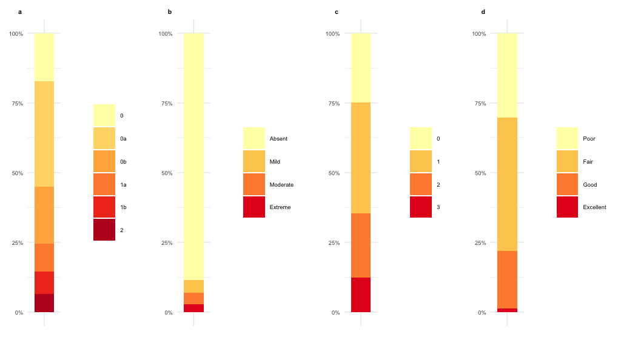
Supplementary Figure 2: Bone fragment distribution given weathering (A), abrasion (B), erosion (C) and bone tissue integrity (D) in one cultural layer of Tonkij Ushkany Island

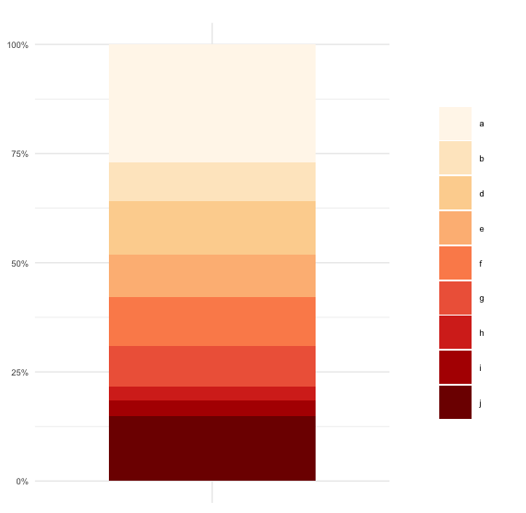
Supplementary Figure 3 Proportion of breakages in the assemblage following Reitz & Wing ¹⁰.

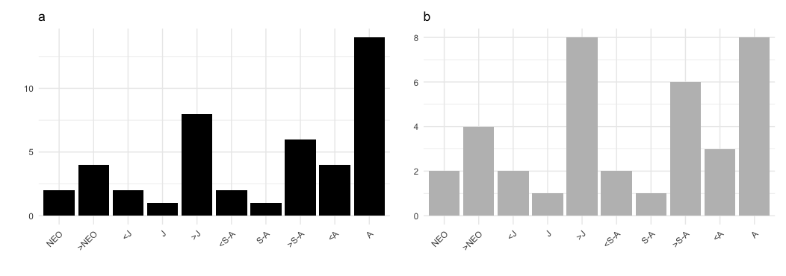
Supplementary Figure 4 Mortality profiles of Baikal seal (Pusa sibirica) following Stora considering NISP (A) and MNE (B).
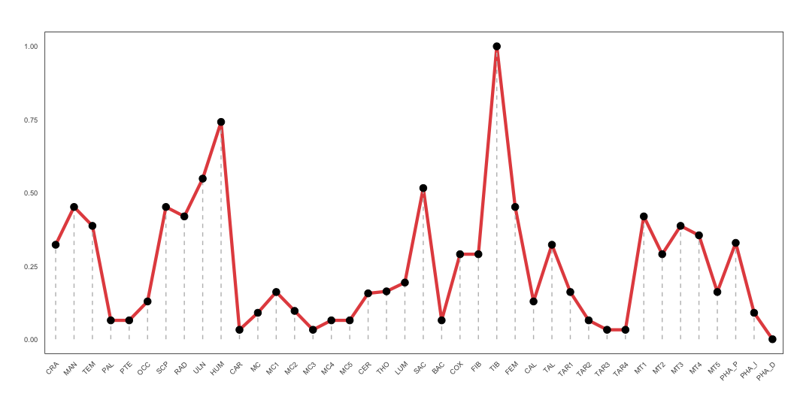
Supplementary Figure 5 Body part representation (% MAU) of Baikal seal (Pusa sibirica)

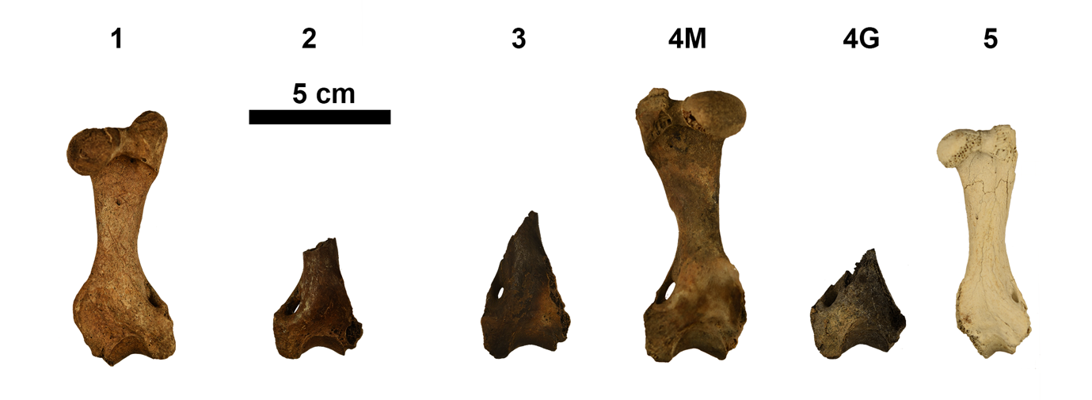
Supplementary Figure 6 Seal bones in different stages of burning

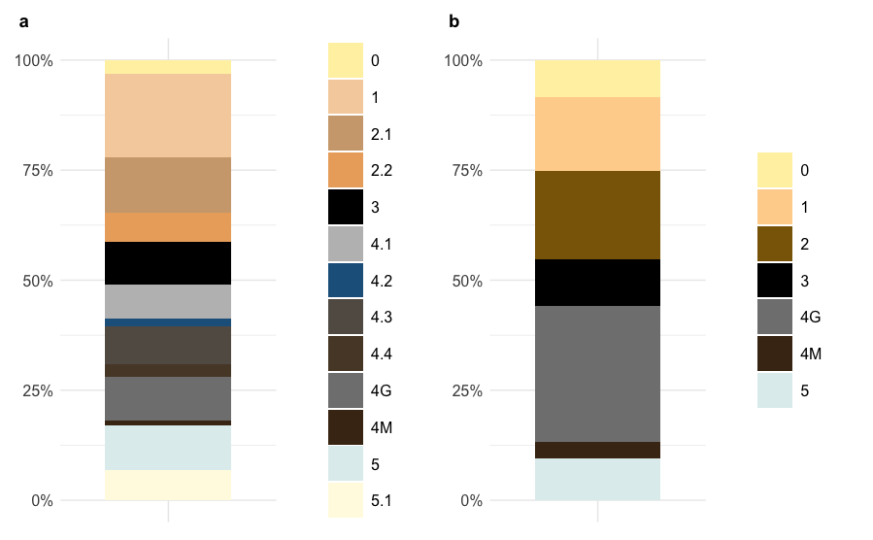
Supplementary Figure 7 Distribution of color (A) and burn stage (B) on identified bones. Colors might appear multiple times on same specimen. Subcategories of 2 and 4 imply burn categories 2 and 4, respectively. Differentiation between colors 1 and 0 is complicated. Color 1 implied stage 0 in some specimens
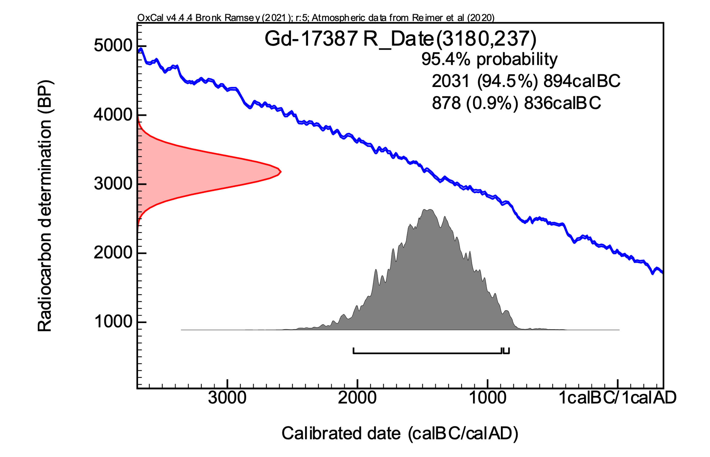
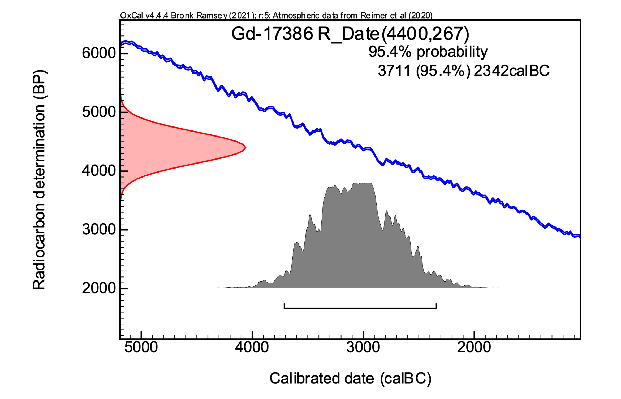
Supplementary Figure 8 Calibrated range of radiocarbon dared seal bones from Tonkij Ushkany Islands

Supplementary Note 3. Charcoal found in seal and bear bones at Tonkij Ushkany island (Baikal): Formation temperature and assessment of natural vs. anthropogenic Factors

Introduction
Charcoal fragments can be produced by both natural fires and anthropogenic processes, regardless of whether these processes are controlled or uncontrolled. Natural wildfires, such as those that occur in forest, swamp, meadow, and steppe ecosystems, can generate significant amounts of charcoal across extensive areas. Additionally, geological processes, including metamorphism¹¹ and the combustion of phytomass in contact with pyroclastic flows¹², also play a role in charcoal formation. Charcoal, the byproduct of wildfires, provides valuable information on the historical occurrence of wildfires^{13,14}.
Combustion processes linked to anthropogenic activity include the burning of wooden materials in residential structures, cremation ceremonies, and the production of charcoal in kilns. They also encompass the heating of furnaces for the production and processing of metals and alloys, as well as the production of ceramics. Furthermore, these processes involve the cooking of meals over open-fire hearths, particularly in prehistoric times, and the use of household ovens that utilize wood or coal as fuel.
Wood (lignocellulosic tissue) transforms into charcoal through the process of pyrolysis, which occurs in a low-oxygen environment. Heating induces the chemical and physical reorganization of plant tissues, accompanied by the release of volatile compounds. This transformation is irreversible and is primarily influenced by the temperature and duration of heat exposure. The experimentally established correlation between the increasing reflectance of charcoal and rising temperature enables the determination of the maximum temperature that organic matter has experienced in the past. Thermal alteration can be quantified by measuring the reflectance of the surfaces of individual charcoal particles^{12,15-25}. In microscopic analysis, the polished surface of thermally altered tissue (charred or burned) is illuminated by a beam of light, and its reflectance is measured using a microphotometer in conjunction with monochromatic unpolarized light.
In general, the greater the temperatures to which plant tissues have been exposed, the higher the reflectance of the resulting charcoal.
A similar trend is observed with the duration of thermal events: the longer the organic matter from plants is subjected to elevated temperatures, the higher its reflectance. However, this relationship is not as straightforward as the direct correlation between temperature and reflectance^{21,26}. If the organic matter has experienced multiple thermal influences throughout its history, its structure and reflectance will reflect the effects of the highest temperature encountered.
To determine the charcoal formation temperature from the measured reflectance, calibration curves are utilized. These curves were developed based on data obtained from the combustion of various types of wood at known temperatures and exposure durations^{13,17,19,21,27,28,29}. So, the temperature to which the organic matter was exposed can be inferred from these curves based on the measured reflectance values.
Reflectance analysis of archaeological materials, such as charcoal, can provide primary evidence regarding the temperatures associated with ancient natural or anthropogenic processes.
Charcoal, found along with fine sediments inside fractured animal bones from Tonkij Ushkany Island (Lake Baikal), was analyzed using methods of organic petrography and light reflectance. Bones are identified as seals (samples: 121, 273, 374, 380, 382, and 918), and a bear (12). The sample preparation and analytical conditions are provided in the Methodology section.

1. Results
1.1 Organic petrography
Microscopic examination of particles extracted from the medullary cavities of animal bones reveals the presence of burned organic matter of plant origin (charcoal), alongside a smaller proportion of aggregates consisting of clay particles, quartz grains, and micro-fragments of bone. The size of these particles ranges from 0.05 to 0.7 mm.
The charcoal is represented by macerals belonging to the inertinite group³¹ (ICCP 2001), specifically fusinite, semifusinite, and inertodetrinite. Among the studied samples, semifusinite is the most abundant maceral, characterized by its gray to gray-white coloration, in contrast to fusinite, which exhibits a white-yellow to yellow hue under reflected white light. Semifusinite possesses relatively thicker intercellular walls, with less pronounced cell cavities that display a greater variety of shapes and sizes among the individual studied particles (SI Fig. 9: a, c, d, e, f; SI Fig. 10: c, d, g, h, i; SI Fig. 11: a, c, e, g).
Fusinite, identified primarily by its thinner intercellular walls and more regular shapes of cell cavities, is depicted in Figures 1A (b), 1B (a, b, e, f), and 1C (b, d, f, i). It is consistently the most reflective maceral present, distinguished by its cell texture with thin walls and a white to yellow color (SI Fig. 9: b; SI Fig. 10: a, b, e, f; SI Fig. 11: b, d, f, i).
Inertodetrinite is present in smaller quantities, primarily as individual particles incorporated within aggregates formed by a clay matrix (SI figure 9: g and h). In most instances, these macerals exhibit minimal internal structure. The size of inertodetrinite particles typically averages around 10 µm. In contrast, semifusinite and fusinite exhibit greater variability in dimensions, commonly ranging from 60 to 120 µm. Some of these macerals, similar to most of the inertodetrinite, were also found within the clay matrix.
Under standard observation conditions, irregular and subtle anisotropy was noted in the macerals, most prominently in semifusinite. This anisotropic effect was particularly evident at the edges of individual particles, where the color of the semifusinite shifted from brighter shades of gray to darker grays as the microscope stage was rotated.
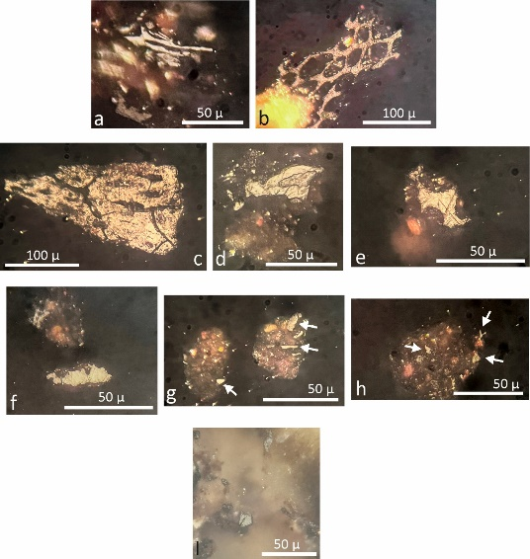
Supplementary Figure 9 Microphotographs of charcoal particles found in the cavities of seal bones, samples no. 273 (a, b); 374 (c - h); 380 (i). Semifusinite: a), c), d), e), and f). Fusinite: b). In microphotographs g) and h), small fragments of inertodetrinite are visible within the clay matrix.

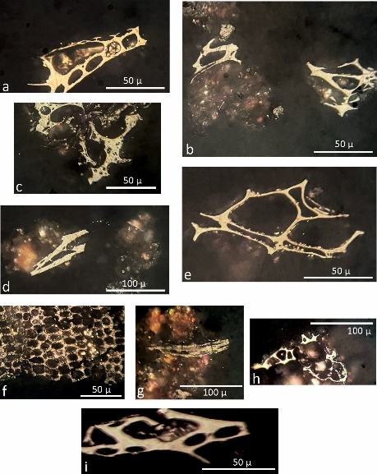
Supplementary Figure 10 Microphotographs of charcoal particles found in the cavity of seal bone in sample no. 382. Fusinite is shown in microphotographs a), b), e), and f); semifusinite is present in c), d), g), h), and i). In microphotograph g), semifusinite is visible within the clay matrix.

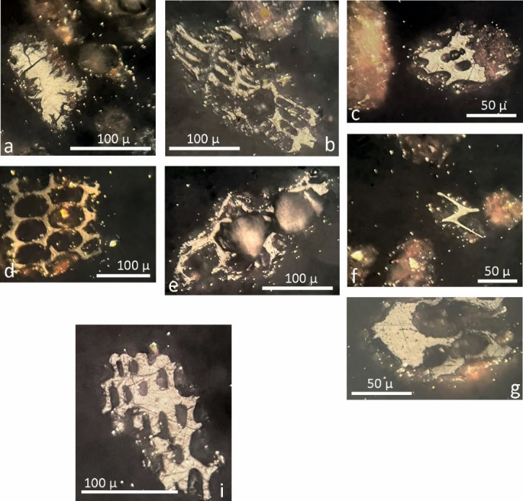
Supplementary Figure 11 Microphotographs of charcoal particles in the cavities of seal bone in sample no. 918 and bear bone in sample no. 12. In microphotographs a), c), e), and g), the maceral semifusinite is visible. Fusinite is present in microphotographs b), d), f), and i).

1.2 Reflectance of Charcoal and Combustion Temperature
In the analyzed samples, the average random reflectance of the inertinite macerals, i.e. semifusinite, fusinite, and inertodetrinite (charcoal) ranges from 0.66 to 1.03 %Rr, with individual measurement values varying from 0.38 to 1.36 %Rr (Tab. 1). The overall average reflectance across all samples is determined to be 0.86 %Rr. The graphs presented in Fig. 2 illustrate the distribution of reflectance measurements across the studied samples.

Tab. 1 Reflectance of macerals (%Rr) (semifuzinite, fusinite, and inertodetrinite) in the studied samples. Values represent the random reflectance. The right side of the table displays the formation temperature, calculated according to McParland et al. (2009a)²¹. It indicates the extent of thermal decomposition of lignocellulosic tissues during combustion.
Reflectance is recorded for randomly oriented particles of charcoal macerals. In certain instances, extreme bireflectance values are observed, attributed to anisotropy^{31,32}. No thermally unaltered plant tissue is detected in the samples.
In the studied samples, the average reflectance of charcoal microparticles, ranging from 0.66-1.03 %Rr, corresponds to an estimated combustion temperature of 380 to 422 °C (Tab. 1, SI Fig. 13), calculated according to McParland et al. (2009a)²¹.

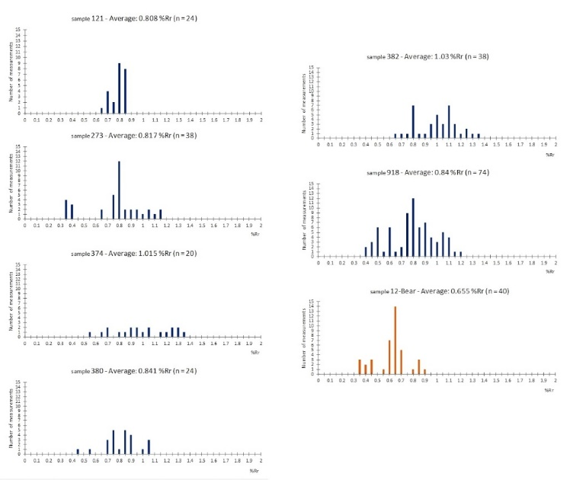
Supplementary Figure 12 Distribution of analyzed random reflectance of inertinite macerals (charcoal) in individual samples.

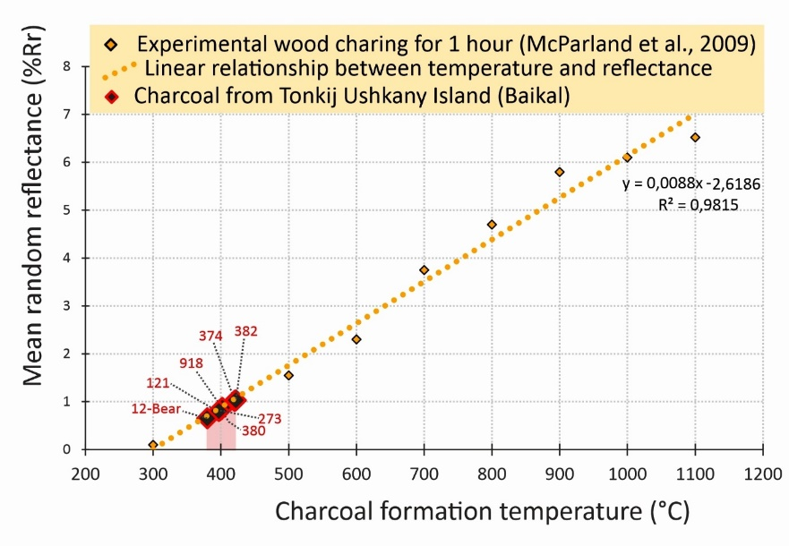
Supplementary Figure 9 The average reflectance of charcoal found in individual animal bones from Tonkij Ushkany Island in Baikal is illustrated in a graph depicting the dependency obtained from experimental wood charring at various temperatures for 1 hour, followed by reflectance analysis²¹. Labelling of samples: 12-Bear, 121, 273, 374, 380, 382, 918.

2 Discussion
In fire research, a standardized protocol for conducting investigations has yet to be universally established³³ and the interpretation of temperature is complex. Nevertheless, temperature data are expected to provide insights that could help characterize specific thermal events and, most importantly, distinguish natural fires from anthropogenic fire-related activities.
The use of charcoal reflectance is expected to provide precise combustion temperature values for phytomass burning, serving as an indicator of the origin and type of fire, including the identification of specific anthropogenic activities. Experimental studies exploring the relationship between burning temperature and charcoal reflectance have consistently produced reliable results, highlighting critical factors that influence the accuracy and interpretation of combustion temperatures12,15,16,17,19,20,21,22,23,24,25,29,34. This method has become an essential tool in paleo-fire research and paleoenvironmental studies^{35,36,37}. However, in archaeological contexts, this technique often results in lower combustion temperatures when compared to other methods, such as bone analysis^{38,39,40,41} or FTIR spectroscopy²⁵.
McParland et al. (2009a)²¹ presented findings that demonstrate how examining the distribution of reflectance values within samples can help determine the origin of charcoal, indicating whether it was produced by natural events or anthropogenic activities. However, increasing evidence and data show that distinguishing between natural and anthropogenic fires remains difficult, as the temperature ranges characteristic of these different thermal events often overlap (SI Fig. 14).
The temperatures of natural fires vary depending on several factors. Fuel type, fuel load, vegetation density, oxygen availability and moisture content all play critical roles in influencing fire behavior and combustion temperatures in natural fires. The vertical distribution of vegetation within ecosystems also determines the available fuel load, affecting the type of fire, its severity, and the resulting combustion temperature.
Ground fires, which burn organic material beneath the litter layer, typically produce temperatures below 300 °C. Surface fires, which consume litter, herbaceous vegetation, and shrubs, generally reach temperatures around 600 °C. Crown fires, burning the canopies of trees and larger shrubs, generate intense heat, with temperatures ranging from 800 °C to 900 °C or higher, particularly in coniferous stands^{28,29,42}. Flame temperatures during the combustion of conifer tree crowns can rise as high as 1300 °C⁴³.

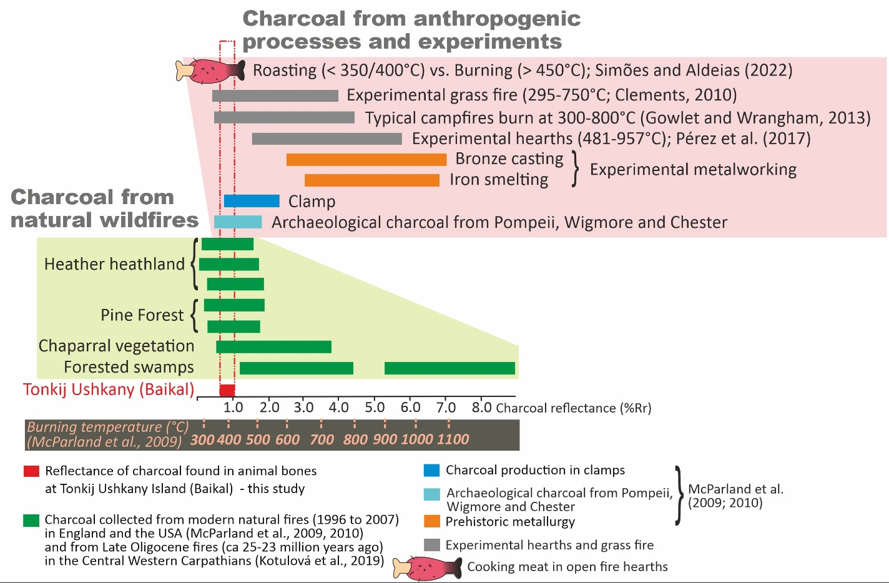
Supplementary Figure 14 Distribution of charcoal reflectance and its formation temperature due to various natural processes and anthropogenic activities.
Pyne et al. (1996)⁴⁴ report that smoldering temperatures in piles of leaf litter are generally lower, around 300 °C, but can rise to as much as 600 °C, persisting for several hours or even days. Wright and Bailey (1982) recorded average surface temperatures in grassfires ranging from 102 °C to 388 °C, with peak surface temperatures reaching up to 682°C. Similarly, Gibson et al. (1990) observed wildfire temperatures in a Kansas tallgrass prairie reaching 399 °C, with the highest temperatures occurring in areas with small woody fuels, such as shrubs and small trees.
During a dense grass fire, the surface temperature ranges from less than 70 °C to over 800 °C, while at a height of 1 meter above the surface, it ranges from 200 °C to 800 °C (Frost and Robertson 1987 and references therein). Grass fires often progress quickly, with high temperatures sustained for only a short duration. As a result, sediments and various other objects lying on the ground (including bones) are not subjected to prolonged heat exposure (Gowlett and Wrangham, 2013)³³. For instance, Clements (2010) documented an experimental grass fire where elevated temperatures lasted approximately three minutes, with combustion zone gases reaching around 750 °C.
Based on reflectance values analyzed from the charcoal assemblage, modern wildfires in heather heathlands and pine forests reached reflectance levels of 0.06 to 1.85 %Rr, indicating temperatures of approximately 300-520 °C²¹, as shown in SI Fig. 14. California's chaparral shrubland is characterized by repeated wildfires within a high-intensity crown-fire regime, where fires consume nearly all above-ground vegetation. Charcoal collected from this environment after the 2007 wildfire revealed reflectance values ranging from 0.56 to 3.8 %Rr, indicating temperatures between 300 °C and 700 °C²¹, (SI Fig. 14).
Research on charcoal and char from the late Jurassic/early Cretaceous lacustrine deposits near Tasgorosay (Kazakhstan) reveals evidence of paleo-fires in a swamp environment³⁶. Reflectance values range from 1.1 to 6.01 %Rr, indicating both flaming and smoldering combustion with temperatures ranging from 465 to 1144 °C (temperatures derived according to Hudspith et al., 2014).
Charcoal found in the deep marine sediment of the Central Carpathian Paleogene Basin, outcropping near the Slovak-Polish border, suggests an onshore forest-swamp type environment that was affected by wildfires during the late Paleogene period (approximately 23-25 million years ago), Kotulová et al. (2019). Reflectance values from 1.2 to 4.4 %Rr suggest charcoal formation temperatures between 370 °C and 705 °C, indicating ground and surface fires, as well as combustion of gelified organic matter in a peat swamp. Random reflectance values ranging from 5.3 to 8.87 %Rr indicate temperatures above 900 °C (SI Fig. 14), which are typical for crown fires, where the fire races through the treetops and generates intense heat⁴⁴.
Research on archaeological materials from sites where charcoal was produced as a result of anthropogenic activity has been exemplified by the works of Veal et al.²⁵ and McParland et al. ^{21,30,34}. In some cases, these data can help distinguish between natural and anthropogenic activities (SI Fig. 14). Archaeological charcoal found in midden material from Pompeii, Wigmore, and Chester exhibits reflectance values in the range of 0.51 to 1.21 %Rr, indicating formation temperatures of 310-530 °C²¹ (SI Fig. 14).
Charcoal produced in a wood charcoal kiln reaches temperatures of approximately 475 °C, while charcoal from metallurgical furnaces indicates significantly higher temperatures, exceeding 1100 °C²¹, SI Fig. 14. Sediments beneath hearths are typically subjected to temperatures ranging from approximately 300° C to 800 °C³³. Experimental hearth studies conducted by Pérez et al. (2017)⁴⁵ recorded temperatures between 481 °C and 957 °C.
Simões and Aldeias (2022)⁴⁶ conducted a combined microstratigraphic and mineralogical analysis of shells to differentiate between temperatures associated with shellfish preparation through roasting at the hearth for consumption and those resulting from exposure to high temperatures generated by the long high-temperature heat of hearth. They found that during the roasting of shellfish, temperatures reached between 350 °C and 400 °C; however, temperatures exceeding 450 °C led to the burning of the shells (SI Fig. 14). This burning occurred after consumption when the shells were subjected to prolonged high temperatures from the hearth.
Reflectance analysis of charcoal micro-particles found in seven seals and one bear bones at Tonkij Ushkany Island (Baikal) yielded values ranging from 0.66 to 1.03 %Rr. This indicates an average combustion temperature of lignocellulosic material between 380 °C and 422°C (SI Fig. 14).
When comparing the results with those published and visualized in SI Fig. 14, several possible scenarios, varying in probability and relevance, can be identified.

- Charcoal may have formed from the combustion of vegetation on the island during a natural fire. The relatively low combustion temperatures indicated by charcoal analysis suggest that the fire involved grasses, shrubs, or possibly sparse tree cover. Fires on the Baikal islands are relatively common, occurring approximately every 25 to 50 years, according to dendrological studies⁴⁷ (Vashukevič et al., 2022). However, many grass fires tend to spread rapidly, achieving high temperatures for only a brief duration. This limited exposure is insufficient to produce the level of thermal alteration in bones observed through Fourier Transform Infrared Spectroscopy (FTIR) and bone analysis.
- The charcoal found in animal bones likely originated from the remnants of a hearth used for roasting meat. This charcoal likely entered the bones after they had been broken. Analyses of certain collected bones confirmed significant thermal alteration, which correlates with the high temperatures typically generated in controlled hearths (SI Fig. 14). It is possible that these bones were thrown into the center of the hearth, where temperatures are elevated. Additionally, they may have been repeatedly exposed to high temperatures during the hearth's repeated use.

- Conclusions
Charcoal found in the bones of seals and a bear at Tonkij Ushkany Island (Baikal) provides valuable insights into the combustion temperatures of wood. This study utilizes reflectance analysis to determine the temperatures at which the charcoal was formed. The formation temperatures of charcoal found in animal bones ranged from 380 to 422 °C, which closely resembles those typically used for cooking over an open fire, reaching maximum temperatures of 350 to 400 °C⁴⁶.
The observed charcoal formation temperatures also fall within the range associated with typical natural grassland fires. While such fires can be intense, they are usually of short duration. Therefore, the significant thermal alterations observed in some bones, and as confirmed by FTIR analysis, are likely not a result of these fire events.
Understanding the origin of the charcoal could help contribute to reconstructing past environmental conditions and human interactions in the area and assist archaeologists by determining whether the charcoal found in bones is a product of natural wildfires or a result of anthropogenic activities.

References
1. Amano, N., Piper, P. J., Hung, H. & Bellwood, P. Introduced Domestic Animals in the Neolithic and Metal Age of the Philippines: Evidence From Nagsabaran, Northern Luzon. J. Isl. Coast. Archaeol. 8, 317–335 (2013).
2. Lyman, R. L. Archaeofaunas and Butchery Studies: A Taphonomic Perspective. Adv. Archaeol. Method Theory 1, 249–337 (1987).
3. Rixson, D. Butchery evidence on animal bones. Circaea 6, 49–62 (1989).
4. Lyman, R. L., Savelle, J. M. & Whitridge, P. Derivation and application of a meat utility index for Phocid Seals. J. Archaeol. Sci. 19, 531–555 (1992).
5. Lyman, R. L. Prehistoric Seal and Sea-Lion Butchering on the Southern Northwest Coast. Am. Antiq. 57, 246–261 (1992).
6. Fernandez-Jalvo, Y. & Andrews, P. Atlas of Taphonomic Identifications: 1001+ Images of Fossil and Recent Mammal Bone Modification. (Springer Netherlands, Dordrecht, 2016).
7. Pastukhov, V. D. & Evsikov, V. I. Nerpa Baĭkala: Biologicheskie Osnovy Rat︠s︡ionalʹnogo Ispolʹzovanii︠a︡ i Okhrany Resursov. (VO ‘Nauka’, Novosibirsk, 1993).
8. Petrov, E. A., Kupchinsky, A. B. & Fialkov, V. A. Summer coastal rookeries and perspectives of the Baikal seal (Pusa sibirica) population in the conditions of the global warming. Biosyst. Divers. 29, 387–392 (2021).
9. Ivanov et al. Experience in application of UAV in ecological studies of the Baikal seal (Pusa sibirica GM.) population at the beginning of shore rookeries formation. Международный Научно-Исследовательский Журнал 5 (2022).
10. Reitz, E. J. & Wing, E. S. Zooarchaeology. Cambridge Manuals in Archaelogy. (Cambridge: Cambridge University Press, 2007).
11. Hudspith V.A., Belcher C.M. and Yearsley J.M. Charring temperatures are driven by the fuel types burned in a peatland wildfire. Front. Plant Sci. 5:714 (2014) doi: 10.3389/fpls.2014.00714
12. Scott, A.C., Glasspool, I.J. Charcoal reflectance as a proxy for the emplacement temperature of pyroclastic flow deposits. Geology 33, 589–592 (2005).
13. Scott, A., Glasspool, I., The diversification of Paleozoic fire systems and fluctuation in atmospheric oxygen concentration. Proc. Nat. Acad. Sci. U. S. A. 103, 10861-10865 (2006)
14. Glasspool, I.J., Scott, A.C. Phanerozoic concentrations of atmospheric oxygen reconstructed from sedimentary charcoal. Nature Geoscience 3, 627–30 (2010)
15. Goodarzi, F., Gentzis, T. The lateral and vertical reflectance and petrological variation of a heat-affected bituminous coal seam from southeastern British Columbia, Canada. Int. J. Coal Geol. 15, 317–339 (1990)
16. Jones, T.P., Scott, A.C., Cope, M. Reflectance measurements and the temperature of formation of modern charcoals and implications for studies of fusain. B. Soc. Geol. Fr. 162, 193–200 (1991)
17. Scott, A.C., Glasspool, I.J. Observations and experiments on the origin and formation of inertinite group macerals. Int. J. Coal Geol. 70, 53–66 (2007)
18. Scott, A.C. Charcoal recognition, taphonomy and uses in palaeoenvironmental analysis. Palaeogeogr. Palaeoclimatol. Palaeoecol. 291, 11–39 (2010)
19. Braadbaart, F., Poole, I. Morphological, chemical and physical changes during charcoalification of wood and its relevance to archaeological contexts. J. Archaeol. Sci. 35 (9), 2434–2445 (2008)
20. Bunt, J.R., Joubert, J.P., Waanders, F.B. Coal char temperature profile estimation using optical reflectance for a commercial-scale Sasol-Lurgi FBDB gasifier. Fuel 87, 2849–2855 (2008)
21. McParland, L.C., Collinson, M.E., Scott, A.C., Campbell, G. The use of reflectance values for the interpretation of natural and anthropogenic charcoal assemblages. Archaeol. Athropol. Sci. 1, 249–261 (2009a)
22. Hudspith, V.A., Belcher, C.M., Kelly, R., Hu, F.S. Charcoal reflectance reveals early Holocene Boreal deciduous forests burned at high intensities. PLoS One 10 (4), e0120835 (2015) https://doi.org/10.1371/journal.pone.0120835.
23. Hudspith, V. A., & Belcher, C. M. Some semifusinite in coal may form during diagenesis, not wildfires. International Journal of Coal Geology, 218, 103360 (2020). https://doi.org/10.1016/j.coal.2019.103360
24. Belcher, C., Hudspith, V.A. The formation of charcoal reflectance and its potential use in post-fire assessments. Int. J. Wildland Fire 25, 775–779 (2016)
25. Veal, R., O'Donnell, L., McParland, L. Reflectance - current state of research and future directions for archaeological charcoal; results from a pilot study on Irish Bronze Age cremation charcoals. J. Archaeol. Sci. 75, 72–81 (2016)
26. Belcher CM, New SL, Santín C, Doerr SH, Dewhirst RA, Grosvenor MJ and Hudspith VAWhat Can Charcoal Reflectance Tell Us About Energy Release in Wildfires and the Properties of Pyrogenic Carbon? Front. Earth Sci. 6:169 (2018) doi:10.3389/feart.2018.00169
27. Scott, A., Jones, T. Fossil charcoal: a plant-fossil record preserved by fire. Geol. Today 7, 214-216 (1991)
28. Scott, A., Jones, T. The nature and influence of fire in Carboniferous ecosystems. Palaeogeogr. Palaeoclimatol. Palaeoecol. 106, 91-112 (1994)
29. Scott, A.C., The Pre-Quaternary history of fire. Palaeogeogr Palaeoclimatol Palaeoecol. 164, 1-4, 281-329 (2000) DOI: 10.1016/S0031-0182(00)00192-9
30. McParland, L. C., Collinson, M. E., Scott, A. C., Campbell, G., & Veal, R. Is vitrification in charcoal a result of high temperature burning of wood? Journal of Archaeological Science 37, 2679-2687 (2010)
31. International Committee for Coal and Organic Petrology (ICCP). The new inertinite classification (ICCP System 1994), reprinted from Fuel 80, 459-471 (2001)
32. Taylor, G.H., Teichmüller, M., Davis, A., Diessel, C.F.K., Littke, R., Robert, P. (Eds) Organic Petrology. Gerbrüder Borntraeger, Berlin, 180. (1998)
33. Gowlett, J. A. J., & Wrangham, R. W. Earliest fire in Africa: towards the convergence of archaeological evidence and the cooking hypothesis. Azania: Archaeological Research in Africa, 48(1), 5–30 (2013). https://doi.org/10.1080/0067270X.2012.756754
34. McParland, L.C., Hazell, Z., Campbell, G., Collinson, M.E., Scott, A.C. How the Romans got themselves into hot water: temperatures and fuel types used in firing a hypocaust Environmental Archaeology, 14 (2009b), pp. 176-183, 10.1179/146141009X12481709928445
35. Kotulová, J., Starek, D., Havelcová, M., & Pálková, H. Amber and organic matter from the late Oligocene deep-water deposits of the Central Western Carpathians (Orava–Podhale Basin). International Journal of Coal Geology, 207, 96-109. (2019) https://doi.org/10.1016/j.coal.2019.02.006
36. Majtaník, M. and Kotulová, J. Insect J3‑K1 assemblage from Tasgorosay in Kazakhstan was dominated by cockroaches. Biologia (2023) 78:1565–1584. https://doi.org/10.1007/s11756-022-01307-0
37. Vršanský, P., Sendi, H., Kotulová, J., Szwedo, J., Havelcová, M., et al. Jurassic Park approached: a coccid from Kimmeridgian cheirolepidiacean Aintourine Lebanese amber. National Science Review, nwae200 (2024) https://doi.org/10.1093/nsr/nwae200
38. Bennett, J. L. Thermal Alteration of Buried Bone. Journal of Archaeological Science, 26(1), 1–8. (1999)doi:10.1006/jasc.1998.0283
39. Asmussen, B.. Intentional or incidental thermal modification? Analysing site occupation via burned bone. J. Archaeol. Sci. 36:528–536 (2009). http://dx.doi.org/10.1016/j.jas.2008.10.005.
40. Devlin, J.B., Herrmann, N.P. Bone colour as an interpretive tool of the depositional history of archaeological cremains. In: Schmidt, C.W., Symes, S.A. (Eds.), The Analysis of Burned Human Remains. Elsevier Academic Press, London, 109-128 (2008)
41. Castillo, R.F., Ubelaker, D.H., Acosta, J.A.L., de la Fuente, G.A.C. Effects of temperature on bone tissue. Histological study of the changes in the bone matrix. Forensic Sci. Int. 226:33–37 (2013) http://dx.doi.org/10.1016/j.forsciint.2012.11.012
42. Petersen, H.I, Lindström, S. Synchronous Wildfire Activity Rise and Mire Deforestation at the Triassic–Jurassic Boundary. PLoS ONE, 7(10): e 7236 (2012)
43. Kvarčák, M. Basics of fire protection. 1st ed. Association of Fire and Safety Engineering., Ostrava, 134 s. ISBN 80-86634-76-0 (2005) (In Czech)
44. Pyne, S.J., Andrews, P.L., Laven, R.D., Introduction to Wildland Fire. J. Wiley & Sons, New York, 769 (1996)
45. Pérez, L., Sanchis, A., Hernández, C. M., Galván, B., Sala, R., & Mallol, C. Hearths and bones: An experimental study to explore temporality in archaeological contexts based on taphonomical changes in burnt bones. Journal of Archaeological Science: Reports, 11, 287–309 (2017). doi:10.1016/j.jasrep.2016.11.036
46. Simões C.D. and Aldeias V. Thermo-microstratigraphy of shells reveals invisible fire use and possible cooking in the archaeological record. Front. Earth Sci. 10:869487 (2022), doi: 10.3389/feart.2022.869487
47. Vashukevič N.V. Timoshkin O.A., Samsonov D.P., Kulikova N.N., Levasheva, M.B., Post-pyrogenic soil transformation II: The problem of eutrophication in the coastal zone of Lake Baikal. In: Soils as a strategic resource of Russia. VIII Congress. Soil Science Society named after V.V. Dokuchaeva (Syktyvkar, 2020-2022); (Eds. S.A. Shoba, I.Yu. Savin), Moskva-Syktyvkar, 149-151 (2021) (in Russian)

