Supplementary materials
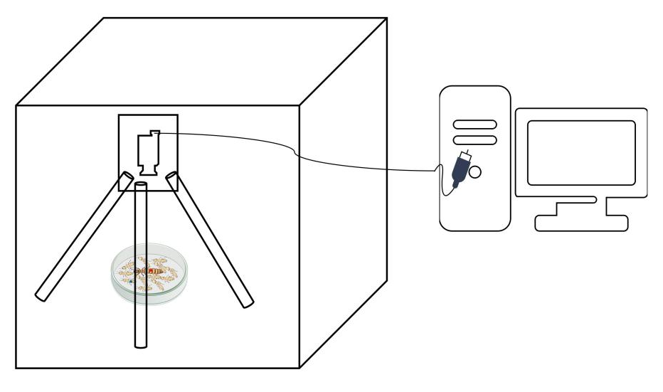
Figure S1. Experimental setup for high-resolution behavioral tracking of termite movement. The recording system consisted of a digital camera mounted above a Petri dish arena inside a controlled observation chamber. The camera was fixed on a tripod stand and connected to a computer for continuous image acquisition and storage.

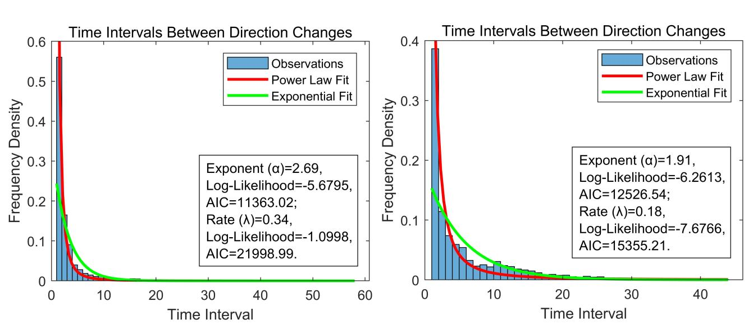
Figure S2. Distributions of time intervals between directional changes in queens and workers. Frequency distributions of turning intervals (blue histograms) for queens (left) and workers (right) fitted with power-law (red lines) and exponential (green lines) models. The power-law model provided a substantially better fit (lower AIC values) than the exponential alternative for both castes, indicating scale-free temporal structure in directional reorientation. Estimated exponents were used to parameterize the agent-based simulations shown in Figure 6, capturing caste-specific turning dynamics that underlie differences in Lévy-like movement.
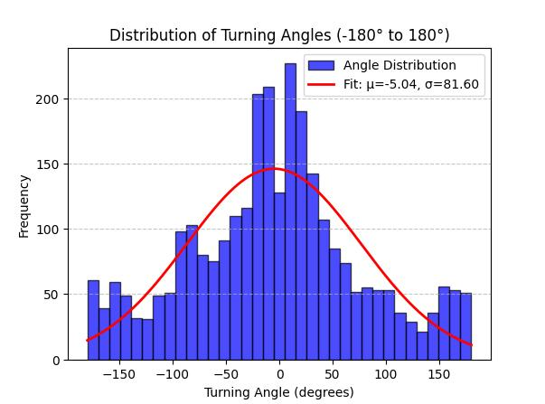
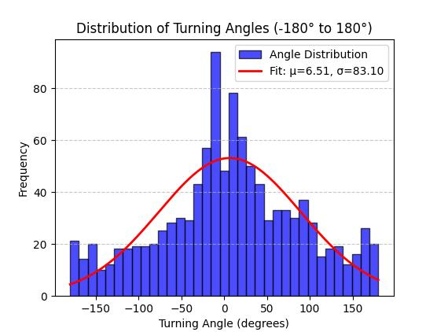
Figure S3. Distributions of turning angles in queens and workers. Frequency distributions of turning angles (blue bars) for queens (left) and workers (right), with fitted normal curves shown in red. Turning angles were approximately normally distributed in both castes, indicating predominantly forward-directed movement with occasional wide reorientations.

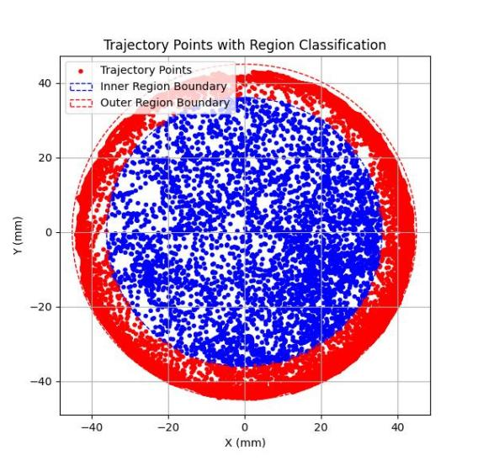
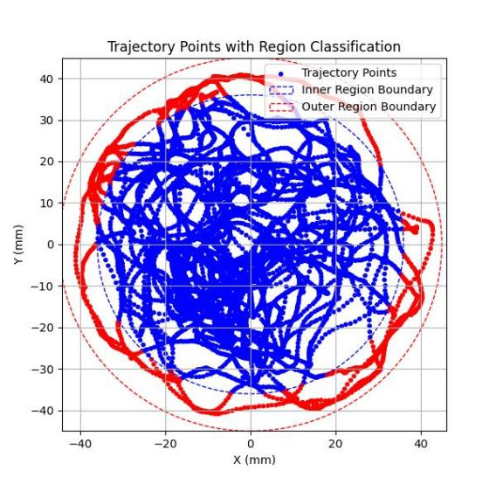
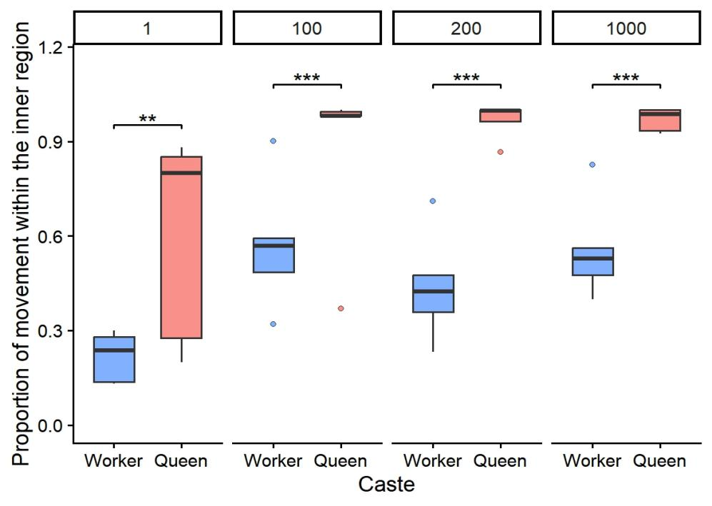
(A)
(B)
(C)
Figure S4. Movement allocation of queens and workers within the arena. (A–B) Representative trajectory maps showing spatial occupancy of queens (A) and workers (B) within a circular arena. Blue and red dots represent trajectory points, while blue and red circles indicate the boundaries of the inner and outer regions used for spatial classification. Queens primarily concentrated their movements in the central area, whereas workers exhibited strong edge-oriented exploration. (C) Proportion of movement occurring within the inner region for queens (red) and workers (blue) across four group sizes (1, 100, 200, and 1,000 individuals). Workers consistently spent less time in the inner region than queens. Boxplots show the median (horizontal line), interquartile range (box), and outliers (points). Asterisks indicate significance levels: p < 0.01 (“**”), and p < 0.001 (“***”).
.

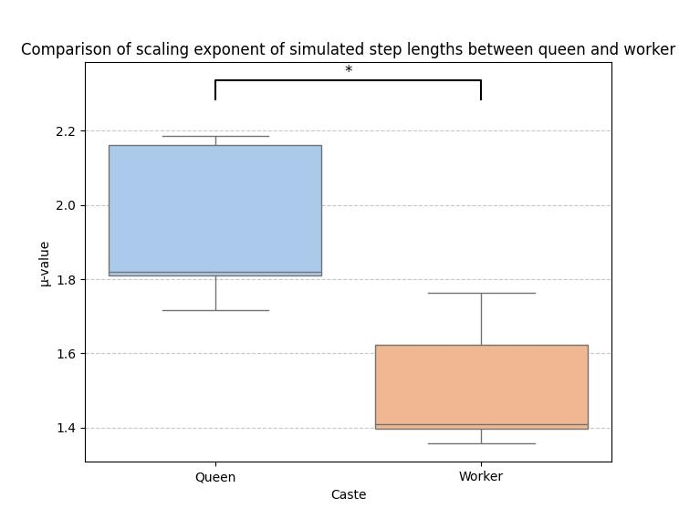
Figure S5. Comparison of scaling exponents (μ) of simulated step-length distributions between queens and workers. Boxplots show the scaling exponents derived from truncated power-law fits to simulated step-length distributions of queens and workers generated under caste-specific turning dynamics. Queens exhibited significantly higher μ-values than workers (t₍₈₎ = 3.43, p = 0.0096). Boxplots represent the median (horizontal line), interquartile range (box), and range excluding outliers (whiskers); * indicates p < 0.05.
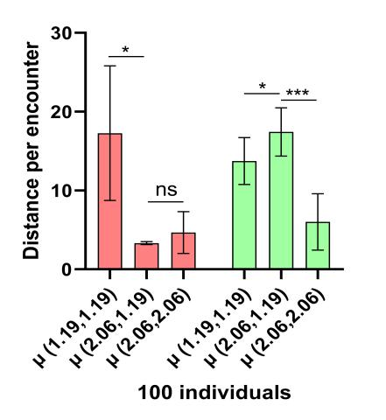
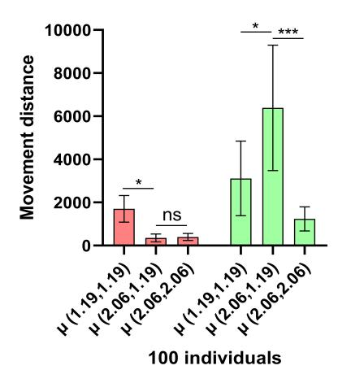
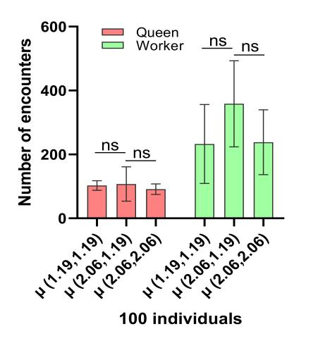
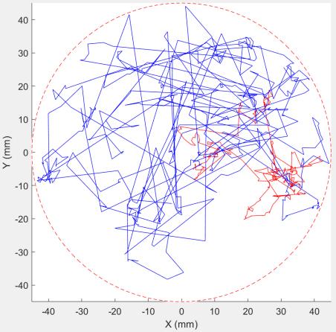
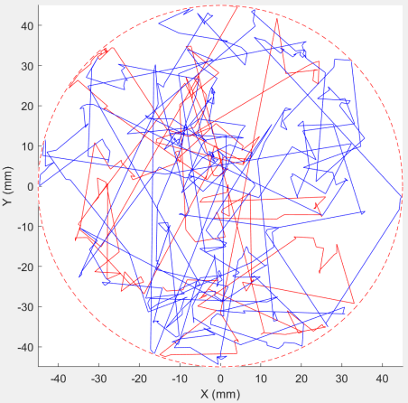
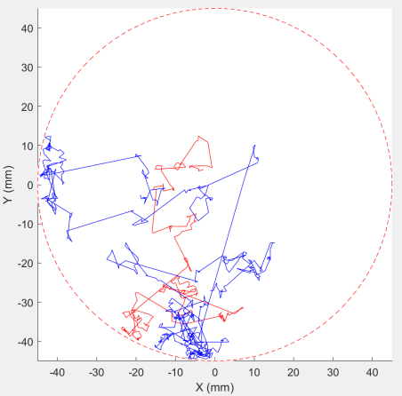
Figure S6. Simulation of encounter efficiency under exchanged scaling exponents between queens and workers. (A–C) Representative simulated trajectories of queens (red) and workers (blue) in 100-individual groups under three conditions: (A) each caste following its own empirically derived scaling exponent (queen μ = 2.06, worker μ = 1.19); (B) both castes adopting the worker’s scaling exponent; and (C) both adopting the queen’s scaling exponent. (D–F) Quantitative comparisons of the number of encounters (D), total movement distance (E), and mean distance per encounter (F) under the three simulation conditions. Workers exhibited significantly reduced encounter frequency, movement distance, and per-encounter distance when adopting the queen’s scaling exponent, whereas queen performance was largely unaffected by exponent exchange. Error bars represent standard error of the mean (SEM). Asterisks indicate significance levels from post hoc t-tests (p < 0.05; *p < 0.01; **p < 0.001; ns, not significant).
(A)
(F)
(E)
(D)
(C)
(B)

Caste | Group Size | mu | TP GOF | E GOF | TP LLH | E LLH | TP AIC | E AIC | TP wAIC
Queen-1-1 | 1 individual | 1.084 | 0.0885 | 0.244 | -1260.7398 | -1373.6434 | 2523.4796 | 2749.2868 | 1
Queen-1-2 | 1 individual | 1.373 | 0.1012 | 0.237 | -869.0098 | -933.9717 | 1740.0196 | 1869.9434 | 1
Queen-1-3 | 1 individual | 1.527 | 0.1219 | 0.3438 | -726.4924 | -847.4347 | 1454.9848 | 1696.8694 | 1
Queen-1-4 | 1 individual | 1.217 | 0.0829 | 0.2293 | -1013.5554 | -1077.5456 | 2029.1108 | 2157.0912 | 1
Queen-1-5 | 1 individual | 1.048 | 0.0719 | 0.2262 | -1637.2579 | -1751.1292 | 3276.5158 | 3504.2584 | 1
Queen-100-1 | 100 individuals | 1.923 | 0.221 | 0.3369 | -480.7513 | -539.3989 | 963.5026 | 1080.7978 | 1
Queen-100-2 | 100 individuals | 2.062 | 0.1856 | 0.268 | -209.5853 | -225.2702 | 421.1706 | 452.5404 | 1
Queen-100-3 | 100 individuals | 2.013 | 0.2044 | 0.3285 | -364.9273 | -446.4788 | 731.8546 | 894.9576 | 1
Queen-100-4 | 100 individuals | 1.705 | 0.1455 | 0.226 | -558.703 | -591.0659 | 1119.406 | 1184.1318 | 1
Queen-100-5 | 100 individuals | 1.525 | 0.15 | 0.2 | -242.4564 | -245.0516 | 486.9128 | 492.1032 | 1
Queen-200-1 | 200 individuals | 2.019 | 0.1916 | 0.2814 | -406.0337 | -419.526 | 814.0674 | 841.052 | 1
Queen-200-2 | 200 individuals | 1.713 | 0.1544 | 0.2842 | -487.8788 | -561.3581 | 977.7576 | 1124.7162 | 1
Queen-200-3 | 200 individuals | 2.185 | 0.2208 | 0.3201 | -406.278 | -445.2281 | 814.556 | 892.4562 | 1
Queen-200-4 | 200 individuals | 1.895 | 0.1728 | 0.251 | -296.2 | -312.8398 | 594.4 | 627.6796 | 1
Queen-200-5 | 200 individuals | 2.531 | 0.3007 | 0.3791 | -65.0721 | -73.8578 | 132.1442 | 149.7156 | 1
Queen-1000-1 | 1000 individuals | 2.326 | 0.2341 | 0.3315 | -442.6369 | -482.55 | 887.2738 | 967.1 | 1
Queen-1000-2 | 1000 individuals | 2.472 | 0.2158 | 0.3162 | -377.4136 | -435.068 | 756.8272 | 872.136 | 1
Queen-1000-3 | 1000 individuals | 2.388 | 0.2467 | 0.3341 | -314.287 | -340.9817 | 630.574 | 683.9634 | 1
Queen-1000-4 | 1000 individuals | 2.401 | 0.2249 | 0.301 | -202.1567 | -215.3086 | 406.3134 | 432.6172 | 1
Queen-1000-5 | 1000 individuals | 2.006 | 0.1833 | 0.2668 | -512.0735 | -528.0819 | 1026.147 | 1058.1638 | 1
Worker-1-1 | 1 individual | 1 | 0.0865 | 0.1958 | -2257.2507 | -2359.3017 | 4516.5014 | 4720.6034 | 1
Worker-1-2 | 1 individual | 1.184 | 0.0998 | 0.3161 | -1871.1985 | -2187.1972 | 3744.397 | 4376.3944 | 1
Worker-1-3 | 1 individual | 1.349 | 0.0968 | 0.2292 | -1540.5812 | -1636.7712 | 3083.1624 | 3275.5424 | 1
Worker-1-4 | 1 individual | 1.12 | 0.0652 | 0.2159 | -1611.6381 | -1709.1666 | 3225.2762 | 3420.3332 | 1
Worker-1-5 | 1 individual | 1.327 | 0.1034 | 0.3534 | -1493.3187 | -1793.6966 | 2988.6374 | 3589.3932 | 1
Worker-100-1 | 100 individuals | 1 | 0.0941 | 0.1843 | -3428.8065 | -3525.2937 | 6859.613 | 7052.5874 | 1
Worker-100-2 | 100 individuals | 1.237 | 0.0813 | 0.2512 | -2423.256 | -2640.4278 | 4848.512 | 5282.8556 | 1
Worker-100-3 | 100 individuals | 1.411 | 0.1362 | 0.2646 | -607.0921 | -666.6203 | 1216.1842 | 1335.2406 | 1
Worker-100-4 | 100 individuals | 1.185 | 0.1026 | 0.203 | -2682.1372 | -2841.8213 | 5366.2744 | 5685.6426 | 1
Worker-100-5 | 100 individuals | 1.191 | 0.0855 | 0.2112 | -1685.5618 | -1797.8568 | 3373.1236 | 3597.7136 | 1
Worker-200-1 | 200 individuals | 1.485 | 0.1111 | 0.2249 | -877.5945 | -954.6042 | 1757.189 | 1911.2084 | 1
Worker-200-2 | 200 individuals | 1.278 | 0.1026 | 0.1624 | -729.8076 | -749.9136 | 1461.6152 | 1501.8272 | 1
Worker-200-3 | 200 individuals | 1.651 | 0.1446 | 0.261 | -481.5653 | -529.2718 | 965.1306 | 1060.5436 | 1
Worker-200-4 | 200 individuals | 1.905 | 0.1905 | 0.3036 | -238.4419 | -280.2963 | 478.8838 | 562.5926 | 1
Worker-200-5 | 200 individuals | 2.059 | 0.2262 | 0.369 | -106.0968 | -139.8904 | 214.1936 | 281.7808 | 1
Worker-1000-1 | 1000 individuals | 1.859 | 0.1629 | 0.2429 | -509.6552 | -542.0803 | 1021.3104 | 1086.1606 | 1
Worker-1000-2 | 1000 individuals | 1.733 | 0.1784 | 0.3112 | -423.44 | -494.9799 | 848.88 | 991.9598 | 1
Worker-1000-3 | 1000 individuals | 1.762 | 0.1493 | 0.2376 | -1018.6499 | -1079.688 | 2039.2998 | 2161.376 | 1
Worker-1000-4 | 1000 individuals | 1.632 | 0.1326 | 0.2161 | -1312.182 | -1384.0094 | 2626.364 | 2770.0188 | 1
Worker-1000-5 | 1000 individuals | 1.637 | 0.146 | 0.249 | -1366.1614 | -1467.5207 | 2734.3228 | 2937.0414 | 1
Table S1. Model comparison of truncated power-law and exponential distributions fitted to the cumulative frequency distributions of step lengths across all samples.
The table summarizes maximum-likelihood parameter estimates, goodness-of-fit (GOF) statistics, log-likelihood (LLH) values, Akaike information criterion (AIC) scores, and Akaike weights for the two competing models. For each sample, the truncated power-law consistently provided a better fit than the exponential distribution, as indicated by lower AIC values and higher Akaike weights. Sample labels (e.g., Queen-1-1, Queen-100-1, Queen-200-1, Queen-1000-1) denote queens tested in groups of 1, 100, 200, or 1,000 individuals, respectively; the same convention applies to worker samples.
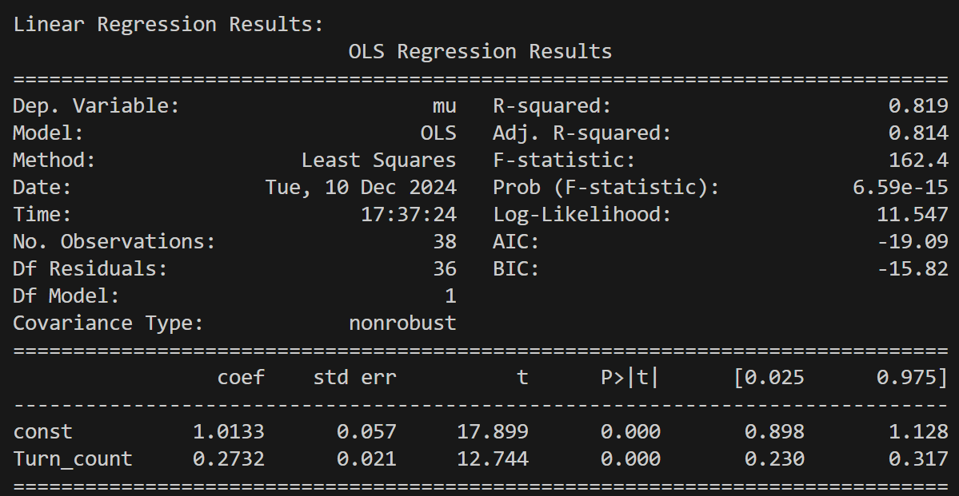

Table S2. Results of linear regression analysis examining the relationship between turning frequency and scaling exponent (μ) of step-length distributions. Turning frequency was a significant positive predictor of μ (t = 12.74, p < 0.0001), explaining approximately 81.9% of the variance in scaling exponent values (Adjusted R² = 0.814).
Movie S1. Agent-based simulation illustrating caste-specific Lévy-like movement patterns in termites. Visualization of an agent-based model showing how caste-specific turning rules during social encounters generate distinct Lévy-like movement patterns. The simulation arena (9 cm in diameter) contains 100 mobile agents represented as solid spheres moving in continuous space. The red sphere denotes the queen (4 mm diameter), and the blue spheres denote workers (2 mm diameter). Each agent moves with a fixed probability per time step (0.3 for the queen, 0.6 for workers), matching empirically measured activity levels. Turning intervals follow truncated power-law distributions (β = 2.7 for the queen; β = 2.0 for workers), and turning angles are normally distributed. Directional updates occur upon social encounters when the elapsed time since the last turn exceeds the sampled interval. The simulation runs for 2,000 time steps, illustrating more localized motion in the queen and Lévy-like displacements in workers. Playback speed is 10× real time.

