Table S1 ICD-9 and ICD-10 Codes Used for the Diagnosis of Cardiac Arrest
icd_code | icd_version | long_title
4275 | 9 | Cardiac arrest
I469 | 10 | Cardiac arrest, cause unspecified
I462 | 10 | Cardiac arrest due to underlying cardiac condition
I468 | 10 | Cardiac arrest due to other underlying condition
I97711 | 10 | Intraoperative cardiac arrest during other surgery
I97710 | 10 | Intraoperative cardiac arrest during cardiac surgery
I97121 | 10 | Postprocedural cardiac arrest following other surgery
I97120 | 10 | Postprocedural cardiac arrest following cardiac surgery

Table S2 Missing Number (%) for Included Variables in Dataset
variables | MIMIC Database Missing (%) | NWICU Database Missing (%)
Weight (kg) | 12(0.39%) | 880(47.59%)
HR (bpm) | 0(0%) | 660(35.69%)
SBP (mmHg) | 22(0.72%) | 671(36.29%)
DBP (mmHg) | 22(0.72%) | 671(36.29%)
RR (bpm) | 3(0.1%) | 664(35.91%)
SpO2 (%) | 0(0%) | 663(35.86%)
Temperature (°C) | 12(0.39%) | 665(35.97%)
WBC (K/uL) | 9(0.29%) | 16(0.87%)
RBC (m/uL) | 9(0.29%) | 34(1.84%)
PLT (K/uL) | 12(0.39%) | 17(0.92%)
Hb (g/dL) | 9(0.29%) | 38(2.06%)
RDW (%) | 10(0.33%) | 19(1.03%)
Hct (%) | 9(0.29%) | 40(2.16%)
Sodium (mEq/L) | 0(0%) | 7(0.38%)
Potassium (mEq/L) | 2(0.07%) | 19(1.03%)
Total Calcium (mg/dL) | 171(5.59%) | 7(0.38%)
Chloride (mEq/L) | 0(0%) | 4(0.22%)
Phosphorus (mg/dL) | 171(5.59%) | 1167(63.12%)
Magnesium (mg/dL) | 166(5.43%) | 562(30.39%)
PT (sec) | 255(8.34%) | 536(28.99%)
PTT (sec) | 261(8.53%) | 833(45.05%)
LDL-C (mg/dL) | 74(2.42%) | 0(0%)
Total Bilirubin (mg/dL) | 794(25.96%) | 425(22.99%)
ALT (IU/L) | 733(23.96%) | 1021(55.22%)
AST (IU/L) | 717(23.44%) | 443(23.96%)
BUN (mg/dL) | 1(0.03%) | 7(0.38%)
Creatinine (mg/dL) | 0(0%) | 4(0.22%)
CK (IU/L) | 1068(34.91%) | 1664(89.99%)
Notes: In the NWICU validation cohort, variables with missing data exceeding 50% were not included in the final covariate-adjusted model. However, these variables are retained in the table for completeness. Additionally, the height variable was excluded from both databases, as the proportion of missing data exceeded 50% in both the MIMIC and NWICU databases.
Abbreviations: WBC, white blood cell; PLT, platelet count; RDW, red cell distribution width; BUN, blood urea nitrogen; PT, prothrombin time; PTT, partial thromboplastin time; HDL-C, high-density lipoprotein cholesterol; LDL-C, low-density lipoprotein cholesterol; ALT, alanine aminotransferase; AST, aspartate aminotransferase; HR, heart rate; SBP, systolic blood pressure; DBP, diastolic blood pressure; SpO₂, pulse oxygen saturation; Hb, hemoglobin; CK, creatine kinase; HbA1c, glycated hemoglobin.

Table S3 Baseline Characteristics of Patients Stratified by the Presence or Absence of AKI
Variables | MIMIC (n=3059) |  | P |  | NWICU (n=1849) |  | P
Variables | No AKI (n = 846) | AKI (n = 2213) | P |  | No AKI (n = 1736) | AKI (n = 113) | P
Baseline characteristics
Age (years) | 68.000 (57.000, 81.000) | 71.000 (61.000, 82.000) | <0.001 |  | 66.000 (56.000, 76.000) | 67.000 (53.000, 75.000) | 0.53
Weight (kg) | 74.500 (62.713, 88.000) | 80.150 (67.500, 95.200) | <0.001 |  | 80.990 (67.220, 98.520) | 83.530 (68.480, 102.230) | 0.451
Gender |  |  | <0.001 |  |  |  | 0.064
Female | 436 (51.537%) | 962 (43.470%) |  |  | 722 (41.590%) | 37 (32.743%)
Male | 410 (48.463%) | 1251 (56.530%) |  |  | 1014 (58.410%) | 76 (67.257%)
Race |  |  | 0.031 |  |  |  | 0.035
Other | 340 (40.189%) | 985 (44.510%) |  |  | 584 (33.641%) | 49 (43.363%)
White | 506 (59.811%) | 1228 (55.490%) |  |  | 1152 (66.359%) | 64 (56.637%)
Comorbidities
Diabetes |  |  | <0.001 |  |  |  | <0.001
No | 643 (76.005%) | 1519 (68.640%) |  |  | 1555 (89.574%) | 88 (77.876%)
Yes | 203 (23.995%) | 694 (31.360%) |  |  | 181 (10.426%) | 25 (22.124%)
Heart failure |  |  | <0.001 |  |  |  | <0.001
No | 727 (85.934%) | 1576 (71.216%) |  |  | 1615 (93.030%) | 88 (77.876%)
Yes | 119 (14.066%) | 637 (28.784%) |  |  | 121 (6.970%) | 25 (22.124%)
Hypertension |  |  | 0.707 |  |  |  | 0.19
No | 382 (45.154%) | 1016 (45.911%) |  |  | 1436 (82.719%) | 88 (77.876%)
Yes | 464 (54.846%) | 1197 (54.089%) |  |  | 300 (17.281%) | 25 (22.124%)
Sepsis |  |  | <0.001 |  |  |  | <0.001
No | 736 (86.998%) | 1371 (61.952%) |  |  | 1709 (98.445%) | 95 (84.071%)
Yes | 110 (13.002%) | 842 (38.048%) |  |  | 27 (1.555%) | 18 (15.929%)
Vital signs
HR (bpm) | 77.000 (67.000, 90.000) | 81.000 (70.000, 94.000) | <0.001 |  | 80.000 (70.000, 97.000) | 81.000 (71.000, 99.000) | 0.508
SBP (mmHg) | 136.000 (121.000, 153.000) | 136.000 (119.000, 152.000) | 0.323 |  | 141.000 (124.000, 159.000) | 148.000 (125.000, 167.000) | 0.253
DBP (mmHg) | 76.000 (66.000, 89.000) | 76.000 (66.000, 89.000) | 0.733 |  | 76.000 (66.000, 88.000) | 75.000 (65.000, 87.000) | 0.349
RR (bpm) | 18.000 (15.000, 21.000) | 18.000 (16.000, 22.000) | 0.001 |  | 20.000 (17.000, 24.000) | 20.000 (17.000, 25.000) | 0.15
SpO2 (%) | 98.000 (96.000, 99.000) | 98.000 (95.000, 100.000) | 0.437 |  | 97.000 (95.000, 99.000) | 97.000 (96.000, 99.000) | 0.944
Temperature (°C) | 36.780 (36.560, 37.000) | 36.780 (36.560, 37.060) | 0.045 |  | 36.722 (36.500, 37.000) | 36.722 (36.444, 36.944) | 0.333
Laboratory tests
SHR | 0.950 (0.840, 1.108) | 1.036 (0.890, 1.227) | <0.001 |  | 1.086 (0.911, 1.296) | 1.356 (0.991, 1.720) | <0.001
TYG | 8.638 (8.292, 9.090) | 8.797 (8.403, 9.239) | <0.001 |  | 8.864 (8.417, 9.370) | 9.225 (8.622, 9.809) | <0.001
CHG | 5.240 (4.974, 5.592) | 5.389 (5.083, 5.718) | <0.001 |  | 5.499 (5.154, 5.909) | 5.835 (5.338, 6.481) | <0.001
Glu (mg/dL) | 113.000 (97.500, 138.000) | 127.000 (106.000, 157.500) | <0.001 |  | 132.000 (108.000, 175.000) | 175.000 (118.000, 304.000) | <0.001
HbA1c (%) | 5.700 (5.400, 6.100) | 5.800 (5.400, 6.400) | <0.001 |  | 5.800 (5.500, 6.600) | 6.200 (5.500, 8.300) | 0.006
TG (mg/dL) | 98.000 (71.000, 142.000) | 101.000 (74.000, 141.000) | 0.181 |  | 102.500 (73.000, 148.000) | 118.000 (77.000, 171.000) | 0.036
TC (mg/dL) | 166.000 (137.250, 196.000) | 158.000 (127.000, 189.000) | <0.001 |  | 155.000 (127.000, 189.000) | 132.000 (108.000, 178.000) | <0.001
HDL-C (mg/dL) | 48.000 (39.000, 61.000) | 45.000 (37.000, 57.000) | <0.001 |  | 42.000 (34.000, 53.000) | 37.000 (29.000, 46.000) | <0.001
LDL-C (mg/dL) | 90.000 (66.000, 116.000) | 85.000 (61.000, 112.000) | <0.001 |  | 86.000 (62.000, 115.000) | 66.000 (43.000, 112.000) | 0.001
WBC (K/uL) | 9.000 (6.950, 11.450) | 10.200 (7.900, 13.000) | <0.001 |  | 9.300 (7.300, 12.100) | 10.600 (8.000, 14.700) | <0.001
RBC (m/uL) | 4.150 (3.750, 4.547) | 4.090 (3.630, 4.550) | 0.03 |  | 4.480 (3.820, 4.980) | 3.950 (3.190, 4.870) | <0.001
PLT (K/uL) | 212.250 (174.000, 263.000) | 211.000 (168.000, 259.500) | 0.216 |  | 232.500 (188.000, 285.000) | 243.000 (185.000, 295.000) | 0.512
Hb (g/dL) | 12.500 (11.200, 13.600) | 12.350 (10.900, 13.700) | 0.135 |  | 13.700 (12.200, 14.900) | 12.600 (10.300, 14.500) | <0.001
RDW (%) | 13.500 (12.900, 14.300) | 13.770 (13.100, 14.700) | <0.001 |  | 13.400 (12.900, 14.400) | 14.000 (13.000, 15.300) | 0.002
Hct (%) | 37.775 (34.300, 40.588) | 37.350 (33.150, 41.100) | 0.18 |  | 41.300 (37.075, 45.000) | 38.300 (32.700, 44.200) | <0.001
Sodium (mEq/L) | 139.000 (137.000, 141.150) | 139.000 (137.000, 141.500) | 0.682 |  | 138.000 (136.000, 140.000) | 136.000 (132.000, 140.000) | <0.001
Potassium (mEq/L) | 4.000 (3.750, 4.300) | 4.000 (3.730, 4.300) | 0.596 |  | 4.000 (3.700, 4.300) | 4.300 (3.900, 5.100) | <0.001
Total Calcium (mg/dL) | 8.900 (8.535, 9.200) | 8.700 (8.350, 9.100) | <0.001 |  | 9.100 (8.700, 9.500) | 8.900 (8.200, 9.400) | 0.002
Chloride (mEq/L) | 104.000 (102.000, 106.500) | 104.000 (101.000, 106.500) | 0.055 |  | 104.000 (101.000, 106.000) | 102.000 (96.000, 105.000) | <0.001
Phosphorus (mg/dL) | 3.300 (2.900, 3.700) | 3.350 (2.900, 3.870) | <0.001 |  | 3.200 (2.600, 3.800) | 3.900 (3.000, 4.800) | <0.001
Magnesium (mg/dL) | 2.000 (1.800, 2.100) | 2.000 (1.850, 2.100) | 0.227 |  | 1.900 (1.800, 2.100) | 2.100 (1.900, 2.400) | <0.001
PT (sec) | 12.300 (11.500, 13.300) | 12.700 (11.800, 14.100) | <0.001 |  | 12.200 (11.300, 13.500) | 12.800 (11.500, 15.200) | 0.005
PTT (sec) | 29.400 (26.700, 33.400) | 29.600 (26.800, 37.340) | 0.04 |  | 30.000 (27.300, 33.500) | 29.900 (26.800, 34.100) | 0.948
CK (IU/L) | 119.000 (68.000, 288.000) | 151.000 (77.500, 416.000) | <0.001 |  | 129.000 (71.000, 372.000) | 267.000 (73.000, 882.000) | 0.002
Total Bilirubin (mg/dL) | 0.500 (0.400, 0.800) | 0.600 (0.400, 0.800) | <0.001 |  | 0.600 (0.400, 0.800) | 0.600 (0.400, 1.100) | 0.03
ALT (IU/L) | 20.000 (13.000, 31.000) | 20.000 (14.000, 35.000) | 0.034 |  | 23.500 (15.000, 35.000) | 29.000 (18.000, 52.000) | <0.001
AST (IU/L) | 23.000 (17.000, 37.000) | 27.000 (19.000, 47.000) | <0.001 |  | 23.000 (17.000, 35.250) | 28.000 (18.000, 108.000) | <0.001
BUN (mg/dL) | 15.000 (12.000, 19.657) | 17.000 (12.670, 24.500) | <0.001 |  | 17.000 (13.000, 23.000) | 36.000 (24.000, 55.000) | <0.001
Creatinine (mg/dL) | 0.800 (0.700, 1.000) | 0.930 (0.750, 1.220) | <0.001 |  | 1.000 (0.800, 1.240) | 1.900 (1.400, 3.220) | <0.001
length of hospitalization (day) | 3.995 (2.590, 6.912) | 7.680 (4.490, 13.840) | <0.001 |  | 3.985 (2.130, 7.812) | 6.910 (3.840, 13.720) | <0.001
length of ICU (day) | 1.800 (1.290, 2.638) | 3.710 (2.070, 6.680) | <0.001 |  | 1.890 (1.160, 3.243) | 2.890 (1.690, 4.880) | <0.001
Notes: Data were presented as median (Q1, Q3), or n (%).
Abbreviations: AKI, acute kidney injury; HR, heart rate; SBP, systolic blood pressure; DBP, diastolic blood pressure; SpO₂, pulse oxygen saturation; WBC, white blood cell; PLT, platelet count; RDW, red cell distribution width; Hb, hemoglobin; Hct, hematocrit; BUN, blood urea nitrogen; PT, prothrombin time; PTT, partial thromboplastin time; TG, triglycerides; TC, total cholesterol; HDL-C, high-density lipoprotein cholesterol; Glu, glucose; LDL-C, low-density lipoprotein cholesterol; ALT, alanine aminotransferase; AST, aspartate aminotransferase; CK, creatine kinase; HbA1c, glycated hemoglobin; ICU, intensive care unit; TYG, triglyceride-glucose index; CHG, cholesterol-glucose index; SHR, stress hyperglycemia ratio.

Table S4 Baseline Characteristics of Patients Stratified by the Presence or Absence of Sepsis
Variables |  | MIMIC(n=3059) |  |  |  | P | NWICU (n=1849) |  |  |  | P
 |  | No Sepsis (n = 2107) |  | Sepsis (n = 952) |  | P | No Sepsis (n = 1804) |  | Sepsis (n = 45) |  | P
Baseline characteristics
Age (years) |  | 70.000 (59.000, 81.000) |  | 71.000 (61.000, 82.000) |  | 0.039 | 66.000 (56.000, 76.000) |  | 66.000 (54.000, 75.000) |  | 0.735
Weight (kg) |  | 78.900 (66.000, 93.950) |  | 78.000 (65.300, 93.608) |  | 0.52 | 80.990 (67.360, 98.520) |  | 82.960 (65.220, 109.310) |  | 0.908
Gender |  |  |  |  |  | 0.587 |  |  |  |  | 0.09
Female |  | 956 (45.373%) |  | 442 (46.429%) |  |  | 735 (40.743%) |  | 24 (53.333%)
Male |  | 1151 (54.627%) |  | 510 (53.571%) |  |  | 1069 (59.257%) |  | 21 (46.667%)
Race |  |  |  |  |  | <0.001 |  |  |  |  | 0.409
Other |  | 860 (40.816%) |  | 465 (48.845%) |  |  | 615 (34.091%) |  | 18 (40.000%)
White |  | 1247 (59.184%) |  | 487 (51.155%) |  |  | 1189 (65.909%) |  | 27 (60.000%)
Comorbidities
Diabetes |  |  |  |  |  | 0.041 |  |  |  |  | <0.001
No |  | 1513 (71.808%) |  | 649 (68.172%) |  |  | 1610 (89.246%) |  | 33 (73.333%)
Yes |  | 594 (28.192%) |  | 303 (31.828%) |  |  | 194 (10.754%) |  | 12 (26.667%)
Heart failure |  |  |  |  |  | <0.001 |  |  |  |  | 0.006
No |  | 1694 (80.399%) |  | 609 (63.971%) |  |  | 1667 (92.406%) |  | 36 (80.000%)
Yes |  | 413 (19.601%) |  | 343 (36.029%) |  |  | 137 (7.594%) |  | 9 (20.000%)
Hypertension |  |  |  |  |  | <0.001 |  |  |  |  | 0.971
No |  | 897 (42.572%) |  | 501 (52.626%) |  |  | 1487 (82.428%) |  | 37 (82.222%)
Yes |  | 1210 (57.428%) |  | 451 (47.374%) |  |  | 317 (17.572%) |  | 8 (17.778%)
AKI |  |  |  |  |  | <0.001 |  |  |  |  | <0.001
No |  | 736 (34.931%) |  | 110 (11.555%) |  |  | 1709 (94.734%) |  | 27 (60.000%)
Yes |  | 1371 (65.069%) |  | 842 (88.445%) |  |  | 95 (5.266%) |  | 18 (40.000%)
Vital signs
HR (bpm) |  | 79.000 (68.000, 91.000) |  | 84.000 (72.000, 98.250) |  | <0.001 | 80.000 (70.000, 97.000) |  | 92.000 (79.000, 105.000) |  | 0.005
SBP (mmHg) |  | 137.000 (122.000, 153.500) |  | 133.000 (114.000, 149.000) |  | <0.001 | 141.000 (125.000, 159.000) |  | 132.000 (111.000, 154.000) |  | 0.051
DBP (mmHg) |  | 77.000 (67.000, 89.000) |  | 74.000 (63.000, 88.000) |  | <0.001 | 76.000 (66.000, 88.000) |  | 68.000 (61.000, 87.000) |  | 0.041
RR (bpm) |  | 18.000 (15.000, 21.000) |  | 19.000 (16.000, 23.000) |  | <0.001 | 20.000 (17.000, 24.000) |  | 20.000 (18.000, 24.000) |  | 0.426
SpO2 (%) |  | 97.000 (96.000, 99.000) |  | 98.000 (95.000, 100.000) |  | <0.001 | 97.000 (95.000, 99.000) |  | 98.000 (95.000, 99.000) |  | 0.496
Temperature (°C) |  | 36.720 (36.560, 37.000) |  | 36.830 (36.560, 37.170) |  | <0.001 | 36.722 (36.500, 36.944) |  | 36.833 (36.500, 37.056) |  | 0.18
Laboratory tests
SHR |  | 0.985 (0.855, 1.159) |  | 1.086 (0.930, 1.286) |  | <0.001 | 1.086 (0.911, 1.304) |  | 1.506 (1.244, 1.983) |  | <0.001
TYG |  | 8.697 (8.339, 9.149) |  | 8.874 (8.470, 9.334) |  | <0.001 | 8.868 (8.417, 9.381) |  | 9.390 (8.906, 10.112) |  | <0.001
CHG |  | 5.326 (5.018, 5.657) |  | 5.416 (5.135, 5.774) |  | <0.001 | 5.501 (5.156, 5.916) |  | 6.061 (5.583, 6.463) |  | <0.001
Glu (mg/dL) |  | 118.000 (100.330, 146.585) |  | 132.000 (110.500, 168.812) |  | <0.001 | 132.000 (108.000, 176.250) |  | 206.000 (159.000, 303.000) |  | <0.001
HbA1c (%) |  | 5.700 (5.400, 6.300) |  | 5.800 (5.400, 6.325) |  | 0.403 | 5.800 (5.500, 6.600) |  | 6.000 (5.700, 7.300) |  | 0.105
TG (mg/dL) |  | 99.000 (72.000, 138.000) |  | 105.000 (74.000, 147.000) |  | 0.015 | 103.000 (73.000, 148.000) |  | 125.000 (82.000, 171.000) |  | 0.05
TC (mg/dL) |  | 165.000 (135.000, 195.000) |  | 150.000 (122.750, 182.000) |  | <0.001 | 154.000 (126.000, 189.000) |  | 135.000 (104.000, 169.000) |  | 0.011
HDL-C (mg/dL) |  | 47.000 (38.000, 59.000) |  | 44.000 (34.000, 56.000) |  | <0.001 | 42.000 (34.000, 52.000) |  | 32.000 (26.000, 45.000) |  | <0.001
LDL-C (mg/dL) |  | 91.000 (66.000, 116.000) |  | 76.000 (55.000, 106.000) |  | <0.001 | 86.000 (60.000, 115.000) |  | 73.000 (41.000, 97.000) |  | 0.013
WBC (K/uL) |  | 9.300 (7.200, 11.600) |  | 11.460 (8.900, 14.478) |  | <0.001 | 9.300 (7.300, 12.100) |  | 14.600 (10.500, 22.400) |  | <0.001
RBC (m/uL) |  | 4.190 (3.775, 4.590) |  | 3.915 (3.460, 4.442) |  | <0.001 | 4.450 (3.800, 4.962) |  | 4.400 (3.400, 5.060) |  | 0.83
PLT (K/uL) |  | 215.000 (174.000, 259.000) |  | 204.375 (158.000, 264.000) |  | 0.002 | 234.000 (188.000, 286.000) |  | 204.000 (127.000, 314.000) |  | 0.093
Hb (g/dL) |  | 12.600 (11.300, 13.800) |  | 11.800 (10.300, 13.200) |  | <0.001 | 13.600 (12.000, 14.900) |  | 13.600 (11.400, 15.100) |  | 0.79
RDW (%) |  | 13.500 (12.900, 14.400) |  | 14.015 (13.200, 15.100) |  | <0.001 | 13.400 (12.900, 14.500) |  | 14.000 (13.000, 16.000) |  | 0.059
Hct (%) |  | 38.000 (34.400, 41.250) |  | 35.845 (31.700, 39.807) |  | <0.001 | 41.200 (36.800, 44.900) |  | 40.900 (35.600, 45.900) |  | 0.756
Sodium (mEq/L) |  | 139.000 (137.000, 141.000) |  | 139.000 (137.000, 142.000) |  | 0.221 | 138.000 (136.000, 140.000) |  | 136.000 (133.000, 140.000) |  | 0.095
Potassium (mEq/L) |  | 4.000 (3.700, 4.300) |  | 4.050 (3.738, 4.400) |  | 0.005 | 4.000 (3.700, 4.300) |  | 4.100 (3.600, 4.500) |  | 0.616
Total Calcium (mg/dL) |  | 8.850 (8.500, 9.200) |  | 8.600 (8.170, 9.000) |  | <0.001 | 9.100 (8.700, 9.500) |  | 8.900 (8.400, 9.500) |  | 0.156
Chloride (mEq/L) |  | 104.000 (101.000, 106.000) |  | 104.000 (101.000, 107.000) |  | 0.009 | 103.000 (100.750, 106.000) |  | 100.000 (95.000, 104.000) |  | <0.001
Phosphorus (mg/dL) |  | 3.300 (2.900, 3.750) |  | 3.400 (2.870, 4.000) |  | 0.006 | 3.200 (2.600, 3.900) |  | 3.400 (2.400, 4.200) |  | 0.691
Magnesium (mg/dL) |  | 2.000 (1.850, 2.100) |  | 2.000 (1.830, 2.150) |  | 0.011 | 1.900 (1.800, 2.100) |  | 1.900 (1.700, 2.200) |  | 0.591
PT (sec) |  | 12.400 (11.600, 13.500) |  | 12.900 (12.030, 14.500) |  | <0.001 | 12.200 (11.300, 13.600) |  | 12.800 (11.400, 15.200) |  | 0.198
PTT (sec) |  | 29.500 (26.800, 34.400) |  | 29.690 (26.637, 41.502) |  | 0.213 | 30.000 (27.275, 33.400) |  | 31.600 (28.200, 37.700) |  | 0.023
CK (IU/L) |  | 131.000 (73.000, 321.500) |  | 172.000 (78.000, 572.812) |  | <0.001 | 130.000 (71.000, 372.000) |  | 404.000 (127.000, 1520.000) |  | <0.001
Total Bilirubin (mg/dL) |  | 0.600 (0.400, 0.800) |  | 0.600 (0.400, 0.900) |  | 0.129 | 0.600 (0.400, 0.800) |  | 0.800 (0.600, 1.200) |  | <0.001
ALT (IU/L) |  | 19.000 (13.000, 31.000) |  | 22.000 (15.000, 41.000) |  | <0.001 | 24.000 (15.000, 36.000) |  | 29.000 (21.000, 45.000) |  | 0.009
AST (IU/L) |  | 24.000 (18.000, 38.000) |  | 30.000 (21.000, 63.625) |  | <0.001 | 23.000 (17.000, 36.000) |  | 36.000 (23.000, 107.000) |  | <0.001
BUN (mg/dL) |  | 15.500 (12.000, 21.000) |  | 19.000 (13.938, 29.500) |  | <0.001 | 17.000 (13.000, 24.000) |  | 26.000 (17.000, 48.000) |  | <0.001
Creatinine (mg/dL) |  | 0.900 (0.700, 1.100) |  | 1.000 (0.780, 1.433) |  | <0.001 | 1.000 (0.810, 1.290) |  | 1.510 (1.190, 2.130) |  | <0.001
length of hospitalization (day) |  | 5.000 (3.000, 8.610) |  | 11.865 (6.558, 19.415) |  | <0.001 | 4.010 (2.158, 7.852) |  | 10.620 (5.870, 15.940) |  | <0.001
length of ICU (day) |  | 2.240 (1.630, 3.850) |  | 5.690 (2.988, 10.887) |  | <0.001 | 1.900 (1.160, 3.290) |  | 3.400 (2.460, 8.780) |  | <0.001
Notes: Data were presented as median (Q1, Q3), or n (%).
Abbreviations: HR, heart rate; SBP, systolic blood pressure; DBP, diastolic blood pressure; SpO₂, pulse oxygen saturation; WBC, white blood cell; PLT, platelet count; RDW, red cell distribution width; Hb, hemoglobin; Hct, hematocrit; BUN, blood urea nitrogen; PT, prothrombin time; PTT, partial thromboplastin time; TG, triglycerides; TC, total cholesterol; HDL-C, high-density lipoprotein cholesterol; Glu, glucose; LDL-C, low-density lipoprotein cholesterol; ALT, alanine aminotransferase; AST, aspartate aminotransferase; CK, creatine kinase; HbA1c, glycated hemoglobin; ICU, intensive care unit; TYG, triglyceride-glucose index; CHG, cholesterol-glucose index; SHR, stress hyperglycemia ratio.

Table S5 Univariate logistic regression analysis
variables | P | OR (95% CI)
Gender | 0.031 | 1.647 (1.046 ~ 2.594)
Age (years) | 0.010 | 0.982 (0.969 ~ 0.996)
Weight (kg) | <0.001 | 1.014 (1.006 ~ 1.021)
Diabetes | 0.458 | 1.190 (0.752 ~ 1.883)
Heart failure | <0.001 | 3.409 (2.210 ~ 5.260)
Hypertension | <0.001 | 0.449 (0.286 ~ 0.705)
HR (bpm) | 0.014 | 1.014 (1.003 ~ 1.025)
SBP (mmHg) | <0.001 | 0.973 (0.964 ~ 0.983)
DBP (mmHg) | 0.375 | 0.995 (0.982 ~ 1.007)
RR (bpm) | 0.021 | 1.037 (1.005 ~ 1.070)
SpO₂ (%) | 0.432 | 0.974 (0.913 ~ 1.040)
Temperature (°C) | 0.019 | 0.910 (0.841 ~ 0.985)
TYG | <0.001 | 1.725 (1.328 ~ 2.241)
CHG | <0.001 | 2.439 (1.715 ~ 3.470)
SHR | <0.001 | 5.025 (3.237 ~ 7.802)
Glu (mg/dL) | <0.001 | 1.009 (1.007 ~ 1.012)
HbA1c (%) | 0.899 | 1.009 (0.878 ~ 1.160)
TG (mg/dL) | 0.361 | 1.000 (1.000 ~ 1.001)
TC (mg/dL) | 0.008 | 0.993 (0.988 ~ 0.998)
HDL-C (mg/dL) | 0.002 | 0.978 (0.964 ~ 0.992)
LDL-C (mg/dL) | 0.008 | 0.992 (0.986 ~ 0.998)
WBC (K/uL) | <0.001 | 1.091 (1.051 ~ 1.133)
RBC (m/uL) | 0.628 | 0.924 (0.671 ~ 1.273)
PLT (K/uL) | 0.610 | 1.001 (0.998 ~ 1.004)
Hb (g/dL) | 0.779 | 1.016 (0.911 ~ 1.132)
RDW (%) | 0.360 | 1.054 (0.942 ~ 1.179)
Hct (%) | 0.747 | 1.006 (0.968 ~ 1.046)
Sodium (mEq/L) | <0.001 | 0.917 (0.872 ~ 0.965)
Potassium (mEq/L) | <0.001 | 2.096 (1.442 ~ 3.048)
Total Calcium (mg/dL) | <0.001 | 0.443 (0.325 ~ 0.602)
Chloride (mEq/L) | 0.186 | 0.968 (0.924 ~ 1.016)
Phosphorus (mg/dL) | <0.001 | 1.607 (1.341 ~ 1.924)
Magnesium (mg/dL) | <0.001 | 6.011 (3.062 ~ 11.798)
PT (sec) | 0.002 | 1.043 (1.015 ~ 1.072)
PTT (sec) | <0.001 | 1.024 (1.016 ~ 1.031)
BUN (mg/dL) | <0.001 | 1.026 (1.016 ~ 1.035)
Creatinine (mg/dL) | <0.001 | 1.303 (1.166 ~ 1.457)
CK (IU/L) | <0.001 | 1.001 (1.001 ~ 1.001)
Abbreviations: WBC, white blood cell; PLT, platelet count; RDW, red cell distribution width; BUN, blood urea nitrogen; PT, prothrombin time; PTT, partial thromboplastin time; TG, triglycerides; TC, total cholesterol; HDL-C, high-density lipoprotein cholesterol; LDL-C, low-density lipoprotein cholesterol; HbA1c, glycated hemoglobin; HR, heart rate; SBP, systolic blood pressure; DBP, diastolic blood pressure; SpO₂, pulse oxygen saturation; Hct, hematocrit; Glu, glucose; CK, creatine kinase; TYG, triglyceride-glucose index; CHG, cholesterol-glucose index; SHR, stress hyperglycemia ratio.

Table S6 The variance inflation factor test
variables | P | OR (95% CI) | VIF
Gender | 0.722 | 1.097 (0.659 ~ 1.827) | 1.189
Age (years) | 0.116 | 0.986 (0.968 ~ 1.004) | 1.402
Weight (kg) | 0.041 | 1.010 (1.001 ~ 1.019) | 1.249
Heart failure | 0.020 | 1.936 (1.112 ~ 3.370) | 1.377
Hypertension | 0.861 | 1.050 (0.605 ~ 1.824) | 1.266
HR (bpm) | 0.925 | 0.999 (0.987 ~ 1.012) | 1.170
SBP (mmHg) | 0.023 | 0.988 (0.978 ~ 0.998) | 1.172
RR (bpm) | 0.765 | 1.006 (0.966 ~ 1.047) | 1.115
Temperature (°C) | 0.262 | 0.943 (0.850 ~ 1.045) | 1.031
LDL-C (mg/dL) | 0.184 | 0.996 (0.989 ~ 1.002) | 1.176
WBC (K/uL) | 0.002 | 1.040 (1.015 ~ 1.066) | 1.073
Sodium (mEq/L) | 0.211 | 0.966 (0.915 ~ 1.020) | 1.053
Potassium (mEq/L) | 0.510 | 1.167 (0.737 ~ 1.849) | 1.205
Total Calcium (mg/dL) | 0.004 | 0.590 (0.410 ~ 0.849) | 1.144
Phosphorus (mg/dL) | 0.449 | 1.103 (0.856 ~ 1.421) | 1.462
Magnesium (mg/dL) | <0.001 | 3.393 (1.679 ~ 6.859) | 1.135
PT (sec) | 0.716 | 0.992 (0.952 ~ 1.034) | 1.292
PTT (sec) | 0.018 | 1.011 (1.002 ~ 1.020) | 1.158
ALT (IU/L) | 0.191 | 1.001 (1.000 ~ 1.002) | 6.386
AST (IU/L) | 0.304 | 0.999 (0.998 ~ 1.001) | 6.409
BUN (mg/dL) | 0.910 | 1.001 (0.985 ~ 1.017) | 2.237
Creatinine (mg/dL) | 0.386 | 1.081 (0.906 ~ 1.290) | 1.953
CK (IU/L) | 0.069 | 1.000 (1.000 ~ 1.000) | 1.218
Notes: (1) Univariate binary logistic regression was used to select variables with P < 0.1 for inclusion in the subsequent adjusted models; (2) Due to the calculation formulas for the TYG = Ln (TG × Glu / 2), SHR = Glu / (28.7 × HbA1c − 46.7), and CHG = Ln (TC × Glu / [ HDL-C × 2]), these composite indices were not included for further analysis to prevent multicollinearity.(3) Considering the significant role of demographic information in various diseases, the final model retained the following variables: Gender, Age, Race, Weight, Heart failure (yes/no), SBP, WBC, Total Calcium, Magnesium, and PTT.
Abbreviations: SBP, systolic blood pressure; WBC, white blood cell; PTT, partial thromboplastin time; HR, heart rate; RR, respiratory rate; LDL-C, low-density lipoprotein cholesterol; ALT, alanine aminotransferase; AST, aspartate aminotransferase; BUN, blood urea nitrogen; CK, creatine kinase; VIF, variance inflation factor; PT, prothrombin time; TG, triglycerides; TC, total cholesterol; HDL-C, high-density lipoprotein cholesterol; HbA1c, glycated hemoglobin; Glu, glucose; TYG, triglyceride-glucose index; CHG, cholesterol-glucose index; SHR, stress hyperglycemia ratio.

Table S7 Multivariable Logistic Regression Analysis of the Association Between Three Biomarkers and Different Outcomes in the MIMIC Database
 | Exposure | Non-adjusted |  |  | Model Ⅰ |  |  | Model Ⅱ
 | Exposure | OR (95% CI) | P |  | OR (95% CI) | P |  | OR (95% CI) | P
Cardiac arrest
SHR |  | 5.025 (3.237 ~ 7.802) | <0.001 |  | 4.340 (2.840 ~ 6.631) | <0.001 |  | 2.888 (1.883 ~ 4.427) | <0.001
T1 |  | Ref |  |  | Ref |  |  | Ref
T2 |  | 1.516 (0.653 ~ 3.519) | 0.333 |  | 1.473 (0.633 ~ 3.427) | 0.369 |  | 1.328 (0.557 ~ 3.166) | 0.522
T3 |  | 7.267 (3.591 ~ 14.703) | <0.001 |  | 6.106 (3.000 ~ 12.427) | <0.001 |  | 4.229 (2.016 ~ 8.870) | <0.001
P for trend |  |  | <0.001 |  |  | <0.001 |  |  | <0.001
TYG |  | 1.725 (1.328 ~ 2.241) | <0.001 |  | 1.552 (1.176 ~ 2.049) | 0.002 |  | 1.446 (1.075 ~ 1.946) | 0.015
T1 |  | Ref |  |  | Ref |  |  | Ref
T2 |  | 1.469 (0.776 ~ 2.782) | 0.238 |  | 1.393 (0.732 ~ 2.650) | 0.313 |  | 1.241 (0.634 ~ 2.429) | 0.529
T3 |  | 2.897 (1.627 ~ 5.160) | <0.001 |  | 2.425 (1.348 ~ 4.365) | 0.003 |  | 2.139 (1.157 ~ 3.954) | 0.015
P for trend |  |  | <0.001 |  |  | <0.001 |  |  | <0.001
CHG |  | 2.439 (1.715 ~ 3.470) | <0.001 |  | 1.955 (1.332 ~ 2.867) | <0.001 |  | 1.580 (1.050 ~ 2.378) | 0.028
T1 |  | Ref |  |  | Ref |  |  | Ref
T2 |  | 1.082 (0.569 ~ 2.057) | 0.811 |  | 1.009 (0.526 ~ 1.935) | 0.978 |  | 0.910 (0.466 ~ 1.777) | 0.783
T3 |  | 2.690 (1.551 ~ 4.664) | <0.001 |  | 1.968 (1.108 ~ 3.495) | 0.021 |  | 1.513 (0.828 ~ 2.766) | 0.178
P for trend |  |  | <0.001 |  |  | 0.008 |  |  | 0.112
AKI
SHR |  | 3.737 (2.706 ~ 5.160) | <0.001 |  | 3.438 (2.463 ~ 4.800) | <0.001 |  | 2.484 (1.752 ~ 3.521) | <0.001
T1 |  | Ref |  |  | Ref |  |  | Ref
T2 |  | 1.529 (1.268 ~ 1.844) | <0.001 |  | 1.602 (1.320 ~ 1.944) | <0.001 |  | 1.479 (1.215 ~ 1.801) | <0.001
T3 |  | 2.374 (1.940 ~ 2.905) | <0.001 |  | 2.204 (1.790 ~ 2.714) | <0.001 |  | 1.770 (1.420 ~ 2.207) | <0.001
P for trend |  |  | <0.001 |  |  | <0.001 |  |  | <0.001
TYG |  | 1.329 (1.176 ~ 1.502) | <0.001 |  | 1.270 (1.119 ~ 1.443) | <0.001 |  | 1.151 (1.010 ~ 1.311) | 0.035
T1 |  | Ref |  |  | Ref |  |  | Ref
T2 |  | 1.313 (1.087 ~ 1.587) | 0.005 |  | 1.252 (1.030 ~ 1.522) | 0.024 |  | 1.162 (0.952 ~ 1.418) | 0.139
T3 |  | 1.695 (1.391 ~ 2.064) | <0.001 |  | 1.584 (1.288 ~ 1.949) | <0.001 |  | 1.337 (1.079 ~ 1.658) | 0.008
P for trend |  |  | <0.001 |  |  | <0.001 |  |  | <0.001
CHG |  | 1.582 (1.343 ~ 1.864) | <0.001 |  | 1.459 (1.226 ~ 1.736) | <0.001 |  | 1.247 (1.041 ~ 1.494) | 0.016
T1 |  | Ref |  |  | Ref |  |  | Ref
T2 |  | 1.288 (1.066 ~ 1.555) | 0.009 |  | 1.218 (1.001 ~ 1.482) | 0.049 |  | 1.100 (0.900 ~ 1.345) | 0.353
T3 |  | 1.790 (1.468 ~ 2.183) | <0.001 |  | 1.595 (1.289 ~ 1.974) | <0.001 |  | 1.320 (1.057 ~ 1.649) | 0.014
P for trend |  |  | <0.001 |  |  | <0.001 |  |  | 0.014
Sepsis
SHR |  | 3.535 (2.717 ~ 4.599) | <0.001 |  | 3.090 (2.369 ~ 4.032) | <0.001 |  | 1.776 (1.340 ~ 2.354) | <0.001
T1 |  | Ref |  |  | Ref |  |  | Ref
T2 |  | 1.579 (1.292 ~ 1.928) | <0.001 |  | 1.632 (1.332 ~ 2.001) | <0.001 |  | 1.463 (1.185 ~ 1.806) | <0.001
T3 |  | 2.609 (2.146 ~ 3.172) | <0.001 |  | 2.440 (1.999 ~ 2.978) | <0.001 |  | 1.694 (1.366 ~ 2.102) | <0.001
P for trend |  |  | <0.001 |  |  | <0.001 |  |  | <0.001
TYG |  | 1.410 (1.262 ~ 1.575) | <0.001 |  | 1.446 (1.287 ~ 1.624) | <0.001 |  | 1.250 (1.104 ~ 1.416) | <0.001
T1 |  | Ref |  |  | Ref |  |  | Ref
T2 |  | 1.270 (1.046 ~ 1.542) | 0.016 |  | 1.275 (1.046 ~ 1.555) | 0.016 |  | 1.126 (0.916 ~ 1.384) | 0.259
T3 |  | 1.799 (1.487 ~ 2.176) | <0.001 |  | 1.855 (1.521 ~ 2.262) | <0.001 |  | 1.431 (1.159 ~ 1.767) | <0.001
P for trend |  |  | <0.001 |  |  | <0.001 |  |  | <0.001
CHG |  | 1.520 (1.310 ~ 1.762) | <0.001 |  | 1.560 (1.330 ~ 1.829) | <0.001 |  | 1.235 (1.039 ~ 1.468) | 0.016
T1 |  | Ref |  |  | Ref |  |  | Ref
T2 |  | 1.297 (1.069 ~ 1.574) | 0.008 |  | 1.373 (1.125 ~ 1.675) | 0.002 |  | 1.231 (1.001 ~ 1.513) | 0.049
T3 |  | 1.714 (1.417 ~ 2.074) | <0.001 |  | 1.770 (1.444 ~ 2.169) | <0.001 |  | 1.353 (1.089 ~ 1.681) | 0.006
P for trend |  |  | <0.001 |  |  | <0.001 |  |  | 0.007
Notes: Non-adjusted models: None; Model Ⅰ adjusted for: gender, race, age, weight, heart failure(yes/no); Model Ⅱ adjusted for: confounders in the minimally adjusted (Model Ⅰ) + SBP, WBC, total calcium, magnesium, and PTT.
Abbreviations: T, tertile; OR, odds ratios; CI, confidence intervals;SBP, systolic blood pressure; WBC, white blood cell; PTT, partial thromboplastin time; TYG, triglyceride-glucose index; CHG, cholesterol-glucose index; SHR, stress hyperglycemia ratio.

Table S8 Multivariable Logistic Regression Analysis of the Association Between Three Biomarkers and Different Outcomes in the NWICU Database
 | Exposure | Non-adjusted |  |  | Model Ⅰ |  |  | Model Ⅱ
 | Exposure | OR (95% CI) | P |  | OR (95% CI) | P |  | OR (95% CI) | P
Cardiac arrest
SHR |  | 2.555 (1.806 ~ 3.613) | <0.001 |  | 2.966 (2.042 ~ 4.308) | <0.001 |  | 2.636 (1.789 ~ 3.883) | <0.001
T1 |  | Ref |  |  | Ref |  |  | Ref
T2 |  | 0.970 (0.241 ~ 3.893) | 0.965 |  | 0.960 (0.238 ~ 3.869) | 0.954 |  | 0.921 (0.218 ~ 3.894) | 0.911
T3 |  | 6.745 (2.340 ~ 19.442) | <0.001 |  | 6.849 (2.364 ~ 19.842) | <0.001 |  | 6.762 (2.243 ~ 20.385) | <0.001
P for trend |  |  | <0.001 |  |  | <0.001 |  |  | <0.001
TYG |  | 2.523 (1.759 ~ 3.618) | <0.001 |  | 2.772 (1.855 ~ 4.144) | <0.001 |  | 2.752 (1.800 ~ 4.206) | <0.001
T1 |  | Ref |  |  | Ref |  |  | Ref
T2 |  | 8.840 (1.117 ~ 69.988) | 0.039 |  | 8.372 (1.054 ~ 66.497) | 0.044 |  | 8.220 (1.029 ~ 65.638) | 0.047
T3 |  | 24.942 (3.363 ~ 184.960) | 0.002 |  | 24.373 (3.267 ~ 181.859) | 0.002 |  | 23.029 (3.070 ~ 172.747) | 0.002
P for trend |  |  | <0.001 |  |  | <0.001 |  |  | <0.001
CHG |  | 2.356 (1.579 ~ 3.517) | <0.001 |  | 2.650 (1.668 ~ 4.209) | <0.001 |  | 2.499 (1.521 ~ 4.105) | <0.001
T1 |  | Ref |  |  | Ref |  |  | Ref
T2 |  | 1.459 (0.410 ~ 5.195) | 0.560 |  | 1.268 (0.353 ~ 4.551) | 0.716 |  | 1.272 (0.352 ~ 4.603) | 0.713
T3 |  | 6.205 (2.140 ~ 17.989) | <0.001 |  | 5.605 (1.892 ~ 16.604) | 0.002 |  | 5.170 (1.723 ~ 15.512) | 0.003
P for trend |  |  | <0.001 |  |  | <0.001 |  |  | <0.001
AKI
SHR |  | 2.300 (1.761 ~ 3.004) | <0.001 |  | 2.266 (1.723 ~ 2.979) | <0.001 |  | 1.996 (1.503 ~ 2.652) | <0.001
T1 |  | Ref |  |  | Ref |  |  | Ref
T2 |  | 0.928 (0.524 ~ 1.644) | 0.799 |  | 0.977 (0.549 ~ 1.737) | 0.936 |  | 0.899 (0.498 ~ 1.620) | 0.722
T3 |  | 2.743 (1.703 ~ 4.418) | <0.001 |  | 2.620 (1.618 ~ 4.242) | <0.001 |  | 2.367 (1.440 ~ 3.892) | <0.001
P for trend |  |  | <0.001 |  |  | <0.001 |  |  | <0.001
TYG |  | 1.864 (1.492 ~ 2.329) | <0.001 |  | 1.968 (1.555 ~ 2.491) | <0.001 |  | 1.861 (1.450 ~ 2.388) | <0.001
T1 |  | Ref |  |  | Ref |  |  | Ref
T2 |  | 1.125 (0.657 ~ 1.925) | 0.668 |  | 1.152 (0.669 ~ 1.985) | 0.610 |  | 1.179 (0.679 ~ 2.047) | 0.559
T3 |  | 2.315 (1.435 ~ 3.735) | <0.001 |  | 2.463 (1.507 ~ 4.027) | <0.001 |  | 2.216 (1.336 ~ 3.676) | 0.002
P for trend |  |  | <0.001 |  |  | <0.001 |  |  | <0.001
CHG |  | 2.192 (1.713 ~ 2.805) | <0.001 |  | 2.316 (1.774 ~ 3.023) | <0.001 |  | 2.151 (1.614 ~ 2.867) | <0.001
T1 |  | Ref |  |  | Ref |  |  | Ref
T2 |  | 1.278 (0.734 ~ 2.227) | 0.386 |  | 1.261 (0.719 ~ 2.210) | 0.418 |  | 1.312 (0.743 ~ 2.316) | 0.349
T3 |  | 2.784 (1.698 ~ 4.565) | <0.001 |  | 2.676 (1.608 ~ 4.453) | <0.001 |  | 2.494 (1.474 ~ 4.221) | <0.001
P for trend |  |  | <0.001 |  |  | <0.001 |  |  | <0.001
Sepsis
SHR |  | 2.120 (1.532 ~ 2.933) | <0.001 |  | 2.202 (1.583 ~ 3.063) | <0.001 |  | 1.884 (1.346 ~ 2.638) | <0.001
T1 |  | Ref |  |  | Ref |  |  | Ref
T2 |  | 2.607 (0.688 ~ 9.871) | 0.159 |  | 2.664 (0.702 ~ 10.114) | 0.150 |  | 2.938 (0.680 ~ 12.690) | 0.149
T3 |  | 11.943 (3.648 ~ 39.100) | <0.001 |  | 12.054 (3.668 ~ 39.610) | <0.001 |  | 12.897 (3.429 ~ 48.501) | <0.001
P for trend |  |  | <0.001 |  |  | <0.001 |  |  | <0.001
TYG |  | 2.306 (1.671 ~ 3.181) | <0.001 |  | 2.475 (1.761 ~ 3.480) | <0.001 |  | 2.239 (1.558 ~ 3.218) | <0.001
T1 |  | Ref |  |  | Ref |  |  | Ref
T2 |  | 5.961 (1.747 ~ 20.340) | 0.004 |  | 6.032 (1.763 ~ 20.633) | 0.004 |  | 7.201 (1.867 ~ 27.775) | 0.004
T3 |  | 8.287 (2.482 ~ 27.667) | <0.001 |  | 8.636 (2.567 ~ 29.058) | <0.001 |  | 9.092 (2.398 ~ 34.474) | 0.001
P for trend |  |  | <0.001 |  |  | <0.001 |  |  | <0.001
CHG |  | 2.638 (1.864 ~ 3.734) | <0.001 |  | 2.938 (2.020 ~ 4.272) | <0.001 |  | 2.570 (1.704 ~ 3.876) | <0.001
T1 |  | Ref |  |  | Ref |  |  | Ref
T2 |  | 1.792 (0.658 ~ 4.876) | 0.253 |  | 1.872 (0.684 ~ 5.122) | 0.222 |  | 2.142 (0.749 ~ 6.131) | 0.156
T3 |  | 4.843 (1.991 ~ 11.782) | <0.001 |  | 5.239 (2.116 ~ 12.968) | <0.001 |  | 4.727 (1.813 ~ 12.322) | 0.001
P for trend |  |  | <0.001 |  |  | <0.001 |  |  | <0.001
Notes: Non-adjusted models: None; Model Ⅰ adjusted for: gender, race, age, weight, heart failure(yes/no); Model Ⅱ adjusted for: confounders in the minimally adjusted (Model Ⅰ) + SBP, WBC, total calcium, magnesium, and PTT.
Abbreviations: T, tertile; OR, odds ratios; CI, confidence intervals;SBP, systolic blood pressure; WBC, white blood cell; PTT, partial thromboplastin time; TYG, triglyceride-glucose index; CHG, cholesterol-glucose index; SHR, stress hyperglycemia ratio.

Table S9 Inflection Point Analysis of Stress Hyperglycemia Ratio (SHR) and Triglyceride-Glucose Index (TYG) for Clinical Outcomes
Database | Outcome | Variable | Inflection Point | Range | Effect (95% CI) | P-value | P for Likelihood Test
MIMIC | CA | SHR | 1.436 | <1.436 | 21.557 (4.631 - 100.351) | <0.001 | <0.001
 |  |  |  | ≥1.436 | 0.967 (0.460 - 2.033) | 0.929
NWICU | CA | SHR | 2.015 | <2.015 | 13.044 (3.490 - 48.752) | <0.001 | <0.001
 |  |  |  | ≥2.015 | 1.239 (0.547 - 2.809) | 0.608
NWICU | CA | TYG | 8.887 | <8.887 | 11674.085 (0.323 - 421511666.083) | 0.08 | 0.012
 |  |  |  | ≥8.887 | 1.803 (1.001 - 3.247) | 0.049
NWICU | AKI | SHR | 0.863 | <0.863 | 0.030 (0.001 - 1.766) | 0.092 | 0.024
 |  |  |  | ≥0.863 | 2.309 (1.689 - 3.157) | <0.001
NWICU | Sepsis | SHR | 1.724 | <1.724 | 22.065 (4.774 - 101.986) | <0.001 | <0.001
 |  |  |  | ≥1.724 | 0.517 (0.154 - 1.733) | 0.285
Abbreviations: CA, cardiac arrest; AKI, acute kidney injury; SHR, stress hyperglycemia ratio; TYG, triglyceride-glucose index; CI, confidence interval.

Figure S1 Dose-Response Relationship between Three Biomarkers and AKI using Restricted Cubic Splines in the MIMIC and NWICU Databases
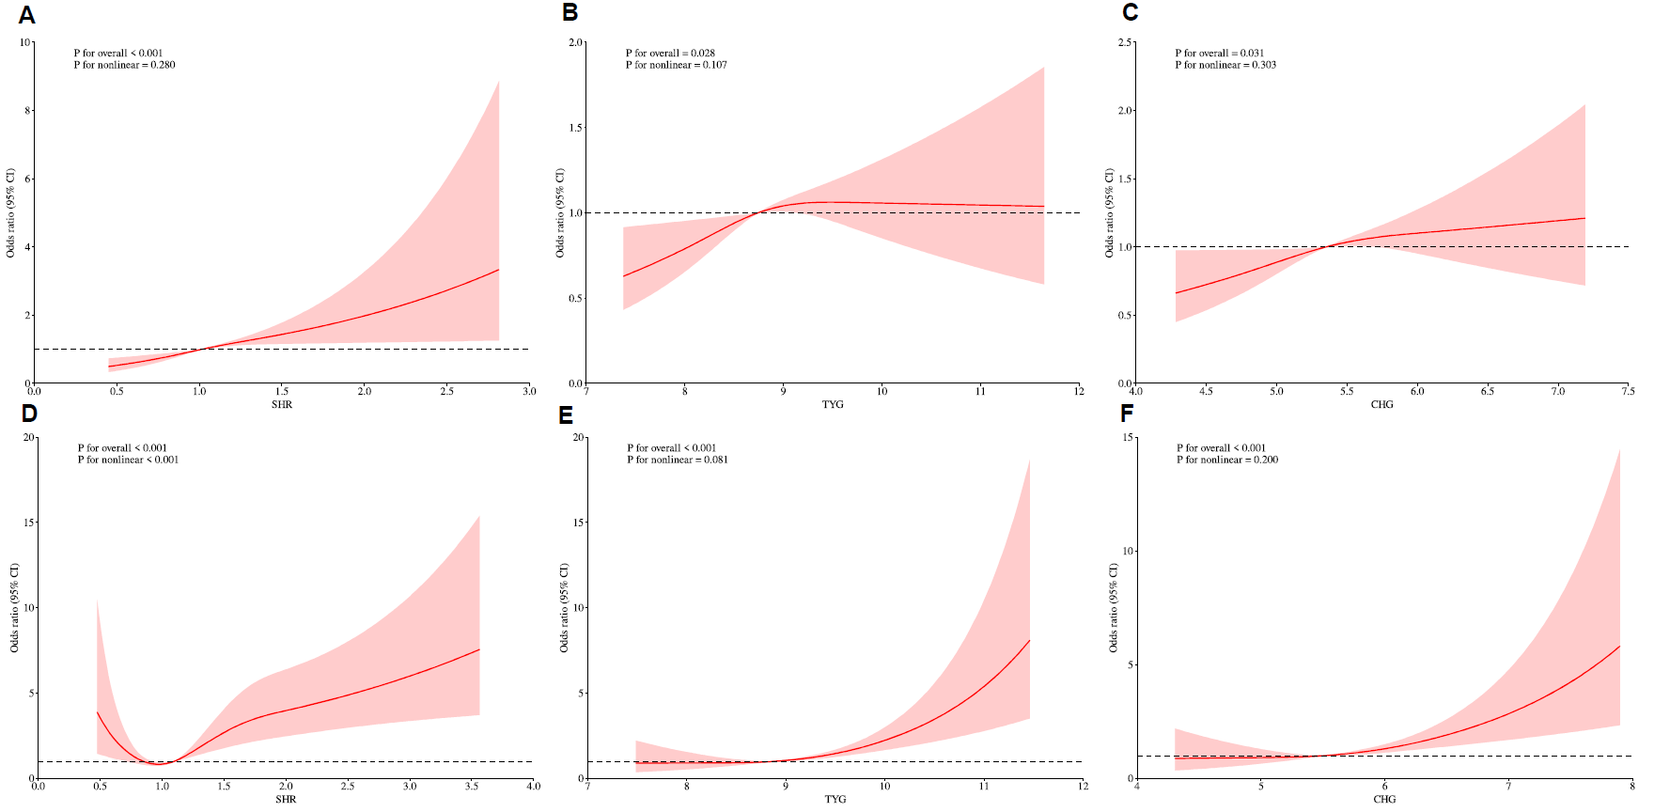
Note：Panels A-C present the results from the MIMIC database, while panels D-F show the results from the NWICU database. Specifically, (A) and (D) represent SHR, (B) and (E) represent TYG, and (C) and (F) represent CHG.
Abbreviations: AKI, acute kidney injury; SHR, stress hyperglycemia ratio; TYG, triglyceride-glucose index; CI, confidence interval.

Figure S2 Dose-Response Relationship between Three Biomarkers and Sepsis using Restricted Cubic Splines in the MIMIC and NWICU Databases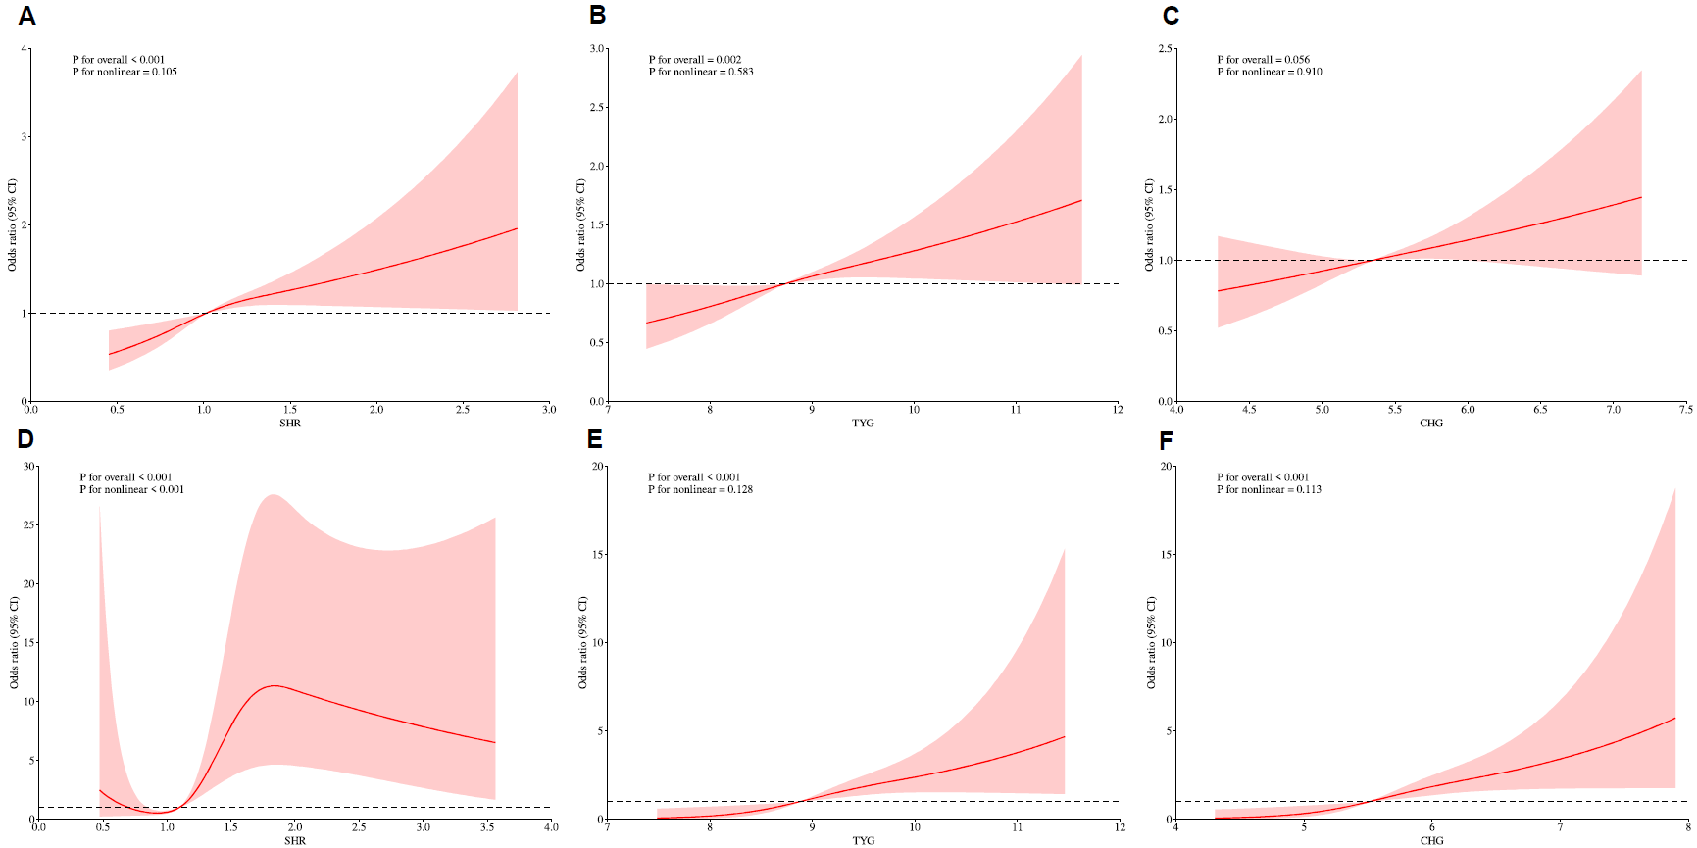
Note：Panels A-C present the results from the MIMIC database, while panels D-F show the results from the NWICU database. Specifically, (A) and (D) represent SHR, (B) and (E) represent TYG, and (C) and (F) represent CHG.
Abbreviations: SHR, stress hyperglycemia ratio; TYG, triglyceride-glucose index; CI, confidence interval.

Figure S3 Subgroup Analysis for the Association Between Three Biomarkers and the Risk of AKI in the MIMIC and NWICU Databases
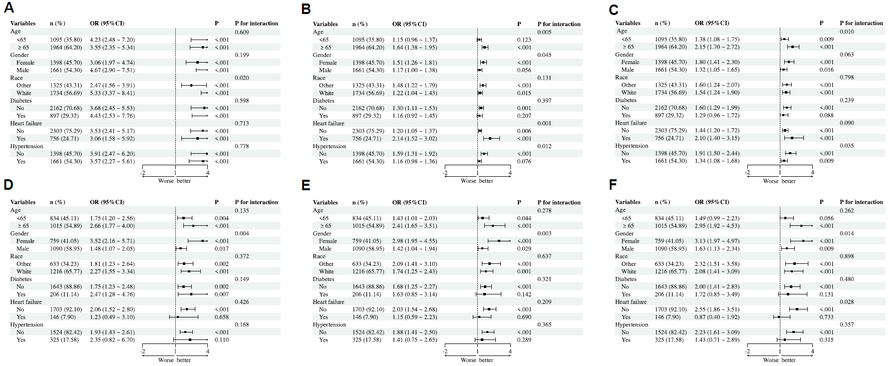
Note：Panels A-C present the results from the MIMIC database, while panels D-F show the results from the NWICU database. Specifically, (A) and (D) represent SHR, (B) and (E) represent TYG, and (C) and (F) represent CHG.
Abbreviations: SHR, stress hyperglycemia ratio; TYG, triglyceride-glucose index; CI, confidence interval.

Figure S4 Subgroup Analysis for the Association Between Three Biomarkers and the Risk of Sepsis in the MIMIC and NWICU Databases
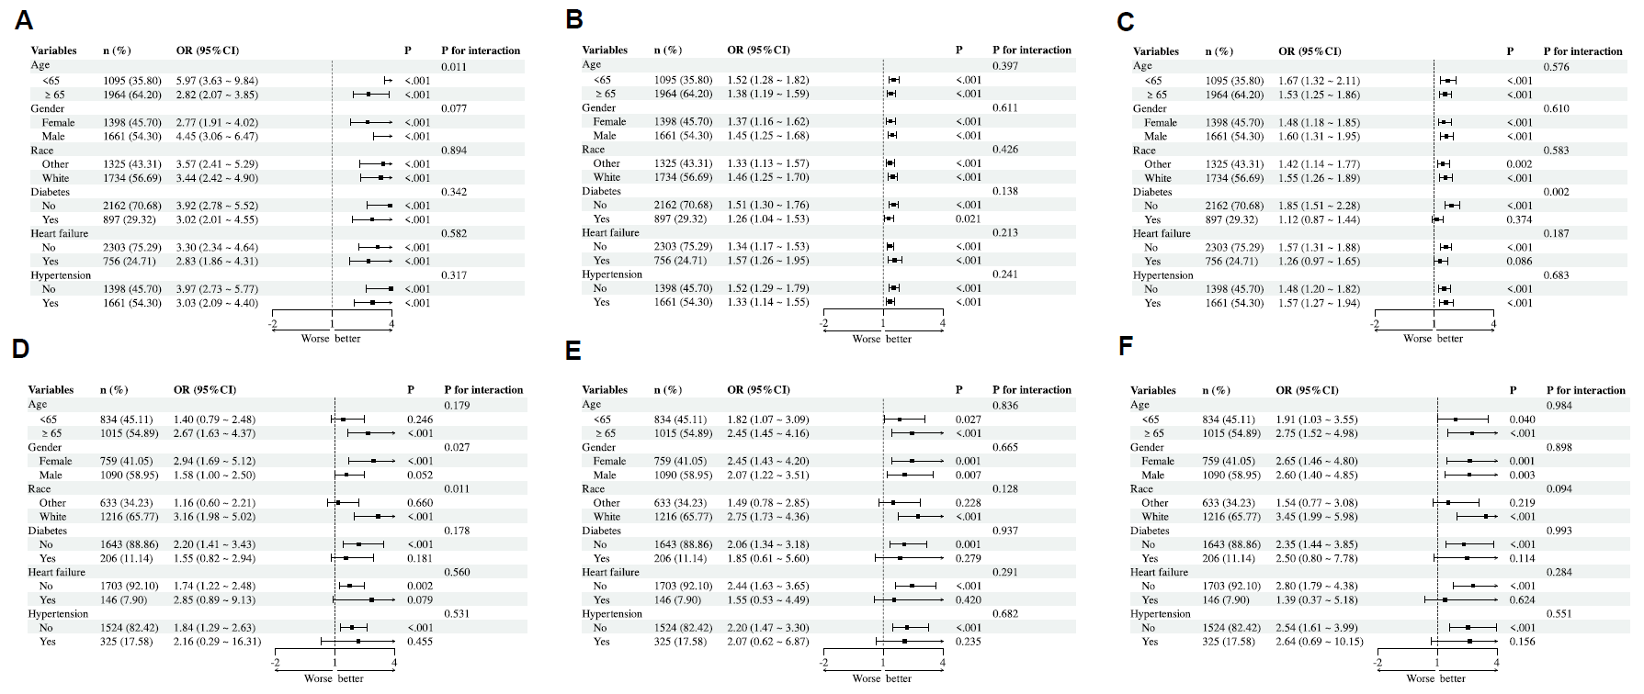
Note：Panels A-C present the results from the MIMIC database, while panels D-F show the results from the NWICU database. Specifically, (A) and (D) represent SHR, (B) and (E) represent TYG, and (C) and (F) represent CHG.
Abbreviations: SHR, stress hyperglycemia ratio; TYG, triglyceride-glucose index; CI, confidence interval.

Figure S5 Mediation Effect of WBC on the Association between Three Biomarkers and AKI in the MIMIC and NWICU Databases
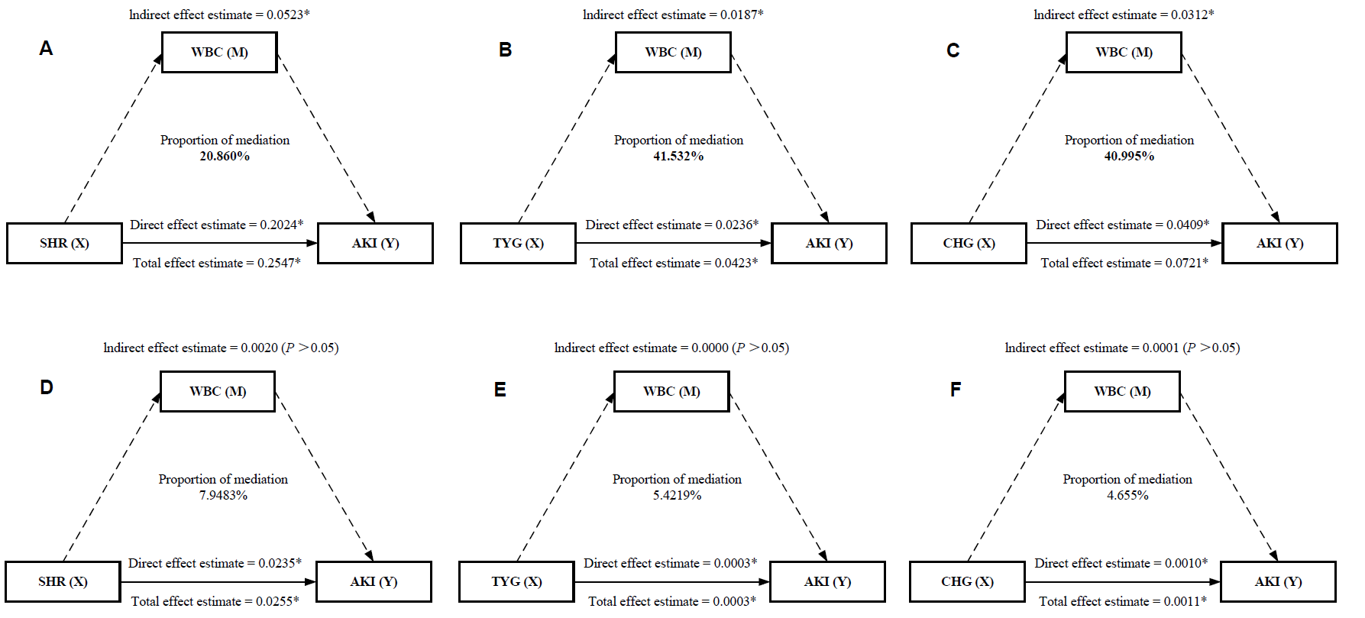
Note：* indicates P < 0.05
Panels A-C present the results from the MIMIC database, while panels D-F show the results from the NWICU database. Specifically, (A) and (D) represent SHR, (B) and (E) represent TYG, and (C) and (F) represent CHG.
Abbreviations: AKI, acute kidney injury; SHR, stress hyperglycemia ratio; TYG, triglyceride-glucose index; CI, confidence interval.

Figure S6 Mediation Effect of WBC on the Association between Three Biomarkers and Sepsis in the MIMIC and NWICU Databases
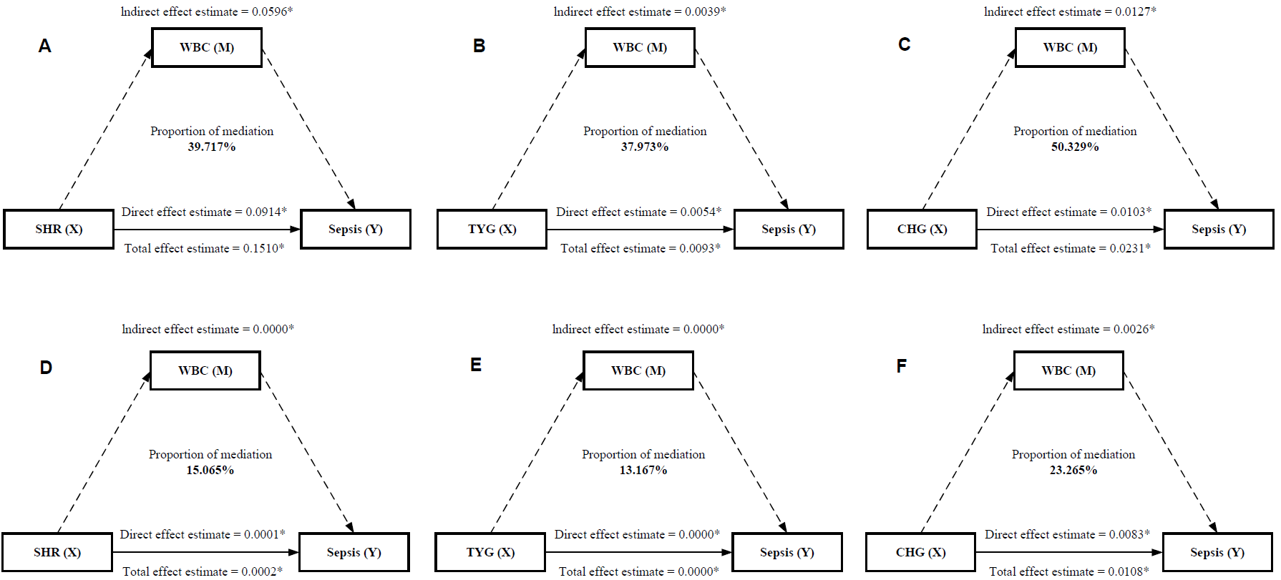
Note：* indicates P < 0.05
Panels A-C present the results from the MIMIC database, while panels D-F show the results from the NWICU database. Specifically, (A) and (D) represent SHR, (B) and (E) represent TYG, and (C) and (F) represent CHG.
Abbreviations: AKI, acute kidney injury; SHR, stress hyperglycemia ratio; TYG, triglyceride-glucose index; CI, confidence interval.

