An interpretable radiomics-machine learning model for diagnosing invasive fungal infections in community-acquired pneumonia: multicenter study

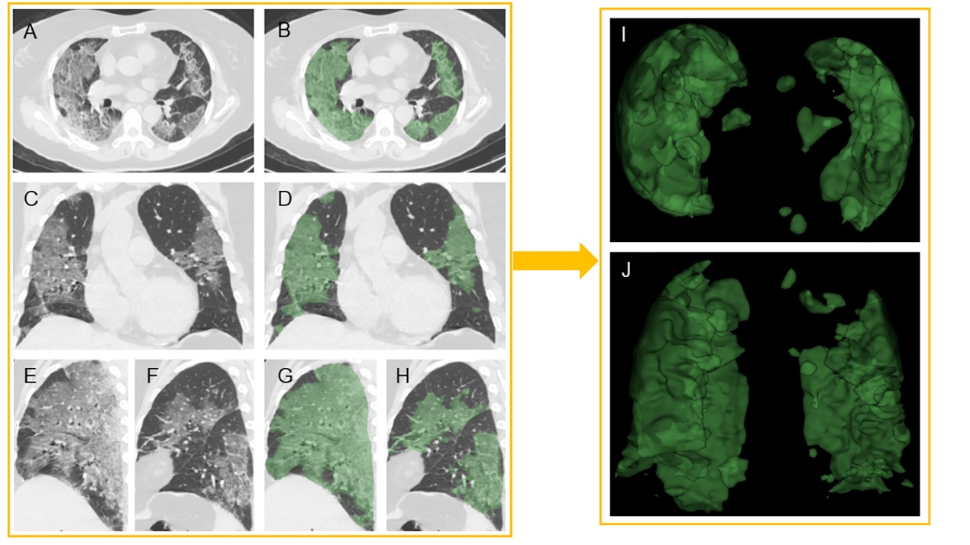
Figure S1. Representative ROI segmentation.

Figure S2. Heatmap analysis of the selected radiomics features.

S1. Acquisition of CT images
In all patients, HRCT images were acquired in the supine position at full inspiration.
In Center 1, HRCT scans were performed in the axial plane with 1-mm-thick sections by multi-detector CT scanners, including uCT 760 (United Imaging Company, Shanghai, China), QuantumEye 789 (MinFound Company, Hangzhou, China), Brilliance 64 and IQon-Spectral CT (Philips Company, Amsterdam, Netherlands). Image reconstruction convolution kernels included Soft, stnd, lung, and chest.
In Center 2, HRCT scans were performed in the axial plane with 1-mm-thick sections by multi-detector CT scanners, including Light Speed 64 (General Electric Company, Boston, America) and uCT 760 (United Imaging Company, Shanghai, China). Image reconstruction convolution kernels included Soft, stnd, lung, and chest.

S2. Radiomics feature extraction method and feature details
B-spline interpolation resampling algorithm was used to standardize the voxel spacing. The parameters used in PyRadiomics were as follows: Interpolator: sitk B Spline; bin Count: 35; resampled Pixel Spacing: 1 mm × 1 mm × 1 mm. This approach guarantees all features hold a uniform range of values, preventing any single feature from having undue influence on the model because of scale differences. Radiomics features were extracted from the ROI using the IBSI compliant uAI Research Portal (V20230515. https://urp.united-imaging.com/). A total of 2,264 radiomic features were extracted from each region of interest (ROI), comprising 14 shape features, 451 first-order statistical features, and 1,801 high-order texture features. The texture features included 526 gray-level co-occurrence matrix (GLCM) features, 351 gray-level dependence matrix (GLDM) features, 401 gray-level run-length matrix (GLRLM) features, 401 gray-level size zone matrix (GLSZM) features, and 126 neighboring gray tone difference matrix (NGTDM) features. All radiomic features were standardized using z-score normalization prior to subsequent analyses.

