Supplementary Material

This supplemental material has been provided by the authors to give readers additional information about their work.

Figure S1. PRISMA 2020 flowchart of the selection process.
Identification of studies via other methods
Identification of studies via databases and registers

Records identified from:
Grey literature sources (n = 0)
Citation searching (n = 2)
Records removed before screening:
Duplicate records removed (n = 195)
Records identified from:
Databases (n = 885)
Registers (n = 10)

Identification

Records screened
(n = 700)
Records excluded
(n = 698)

Reports not retrieved
(n = 0)
Reports sought for retrieval
(n = 2)
Reports sought for retrieval
(n = 12)
Reports not retrieved
(n = 0)

Screening

Reports assessed for eligibility
(n = 2)
Reports excluded (n = 2)
Reports assessed for eligibility
(n = 12)
Reports excluded (n=6):
Wrong study design (n = 4)
Wrong intervention or control (n = 2)

Studies included in review
(n = 6)
Reports of included studies
(n = 6)
Included

Figure S2. Quality assessment of included trials.
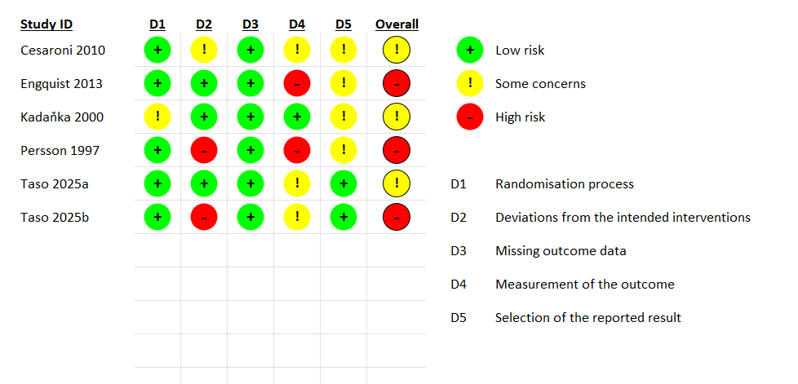

Figure S3. Sensitivity analysis of physical function outcomes (excluding Kadanka 2000).
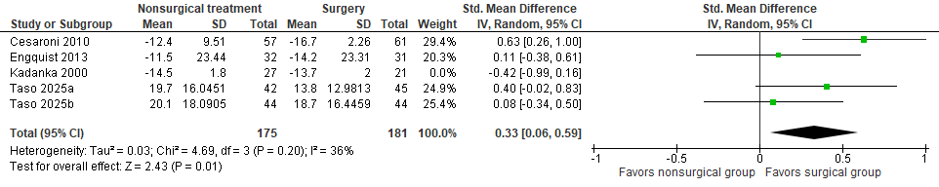

Figure S4. Forest plot of emotional/mood improvement.
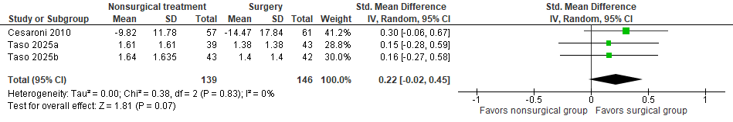

Figure S5. Forest plot of patient-reported symptom improvement.
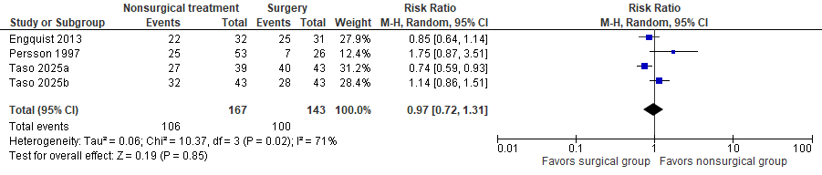

Figure S6. Forest plot of patient-reported analgesic use.
